Introduction
During this assignment using the Entrecomp Framework (Bacigalupo et al, 2016), I will address creativity within the classroom, in terms of my own creative teaching and also how I would develop children’s creativity through my own pedagogy. As I will be using the Entrecomp Framework (Bacigalupo et al, 2016) to reflect on my own creativity and enterprise skills it is worth noting that although the Entrecomp Framework does address creativity the framework is specifically designed to foster entrepreneurial skills, and consequently may not evaluate all key areas of creativity and enterprise. However, there are elements of creativity and enterprise addressed within the framework, so it is useful. Throughout the reflection it is important to recognise that the framework is not designed for teachers so some threads may be difficult to relate to my own pedagogy.
As this discussion is centred around creativity it is important to have an understanding of what creativity actually means. It is suggested by Desailly (2012, p.11), that there is a substantial amount of debate with regards to what creativity should look like within the primary classroom and how best to teach and develop it. It is noted within Charlie and Jordan (2012, p.7), that the definition that Boden (1994) provides for creativity is ‘a conceptual ability to come up with new ideas that are surprising, yet intelligible and also valuable’. This is further supported by Wright (2010, p.3) in which Sternberg and Lubart (1995) suggests that ‘creativity is the process of generating ideas that are novel and bringing into existence a product that is appropriate and of high quality’. However the definition that will be sustained throughout this assignment is (Newton, 2012, p.8), from the National Advisory Committee on Creative and Cultural Education who defined creativity as an ‘imaginative activity fashioned so as to produce outcomes that are both original and of value’.
Within this assignment it is also important to have a good understanding of the enterprise skills that a teacher possess in order to help develop children’s creativity and their own enterprising skills. It can be noted that BridgewaterUK (2017) defines enterprising as ‘having or showing initiative and resourcefulness’ as well as making the most of opportunities that present themselves. It can be noted that Essex Work Skills (2020), suggests ‘Being enterprising is characterised by exhibiting skills such as individuality, creativity, and leadership’ and Lowe and Marriott (2006, p.4), proceeds to suggest that a key aspect of being an enterprising individual is being willing and able to take risks. As such enterprise and creativity are interlocked with a variety of skills which allows for the creation of new and innovative concepts.
It is important for us to discuss why we strive for children to be innovative and creative young members of society. It is acknowledged by Donaldson (2015, p.28) that creativity and enterprise should be developed progressively throughout a child’s school career due to the importance of these aspects in modern life. This is further supported by Duffy (2006, pp.6-7), who corroborates the notion that due to the constant fast-paced changing nature of the modern world it is important that children have the creativity, enterprise and innovation skills to tackle new challenges by thinking flexibly, connecting knowledge and taking risks. It is also worth considering why it is essential that we develop creativity within young children and ourselves before engaging with specific elements of creativity. It can be noted within Soffel (2016) that creativity is seen, by the World Economic Forum, as a 21st Century Skill Competency which will help children to tackle current challenges and also challenges in later life. This is further supported through Donaldson (2015) suggesting that the future curriculum meets the demands of modern life by putting a more recognised emphasis on creativity and enterprise. However, it is also acknowledged by Sternberg (2010, p.394), that the use of creativity is not always welcomed within the school environment, for example within standardised testing as this type of assessment requires children to just produce the correct answer. This can prove to be a challenge for teachers trying to encourage children to be innovative and creative.

Main Body
It is important to have an understanding of ones own level of creativity and enterprise skills as a teacher, but also how to develop creativity in the children that you teach. Boden (2001, p.98), would suggest that both of these elements link together within the classroom as a teachers attitude towards creativity and enterprise skills and as such the teaching and learning of said elements can influence a child’s own perspective and abilities of creativity both positively and negatively. Therefore both elements will be discussed during this assignment, starting with my own creativity and enterprise. Overall when rating myself using the Entrecomp Framework (Bacigalupo et al, 2016), when looking at creativity I have decieded that my personal creativity best fits within level 2. I concluded my level by looking at the specific threads for creativity and averaging the results.

Within the EntreComp Framework (Bacigalupo et al, 2016) with regards to creativity the first thread is being open and curious, and I believe that I fit best within a level 2 of this thread. This level of being open and curious reflects the importance of being able to overcome functional fixedness. Functional fixedness coined by Karl Duncker is a key aspect in being creative as it involves seeing different and new uses for something that may already have a set function (Boyd, 2013). It is noted by Cherry (2019) that functional fixedness can present as a barrier to activities such as creative problem solving and can prevent the creation of possible solutions to problems. As such being able to overcome functional fixedness is essential in the creation of new and innovative ideas.
There is evidence to suggest that I have overcome functional fixedness, as while on placement within a lesson, collaboratively with the children we used ordinary pictures to create sums. Rather than writing sums on the board and then the children answer the questions, together we used photographs to make a number story and as such created addition sums (Appendix 1). This shows that I am able to adapt the use of certain objects for a new purpose and reinforced this concept with the children that I was teaching. There is more evidence to suggest that I have been able to overcome functional fixedness within my teaching within a mathematics lesson (Appendix 2). Within this mathematics lesson I encouraged the children to measure items around the classroom by using objects around the classroom. For example, the children used their hands, paperclips, pencils and books, of which their prescribed function is not to measure other items.
In order to get to level 3 for the thread of being open and curious I would need to develop my own ability to use my skills in new situations and this relates to taking risks in order for a creative output. It can be recognised within Kallick and Costa’s Habits of Mind (Teach Thought Staff, 2019), that taking responsible risks is one of the key habits of mind that a creative person may possess. It is noted by Quigley (2016, p.58), that although genetics dispositions may not be able to be changed, in order for professional growth we are able to alter our habits and as such our view and attitudes. Therefore, in order to progress in my ability to experiment with new skills and competencies I will try to embrace the habit of mind that is to take responsible risks. Furthermore, it is recommended by Thorne (2007, p.76), that in order for creativity to develop there needs to be an understanding of how to appropriately manage risks, in order to generate new solutions. As such during placement and within my teaching career I will take new opportunities to explore and take responsible risks within my teaching which will allow for me to develop my creativity and enterprise skills. This can be done through my lesson planning and experimenting with new ideas that may or may not work, and this may require me to step outside of my comfort zone.

Within the thread of developing ideas, I believe that I am on level 2 also, and this level relates to the process of divergent thinking. Divergent thinking noted by Starko (2010, p.56) is the process of being able to identify multiple possible solutions to a proposed question. Although it could be suggested that I am able to use the divergent thinking model to help my thinking and creative processes it is also important to note that Kozbelt, Beghetto and Runco (2010, p.20) argues sometimes divergent thinking can lead to the creation of irrelevant ideas. This is why it is important to apply divergent thinking and then convergent thinking in order to have a range of suitable ideas for your problem.
There is evidence to suggest that I am currently at the level 2 for developing ideas as while on professional teaching practice I noted that I needed to work on my assessment for learning within the classroom and as such I brainstormed various possible strategies that could be used with the children (Appendix 3). After this, using the process of convergent thinking, I was able to make an informed decision on the best strategies to try with the class. Also, I was able to use the process of divergent thinking within my own pedagogy to produce possible strategies that could help promote good behaviour within the class (Appendix 4). I found this process useful as if one strategy did not work effectively with that class, I had various other methods that I could trial in order to find the best options for the class that I was teaching.
To move on to level 3, it is important that I am able to experiment with available resources in order to solve problems and consequently develop my understanding of prototyping. As such prototyping for teachers can involve experimenting with new ideas in order to create viable solutions to problems that may occur within the classroom.
One of the ways I can develop my ability to use prototypes is to use De Bono’s Six Thinking Hats to support the process. De Bono’s Thinking Hats can allow me to design prototypes and evaluate them in order to develop new ideas to best suit the problem. As it is suggested by Wyse and Dowson (2009, p.86), the Thinking hats allows thinking in different perspectives, which allows for more experimentation with available equipment that may not have been thought of before. Again, the perfect time for me to explore using prototypes to experiment is while on professional teaching practice. What automatically accompanies prototyping is the ability to reflect and edit prototypes in order to improve. As such it is important to embrace failures and acquire honest feedback on those failures (Cleverism, date unknown). These points are further supported by Tarrant (2013, p.) who suggests that through reflecting and what has already happened teachers can take control over their practice and can acknowledge strengths and what improvements need to be made. It is discussed within TED (2010) that children who have just graduated kindergarten are some of the best performers within the Marshmallow challenge because they prototype repeatedly throughout the allotted time meaning that they ‘get instant feedback about what works and what doesn’t work’. Consequently, is seems that some of the best ideas are created if they are prototyped multiple times within their production. As such I will make use of my personal reflections on placement and the guidance from my class mentors and university tutors as every lesson can be thought of as a prototype for the next.

Within the thread of defining problems, I believe that I am on level 3 as I am able to work within a group dynamic to define problems, and this level relates to the process of collaboration. Collaboration is thought of a key to creative processes, according to Starko (2010, p.55), creativity is the result of individuals collaborating with other individuals. It is commented by Estyn (2018) that when leaders in schools encourage a collaborative working ethos, new ways of working emerge and because of this staff and children enjoy their school experience. This is further supported by Quigley (2016, p.46) who comments that through collaboration with fellow teachers and staff members, a teacher can develop their confidence, and this could help teachers to feel free to be more creative in the workspace.
There is evidence to suggest that I have been able to take part in collaborative problem solving with other members of the school community. While on professional teaching practice I was able to work in collaboration with members of staff in order to deal with issues that may arise day to day (Appendix 5). Also, during professional teaching practice, I was able to work collaboratively with the children and class teacher in order to make the mathematics we were developing more engaging and fun. The children were not engaged with the lessons and so together we discussed what could make the mathematics more fun and engaging for them. I then used this to devise a more interesting lesson in which the children used mathematics to discover who was the criminal in a line-up of possible suspects (Appendix 6).
To move on to level 3, it is important that I develop the way that I reframe problems in order for problems to be better suited to my skills. One of the ways that this can be achieved is through persistence. It is acknowledged by Dottin (2010, p.3) that the Habit of Mind that is persisting is essential to achieving results if an obstacle presents itself. As such in order to reach the next level it is important that I set myself goals and remember to persist, this could be just by thinking about the problem in a different way until I reach a solution. It should be considered that the previous discussion about collaborating would be useful in aiding my persistence, as working with other teachers and professionals could help me find a solution to the problem.

Within the thread of design value, I believe that I am on level 1 as I can assemble items of value, and this level relates to the process of assembling products for a purpose. There is evidence to suggest that within my teaching that I am currently at this level. During my professional teaching practice, I was able to construct a spin board for the children to use within a mathematics addition lesson (Appendix 8). Rather than ordinarily giving the children addition questions to answer I created a game in which the children can spin the board giving them two numbers and this will then be their sums. This proved to be a fun and engaging resource for the children. For this thread level 2 requires you to improve existing services and products and developing them further. In order to achieve this level, I could use the tool of SCAMPER which would help to develop ideas further by means of substituting, combining, adapting, modifying, putting to another use, eliminating and reversing product already in use (Mind Tools Videos, 2018).

Within the thread of being innovative, I believe that currently within my own creativity I am at a level 1 which means that I can find innovative products. There is evidence within my professional teaching practice that would indicate that I am currently working at this level, as I was able to use information and products that I already knew to develop lessons into more engaging creative experiences for the children.
I noted that the children enjoyed working things out by using problem solving. This then informed my lesson where the children had to solve different puzzles which I knew would be engaging, in order to find out key pieces of information that needed to be placed within our timeline, this consisted of; sentence organising, mathematics questions and picture-letter representation keys (Appendix 8), (Appendix 9). This lesson gave the children the chance to discover new information for themselves and gave them a chance to develop problem solving skills at the same time. It was also noted by my classroom teacher and myself that the children were finding the mathematics questions repetitive and monotonous, so we constructed a lesson which I adapted so it would reinforce the learning but be more engaging for the children (Appendix 10). This alternative to the usual mathematics lessons helped the children to put their learning in context and made the learning more fun and engaging.
To progress to level 2, I will need to be able to acknowledge how innovations have help to transform society. It is important to acknowledge innovations within society as in the draft document for the new curriculum by Welsh Government (2019), one of the achievement outcomes discusses innovative thinking. As such in order to achieve level 2, I will need to keep up to date with new technology and creative and innovative ideas, so that I can pass this information on to the children that I teach.

I also have addressed my level for the thread of being resilient within the motivation and perseverance competence. For this thread I believe that I am a level 2 which links to persevering to achieve goals. There is evidence that I am at level 2 for this thread within a lesson observation on my professional teaching practice (Appendix 11). Within the observation the teacher comments that I have continued to try to achieve set targets and have been willing to accept advice from other members of staff in order to continue to progress. There is additional evidence also supplied through the means of an observation while on professional teaching practice which supports the levelling (Appendix 12). Within this observation the tutor has suggested that I have accepted advice and used reflections to further develop my knowledge. In order to develop to a level 3, I will need to overcome simple adverse challenges. However, it could be argued that I have shown some evidence of that within the observations. Despite this, I feel that overcoming more challenges is something I need to work on. It is acknowledged by Daum (2013) that one of the ways to overcome challenges is to engage in creativity. Therefore, all of the previous strategies I have mentioned will help me to develop my creativity which will ultimately allow me to overcome challenges.

It is noted by Ken Robinson within TED (2007) that due to the expectations of teachers and schools within education we are ‘educating people out of their creative capacities’. As such it is important that to acknowledge how as teachers are, we going to develop the creativity of the young children in Wales. It is suggested by Desailly (2012, p.45), that in order for children to be creative throughout their lives they will develop skills, dispositions and attributes however to nurture and progress their creative capacity the children have to understand how they are creative in the first place. It can be noted by Davies and Newton and Newton (2018, p.887), that although schools currently are striving towards an ethos that values creativity, often teachers have a lack of understanding on how to facilitate the development of creativity and enterprise within the children, in essence they may be unable to differentiate between teaching for creativity and teaching creatively.
One of the ways that would help to develop young children’s creative and enterprise skills is through the development of both their divergent and convergent thinking. In order to promote creativity and enterprise skills within the classroom it is important that young children are able to generate ideas. This links with divergent thinking which allows children to develop a range of ideas. Convergent thinking helps to focus on a specific idea that will solve a problem.
It is important to recognise that convergent thinking and divergent thinking, developed by Guilford, (TeachThought, 2019), can work in collaboration to improve the process of idea generation (Cleverism, 2015). With children activities such as naming uses for a certain object, will certainly help to develop their divergent thinking. Furthermore, this can be progressed by helping children to identify categories in their thinking in order to allow for the creation of new ideas.
In order to enhance divergent thinking, there are many elements that a teacher can influence which allows them to help the creative process. One of the ways, is taking into account the environment in which the children are instructed to be creative in. Acknowledged by EYFS (2008, p.107) is the need to ‘provide a stimulating environment in which creativity, originality and expressiveness are valued’, consequently giving the children an environment where they can explore their creative and enterprise skills. The environment is a key aspect of a child’s learning and development within school and can act as a stimulus for their imagination as noted by Hodgman (2012, p.2). As such the classroom should be a space both physically and emotionally in which children feel that they can be creative and enterprising in order for them to develop. It is also worth acknowledging that the classroom is not the only place where children can be creative, as the use of outdoor spaces can be invaluable to a child’s creativity. This is supported by Richardson (2014, p.12), who suggests that an outdoor learning space can give children the freedom to experiment, modify and develop dispositions for learning that may not always occur indoors. As such there should be opportunities for children to experiment with creativity and enterprise skills in various environments in and around the school in order to help to develop their skills to their full potential. Taking into account that it is suggested by Wong (2014) that walking can help to raise people’s creative output up to 60%, it is worth giving children the opportunity to have time to create their own ideas and not have to be rushed into being creative. So, it is important that teachers allow children to take the time to explore the world as inspiration is all around us and just a change of location can help children be more creative.
Another vital aspect of developing divergent thinking in children is the avoidance of ridicule of children’s ideas and thinking processes. As such it is suggested by Nottingham (2013, p.47), that in order to create a safe, secure learning space that allows for free expression of creativity not all pieces of work should be marked as it can affect their growth mindset. Children having the opportunity to explore and come up with new ideas without being judged (marking) can help to prevent children disposing of ideas they think are insignificant or incorrect. This is further supported by Maslow’s Hierarchy of Needs (1954) noted by Lester (2013, p.15) as it indicates that the children’s need to feel safe and secure in an environment before they can begin to feel confident enough to be creative and innovative within their learning experiences. It is also important to recognise that Allen and Gordon (2011, p.73), suggests that when children have high levels of both self confidence and self esteem they are more likely to produce work of a higher quality as overall performance improves further supporting the argument that children need to be in a good mental state before they can really reach their creative potential, this applies to divergent thinking but also to other areas of creativity. National Advisory Committee on Creative and Cultural Education (1999) suggests that not only does self-confidence and good self-esteem result in creativity but finding personal creative strengths can help raise self-esteem, so it results in a positive creative cycle.
There is also a debate surrounding whether creativity should be developed within groups or individually. It is acknowledged by Creative Huddle (2013) that within working groups there is always different personality types such as introverted and extraverted people. This can sometimes result in the more introverted people not developing their creativity and enterprise skills to their full potential because they do not feel comfortable contributing to group idea generations. It is suggested (Communication Theory, date unknown) that innovative ideas are developed through the collaboration between different people, as it is human nature to be inspired by other people and their ideas. This is further supported by Vygotsky’s social constructivist theory (Jordan and Carlile and Stack, 2008, p.59), in which it is discussed that social interaction and language helps to develop and construct knowledge. Paulus (2000, p.253) found evidence within his study that the creative process of generating ideas may work best when children have a chance to work individually initially and then collaborate with a group to enhance or refine those ideas, this is also supported by Clegg and Birch (2007, p.12). Therefore, in order for the best opportunities to be innovative it is important that teachers recognise when to use different approaches, so the children have the various experiences to develop their creative thinking, both independently and within a group.
In order to help develop convergent thinking with children, it is important that they understand how to focus on the problem they are trying to solve so that they can develop all of their ideas into a viable solution. One of the ways that this can be done is through the use of the six thinking hats. The Six Thinking Hats (2000) is a clear concept for children to address different models of thinking (Grigg, 2010, p.94). Using these different models of thinking when trying to decide on an idea to move forward with the children can consider different aspects of their idea in order to make the best choice, or to adapt an idea to fit a specific purpose. As such the Six Thinking Hats may be a suitable aid to thinking to introduce into the classroom, which will help children during their convergent thinking activities and problem-solving situations.
It is important to let children know that when they are trying to solve a problem, using convergent thinking that it does not stop you from further developing ideas that you have already conceived. A way that this can be done is through a model called SCAMPER. SCAMPER is a tool which can help to develop ideas further by editing those ideas in some way, this can be done by means of substituting, combining, adapting, modifying, putting to another use, eliminating and reversing (Cleverism, 2015b). The SCAMPER can help to develop children’s creative capacity as noted by Ozyaprak (2016, p.37), within the findings of a study, SCAMPER can help enhance creative thinking, especially for divergent thinking. However although this study specifically says that it helps to enhance divergent thinking, I would personally not only use it as a tool for divergent thinking but also convergent thinking as I think divergent and convergent thinking work in unison although they are two different concepts of thinking. The idea of using SCAMPER for both divergent and convergent thinking is supported by Radziszewski (2017, p.314), who argues that children’s ability to develop suitable and creative ideas will progress when using SCAMPER during the process of idea development and also the evaluation of ideas. For example, a child may have develop a range of options to a problem, using divergent thinking, however when they begin to use convergent thinking in order to pinpoint the most viable solution, they may need to combine two or three ideas that they think will work together to develop the one idea that will ultimately be the solution. This again is a model that could easily be adopted into the classroom as a tool to help develop creativity and enterprise skills.

Conclusion
Throughout this assignment the use of the Entrecomp Framework (Bacigalupo et al, 2016) has helped to evaluate my own creativity and innovation, however the results should be treated with caution as the framework is not constructed specifically for teachers. It is acknowledged by Tanggaard (2011, pp.230), that ‘teachers must lay the basis for pupil creativity, by themselves acting as creative and reflective practitioners’. As such it is important that both elements discussed in this assignment, a teacher’s creativity and developing children’s creativity, need to be developed in unison so that an enterprising and creative ethos is encouraged within the classroom. There are many ways to develop children’s creativity and it is essential that we do so as it is noted as an essential factor of survival (Clegg and Birch, 2007, p.2). As such it is important that teachers acknowledge how they are developing children’s creativity as it is so important within today’s society and across all manner of jobs. It is important that I not only make sure that the children are having opportunities to develop creativity and enterprise skills, but also that I am able keep track of my own creativity and keep setting new targets in order to progress. As mentioned previously the world changes very quickly so, it is important to stay up to date with my professional development in all aspects of teaching, including creativity. The teacher’s role in developing children’s education is vital. It is evident that Black et al. (2002, quoted in Cremin et al, 2009, p.3), suggested that teachers are not in the classroom just to deliver information but to facilitate innovative and creative exploration of the world around us.

Reference List
Allen, S. and Gordon, P. (2011) How Children Learn 4 – Thinking on Special Educational Needs and Inclusion. London: Practical Pre-School Books.

Bacigalupo, M. et al. (2016) EntreComp: The Entrepreneurship Competence Framework. Luxembourg: Publication Office of the European Union.

Boden, M, A. (2001) ‘Creativity and Knowledge’, in Craft, A. and Jeffery, B. and Leibling, M. (ed.) Creativity in Education. London: Continuum.

Boyd, D. (2013) Fixedness: A Barrier to Creative Output. Available at: https://www.psychologytoday.com/us/blog/inside-the-box/201306/fixedness-barrier-creative-output (Accessed: 1st January 2020).

BridgewaterUK (2017) Enterprise Skills: What Are They and Do You Have Them?. Available at: https://www.bridgewateruk.com/2017/09/enterprise-skills/ (Accessed: 1st January 2020).

Charlie, O. and Jordan, A. (2012) Approaches to Creativity: A Guide for Teachers. Berkshire: Open University Press.

Cherry, K. (2019) Functional Fixedness as a Cognitive Bias. Available at: https://www.verywellmind.com/what-is-functional-fixedness-2795484 (Accessed: 1st January 2020).

Cleverism (2015) Idea Generation: Divergent vs. Convergent Thinking. Available at: https://www.cleverism.com/idea-generation-divergent-vs-convergent-thinking/ (Accessed: 4th January 2020).

Cleverism (2015b) Idea Generation and Problem Solving Using SCAMPER Technique. Available at: https://www.cleverism.com/idea-generation-problem-solving-using-scamper-technique/ (Accessed: 7th January 2020).

Cleverism (date unknown) Prototyping. Available at: https://www.cleverism.com/skills-and-tools/prototyping-skills/ (Accessed: 6th January 2020).
Communication Theory (date unknown) Creativity in Groups. Available at: https://www.communicationtheory.org/creativity-in-groups/ (Accessed: 6th January 2020).

Creative Huddle (2013) Creativity: better alone or in groups? Available at: https://www.creativehuddle.co.uk/creativity-better-alone-or-in-groups (Accessed: 6th January 2020).

Cremin, T, et al. (2009) Teaching English Creatively. Oxon: Routledge.

Daum, K. (2013) 4 Tips for Overcoming Obstacles. Available at: https://www.inc.com/kevin-daum/4-tips-for-overcoming-obstacles.html (Accessed: 7th January 2020).

Davies, L, M. and Newton, L, D. and Newton, D, P. (2018) ‘Creativity as a twenty-first-century competence: an exploratory study of provision and reality’, Education 3-13, 46(7), pp.879-891.

Desacilly, J. (2012) Creativity in the Primary Classroom. London: SAGE Publications Ltd.

Donaldson, G. (2015) Successful Futures. Crown copyright. Available at: https://dera.ioe.ac.uk/22165/2/150225-successful-futures-en_Redacted.pdf (Accessed: 27th November 2019).

Duffy, B. (2006) Supporting Creativity and Imagination in the Early Years. 2nd edn. Berkshire: Open University Press.

Essex Work Skills (2020) Enterprise Skills. Available at: https://essexworkskills.co.uk/education-support/enterprise-skills/ (Accessed: 6th January 2020).

Estyn (2018) The Annual Report of Her Majesty’s Chief Inspector of Education and Training in Wales 2017-2018. Cardiff: Estyn.

EYFS (2008) Practice Guidance for the Early Years Foundation Stage. Nottingham: Department for Children, Schools and Families.

Hodgman, L. (2012) Enabling Environments in the Early Years. London: Practical Pre-School Books.
Jordan, A. and Carlile, O. and Stack, A. (2008) Approaches to Learning. Berkshire: Open University Press.

Kozbelt, A. and Beghetto, R, A. and Runco, M, A. (2010) ‘Theories of Creativity’, in Kaufman, J, C. and Sternberg, R, J. (ed.) The Cambridge Handbook of Creativity. Cambridge: Cambridge University Press.

Lester, D. (2013) ‘Measuring Maslow’s Hierarchy of Needs’, Psychological Reports: Mental & Physical Health, 113(1), pp.15-17.

Lowe, R. and Marriott, S. (2006) Enterprise: Entrepreneurship and Innovation. Oxford: Elsevier Ltd.

Mind Tools Videos (2018) SCAMPER. [video] Available at: https://www.youtube.com/watch?v=vqnIEtlp9d8 (Accessed: 6th January 2020).

National Advisory Committee on Creative and Cultural Education (1999) All Our Futures: Creativity, Culture and Education. London: DfEE.

Newton, L. (2012) ‘Creativity and Problem Solving: An Overview’, in Newton, L. (ed.) Creativity for a New Curriculum: 5-11. Oxon: Routledge.

Nottingham, J. (2013) Encouraging Learning. Oxon: Routledge.

Ozyaprak, M. (2016) ‘The Effectiveness of SCAMPER Technique on Creative Thinking Skills’, Journal for the Education of Gifted Young Scientists, 4(1), pp.31-40.

Paulus, P, B. (2000) ‘Groups, Teams, and Creativity: The Creative Potential of Idea-generating Groups’, Applied Psychology: An International Review, 49 (2), pp.237-262.

Quigley, A. (2016) The Confident Teacher. Oxon: Routledge.

Radziszewski, E. (2017) ‘SCAMPER and Creative Problem Solving in Political Science: Insights from Classroom Observation’, Journal of Political Science Education, 13(3), pp.308-316.

Soffel, J. (2016) What are the 21st-century skills every student needs?. Available at: https://www.weforum.org/agenda/2016/03/21st-century-skills-future-jobs-students (Accessed: 27th November 2019).

Starko, A, J. (2010) Creativity in the Classroom. 4th edn. Oxon: Routledge.
Sternberg, R, J. (2010) ‘Teaching for Creativity’, in Beghetto, R, A. and Kaufman, J, C. (ed.) Nurturing Creativity in the Classroom. Cambridge: Cambridge University Press.

Tanggaard, L. (2011) ‘Stories about creative teaching and productive learning’, European Journal of Teacher Education, 34(2), pp.219-232.

Tarrant, P. (2013) Reflective Practice and Professional Development. London: SAGE Publications Ltd.

Teach Thought Staff (2019) What Are The Habits Of Mind? Avialable at: http://www.teachthought.com/pedagogy/what-are-the-habits-of-mind/ (Accessed: 30th December 2019).

TeachThought (2019) 3 Modes of Thinking: Lateral, Divergent & Convergent Thought. Available at: https://www.teachthought.com/critical-thinking/3-modes-of-thought-divergent-convergent-thinking/ (Accessed: 7th January 2020).

TED (2007) Do Schools Kill Creativity? | Sir Ken Robinson [video]. Available at: https://www.youtube.com/watch?v=iG9CE55wbtY (Accessed: 3rd January 2020).

TED (2010) Build a tower, build a team | Tom Wujec [video]. Available at: https://www.youtube.com/watch?v=H0_yKBitO8M (Accessed: 6th January 2020).

Thorne, K. (2007) Essential Creativity in the Classroom. Oxon: Routledge.

Wong, M. (2014) Stanford study finds walking improves creativity. Available at: https://news.stanford.edu/2014/04/24/walking-vs-sitting-042414/ (Accessed: 4th January 2020).

Wright, S. (2010) Understanding Creativity in Early Childhood. London: SAGE Publications Ltd.

Wyse, D. and Dowson, P. (2009) The Really Useful Creativity Book. Oxon: Routledge.


Appendix 1

Appendix 2

Appendix 3
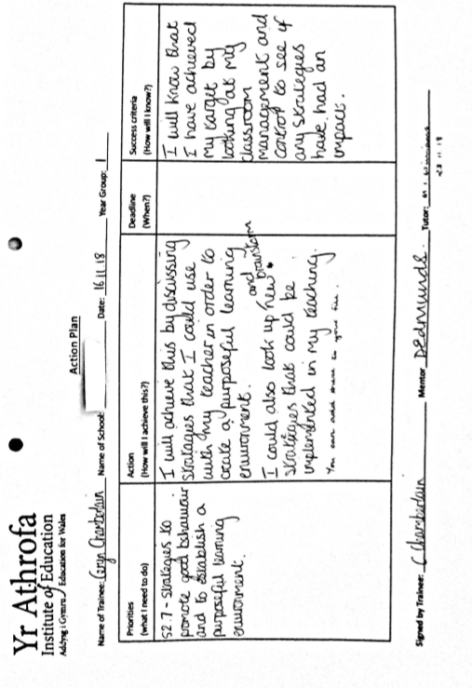
Appendix 4
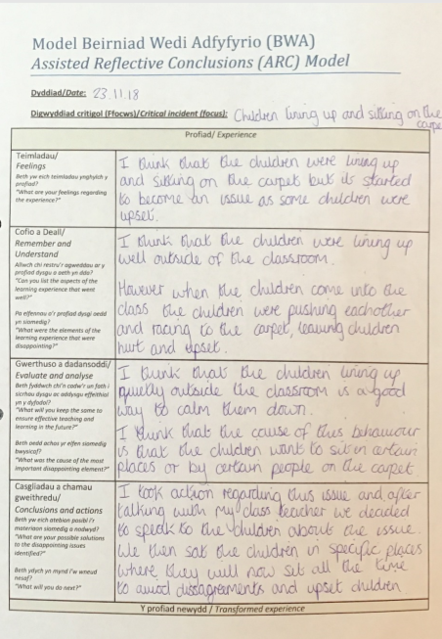
Appendix 5
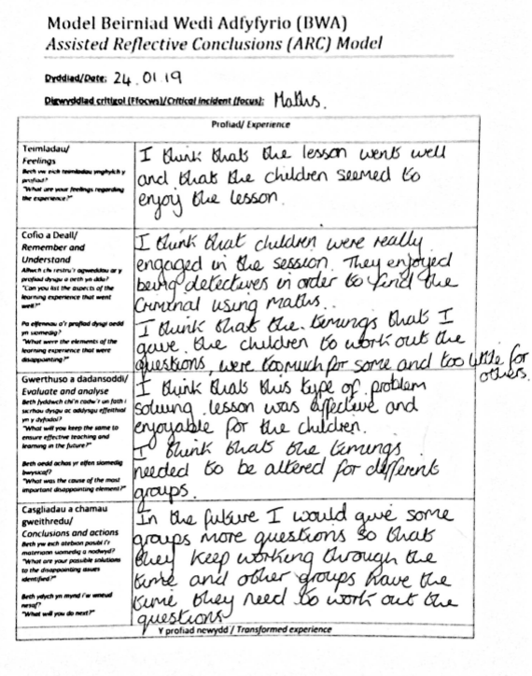
Appendix 6
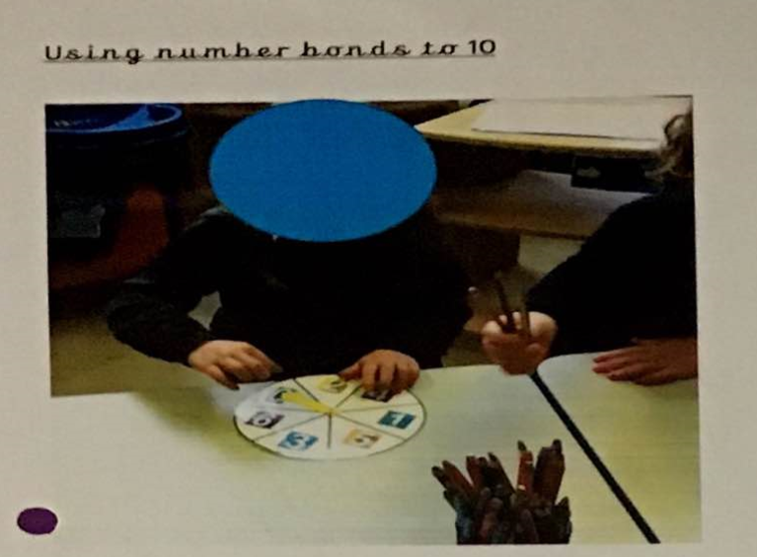
Appendix 7

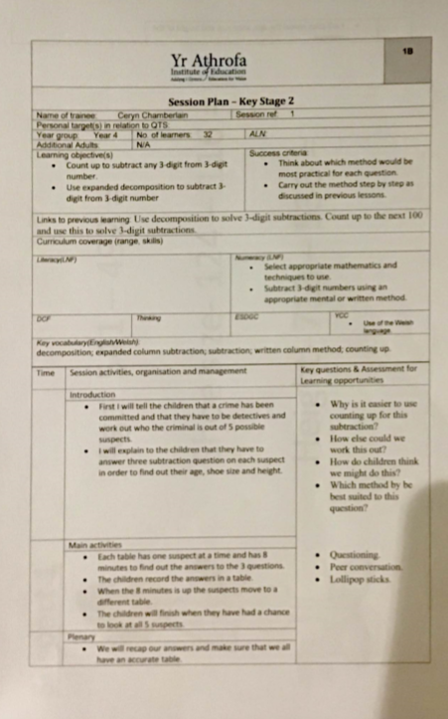
Appendix 8
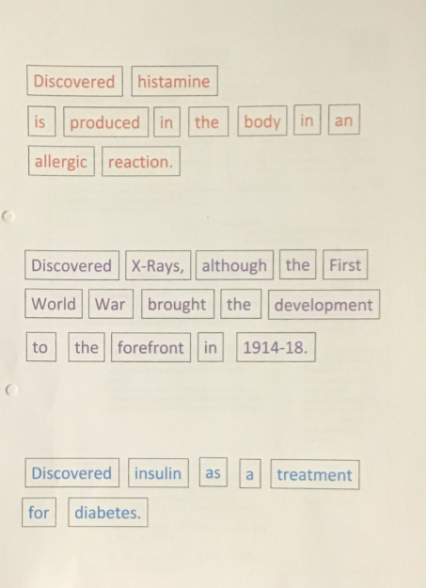
Appendix 9
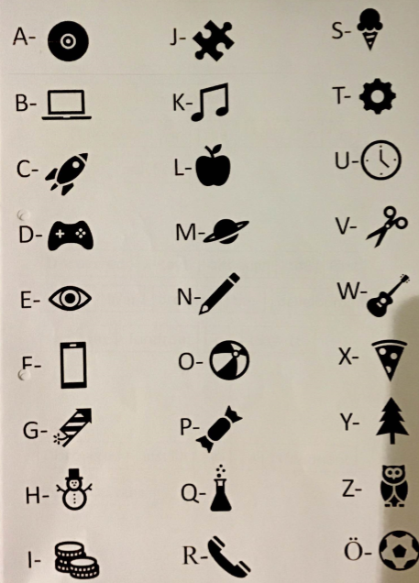
Appendix 10
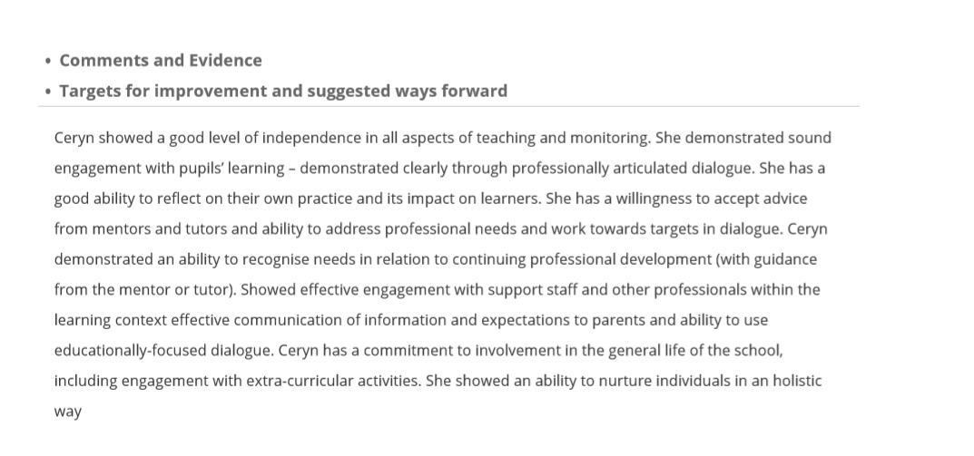
Appendix 11

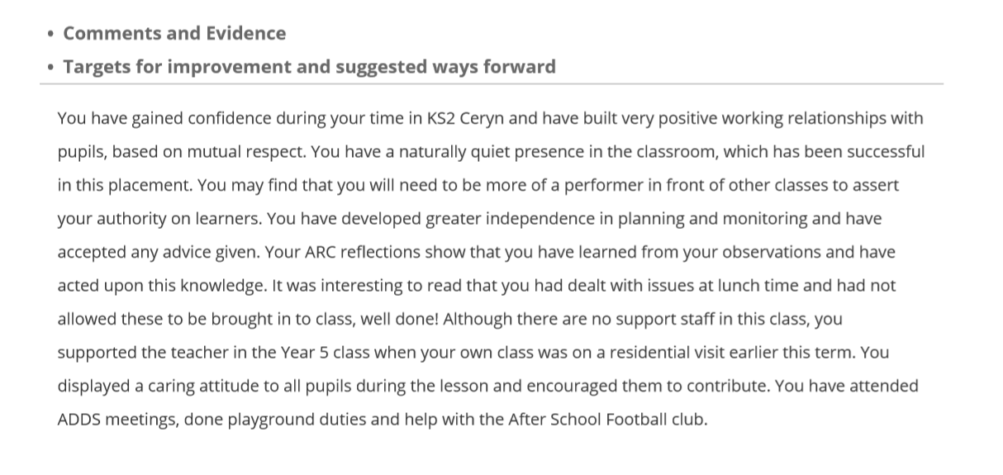
Appendix 12

