Student 1810088 T Hammond
HPMF4002/2
Understanding Film Technique – Essay
The objective of this essay is :
To provide a critical interpretation of the representation of social class in :
The Bicycle Thieves (De Sica, 1948) and The Grand Budapest Hotel (Anderson, 2014) and how this is seen to affect the films ideological position.
By comparing these two films and relevant references, it will allow us to consider social class initially in its original organic state seen through the authentic eyes of Italian Neorealism just after WWII and by contrast more recent entertaining film by Anderson where we observe the narrative produced by hotel employees and its interaction in a dying social class divide of its generation.
Before we start to consider the Bicycle Thieves, we need to understand what Italian Neorealism represented , and why in this genre this film fits so perfectly.
In the 1950s the British cinemagoers were exposed to war propaganda films initially to raise moral, like The Cruel Sea (Frend, 1953) and The Wooden Horse (Lee, 1950). There was no need to portray the Enemy in a bad light as the British public already had a united hatred for the German nation and a reluctant sense of debt to the USA for helping out. Whereas in total contrast Italian families had lost people not just due to the war , but also German occupation as demonstrated at the end of Open City (Rossellini, 1950) when the Italian priest was executed. But would also nurture a resentment to the US, who had bombed numerous Italian cities as described in Catch 22 ( Heller J, 1961) hence the loss of homes and the building of tenement houses as seen both in The Bicycle Thieves and more recently in My Brilliant Friend (Costanzo, 2018-)
With this deep routed loss, no love or respect would be afforded to either the German or American film making industry, so the emergence of Italian neorealism would appear a logical response. Fundamentally Italian Directors like Roberto Rossellini, Vittorior De Sica and Federico Fellini of this period chose to not just rebel against Hollywood ideals, but instead make the Italian working-class survivors of the war their heroes.
There famous non closure endings and depiction of unsatisfied dreams becoming a trademark. Open City (Rossellini, 1950), and Bicycle Thieves showed an alternative to the Hollywood happy ending and gave a sense of loss and despair which was a truer reflection of Italian life. In later years La Dolce Vita (Fellini.F.1960) and My Brilliant Friend in the television dramatization in 2018 of the four Neapolitan novels by Elena Ferrante carried on the torch of an unhappy ending.
But it was De Sica’s choice to shoot on location and use non actors , that creates the true challenge to change. The film’s ethos was to expose the viewer to the authentic daily life of unemployed Italian families in post war Rome.
De Sica was determined to employ nonprofessional actors – the first time he had done so – in order to enhance the realism of his film with respect to performance. A factory worker, Lamberto Maggiorani, was cast in the role of Antonio, and Enzo Staiola was cast in the role of the boy Bruno, because of his natural appearance of innocence and warmth. p56 Shiel M.
Italian Neorealism Rebuilding the Cinematic City.
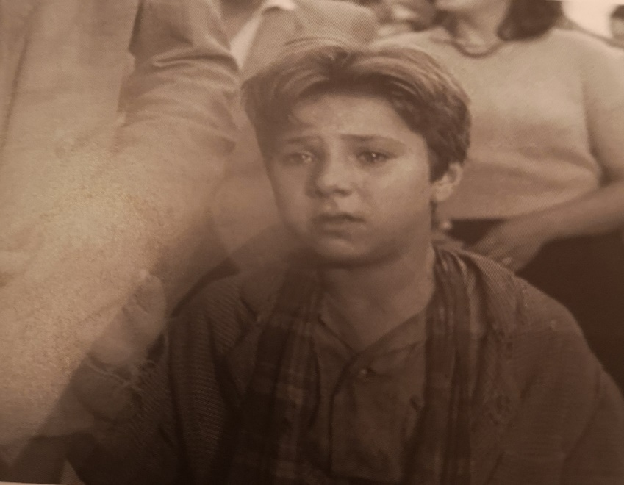
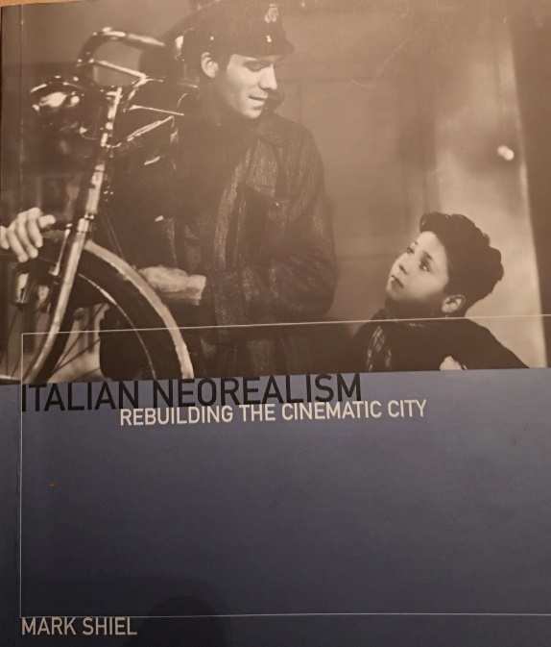

This prevalent use of non actors in not just supporting but leadings roles was the total opposite to Hollywood films of this era.
“When the bicycle is stolen , we get no hints as to the man’s state of mind : we simply witness his immediate erratic reactions”. P103 Sorlin P . Italian National Cinema 1896- 1996.
De Sica wanted you to observe an honest reflection of how Italian families lived and not to hide the depravity that many families were exposed to. This was not a film set this was true life and he wanted Italian neorealism to make that statement. The simple plot of an unemployed man being offered a job on the condition of him owning a bicycle is witnessed by the audience but to follow is the even sadder tale of despair of the man with his young son by his side as they desperately search the Streets of Rome for the bicycle which is stolen on his first day of work.
De Sica declared that the Bicycle Thieves was a film “dedicated to the suffering of the humble and asserted that realism could never be a matter of mere documentation” 1979:88.
Where the working class stood within Italian society is demonstrated perfectly in two scenes in the Bicycle Thieves. First, we witness the desperate and downtrodden mother taking her “bottom drawer” wedding gift linen as well as their everyday bed linen to the Pawn Brokers. This is necessary as they had already pawned the bicycle and it was essential for them to retrieve the bicycle to enable the father to work. This is symbolic on so many levels. Initially the huge size of the building itself followed by the endless tiers of shelves the employee has to climb to store the sheets demonstrating they were not the first to do so. De Sica uses non actors wherever possible and this is so apparent with the ease we observe the man climbing the racking. Pawning ones sheets was an everyday occurrence, people had little else of any value and if we consider Naples as an even poorer city than Rome, sheets are hung across the streets and alley ways on a regular basis, not just to dry but possibly to demonstrate to other families “we still have our sheets”.
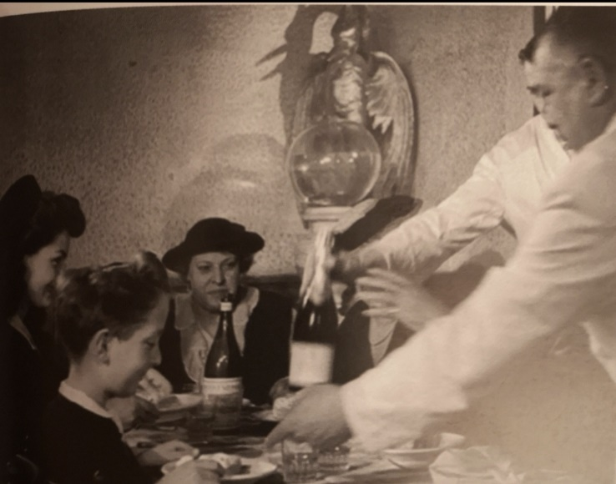
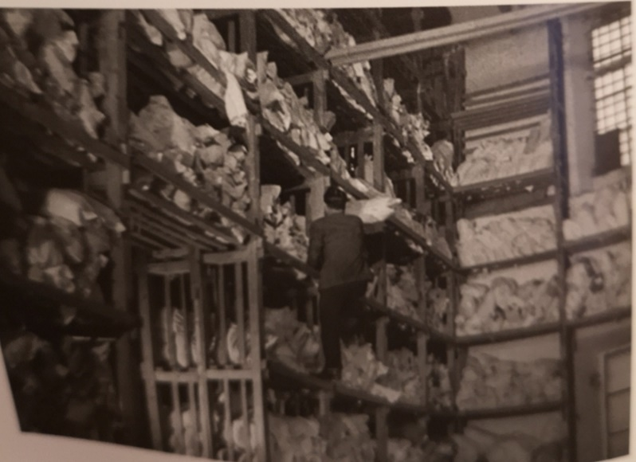

To counter basic poverty, we may also consider what Italian working families believed as luxury. The love of opera was replaced with the love of football, as demonstrated by the mass crowds at the end of Bicycle Thieves as hordes of men leave the stadium . And the passion for authentic good food , with the average working man unable to afford to eat out. At best a family could buy a single pizza to share from a Pizzeria and a carafe of house wine. This is portrayed perfectly in the restaurant scene where the father Antonio (Lamberto Maggiorini) takes his son Bruno (Enzo Staiola) to dine, in a desperate attempt to raise their dark mood of despair. With no pizza on the menu the father orders bread and the creamy mozzarella. Bruno desperately out of his comfort zone tries to copy the wealthy family as they also eat but his imitations are only to be ignored. This would no doubt focus for many the divide of the social class in Italy after the war, food is a massive part of their culture and even here a working family is left short changed. We feel for both the father and son and are meant to.
Andre Bazin praised De Sica’s uncompromising portrait of hardship as “the only valid communist film of the past decade” and that “a film could be both communist and a work of art of philosophical and human value.” P62 Sheil M. Italian Neorealism.
Statements as varied and bias as these no doubt became fuelled by the fact the Bicycle Thieves went on to win Best Picture in a Foreign Language in 1949 .
By portraying the lower paid social class and their daily struggle against life’s endless drudgery and poverty De Sica set a template, and these style of films were adopted across Europe. We see The Four Hundred Blows (Truffaut, 1959) in France and The loneliness of the long distance runner (Richardson, 1962) in England. Would this have happened if De Sica had not refused Hollywood’s suggestion to use Carry Grant for the lead in the Bicycle Thieves in return for investment and distribution? But we also know that certain films work because of the time and place they were made and the attitude of the audience during that decade.
If we scroll forward to this century is the social class struggle still relevant? The viewing public seem to think so and still enjoy the nostalgia, we see the success of Peaky Blinders (Knight ,2013 -) and The Grand Budapest Hotel (Anderson 2014) which is my second text I wish to consider in more detail.
The lead roll of Gustave is played Ralph Fiennes who brings his own authority and huge belief in principals from films like The English Patient (Minghella ,1997) and In Bruges (McDonagh, 2008) and channels his own personal dignity into the grace and purpose of what he believes a true concierge should be.
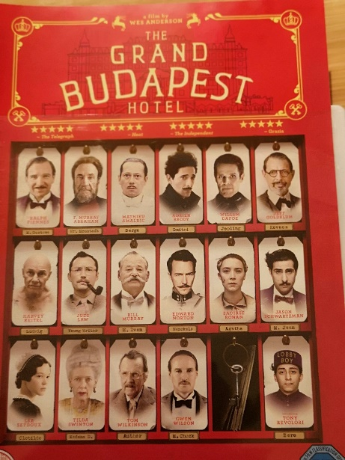
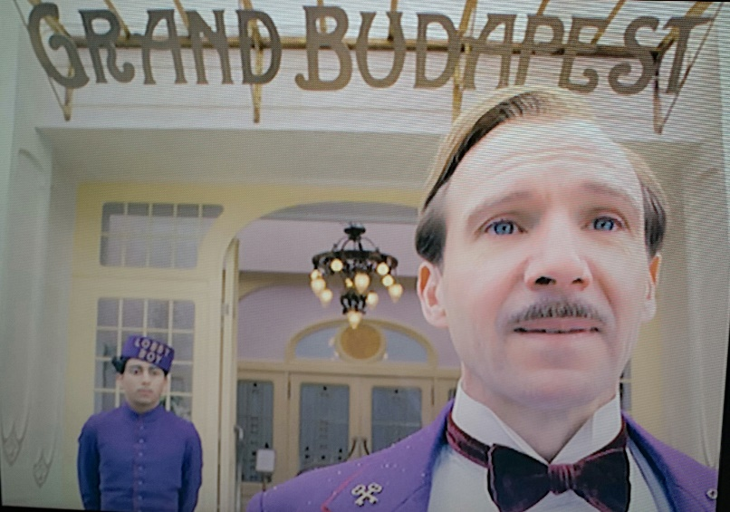

This was a dying age for the wealthy classes and Gustave’s attitude was dated too. The Grand Budapest Hotel is a film of the class divide as it loses its grip on the real world. The wealthy were to summer in Europe less and less and Gustave’s principals, code of ethics and large army of staff would no longer be required. The Hotel is like a great coal mine marked for closure and Gustave totally ignoring the signs of the encroaching doom. For him etiquette, good manners and attention to detail were the only considerations of importance. He was the concierge after all, and people came to the hotel for him.
Anderson uses Gustave and his lobby boy prodigy Zero, played by Tony Revolori beautifully to demonstrate his art with a camera, his editing and total devotion to symmetry. In fact Anderson’s attention to detail and the belief in what he is doing is a mirror of the character displayed by Ralph Fiennes. The actor, Director and cinematography are all in total tune together like a perfectly executed dance routine. Both visually and humorously entertaining. Gustave inherits a priceless painting from a regular, but now deceased guest, “ Boy with apple”. However, being a servant the Deceased’s family are having none of it.
Gustave’s membership of the Occulta Claves Decussatae Societats known as The Society of the Crossed Keys formed in 1911, although a fictional organisation is a sublime mickey take of the real Les Clefs d’Or the Society of the Golden Keys formed later in 1952 and being a member was considered to be as powerful as being a Free Mason and he uses his contacts of other Crossed key members who continue to help him when he is on the run ,with the lapel pin a notable motif .

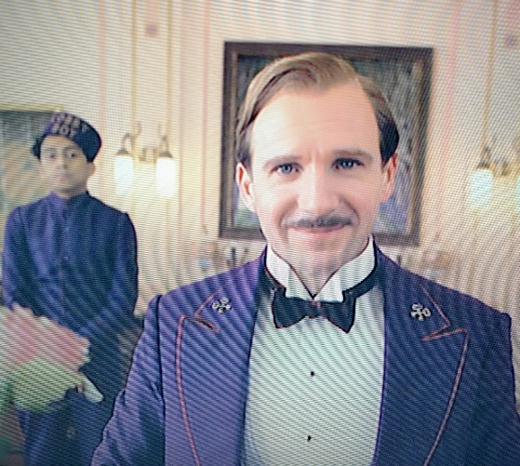

Refugees often look for jobs in service as does Zero the lobby boy, as food and lodgings are offered and anonymity as you are known by your occupation rather than your name.
This is highlighted in The Night Porter (Cavani ,1974) played by Dirk Bogarde. A Gestapo officer in hiding.
Gustave however is a far less sinister individual, with his trademark saying “I’ll see to it myself immediately” and then passes the job onto the lowest person available, demonstrating his contempt for the people he serves.
“Gustave is manipulative, shallow, self serving, self important, and completely self involved.” P183 Whitney.c.d The cinema of Wes Anderson.
Whom whoever Gustave confronts are all met with his full on stage presence, but also with his hidden disdain and scorn. The story also allows us to see Gustave at one stage although imprisoned , offering gruel to fellow prisoners with exactly the same demure as if they were titled hotel guests. “May I offer any of you inmates a plate of mush” and “quite warm and nourishing” demonstrates his ethics and ideology. This is work, he has principles, and it is to be done correctly.

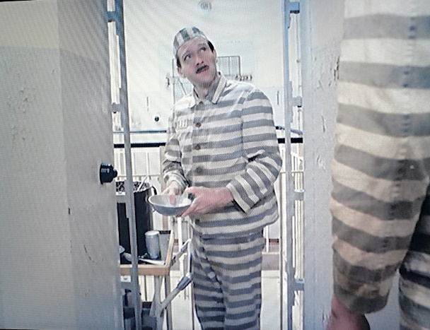

Gustave’s ideals and principles however eventually lead to his demise. With his dealing with the Military personnel on the train and his protection of his loyal lobby boy. People in service may be servants but should also be considered with respect.
Gustave’s first confrontation with the authorities on the train ends with a knock out blow of success for him and the audience and gains Zero his all important travel papers. His second confrontation on the train with the death squad not so, and as Zero matter of factly says “In the end they shot him” and the conversation moves on.
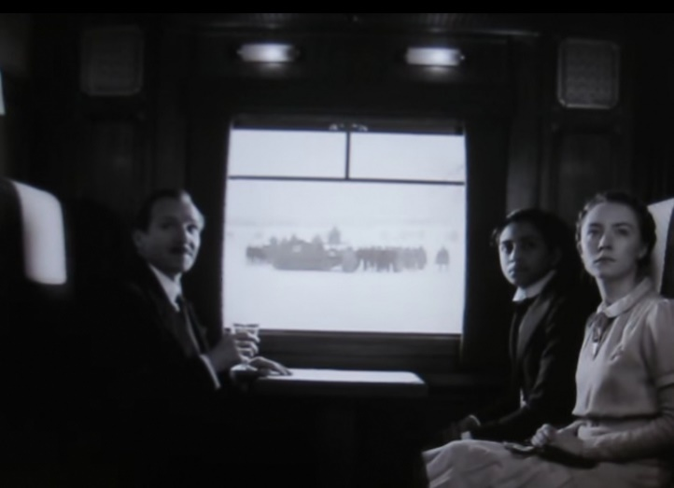
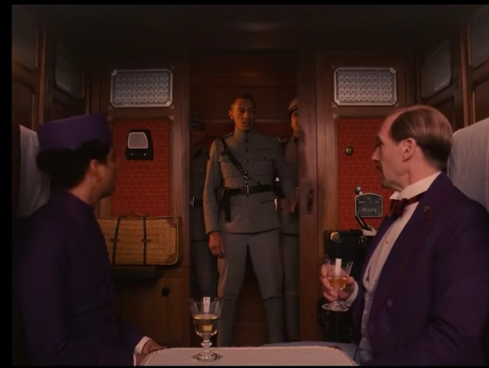

Gustave’s death is presented by Zero as a fatal instance of overreach by a man who is used to charming everyone he meets, the moment when, “faint glimmers of civilization” still remaining at that time finally came face to face with “this barbaric slaughterhouse which was once known as humanity”. P134 Kornhaber D. Contemporary Film Directors – Wes Anderson.
“To be frank, I think his world had vanished long before he ever entered it – but, I will say: he certainly sustained the illusion with a marvellous grace “ ! P197 Whitney c.d the cinema of Wes Anderson .
Indeed, with both De Sica and Anderson, social class during each time period have influenced both the films’ meaning and final outcome. Where we stand as individuals and what our lives stood for is the message. Without the class division so amplified by both Directors neither of the films’ endings would mean anything other than entertainment. But by including this class divide we are left with uncertainty and a feeling of loss and insecurity as to what our own lives will stand for.

Bibliography
Gordon R.S.C. (2008) BFI Film Classics – Bicycle Thieves : Palgrave Macmillan
Heller J. - Catch 22 (1961) Simon and Schuster
Kornhaber D. (2017) – Contemporary Film Directors – Wes Anderson :University of Illinois Press
Kunze P.C. The Films of Wes Anderson – Critical Essays on an Indiewood Icon (2014) : Palgrave Macmillan
Shiel M (2006) – Short Cuts- Italian Neorealism – Rebuilding the Cinematic City : Wallflower London and New York
Sorlin P. – Italian National Cinema 1896 – 1996 (2002) Routledge
Whitney C. D. (2017) the cinema of Wes Anderson – brining nostalgia to life : Wallflower Press

Filmography

Four Hundred Blows (Truffaut , 1959)
Grand Hotel Budapest (Anderson , 2014)
In Bruges (McDonagh, 2008)
La Dolce Vita (Fellini ,1960)
Life Aquatic (Anderson, 2004)
Open City (Rossellini, 1950)
The Bicycle Thieves (De Sica, 1948)
The Cruel Sea (Frend, 1953 )
The English Patient (Minghella, 1997)
The Loneliness of the Long-Distance Runner (Richardson, 1962)
The Night Porter (Cavani , 1974)
The Wooden Horse (Lee, 1950 )

