Advanced Physics of OME Assignment (ACDA5015)
ABAQUS MODELLING SHAPED CHARGE

University of Wales Trinity Saint David
Owain Plant (1910280)

Abstract
This assignment will be looking at shaped charges, it will model and critically analyse what happens when an explosive charge is initiated inside a steel casing with a conical liner. The aim of this assignment as given in the brief is to improve upon the given design giving a better desired result from the cone liner. [1] The simulation will be run firstly as it was given to gain results for initial comparison. The design of the shaped charge will then be improved upon by carrying out research to change the material properties of the casing of the shaped charge and improve upon the meshing of the conical liner. The next thing that was researched and changed was two different types of material properties for the conical liner, the chosen two materials were copper and molybdenum. The results from the three simulations were then taken in different forms showing graphs of the results as well as images at different time steps of the conical liner deforming. There was then a comparison carried out which showed that the edited copper model gave the best desired effect followed by the edited Molybdenum model then the original model.

Table of Contents
1. Introduction 3
2. Background Information 3
2.1. Method 4
3. Results 6
3.1. Model before editing 6
3.2. Model after editing using annealed copper 7
3.3. Model after editing using Molybdenum 8
3.4. Comparison 9
4. Discussion 11
5. Conclusion 13
6. References 14
6.1. Reference List 14
6.2. Bibliography 14
6.3. Tables of Figure and Tables 14
6.3.1. Table of Figures 14
6.3.2. Table of Tables 15
7. Appendix 16
7.1. Simulation before editing simulated images 16
7.2. Simulation after editing copper simulation images 20
7.3. Simulation after editing molybdenum simulation images 24

Introduction
The assignment will discuss the results of a simulated experiment where a model of a shaped charge was created and then critically analysed. The aim of the assignment was to take the original shaped charge designed and improve upon its function. [1] To best do this assignment it has been split into sections, it will firstly look at relevant background information into shaped charge. Then the method used to conduct the exercise, discussing the data that was required to be input to conduct the experiment for instance the material properties that were used. It will then move on to look at the results that have been gained from the three different simulations, comparing, and then discussing them. It will conclude by giving an overview of the whole assignment explaining some of the limiting factors of the simulation and it would compare with real world testing. It will then include all relevant sources used in the reference section and finish with an appendix of all other relevant information for the assignment.

Background Information
A literature review of relevant research was undertaken into shaped charges and their modelling, including the material models used. The rocket that would be used to propel the shaped charge towards the target would in its entirety have a propulsion and navigation system built in to aim and carry the payload to the desired target. The system will also have a built-in ogive in front of the shaped charge, this is to give a built-in standoff distance for optimum damage and time for formation of the jet. The ogive is usually made from aluminium with a nose cap screwed into the forward end. The nose cap assembly contains a piezo electric element which is connected to the fuse rocket. When the rocket impacts the target, the piezoelectric element produces a small amount of electrical energy which transmitted through to ignite the fuse. This fuse will then ignite the explosive composition with the aim of create a jet from the conical liner to breach a given target. Many of the parts of the system will not be considered for this assignment, the part of the system that will be looked at is the shaped charge detonation and the jet formation. The design and information are loosely based on the standard shaped charge design gained from pamphlet 30 free flight rockets part 5 in reference [2] and Aseltine 1980 in reference [3]. The shaped charge itself has an outer steel casing filled with high explosives and a copper conical linear inserted into it, a rough labelled visualization of what the shaped charge looks like can be seen in the image below in Figure 1. [4]
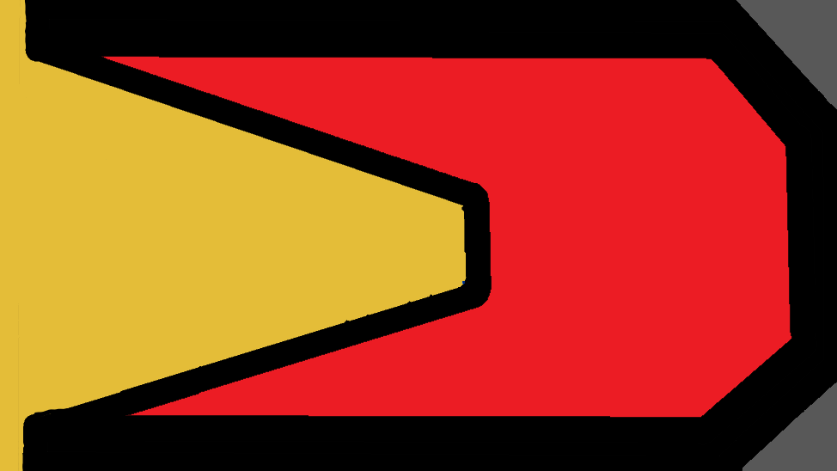
Cone Linear
Explosive Composition
Casing
Figure 1- Image of shaped charge design [3]
The image shown below in Figure 2 shows the beginning to progressive detonation of the explosive compound in the shaped charge. This will be the same for each of the models due to the same explosive being used. It shows the way in which the shaped charge part of the rocket would work by the explosive detonating and heading towards the conical liner and beginning to deform the rear of the liner first. The conical liner will further deform inwards as the explosive further detonates and travels along its length then this material should turn to a dart like shape under the high pressure. This conical liner will be pushed outwards towards the target becoming a jet of high-pressure material capable of penetrating through the designated target [5].
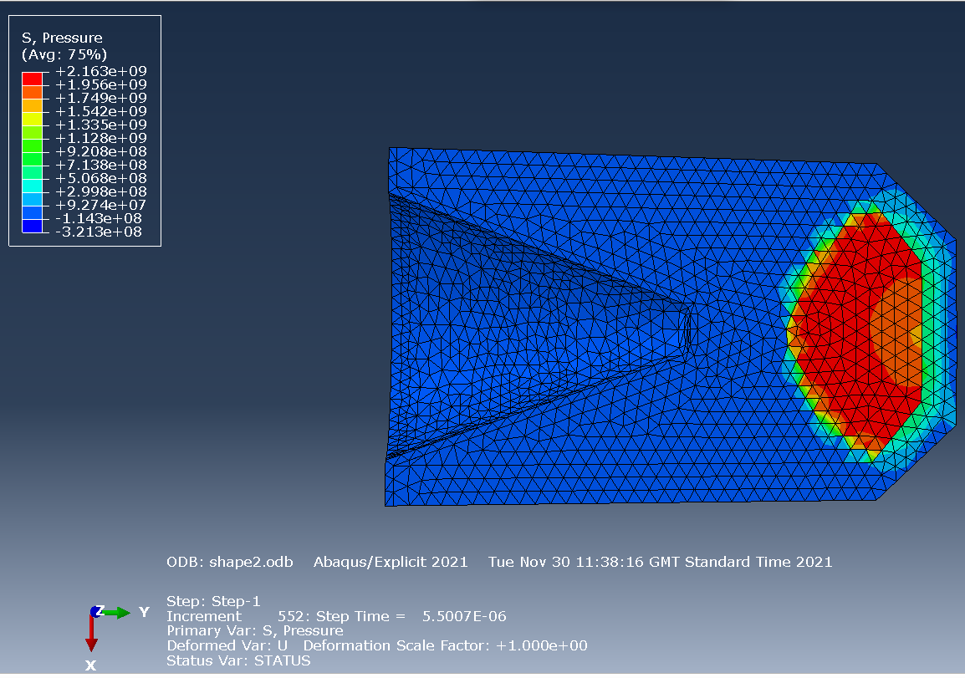
Figure 2- The explosive beginning to progressively detonate

Method
The aim of this assignment is to take the existing model and modify it with the aim of producing a better jet formation. This was attempted in the first model by changing the material properties of the cone liner to annealed copper, changing the material properties of the casing to medium carbon steel and improving the parts mesh. The second model attempted to meet the brief in a similar way but instead of using copper for the cone liner molybdenum was used instead. This meant that only the material properties of the liner were required to be changed for this model, due to a good mesh and material properties for the casing already being in place from the previous model.
The software package that was used for the exercise was Abaqus FEA (Finite Element Analysis). The drawings for the shaped charge were already created using a standard shaped charge design as described in Aseltine 1980 in reference [3]. This system in its entirety has not been drawn in ABAQUS due to calculation time and complexity. Each of the models were submitted as jobs individually and left to run, the results from each at different time steps can be seen later in the assignment. There are two different methods that could have been used to model the shaped charge for this exercise, these are the Eulerian model and the Lagrangian model. The chosen method for this assignment was the Lagrangian model due to its higher level of accuracy, which is confirmed by Saidi et al in reference [6].
Research was carried out to find the most suitable two materials for the conical liner and was found to be annealed copper and molybdenum. These materials were chosen due to their previous use as cone liners and their malleability meaning that they deform under pressure relatively easily. The material properties for the annealed copper conical liner, molybdenum conical liner and the medium carbon steel casing are shown below in Table 1. This information was acquired from Mat Web and then confirmed using AZO Materials. The images shown after this in Figures 3, 4 and 5 show the explosive material properties that were prepopulated into ABAQUS and was gained from R. Tiwari et all in reference [7].
Material Property | Value of Annealed Copper | Value of Medium Carbon Steel | Value of Annealed Molybdenum
Density | 8.93 g/cc | 7.85 g/cc | 10.22 g/cc
Youngs modulus | 110 GPa | 203 GPa | 330 GPA
Poison’s ratio | 0.343 | 0.290 | 0.38
Tensile Strength Yield | 33.3 MPa | 685 MPa | 415 MPa
Tensile Strength Ultimate | 210 MPa | 987 MPa | 515 MPa
Elongation at break | 60% | 18.9 % | 2- 17 %
Reference | [8] | [9] | [10] [11]
Table 1- Table of Material Properties for Copper Liner, Medium Carbon Steel Casing and Molybdenum Liner
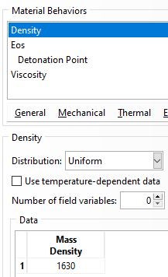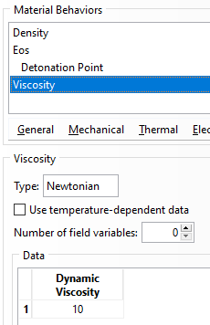
Figure 3- Input Mass Density for TNT [7] Figure 4- Input Dynamic Viscosity for TNT [7]
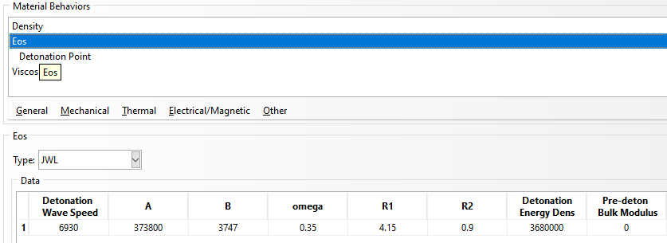
Figure 2- Input JWL for TNT [7]

Results
Once each of the three models were created with the relevant information input and the simulation was running without errors the results were taken. These results can be seen below with additional information shown in the appendix.

Model before editing
This section shows what happened when the original model was set to run giving the graphs of velocity vs time and pressure vs time, these can be seen below in Figures 6 and 7.
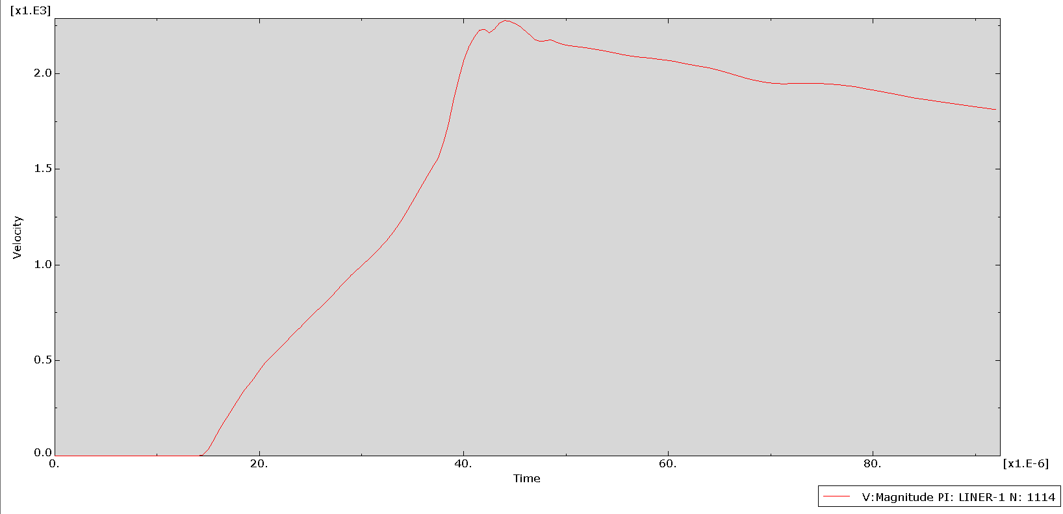
Figure 6- Graph of Velocity vs Time before editing model
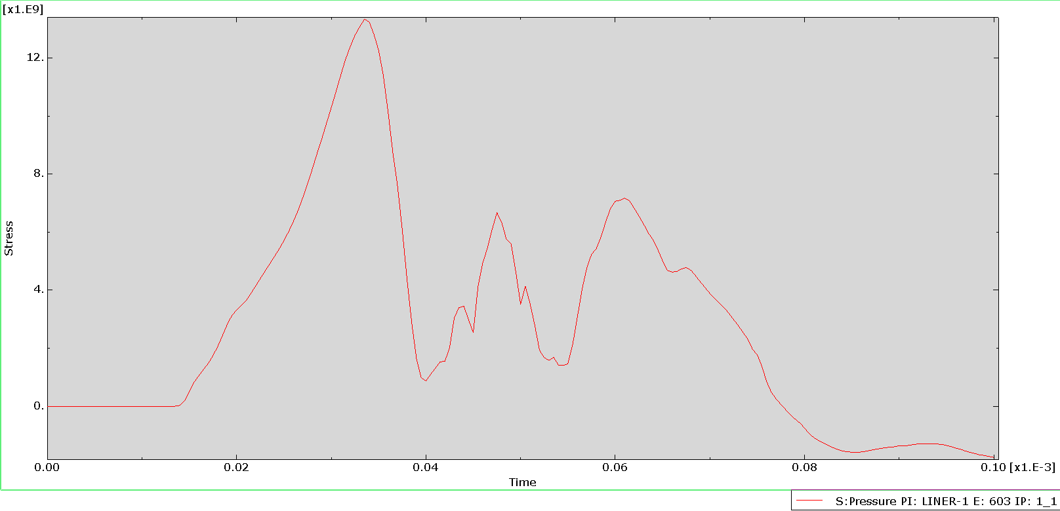
Figure 7- Graph of Pressure vs Time before editing model

Model after editing using annealed copper
This section shows graphs of velocity vs time and pressure vs time for an edited model using annealed copper as the cone liner, these can be seen below in figures 8 and 9.
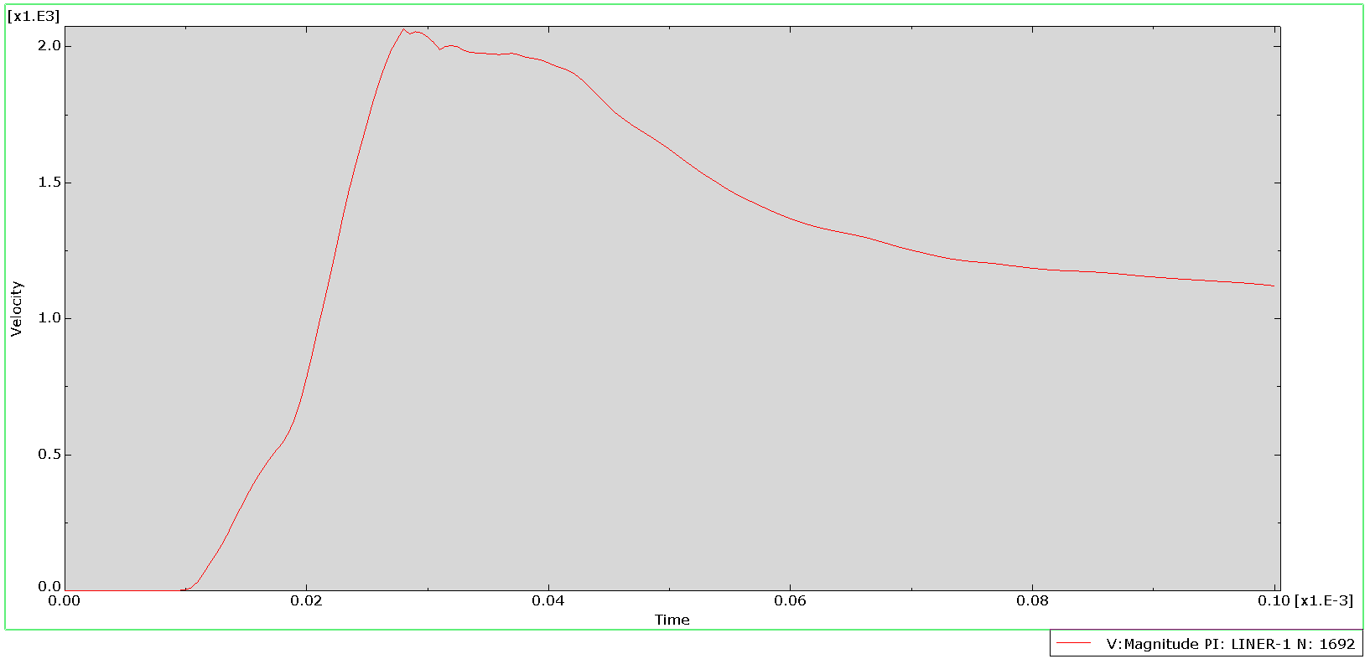
Figure 8- Graph of Velocity vs Time after editing model for copper
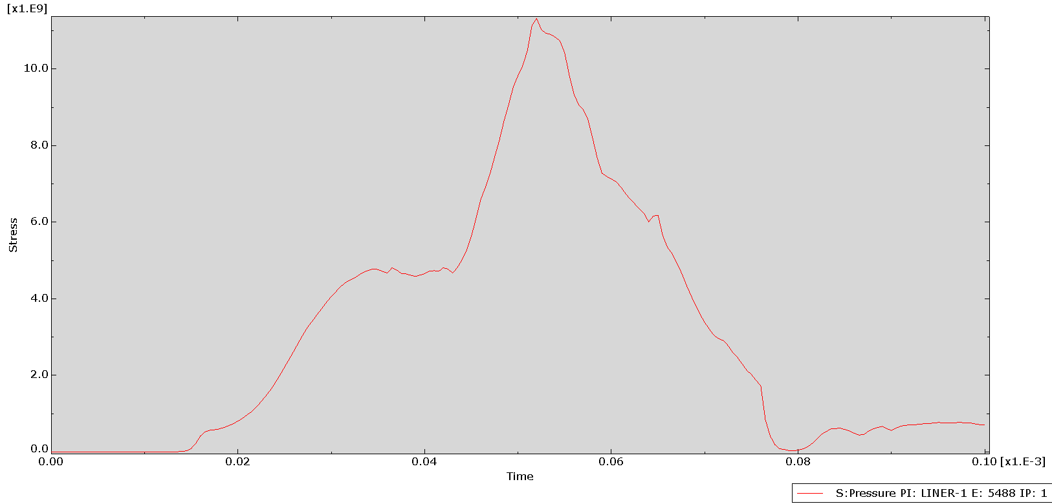
Figure 9- Graph of Pressure vs Time after editing model for copper

Model after editing using Molybdenum
Graphs of velocity vs time and pressure vs time were created for the Molybdenum cone liner, these can be seen below in figures 10 and 11.
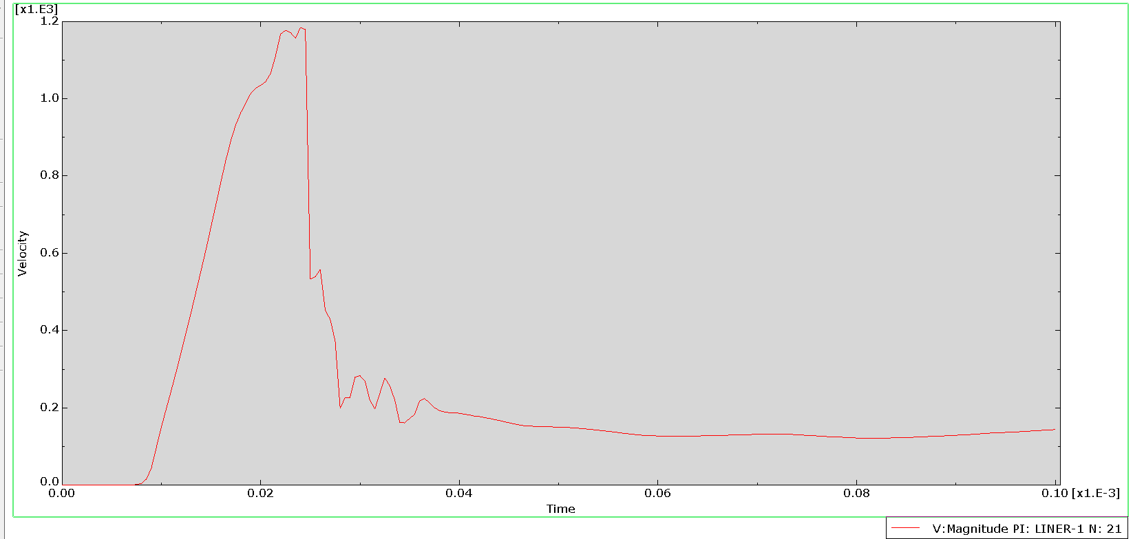
Figure 10- Graph of Velocity vs Time after editing model for Molybdenum

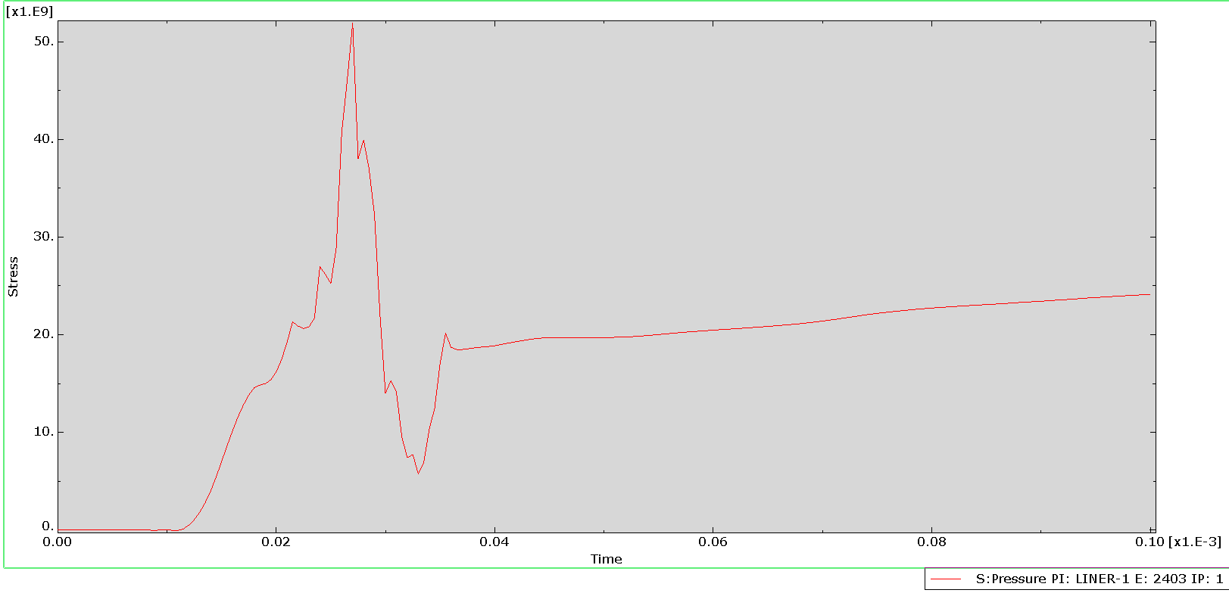
Figure 11- Graph of Pressure vs Time after editing model for Molybdenum

Comparison
The table below in Table 2 shows all three of the models cone liners at different time stages as it collapses to form a jet side by side for comparison.
Comparisson of cone linear collapse into a formation of a jet
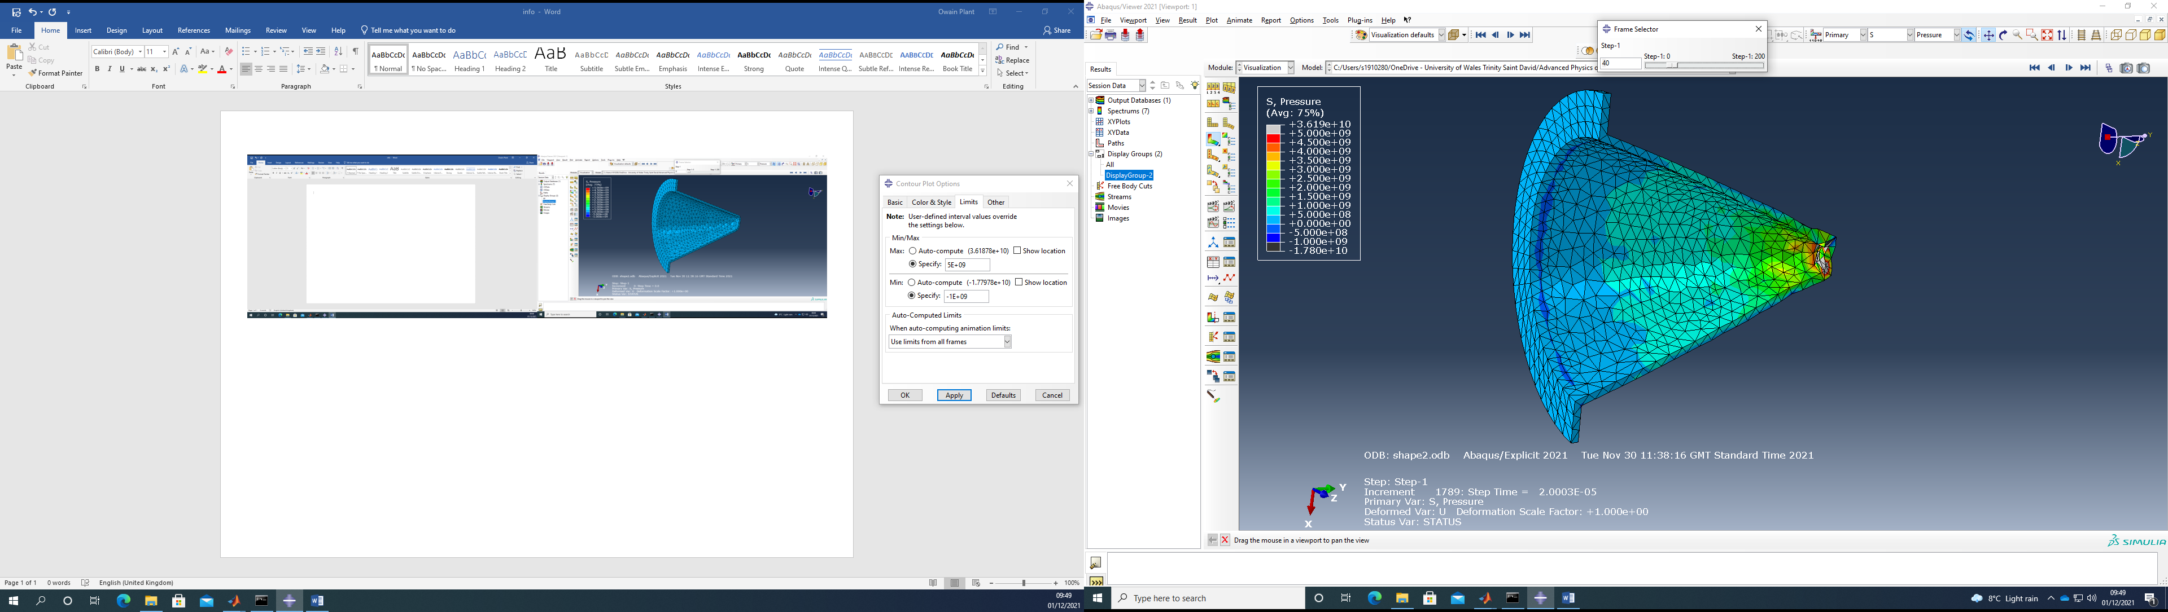  Figure 12- Initial collapse of rear of cone liner before editing | 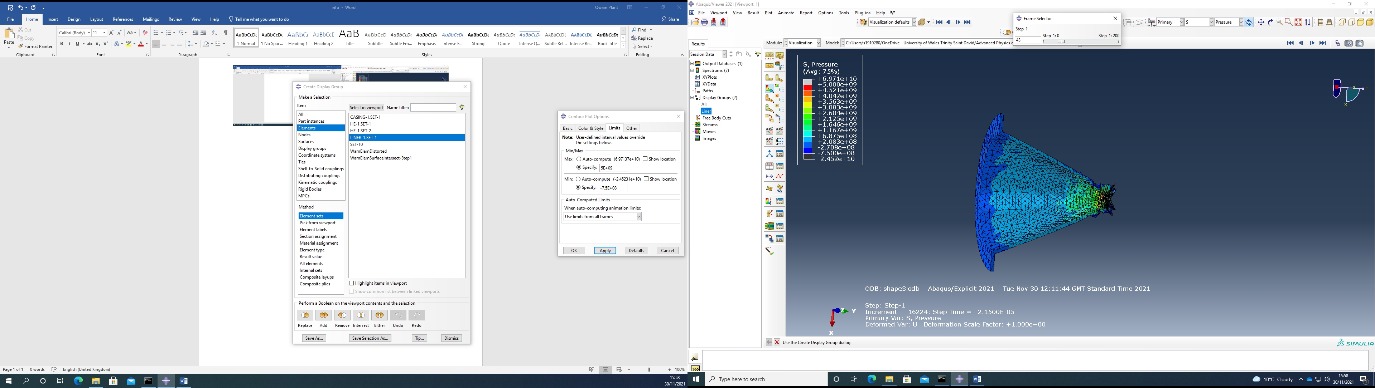  Figure 13- Initial collapse of rear of cone liner after editing | 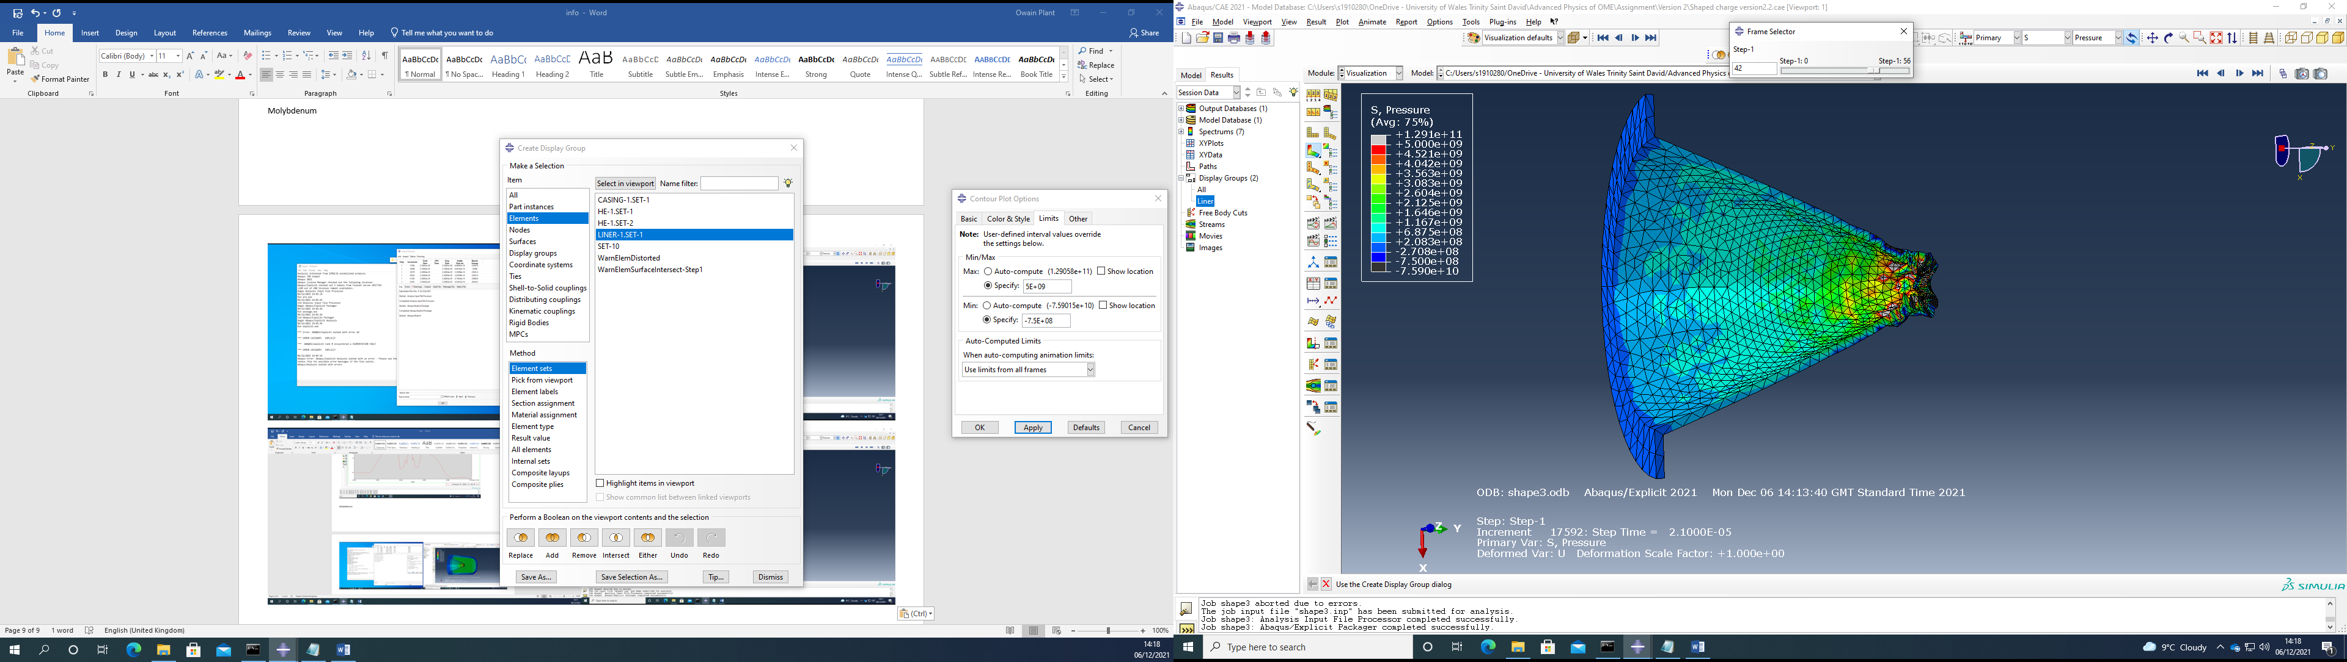  Figure 14- Initial collapse of rear of cone liner after editing
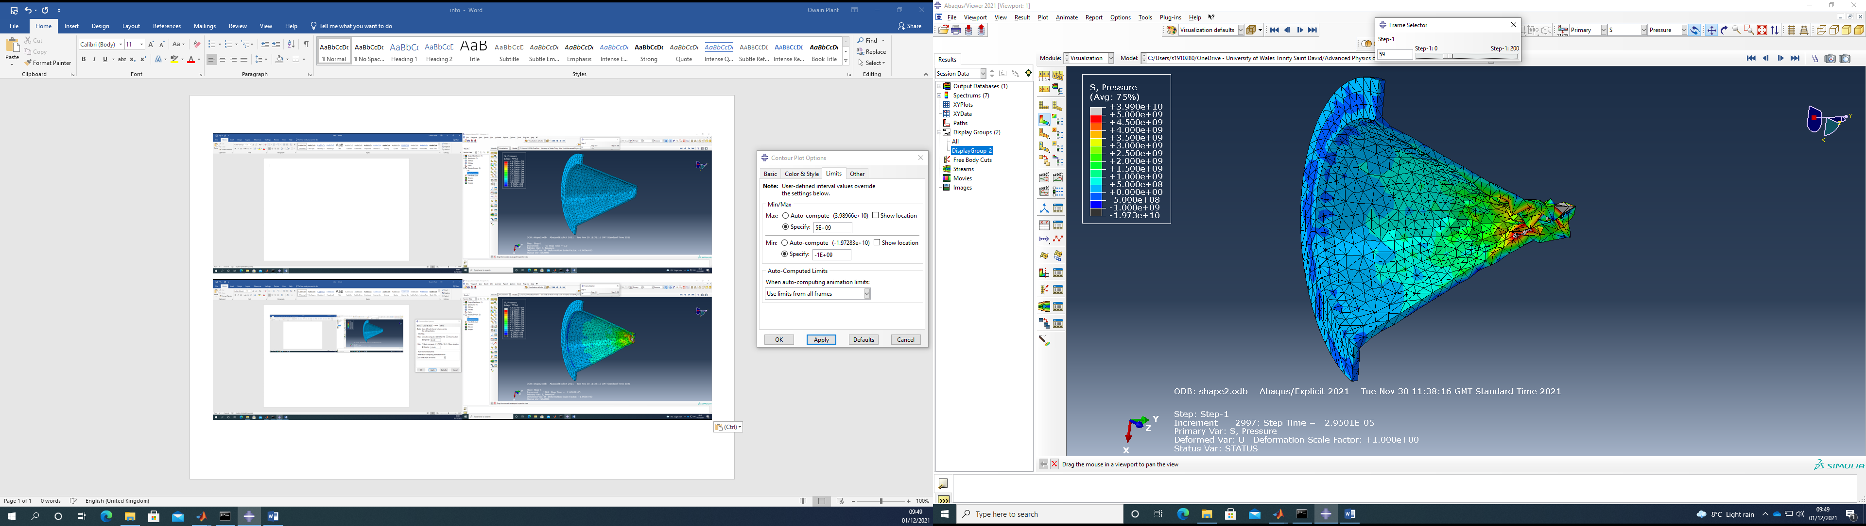  Figure 15- Further collapse of the rear cone liner before editing | 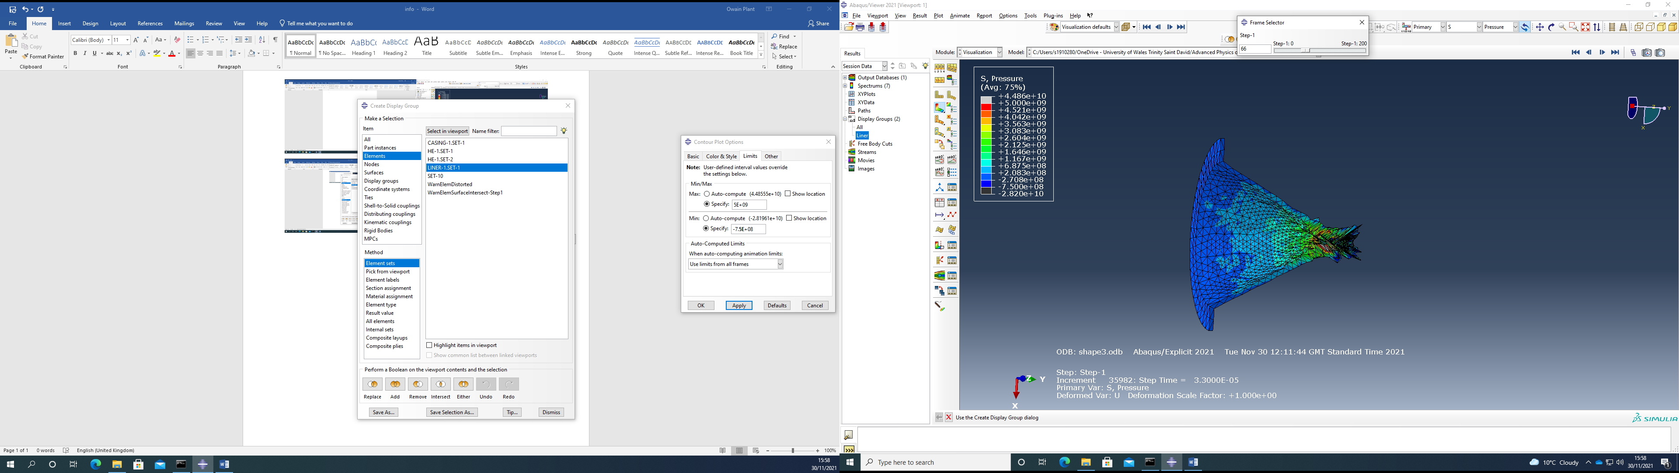  Figure 16- Further collapse of the rear cone liner after editing | 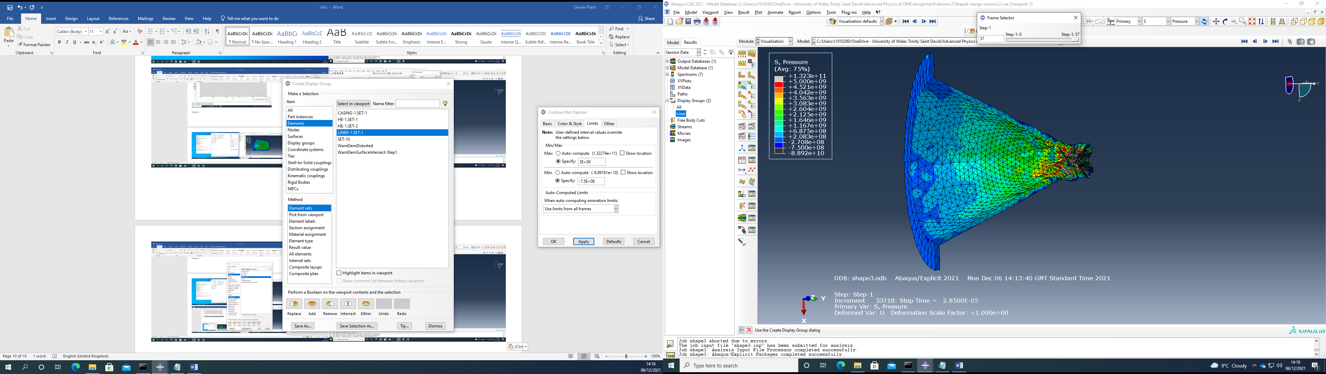  Figure 17- Further collapse of the rear cone liner after editing
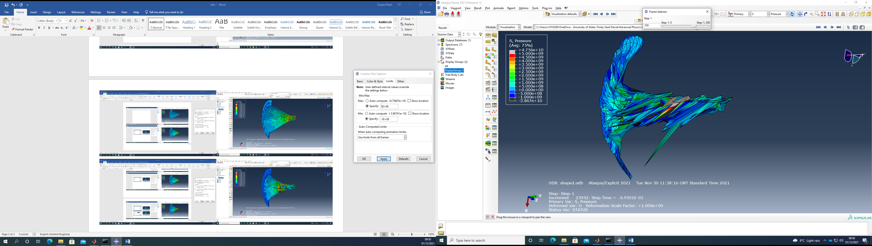  Figure 18- Beginning of jet formation before editing | 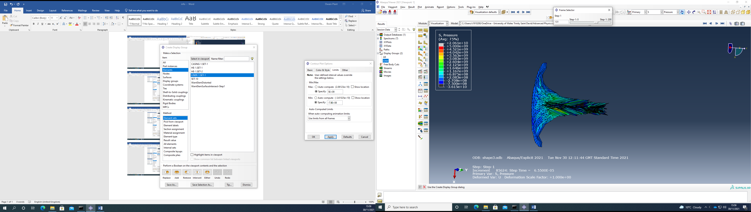  Figure 19- Beginning of jet formation after editing | 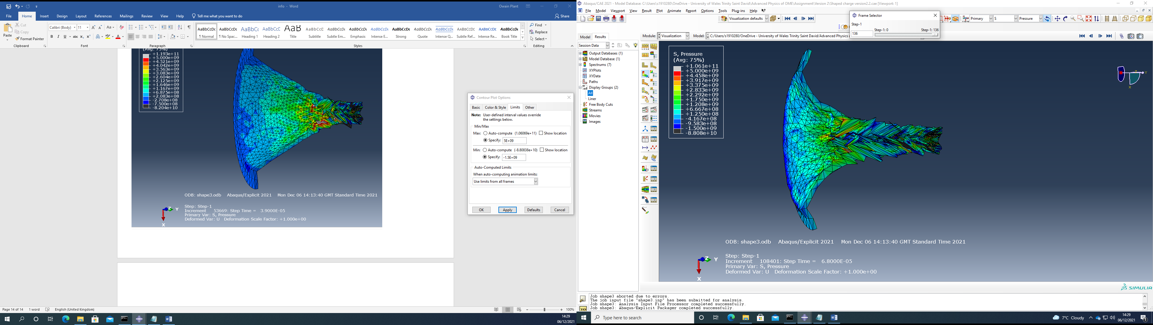  Figure 20- Beginning of jet formation after editing
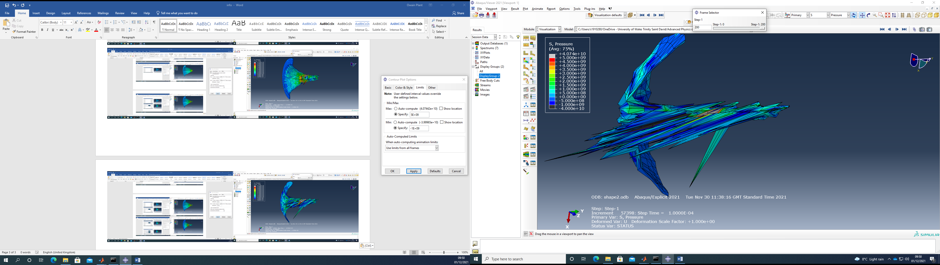  Figure 21- J Jet fully formed before editing | 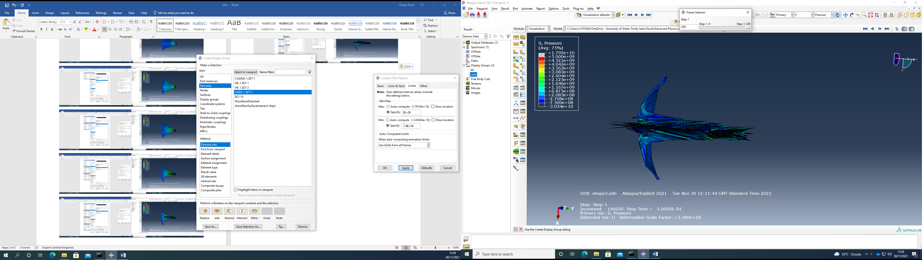  Figure 22- Jet fully formed after editing | 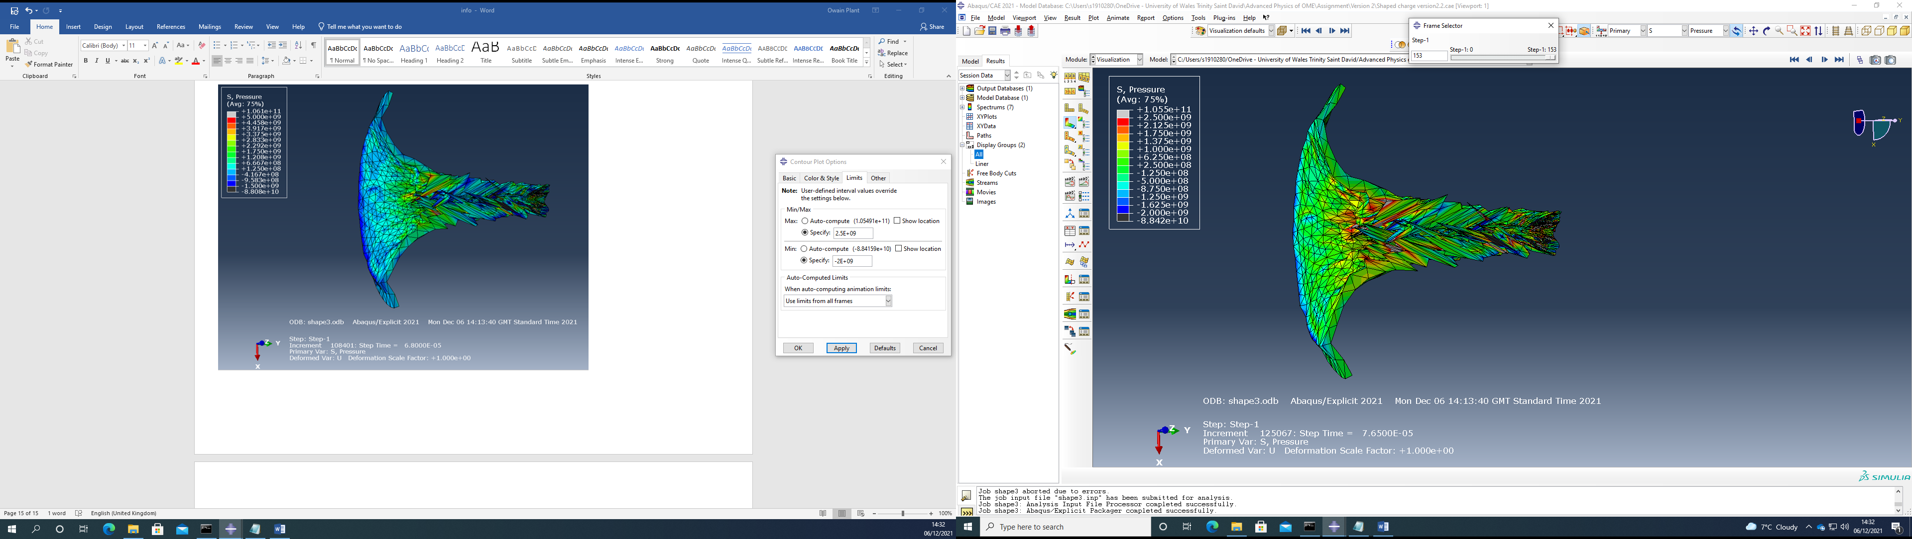  Figure 23- Jet fully formed after editing
Table 2- Table of results comparison

Discussion
The graphs in Figures 6, 8 and 10 above in the results section show the velocities against time for each of the three models. The model before editing has the highest velocity of the three, followed by the copper model after editing and then the molybdenum after editing. The graph of the molybdenum shows it has the most increase in velocity in the shortest time, this velocity however reduces quickly after this. This is unlike the other two models which reduce at a much slower rate.
The graphs in the results section shown above show the pressure against time for the three different models as can be seen in Figure 7, 9 and 11. The model with the highest pressure increase and in the shortest time is the molybdenum after editing followed by the original model before editing then the copper model after editing. The graph with the least fluctuation is the copper model after editing due to it having a steady increase then a smooth decline. The molybdenum graph after editing has a sharp increase in pressure followed by a quick decline in pressure, this is followed by another small sharp increase in pressure followed by a consistent increase in pressure. The graph of the model before editing has a pressure increases and decreases then does the same twice more but with less increase, this gives a visual display of the pressure fluctuating sporadically throughout.
The table shown above in Table 2 in the results section compares the three different models at four different time steps. The images in Figures 12, 13 and 14 in the table above show the first comparison time step, showing the initial collapse of the cone liner for all three of the models. This time step shows the model before editing having little change whereas the two other models cone liners beginning to collapse inwards and up.
The second time step shows the three models cone liner further collapsing this can be seen in Figures 15, 16 and 17. At this time step the copper model after editing has had the largest change and deformation followed by the molybdenum then the model after editing. The reason for this is due to the different ways the two edited models and the original model have been meshed.
The third time step shows the initial formation of the jet for the three different models in Figures 18, 19 and 20. This shows the model before editing has deformed beyond its boundary constraints whereas the other two models have continued to collapse inwards as would be expected. The copper model after editing at this time step has deformed and begins to take its dart like shape more than the molybdenum. This is because the two different material properties of the two selected materials with the selected molybdenum having higher density, Youngs modulus, tensile strength yield and tensile strength ultimate than the copper.
The fourth and final time step shows the final image of the model after the simulation had completed running, this can be seen above in Figures 21, 22 and 23. This shows the copper model after editing holding together well as well as looking like a dart as expected from a shaped charge. The model before editing although it has a dart like shape it has broken its boundary constraints further here so is difficult to analyse, again this is because of the poor meshing of the part. The molybdenum model although it has deformed somewhat and has a good shape it has not deformed to the same level as the copper after editing. The material has not penetrated outwards crating the dart like shape, this again is likely down to the input material properties.
The results are not what was initially expected given the background research done it was believed it would have been the molybdenum model after editing that would have performed the best of the three. The reason the molybdenum liner did not work as expected is likely down to several different reasons. One being that the shape of the cone was slightly different to the one drawn which could have affected its performance. The researched design also had a wave shaper built into the model which is likely another contributing factor to the reason the shaped charge did not perform as expected. The wave shaper works by creating a better collapse of the cone liner from the explosive than the conventional method. It does this by hitting the side walls all at the same time and travelling up it rather than hitting from the back and pushing through, thus affecting the formation of the jet. This can be seen in a rough visual example in Figure 25 below. These changes to the design however were not carried out due to the time it would have taken to redesign the whole shaped charge and run it successfully given the limited laboratory time.
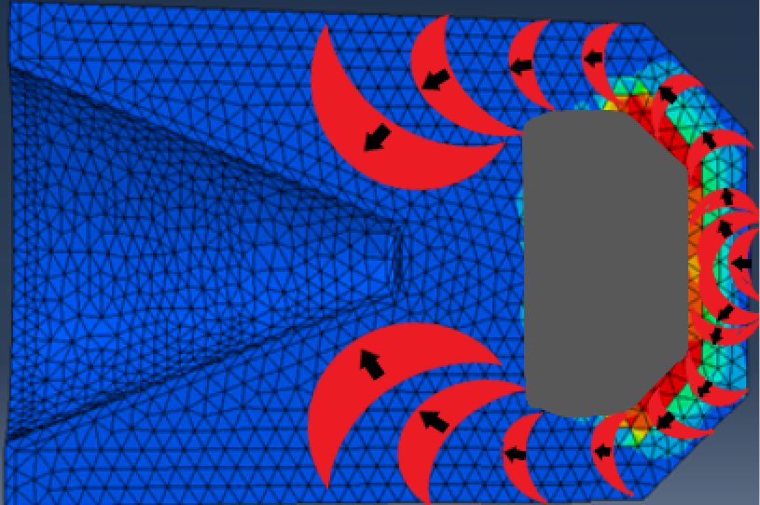
Detonation Wave
Wave Shape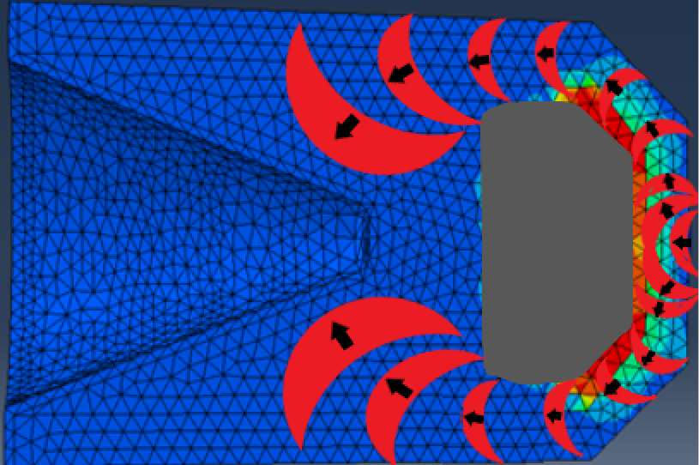r
Figure 25- Shaped charge with added wave shaper [2]
The researched shaped charges explosive composition was Octol which is a mixture of HMX (High Melting Explosive) and TNT (Trinitrotoluene). This explosive would have different explosive properties to the ones that were input for this exercise. The reason that it was not used is due to the information on the exact mixture and its properties being classed as officially sensitive. Another factor is the material properties entered for the molybdenum cone liner are taken for annealed molybdenum not the exact material properties of the shaped charge liner researched, which was a molybdenum alloy. This again is due to the exact alloy mixture and its material properties being classed as officially sensitive so could not be included in the assignment. [2]
The model before editing performed well however due to the different material properties and further material properties being input it did not perform as well as the copper model after editing. Another factor is the meshing of the part for the model before editing in comparison with the other two models. This meshing for the other two cone liners was changed so that it had a much finer mesh towards the end of the cone liner. These two models cone liners also had progressive mesh added to them so the mesh size changed from finer at the base of the cone to more course towards the opening. This difference in meshing can be seen in Figure 12, 13 and 14 above, as well as further images of each of the models shown in the appendix later in the assignment. The reason the mesh was done in this way is because the area at the narrow end of the cone is of interest due to the high pressures and the high levels of deformation happening. This meshing makes the two models much easier to visually see the deformation and what is happening whereas the original model is much more difficult to analyse. Given this information discussed above and results from the exercise it clearly shows that the copper model after editing has the best shape charge jet out of the three models.

Conclusion
The exercise went well and the objective of the assignment was achieved by improving the shaped charges jet, as can be seen and discussed above clearly showing the difference between the models before and after editing. This was done by improving the meshing and the material properties of the parts as previously discussed. Further improvement to the results would have been possible by meshing the cone liner into even smaller elements, this would have given more accurate and precise results. This was not done due to the increase in running time and the available time in the laboratory. There are some drawbacks associated using software packages like this in general when compared to real world test results. This is because the produced drawings are not exact replicas of the real-world components, for example due to manufacturing tolerances. Another factor is because idealistic material properties are used which can differ when used. The results that the simulation give is accurate to a point although they do not exactly always represent real world test results. The processing power required for further accuracy of the results is not efficient due to the accuracy being good enough to give a sufficient idea of how it will perform.

References

Reference List

[1] | P. K. Donne, Level 5 asssessment specification Advanced Physics for OME, Swansea: UWTSD, 2021.
[2] | UK MOD IGMR PT, Technical Information, Surveillance and Repair. Rocket 66mm HE Anti-Tank, vol. 3, Bristol, 2006.
[3] | C. L. Aseltine, “Analytical Predictions of the Effect of Warhead Asymmetries on Shaped Charge Jets,” ARMY BALLISTIC RESEARCH LAB ABERDEEN PROVING GROUND MD, 1980.
[4] | H. S. A. V. F. W. R. P. T. Hebesberger, “Structure of Cu deformed by high pressure torsion,” Acta Materialia, vol. 53, no. 2, pp. 393-402, 2005.
[5] | R. a. J. M.Homel, “SIMULATION OF SHAPED-CHARGE JET PENETRATIONINTO DRAINED AND UNDRAINED SANDSTONE USINGTHE MATERIAL POINT METHOD WITH NEWAPPROACHES FOR CONSTITUTIVE MODELING,” in 11th Wo5th European Conference on Computational Mechanics (ECCM V)6th European Conference on Computational Fluid Dynamics (ECFD VI), Barcelona, Spain, 2014.
[6] | M. S. e. al, “Comparison between Lagrangian and Eulerian approaches in predicting motion of micron-sized particles in laminar flows,” Atmospheric Environment, vol. 89, pp. 199-206, 2014.
[7] | T. C. V. M. R. Tiwari, “Dynamic Analyssis of Underground Tunnels Subjected to Internal Blast Loading,” Indian Geotechnical Journal, vol. 4, no. 46, pp. 343-354, 2015.
[8] | Mat Web, “Copper, Cu; Annealed,” Mat Web, [Online]. Available: http://www.matweb.com/search/DataSheet.aspx?MatGUID=9aebe83845c04c1db5126fada6f76f7e&ckck=1. [Accessed 17 November 2021].
[9] | Mat Web, “Overview of materials for Medium Carbon Steel,” Mat Web, [Online]. Available: http://www.matweb.com/search/DataSheet.aspx?MatGUID=098700ed63b24b14bd3bfdbec937489f&ckck=1. [Accessed 28 November 2021].
[10] | Mat web , “Molybdenum, Mo, Stress Relieved,” Mat Web, [Online]. Available: http://www.matweb.com/search/DataSheet.aspx?MatGUID=ac6761febc3a43c0817ce38f6f5f526c&ckck=1. [Accessed 06 December 2021].
[11] | AZO Materials, “Molybdenum - Mechanical Properties And Material Application,” AZO Materials, 20 December 2012. [Online]. Available: https://www.azom.com/article.aspx?ArticleID=7637. [Accessed 06 December 2021].

Bibliography
[1] J. Akhavan, The Chemistry of Explosives, 3rd Edition ed., Swindon: RSC Publishing, 2011
[2] AMCP 706-177, “Explosive Series, Properties of Explosives of Military Interest, Engineering Design Handbook”, U. S. Army Material Command Jan 1971
[3] Walters W.P. & Zukas J.A. “Fundamentals of shaped charges” [Wiley], 1989
[4] Zhang, Z., Jin, WW. Finite element modelling of the shaped charge jet and design of the reusable perforating gun. Pet. Sci. 17, 1389–1399 (2020). https://doi.org/10.1007/s12182-020-00468-4

Tables of Figure and Tables

Table of Figures
Figure 1- Image of shaped charge design [3] 3
Figure 2- The explosive beginning to progressively detonate 4
Figure 3- Input Mass Density for TNT [7] Figure 4- Input Dynamic Viscosity for TNT [7] 5
Figure 2- Input JWL for TNT [7] 6
Figure 6- Graph of Velocity vs Time before editing model 6
Figure 7- Graph of Pressure vs Time before editing model 7
Figure 8- Graph of Velocity vs Time after editing model for copper 7
Figure 9- Graph of Pressure vs Time after editing model for copper 8
Figure 10- Graph of Velocity vs Time after editing model for Molybdenum 8
Figure 11- Graph of Pressure vs Time after editing model for Molybdenum 9
Figure 12- Initial collapse of rear of cone liner before editing 9
Figure 13- Initial collapse of rear of cone liner after editing 9
Figure 14- Initial collapse of rear of cone liner after editing 9
Figure 15- Further collapse of the rear cone liner before editing 9
Figure 16- Further collapse of the rear cone liner after editing 9
Figure 17- Further collapse of the rear cone liner after editing 9
Figure 18- Beginning of jet formation before editing 10
Figure 19- Beginning of jet formation after editing 10
Figure 20- Beginning of jet formation after editing 10
Figure 21- J Jet fully formed before editing 10
Figure 22- Jet fully formed after editing 10
Figure 23- Jet fully formed after editing 10
Figure 25- Shaped charge with added wave shaper [2] 12
Figure 26- Simulation before editing of full model during initial explosion 16
Figure 27- Simulation before editing image 1 of cone liner 16
Figure 28- Simulation before editing image 2 of cone liner 17
Figure 29- Simulation before editing image 3 of cone liner 17
Figure 30- Simulation before editing image 4 of cone liner 18
Figure 31- Simulation before editing image 5 of cone liner 18
Figure 32- Simulation before editing image 6 of cone liner 19
Figure 33- Simulation after editing for copper of full model during initial explosion 20
Figure 34- Simulation after editing for copper image 1 of cone liner 20
Figure 35- Simulation after editing for copper image 2 of cone liner 21
Figure 36- Simulation after editing for copper image 3 of cone liner 21
Figure 37- Simulation after editing for copper image 4 of cone liner 22
Figure 38- Simulation after editing for copper image 5 of cone liner 22
Figure 39- Simulation after editing for copper image 6 of cone liner 23
Figure 40- Simulation after editing for copper image 7 of cone liner 23
Figure 41- Simulation after editing for molybdenum of full model during initial collapse of cone 24
Figure 42- Simulation after editing for molybdenum of full model with further initial collapse of cone 24
Figure 43- Simulation after editing for molybdenum image 1 of cone liner 25
Figure 44- Simulation after editing for molybdenum image 2 of cone liner 25
Figure 45- Simulation after editing for molybdenum image 3 of cone liner 26
Figure 46- Simulation after editing for molybdenum image 4 of cone liner 26
Figure 47- Simulation after editing for molybdenum image 5 of cone liner 27

Table of Tables
Table 1- Table of Material Properties for Copper Liner, Medium Carbon Steel Casing and Molybdenum Liner 5
Table 2- Table of results comparison 10

Appendix

Simulation before editing simulated images
Figure 26- Simulation before editing of full model during initial explosion
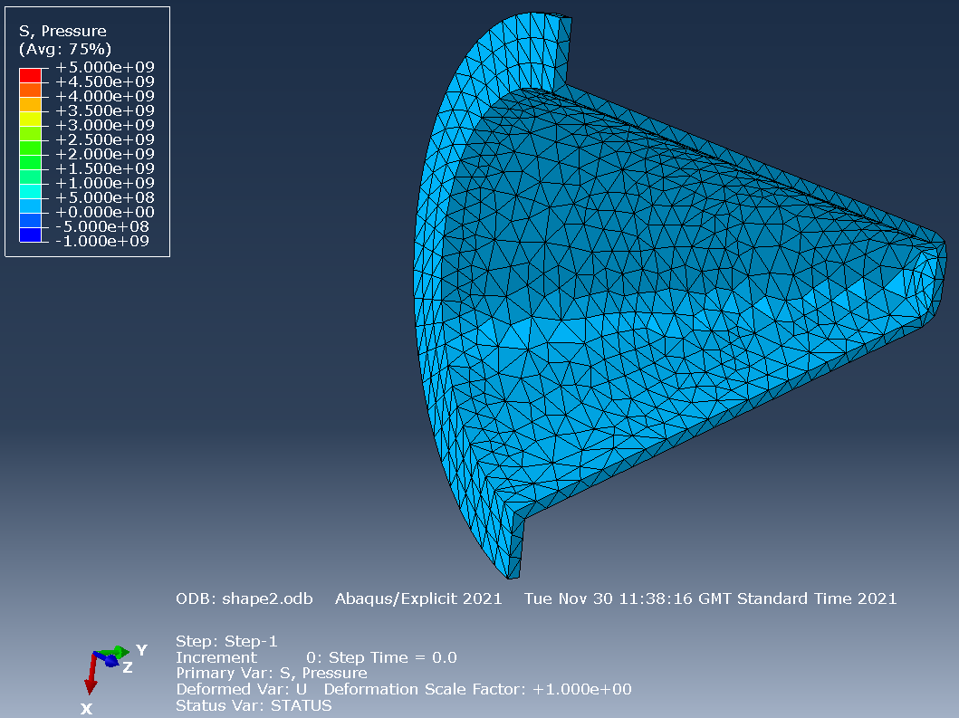
Figure 27- Simulation before editing image 1 of cone liner
Figure 28- Simulation before editing image 2 of cone liner
Figure 29- Simulation before editing image 3 of cone liner

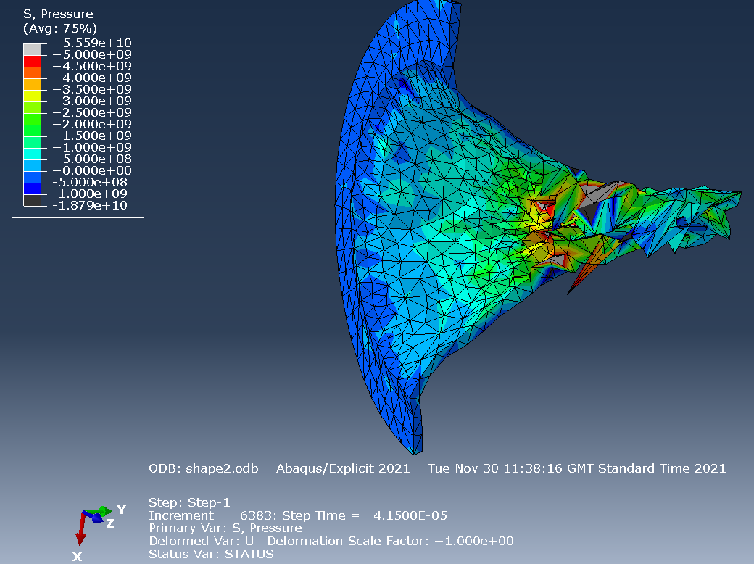
Figure 30- Simulation before editing image 4 of cone liner
Figure 31- Simulation before editing image 5 of cone liner
Figure 32- Simulation before editing image 6 of cone liner

Simulation after editing copper simulation images
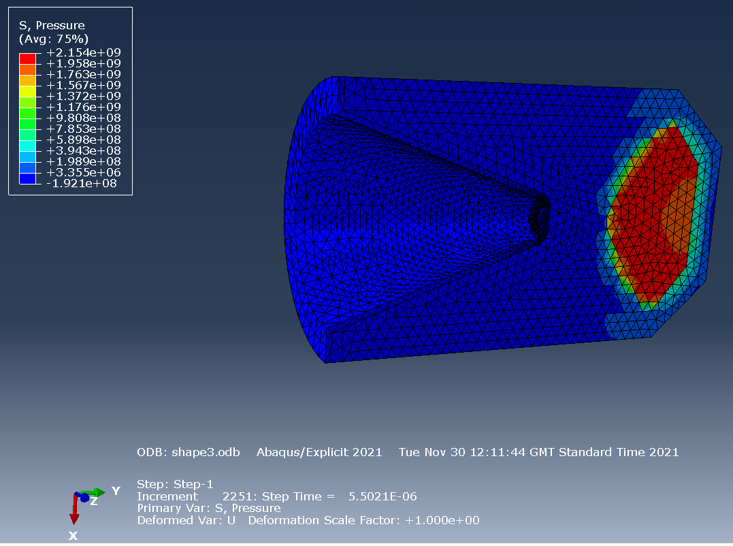
Figure 33- Simulation after editing for copper of full model during initial explosion
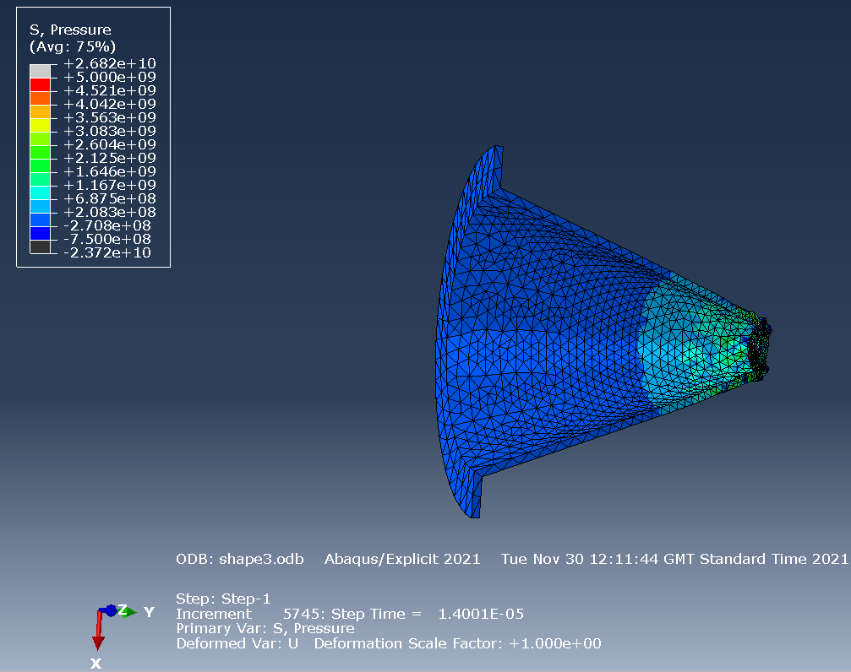
Figure 34- Simulation after editing for copper image 1 of cone liner
Figure 35- Simulation after editing for copper image 2 of cone liner
Figure 36- Simulation after editing for copper image 3 of cone liner
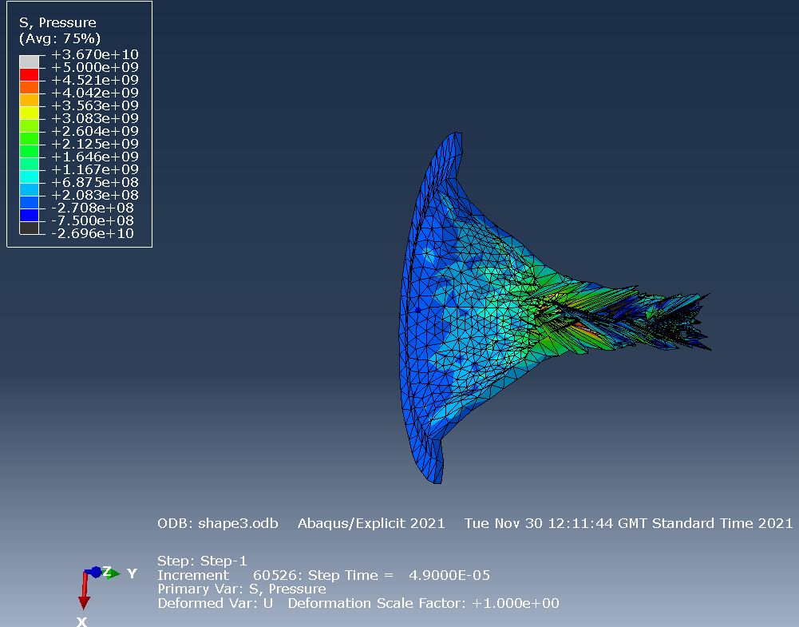
Figure 37- Simulation after editing for copper image 4 of cone liner
Figure 38- Simulation after editing for copper image 5 of cone liner
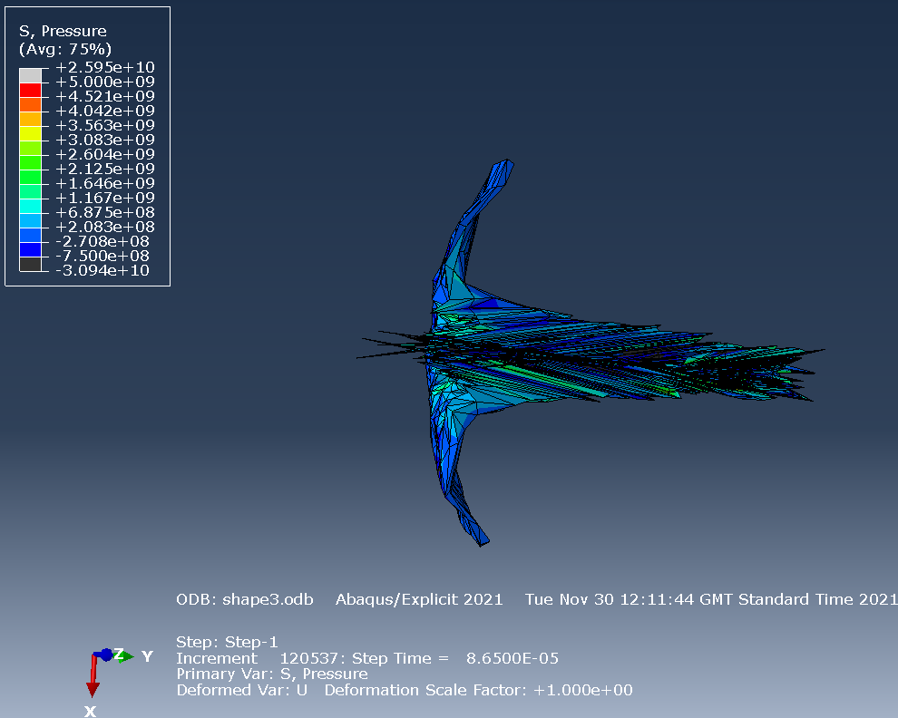
Figure 39- Simulation after editing for copper image 6 of cone liner
Figure 40- Simulation after editing for copper image 7 of cone liner

Simulation after editing molybdenum simulation images
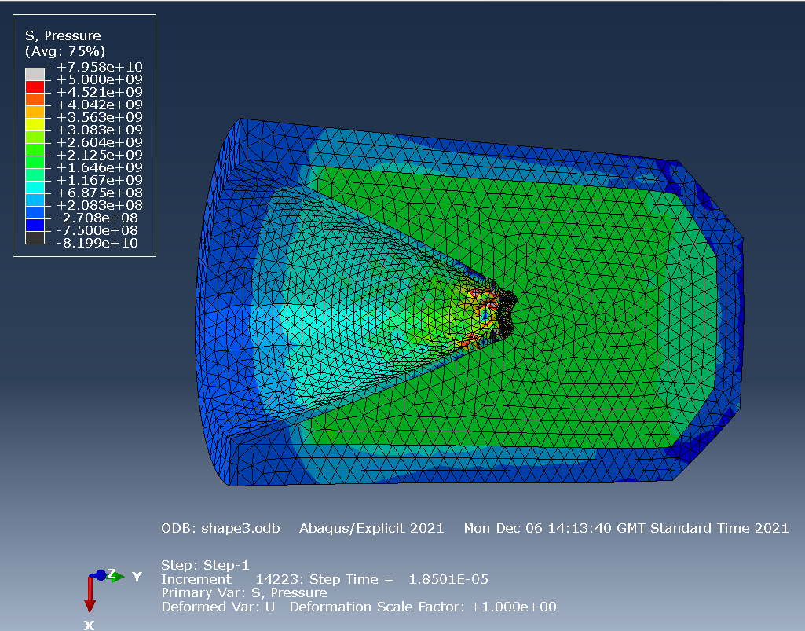
Figure 41- Simulation after editing for molybdenum of full model during initial collapse of cone
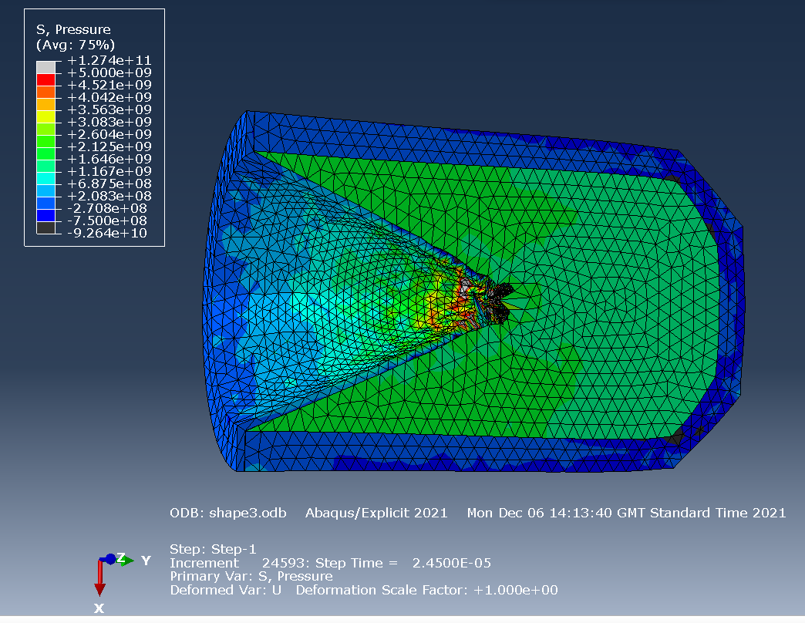
Figure 42- Simulation after editing for molybdenum of full model with further initial collapse of cone
Figure 43- Simulation after editing for molybdenum image 1 of cone liner
Figure 44- Simulation after editing for molybdenum image 2 of cone liner
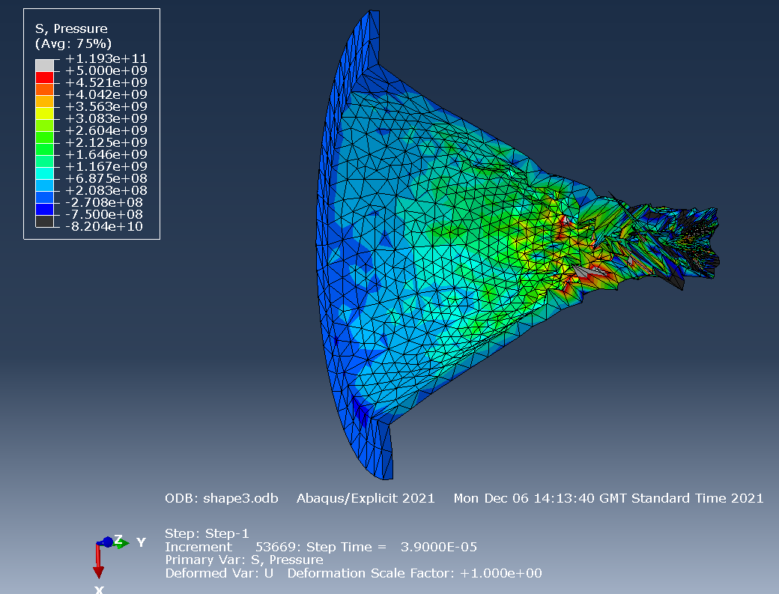
Figure 45- Simulation after editing for molybdenum image 3 of cone liner
Figure 46- Simulation after editing for molybdenum image 4 of cone liner
Figure 47- Simulation after editing for molybdenum image 5 of cone liner

