

Student Name: Shubhamsingh Satyendrasingh
Bhadauriya

Student ID:2510990

Module Name: International Marketing: Principles and Practices

Module Code: LCMB7026

Lecturer’s Name: Tushara Balendran

Term 2

Contents
Introduction – 4
1.1 Background Information About the Company 5
The Macro environment – PESTLE analysis 5
1. Political Factors 6
2.Economical Factors – 7
3.Social Factors – 7
Culture - Hofstede's Cultural Dimensions Theory 8
4.Technological Factor – 10
5. Legal – 10
6.Environmental 11
Similarities: 11
Differences 12
STP analysis 12
Segmentation – 12
Targeting 14
Positioning – 15
Similarities: 17
Differences: 17
International Marketing Mix (7Ps) strategies – 18
1. Product 19
2. Price 21
3. Place 23
4. Promotion 24
5. People 25
6. Process 26
7.Physical evidence – 27
Similarity 29
Differences 30
Directional Development Strategy – 30
Market Penetration – 31
Product Development – 32
Ethical and nonethical issue in KFC in India 32
Ethical issue for India 32
Unethical issue for India 33
Recommendations 34
Product and Brand development strategy for India 34
Product and Brand development strategy for USA 34
Conclusion 35
Gibbs’ reflective cycle 35
Description – 36
Feelings 37
Evaluation 37
Analysis 37
Conclusion 37
Action Plan 38
Final reflection 38
REFERENCE 39

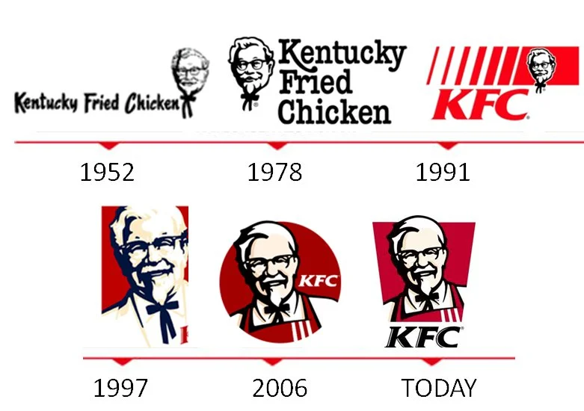
(Logolook.net, 2024)

Introduction –
In this report, we compare KFC marketing strategies in India and USA and compare how macro-environmental factors like PESTLE elements affect the brand value and shift the company strategy. After that, Hofstede Cultural Dimensions model is used to understand and compare culture behavior, communication, and business practices in two countries. The comparative analysis of Segmentation, Targeting, Differentiation, and Positioning is used to identify the target customer base for the company. 7P (Product, Price, Place, Promotion, People, Process, and Physical Evidence) is used which highlights how the company balances global standardization with local adaptation. Ethical considerations are discussed, followed by strategic recommendations for future growth. At the end, a reflective account using Gibbs’ Reflective Cycle is included to spread its mission and directional development strategy of KFC in India.

1.1 Background Information About the Company
Fast-food is the most demanding and working model for all the restaurant and café and KFC is the one of the biggest and successful fast-food chain in the world, it has approximately 31,981 KFC restaurant operating worldwide. The father of the KFC brand ,” Colonel Harland Sanders” had started his first store in 1930 at Sanders Court & Café in Corbin, Kentucky, and first official franchise started in 1952 at Harman's Café in South Salt Lake, Utah,. The idea behind the restaurant is to serve fried chicken to the roadside travelers but the hurdle they were facing was the time fry pan took to cook chicken but after invention of pressure cooker and with their secret herbs they had expanded their business with 600 stores and later sold it in $ 2 Million in 1964 and since then he is the main face of this global Brand. The KFC is currently owned and operated by Yum! Brands, Inc., an American multinational corporation based in Louisville, Kentucky. Yum! Brands also own other major fast-food chains including Taco Bell, Pizza Hut, and The Habit Burger (KFC, n.d.). In 1995 KFC had started its first outlet in BBengaluru, India and now they have 1300 plus outlets which are working and keep growing (Livemint, 2026).
KFC Global brings finger licking good fried chicken to the world. Our team members can be their best selves, make a difference and have fun – all while serving chicken and delighting customers at more than 30,000 restaurants in 150 countries and territories. There’s room for all people and voices at our table. Pull up a chair (KFC, n.d.).

The Macro environment – PESTLE analysis
PESTLE analysis is used to identify the External factors that effect a business or an organization. It has six factors: Political, Economic, Social, Technological, Legal, and Environmental (Gheibi et al., 2018). It provides an overall understanding of external factors which helps company to identify the potential of growth and threats and helps them to make strategic plan according to the situation.
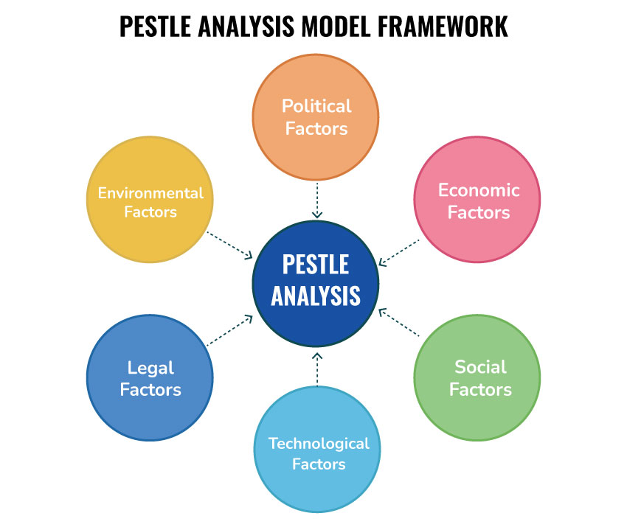
(Speaking Nerd, 2021)

1. Political Factors
Unfavourable for India -
- There are some Political Factors which are against of KFC in India. For KFC government need to change the food rules so it could sell its chicken and farmers are also against of KFC due to insecurity (Indian Farmers Fry the Colonel, 1996).Now Restaurants have to pay 5% GST which is a major disadvantage for KFC is that they cannot claim Input Tax Credit (Goods and Services Tax Council, n.d.).
Favourable for USA -
- USA support local business and their easy doing business policy supports KFC growth. Also, the legal protection of trademarks and franchising support the franchising model. USA has stronger political stability than most countries in the world and has 0 to 10% state and local sales which is paid by costumer at the point of sale and do not carry the "no-ITC" penalty found in India(Tax Foundation, 2024).

2.Economical Factors –
Favourable for India –
- Rapid urbanization and demand of fast food increased in India which support the growth of KFC with that the marketing collaboration with Krafton India to offer gaming to attract younger customers and improve the brand loyalty among them (Afaqs, 2024).Also India is a growing economy, with a GDP of $4.51 trillion (Worldometer, 2026), a GNP of $3.65 trillion as of December 2024 (CEIC Data, 2025), and an inflation rate of 3.21% (TradingEconomics, 2026), which shows strong demand for products and services in the country.
Favourable for USA
- Economic conditions are favorable for KFC in USA in term of higher individual income , strong supply chain with low-cost product availability and increasing growth of online platform boosts the growth of KFC. The GDP of USA is $30.62 trillion (Worldometer, 2025) and GNP is $24,059 billion for 2025. (U.S. Bureau of Economic Analysis, n.d.) and the current inflation is 2.4% (Fox Business, 2026) shows strong economic condition and perfect place for business.

3.Social Factors –
Favourable India –
- India has large youth population and most of the people like to eat western food which support the demand of fast food whereas KFC is one of the brands which modify their menus according to the people. Also, social media and rising urbanization supports the growth of fast-food industry (UNICEF, 2025).
Favourable for USA
- USA has history of fast-food business, most of the brand comes from the USA because of their fast-paced lifestyle and Diverse, multicultural population and increasing income of middle class supports the growth of this industry.

Culture - Hofstede's Cultural Dimensions Theory
Hofstade’s Cultural Dimensions Theory is a framework developed to analyze national cultures based on empirical data, linking cultural values to organizational behavior.
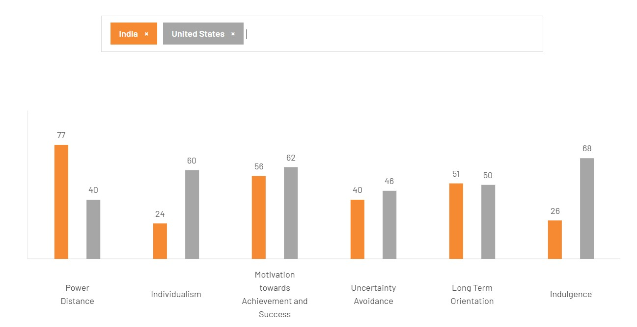
(The Culture Factor, n.d.)

In comparison to the USA, power distance is very high in India, which shows hierarchy takes most decisions. Individualism in India is 24 while in the USA it is 60, showing USA people prioritise their needs and make individual decisions, while in India people think about family and group decisions. India scores 56 on achievement and success, showing a moderately achievement-focused society, while the USA scores 62, showing a stronger focus. Uncertainty avoidance in India is 40 and in the USA is 46, showing USA prefers more rules and structure. Long-term orientation in India is 51 and in the USA is 50, showing similar focus on future goals. Indulgence in the USA is higher than India, showing more focus on leisure, entertainment, and personal freedom.
Favourable
India and the USA both focus on future goals and success, which helps in planning and growth. India’s group-based culture helps teamwork and strong relationships, while the USA’s individual culture supports independence and new ideas.
Unfavourable
In India, high power distance means decisions are mostly made by seniors, so employees are less involved. Low individualism in India can reduce independent thinking. In the USA, high individualism can reduce teamwork. Differences in indulgence can also affect work-life balance.
Advantages
The Hofstede Cultural Dimensions model helps businesses understand cultural differences between countries. It provides a clear structure to compare factors like individualism, power distance, and uncertainty avoidance. This helps companies adjust their marketing, communication, and management styles. It also supports better decisions when entering new markets. The model is widely used, so it is considered a reliable tool.

Disadvantage
The model has limitations. It is based on old data, so it may not reflect current cultural changes. It treats whole countries as having the same culture, ignoring regional and individual differences. It can also oversimplify cultural behavior and lead to wrong assumptions. Therefore, it should be used with other methods for more accurate results.

4.Technological Factor –

Favorable for India –
KFC in India is using digital platforms, online delivery apps and automatic machine ordering systems in stores, which provide convenience to customers while making orders. According to the Press Information Bureau (PIB, 2026), India is spending 0.6 – 0.7% of GDP in R&D which present the country is focusing on technological development and Indian IT companies are paying huge amount to develop AI tools to make their work easy.

Favorable for USA –
KFC in USA uses advanced technology and AI system which improve operational efficiency, enhance customer experience. According to the World Bank (2025), the USA is spending 3.59% of GDP in research and development which show the technological advancement of USA.

5. Legal –
Unfavourable for India –

In India, companies follow FSSAI (Food Safety and Standards Authority of India) regulations and follow the employment rules including minimum wages and employee regulations. However, FSSAI frequently changes the regulations. As a result, KFC must follow all the rules and regulations and file the other compliances which increases operational cost.

Favorable in USA –
The USA has strong franchise rule which protect companies from unauthorized copying and misuse of trademarks as well as it has world strongest food and transparent food and safety law which ensure food quality standards and increase customer trust.

6.Environmental
Favorable for India –

In India ,Environmental factors are favorable for KFC because of increasing consumer awareness toward the environment and companies started to follow sustainable practices and healthy food options. The government encourages eco-friendly packaging and waste management, which aligns with KFC’s initiatives for responsible sourcing and sustainable operations.

Favorable for USA –

In the USA, environmental factors are favorable for KFC because of incentives for energy efficiency and waste reduction. Consumers are highly conscious of environmental impact, creating a market for brands that implement eco-friendly operations. Also, KFC promotes earth day which help to improve their image among the customers.

Similarities:
India and the USA both have strong growth in the fast-food industry because of rising demand, urbanisation, and changing food habits. In both countries, online delivery apps and digital platforms help companies to grow. Both markets focus on long-term success and business growth. Environmental awareness is increasing rapidly in countries so companies like KFC are using eco-friendly practices. Also, India and the USA both use technology to improve the service and customer experience.
Differences:
India is a developing economy and it has a large young population who like to eat fast food, while the USA is a developed country with higher income and stronger buying power. In India, Government food rules and regulations are frequent changes which increase business costs, while in the USA rules are more stable and business-friendly. India also faces higher tax and compliance challenges compared to the USA. The USA spends more on research and advanced technology than India.

STP analysis
STP analysis indicates to the marketing strategy framework which involves Segmentation, Targeting, and Positioning, which serves as a foundation for developing effective marketing strategies. Segmentation divides the market into groups based on characteristics, targeting selects the most appropriate segments to focus on, and positioning establishes a product’s image in the minds of the target consumers (Ayu Lestari, Liantifa and Abdallah, 2026).STP analysis of KFC shows how company analysis the different market based on based on demographics and lifestyle, targets the customer and positions its products as affordable and convenient.

Segmentation –
Segmentation divide market into different group like Demography, Geographic, Psychographic and Behavioural Segmentation.
- India
Demographic Segmentation
In this Segmentation company consider age, gender, income, education, and household characteristics (Martins, 2002).
Age - 10–45 years teenagers, college students, young professionals are mainly target for the KFC in India.
Gender – KFC target all gender group people and makes its products suitable for everyone.
Income - Middle-income and upper-middle-income consumers are in the center point of the income criteria.

Geographic Segmentation
Geographic segmentation involves dividing the market based on location, such as regions or countries. (Smith & Haughton, 2018). KFC Focuses on urban and semi-urban cities and target the market where shopping malls, metro cities, and commercial areas are available. And where they can access people easily.
Psychographic Segmentation
Psychographic segmentation focuses on psychological attributes such as personality, attitudes, and lifestyle (Ciribeli & Miquelito, 2015).It gives information about the consumer interest toward western lifestyle and social trends which helps KFC to making marketing strategy according to it. In India, KFC uses the VALS strategy to divide customers based on their lifestyle and behaviour. Innovators and Achievers prefer premium food. Experiencers and Strivers are young people influenced by trends and are the main target group.
Behavioural Segmentation
Behavioral segmentation classifies consumers based on their behaviors, such as purchasing patterns or brand loyalty (Ciribeli & Miquelito, 2015). This tool helps KFC to identify and create their market value as well as create their loyalty which helps it to gain customer base in the market.
- USA
Demography Segmentation
Age – KFC targets customers age approximately 10 to any years, including young adults, working professionals, and families.
Gender – KFC targets all gender groups and designs its menu offerings to appeal to a diverse customer base.
Income – Lower income to higher income households forms the target market, as customers looking for affordable and value-for-money meal options suitable for individuals and families.
Geographic Segmentation
KFC in the USA targets broad areas because of their different products and fast-food facilities, along with cities and malls they have a huge chain along highways which makes them one of biggest food chain USA.
Psychographic Segmentation
In USA, People have very busy and fast-paced lifestyle, they work longer hours and want to use their time efficiently, because of their life style and attitude they prefer quick meals and often choose fast-food restaurants that are convenient and save time which helps KFC to target customers effectively. KFC in the USA uses marketing strategies to attract younger and diverse consumers. It partnered with hip-hop artist Jack Harlow to connect with a younger audience through celebrity and cultural marketing. The campaign used digital platforms, events, and culturally relevant content, showing KFC’s focus on consumers who value trends, entertainment, and social engagement, which aligns with certain VALS segments (Adams, 2021).
Behavioral Segmentation
KFC is a trustworthy brand organization they use good quality food and provide same taste at every outlet, which creates trust in the brand and customer loyalty encourage repeating customer.

Targeting
Targeting is a part of marketing strategy for the company where company select which ccustomers groups it wants to sell their product and services. Company divides a large market into, smaller customer groups based on similar needs, preferences, or behaviors. Companies mainly use Undifferentiated Targeting , differentiated Targeting and Concentrated based om their characteristic (Sarin, 2011).Concentrated targeting focuses on one specific market segment or a small group of customers. KFC sales halal food in non-Muslim countries to attract Muslim customers (Wilkins et al., 2019).
Targeting strategy for KFC in India –
Company use Differentiated Targeting strategy in different country according to the food, culture and religion. In India, company modifies its menu and marketing strategies to suit local tastes and cultural expectations.
Targeting strategy for KFC in USA –
KFC in USA use Differentiated Targeting strategy, focuses on multiple customer groups instead of treating the entire market as one segment.

Positioning –
The brand positioning is a process of creating brand image unique attributes, positive associations and values in the consumer’s mind. It has multiple stages which includes analysis of the external and internal environment, trademark design, selection of differential positioning features, strategy definition, target setting, implementation planning, execution, evaluation, and corrective actions (Fayvishenko, 2018).

- Positioning in India
KFC becomes the first QSR in India to launch a Sign Language training program for 100% of its employees (KFC, 2024)which positions itself an inclusive, socially responsible, and culturally aware QSR brand and KFC India launched add HOPE™ – an initiative to fight hunger in the country to help contribute towards fighting hunger in India, Blink Digital added another leg to KFC’s add HOPE™ with the ‘Plate of Hope’ digital campaign (3BL Media, 2016). Also, KFC added vegan and plant-based product in their menu to create brand image among the customers (Global Food Consumers Forum, 2024).
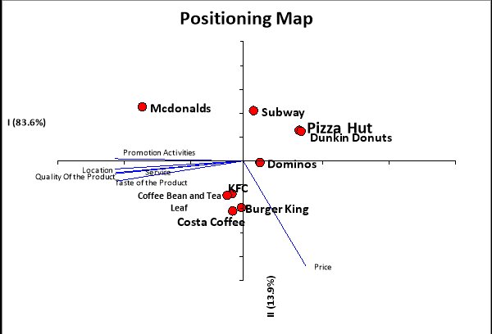
(Panwar & Patra, 2017)
- Positioning in USA –
In USA , KFC positions itself as a affordable fast-food brand offering high-quality fried chicken with consistent taste, Also run community program like Harvest food donation initiative, where unsold but wholesome food is donated to hunger-relief organizations across the country (KFC, n.d.).

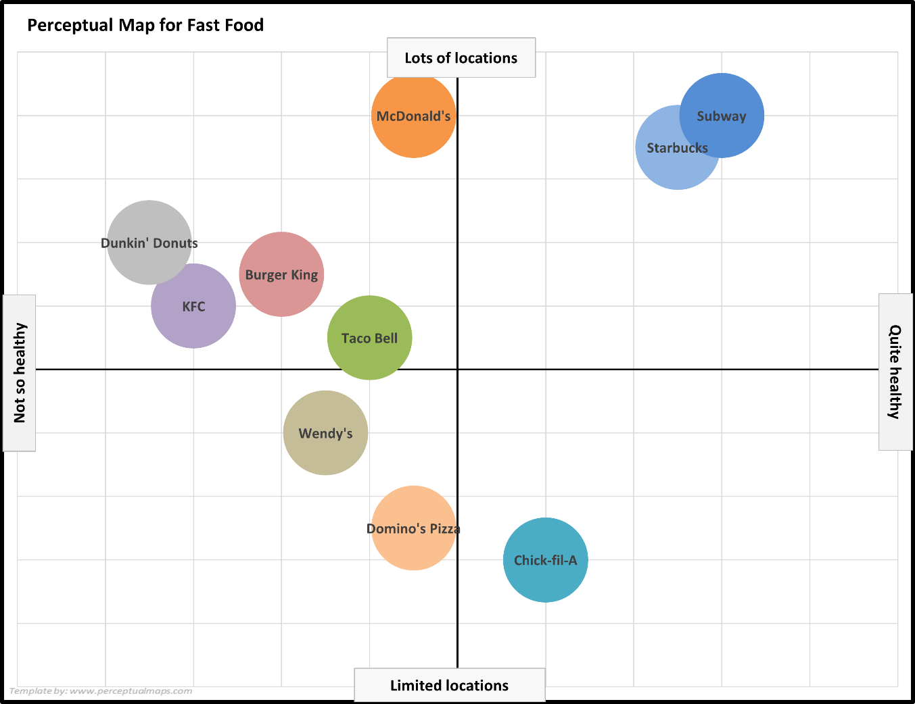

(PerceptualMaps.com, 2023)

Similarities:
KFC uses STP in both India and the USA to target different age, income, and family groups. it focuses on urban areas and offers affordable fast food and ensure the same taste customers get in every outlet. It also uses digital marketing and social activities to build brand image.
Differences:
In India, KFC changes its menu more to match local taste, culture, and religious needs, while in the USA it offers more standard fast food. Their marketing strategy is more focused on culture, social values, and different customer needs, while in the USA it focuses more on busy lifestyle, speed, and convenience. In India, KFC also uses campaigns like HOPE and plant-based food to connect with social issues, while in the USA it focuses more on affordability, consistent quality, and food donation programs.

International Marketing Mix (7Ps) strategies –
International marketing mix strategies, particularly the 7Ps framework—product, price, place, promotion, people, process, and physical evidence help company to change and adopt these elements in their marketing behavior. Multinational companies position themselves on a continuum between standardization and adaptation of these elements, which are influenced by various significant and peripheral factors that affect their marketing mix decisions in international markets. This continuum reflects their overall attitude towards balancing global consistency with local responsiveness, which has managerial implications for marketing tactics in internationalization efforts (Vrontis, Thrassou and Lamprianou, 2009).

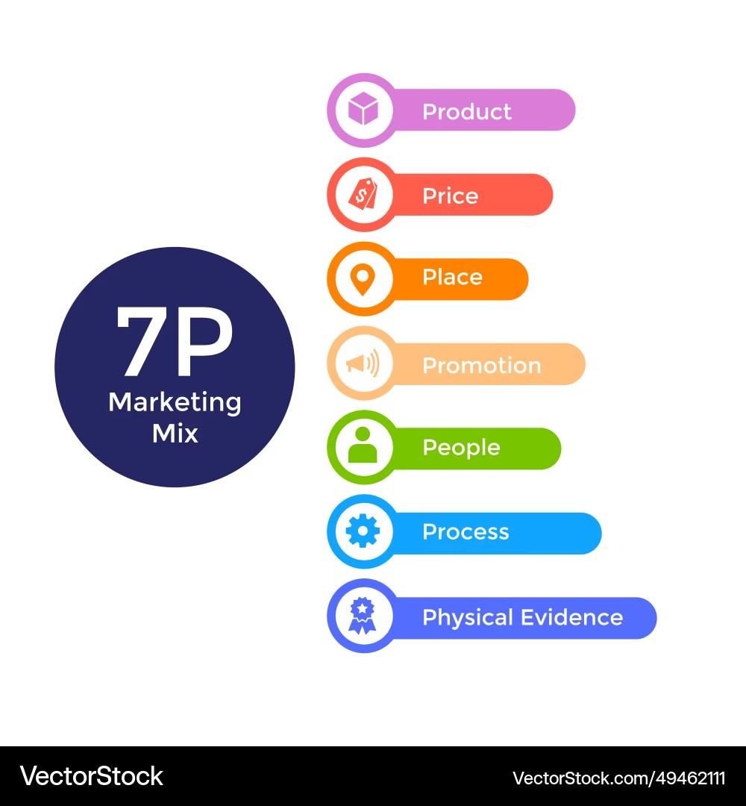
(VectorStock, 2023)

- Product –
Product Depth (India)
KFC offers a wide variety of products within its chicken product, like Original Recipe chicken, Extra Crispy chicken, Spicy chicken, chicken sandwiches.
Product Width (India)
In India , KFC offer vegetarian burger ,Rizz Fizz drink cakes , drink

KFC use different product strategy in India to match local taste and culture. Indian people like spicy food so KFC add spicy and local items to its menu to make their product famous among Indian people. Additionally, KFC sells different types of products in India with same taste.
In Gujarat, India where a large most of people are vegetarian, it has already added vegetarian items and still increase type of product in their menu. On the other hand, in Kerala and in south India, they mainly sell non vegetarian items in the stores.
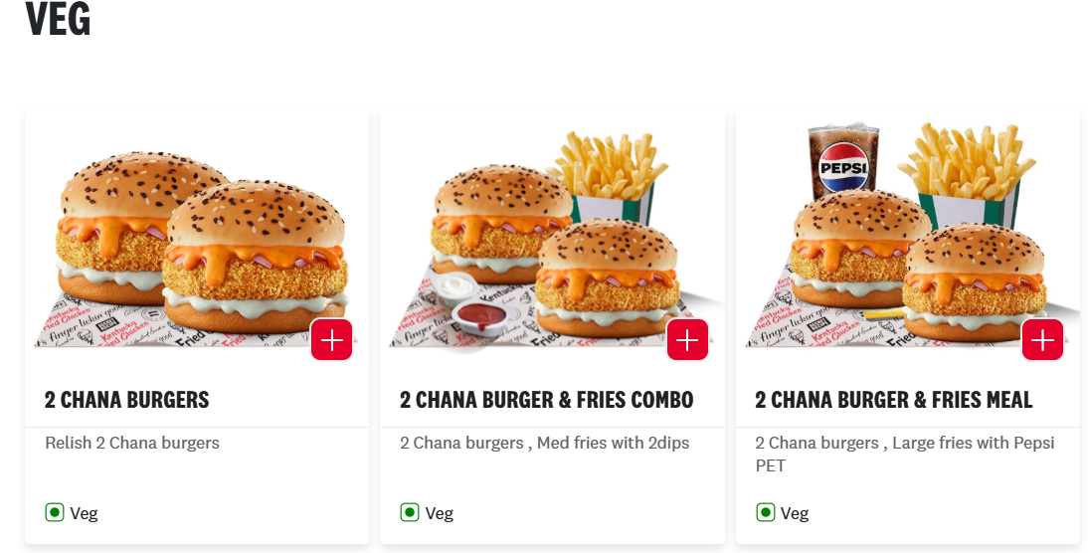
(KFC India, n.d.)
Product Depth (USA)
In the United States, KFC also shows strong product depth within its chicken-based menu. Customers can choose from Original Recipe Chicken, Extra Crispy Chicken, Grilled Chicken, Chicken Sandwiches, Chicken Tenders, and Popcorn Nuggets.
Product Width (USA)
In the United States, KFC is known for its classic fried chicken meals. The most popular item is Original Recipe chicken, which is seasoned with a special blend of herbs and spices and pressure-fried to give a crispy outside and juicy inside. Along with chicken pieces, KCF also sells chicken sandwiches, Extra Crispy Chicken, mashed potatoes with gravy, biscuits, and coleslaw and family bucket meals and most of the product they sell are non-vegetarian and chicken product. However, they have also started plant-based meals like plant-based chicken sandwiches and nuggets (GISuser, 2026).
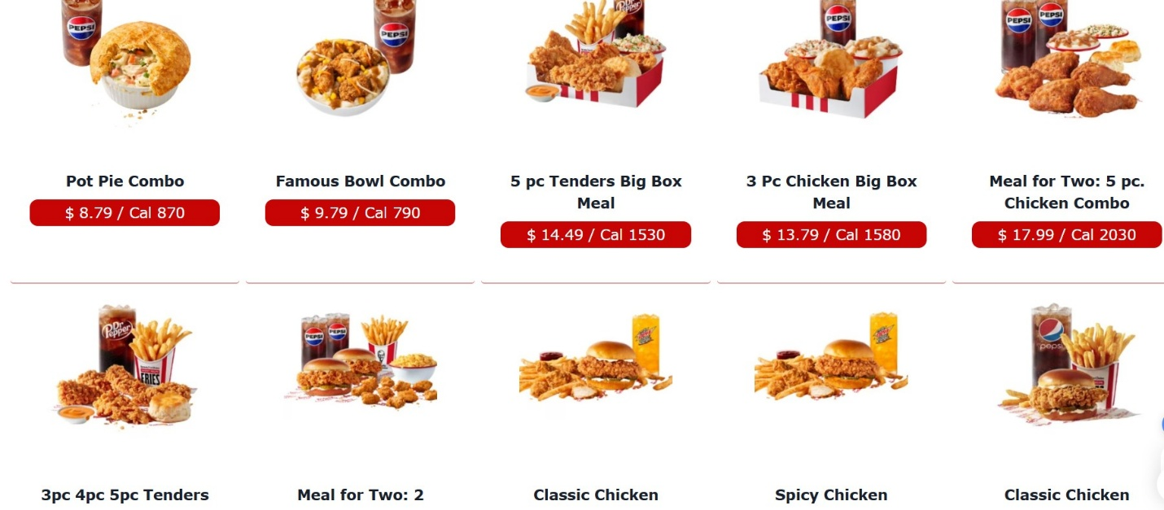
(KFCMenuUSA, n.d.)

- Price –
Every product comes with its own value and that value provide the place of that product in the market. Companies use different price strategy to target its audition, In the context of competitive fast-food market, KFC use price value-based options to attract price-sensitive consumer (Howard, 1994). To consider the price-sensitiveness companies use bundle pricing strategy a strategy where a firm offers prices based on the size of the bundle rather than on specific combinations of products (Abdallah et al., 2021).
In India KFC use meal box and combo offer which help it to attract more customers for example 1 Meal Box combines chicken pieces, a burger, fries, a drink, and a dessert at a single discounted price, is lower than the purchasing items separately.
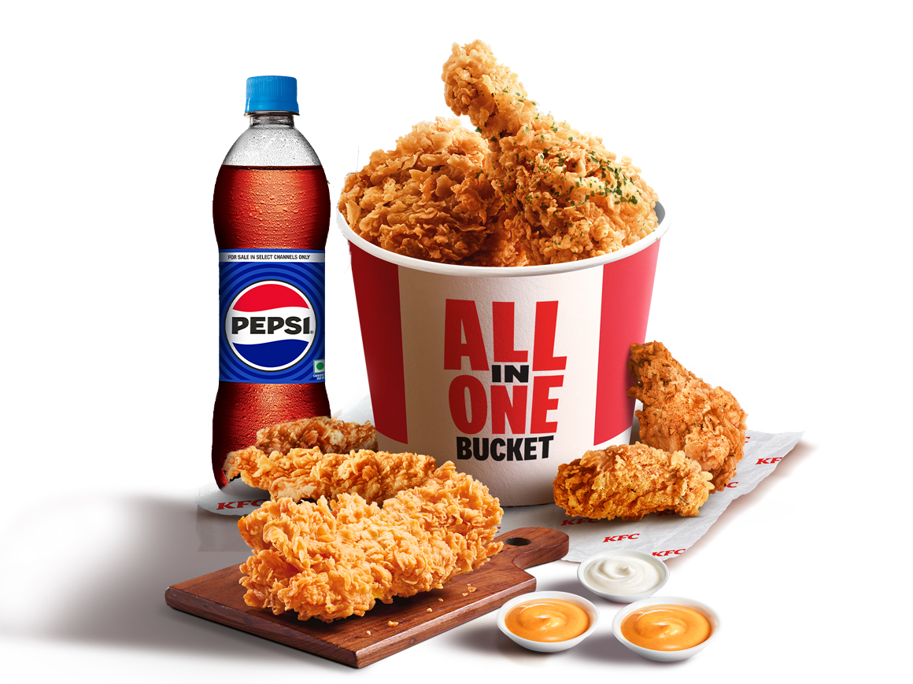
(KFC, 2026)
In USA fast food market is also highly competitive, where KFC focus on value meals and bundled pricing strategies to attract customers. KFC offers combo meals, family buckets, and limited-time bundle deals that combine chicken, sides, and beverages at a reduced overall price.
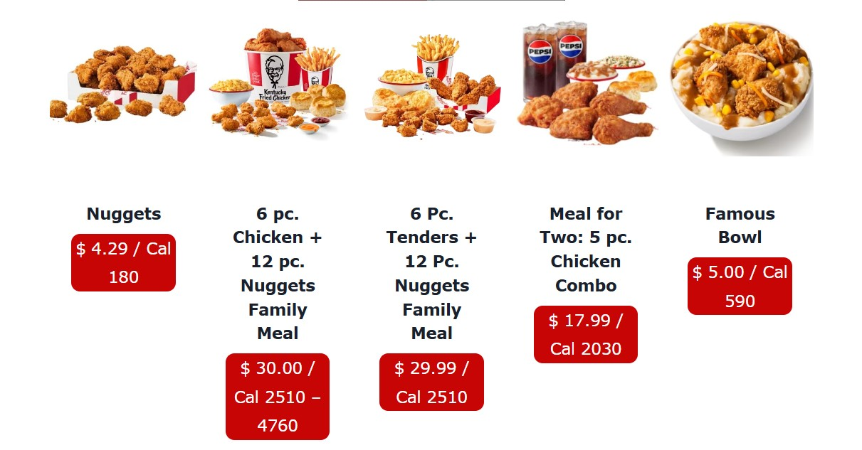
(KFC Menu, 2026)
- Place –
Place refer to how a company distribute its product in the market by using different source and channel. It includes distribution channels, logistics systems, and location decisions to ensure product availability and convenience for consumers.
In India KFC uses franchising-based distribution strategy and sells their franchising instead of opening its own stores, this strategy saves money and control the brand value. Also, KFC target shopping malls, high-traffic urban areas, and commercial centers to maximize customer accessibility and collaborates with online food delivery platforms to expand reach.

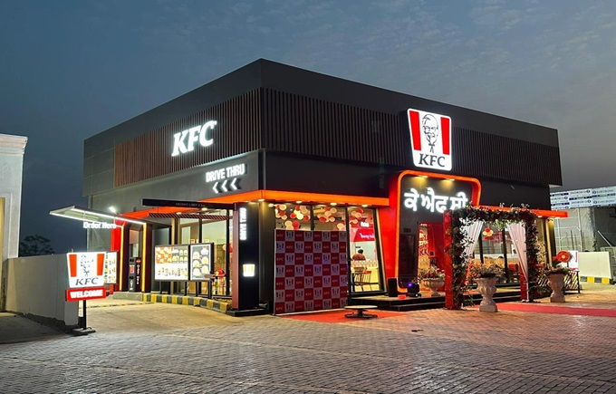

(TFW Bureau, 2024)

In USA , KFC use same strategy but they also have their own stores and the franchise system and quick service and car accessibility.

- Promotion –
Integrated Marketing Communication (IMC) uses various communication tools to provide a clear and consistent message to target audiences by ensuring coordination across different marketing channels (Fraculj, Brkanić and Plantić Tadić, 2024). KFC use different promotion activity India to stand out itself in this competitive market, KFC does advertise on Television commercials to attract young and family, print ads in newspapers and magazines highlighting its offers like combo meals, social media campaigns and Sales Promotion. Additionally, to target and expand its customer base, KFC has launched Shawarma wrap, with that shifting focus from traditional meal-time offerings to snacks, reflecting changing consumer habits and the growing snacking market (Brand Equity, 2026).
KFC Peri Peri | Let's KFC
https://www.youtube.com/watch?v=99YCrTfOaFU

Shawarma wrap
https://www.instagram.com/kfcindia_official/reel/DWx72mqEYxW/

In USA , KFC use tradition promotion activity with digital engagement.Also, in USA One campaign, “Fried Chicken USA,” showed a made-up Colonel Sanders running for President during election time and in another campaign they for Extra Crispy Colonel, they used actor George Hamilton, highlighting their Extra Crispy Chicken(Marketing Explainers, 2024).

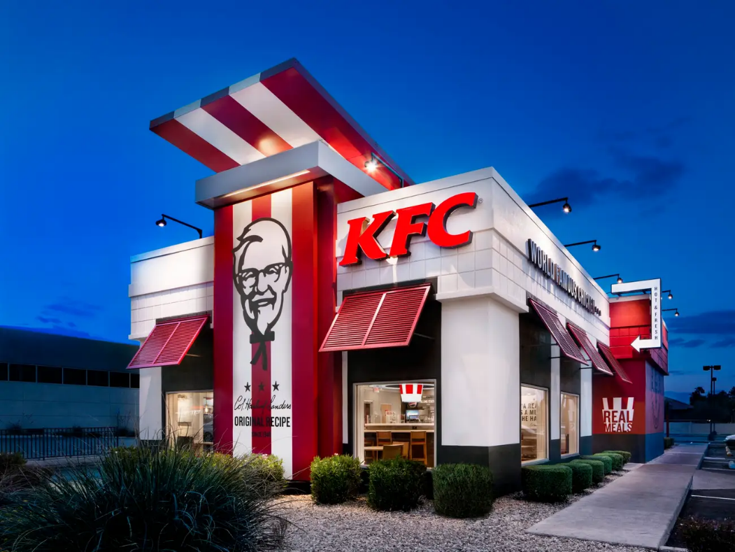
(Taylor, 2016)
- People –
In KFC India, the people element is important for its success. Employees like cashiers, kitchen staff, delivery partners, and managers ensure fast service, good-quality food, and hygiene. Employees are trained to handle high customer demand, especially in urban outlets. KFC India also provides bonuses, salary increments, and rewards to motivate employees and promotes a supportive workplace culture to improve retention (Ivory Research, 2019).
KFC employs about 800,000 to 900,000 people in the USA, showing its importance in the economy (EatHealthy365, 2026). KFC USA focuses on structured training, continuous development, and financial and non-financial incentives to improve performance and retention.
- Process –
KFC focuses on customers satisfaction for that they always try to solve all the customers complain to make their place a better and more welcoming place for customers. They have different process in different countries, In India, customers can fill online complain and review forms via using KFC official website or they can also ask to the manager about their issue (KFC India, n.d.).
USA has much strict rules and regulation for food and safety, and the system is more advanced compared to many other countries. KFC takes all the customers complaints very seriously and take action as soon as possible, the company also focuses strongly on hygiene standards and quality product should always remain same and if anyone want complain about anything they can use online platform or directly complain to the customers helpline (ComplaintsBoard, 2026).
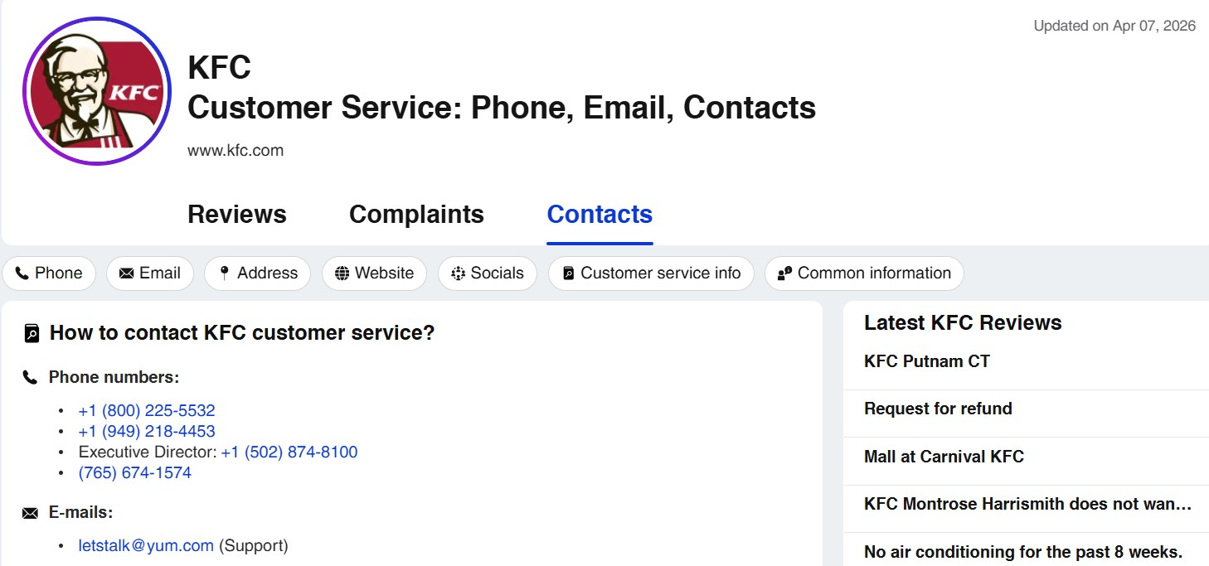

(ComplaintsBoard, 2026)

7.Physical evidence –
KFC use same product packaging in every county to maintain the brand image , they use its signature red and white color scheme with Colonel Sanders image, which helps customers to recognize brand easily. But in India the clothes are lighter because of the hot weather and the website includes more vegetarian options in the menu.
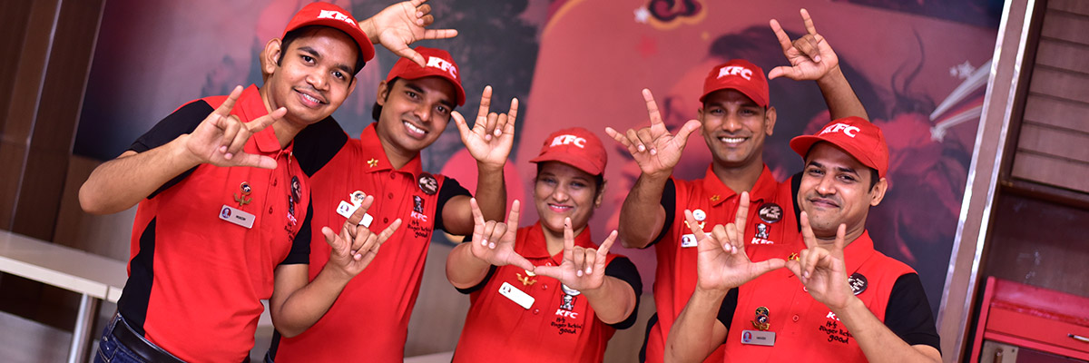
(KFC India, n.d.)
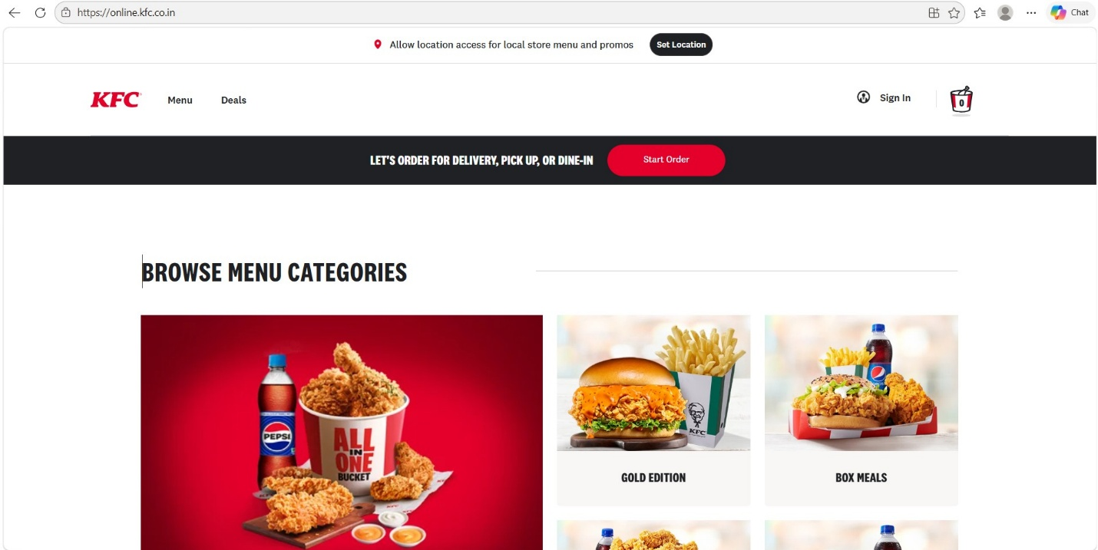
(KFC India, n.d.)

In the USA, KFC uses a similar website structure with slight differences in menu categories and the navigation tabs and mainly it includes non-vegetarian and USA-based menu products in the stores. Also, the clothes of the staff in USA are almost same and due to the cold weather, the quality of the product is much thicker.
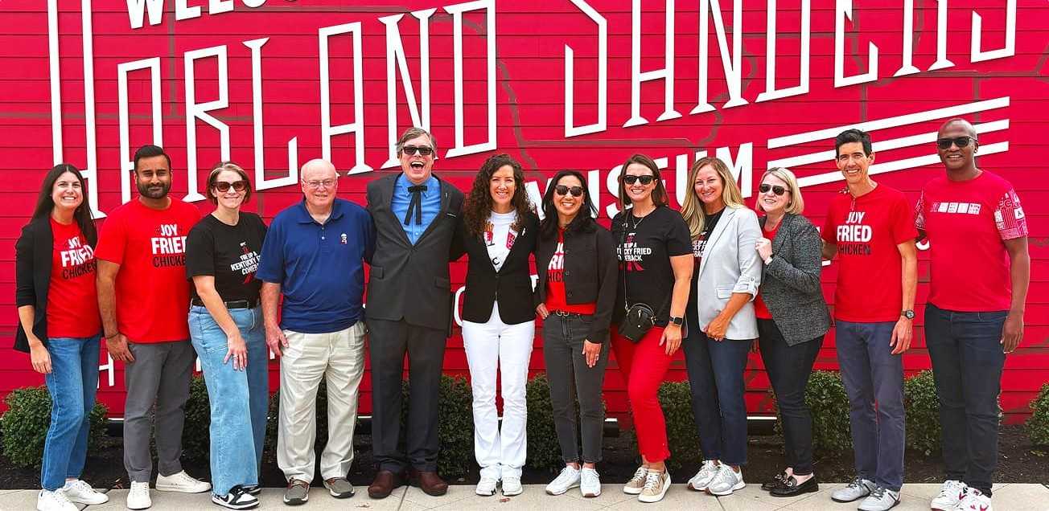
(KFC Menu USA, n.d.)
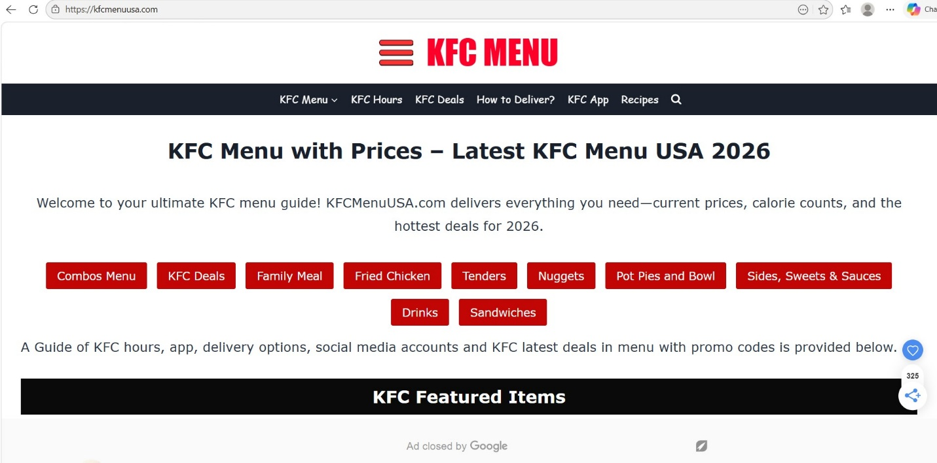
(KFC Menu USA, n.d.)

Similarity:
KFC uses similar strategies in India and USA across all 7Ps. It uses value-based and bundle pricing, franchising and high-traffic locations, and IMC with ads and social media. Product depth is similar with different chicken items, and both focus on employee training, customer service, complaint handling, and consistent brand image like red and white packaging and Colonel Sanders logo.
Differences:
In India, KFC focuses more on low-price meal boxes, franchising, vegetarian and spicy products, and family-based promotion. In USA, KFC focuses on value meals, both franchise and company-owned stores, non-vegetarian products, and creative campaigns with celebrities. USA also has stricter processes and more advanced systems, while India adapts more to local taste and conditions.

Directional Development Strategy –
A Directional Development Strategy explains the long-term direction a company chooses to growth strategy by using different strategy whether the firm wants to expand the business or maintain stability. To get the perfect and planned strategy, companies use Ansoff Matrix, a strategic framework for visualizing a company’s strategy to sell existing products in existing markets, develop new products for existing markets, enter new markets with existing products, and diversify by developing new products for new markets (ECOBICI, 2017).
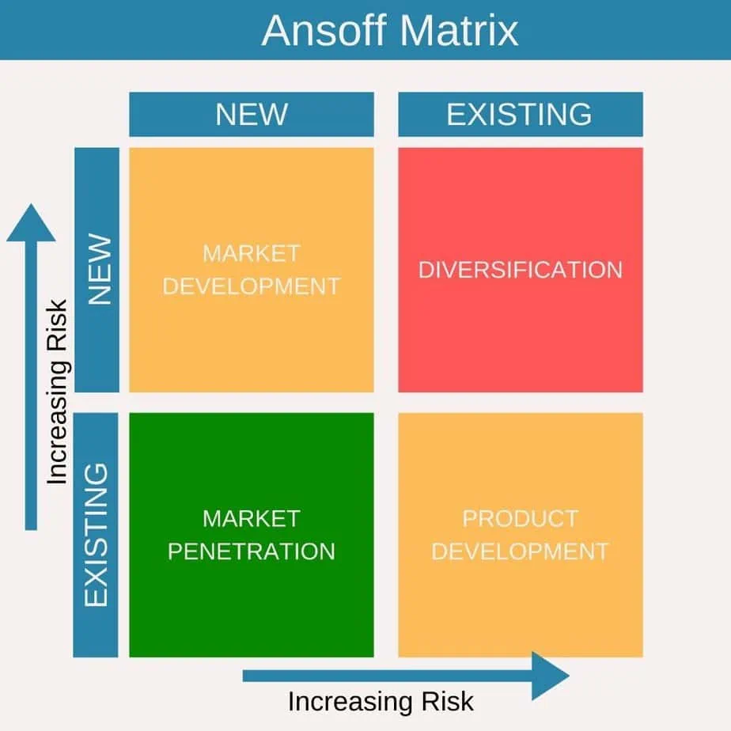
(Animas Marketing, 2024)

Market Penetration –
KFC started to increase its market share by different ways like offering aggressive pricing strategies, value meals, combo offers, and strong digital engagement through food delivery apps and also expanding its business in small town in India to maximize its reach among Indian customers (MoneyMuscle, 2025).

Product Development –
In India, KFC has introduced a wide range of vegetarian and locally products like paneer-based burgers, rice bowls, and spicy Zinger variations to suit Indian taste preferences. It also has regionally inspired flavours and limited-time offer and seasonal items to attract more customers (KFC India, 2026).

Ethical and nonethical issue in KFC in India
Companies always use marketing mix strategy for product promotion and they use strategies which are both ethical and nonethical. In the ethical marketing mix, they maintain trust , honesty and transparency while in nonethical they mislead customer via promotions and pricing and other (Kuenzi, Mayer and Greenbaum, 2020).

Ethical issue for India
Product –

KFC is well known brand so the quality of product is consistent across all the country. It always ensures to maintain the same quality everywhere to attract and retain customers. Also, KFC follows Indian food and safety laws and regulations to ensure hygienic and standers of product.

Price –
KFC has clear pricing and menu transparency in all the store and on online platforms. This helps customer to know how much price they are paying for their product.

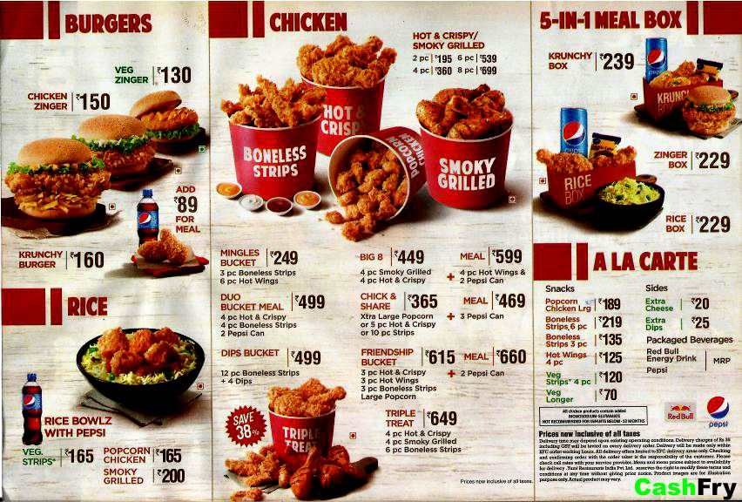

(CashFry, 2023)

Unethical issue for India
Promotion –
The promotion activity in India related to fresh chicken consider as an unethical activity because of the lack of knowledge and information about its source. Also, the Advertising Standards Authority discovered that since the meat was delivered to branches only three times a week, the claim in the advertisement did not stand true (Medindia, 2009).
Physical Evidence –
In India, the process of complaint handling in service industries, including fast food, is very slow and customers face delays in responses and the managers are not taking action quickly and sometimes try to ignore that complaint which reduces their brand trust in the market (MarkHub24, 2025).

Recommendations

Product and Brand development strategy for India
- In India, KFC should focus on expanding its presence in rural areas where it does not have stores and Franchise, it should add more region-specific products to attract more and more people with that it should try to host or do promotion activity in regional level to increase brand awareness, and strengthen its presence in local market.
- In India, KFC have already started using recyclable materials in their packaging. To demonstrate their eco-friendly approach KFC should change their unethical marketing approach and give clear massage to people.

Product and Brand development strategy for USA
- In USA , KFC should add low-calorie and healthier options in the menu to attract new generation. also add products for fitness-focused consumers by introducing low-carb and high-protein meals products such as protein salads and other nutritious alternatives can enhance customer experience.
- In USA , it should pursue diversification in the business and develop new business segments to increase its product line. Instead of Fast-food chain, it should expand into its own hotel businesses and local cuisine restaurant, and it can also develop Retail Food Products for chicken and other product.

Conclusion
In conclusion, this report compares KFC’s marketing in India and the USA using PESTLE, Hofstede’s model, STP, and 7Ps. KFC changes its strategy based on culture, economy, and customer needs. India focuses on local taste, vegetarian food, and low prices, while the USA focuses on standard products and convenience. KFC’s success comes from balancing global brand and local needs, which helps its growth worldwide.

Gibbs’ reflective cycle
Gibbs’ reflective cycle is step by step reflective model to analyze experiences and learn from them. It has six stages like description, feelings, evaluation, analysis, conclusion and action plan which highlights that emotions are an important part of reflection and help in learning and improvement (Galli and New, 2022).

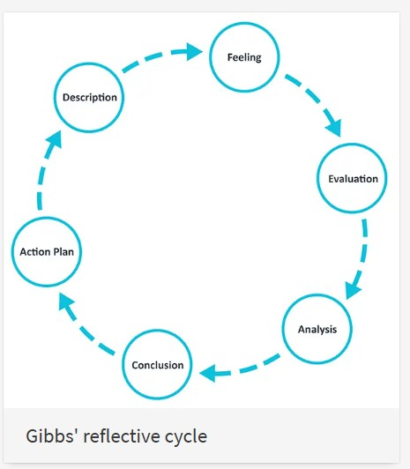
(University of Edinburgh, 2024)

Description –

In my second semester in International Marketing, I have to write a 5000-word assignment on KFC. I have to write about marketing strategies of KFC in India and in USA and do critical analysis of both countries and how they have different demand and business requirements. I need to study historical to current information about KFC, company values, success factors, and sustainable growth. I also include PESTLE factors, Hofstede’s Cultural Dimension, and STP analysis in both countries. I searched articles on the internet, KFC official website, university library, and newspapers to collect authentic information.

Feelings

In my last term I did the same thing so I was very confident about this task. Sometimes some data was very confusing and hard to find, which made me anxious and pushed me to learn more. Sometimes I got hard information easily, but basic information like total number of staff, dress code and mission statement was very hard to find or not authentic. After completing all the steps and writing a meaningful assignment, I am satisfied with my work.

Evaluation

During the research time, I found some valuable information about business and I learned how to use university library sources. I also learned how to summaries complex information into smaller parts and then understand it clearly. I gained knowledge about PESTLE analysis and Hofstede’s cultural dimensions and how they affect customers and their decisions. However, some information such as IMC strategy in promotion and depth and width of product in KFC was very difficult because it looked similar and confusing.

Analysis

During the time I learned about library resources and learned how to find data and write it, I also made some mistakes in my assignment but after taking all the advice and timely guidance I completed my task successfully.

Conclusion

In conclusion, I learned how to compare two countries using PESTLE and 7P frameworks, which helped me understand different business environments in a structured way. I also learned how to develop a Directional Development Strategy for KFC using the Ansoff Matrix. In addition, I gained knowledge about ethical and non-ethical issues in business and how non-ethical issues can be identified and improved. Overall, this experience helped me improve my analytical skills and understanding of business strategies and ethical decision-making.

Action Plan
Next time, I will use my current experience and knowledge what I have gained, and at the starting time I will make it clear and more deep analytics, and I will try to avoid the mistakes what I have made this time.

Final reflection
Overall, this assignment improved my understanding of international marketing and how businesses adapt in different countries. It also improved my analytical and research skills for future academic work.

REFERENCE
Abdallah, T., Asadpour, A. and Reed, J. (2021) Large-scale bundle-size pricing: A theoretical analysis. Operations Research, 69(4), pp. 1158–1185. Available at: https://research-ebsco-com.uwtsd.idm.oclc.org/c/onvpsy/viewer/pdf/7xodycpuwz?route=details (Accessed: 2 April 2026).
Adams, P. (2021) KFC previews new marketing approach with year-long Jack Harlow partnership. Marketing Dive. Available at: https://medium.com/@emilyrosevance/kfc-x-jack-harlow-partnership-campaign-analysis-74f8a8e9d2e3 (Accessed: 15 April 2026).
Afaqs (2024) KFC and KRAFTON India partner to unveil the limited-time KFC Zinger Box with BGMI rewards. Available at: https://www.proquest.com/trade-journals/kfc-krafton-india-partner-unveil-limited-time/docview/3075420371/se-2?accountid=130472 (Accessed: 18 April 2026).
Animas Marketing (2024) Marketing theories – What is the Ansoff Matrix? Available at: https://animasmarketing.com/marketing-theories-what-is-the-ansoff-matrix/ (Accessed: 11 April 2026).
Ayu Lestari, A., Liantifa, M. and Abdallah, Z. (2026) Penerapan strategi segmentasi, targeting, dan positioning (STP) terhadap keputusan pembelian konsumen pada Café Lamanda Sungai Penuh. Media Mahardhika, 24(2), pp. 253–264. https://doi.org/10.29062/mahardika.v24i2.1449 (Accessed: 19 April 2026).
Brand Equity (2026) KFC India targets snacking market with localised shawarma launch campaign. Economic Times Brand Equity. Available at: https://brandequity.economictimes.indiatimes.com/news/research/advertising/kfc-india-targets-snacking-market-with-localised-shawarma-launch-campaign/129942920 (Accessed: 3 April 2026).
CashFry (2023) KFC menu India with prices. Available at: https://www.cashfry.in/blog/food/kfc-menu-india-with-prices-kfc-menu-card/ (Accessed: 12 April 2026).
Ciribeli, J.P. and Miquelito, S. (2015) Market segmentation by psychographic criteria. Vision de Futuro, 19(1). Available at: https://doaj.org/article/6e0306d75cd944d69d9ca3a40e457c45 (Accessed: 16 April 2026).
ComplaintsBoard (2026) KFC complaints, reviews and contacts. Available at: https://www.complaintsboard.com/kfc-b119491/contacts (Accessed: 13 April 2026).
ECOBICI MIHAELA LOREDANA (2017) The use of Ansoff matrix in the field of business. Analele Universităţii Constantin Brâncuşi din Târgu Jiu, pp. 141–149. Available at: https://doaj.org/article/98081e86f78f474b83618dee147d4a36 (Accessed: 8 April 2026).
EatHealthy365 (2026) KFC’s US workforce: The definitive 2026 headcount. Available at: https://eathealthy365.com/kfcs-us-workforce-the-definitive-2026-headcount/ (Accessed: 3 April 2026).
Federal Emergency Management Agency (FEMA) (n.d.) Federal Emergency Management Agency. Available at: https://www.fema.gov/ (Accessed: 13 April 2026).
Federal Trade Commission (2004) KFC’s claims that fried chicken is a way to eat better don’t fly. Available at: https://www.ftc.gov/news-events/news/press-releases/2004/06/kfcs-claims-fried-chicken-way-eat-better-dont-fly (Accessed: 13 April 2026).
Fayvishenko, D. (2018) Formation of brand positioning strategy. Baltic Journal of Economic Studies, 4(2), pp. 245–248. https://doi.org/10.30525/2256-0742/2018-4-2-245-248 (Accessed: 21 April 2026).
Fox Business (2026) Inflation held steady in February and remained above the Fed’s target. Available at: https://www.foxbusiness.com/economy/cpi-inflation-february-2026 (Accessed: 9 April 2026).
Fraculj, M., Brkanić, S. and Plantić Tadić, D. (2024) The integrated marketing communication in Croatian companies. Interdisciplinary Description of Complex Systems, 22(4), pp. 401–414. https://doi.org/10.7906/indecs.22.4.3 (Accessed: 15 April 2026).
Galli, F. and New, C.J. (2022) Gibbs’ cycle review. E-Motion, 19. https://doi.org/10.33776/remo.vi19.7224 (Accessed: 14 April 2026).
Gheibi, M., Karrabi, M., Mohammadi, A. and Dadvar, A. (2018) Controlling air pollution in a city. Integrated Environmental Assessment and Management, 14(4), pp. 480–488. https://doi.org/10.1002/ieam.4051 (Accessed: 21 April 2026).
GISuser (2026) A complete guide to popular KFC menu items in the USA in 2026. Available at: https://gisuser.com/2026/02/a-complete-guide-to-popular-kfc-menu-items-in-the-usa-in-2026 (Accessed: 3 April 2026).
Global Food Consumers Forum (2024) World first vegetarian KFC opened in India. Available at: https://www.globalfoodconsumers.org/news/world-first-vegetarian-kfc-opened-in-india/ (Accessed: 3 April 2026).
Goods and Services Tax Council (n.d.) GST rates and rules for restaurants. Available at: https://www.gst.gov.in/ (Accessed: 14 March 2026).
Howard, T. (1994) Hardee’s enlists value as “choice” war weapon. Nation’s Restaurant News, 28(24), p. 3. Available at: https://www.proquest.com/trade-journals/hardees-enlists-value-as-choice-war-weapon/docview/229292647/se-2?accountid=130472 (Accessed: 3 April 2026).
Indian Farmers Fry the Colonel (1996) Earth First!, XVI, p. 16. Available at: https://www.proquest.com/magazines/indian-farmers-fry-colonel/docview/221823681/se-2?accountid=130472 (Accessed: 21 April 2026).
Ivory Research (2019) What are the key factors which help motivate employees in KFC? Available at: https://www.ivoryresearch.com/samples/what-are-the-key-factors-which-help-motivate-employees-in-kfc/ (Accessed: 3 April 2026).
KFC (2024) KFC pioneers QSR industry-first sign language training for all employees. Available at: https://global.kfc.com/press-releases/kfc-pioneers-qsr-industry-first-sign-language-training-for-all-employees (Accessed: 21 April 2026).
KFC (2024) Our history. Available at: https://global.kfc.com/our-history (Accessed: 21 April 2026).
KFC (2026) Epic bucket of the day. Available at: https://online.kfc.co.in/menu/epic-bucket-of-the-day (Accessed: 3 April 2026).
KFC India (n.d.) About KFC. Available at: https://online.kfc.co.in/about-kfc (Accessed: 7 April 2026).
KFC India (n.d.) Contact us. Available at: https://online.kfc.co.in/contactus (Accessed: 3 April 2026).
KFC India (n.d.) Veg menu. Available at: https://online.kfc.co.in/menu/veg (Accessed: 18 April 2026).
KFC Menu USA (n.d.) KFC menu USA. Available at: https://kfcmenuusa.com/ (Accessed: 7 April 2026).
Kuenzi, M., Mayer, D.M. and Greenbaum, R.L. (2020) Creating an ethical organizational environment. Personnel Psychology, 73(1), pp. 43–71. https://doi.org/10.1111/peps.12356 (Accessed: 11 April 2026).
Livemint (2026) Devyani–Sapphire merger good for efficiency; scale challenges persist. Available at: https://www.livemint.com (Accessed: 14 March 2026).
LogoMyWay (n.d.) The KFC logo and the history behind the company. Available at: https://blog.logomyway.com/kfc-logo/ (Accessed: 21 April 2026).
MarkHub24 (2025) KFC India: Trust-building communication after the quality controversy. Available at: https://www.markhub24.com/post/kfc-india-trust-building-communication-after-the-quality-controversy (Accessed: 13 April 2026).
Marketing Explainers (2024) KFC’s marketing strategy explained. Available at: https://www.marketingexplainers.com/kfcs-marketing-strategy-explained (Accessed: 3 April 2026).
Martins, J.H. (2002) Consumer market segmentation in South Africa. Southern African Business Review, 6(1), pp. 7–17. Available at: https://retailandmarketingreview.co.za/wp-content/uploads/2021/07/Vol1_1_44-58.pdf (Accessed: 21 April 2026).
MoneyMuscle (2025) QSR wars Q3-25. Available at: https://www.moneymuscle.in/p/qsr-wars-q3-25-intense-price-wars-rapid-expansion-and-fight-for-profitability-quick-service-restaurants (Accessed: 8 April 2026).
Panwar, D. and Patra, S. (2017) Study on product positioning efforts. Asian Journal of Research in Business Economics and Management, 7(7), pp. 120–134. Available at: https://indianjournals.com/article/ajrbem-7-7-009 (Accessed: 21 April 2026).
PerceptualMaps.com (2023) Example perceptual map for fast food. Available at: https://www.perceptualmaps.com/wp-content/uploads/2023/05/example-perceptual-map-for-fast-food.png (Accessed: 3 April 2026).
Press Information Bureau (PIB) (2026) Gross expenditure on research and development. Available at: https://www.pib.gov.in/PressReleasePage.aspx?PRID=2223736&reg=3&lang=2 (Accessed: 24 March 2026).
Sarin, S. (2011) Market segmentation and targeting. In Sheth, J. and Malhotra, N. (eds.) Wiley International Encyclopedia of Marketing. https://doi.org/10.1002/9781444316568.wiem01033 (Accessed: 16 April 2026).
Smith, T.A. and Haughton, S.A. (2018) Segmenting Jamaica’s small hotel market. Social and Economic Studies, 67(4), p. 177. Available at: https://www.jstor.org/stable/45204458 (Accessed: 21 April 2026).
Tax Foundation (2024) State and local sales tax rates. Available at: https://taxfoundation.org/sales-tax-rates-by-state/ (Accessed: 14 March 2026).
Taylor, K. (2016) KFC is planning an unprecedented restaurant makeover. Business Insider. Available at: https://www.businessinsider.com/check-out-remodeled-kfc-locations-2016-5 (Accessed: 2 April 2026).
The Culture Factor (n.d.) Country comparison tool. Available at: https://www.theculturefactor.com/country-comparison-tool?countries=india%2Cunited+states (Accessed: 1 April 2026).
Trading Economics (2026) India inflation rate (CPI). Available at: https://tradingeconomics.com/india/inflation-cpi (Accessed: 1 April 2026).
TFW Bureau (2024) KFC expands with new highway location in Punjab. Franchise India. Available at: https://www.franchiseindia.com/insights/en/news/kfc-expands-with-new-highway-location-in-punjab.34528 (Accessed: 2 April 2026).
UNICEF (2025) Advocacy for healthy diets. Available at: https://www.unicef.org/india/media/17466/file/UNICEF%20(nutrition)-reports-2025%2004%20Brief%20Say%20No%20to%20Junk%20Food.pdf (Accessed: 21 April 2026).
University of Edinburgh (2024) Gibbs’ reflective cycle. Available at: https://www.ed.ac.uk/reflection/reflectors-toolkit/reflecting-on-experience/gibbs-reflective-cycle (Accessed: 14 April 2026).
U.S. Bureau of Economic Analysis (n.d.) Gross domestic product data. Available at: https://www.bea.gov/data/gdp/gross-domestic-product (Accessed: 15 April 2026).
VectorStock (2023) Marketing mix 7Ps banner vector. Available at: https://www.vectorstock.com/royalty-free-vector/marketing-mix-7ps-banner-vector-49462111 (Accessed: 15 April 2026).
Vrontis, D., Thrassou, A. and Lamprianou, I. (2009) International marketing adaptation versus standardisation. International Marketing Review, 26(4/5), pp. 477–500. https://doi.org/10.1108/02651330910971995 (Accessed: 3 April 2026).
World Bank (2025) Research and development expenditure (% of GDP) – United States. Available at: https://data.worldbank.org/indicator/GB.XPD.RSDV.GD.ZS?locations=US (Accessed: 24 March 2026).
Worldometer (2025) United States GDP. Available at: https://www.worldometers.info/gdp/us-gdp/ (Accessed: 21 April 2026).

