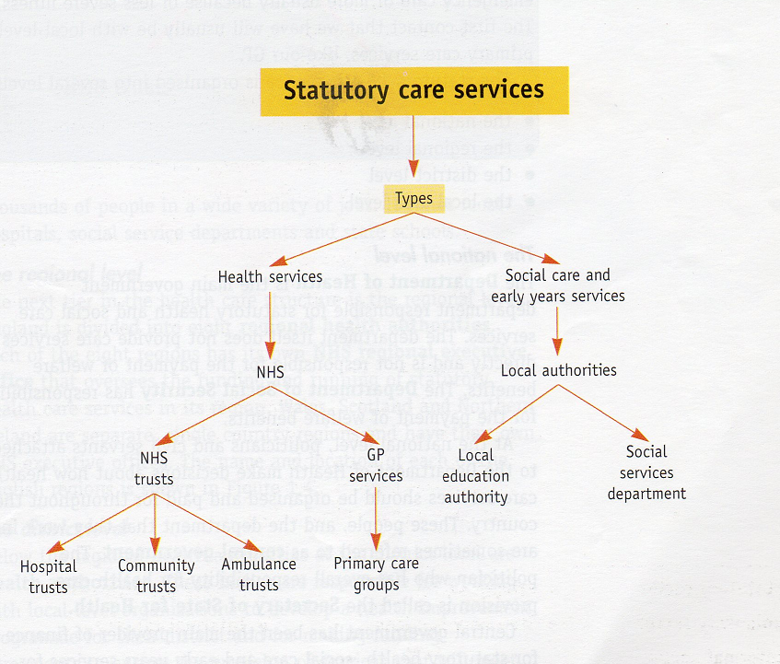
Structure of Statutory care services in the United Kingdom

