

Module: Changemakers: Creativity and Value Creation Professions (BMHP5014).
Student Name: Adriana Ilona Rana Ryng.
Student Number: 2430426.
Lecturer’s Name: G1: Soban Sadiq.

Assessment Component 1:
Online Portfolio of Set Exercises.

Table of contents: .1

Introduction…………………………………………………………………..2
Task 1: Defining Key Concepts in Practice……………………………..2
Innovation……………………………………………………………………..2
Creativity………………………………………………………………………2
Value Creation………………………………………………………………..2
Change…………………………………………………………………………3
Task 2: Mind Map Description……………………………………………..3
Task 3: Self-Reflection of Group Activity………………………………..4
Task 4 – Case Study Analysis of a UK Innovation……………………..4
Task 5 – Research Task……………………………………………………..4
Task 6 – Exploring Digital Innovation in Health and Social Care……5
6.1. Wearable Health Technologies……………………………………….5
6.2. Electronic Health Records (EHRs).................................................5
6.3. Preventative Care and Health Promotion…………………………..6
Task 7 – Understanding the NHS Leadership Framework……………6
7.1. Summary of the NHS Leadership Framework (~150 words)........6
7.2. Leadership Behaviour to Encourage Creativity (~100 words).....6
Task 8 – Self-Reflection Journal Entry (~150 words)...........................6
Task 9 - Reference List (UWTSD Harvard Style)...................................7/8

Introduction
This online portfolio critically appraises the concepts of innovation, creativity, value creation, and change within the context of health and social care. Through a series of tasks, reflective accounts, and case study analyses, this portfolio sheds light on how creativity and leadership can be leveraged to improve care services and, consequently, patients’ quality of life. This portfolio presents evidence highlighting the significance of innovation-driven, cost-effective, and high-quality care in achieving transformational change within the United Kingdom's health and social care system.
Task 1: Defining Key Concepts in Practice (~350 words).
Innovation
‘Innovation’ can be defined as the successful implementation of a new idea that creates value for individuals, organisations, and society (West and Farr, 1990). The health and social care sector cannot afford to stand still given the rising complexity of social work, an ageing population, and diverse patient needs. For example, heart failure remote monitoring technology is innovative because it helps clinicians track their patients' vital signs, thus preventing avoidable hospital admissions.
Rogers’ (2003) diffusion theory illustrates the communication and adoption process of innovations and new ideas over time.
Creativity
'Creativity' refers to the ability to produce novel, unique, and valuable ideas within a particular social setting and conceptualisation (Amabile, 1996). In the context of social care, creativity helps personal carers address limited resources to respond to service users’ needs. For instance, careers can use music and arts therapies to engage older people with dementia.
Amabile’s (1996) componential theory of creativity explains how ideas are conceptualised. According to the theory, ideas emerge when creative practitioners combine domain-specific skills and knowledge with creative abilities and motivation to achieve specific goals.

Value Creation
‘Value’ creation is a process of responding to patients’ needs in health care by balancing health-care-related outcomes and costs associated with care provision (Porter, 2010). In other words, value creation is essential for making health care affordable, reliable, and high-quality since most care settings have limited resources. For example, community multidisciplinary rehabilitation teams embody value creation by enhancing post-surgery rehabilitation to shorten hospitalisation while also improving the patient’s quality of life.
According to the value creation theory, value is determined by the ratio between the cost of a specific service and its impact on patients’ health (Porter, 2010).

Change
‘Change’ is defined as a process of adjusting individual, gr and organisational practices and perspectives to achieve specific goals (Burnes, 2017). Change is significant in the context of health and social care because professionals need to update their practices to follow updated policies and guidelines. For example, the transition from paper-based medical records to their electronic version required developing new practices to ensure proper storage and accessibility. In this case, Lewin’s (1995) change model can be used to facilitate the process by first understanding existing practices, then moving to change, and finally evaluating whether the proposed intervention works.

Task 2: Mind Map Description (130 words)

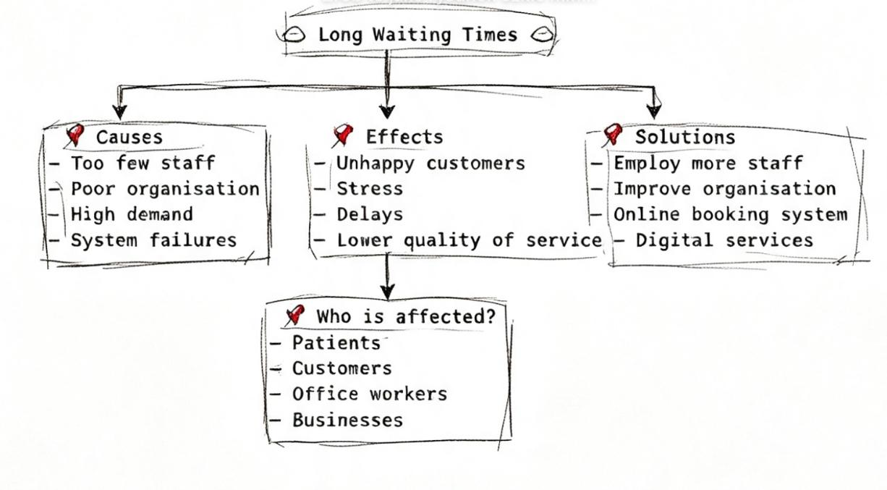

Explanatory Text

Long waiting times for urgent and emergency care represent a critical issue that threatens patients’ safety. The Systems Thinking Approach (Meadows, 2008) helps us understand the complex nature of this problem. In cases when waiting times are too long, it is not the emergency wards that fail to deliver care but the whole care system. This is because social care and NHS hospital beds are often occupied by patients with dementia and frailty, thus blocking new admissions of those who need urgent care. In addition, patients often become frailer and have more complex care needs due to long waiting times. The situation causes a significant strain on carers, increasing the likelihood that they will fail to address the patients’ needs. Therefore, it is important to resolve the problem of long waiting times for NHS services.

Task 3: Self-Reflection of Group Activity (~200 words).

I participated in a group activity to explore divergent and convergent ways of thinking about solutions and issues to service user careers. Divergent thinking is a “process of thinking that generates multiple possible ideas or solutions to a problem or question” (Guilford, 1967, p. 3). In contrast, convergent thinking refers to the process of narrowing down the range of possible options to identify the best solution (Guilford, 1967). Analysing my group’s experience, I have chosen’ Gibbs (1988) reflective cycle. To begin with, my group did not feel confident about caring for people with complex social needs. At the same time, we were excited about the task, so we started thinking divergently to generate a range of ideas to address the issue.
As we progressed to the convergent stage, we faced difficulties since the group members insisted on their ideas. After the evaluation phase, I realised that the problem was that my team did not adhere to a particular method to assess. At this stage, I suggested using a pros-and-cons matrix to do so. Then, we easily reached a consensus and identified the best option. As a member of the group, I realised that divergent approaches are not sufficient to accomplish tasks because they require convergent thinking to reach a consensus.

Task 4 – Case Study Analysis of a UK Innovation (~200 words)
The rapid development of virtual wards in the UK NHS is a creative response to the growing number of hospitalised patients in acute acute care hospitalscase study mentions that the initiative was implemented in response to the increased number of emergency admissions, which put an incredible strain on NHS hospitals. Older people who spend too long in hospitals face many health challenges, ranging from hospital-acquired infections to delirium. Virtual awards have integrated technology to monitor patients at their home to help NHS hospitals up beds. In this case, creativity was essential to make the shift from traditional inpatient wards to a virtual setting. By doing so, clinicians successfully addressed two key areas of value creation: patients’ health outcomes and the overall costs of care. For example, the study states that patients can experience the same level of care in a hospital in the comfort of their own home. Virtual wards are an effective example of Rogers’ (2003) diffusion theory because they were rapidly adopted by clinicians since the new approach appeared to be compatible with their practices. Virtual awards are highly innovative because they can be quickly implemented in other care settings, including social care, by leveraging existing digital technologies.

Task 5 – Research Task (~200 words).
Staff stress, fatigue are critical issues affecting health and social care workers worldwide. Therefore, this task aimed to conduct a critical appraisal of two journal articles to explore this problem’s key contributors. Both studies argue that stress and fatigue result from healthcare-related issues instead of healthcare employees’ individual characteristics.
Montgomery et al. (2019) contend that staff experiences working in hostile environments contribute to health-care professionals’ exhaustion.
Hall et al. (2016), in turn, suggest that operational factors such as excessive workloads, understaffing, and physical demands are key contributors to staff fatigue.
The two studies are aligned with the main aspects of Maslach’s burnout theory that explains the development of fatigue as a result of personal and working environments. The study by Montgomery et al. (2019) focuses on the interpersonal contributors to staff fatigue, whereas the article by Hall et al. (2016) highlights operational factors that lead to health-care professionals’ exhaustion. Thus, the two articles offer significant insights into the core sources of stress in the context of health and social care.

Task 6 – Exploring Digital Innovation in Health and Social Care (~420 words)
1. Wearable Technologies

Wearable health technologies offer numerous benefits for patients with chronic illnesses. For example, smartwatches and glucose monitors allow patients to monitor their vital signs to manage their conditions without going to the hospital. For example, patients with diabetes can use continuous glucose monitors to assess their blood sugar levels. According to the Technology Acceptance Model (TAM), patients are likely to adopt the proposed technology if they perceive it as valuable and easy to use. In this case, patients can use the data captured at home to make informed decisions on their health care without going to the hospital (Ajana, 2021).

2. Electronic Health Records

Electronic health records offer various benefits, but the most significant advantage is their ability to improve interpersonal communication. InIndeed, the ability to access EHRs in various care settings ensures that all clinicians adhere to the same care pathway. For example, when a patient goes from their primary career to the hospital, clinicians can rely on EHRs to access the patient’s health data, including medical records and allergies. According to the TAM, EHRs ensure that patients receive appropriate care while making their health information easily accessible to avoid medication errors (Buntin et al., 2011).

3. Preventative Care and Health Promotion

Preventative care and health promotion can also benefit from digital technologies, such as health apps used in m-Health to promote health and wellbeing. For example, the NHS Couch to 5K app allows individuals to gradually increase their walking and jogging activities to improve their health. In this case, the application follows the TAM model by being user-friendly,thus ensuring that the end-users adopt the technology without experiencing any barriers (Whitelaw et al., 2020). In addition, the app helps users achieve their health goals without going to the hospital because it promotes preventative care and wellness.

Task 7 – Understanding the NHS Leadership Framework (~350 words)
1. Summary of NHS Leadership Framework (~150 words)

The NHS Leadership Framework highlights the leadership behaviours and skills needed at all levels to achieve sustainable and high-quality care in clinical and social settings and offers an in-depth look at what excellent care looks like while also offering guidance on how to deliver it effectively (NHS Leadership Academy, 2014). The model is based on five key areas: demonstrating personal qualities, working with others, managing services, improving services, and setting direction.
I believe that the NHS Leadership Framework is critical to achieving high-quality care because leaders play a key role in determining organisational effectiveness in terms of employees’ performance, patient outcomes, and work environments (West et al., 2018). The framework encourages empowering leaders who can meet an organisation's needs while also being aware that they can influence change at all levels/organisation.

2. Behavioural to encourage creativity (~100 words)

I have selected the behaviour “inspiring shared purpose” that refers to encouraging care workers to achieve the best possible outcomes for their patients. A leader can inspire shared purpose among care workers to encourage creativity by convincing them to make a difference in their practice. For example, the leader can encourage his team to come up with a new approach to patient discharge to support them in identifying the best community.This bebehaviour aligns with transformational theory, which argues that leaders can effectively change agents by encouraging their employees to think creatively and innovatively. For example, a leader can inspire their team by promoting their vision and mission to help them achieve collective goals.

Task 8 – Self-Reflection Journal Entry (~150 words)
Reflective account using Gibbs’ Reflective Cycle
I have gained immense insights into such crucial aspects of health and social care as innovation, creativity, value creation, and change. I have realised that these concepts are essential to delivering high-quality care while responding to the organisation's needs. For example, Task 4 helped me to understand how virtual wards can help deliver cost-effective care while also promoting patients’ wellbeing. At the same time, Task 3 offered a comprehensive understanding of divergent and convergent approaches to problem-solving. Throughout the course, I have also learned the importance of leadership in health and social care settings. For instance, the research tasks have shown that staff fatigue significantly influences the quality of care, emphasising the role of NHS leaders in ensuring their employees are not overwhelmed by their responsibilities. With these insights in mind, I will continue to encourage my future colleagues to be transformational leaders who empower care workers while also promoting their professional growth.

Task 9 - Reference List (UWTSD Harvard Style)

Ajana, B. (2021) Metric Life: Digital Culture and the Quantified Self. London: Palgrave Macmillan.
Amabile, T.M. (1996) Creativity in Context: Update to the Social Psychology of Creativity. Boulder: Westview Press.
Bass, B.M. and Avolio, B.J. (1994) Improving Organizational Effectiveness Through Transformational Leadership. Thousand Oaks: Sage Publications.
Buntin, M.B., Burke, M.F., Hoaglin, M.C. and Blumenthal, D. (2011) 'The benefits of health information technology: a review of the recent literature shows predominantly positive results', Health Affairs, 30(3), pp. 464-471.
Burnes, B. (2017) Managing Change. 7th edn. Harlow: Pearson Education.
Davis, F.D. (1989) 'Perceived usefulness, perceived ease of use, and user acceptance of information technology', MIS Quarterly, 13(3), pp. 319-340.
Gibbs, G. (1988) Learning by Doing: A Guide to Teaching and Learning Methods. Further Education Unit. Oxford: Oxford Polytechnic.
Guilford, J.P. (1967) The Nature of Human Intelligence. New York: McGraw-Hill.
Hall, L.H., Johnson, J., Watt, I., Tsipa, A. and O’Connor, D.B. (2016) 'Healthcare Staff Wellbeing, Burnout, and Patient Safety: A Systematic Review', PLoS ONE, 11(7), e0159015.
Meadows, D.H. (2008) Thinking in Systems: A Primer. White River Junction: Chelsea Green Publishing.
Montgomery, A., Panagopoulou, E., Esmail, A., Richards, T. and Maslach, C. (2019) 'Burnout in healthcare: the case for organisational change', British Medical Journal (BMJ), 366, p. l4774.
Montgomery, A., Todorova, A., Baban, A. and Panagopoulou, E. (2019) 'Improving healthcare through organizational research: Highlighting the role of leadership and culture', Journal of Health Organization and Management, 33(3), pp. 270-281.
NHS England (2023) Virtual Wards: Guidance and Service Models. London: NHS England.
NHS Leadership Academy (2014) Healthcare Leadership Model. Leeds: NHS Leadership Academy.
Porter, M.E. (2010) 'What is value in health care?', New England Journal of Medicine, 363(26), pp. 2477-2481.
Rogers, E.M. (2003) Diffusion of Innovations. 5th edn. New York: Free Press.
UK Parliament (2025) Virtual Wards and Hospital at Home (POSTnote 744). Parliamentary Office of Science and Technology. London: UK Parliament.
West, M.A. and Farr, J.L. (1990) Innovation and Creativity at Work: Psychological and Organizational Strategies. Chichester: John Wiley & Sons.
West, M.A., Bailey, S. and Williams, E. (2018) The NHS Leadership Framework and Workforce Wellbeing. London: The King's Fund.
Whitelaw, S., Mamas, M.A., Topol, E. and Van Spall, H.G. (2020) 'Applications of digital technology in COVID-19 pandemic response and preventative health', The Lancet Digital Health, 2(8), pp. e435-e440.

