Building a Professional Identity for Sustainable Employment in Health and Social Care

Pursuing a Career as a Medical Support Worker in the UK

Module Code and Title:
BMHP5015 – Changemakers: Building your Personal Brand for Sustainable Employment

Student Name: Majida Waseem
Student Number: 2321115

Submission Date: 4 March 2026

Word Count: ~2000 words

Table of contents

Introduction 3
Job Advertisement and Role Overview 4
Employability Skills Required for a Medical Support Worker 5
Communication Skills 5
Teamwork and Interpersonal Skills 6
Emotional Intelligence 6
Resilience and Stress Management 6
Problem-Solving and Critical Thinking 6
Digital and Technological Skills 7
Evaluation of My Own Skills 7
Strengths 7
Areas for Improvement 8
Support and Professional Development 8
Action Plan and Timeline 8
Short-Term Goals (0–1 year) 8
Medium-Term Goals (1–3 years) 9
Long-Term Goals (3–5 years) 9
Building My Personal Brand 10
Promoting My Professional Identity 11
Building a Professional Network 12
References 15

Introduction
Social care is the support people need when they experience difficulties in their lives. Among the various positions in the field, the Medical Support Worker (MSW) role is a key part of all clinical teams and is integral to the delivery of care that prioritizes patient safety and compassion. Medical Support Workers help nurses and doctors and provide patient care directly, observing patients, work in clinical areas, and assisting with administration either in hospitals or in community healthcare units. With the growing demand for healthcare services and workforce shortages in U.K., roles such as MSWs are becoming increasingly vital (Skills for Care, 2024) supporting within the National Health Service (NHS) and allied healthcare providers.
This report has been written to analyze the employability skills pertinent to the Medical support worker role and assess my own skills in relation to this. It further outlines an action plan and timescale to accomplish this career aim. The report also outlines how establishing a personal brand, developing a professional identity and cultivating professional networks can facilitate effective job searching within the UK health and social care environment.

Job Advertisement and Role Overview
For this review, a Medical Support Worker post for the NHS was taken into consideration. Generally, such jobs are responsible for duties like helping patients and monitoring their condition, taking vital signs, assisting nurses, cleaning, and facilitating patients with nursing staff (NHS Jobs, 2025).
The role specification states that as a Medical Support Worker you will need to be compassionate, a team player, good communicator and able to work in a high pace health care environment. Applicants usually need to have some sort of applicable healthcare training or experience, such as a care certificate, first aid training, or work in health and social care fields. Skills that can be applied to everything from customer service to emergency room medicine, such as a knack for problem solving or the ability to stay cool under pressure, are also sought after by managers.
The growing need for healthcare professionals is what makes this job so relevant. It has been reported that the UK health and social care system is under considerable strain from unprecedented a shortage of workforce - with more than 150,000 vacancies in adult social care in England alone (Skills for Care, 2024). As you will have seen in lecture content there were a range of factors for these shortages including, Brexit, increasing demand for services, and leaving the workforce. Therefore jobs like the Medical Support Worker are key to opening doors for aspiring healthcare professionals and for supporting the strength of the healthcare system.

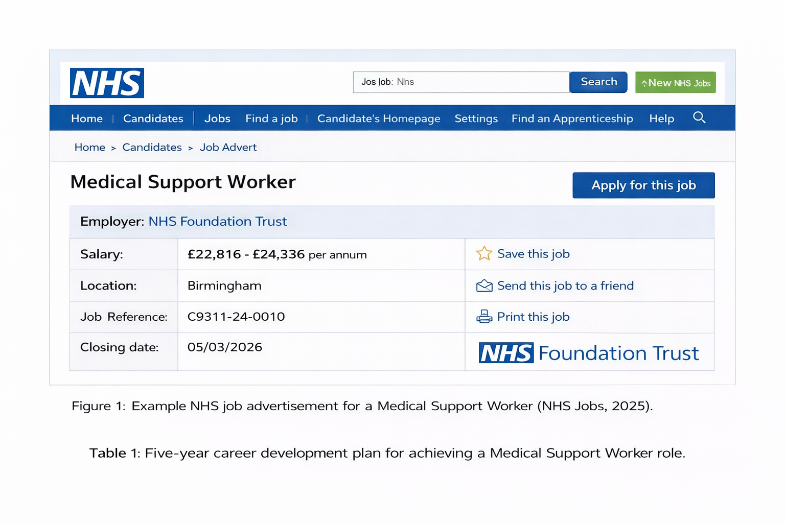

Employability Skills Required for a Medical Support Worker
Employability skills are core skills that are prerequisites for an individual to work proficiently in any working environment. And yet, transformational and transactional skills were equally important in technical qualification for employers in the healthcare and social care (Prospects, 2023).

Communication Skills
Good-to-excellent communication is consistently cited as one of the most important skills a Medical Support Worker should have. You would also have contact with patients, their families, nurses and other medical staff in this role. Good communication contributes to accurate information exchange and high-quality patient care. Communication is important in establishing trust and emotional support in that provides comfort to patients who are often in a vulnerable or fearful state.

Teamwork and Interpersonal Skills
Services in healthcare are heavily dependent on multi-professional working. Medical Support Workers have a unique opportunity to work collaboratively with nurses and doctors and impact the overall working environment. Teamwork guarantees an effective and safe coordination of patient care.

Emotional Intelligence
Emotional intelligence is the capacity to be aware of, control, and express one's emotions, and to handle interpersonal relationships judiciously and empathetically. In healthcare, it allows professionals to increase their response ability towards patients’ needs and care for them humanely (Serrat, 2017). Empathy is central to health and social care practice and is closely associated with emotional intelligence.

Resilience and Stress Management
Healthcare settings may be emotionally challenging and stressful. You need to be able to handle stressful situations such as medical emergencies, patients in pain and high volume of work as a Medical Support Worker. Building resilience enables healthcare workers to flourish and serve a lifetime in the field.
.

Problem-Solving and Critical Thinking
Health care workers are often faced with surprise events that demand decisions on the spot. Problem-solving enables MSWs to recognize problems, raise concerns with senior staff and liaise with them regarding solutions which benefit the patient.

Digital and Technological Skills
Digital technologies, including electronic health records (EHRs) and telehealth systems, are now integral to modern healthcare. Health care workers, therefore, need to be competent in using digital tools to capture patient data and to assist clinical work. So as healthcare becomes more digital, technological know-how is an increasingly essential employability skill.

Evaluation of My Own Skills
Self-assessment is an important process in professional development as it allows individuals to identify strengths and areas requiring improvement.

Strengths
One of my strongest assets is the ability to communicate. With academic work and group work under my belt, I am now capable of communicating in a respectful and clear manner to others. This is a necessary skill in healthcare settings, as the outcome of patients can be influenced by the level of precision in information exchange.
Working under pressure is another of my strengths. Teamwork in the form of group assignments during my degree is where I have gained strong ties and learned what makes a team successful in reaching common objectives. These are skills that are uniquely suited to the Team-based environment within which healthcare is provided.
I also think I have a lot of empathy and emotional awareness which are important aspects of emotional intelligence. These characteristics enable the providers to identify patient needs and deliver empathetic care.

Areas for Improvement
But there are a few things I need to improve on. "I think I'd also need to get some experience in healthcare, working and/or volunteering in a care environment." Getting practical experience would help give me more confidence when I actually talk to patients and apply the theoretical knowledge to real-life situations.
Also, I think it would be interesting to learn more about the healthcare field and to understand some of the procedures: patient monitoring, infection control... Taking suitable training courses and health care qualifications will help to plug these gaps.

Support and Professional Development
In order to build these skills, I will be able to receive assistance from academic advisers, medical professionals, and career counselors. Engaging in reflective practice models such as the Gibbs' Reflective Cycle can further enable me to reflect on experiences and enhance my professional development.

Action Plan and Timeline
To achieve the goal of becoming a Medical Support Worker, a structured action plan is necessary.

Short-Term Goals (0–1 year)
In the near future, I'll be doing some appropriate training courses i.e. Care Certificate, First Aid, Safeguarding. These certifications will give the baseline knowledge needed to work in healthcare.
I plan to get some experience by volunteering, in healthcare or community assistance groups. As well as this volunteering can give me practical experience for the jobs I want to do and also show that I am serious about a career in healthcare.

Medium-Term Goals (1–3 years)
I am looking to work in a healthcare related job at the bottom level if that makes sense, like a care worker or healthcare assistant within the next 3 years. This experience will enable me to acquire clinical skills and knowledge.
In the meantime, professional skills like communication, team work, and digital health will continue to be cultivated.

Long-Term Goals (3–5 years)
In the future, I want to get a Medical Support Worker job in the NHS. This will enable me to make a difference to patient care and also pursue my professional development in the field of health care. Further long term progression may involve training to become a nurse or other specialist healthcare professional.

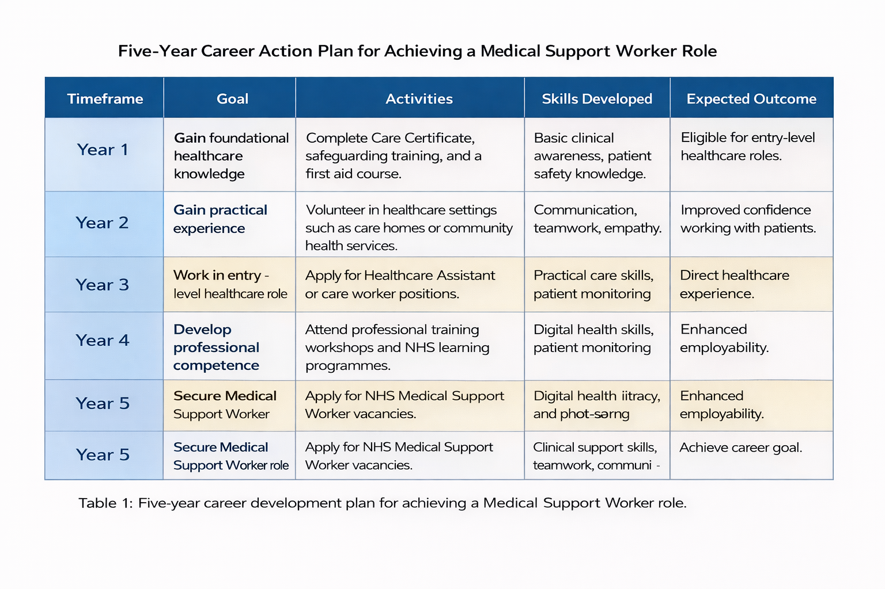

Building My Personal Brand
Creating a strong personal brand is crucial for career progression in the current labour market. A personal brand encompasses who you are as a professional, what you value, what skills you have, and what makes you different from other people in your field. There is a good reason why with potential employers in the health and social care sector a robust personal brand is so crucial, they are looking for people who can convey that they know what professionalism in care, compassion and Patient is at the heart of what we do.
In order to develop my personal brand in healthcare, I will apply myself by exhibiting my core principles of empathy, dependability, and work ethic. They are considered very valuable qualities in NHS and other healthcare services, as they promote good patient outcomes and successful team working. Having a professional online presence is another element of personal branding. They can display their qualifications, experience, skills and career interests on their profile on platforms like LinkedIn. As the lecture pointed out, LinkedIn is a great place to build your network, develop professionally and find employment in the health and social care industry.

Consistency and genuineness also matter when building an online reputation. Using clear, consistent, and careful language in the dissemination of professional information online may increase one's credibility and visibility to potential employers. And to get an edge in the field of medicine, insights on health care issues, training experience, volunteer work, and professional accomplishments can also indicate continued professional growth and dedication.
I am confident that by building my personal brand through professional networking, ongoing learning and a robust online presence that I can be a persuasive and energetic candidate for the position Medical Support Worker in the UK Healthcare system.

Promoting My Professional Identity
Building a professional identity is the process of effectively communicating one’s skills, experiences, and career goals to potential employers. In the health and social care sector, a strong professional identity helps demonstrate commitment to patient care, ethical practice, and professional development.
An important step in promoting my professional identity is developing a well-structured CV and cover letter tailored specifically for healthcare roles. These documents allow me to highlight relevant transferable skills such as communication, empathy, teamwork, and resilience. Demonstrating these competencies can help show employers that I possess the personal qualities required for a Medical Support Worker role.
Maintaining an updated LinkedIn profile is also an important strategy. With the advancement of digital technologies, online presence has become an essential part of career development. Many employers now use professional networking platforms to identify potential candidates, review professional achievements, and advertise job opportunities.
In addition to LinkedIn, other social media platforms such as Facebook and Instagram can also contribute to professional identity when used appropriately. For example, following healthcare organisations, professional groups, and medical pages can help individuals stay informed about industry developments and training opportunities. However, it is important to maintain professionalism and ensure that online content reflects responsible and ethical behaviour.
Furthermore, attending professional development courses, workshops, and healthcare conferences will allow me to continue strengthening my professional identity while demonstrating commitment to lifelong learning and career progression.

Building a Professional Network
Networking is an effective way to get information about job opportunities and advice in the field of health and social care.
Build your professional network As you cultivate relationships with healthcare professionals, lecturers and mentors, you'll gain valuable insight into potential career pathways and what the industry expects of you. Networking can take place at professional events, on-line, or through volunteering.
Professional organizations, health care conferences, and internet sites also offer opportunities to meet professionals in the field. Network Indeed, networking during a job search can help give advice, uncover job leads and keep you up to date on what's happening in healthcare.

Conclusion
The Medical Support Worker is a key delivery role within the UK health and social care system that offers a satisfying career pathway. The report has considered what are the key employability skills for this job e.g. communication, teamworking, emotional intelligence, resilience, digital competence. They are the abilities that allow healthcare professionals to deliver quality care to their patients while collaborating with diverse, multidisciplinary teams.
From my evaluation of myself I discovered I had many strong points like communicating, being empathetic towards people, and working a team but also many areas where I could improve like working more in practical healthcare and learning more clinically. An agreed action plan was formulated to facilitate my professional development and to realise my aspiration of working as a Medical Support Worker within the NHS.
It is also noted in the report the value of a strong personal brand, a professional identity and professional networks. Such strategies may improve employability and long-term career success in healthcare.
In general, going after a Medical Support Worker career goes hand in hand with my own values of compassion, service and ongoing education.” As part of his career vision, through building the necessary skills and professional identity, he wishes to make a positive impact on healthcare and to establish a meaningful and enduring career in health and social care.

References
- Department of Health (2013) Wellbeing and health policy. London: UK Government.
- Herman, H. et al. (2011) ‘What is resilience?’, Canadian Journal of Psychiatry, 56(5), pp. 258–265.
- LinkedIn (2024) Workplace learning report. Available at: https://learning.linkedin.com.
- NHS Jobs (2025) Medical Support Worker job description. Available at: https://www.jobs.nhs.uk
- Office for National Statistics (2025) UK labour market overview. Available at: https://www.ons.gov.uk
- Prospects (2023) Graduate employability skills. Available at: https://www.prospects.ac.uk
- Serrat, O. (2017) Understanding and developing emotional intelligence. Singapore: Springer.
- Skills for Care (2024) State of the adult social care sector and workforce. Available at: https://www.skillsforcare.org.uk
- World Economic Forum (2023) Future of jobs report. Available at: https://www.weforum.org
- NHS England (2023) NHS long term workforce plan. Available at: https://www.england.nhs.uk

