Qualification: CIPD Diploma in Applied Human Resources

Module Name: Contributing to Management of Change

Word Count Assignment 1: 1067
Word Count Assignment 2: 911
Word Count Assignment 3: 532

Student Name: Jade Bowen
Student Number: 2014437
CIPD Membership Number: 5738593

By signing below, I confirm that the work/evidence presented is my own, unaided work. I understand the regulations pertaining to candidate malpractice and the action that may be taken as a result.

Signed: J.Bowen
Date: 21/12/2021

Evidence Matrix
Candidate name: Jade Bowen |  |  |  |  | CIPD Membership/registration No.:  5738593
Qualification title: CIPD Diploma in Applied Human Resources |  |  |  |  | Unique Learner No. (ULN):  2014437
Unit code | Unit title |  | Assessment criteria no. | Evidence description | Evidence reference number |  | Assessor  initials | I/V initials if sampled
5AMOC | Contributing to the Management of Change |  | LO1 | Snapshot – Moving hours purpose – business intranet | EV1.1
5AMOC | Contributing to the Management of Change |  | LO1 | Snapshot – Heatmap pre-change | EV 1.2
5AMOC | Contributing to the Management of Change |  | LO1 | Document – appointing change champion meeting | EV 1.3
5AMOC | Contributing to the Management of Change |  | LO1 | Document – appointing change champion meeting | EV 1.4
5AMOC | Contributing to the Management of Change |  | LO1 | Snapshot - Moving Hours Toolkit | EV 1.5
5AMOC | Contributing to the Management of Change |  | LO1 | Snapshot – Payroll overspend | EV 1.6
5AMOC | Contributing to the Management of Change |  | LO1 | Snapshot – sales LFL growth | EV 1.7
5AMOC | Contributing to the Management of Change |  | LO1 | Document - Change plan | EV 1.8
5AMOC | Contributing to the Management of Change |  | LO1 | Snapshot – email with line manager | EV 1.9
5AMOC | Contributing to the Management of Change |  | LO1 | Document – conversation with colleague | EV 1.10
5AMOC | Contributing to the Management of Change |  | LO1 | Document – availability form | EV 1.11
5AMOC | Contributing to the Management of Change |  | LO1 | Document – communication plan | EV 1.12
5AMOC | Contributing to the Management of Change |  | LO2 | Gantt chart | EV 2.1
5AMOC | Contributing to the Management of Change |  | LO2 | Document – meeting with union rep | EV 2.2
5AMOC | Contributing to the Management of Change |  | LO2 | Document – meeting with change champions | EV 2.3
5AMOC | Contributing to the Management of Change |  | LO2 | Document - review meeting with colleague | EV 2.4
5AMOC | Contributing to the Management of Change |  | LO2 | Document – final meeting with colleague | EV 2.5
5AMOC | Contributing to the Management of Change |  | LO2 | Snapshot – email with Operations Partner | EV 2.6
5AMOC | Contributing to the Management of Change |  | LO2 | Snapshot – email with line manager confirmation | EV 2.7
5AMOC | Contributing to the Management of Change |  | LO3 | Snapshot – customer feedback | EV 3.1
5AMOC | Contributing to the Management of Change |  | LO3 | Snapshot – customer feedback | EV 3.2
5AMOC | Contributing to the Management of Change |  | LO3 | Snapshot – colleague survey feedback | EV 3.3
5AMOC | Contributing to the Management of Change |  | LO3 | Snapshot – heatmap post change | EV 3.4
5AMOC | Contributing to the Management of Change |  | LO3 | Snapshot – payroll cost savings | EV 3.5
5AMOC | Contributing to the Management of Change |  | LO3 | Snapshot – colleague feedback | EV 3.6
5AMOC | Contributing to the Management of Change |  | LO3 | Snapshot – email with HR manager | EV 3.7
Candidate declaration:
- I confirm that the work/evidence presented for assessment is my own unaided work.
- I have read the assessment regulations and understand that if I am found to have ‘copied’ from published work without acknowledgement, or from other candidate’s work, this may be regarded as plagiarism which is an offence against the assessment regulations and leads to failure in the relevant unit and formal disciplinary action.
- I agree to this work being subjected to scrutiny by textual analysis software if required.
- I understand that my work may be used for future academic/quality assurance purposes in accordance with the provisions of the Data Protection Act 1998.
- I understand that the work/evidence submitted for assessment may not be returned to me and that I have retained a copy for my records.
- I understand that until such time as the assessment grade has been ratified through internal and external quality assurance processes it is not final.
Signature: |  | J.Bowen |  |  |  | Date: | 21/12/2021

Contents

Page No. | Content
4-5 | LO1
6-15 | LO1 Evidence
16 | LO1 References
17-18 | LO2
19-24 | LO2 Evidence
25 | LO2 References
26 | LO3
27-28 | LO3 Evidence
29 | LO3 References

Contributing to Change Management
LO1 – Planning for the implementation of change processes within an organisation
Organisational change is a vital process which requires businesses to adapt, grow and transform, in order to stay relevant and competitive (CIPD, 2021). Organisational change is usually driven by internal and external forces impacting the business model and how they operate (Hodges, 2021).
Due to changes in social and economic factors such as change in shopping habits, business rates, and local factors, Tesco are continually reviewing how they operate to remain competitive and to better serve their customers (EV1.1). Due to local impacts of a competitor closing down within the area, I needed to update my stores’ trading patterns and move colleague’s hours around to suit the new demands of the business.
The aim of this change was to realign colleague’s working hours with customer shopping trends, which is indicated by a ‘Heat Map’ highlighting where there were too many or too few colleagues working at the required times indicated by the stores trading pattern and processes (EV1.2). The change would enable colleagues to serve customers at the right time, improve customer service and reduce overtime spend that was originally covering colleague shortfall shifts, which in the long run would support the profitability of the business.
The change would affect the majority of colleagues within the store, as I would need to consultant each colleague and look at moving their shifts inline to where the business requires them to work. The ‘heat map’ would provide colleagues with a clear picture of where the hours were not in the right place and where we required additional staff to the days/times required.
Additionally, the change would also affect customers as they would be benefiting from improved service, and able to complete their shopping trip as colleagues would be working the right hours to complete the right tasks at the right time.
Change agents play an important role in the success of organisational change, as they support the relationship and communication between managers and colleagues (CIPD, 2018) . Therefore, I asked two people to be change champions to support the change process, to which they both agreed (EV 1.3)(EV 1.4). The two champions would then provide updates and any information, and support with any queries or concerns.
Understanding each individuals support needs and preferred communication methods is essential to building commitment, engagement, and motivation from colleagues (Hughes, 2010). I firstly spoke to all colleagues informing them of the proposed change, and if they had any questions or concerns. From these conversations it was clear that the majority of colleagues required regular communication and updates. Due to the emotion of the change, I decided it was best that going forward colleagues would be updated individually to allow them to feel supported and comfortable to ask questions or show emotion.
To support me with the change initiative I used my company’s Moving Hours Toolkit, which provides a detailed step-by-step guide through the moving hours process (EV 1.5).
I also provided evidence of the store’s current payroll Q3, highlighting an overspend of 3.7k vs budget (EV 1.6) which highlights my payroll budget and allowed contracted hours for the store, allowing me to make the most effective changes without overspending my budget.
Additionally, using sales data to show an increase in LFL sales supported my argument for my proposal, as this highlighted the growth in trade (EV 1.7) and the need for the change.
Change plan
A change management plan acts as a roadmap, detailing a step-by-step approach towards delivering successful change, whilst minimising impacts and supporting employees through the process (AIPM, 2020).
I devised a change plan (EV 1.8) breaking down each section into planning, implementing, and sustaining stages. I outlined the reason for change, three proposed objectives and resources I would use to support me and the process. I also included statistics showing the current ‘red’ hours along with a target I would achieve once the change was complete. Additionally, I included annual estimated savings to highlight the cost saving this plan would achieve.
When designing a change plan, organisations must consider any potential risks which may hinder the process (CIPD, 2021). I captured potential risks I feel may arise, such as colleagues unhappy moving their shifts and may leave for alternative jobs, reduced flexibility, and for the change to be successful it requires full team engagement which can causes issues if individuals are not committed. However, the benefits being colleagues working the hours needed, reduced overtime spend, and tasks can now be completed on time by the right people.
I provided clear timelines as to when each step of the process would be achieved, including who the main stakeholders are and communication strategies to ensure the right messages are delivered to the right people.
To ensure sustainability of the change, I will seek customer and colleague feedback and hold informal conversations with colleagues to understand how they are feeling. Feedback will also highlight whether the change has landed successfully and whether future changes are needed, along with improved KPI’s and less payroll spent on overtime to cover shortfall shifts.
Before I communicated the changes to instore colleagues, I sent my change plan to my manager for their approval to which he authorised (EV 1.9). I was then able to inform colleagues individually of the proposed change in more detail, providing them with copies of the heat map, increased LFL sales and what the process would look like. These conversations were documented on a ‘Let’s Talk’ form (EV 1.10). I then issued each colleague with an ‘Availability form’ for them to capture the days and times they were available to work – this would give me clarity as to who could work when (EV 1.11).
I re-emphasised the meetings would be two-way to allow them to ask questions, give opinions or provide feedback and I would work with the colleagues to incorporate any other commitments they have outside of work which may be affected by changing their hours.
However, it was important I spoke to each colleague as soon as possible to eliminate any incorrect information passed around, or for any worries to evolve.
According to (SHRM, 2018) carefully planned communication plans are crucial to the change process and when designed right can support the delivery of key messages. Therefore, to ensure all parties were communicated to clearly and regularly, I created a communication plan, outlining the stakeholders, the key messages, and frequency as to when each individual would be communicated to (1.12).

LO1 Evidence
EV 1.1 – Moving Hours Purpose

EV 1.2 – Heat Map Pre-change
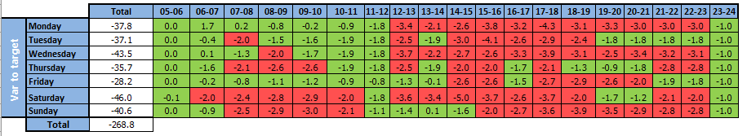
EV 1.3 – Appointing change champion document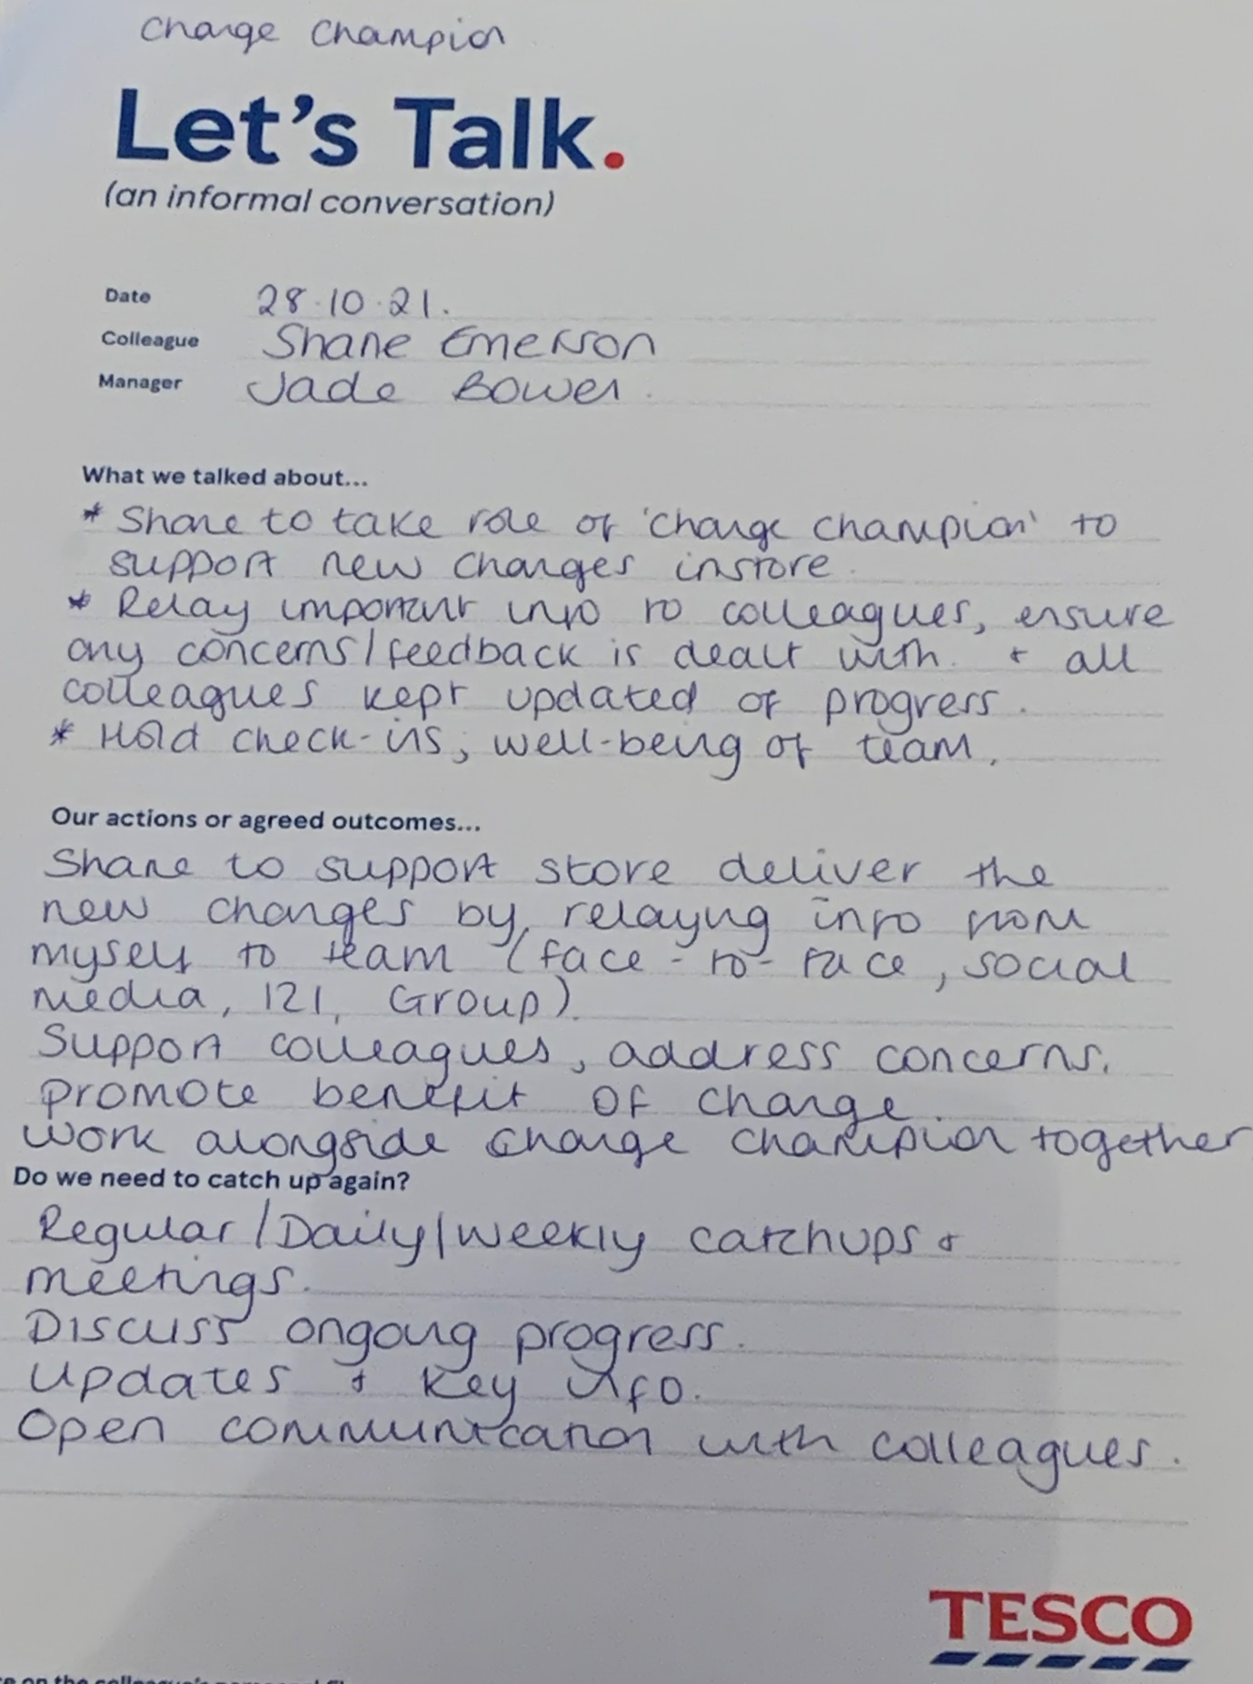

EV 1.4 – Appointing change champion document
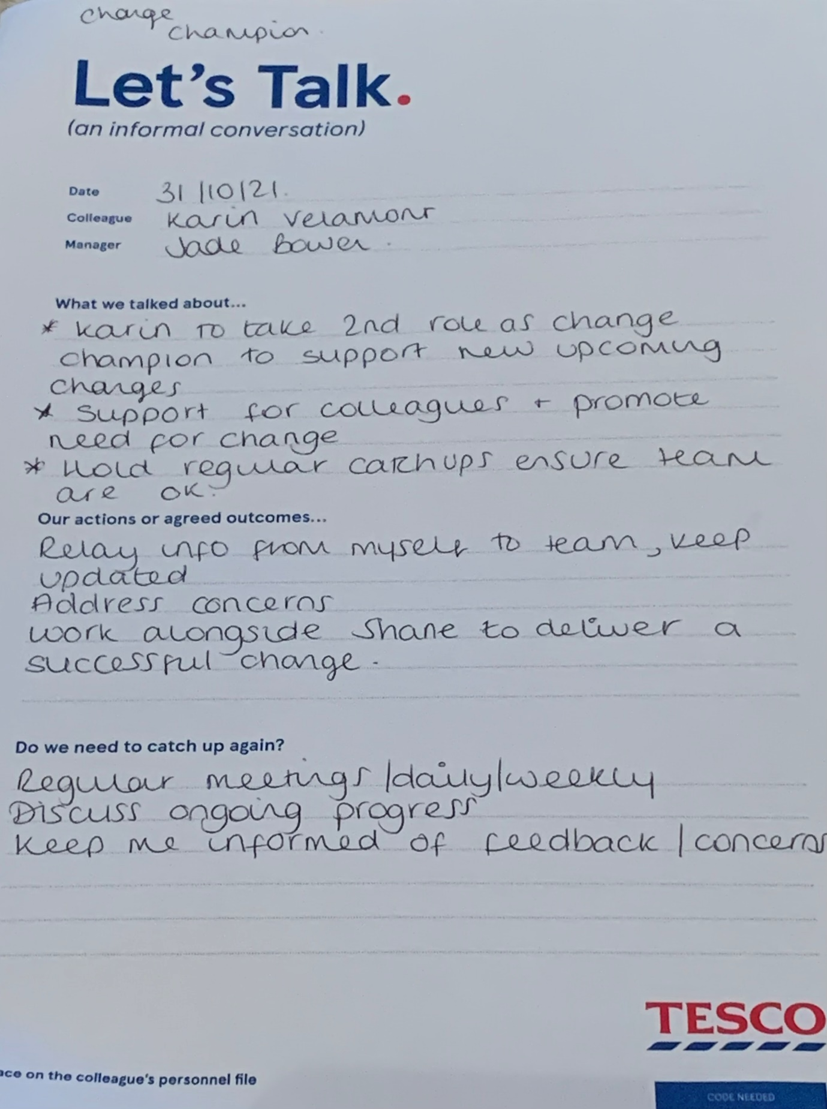

EV 1.5 – Moving Hours Toolkit
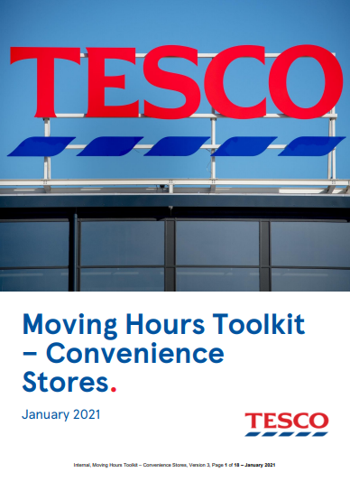

EV 1.6 – Payroll Q3 overspend
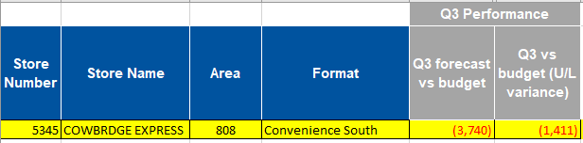
EV 1.7 – Sales budget showing LFL growth
EV 1.8 – Change Plan
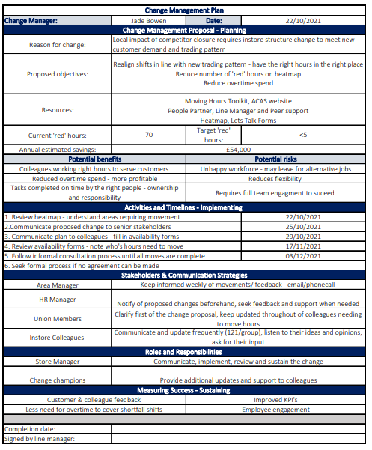
EV 1.9 – Change plan authroisation email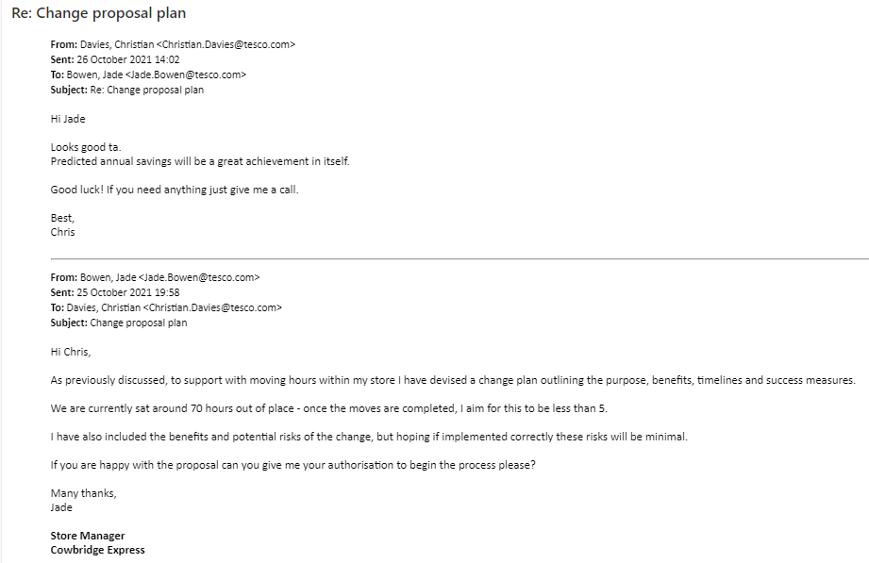
EV 1.10 – Let’s Talk Conversation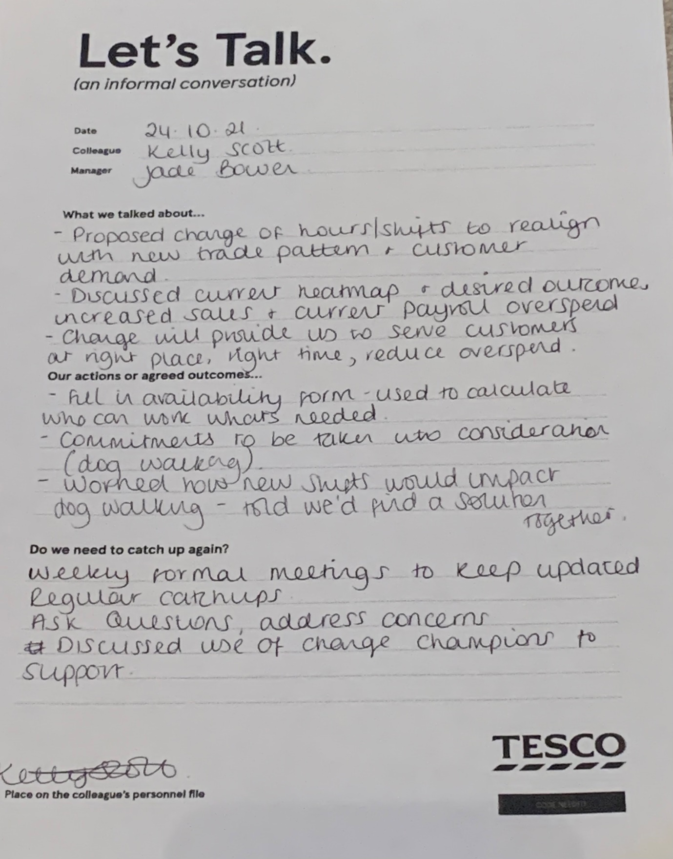

EV 1.11 – Availability Form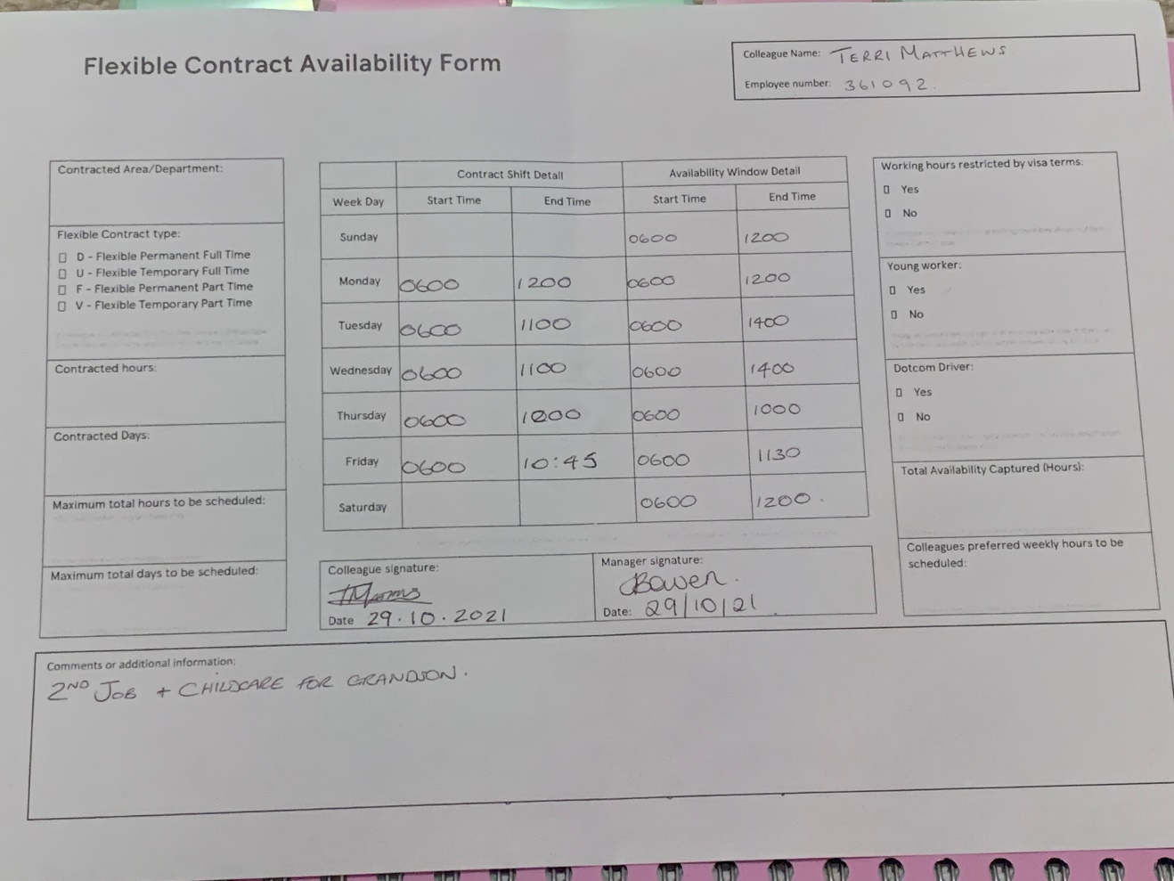

EV 1.12 – Communication Plan
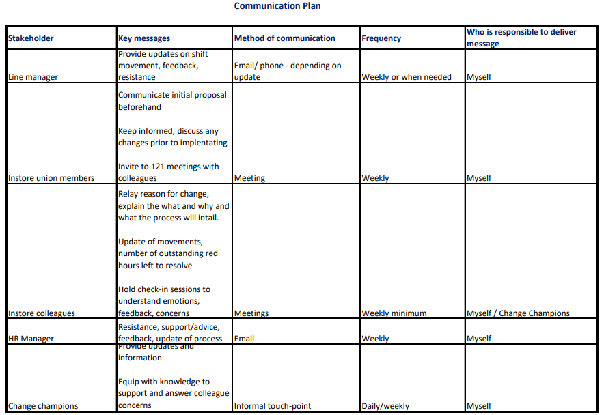

References
AIPM, 2020. How to create a change management plan. Available at: https://www.aipm.com.au/blog/how-to-create-a-change-management-plan#:~:text=CREATING%20A%20CHANGE%20MANAGEMENT%20PLAN%3A%20STEP%20BY%20STEP.,management%20tool%2C%20it%27s%20time%20to%20...%20More%20items
[Accessed 03 11 2021].
CIPD, 2018. HR Professionals - Potential agents of change. Available at: https://www.cipd.co.uk/news-views/changing-work-views/future-work/thought-pieces/hr-professionals-potential-agents--change
[Accessed 02 11 2021].
CIPD, 2021. Change Management. Available at: https://www.cipd.co.uk/knowledge/strategy/change/management-factsheet
[Accessed 05 11 2021].
Hodges, J., 2021. Managing and Leading People through Change. 2nd ed. London: Kogan Page.
Hughes, M., 2010. Managing Change. 2nd ed. London: CIPD.
SHRM, 2018. Communication Plan. Available at: https://www.shrm.org/LearningAndCareer/learning/PublishingImages/Pages/Forms/AllItems/Communications%20Plan%20Template.docx
[Accessed 03 11 2021].

LO2- Implementing a change plan
To support the delivery of my change plan, I designed a Gantt chart listing the key activities alongside a target timeline in which I needed to implement each objective by. This enabled me to visualise my progress and encouraged me to stay focussed. (EV 2.1)
Due to new updates from my organisation, I had to alter the timelines in which I had originally set out on my change plan, meaning all activities had to be completed by 1st December.
Some tasks took less time than originally anticipated, whereas other tasks had overrun due to unforeseen implications that impeded the process. However, this either allowed me additional time to spend on other tasks, or meant I had to work to a tighter deadline on others. This was showcased on my Gantt chart as ‘actual date completed’ vs ‘target deadline’. For example, appointing two change champions took me longer than expected which delayed me reviewing availability forms.
Keeping everyone informed throughout the change was important in order for the process to run as smooth as possible. Using my Communication plan, I was able to stay on track and provide the relevant updates to each stakeholder accordingly.
Initially I communicated the change proposal to the instore union representative, outlining the reasons needed for the change, what the process would entail and the benefits the business would reap from this (EV 2.2).
Throughout the process I held weekly meetings with the union representative and change champions to give regular updates and request their views. It was important to engage the union rep and emphasise the need for change as they encouraged colleagues to welcome the new changes and achieve the initiative. Managers who have a poor relationship with union representatives can face resistance to delivering change strategies (CIPD, 2019). Additionally, the union rep attended colleague 121 meetings to ensure fair practice and offer support for myself or the colleague if needed.
Regular meetings were held with the change champions and with colleagues to discuss progress, address concerns, and understand the general emotions of the colleague (EV 2.3). From this we were able to identify whether certain individuals needed additional support and continue to promote the benefits of the change. I also provided weekly updates to my line manager and HR manager. During uncertain times, communication is important in building trust and creating a culture that welcomes new change (McKinsey, 2016)
As this change initiative was to gradually reach the desired outcome, I decided against using Lewin’s model and opted for Beer’s six-step approach for support instead. By adopting Beer’s model, I was able to focus on building commitment through employee involvement, realigning roles and responsibilities and ensure communication was relevant throughout.
Open and honest communication reinforces positive relationships and builds commitment (McKinsey, 2020). It was crucial my colleagues felt informed, kept updated and were comfortable to raise any concerns.
Therefore, I held weekly meetings with each colleague to provide updates and keep them informed of the process (EV 2.4). Additionally, I held daily informal check-ins with colleagues to understand how they were feeling and if they had any concerns. It was important I recognised my own behaviours and attitudes throughout the change and was able to build and maintain commitment from the team (Indeed, 2016).
Whilst my focus was on delivering the change proposal, I also needed to understand the potential impact the change would have on individuals. By having regular conversations and utilising the support from the union rep and change champions we were able to listen to colleague feedback and address any emotions.
For example, one colleague felt overwhelmed with how the change would affect her emotionally, as the required change meant she would need to work evening shifts but had high concerns of walking home through the town centre alone on a Saturday night. By having honest conversations and understanding her worries we were able to come to an agreement with another colleague who was trained to the same level, resulting in them swapping shifts and the colleague working a weekday evening shift instead (EV 2.5)
Building and maintaining genuine rapports, communicating effectively and utilising the skills around us enables us to successfully design, deliver and maintain any change plan (Hodges, 2021).
Overall, the consultations and change process went well with very little resistance, as colleagues were very clear on why the change was required and the benefits it would bring to the team and for customers. I also took a balanced approach to selecting and changing peoples shifts so minimal impact was caused but we were still able to achieve the desired outcome.
Using a gantt chart enabled me to stay on track and be most effective. I was conscious that I needed to make time to spend with colleagues and have informal check-ins to ensure they were doing ok, so where some tasks didn’t take as long as anticipated I used the spare time to spend speaking with my team and addressing any concerns.
One adaption needed was once the changes had been made accordingly and realigned with the heatmap, it was apparent Friday and Saturday evenings were still an issue with staffing levels. Once speaking to the Operations Partner and reviewing sales LFL and colleague safety it was agreed I would receive extra payroll to recruit for an additional colleague to cover the shortfalls (EV 2.6).
Once the change process was completed, I informed my manager of the changes made, which he was pleased with the outcome (EV 2.7).

LO2 – Evidence
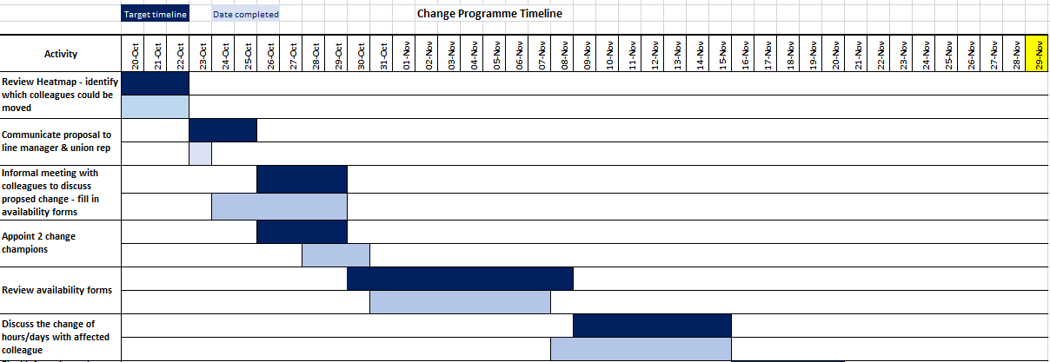
EV 2.1 – Gantt chart to monitor progress

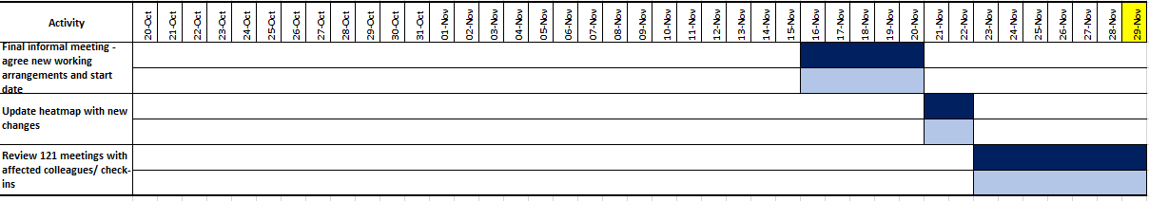

EV 2.2 – Meeting with union rep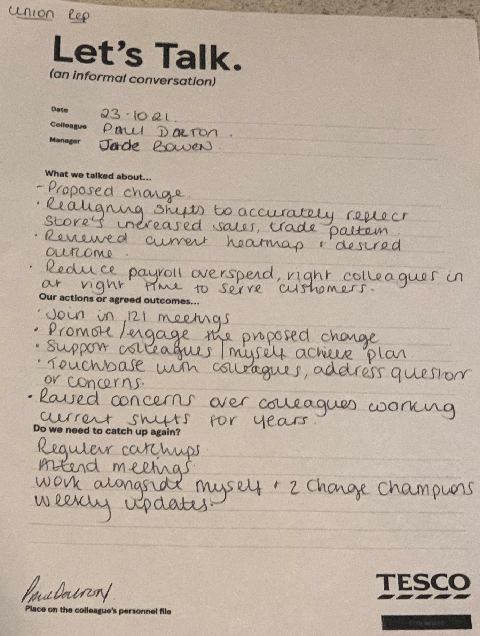
EV 2.3 – Meeting with change champion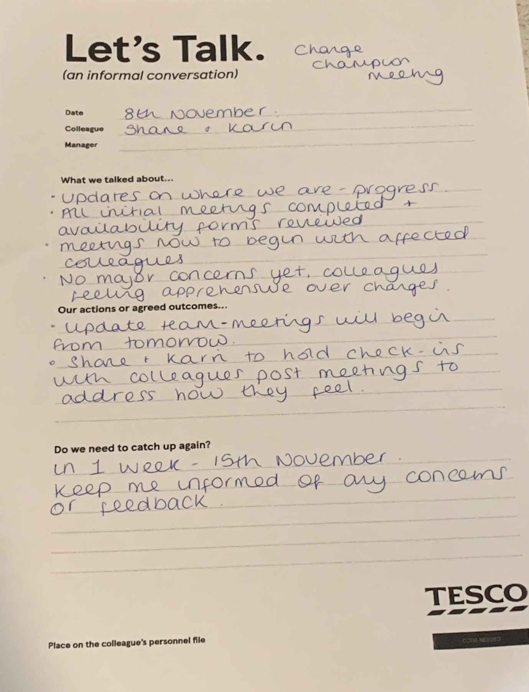
EV 2.4 – Review meeting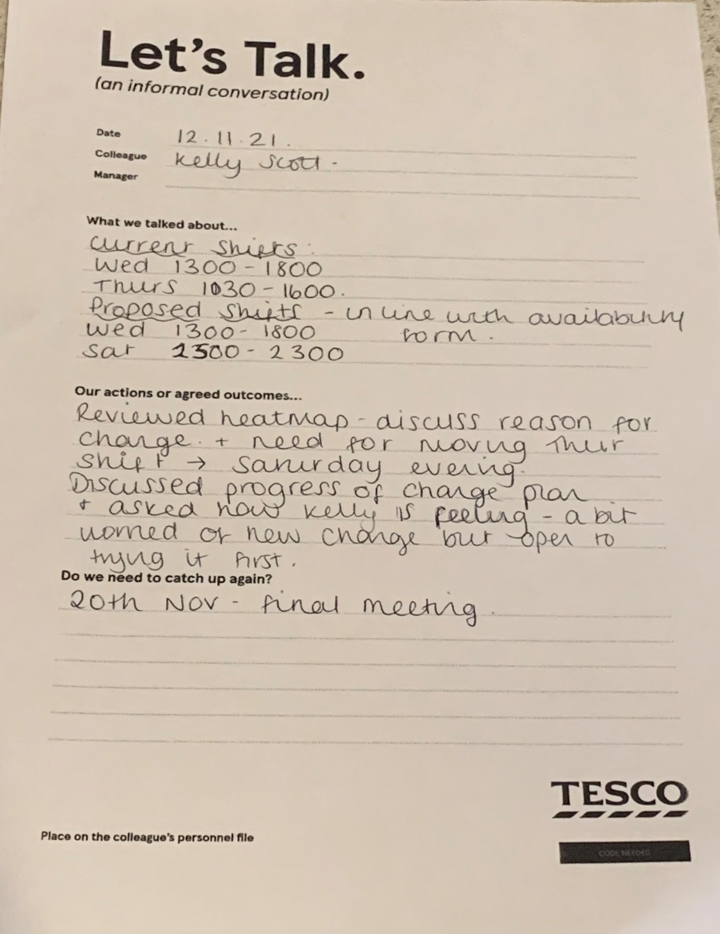
EV 2.5 Final meeting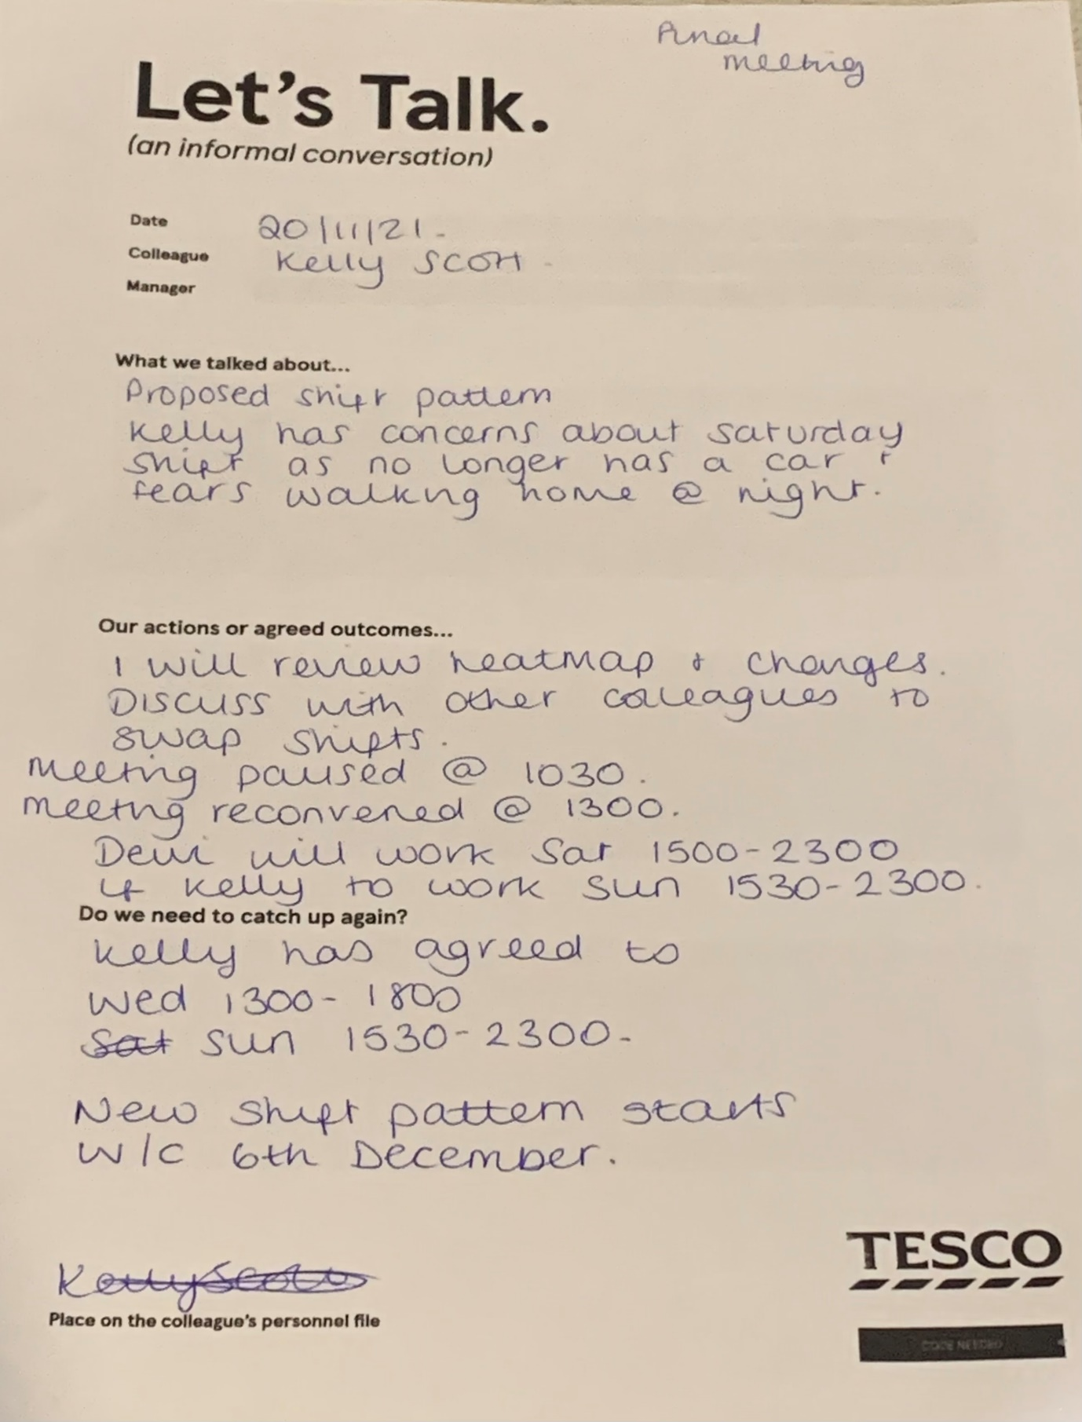
EV 2.6 – Email with Operational Partner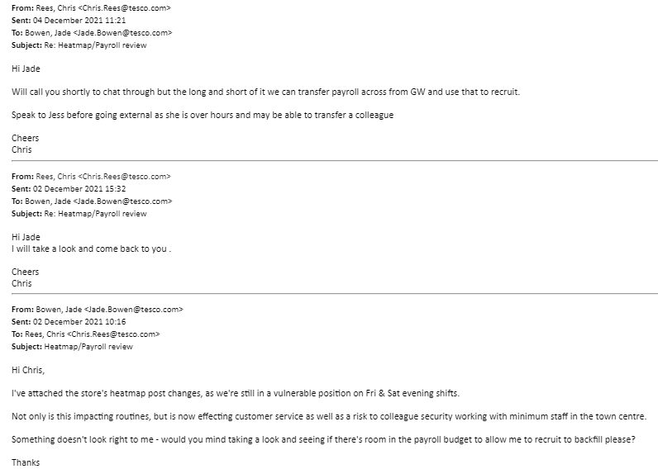

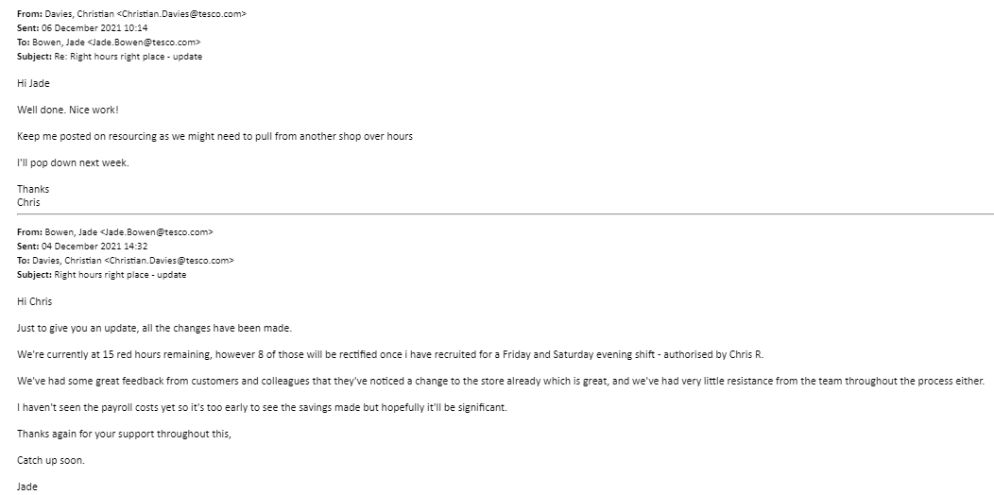
EV 2.7 – Manager confirmation

References
CIPD, (2019). Trade Unions. Available at: https://www.cipd.co.uk/news-views/nutshell/issue-84/trade-unions [Accessed 06 11 2021]
Hodges, J. (2021). Managing and Leading People through Organisational Change. 2nd edn. London: Kogan Page
Indeed, (2016). Measuring the Success of Change Management. Available at: https://www.linkedin.com/pulse/measuring-success-change-management-collin-andrews-mba [Accessed on 20 11 2021]
McKinsey (2016). The four building blocks of change. Available at: https://www.mckinsey.com/business-functions/people-and-organizational-performance/our-insights/the-four-building-blocks--of-change [Accessed 26 11 2021]
McKinsey, (2020). Driving organizational and behaviour changes during a pandemic. Available at: https://www.mckinsey.com/business-functions/people-and-organizational-performance/our-insights/the-organization-blog/driving-organizational-and-behavior-changes-during-a-pandemic [Accessed on 16 11 2021)

LO3 – Assessing the impact of change
Post change data from customer feedback suggested they had seen an improvement in customer service, product availability and reduced queuing at the checkout, indicating the alignment of hours was successful (EV 3.1, EV 3.2)
To gather colleague feedback, I designed a short survey to understand how they felt from the change process, and what improvements they have seen. Findings showed colleagues felt more safer with more colleagues around at night, tasks and routines were being completed on time, and colleagues felt more supported (EV 3.3), accomplishing one of the main objectives.
Originally, the change plan set out to reduce ‘red’ hours from 70 to <5; once I have resourced for Friday and Saturday evening shifts, there will be 7 ‘red’ hours remaining, showing the overall success of the change (EV 3.4). Accumulative payroll figure for Q4 also show a cost saving of more than £1400 which is a great improvement on previous figures (EV 3.5)
Gathering colleague feedback can support in identifying opportunities to improve future change processes (CIPD, 2021). To understand what could be done differently for future changes, colleagues had an opportunity to provide their own feedback. Out of 7 responses, 5 colleagues implied they were happy with how everything went. Whereas 1 colleague suggested providing all new shift patterns first and another colleague fed back more training was needed for those working new shifts (EV 3.6).
Going forward it is important colleague continue to experience soft changes to build a ‘change culture’ whereby change initiatives become the norm. Involving colleagues in the design and implementing stage and gathering feedback and welcoming their ideas allows for a more engaged and committed workforce (Cameron and Green, 2019).
Once the change was completed, I informed my line manager and my HR manager (EV 3.7), explaining to my manager the current ‘red’ hour positioning and a plan to rectify outstanding moves.
I was able to feedback of no major issues throughout the process and colleague and customer feedback showed the improvements the change had made and the success of the change.
Overall, the change process went well, and we achieved the desired outcome. I believe I developed a sufficient business case outlining costs, benefits, and measures to deliver the project.
In order for a workforce to become more inclusive and welcoming of change it requires a true understanding of change and employee involvement (CIPD, 2018) which I believe I did that, by including peoples’ views, keeping them informed and listening to their feedback.
However, on reflecting the CIPD profession map 2018, my current knowledge and skills is at associate level. To successfully deliver future changes to a higher standard I need to build my knowledge on local external data and research and incorporate this into my plan.
Even though I kept my HR and line manager updated regularly, next time it would be beneficial for them to visit me and partake in some of the meetings and provide me with feedback on my performance along the way. Even though feedback from my colleagues is helpful for future projects, I believe to have managerial feedback would help me build on my management style and approach, and what I could do differently from their perspective.

LO3 Evidence
EV 3.1 – Customer feedback
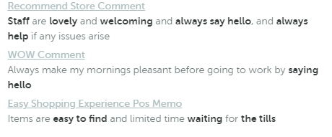
EV 3.2 – Customer feedback
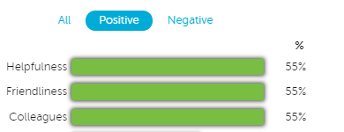
EV 3.3 – Colleague feedback
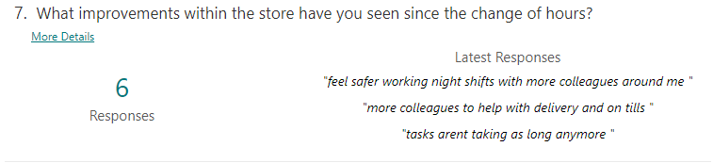
EV 3.4 – Heatmap showing ‘red’ hours post change
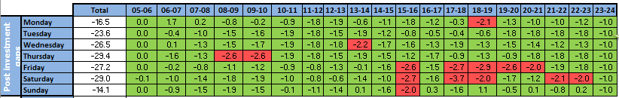
EV 3.5 – Payroll cost saving Q4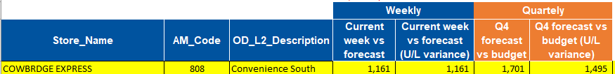
EV 3.6 - Colleague feedback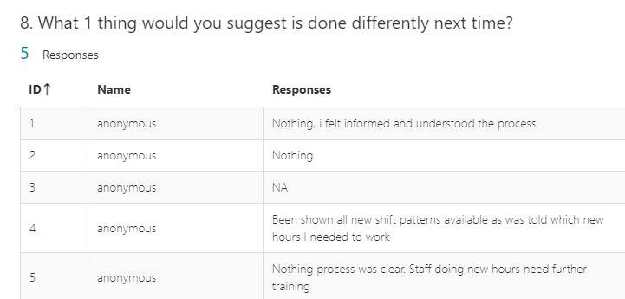
EV 3.7 – HR manager email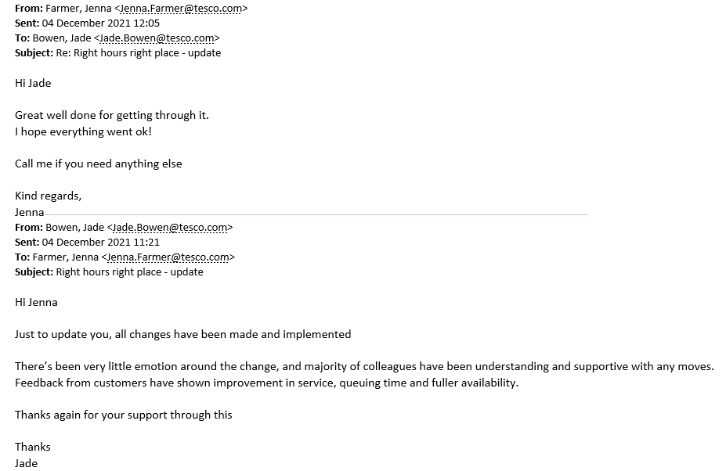

References
Cameron, E., and Green, M. (2019). Making Sense of Change Management. 5th edn. London: Kogan Page
CIPD, (2018). CIPD Profession Map. Available at: https://peopleprofession.cipd.org/profession-map/core-knowledge/change [Accessed 08 11 2021]
CIPD, (2021). Change Management. Available at: https://www.cipd.co.uk/knowledge/strategy/change/management-factsheet
[Accessed 05 11 2021].

