PROGRAMMES

  - PROJECT PLANNING – ACBA5001
  - KERRI FARMER – 2100037

Contents
DETAILED BREAKDOWN ALL MAJOR ACTIVITIES 3
METHOD STATEMENTS 3
Lifting Operations 3
Task Description 3
Scaffolding 4
Task Description 5
Dry Lining and Partitioning 6
Task Description 6
GANTT CHART 7
SITE SPECIFIC REPORT FOR TIME, COST AND RESOURCES 8
References 15

DETAILED BREAKDOWN ALL MAJOR ACTIVITIES
Within the Gantt chart submitted separately,
- Lifting operations
- Scaffolding
- Dry lining partition systems

METHOD STATEMENTS
All construction works are to be carried out within accordance to the following legislation.
- Health and Safety at Work Act 1974 (HASWA)
- Lifting Operations and Lifting Equipment Regulations 1998 (LOLER)
- Provision and Use of Work Equipment Regulations 1998 (PUWER)
- Control of Substances Hazardous to Health Regulations 2002 (COSHH)
- Manual Handling Operations Regulations 1992
- Construction Design Management Regulations 2015 (CDM)
- Working at Height Regulations 2005
- Personal Protective Equipment Regulations 1992
- Reporting of Injuries, Diseases and Dangerous Occurrences Regulations 2013 (RIDDOR)

Staff and Training
All members of staff are experienced and have been deemed competent to carry out tasks requested of them. A responsible person will be appointed to each job, that person will supervise all works and be responsible for quality and safety. Apprentices and young workers will be always supervised and are not allowed to carry out tasks for which they have not been trained.

Lifting Operations
Client: Morganstone
Site Address: Block A – F Plots A1 – F2, Langdon Road, SA1 Swansea Waterfront,
Site Contact: John Baxter
Site Contact Number: 07712345689
Project Start Date: 06/03/2023
Document Author: Kerri Farmer
To provide contract lift operations in compliance with BS7121 part 1 & 3 and Loler Regulations.

PPE
All site workers will wear hard hats, safety boots and hi-visibility vests always; other items of PPE such as dust masks, eye, ear protection and gloves are available to be worn as and when necessary.
Copies of statutory test and inspection certification and reports will be available prior to any lifting taking place.
Exclusion zones need to be placed around the crane with barrier tape or temporary fencing to prevent contractors and or other pedestrians entering the lifting operations area.

Task Description
- Crane and associated labour and tackle will arrive on site.
- The lift supervisor will meet with the clients representative and carry out toolbox talk with all lifting personal involved with the lifting procedures referencing the risk assessment. Once this is completed all involved with the lifting procedure need to sign the register.
- Crane is to reverse into position as shown on the drawings on the lift plan which. The crane will be directed and under control of the slinger/signaller.
- Crane is then to rig up on the main boom as per manufacturers operations manual and will always be adhered to.
- All lifting personal that are assisting with the rigging/derigging of the crane to be always under the guidance of the operator.
- Once rigging has been completed the main boom needs to be telescoped out.
- Crane operator to lower the hook block to ground level.
- Lifting tackle to be used for executing the lift will need to be placed on the hook and checked by lift supervisor.
- The cranes hook will be hoisted into the air.
- Crane to slew over the roof trusses and timber stud walls and lifting tackle to be attached.
- Slinger/signaller to instruct the operator by means of hand signals or two-way radios to slowly hoist up to remove the slack out of the lifting tackle.
- Slinger/signaller will ‘plumb’ boom head of the crane vertically above the lift.
- Tag lines attached to the lift.
- Slinger/signaller to instruct crane operator to hoist item just clear of the ground or transport to be loaded on.
- Lift supervisor to check for correct slinging and adjust if necessary.
- Once the load is correctly slung may the Slinger/signaller proceed with the lifting operations. They will give clear instructions to the crane operator to hoist the load until it is clear and free of any obstructions.
- Slinger/signaller to instruct the crane operator to slew as required left of right within the safe working radius of the crane for the total weight of the load including lifting accessories and hook block.
- Once the load is suspended above the final position the Slinger/signaller is to instruct the crane operator to lower the load slowly again via hand signals or two-way radios avoiding all obstructions.
- The loads are to be landed the client then can check the position and orientation of the roof trusses or timber walls.
- Client is to confirm position and orientation once this is done the Slinger/signaller is to instruct crane operator to lower off all weight on the lifted item.
- Lifting tackle can now be released from the item and checked by lifting supervisor.
- Slinger/signaller to instruct the crane operator to hoist up till all lifting equipment is clear of all obstructions.
- Slinger/signaller to instruct crane operator to slew crane left or right.
- Slinger/signaller to instruct the crane operator to lower down over the next item to be lifted.
- Operations 10 to 23 to be repeated until all trusses and timber walls have been lifted and placed into position.
- Once all lifting operations have been completed the crane operator is to lower the hook block to the ground.
- Lifting tackle is to be removed from hook block and the hook block stowed away.
- Crane is now to derig and move off of the site.

Variations to Method Statement
All significant variations to this Method Statement, including drawings must be notified to the Appointed Person prior to proceeding with the lifting operations. The lift supervisor and client or client’s representative to note all details of variations and comments of the Appointed Person on the onsite changes sheet as well as sign and date it.
(Davies Crane Hire, 2023)

Scaffolding
Client: Morganstone
Site Address: Block A – F Plots A1 – F2, Langdon Road, SA1 Swansea Waterfront,
Site Contact: John Baxter
Site Contact Number: 07712345689
Project Start Date: 06/03/2023
Document Author: Kerri Farmer
To provide the erection and dismantling of scaffold in compliance with BS EN 12811-1-2003 and technical guidance issued by NASC TG20:21 and SG4:15 (National Access & Scaffolding Confederation).

PPE
All site workers will wear hard hats, safety boots and hi-visibility vests always including harness and lanyard; other items of PPE such as dust masks, eye, ear protection and gloves are available to be worn as and when necessary.

Task Description
- Report to Site office prior to commencement of work and meet with the client’s representative or Principal Contractor. carry out inductions and toolbox talk, with all personal involved in erecting and dismantling scaffolding referencing the risk assessment also provide scaffolders proof of training.
- Put on all personal protective clothing and equipment – safety helmet, safety footwear, harness and lanyard, high visibility vest or jacket.
- Prior to commencing with erecting the scaffolding the Principal Contractor has ensured the ground is level and adequate to take the weight of the scaffold, the weight of the materials and persons working on the scaffold.
- Inspect all scaffold components for damage.
- Inspect all ladders for damage.
- Arrange for scaffold boards and tubes to be delivered by mechanical means as close as possible to where the scaffold is to be erected.
- Assess ground and decide whether individual sole boards are required to spread the load or sole boards that need to extend between at least two steel base plates on soft ground.
- Erect standards and ledgers and ensure that standards are vertical, and ledgers are horizontal.
- Position transoms and boards on first level platform from below if possible.
- Erect and secure ladder.
- No materials to be carried up ladders. Forklift or mechanical means to load all materials on loading bay.
- A minimum of a three board wide centralised platform should be worked upon. Handrails to be erected to enable a safe working platform for any materials to be hoisted up.
- No components to be thrown from scaffold or dropped from scaffold.
- Scaffold to be made stable as soon as practicable with ties. Ties to be provided at intervals according to regulations.
- Kinetic methods of lifting and handling to be always used. Only single boards and tubes to be lifted at a time.
- Handrail to be at a minimum height of 950mm above platform and any gap between the top rail and intermediate rail should not exceed 470mm, and therefore middle rail will be provided.
- Toe boards to be provided on all working platforms and secured.
- Guards to be provided and secured on all working platforms where materials are to be stacked above the height of the toe board. If required debris meshing to be provided to protect the public and secured.
- Ledger bracing provided as required.
- Façade bracing will be provided on gable ends and lengths over 30 metres.
- Loading bays will be provided with additional bracing and check couplers. Advise the Site Manager of the maximum loadings for the loading bay and scaffold. Loading bays will be provided with gates which will be up and down gated type.
- Working platforms will be fully boarded with no gaps giving rise to risk of injury.
- Harnesses will be always worn and connected.
- Harness and lanyard will be inspected prior to use and have current 6-month certificate and identity number or asset number.
- No materials to be thrown off scaffold.
- Scaffold should be inspected every 7 days, until it is removed. It should also be inspected each time it is exposed to conditions that can cause deterioration and following substantial alteration.
- Principal Contractor to keep other trades out of working area whilst scaffold is being erected, altered, or being dismantled.
- Dismantling will be in reverse order from step 27 – 1 following all regulations.
(HSE, 2023) (SA Scaffolding Limited, 2023)

Dry Lining and Partitioning
Client: Morganstone
Site Address: Block A – F Plots A1 – F2, Langdon Road, SA1 Swansea Waterfront,
Site Contact: John Baxter
Site Contact Number: 07712345689
Project Start Date: 06/03/2023
Document Author: Kerri Farmer
To provide the installation of dry lining wall and ceiling partition systems in accordance BS 8212 plasterboard should be to BS EN 520.

PPE
All site workers will wear hard hats, safety boots and hi-visibility vests always including harness and lanyard; other items of PPE such as dust masks FFP2, eye, ear protection and gloves are to be worn.

Task Description
- Report to Site office prior to commencement of work and meet with the client’s representative or Principal Contractor. carry out inductions and toolbox talk, with all personal involved with dry lining activities.
- Cordon off all work areas if practical and if it requires to carry out tasks safely.
- Materials will be brought to site via lorry and checked against specification.
- Labour will break down equipment and organise into manageable loads, to manual handle the loads safely any loads that are awkward or over 25kg need to have two persons to assist in carrying and moving.
- All materials that have been delivered to site need to be transported by mechanical means to the allocated storage area on site and stored safely as per manufacturer's requirements.

Partition Wall System Fixing
- Ensure all persons involved in the partition fixing have put on personal protective equipment.
- Ensure there is no obstruction in the area to be worked as well as ensure that all entry and exit points remain clean, clear, and safe to access.
- Mark out partition positions according to approved construction drawings and cut floor and ceiling channels at the required lengths for the floor and soffit fixing. Ensure all deflection heads have been created for the soffit for fire safety regulations.
- Mark out and fix C studs to abutments and all openings with appropriate fixings.
- Mark out and fix I studs to floor and ceiling channels at the specified centres and not greater than 600mm centres.
- Mark out position of doors and construct the door openings as per specifications.
- Check and ensure the metal frame construction is true and plumb.
- Always use local exhaust system when cutting or sanding plasterboards to size, to control dust; or wear a half face mask to EN149 Class FFP2s.
- Measure and cut plasterboard to size and fit plasterboard to one side of the internal metal framing system at appropriate centres and with appropriate fixings.
- Check that all 1st fix trades for example electricians and plumbers have completed 1st fix where needed and required.
- Measure and install rockwool or specified insulation to plasterboard fixing.
- Measure and cut plasterboard to size and fit plasterboard to the opposite side of the internal metal framing system according to manufacturer’s specifications and building regulations at appropriate centres and with appropriate fixings.
- Ensure all screw heads are at the appropriate depth and if not drive in any protruding screw heads, for taping and jointing or plastering.
- Mastic all perimeters of the plasterboard metal wall partition system.
- Ensure all the areas worked in is cleared of rubbish and discarded in the correct skips for recycling.
(British Gypsum, 2023)

Suspended Ceiling System Fixing
- Ensure all persons involved in the partition fixing have put on personal protective equipment.
- Ensure there is no obstruction in the area to be worked as well as ensure that all entry and exit points remain clean, clear, and safe to access.
- Measure and mark out the perimeter trim lines according to specifications and the approved construction drawings.
- Ensure you have marked out the laser point and fix laser to this point to give your reference point around the perimeter of the room.
- Fix wall angle perimeter trim around the perimeter of the room with appropriate fixings and at appropriate centres and distances from wall.
- Ensure trim is fixed into the next trim at the corners of the room or mitre cut.
- Mark out the hanger positions for the area of the room at the required specification and centres, the main runner needs to be at or within 600mm of the wall and at 1200mm centres for lighter systems and 450mm centres for heavier ceiling systems.
- Fix hangers to concrete ceilings with a hammer drill and hammer fixings or appropriate fixings to timber construction.
- Cut and fix main T across the room to each metal hanger with appropriate fixings.
- Cut and fix main MF5 ceiling to slot in at each end of the wall into the perimeter trim and fix to main T with appropriate fixings running in the opposite direction to main T as seen in image below.
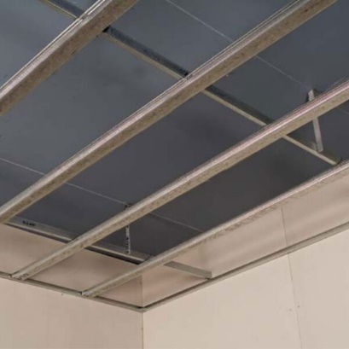
Figure 1 Metal Furring Ceiling Kit for Plasterboard
- Measure and install rockwool or specified insulation to metal furring ceiling frame.
- Always use local exhaust system when cutting or sanding plasterboards to size, to control dust; or wear a half face mask to EN149 Class FFP2s.
- Measure and cut plasterboard to size and fit plasterboard to MF5 ceiling at appropriate centres two persons to lift and place ceiling board into place at appropriate centres and with appropriate fixings.
- Ensure there is a staggered joint as per manufacturers and building regulations specifications for strength.
- Ensure all screw heads are at the appropriate depth and if not drive in any protruding screw heads, for taping and jointing or plastering.
- Mastic all perimeters of the plasterboard metal furring suspended ceiling system.
- Ensure all the areas worked in is cleared of rubbish and discarded in the correct skips for recycling.
(Knauf, 2023)

GANTT CHART
Gantt Chart submitted separately.

SITE SPECIFIC REPORT FOR TIME, COST AND RESOURCES

Cash Flow
The chart shows the project's cumulative cost and the cost per quater.
The table below shows cost information for all top-level tasks.
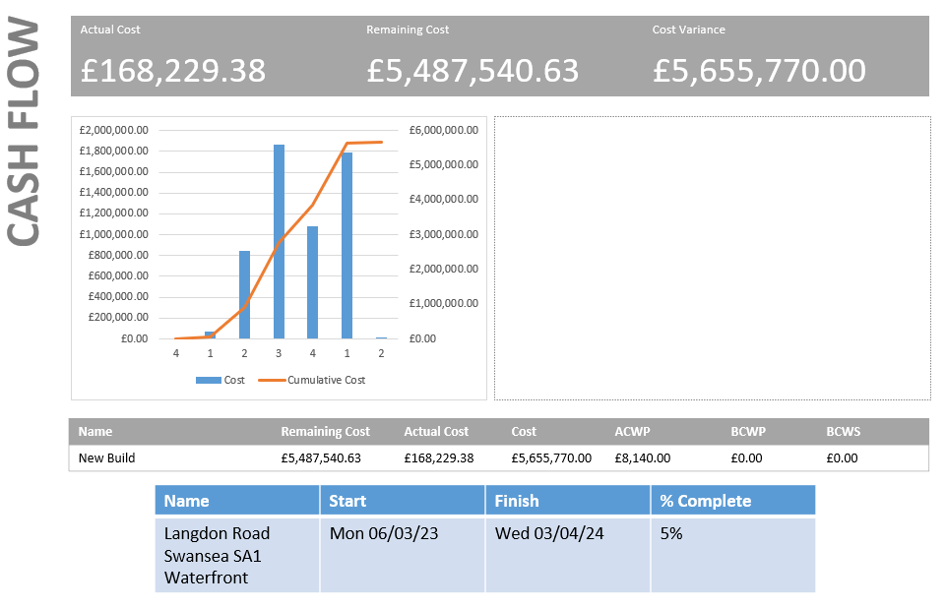

Task Cost Overview
The chart shows the project's cost status for top-level task
The pie chart below represents the task cost based on their status in the project to date
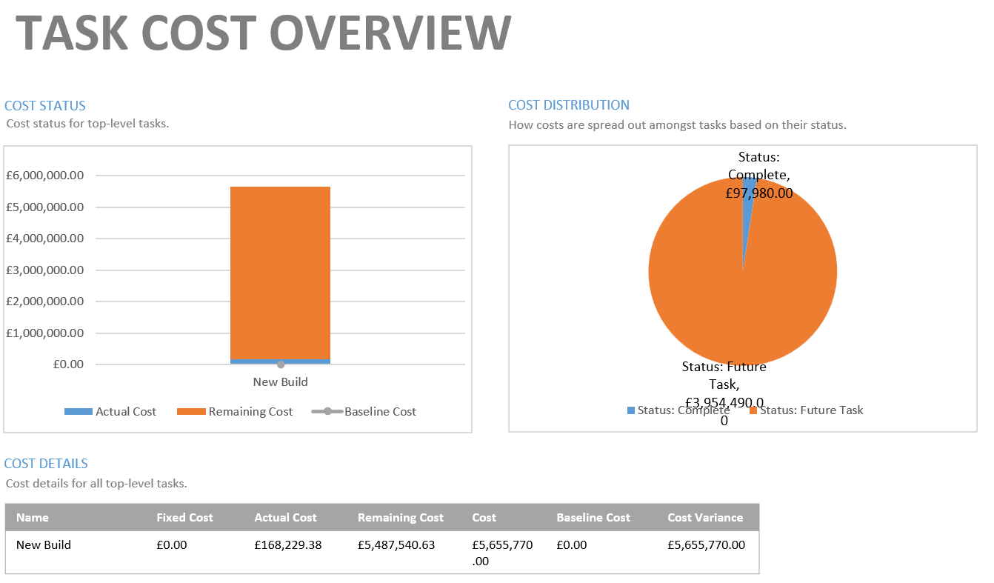

Cost Overview
The below report represents the progress versus the cost, according to the % completed and cost this project is running on time and to budget.
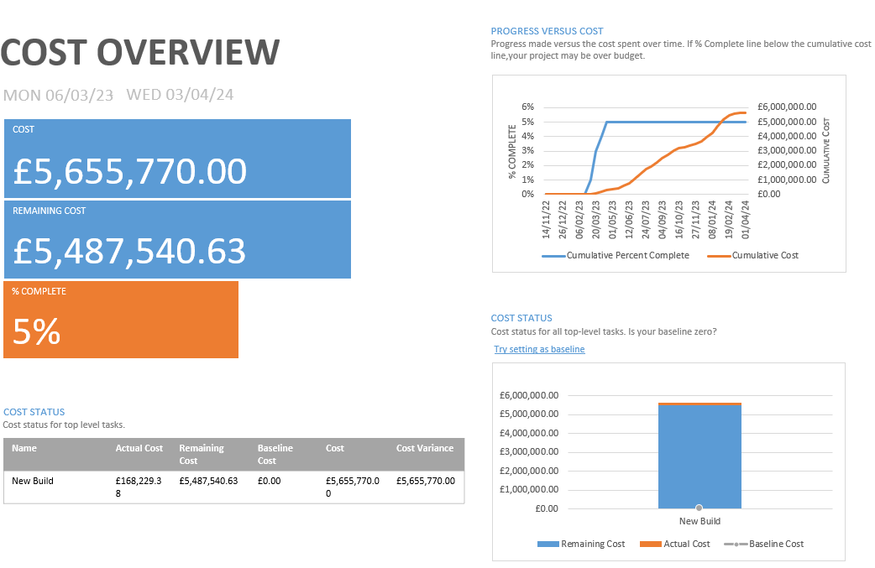

Resource cost overview
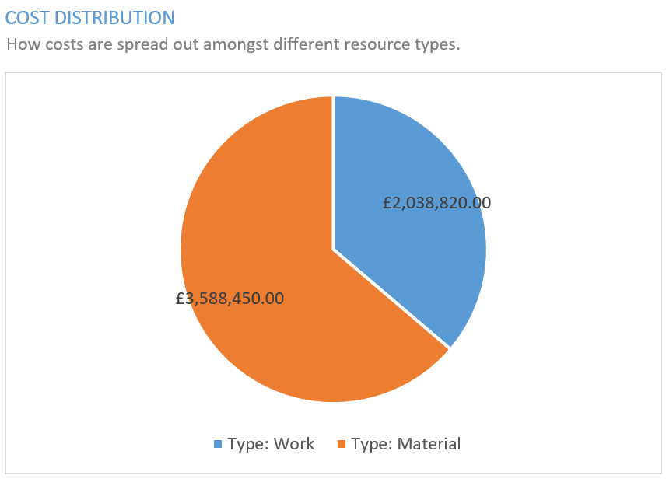

Resource Stats and work status
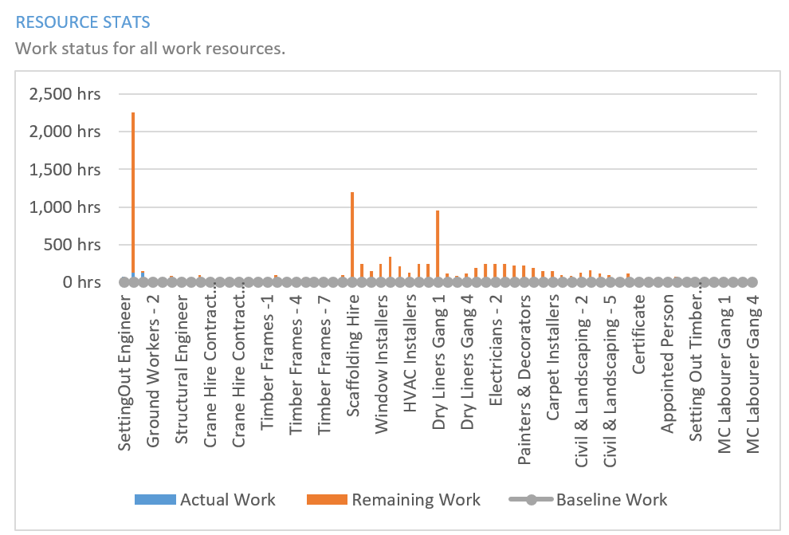

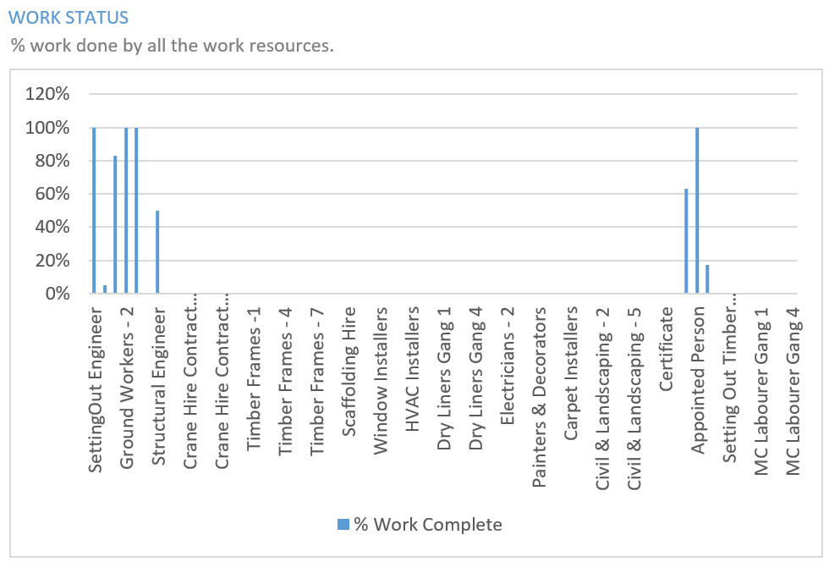

Resource
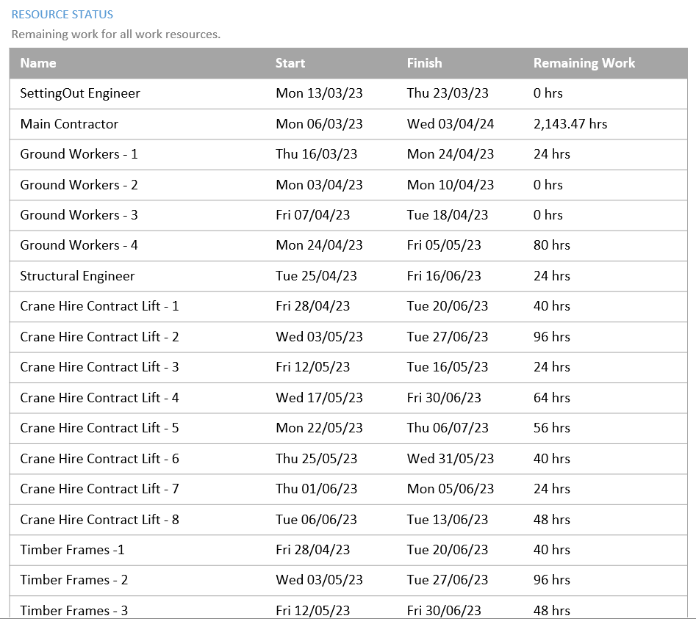
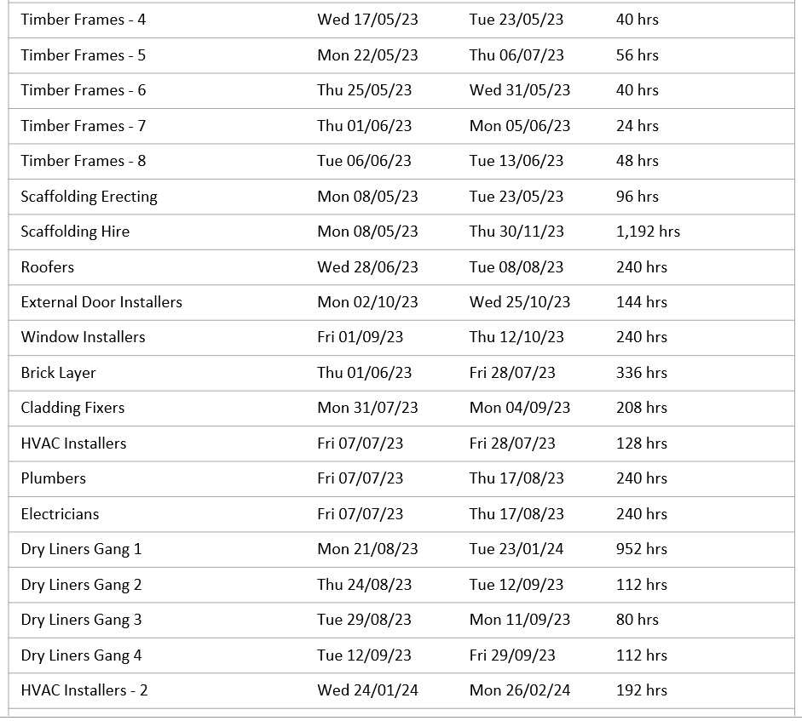
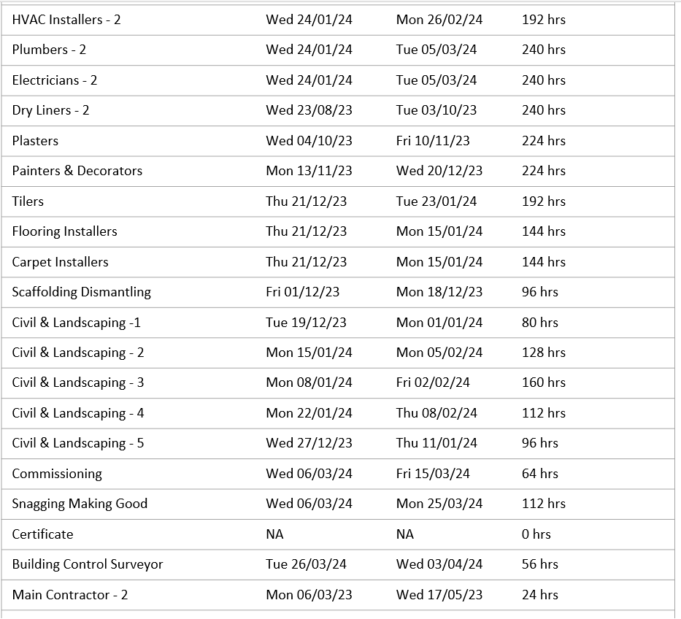
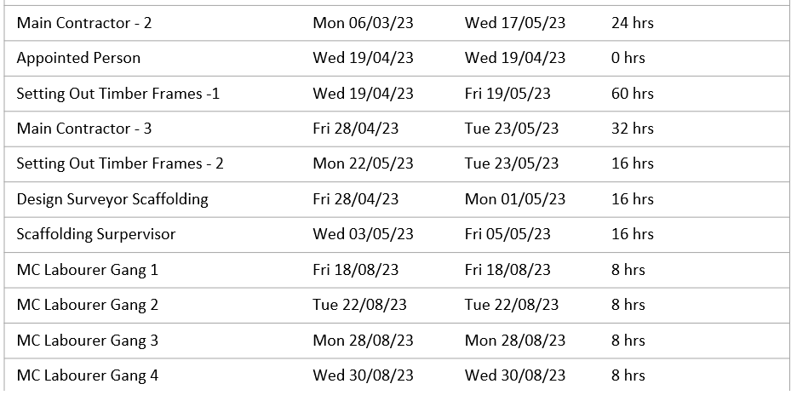

Duration Chart
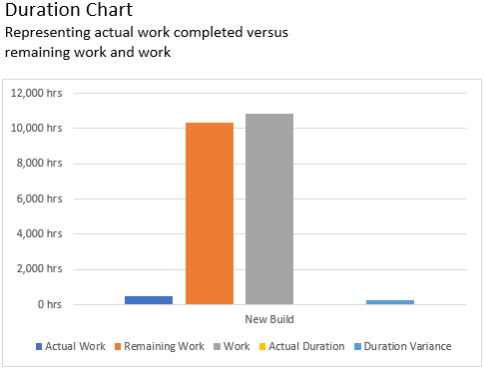

Critical task
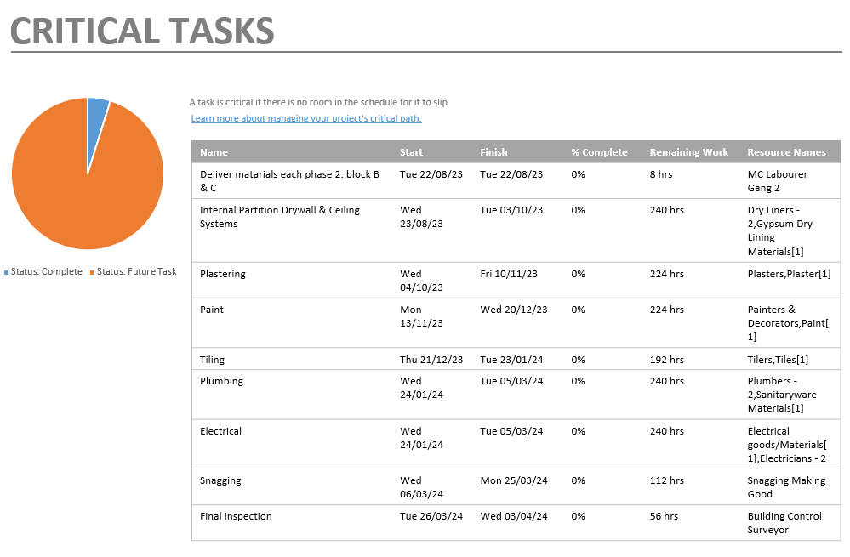

Work burndown
How much work has been completed to date and how much is left, as long as they both follow along the same path downward the project is progressing on time.
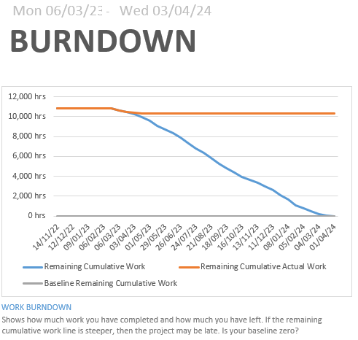

References
British Gypsum. (2023, March 11). White Book – GypWall Single Frame. Retrieved from British Gypsum: https://www.british-gypsum.com/documents/white-book/british-gypsum-wb-gypwall-single-frame-with-introduction.pdf
Davies Crane Hire. (2023).
HSE. (2023, March 5). Construction - Work at height. Retrieved from Health and Safety Executive: https://www.hse.gov.uk/construction/faq-height.htm#:~:text=How%20high%20should%20the%20guardrails,rail%20should%20not%20exceed%20470mm.
Knauf. (2023, March 11). Knauf Ceiling Soltions. Retrieved from Knauf: https://www.knaufceilingsolutions.com/fileadmin/knaufceilingsolutions/01_products/01_mineral/installation_guides/india/IG_Installation_Manual_Mineral_KCS_EN_IN.pdf
SA Scaffolding Limited. (2023, March 5). Health and Safety Method Statement.

