
University of Wales Trinity St. David
Electrical/Electronic Engineering

ACDA6002
Electronic Systems Design
Matt Haycock
2012802

Assignment report – 14 Day Weather and Air
quality measurement and
logging system

Date 16th Jan. 2023

Contents
1. Abstract 6
2. Introduction 7
2.1 Comparable Portable Weather Stations 7
2.1.1 MWS-M625 7
2.1.2 MeteoHelix® IoT Pro - Sigfox Micro-Weather Station 8
2.1.3 Ecowitt Weather Station WS2910 9
2.1.4 Skywatch BL-1000 Weather station 10
2.2 Comparison Table 11
MWS-M625 11
3. System Design 12
3.1 Temperature measurement 12
3.1.1 Temperature Sensor Comparison 13
3.2 Humidity measurement 15
3.2.1 Humidity Sensor Comparison 16
3.3 Wind Speed measurement 17
3.3.1 Wind Speed Sensor comparison 18
3.4 Wind Direction measurement 20
3.4.1 Wind Direction Sensor measurement 21
3.5 Air borne particle count measurement 23
3.5.1 Air borne particle count sensor 24
3.6 Sunlight measurement 25
3.6.1 Sunlight measurement sensor 26
3.7 UV level measurement 27
3.7.1 UV Level measurement sensor 28
3.8 GPS position 30
3.8.1 GPS sensor 31
3.9 VOC level measurement 33
3.9.1 VOC level sensor 34
3.10 Microcontroller 35
3.11 Storage Memory 36
3.12 Connector comparison table 38
3.12.1 Sensor connections 39
3.13 Casing comparison table 41
3.14 LED and Start/Stop button 43
3.15 Battery 43
3.16 Voltage Regulator 44
3.17 USB 44
3.18 Block Diagram 45
3.19 Software Flow chart 46
3.19.1 Temperature sensor 46
3.19.2 Humidity sensor 47
3.19.3 Wind Speed 48
3.19.4 Wind direction 49
3.19.5 Air particle sensor 50
3.19.6 Sunlight sensor 51
3.19.7 GPS sensor 52
3.19.8 VOC Sensor 53
3.19.9 UV Level 54
3.19.10 SD Read/Write 55
4. Result 56
4.1 Temperature sensor system 57
4.2 Humidity sensor system 57
4.3 Wind speed sensor system 58
4.4 Wind direction sensor system 58
4.5 GPS sensor system 59
4.6 VOC sensor system 60
4.7 Air Particle sensor system 60
4.8 UV level sensor system 61
4.9 Microcontroller 61
4.10 Battery layout 62
4.11 Stop/Start LED 62
4.12 USB 62
4.13 SD Card 63
4.14 PCB 64
3.14.1 PCB manufacturing quote 66
5. Conclusion 67
6. References 69

Figures
Figure 1 MWS-M625 portable weather station 7
Figure 2 MeteoHelix® IoT Pro - Sigfox Micro-Weather Station 8
Figure 3 Ecowitt Weather Stations WS2910 9
Figure 4 Skywatch BL-1000 Weather station for emergency and incident response 10
Figure 5 Calculation of number of bytes required over 14-day test for temperature measurement 14
Figure 6 Calculation for total number of bytes over 14 days for humidity measurement 17
Figure 7 Calculation for total number of bytes over 14 days for wind speed measurement 19
Figure 8 Calculation for total number of bytes over 14 days for wind direction measurement 22
Figure 9 Calculation for total number of bytes over 14 days for air borne particle count measurement 25
Figure 10 Calculation for total number of bytes over 14 days for sunlight measurement 27
Figure 11 Calculation for total number of bytes over 14 days for UV level measurement 29
Figure 12 Calculation for total number of bytes over 14 days for GPS measurement 32
Figure 13 Calculation for total number of bytes over 14 days for VOC measurement 35
Figure 14 PIC18F24K50 schematic showing pin functions 36
Figure 15 Illustration of proposed design and layout of weather station located on tripod 42
Figure 16 carry case for dismantled weather station 42
Figure 17 battery configuration 44
Figure 18 Block diagram for weather station syste 45
Figure 19 Temperature sensor flow chart 46
Figure 20 Humidity sensor flow chart 47
Figure 21 Wind speed sensor flow chart 48
Figure 22 Wind direction sensor flow chart 49
Figure 23 Air particle sensor flow chart 50
Figure 24 Sunlight sensor flow chart 51
Figure 25 GPS sensor flow chart 52
Figure 26 VOC sensor flow chart 53
Figure 27 UV sensor flow chart 54
Figure 28 SD Read/Write flow chart 55
Figure 29 Circuit diagram of weather station 56
Figure 30 Temperature sensor circuit layout 57
Figure 31 Humidity sensor circuit layout 57
Figure 32 Wind speed sensor circuit layout 58
Figure 33 Wind direction sensor circuit layout 58
Figure 34 GPS sensor circuit layout 59
Figure 35 Sunlight sensor circuit layout 59
Figure 36 VOC sensor circuit layout 60
Figure 37 Air particle sensor circuit layout 60
Figure 38 UV level sensor circuit layout 61
Figure 39 Microcontroller pin I/O 61
Figure 40 battery layout 62
Figure 41 Stop/start LED configuration 62
Figure 42 USB configuration 62
Figure 43 SD Card configuration 63
Figure 44 2D schematic of PCB circuit 64
Figure 45 3D schematic of PCB circuit 64
Figure 46 Engineering drawing showing PCB schematic 65
Figure 47 Quote from JLPCB for PCB manufacture 66
Tables
Table 1 Weather Station specification comparison table 11
Table 2 Temperature measurement alternatives table 12
Table 3 NTC Temperature Sensor Comparison table 13
Table 4 Humidity measurement alternatives table 15
Table 5 NTC Capacitance Humidity Sensor Comparison table 16
Table 6 Wind Speed measurement alternatives table 17
Table 7 Ultrasonic Wind Speed Sensor Comparison table 18
Table 8 Wind direction measurement alternatives table 20
Table 9 Ultrasonic Wind direction Sensor Comparison table 21
Table 10 Air Borne particle count measurement alternatives table 23
Table 11 Air borne Sensor Comparison table 24
Table 12 Sunlight measurement alternatives table 25
Table 13 Photo Diode Comparison table 26
Table 14 UV level measurement alternatives table 27
Table 15 UV sensor Comparison table 28
Table 16 GPS position alternatives table 30
Table 17 GPS sensor Comparison table 31
Table 18 VOC level measurement alternatives table 33
Table 19 VOC sensor Comparison table 34
Table 20 Total analogue inputs required 35
Table 21 Total digital inputs required 35
Table 22 Memory storage device 36
Table 23 Total bytes required for complete system over 14 days 37
Table 24 Innodisc SD card specification 37
Table 25 Connector comparison table 38
Table 26 Temperature connector colour code chart 39
Table 27 Humidity connector colour code chart 39
Table 28 Wind Speed connector colour code chart 39
Table 29 Wind Direction connector colour code chart 39
Table 30 Air borne particle count connector colour code chart 39
Table 31 Sunlight brightness connector colour code chart 39
Table 32 UV level connector colour code chart 40
Table 33 GPS position connector colour code chart 40
Table 34 VOC level connector colour code chart 40
Table 35 Portable weather station casing comparison table 41
Table 36 Recommended Push button 43
Table 37 Recommended battery 43
Table 38 USB port for PC connection 44
Table 39 Total price of weather station 67

Abstract
The purpose of this report was to show the process of designing a system to acquire data of weather and air quality over a period of 14 days.
Data was required to be monitored and logged by amateur weather teams to help in their forecasts. The system was required to be portable so the weather teams could use it in any location.
A total of nine sensors was used, with eight using analogue signal and one using a digital signal. The total current drawn for the system was 415mA. Total memory calculated over 14 days was 18.44Mb and the total cost for the entire system was £3729.36.
The weather station would be dismantled and transported into a carry case, and would sit on a robust tripod that would keep the station off the ground suspended mid height.

Introduction
Weather stations are crucial to help monitor and predict the conditions of all the natural elements that are thrown at the world’s population every day. Businesses and organization rely on accurate forecasts for a number of reasons such as protect ourselves from extreme conditions, improve our health and economic gains.
The benefit of having a portable weather station is the ability to measure the exact location where the device is monitoring. For example, a fisherman could use the device to see how the weather where they are located will perform for the day and this could aid their decision making for their living and also protect their wellbeing if the wind was too strong for the boat to enter.

Comparable Portable Weather Stations

MWS-M625

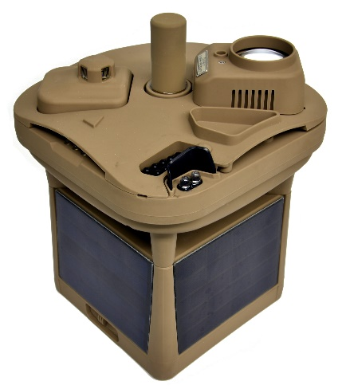 [1]
Figure 1 MWS-M625 portable weather station
Figure 1 shows an MWS-M625 portable weather station. These were made by Intelligence Systems and measures up to 10,000 feet of cloud height. The system was lightweight and very rugged. It would be used in very remote locations. The system also supported real time weather monitoring. [1]

MeteoHelix® IoT Pro - Sigfox Micro-Weather Station
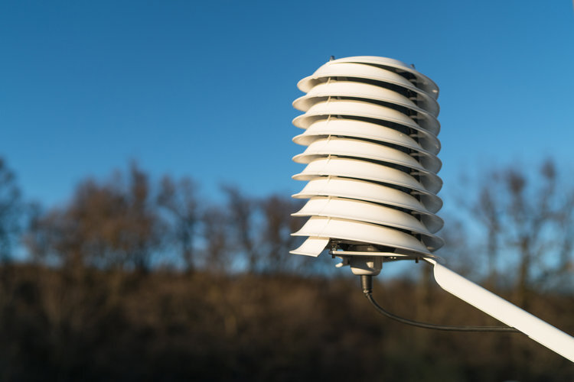 [2]
Figure 2 MeteoHelix® IoT Pro - Sigfox Micro-Weather Station
Figure 2 shows the MeteoHelix® IoT Pro - Sigfox Micro-Weather Station, which is an all-in-one micro weather station. The device incorporates self-charging from its integrated solar panels and battery that lasts up to 6 months without any charge. The device is also wireless, so can be used in a number of remote locations. [2]

Ecowitt Weather Station WS2910
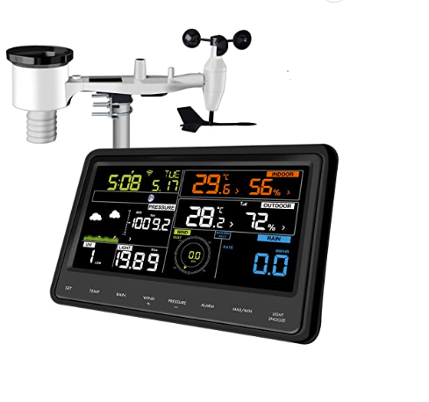 [3]
Figure 3 Ecowitt Weather Stations WS2910
Figure 3 shows the Ecowitt weather WS2910. This device is a 7-in1 wireless device that included a wind vane, wind speed cup, UV sensor, rain gauge and solar collector. It also included a colour LCD display showing all readings collected in real-time. Alerts were capable of being set for maximum and minimum levels of wind temperature etc. [3]

Skywatch BL-1000 Weather station
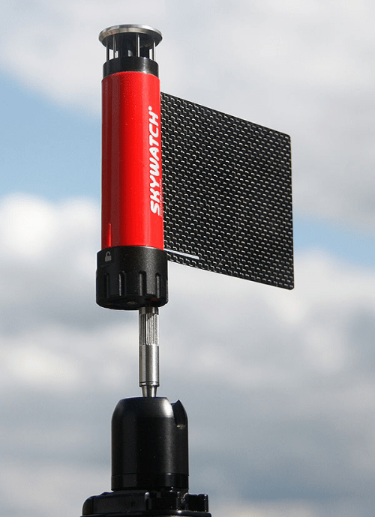 [4]
Figure 4 Skywatch BL-1000 Weather station for emergency and incident response
Figure 4 shows the Skywatch BL-1000 Weather station, which is a portable weather station used for fast deployment. It can be used by the emergency services and incident response teams, open air exhibitions and construction companies.
It measured wind speed, direction, temperature, humidity, and pressure. The device was also wireless and can be connected to smartphone application to monitor and store real time data gathered.

Comparison Table
 | MWS-M625  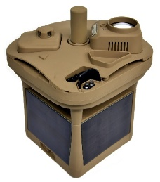 | MeteoHelix® IoT Pro  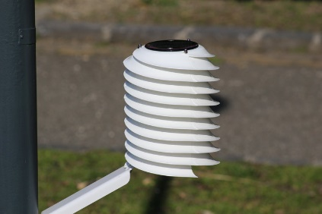 | Ecowitt WS2910  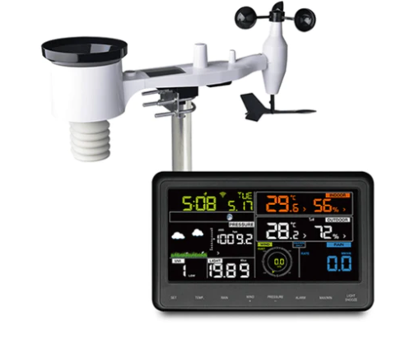 | Skywatch BL-1000  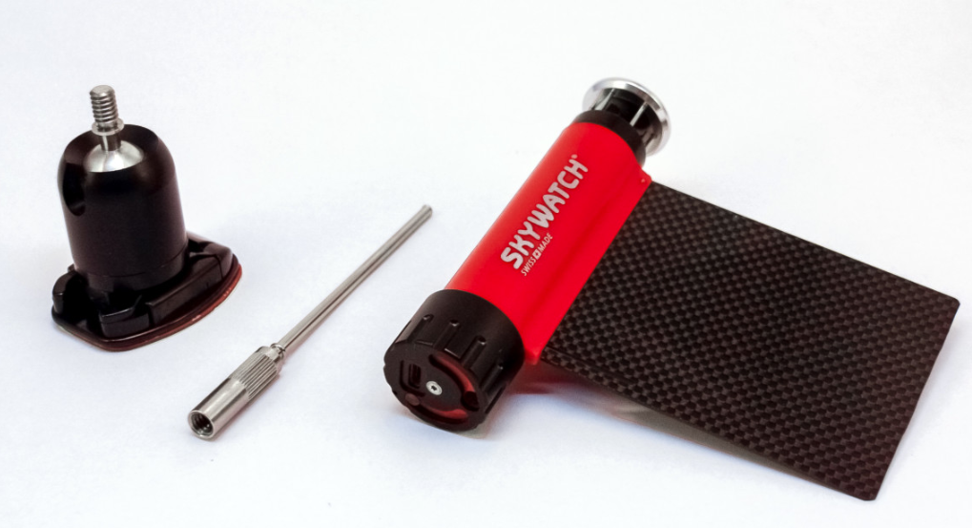
Wireless Communication | Yes | Yes | Yes | Yes
Supply Voltage | Solar powered with LI Ion battery for 6 months without sun | Solar powered with LI Ion battery for 4 months without sun | 2 x AA 1.5V Lithium battery | 5V rechargeable battery. Battery life last more than a week
Operating Temperature | -40 to 60°C | -33 °C to +65 °C | -20 °C to +65 °C | -20 to +50 C
IP Rating | IP 67 | IP65W | IP 65 | IP 67
Dimensions | L –=205mm, W = 100mm, H = 100mm | Diameter = 170 mm, Height = 226 mm | L –=405mm, W = 100mm, H = 35mm | Diameter = 17 mm, Height = 305 mm
Weight | 1.2Kg | 1.2 kg | 2.2Kg | 0.5Kg
Temperature Accuracy | ± 1.0°C | ±0.2 °C (typical) | ±0.2 °C | +/- 0.3 C
Temperature Resolution | 0.1°C | 0.1 °C | +/- 0.1 C | 0.1 °C
Temperature measuring range | -45 ° to 110 °C | -45 ° to 105 °C | -25 ° to 60 °C | -25 C to +60 C
Humidity Accuracy | ±2 %RH | ±1.5 %RH @ 25 °C hysteresis ±1 % | ±5 %RH | +/0 3% (10-90 %rH)
Solar Irradtion operating range | N/A | -40 °C to 65 °C  (Battery limitation) | N/A | N/A
Atmospheric Pressure measuring range | 600 to 1110 mb | 300 to 1300 hPa | 700-1100hPa (20.67-32.5inHg) | 300 to 1200 hPa
Table 1 Weather Station specification comparison table

System Design
For the portable weather station system design a comparison of possible sensors was carried out to ascertain which type would best suit for the operation required. The following tables showed alternate types, with the appropriately selected. Advantages and disadvantages showing for the criteria.

Temperature measurement
Type of Contact | Component | Pros | Cons
Non-contact | Mercury Thermometer  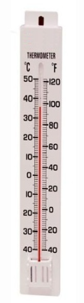 [5] | - Low cost  - Very robust | - Display can be difficult to read  - Doesn’t work below -40°C  - Cannot be connected to MCU  - Not accurate
Contact | Thermocouple  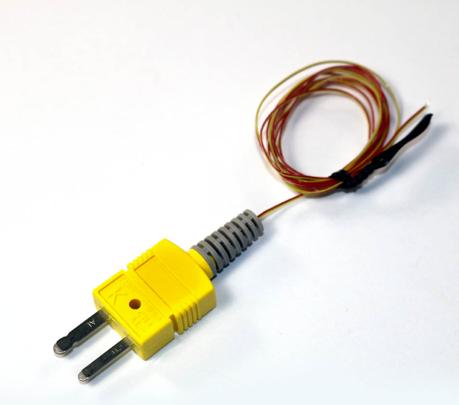 [6] | - Low Cost  - Very robust  - Very accurate | - Needs contact to function  - Requires amplification
Non-contact | NTC Temperature Sensor  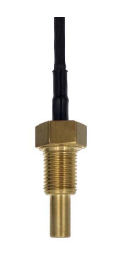 [7] | - Low cost  - Very Robust  - Very Accurate | • Current from excitation must be low to avoid over heating
Table 2 Temperature measurement alternatives table
As shown in table 2, an NTC Temperature sensor was chosen to record the temperature on the weather station. This type of sensor was used for environmental capture and was non-contact. The mercury thermometer would have to be manually read as it didn’t have connection capability. Thermocouple required contact to pick up the temperature.

Temperature Sensor Comparison
Part Number | Manufacturer/  Supplier | Dimensions  (mm) | Technical Spec | Price
SA-NTCM06_5V-000  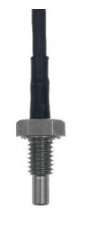 [7] | 2D Debus & Diebold Meßsysteme GmbH | 20mm X  Ø4mm, 10mm | Operating Voltage – 5V  Current draw – 40mA  Signal - Analogue  Measurement range - 0°C to 150°C  Accuracy - ±0.5  IP rating – 67  Ambient op. range - -25°C to 85°C  Humidity – 5 to 95% [7] | £40.12
TT541/10K3A1, Pipe, Thermistor  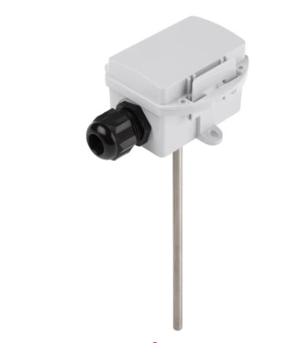 [8] | RS PRO Type NTC Temperature Sensor | 150x Ø6mm | Operating Voltage – 24V  Current draw – 30mA  Signal - Analogue  Measurement range - -10°C to 110°C  Accuracy - ±0.5  IP rating – 65  Ambient op. range - -25°C to 85°C  Humidity – 5 to 95% [7] | £32.17
NTC015WH01  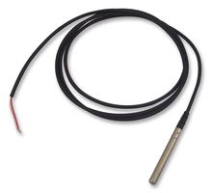 [9] | Farnell UK | 50mm X Ø6mm | Operating Voltage – 5V  Signal – Analogue  Current draw – 40mA  Measurement range - -50°C to 110°C  Accuracy - ±0.5  IP rating – 68  Ambient op. range - -25°C to 85°C  Humidity -  5 to 90°C | £16.21
Table 3 NTC Temperature Sensor Comparison table
As shown in table 3, the NTC015WH01 NTC temperature probe was chosen due to its low voltage and current draw. The sensors measurement range was wide, so could measure deep into artic and tropical conditions.The IP rating was 68, so had a high level of protection against dust and water immersion.

1 reading taken every 15 seconds over the 14 days test time.

2 bytes was taken per reading
Number of bytes per minute $\frac{15}{60}$ = 4 bytes per min
14 days test = 1440 mins per day X 14 days
=80,640 bytes
Figure 5 Calculation of number of bytes required over 14-day test for temperature measurement

Humidity measurement
Type of Contact | Component | Pros | Cons
Non - contact | Hygrometer  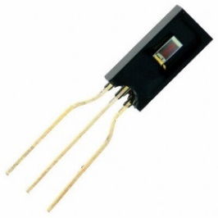 [10] | - Provides linear voltage  - Resistant to chemical vapours | - Readings heightened if humidity increases quick  - Sensitivity compromised in harsh environments
Non - contact | Electronic capacitance polymer film sensor  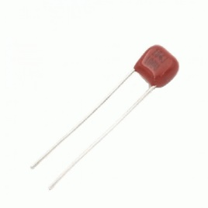 [11] | - High sensitivity  - Low cost  - Excellent resolution  - Excellent frequency response | - Sensitive to changes in humidity  - Not as accurate as inductive sensor
Table 4 Humidity measurement alternatives table
As shown in table 4, an electronic capacitance sensor was chosen due to its high level of sensitivity and high level of resolution and frequency. This allowed higher level of data points and rate of transmission. The humidity was positioned underneath the system to prevent moisture and rainfall gathering on the sensor.

Humidity Sensor Comparison
Part Number | Manufacturer/  Supplier | Dimensions  (mm) | Technical Spec | Price
246-5635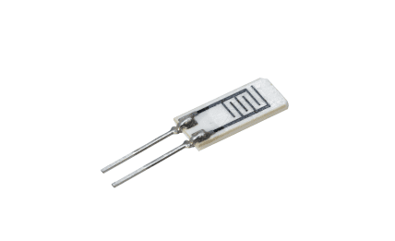 [12] | RS | 18mm X 10mm X 2mm | Operating Voltage – 1V  Current draw – 10mA  Signal - Analogue  Measurement range – 20 – 90%RH  Accuracy - ±3%RH  IP rating – 64  Ambient op. range - -0°C to 60°C  Humidity -  5 to 90°C [12] | £1.80
DHT11  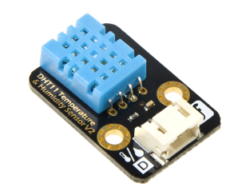 [13] | RS | 12mm x 15.5mm x 5.5mm | Operating Voltage – 5.5V  Current draw – 10mA  Signal - Digital  Measurement range – 20 – 90%RH  Accuracy - ±1%RH  IP rating – 64  Ambient op. range - -0°C to 60°C  Humidity -  5 to 90°C [12] | £6.17
HIH-4000 Series  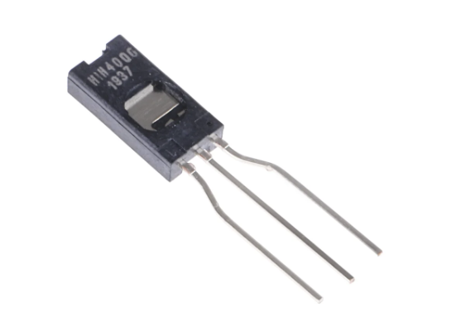 | Honeywell | 4.17 x 2.03 x 20.79mm | Operating Voltage – 5.5V  Current draw – 20mA  Signal - Analogue  Measurement range – 15 – 90%RH  Accuracy - ±3.5%RH  IP rating – 64  Ambient op. range - -0°C to 60°C  Humidity -  5 to 90°C | 30.46
Table 5 NTC Capacitance Humidity Sensor Comparison table
As shown in table 5, the Honeywell HIH-400 Humidity sensor was chosen for the weather station. With a 5V operating voltage there was no need to alter the output voltage for the microcontroller. This sensor had the highest Relative Humidity range, so was able to detect arid and dense environments. [14]
1 reading taken every 15 seconds over the 14 days test time.

2 bytes was taken per reading
Number of bytes per minute $\frac{15}{60}$ = 4 bytes per min
14 days test = 1440 mins per day X 14 days
=80,640 bytes
Figure 6 Calculation for total number of bytes over 14 days for humidity measurement

Wind Speed measurement
Type of Contact | Component | Pros | Cons
Non-contact | Anemometer  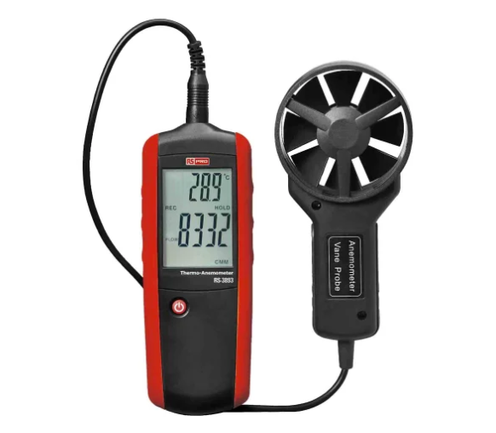 [15] | - Will also measure wind pressure, velocity, direction  - High precision  - Low power  - Low cost | - Extreme weather can cause damage
 | Laser-based LIDAR  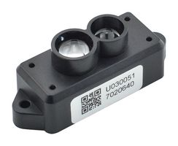 [16] | - High Accuracy  - Fast acquisition and processing  - Low weather independence | - High cost  - Affected in extreme weather  - Complicated data sets
Non-contact | Doppler Radar  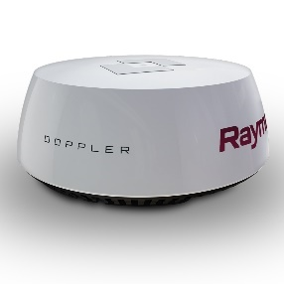 [17] | - High cost  - Lightweight  - High accuracy | - Limited range  - Unable to detect wind independently  - Unreliable
Non-contact | Ultrasonic Wind Speed  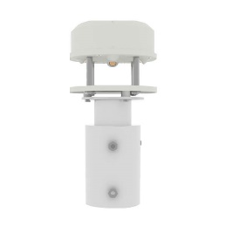 | - Lightweight  - Very robust  - Measures speed and direction | - High cost
Table 6 Wind Speed measurement alternatives table
As shown in table 6, the Ultrasonic anemometer was chosen to measure wind speed. This was chosen due to its portability as the weather station was required to be able to move to varying locations. It gave a high level of precision for readings and would consume a low amount of power to run.

Wind Speed Sensor comparison
Part Number | Manufacturer/  Supplier | Dimensions  (mm) | Technical Spec | Price
Renke RS-CFSFX  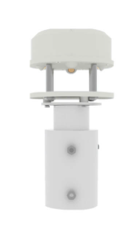 [18] | Renke | 282mm X Ø41mm | Operating Voltage – 5V  Current draw – 20mA  Signal - Analogue  Measurement range – 0 – 60m/s  Accuracy - ±(0.2m/s±0.02*v) (v is the real wind speed)  IP rating – 66  Ambient op. range - -40°C to 60°C  Resolution – 0.1s  [18] | £200
OMC-116  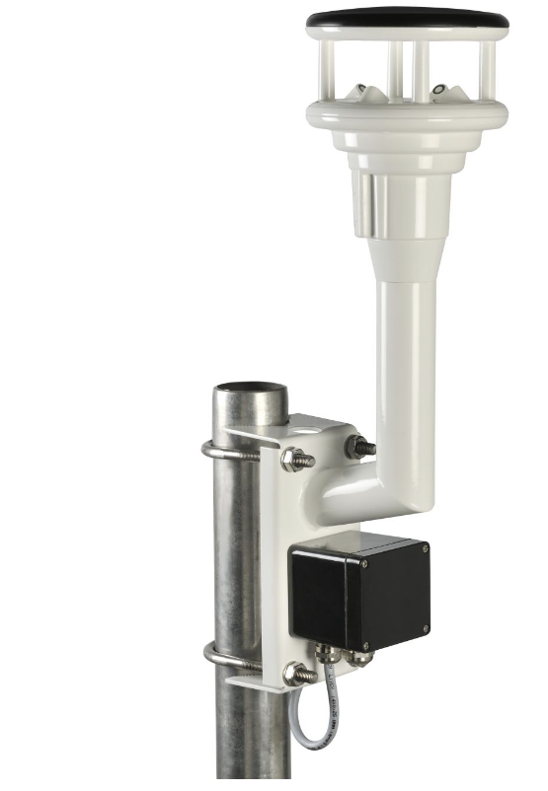 [19] | Observator Instruments | 570mm X Ø45mm | Operating Voltage – 12V  Current draw – 40mA  Signal - Analogue  Measurement range – 0 – 90m/s  Accuracy - ±0.2m  IP rating – 66  Ambient op. range - -20°C to 60°C  Resolution – 0.2s  [19] | £1200
110WX  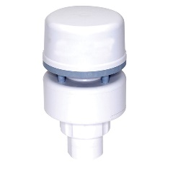 [20] | NAVICO | 131mm X Ø75mm | Operating Voltage – 12V  Current draw – 50mA  Signal - Analogue  Measurement range – 0 – 40m/s  Accuracy - ±0.1m  IP rating – X6  Ambient op. range - -25°C to 55°C  Resolution – 0.1s  [20] | £100
Table 7 Ultrasonic Wind Speed Sensor Comparison table
As shown in table 7, the Renke RS-CFSFX was chosen to measure the wind speed for the potable weather station. Operating voltage was 5V, so required no manipulation to use with a microcontroller. The range of measurement was at 0 – 40m/s, so would detect a high level of speed. A high level of resolution was also capable from this sensor.
1 reading taken every 30 seconds over the 14 days test time.

2 bytes was taken per reading
Number of bytes per minute $\frac{30}{60}$ = 2 bytes per min
14-day test = 1440 x 14
= 20,160 mins
Total number of bytes per 14-day test =
2 x 20,160 =
40,320 bytes
Figure 7 Calculation for total number of bytes over 14 days for wind speed measurement

Wind Direction measurement
Type of Contact | Component | Pros | Cons
Non-contact | Anemometer  [15] | - Will also measure wind pressure, velocity, direction  - High precision  - Low power  - Low cost | - Extreme weather can cause damage
 | Laser-based LIDAR  [16] | - High Accuracy  - Fast acquisition and processing  - Low weather independence | - High cost  - Affected in extreme weather  - Complicated data sets
Non-contact | Doppler Radar  [17] | - High cost  - Lightweight  - High accuracy | - Limited range  - Unable to detect wind independently  - Unreliable
Non-contact | Ultrasonic Wind Speed | - Lightweight  - Very robust  - Measures speed and direction | - High cost
Table 8 Wind direction measurement alternatives table
As shown in table 8, the ultrasonic wind sensor was chosen to measure wind direction. This was chosen as this type of sensor was also chosen for wind speed. The same sensor could be used for both measurements.

Wind Direction Sensor measurement
Part Number | Manufacturer/  Supplier | Dimensions  (mm) | Technical Spec | Price
Renke RS-CFSFX  [18] | Renke | 282mm X Ø41mm | Operating Voltage – 5V  Current draw – 20mA  Signal - Analogue  Measurement range – 0 – 359°  Accuracy - ±3°  IP rating – 66  Ambient op. range - -40°C to 60°C  Resolution – 0.1°  [18] | £200
OMC-116  [19] | Observator Instruments | 570mm X Ø45mm | Operating Voltage – 12V  Current draw – 40mA  Signal - Analogue  Measurement range – 0 – 359°  Accuracy - ±2°  IP rating – 66  Ambient op. range - -20°C to 60°C  Resolution – 0.2°  [19] | £1200
110WX  [20] | NAVICO | 131mm X Ø75mm | Operating Voltage – 12V  Current draw – 50mA  Signal - Analogue  Measurement range – 0 – 359°  Accuracy - ±3°  IP rating – X6  Ambient op. range - -25°C to 55°C  Resolution – 0.1°  [20] | £100
Table 9 Ultrasonic Wind direction Sensor Comparison table
As shown in table 9, the Renke RS-CFSFX was chosen to measure the wind direction. This was chosen due to the output voltage of 5V, so the voltage would not require to be altered for the microcontroller. Resolution was high at 0.1°, and the IP rating was 66, so was water resistant and protected from dust.

2 bytes was taken per reading
Number of bytes per minute $\frac{30}{60}$ = 2 bytes per min
14-day test = 1440 x 14
= 20,160 mins
Total number of bytes per 14-day test =
2 x 20,160 =
40,320 bytes
Figure 8 Calculation for total number of bytes over 14 days for wind direction measurement

Air borne particle count measurement
Type of Contact | Component | Pros | Cons
Non-contact | Ambient Air Passive Sampler  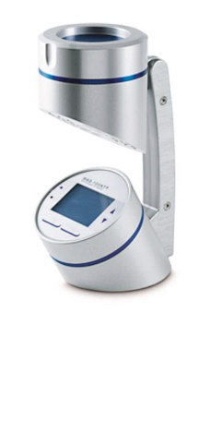 [21] | - Low cost | - Unable to measure all particles due to low diffusion of particle
Non-contact | Air Quality Sensor  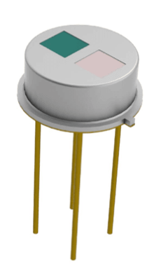 [22] | - Low cost  - Low power  - High Accuracy | - Sensitivity
Table 10 Air Borne particle count measurement alternatives table
As shown in table 10, the type of sensor to measure air particle count was an air quality sensor as this type of sensor was cheap and had a low power consumption.

Air borne particle count sensor
Part Number | Manufacturer/  Supplier | Dimensions  (mm) | Technical Spec | Price
LM393 MQ-135  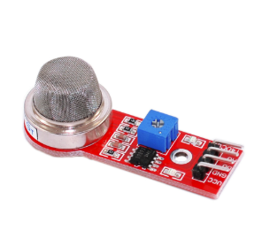 [23] | OKY3339 | 35mm X 32mm X 13mm | Operating Voltage – 5V  Signal - Digital  Particle Measurement range – 0.3 ~ 1.0 / 1.0 ~ 2.5 / 2.5 ~ 10 (micron)  Max Current – 100mA  IP rating – 66  Ambient op. range - -15°C to 50°C  Response time – 2s | £23.12
PM2.5 Particle Sensor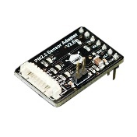  [24] | DFRobot | 46mm X 35mm X 20mm | Operating Voltage – 5V  Signal - Digital  Particle Measurement range – 0.4 ~ 1.0 / 1.0 ~ 2.5 / 2.5 ~ 10 (micron)  Max Current – 120mA  IP rating – 66  Ambient op. range - -20°C to 50°C  Response time – 2s | £45.18
IPS-7100-1  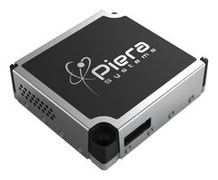 [25] | PIERA SYSTEMS | 46mm x 415mm x 1.24cm | Operating Voltage – 5.5V  Signal - Digital  Particle Measurement range – 0.5 - 1(micron)  Max Current – 65mA  IP rating – 66  Ambient op. range - -10°C to 55°C  Response time – 1s [20] | £79.80
Table 11 Air borne Sensor Comparison table
As shown in table 11, the LM393 MQ-135 was chosen due to its range of particle measurement as the range was wider than the alternatives, so could potentially capture a wider size of particle for analysis. The IP rating was 66, so was dust proof and water resistant.

To find the number of bytes for the 14-day test: -
1 byte per reading – 1 reading per second
Number of bytes per min = 1 X 60=
60 bytes per min
Total mins = 1440 X 14
= 20,160
Total bytes for 14-day test = 60 X 20,160 -=
1.2Mb
Figure 9 Calculation for total number of bytes over 14 days for air borne particle count measurement

Sunlight measurement
Type of Contact | Component | Pros | Cons
Non-contact | Light sensor  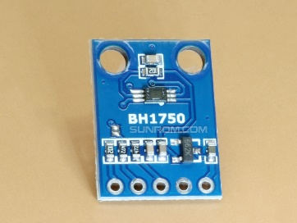 [26] | - High level of accuracy  - Low cost | - Sensitivity
Non-contact | Photo diode  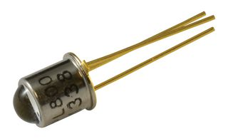 [27] | - Low cost  - Quick, linear response  - High speed | - Poor temperature stability  - Amplification required
Non-contact | Light dependant resistor (LDR)  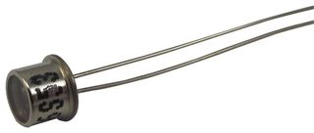 | - Low power  - High sensitivity  - No biasing required | - Poor temperature stability  - Slow response  - Affected by hysteresis
Table 12 Sunlight measurement alternatives table
As shown in table 12, the photo diode sensor was chosen to measure sunlight. This was chosen due to its high-speed transmission of data and its quick response to changes in light. This type of sensor produces a low output, so required amplification.
A transimpedance amplifier circuit was used for the photo diode. The diode was used in zero-bias mode, so when no light shone, no current would flow.

Sunlight measurement sensor
Part Number | Manufacturer/  Supplier | Dimensions  (mm) | Technical Spec | Price
QSD2030  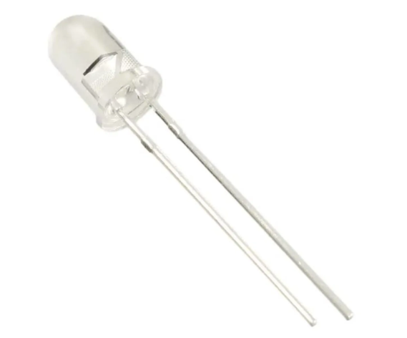  [28] | OnSemi/Fairchild | 30mm X Ø5mm | Operating Voltage – 1.3V  Signal - analogue  Wide Reception Angle - 40°  Peak sensitivity – 880nm  Max. current – 80mA | £0.254
OPL800  [27] | TT Electronics/Optek technology | 33mm X Ø5mm | Operating Voltage – 5.5V  Signal - analogue  Wide Reception Angle - 35°  Peak sensitivity – 935nm  Max. current – 15mA | £0.31
S5973  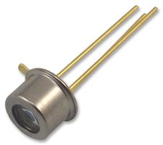  [29] | Hamamatsu | 32mm X Ø6mm | Operating Voltage – 3.3V  Signal - analogue  Wide Reception Angle - 40°  Peak sensitivity – 760nm  Max. current – 740mA | £27.60
LSIPD-L2  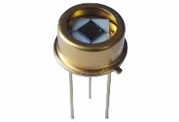 [30] | Beamqus | 342mm X Ø8mm | Operating Voltage – 5V  Signal - analogue  Wide Reception Angle - 42°  Peak sensitivity – 1700nm  Max. current – 3mA | £80
Table 13 Photo Diode Comparison table
As shown in table 13, the On semi QSD2030 was chosen even though the voltage was low and required an op-amp to boost the signal for the microcontroller to read. Mid-range sensitivity compared to the alternatives. The other sensors required a transducer in set up.
To find the number of bytes for the 14-day test: -
1 byte per reading – 1 reading per 10 seconds
Number of bytes per minute $\frac{10}{60}$ = 6 bytes per min
Total mins = 1440 X 14
= 20,160
Total bytes for 14-day test = 6 X 20,160 -=
120,960 bytes
Figure 10 Calculation for total number of bytes over 14 days for sunlight measurement

UV level measurement
Type of Contact | Component | Pros | Cons
Non-contact | UV phototube  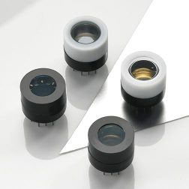 [31] | - Wide spectral response  - Very stable | - High voltage required  - Very fragile  - High cost
Non-contact | UV Light Sensor  [26] | - High level of accuracy  - Low cost | - Sensitivity
Non-contact | UV Spectrum sensor  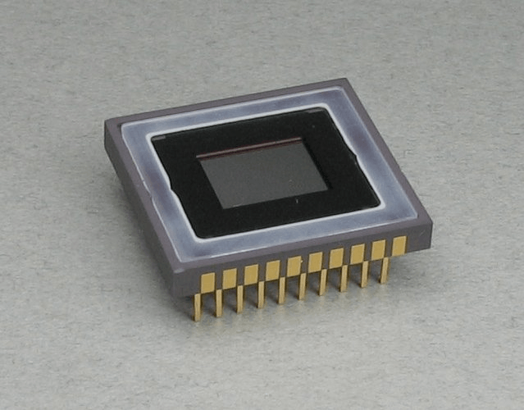 [32] | - Low cost  - Data analysis simple  - Ease of use | - Only analyzes liquid samples
Table 14 UV level measurement alternatives table
As shown in table 14, the UV light sensor was chosen due to its robustness to handle extreme weather, as the phototube was very fragile and had the potential to become damaged from bad conditions. The spectrum sensor would measure a lager range of UV spectrum that included harmful UV light. [33] This level of measurement was not required to measure UV rays for the weather station.

UV Level measurement sensor
Part Number | Manufacturer/  Supplier | Dimensions  (mm) | Technical Spec | Price
PMA1110  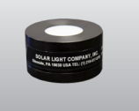 [34] | Solar Light | 21mm X Ø15mm | Operating Voltage – 5V  Signal - analogue  IP rating - 68  Spectral Response – 320 – 400nm  Operating temp. 0 to 50°C  Max. current – 30mA  Sensitivity - 11mV / W/m² | £34.12
UVA-BTA  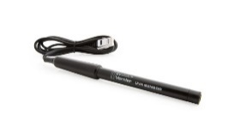 [35] | Vernier | 210mm X Ø2mm | Operating Voltage – 3.5V  Signal - analogue  IP rating - 64  Spectral Response – 320 – 390nm  Operating temp. 0 to 40°C  Max. current – 50mA  Sensitivity - 10mV / W/m² | £150.31
SKU 421  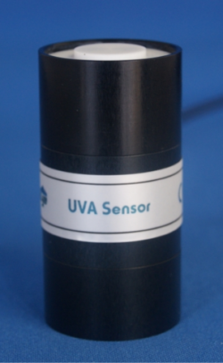 | Skye Instruments | 67mm X Ø16mm | Operating Voltage – 10V  Signal - analogue  IP rating - 67  Spectral Response – 315 – 400nm  Operating temp. -30 to 60°C  Max. current – 20mA  Sensitivity - 10mV / W/m² | £192.60
UV-405-E  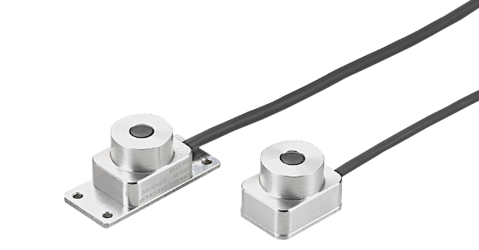 | Fotek | 20mm X Ø14mm | Operating Voltage – 5V  Signal - analogue  IP rating - 68  Spectral Response – 340 – 440nm  Operating temp. -20 to 80°C  Max. current – 20mA | £42
Table 15 UV sensor Comparison table
As shown in table 15, the Fotek UV-405-E was chosen to measure UV. Output voltage of 5V, so no manipulation was required for the microcontroller. The IP rating was 68, so was protective against harsh elements.The spectral response was one of the widest ranges at 340 – 440nm, so would pick up a higher level of UV. The operating temperature was -20 to 80°C, so would operate in all environmental conditions.

To find the number of bytes for the 14-day test: -
1 byte per reading – 1 reading per 10 seconds
Number of bytes per minute $\frac{10}{60}$ = 6 bytes per min
Total mins = 1440 X 14
= 20,160
Total bytes for 14-day test = 6 X 20,160 -=
120,960 bytes
Figure 11 Calculation for total number of bytes over 14 days for UV level measurement

GPS position
Type of Contact | Component | Pros | Cons
Non-contact | Gyroscope  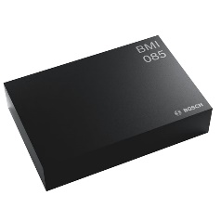 [36] | - Measures 3-axis  - Fast in response  - Low in cost | - Used primarily for orientation  - Unable to give an exact location
Non-contact | Accelerometer  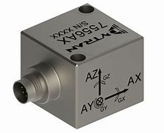  [37] | - Low cost  - High frequency response  - High sensitivity | - Measures change in velocity, not constant velocity  - Sensitive to temperature
Non-contact | Magnetometer  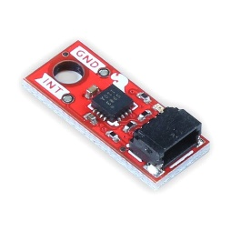 [38] | - Low power consumption  - Gives wide magnetic field of range | - Low precision  - Very sensitive to environment
Non - contact | GPS Sensor  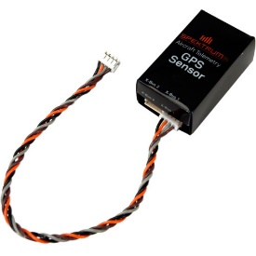 [39] | - Full coverage of earth  - Accessible anywhere  - Works in all conditions | - High in power consumption
Table 16 GPS position alternatives table
As shown in table 16, the GPS sensor was chosen due to its reliability to give a signal to the associated satellites in any location on earth. Even though the sensor consumes a higher level of power compared to the alternatives. The other sensors would only measure direction, orientation, and speed.

GPS sensor
Part Number | Manufacturer/  Supplier | Dimensions  (mm) | Technical Spec | Price
2195768-1  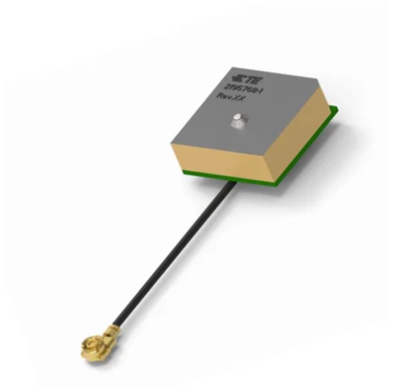 [40] | TE Connectivity | 12mm X 12mm X 6.5mm | Operating Voltage – 3V  Signal - analogue  IP rating - 64  Bandwidth – 10MHz  Operating temp. -40 to 90°C  Max. current – 5mA  Frequency range – 1575.42 ±2MHz | £24.72
L70B-M39  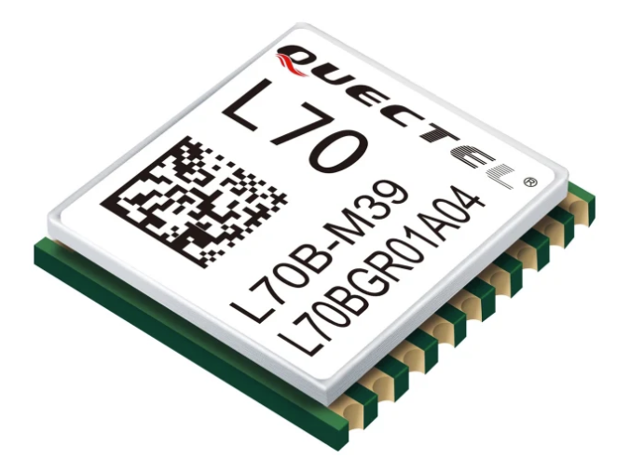 [41] | Quectel | 10mm X 9mm X 2.5mm | Operating Voltage – 3V  Signal - Digital  IP rating - 64  Bandwidth – 10MHz  Operating temp. -40 to 85°C  Max. current – 18mA  Frequency range – 1575.42 ±2MHz | £14.31
Dev 50Hz  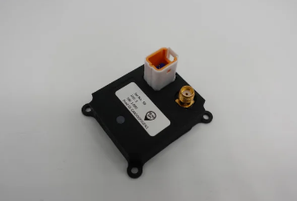 [42] | Metis | 22mm X 40mm X 45mm | Operating Voltage – 28V  Signal - analogue  IP rating - 65  Bandwidth – 10MHz  Operating temp. -20 to 80°C  Max. current – 110mA  Frequency range – 1000 ±2MHz | £40.12
113020003  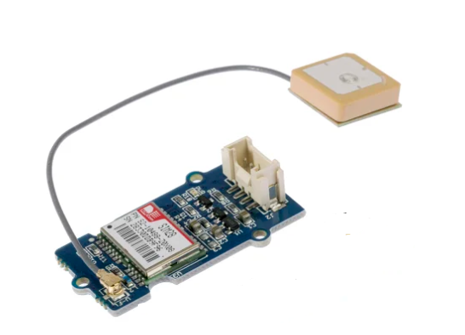 [43] | TNT | 40mm X 13mm X 13mm | Operating Voltage – 3V  Signal - analogue  IP rating - 64  Bandwidth – 10MHz  Operating temp. -40 to 85°C  Max. current – 40mA  Frequency range – 1575.42 ±2MHz | £26.38
Table 17 GPS sensor Comparison table
As shown in table 17, the 2195768-1 was chosen due to its low current consumption, large bandwidth, and high range of frequency. With a low voltage of 3V, the sensors output required to an op-amp to magnify its voltage to 5V for the microprocessor to recognise the signal.
1 reading taken every 15 seconds over the 14 days test time.

2 bytes was taken per reading
Number of bytes per minute $\frac{15}{60}$ = 4 bytes per min
14 days test = 1440 mins per day X 14 days
=80,640 bytes
Figure 12 Calculation for total number of bytes over 14 days for GPS measurement

VOC level measurement
Type of Contact | Component | Pros | Cons
Non-contact | Photoionization Sensor  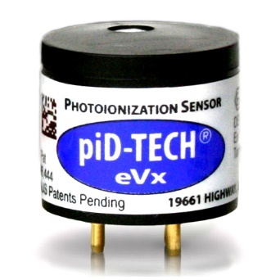 [44] | - Measures low level of VOC  - Low cost  - Ease of operation | - Unable to measure all types of gas
Non-contact | Flame Ionization Sensor  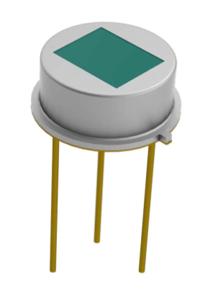 [45] | - Low maintenance  - Robust in build  - Large linearity range of measurement | - Unable to detect some inorganic substances
Non-contact | Metal Oxide Semiconductor Sensor  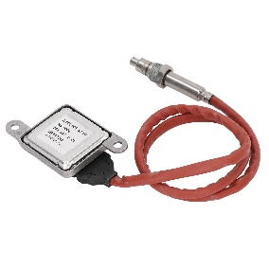 [46] | - High response to ozone  - High accuracy  - Low cross interference | - High power consumption
Table 18 VOC level measurement alternatives table
As shown in table 18, the MOS sensor was chosen due to its sensitivity to measuring gases included in the ozone, high level of accuracy and its ability to withstand interference. The only downside to this type of sensor was it being susceptible to a higher level of current draw.

VOC level sensor
Part Number | Manufacturer/  Supplier | Dimensions  (mm) | Technical Spec | Price
MQ-4  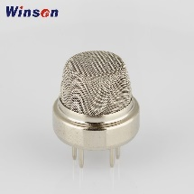 [47] | Wilsen | 12mm X Ø6.5mm | Operating Voltage – 5V  Signal - analogue  IP rating - 67  Detection Range – 300 -10000ppm  Operating temp. -40 to 90°C  Max. current – 20mA | £14.72
SGP40-D-R4 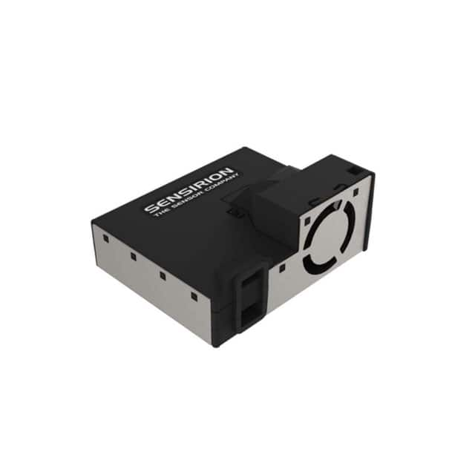  [48] | Sensirion AG | 43mm X 9  52mm X 25mm | Operating Voltage – 5V  Signal – Digital/I2C  IP rating - 64  Detection Range – 400 -10000ppm  Operating temp. -10 to 90°C  Max. current – 110mA | £27.31
SVM30-J  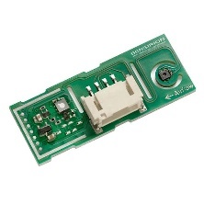 [49] | Sensirion AG | 39mm X 16mm X 6.5mm | Operating Voltage – 5V  Signal - Digital/I2C  IP rating - 64  Detection Range – 500 -10000ppm  Operating temp. -20 to 85°C  Max. current – 49mA | £19.12
PS1-VOC-1000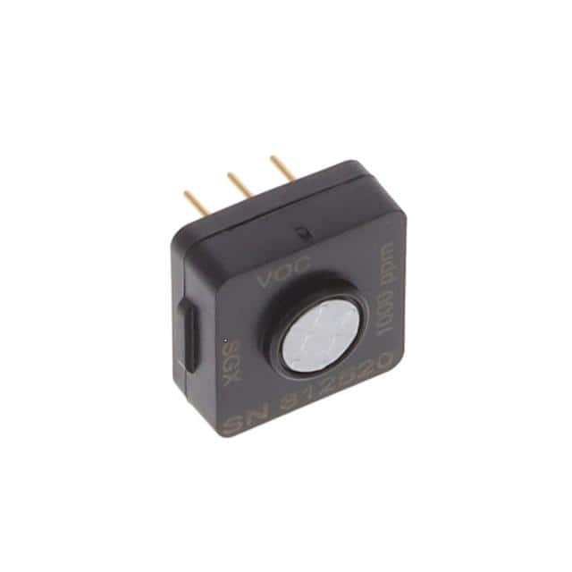  [50] | Amphenol SGX Sensortech | 25mm X 13mm X 13mm | Operating Voltage – 5V  Signal - analogue  IP rating - 66  Detection Range – 300 -10000ppm  Operating temp. -40 to 55°C  Max. current – 35mA | £26.38
Table 19 VOC sensor Comparison table
As shown in table 19, the MQ-4 VOC sensor was chosen due to its high IP rating to avoid dust or moisture affecting the device, its low current draw of 20mA, and its high range of detection for the applicable gases for the weather station.
To find the number of bytes for the 14-day test: -
1 byte per reading – 1 reading per 10 seconds
Number of bytes per minute $\frac{10}{60}$ = 6 bytes per min
Total mins = 1440 X 14
= 20,160
Total bytes for 14-day test = 6 X 20,160 -=
120,960 bytes
Figure 13 Calculation for total number of bytes over 14 days for VOC measurement

Microcontroller
When choosing a microcontroller, for the size of the system, memory was estimated. Around 16k of space for programme memory was chosen. A clock frequency of around 45MHz was required. For all sensors connected to the microcontrollers, interrupts were also required. This was due to the system functioning on condensed timings. The system also required connection via a USB port, so that was also taken into consideration.

Total analogue inputs required were: -
Sensor | No. of sensors | No. of inputs
Temperature | 1 required | 1
Humidity | 1 required | 1
Wind Speed | 1 required | 1
Wind Direction | 1 required | 1
Sunlight Brightness | 1 required | 1
UV levels | 1 required | 1
GPS Position | 1 required | 1
VOC level | 1 required | 1
 |  | Total analogue 8
Table 20 Total analogue inputs required
Total digital inputs required were: -
Sensor | No. of sensors | No. of inputs
Air borne particle count | 1 | 1
 |  | Total digital 1
Table 21 Total digital inputs required
Total pins required = 9
As shown in tables 20 and 21, the total number of pins required was 9 for the sensors. A push START/STOP button was also required on the system. The microcontroller also required to be USB compliant. The microcontroller chosen was PIC18F24K50, as shown in figure. This was chosen due to the criteria required for memory, clock speed, USB capability and number of I/O required.
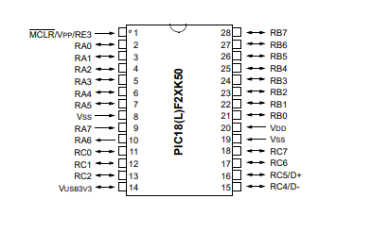
Figure 14 PIC18F24K50 schematic showing pin functions

Storage Memory
Part Number | Dimensions (mm) | Technical Spec | Price
410-123  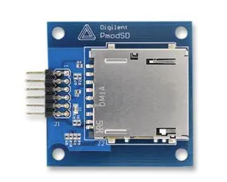 [51] | 46mm X 46mm | Number of pins – 12  Communication size – 1bit/4bit  Interface – SPI | £12.71
Table 22 Memory storage device
When the sensors recorded their respective stimuli and sent to the microcontroller, the data was required to be stored and sent to a storage device which could be externally read via a PC. A reason to back up the data was to prevent data loss in case the system failed from power issues.
A non-volatile SD card was chosen for the back-up data medium. This negated the process if the power was cut or lost during data collection.
SD means Secure Digital and is usually a removable memory card that is flashed based. Synchronous Serial protocol (SPI) is a communication protocol from the microcontroller and the SD card. [52]
Due to the simplicity of connection and rate of transfer, the SPI protocol was chosen. The SD input from the microcontroller was around 4.5V, so the voltage was lowered using a resistor as the operating voltage of the SD card was around 3V.

Sensor | Bytes/reading | Number/min | Total mins | Total for 14 days
Temperature | 2 | 4 | 20,160 | 80,640
Humidity | 2 | 4 | 20,160 | 80,640
Wind Speed | 2 | 2 | 20,160 | 40,320
Wind Direction | 2 | 2 | 20,160 | 40,320
Air particle count | 1 | 60 | 20,160 | 1,200,000
Sunlight bright | 1 | 6 | 20,160 | 120,960
UV Levels | 1 | 6 | 20,160 | 120,960
GPS position | 2 | 4 | 20,160 | 80,640
VOC level | 1 | 6 | 20,160 | 120,960
Total (Bytes) |  |  |  | 1,885,4400
Table 23 Total bytes required for complete system over 14 days
As shown in table 23, the total amount of bytes from all sensors over a period of 14 days was 18.85Mb
Part Number | Technical spec | Price
DS2A-512I81C1B  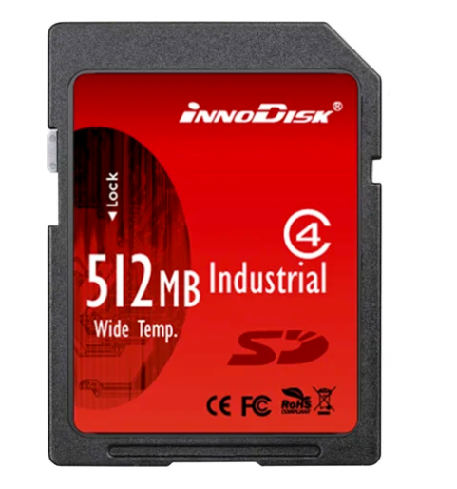  [53] | Manufacturer - Innodisc  Memory capacity – 512Mb  DC input – 2.7V to 3.6V  Transfer mode – SPI  Flash type – SLC (Single Level cell)  Operating temp. -40 to 85°C | £28.12
Table 24 Innodisc SD card specification
As shown in table 24, the Innodisc SD card was used for non-volatile storage which could be accessed via a PC. The storage size of 512Mb was ample for the amount of data accumulated over 14 days at the different locations. The card had SPI protocol and which the microcontroller supported.

Connector comparison table
Component | Material | Specifications | Pros | Cons
Amphenol  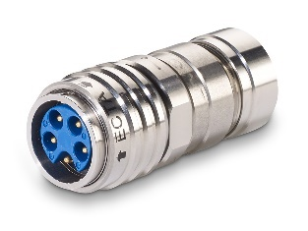  [54] | Stainless Steel | Current rating – 6A  Voltage rating – 500V  Material – Stainless Steel  IP rating – 67 | - Push pull lock system  - Waterproof  - High mating cycle | - High cost
Deutsch  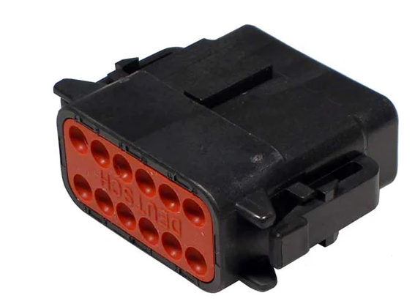  [55] | Polymer | Current rating – 3A  Voltage rating – 300V  Material – Plastic  IP rating – 64 | - Mid-range cost | - Non waterproof
Lemo 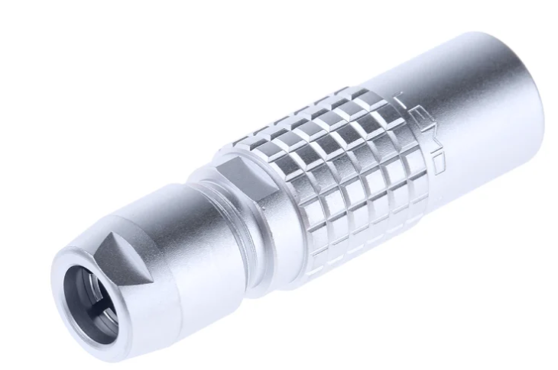 [56] | Polymer | Current rating – 6A  Voltage rating – 500V  Material – Stainless Steel  IP rating – 67 | - Push pull lock system | - High cost
RS Pro  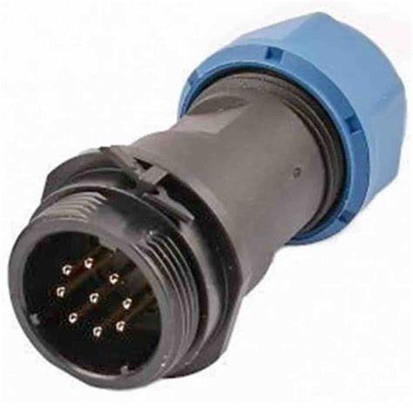 [57]A | Polymer | Current rating – 2A  Voltage rating – 200V  Material – Plastic  IP rating – 63 | - Low cost | - Non waterproof
Table 25 Connector comparison table
As shown in table 25, Amphenol mating connectors , were chosen for the connection of the sensors to the microcontroller. They would handle all types of extreme weather that the system would be subjected to due to the material of stainless steel, and they were waterproof and dust proof, with an IP rating of 67. They would also be able to withstand the constant movement of relocation for the portability of the weather station.
To complement the connectors, mating gold sockets and pins were used in the connector housings. This was due to the fact that the system was in extreme conditions, the gold material would negate harmful oxides that would affect the conductance and not react with the environment. It also has a low contact resistance with low voltages and currents. [58]
A different number of pins was allocated to each different sensor. This was to negate any connection errors when the sensor was connected to the system and prevent false or no readings occurring. A colour code system was also implemented so that the correct sensors were connected.

Sensor connections

Temperature
Sensor | No. of pins | Colour
Temperature | 3
Table 26 Temperature connector colour code chart
As shown in table 26, the temperature sensor was colour coded to prevent error in connection.

Humidity
Sensor | No. of pins | Colour
Humidity | 4
Table 27 Humidity connector colour code chart
As shown in table 27, the humidity sensor was colour coded to prevent error in connection.

Wind Speed
Sensor | No. of pins | Colour
Wind Speed | 5
Table 28 Wind Speed connector colour code chart
As shown in table 28, the wind speed sensor was colour coded to prevent error in connection.

Wind Direction
Sensor | No. of pins | Colour
Wind Direction | 6
Table 29 Wind Direction connector colour code chart
As shown in table 29, the wind direction sensor was colour coded to prevent error in connection.

Air borne particle count
Sensor | No. of pins | Colour
Air borne particle count | 7
Table 30 Air borne particle count connector colour code chart
As shown in table 30, the Air borne particle count sensor was colour coded to prevent error in connection.

Sunlight brightness
Sensor | No. of pins | Colour
Sunlight brightness | 8
Table 31 Sunlight brightness connector colour code chart
As shown in table 31, the Air borne particle count sensor was colour coded to prevent error in connection.

UV levels
Sensor | No. of pins | Colour
UV level | 9
Table 32 UV level connector colour code chart
As shown in table 32, the UV level sensor was colour coded to prevent error in connection.

GPS position
Sensor | No. of pins | Colour
GPS | 10
Table 33 GPS position connector colour code chart
As shown in table 33, the GPS sensor was colour coded to prevent error in connection.

VOC level
Sensor | No. of pins | Colour
VOC level | 11
Table 34 VOC level connector colour code chart
As shown in table 34, the VOC level sensor was colour coded to prevent error in connection.

Casing comparison table
Component | Material | Pros | Cons
FTS QD Quick Deploy  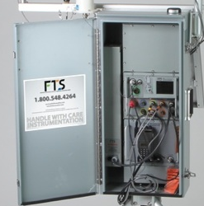  [59] | Stainless Steel | - Waterproof to IP67  - Foam gasket sealed  - Rain drip rail over lid | - High cost
HOBO RX3000  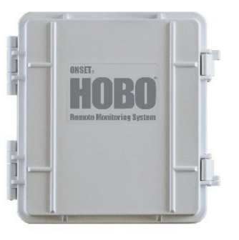 [60] | Aluminium | - NEMA 4X rated protection | - Mid-range cost
Harvest ITU G2  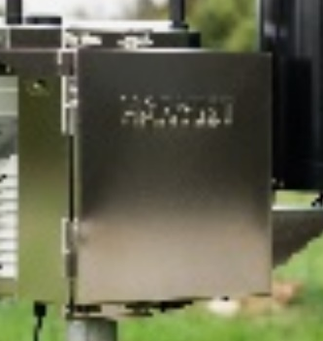  [61] | Stainless Steel | - Waterproof to IP67 | - High cost
Table 35 Portable weather station casing comparison table
As shown in table 35, the FTS QD case was chosen to house the microcontroller and sensors. This was chosen due to its stainless-steel material, which would withstand extreme conditions. The casing also an IP rating of 67, so could repel dust and was waterproof. A gasket seal was also present and a rain drip lid which would protect the electrical hardware inside when the door was open. The compartment was also able to sit upon a tripod, which would allow the weather station to hover above the ground on a stable foundation, as shown in figure 15.

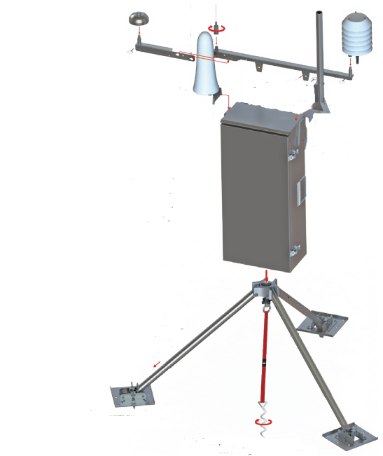 [62]
Figure 15 Illustration of proposed design and layout of weather station located on tripod
As shown in figure 15, the weather station casing situated on a tripod for stability. This would allow the system to be located in various locations without the hardware being subjected to the ground where it could get damaged. This could be dismantled and placed inside its carrying case for easy transport, as shown in figure 16.
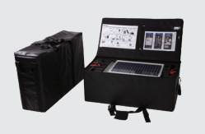 [62]
Figure 16 carry case for dismantled weather station

As shown in figure 16, when dismantled the weather station and tripod would be stored safely away in its carry case for safe transport.

LED and Start/Stop button
A push button was included to operate the weather stations power. This button would illuminate by flashing once every 10 secs for 1 minute to indicate that the system was in operation.
Component | Specification | Price
RS 175-8474  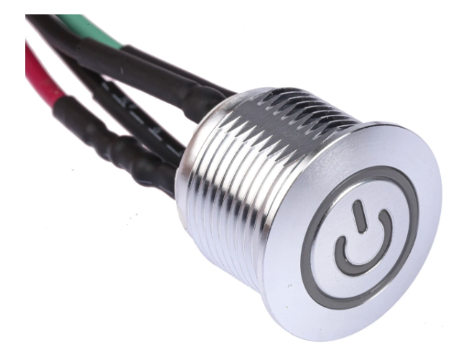 [63] | Switch rating – 2A/36VDC  IP rating – 67  Material - Alloy | £15.97
Table 36 Recommended Push button
As shown in table 36, the RS 175-8474 was chosen to power the weather station due to its IP 67 rating, as this protected the switch from debris, dust and was waterproof so would be protected against extreme weather.

Battery
Component | Specification | Price
Kedanone  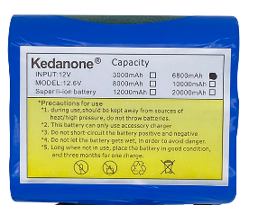 [64] | Voltage – 12V  Capacity – 6.8Ah  Chemistry – Lithium-Ion  Operating Temperature -20 to 70°C | £25 each
Table 37 Recommended battery
As shown in table 37, the Kedanone 12v was chosen to power the weather station system. These were rechargeable lithium-ion, with a maximum voltage of 12V and capacity of 6.8Ah.
Total current draw =415mA
Total battery voltage = 12V
Total battery current supply – 6.8Ah
Total current time for 1 battery =
$\frac{415mA}{6800mA}$ = 16.3 hrs
Hours for 14-day data collection = 336hrs
Number of batteries required =
$\frac{16.8hrs}{336hrs}$ = 21

In order to allow power to the system for the full 14 days, 21 batteries were in a parallel configuration. This would also allow a voltage of 12V.
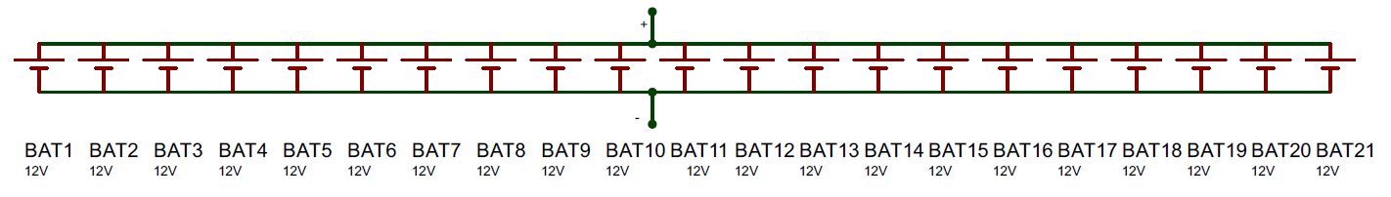
Figure 17 battery configuration
Figure 17 shows the parallel battery configuration to power the weather station for 14 days.

Voltage Regulator
The maximum voltage input for the microcontroller was 5V, so a voltage regulator was included to drop the batteries 12V output. A 7850 regulator was included to the circuit, with capacitors on both sides. This was to smooth out the noise from the regulator. The regulator would monitor the output and perform a feedback loop. [65]

USB
Component | Specification | Price
USB port  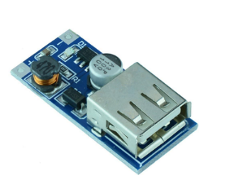 [66] | Voltage – 5V  Current output – 30mA  Operating temperature - -20 to 60°C | £4.63
Table 38 USB port for PC connection
As shown in table 38, a USB port was used to connect the system to a PC to charge the batteries and to transfer data collected. The module would be connected to the PCB via soldering. A maximum of 30mA was drawn from the device.

Block Diagram
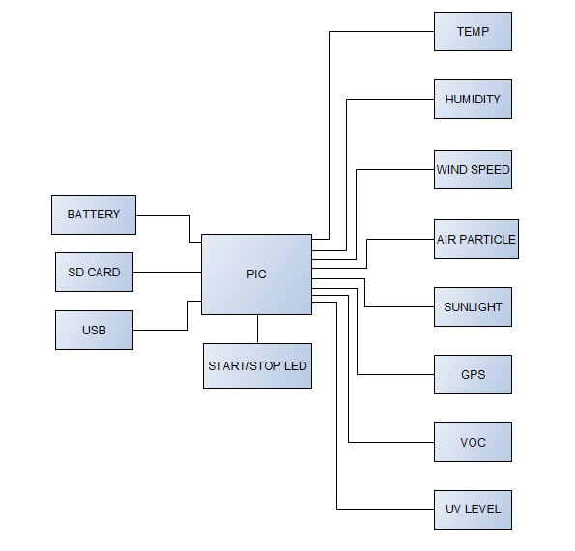
Figure 18 Block diagram for weather station system

Software Flow chart

Temperature sensor
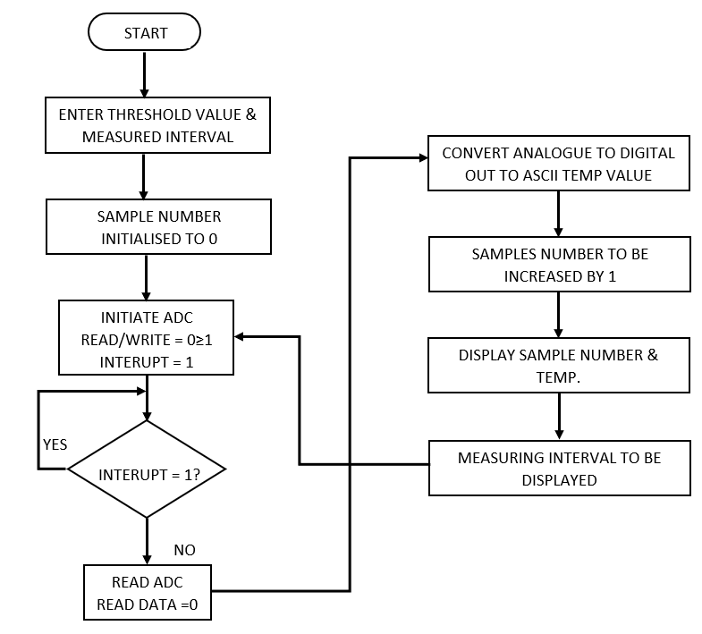
Figure 19 Temperature sensor flow chart
Figure 19 shows flow chart for the temperature sensors order of commands to capture and send data to the microcontroller with a value readable from associated voltage.

Humidity sensor
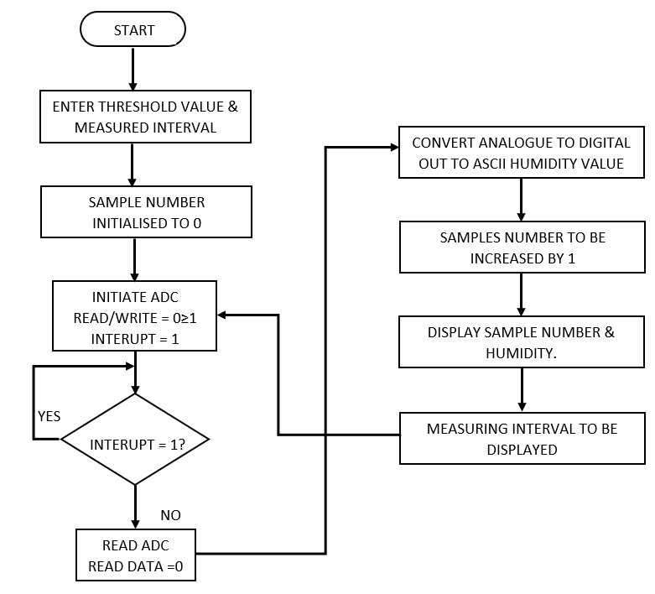
Figure 20 Humidity sensor flow chart
Figure 20 shows flow chart for the humidity sensors. As with the temperature sensor, humidity recorded produced associated voltage for the microcontroller to calculate.

Wind Speed
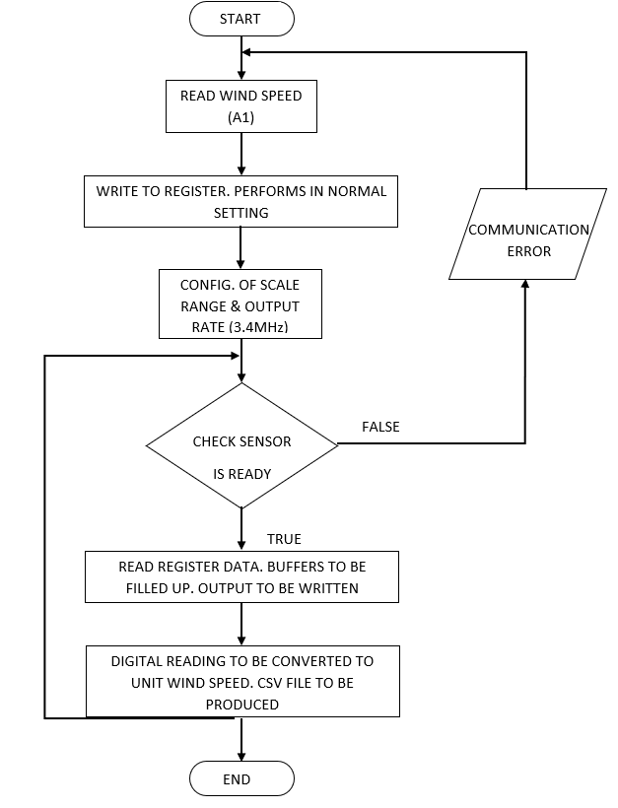
Figure 21 Wind speed sensor flow chart
Figure 21 shows the flow chart for the wind sensor. Associated wind speed with voltage was sent to the microcontroller to read.

Wind direction
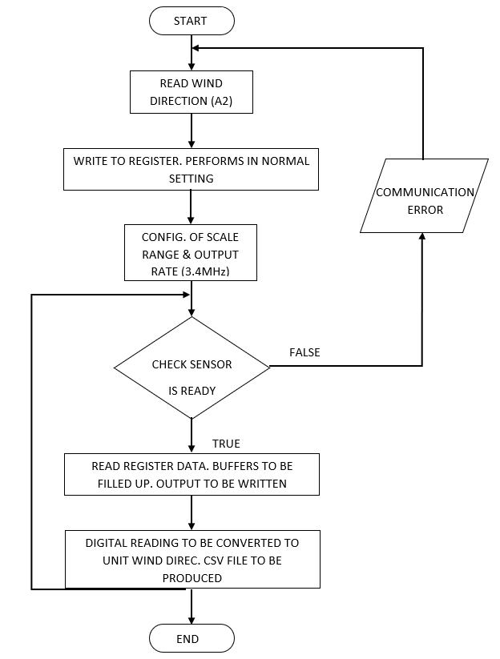
Figure 22 Wind direction sensor flow chart
Figure 22 shows wind direction flow chart. Orientation of wind was associated with a voltage and send to the microcontroller to produce data.

Air particle sensor
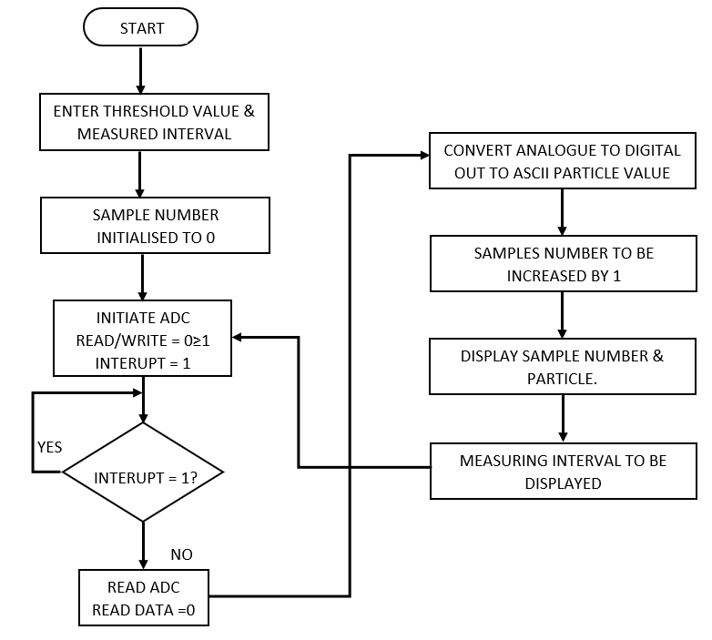
Figure 23 Air particle sensor flow chart
Figure 23 shows air particle sensor flow chart with sampled particle number converted into a readable voltage and sent to the microcontroller.

Sunlight sensor
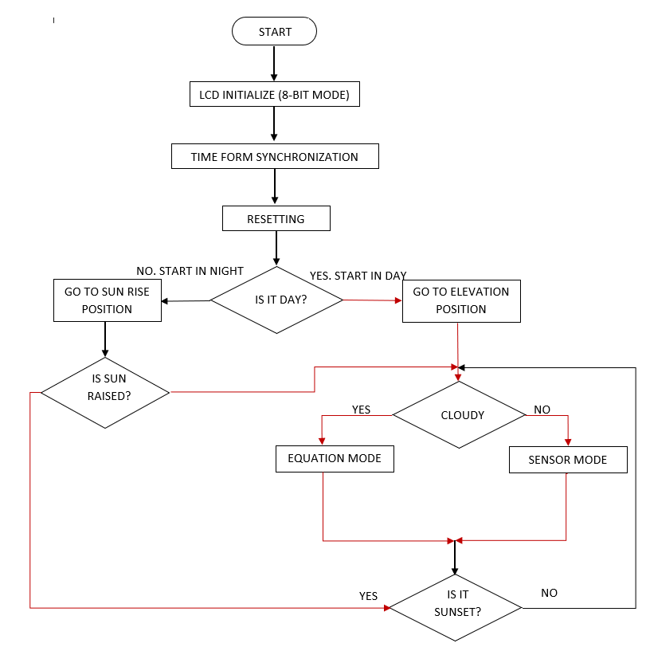
Figure 24 Sunlight sensor flow chart
Figure 24 shows the process of how the sunlight sensor gathers and sends the data collected to be sent to the microcontroller.

GPS sensor
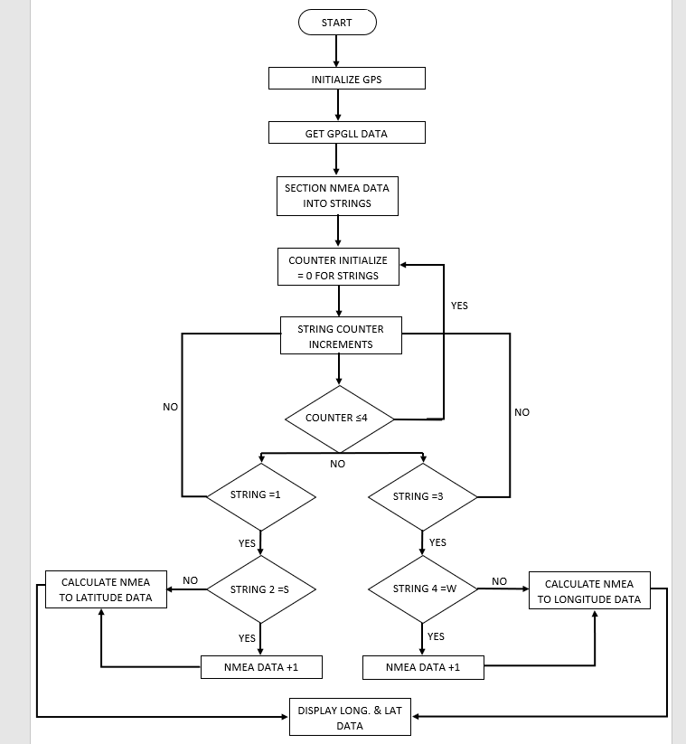
Figure 25 GPS sensor flow chart
Figure 25 shows the flow chart for the GPS sensor and how it captured the position of the weather station and send to the microcontroller.

VOC Sensor
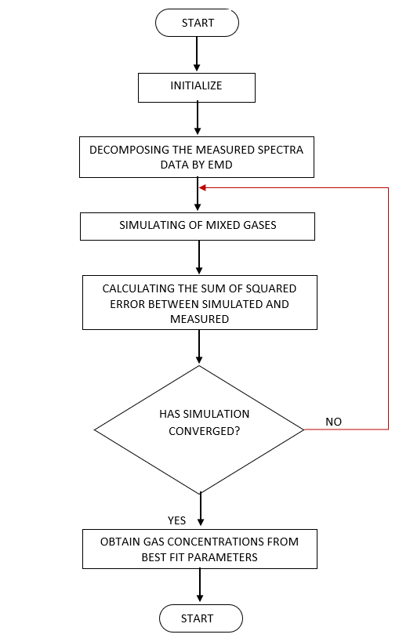
Figure 26 VOC sensor flow chart
Figure 26 shows flow chart for VOC sensor and how the process of how the sensor collects the level of gases and send the associated signal to the microcontroller.

UV Level
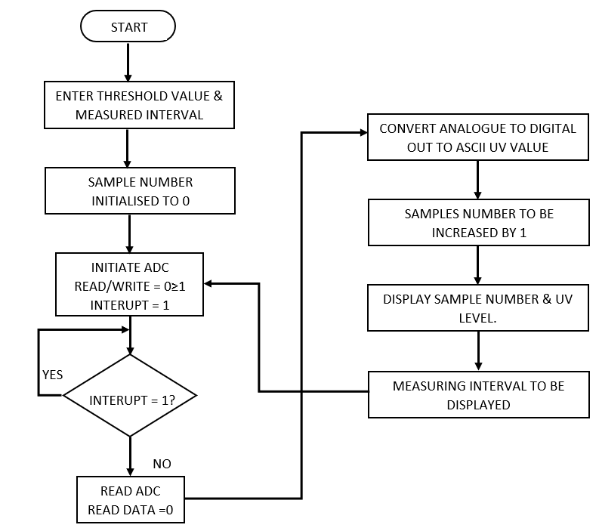
Figure 27 UV sensor flow chart
Figure 27 shows flow chart for UV sensor. The data gathered would send an associated voltage to the microcontroller the be read and collected.

SD Read/Write
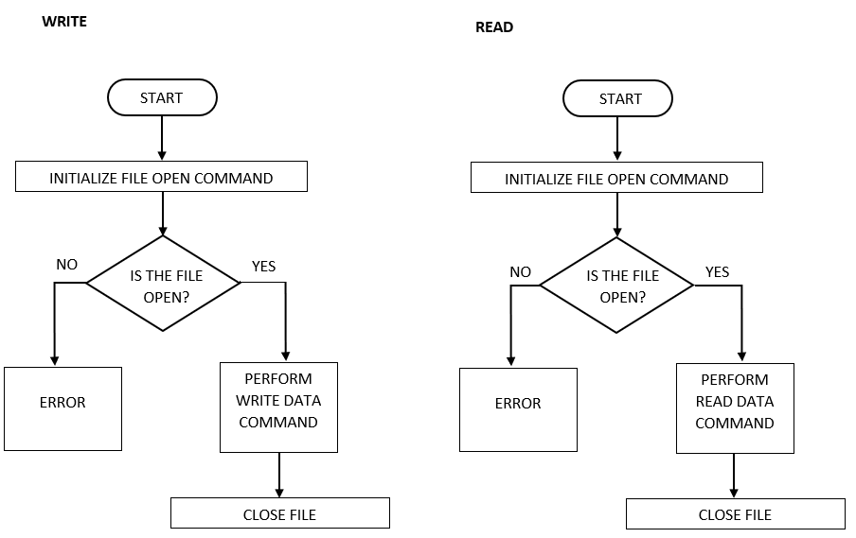
Figure 28 SD Read/Write flow chart
Figure 28 shows SD card flow chart. Data acquisition was carried out by way of the card enquiring if the system was in a position for read or write function.

Result
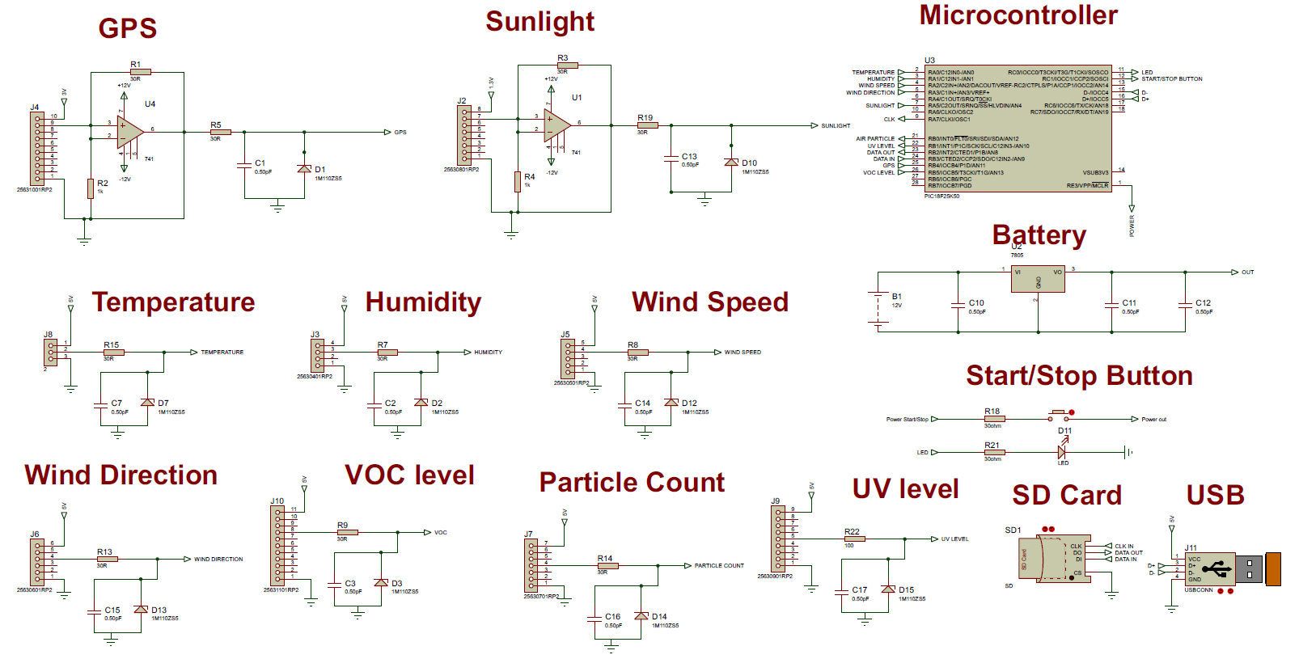
Figure 29 Circuit diagram of weather station

Temperature sensor system
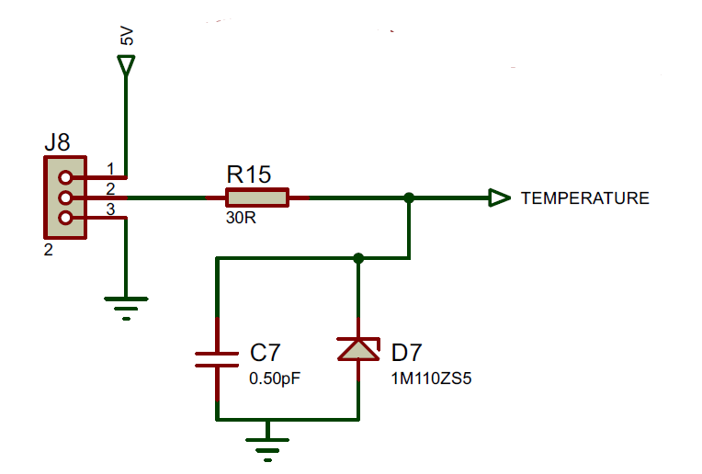
Figure 30 Temperature sensor circuit layout
As shown in figure 30, the output of the temperature sensor was 5V, so no manipulation was required. The received temperature would determine the analogue output. The output had signal conditioning by a resistor and capacitor in the system. This filtered out the noise and help a smooth signal. To prevent spiking, a Zener diode was included. This also allowed clamping of the output.

Humidity sensor system
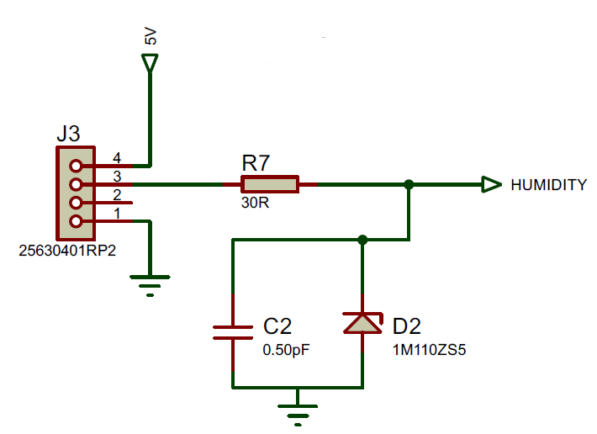
Figure 31 Humidity sensor circuit layout
As shown in figure 31, output for the sensor was 5V.The resistor and capacitor produced signal conditioning, and the diode clamped the output to avoid high voltage spikes.

Wind speed sensor system
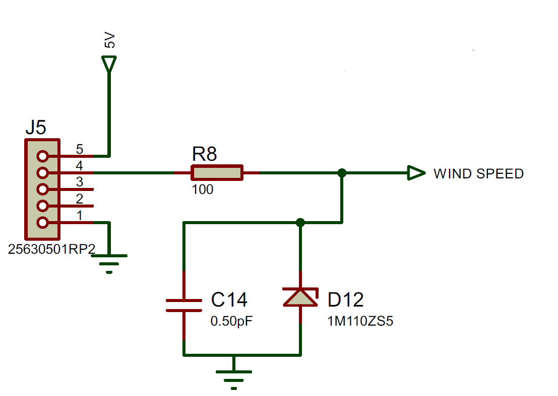
Figure 32 Wind speed sensor circuit layout
Figure 32 shows no voltage manipulation for the output of the sensor, due to 5V being produced. Clamping and signal conditioning components were present in the system.

Wind direction sensor system
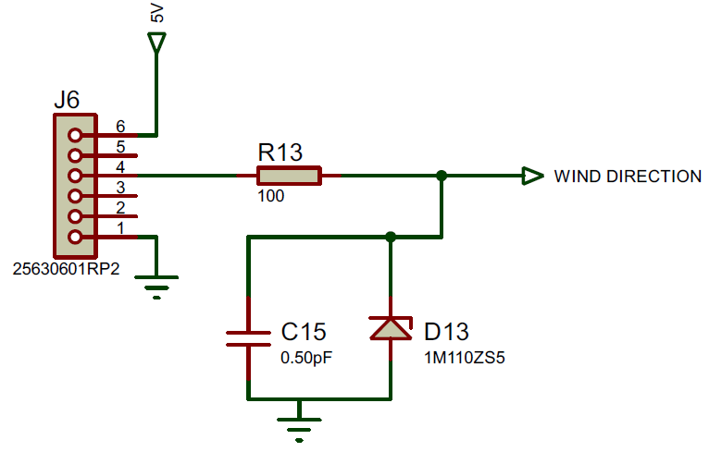
Figure 33 Wind direction sensor circuit layout
Figure 33 shows wind direction sensor layout. 5V output, clamping and signal conditioning prevented spiking in the circuit, and a smooth signal. A six-pin connector was also included to differentiate sensor when connecting.

GPS sensor system
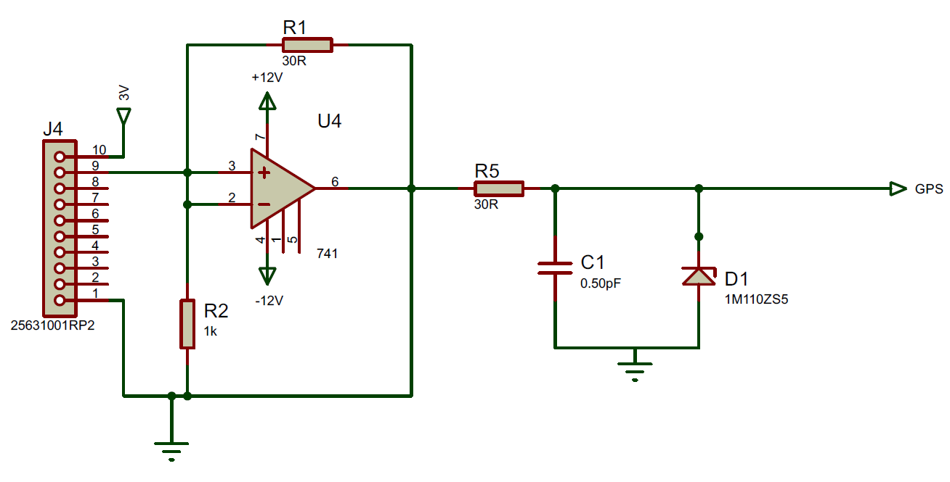
Figure 34 GPS sensor circuit layout
Figure 34 shows the GPS circuit diagram. Due to only 3V maximum output, a non-inverting op amp was required to boost the voltage to 5V. This boosted output was then signal conditioned and clamped.
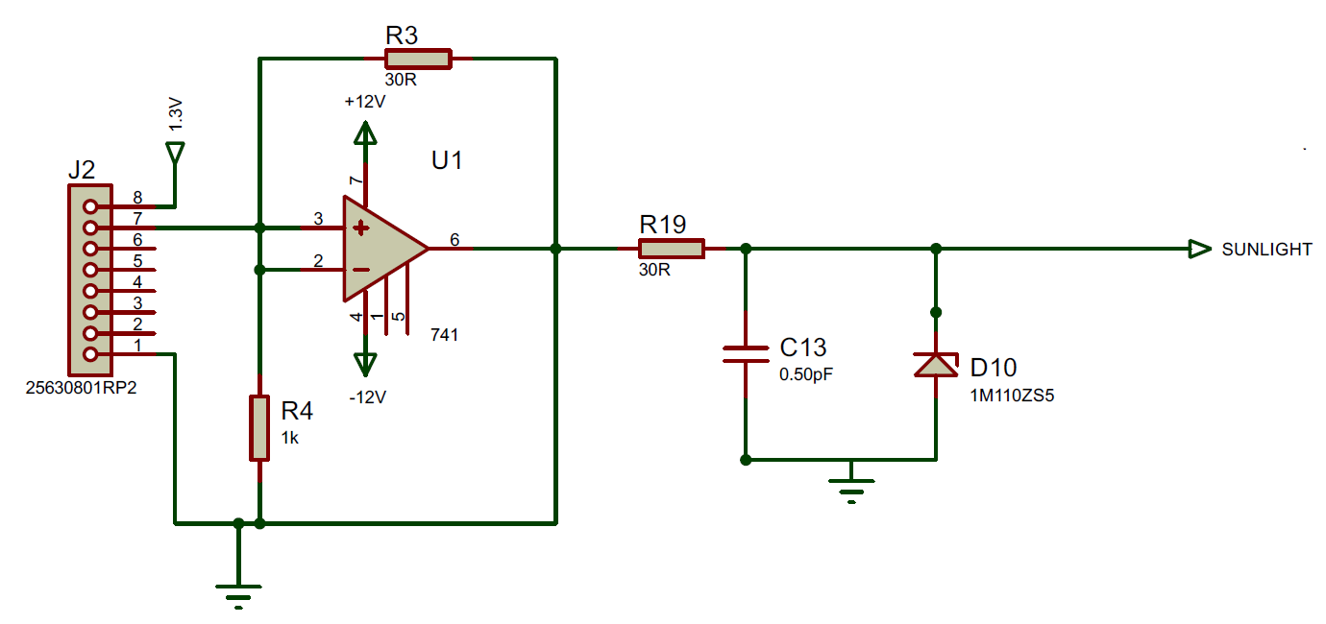
Figure 35 Sunlight sensor circuit layout
As shown in figure 35, the sunlight sensor required a non-inverting op-amp to boost its 1.3V output to 5V for the PIC to recognise. Clamp and signal conditioning followed this increased voltage.

VOC sensor system
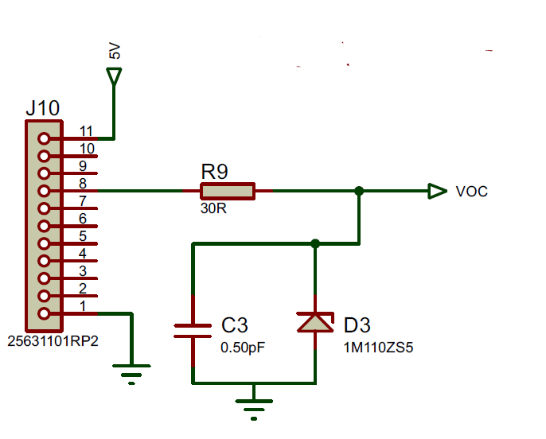
Figure 36 VOC sensor circuit layout
Figure 36 shows the ten-pin connector for the VOC sensor, including signal conditioning and clamping to prevent spiking. The sensors output was 5V, so no manipulation was required.

Air Particle sensor system
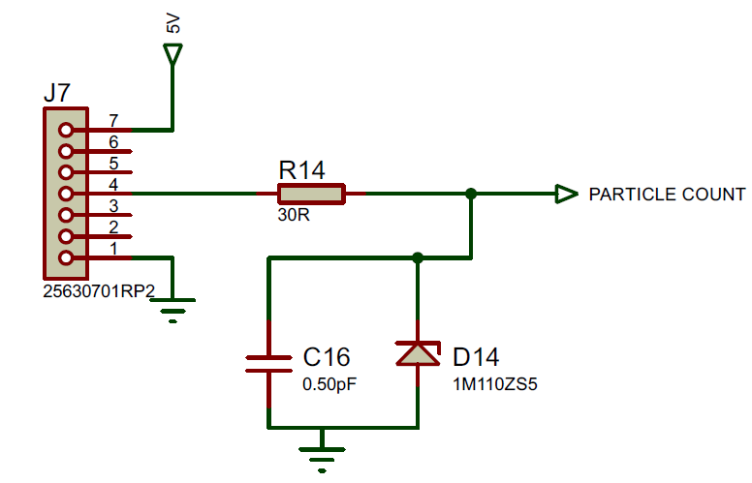
Figure 37 Air particle sensor circuit layout
As shown in figure 37, the seven-pin connector for the particle sensor produced an output of 5V and included a system of a resistor and capacitor to smooth out the digital signal. It also included a diode to clamp the voltage and prevent spiking.

UV level sensor system
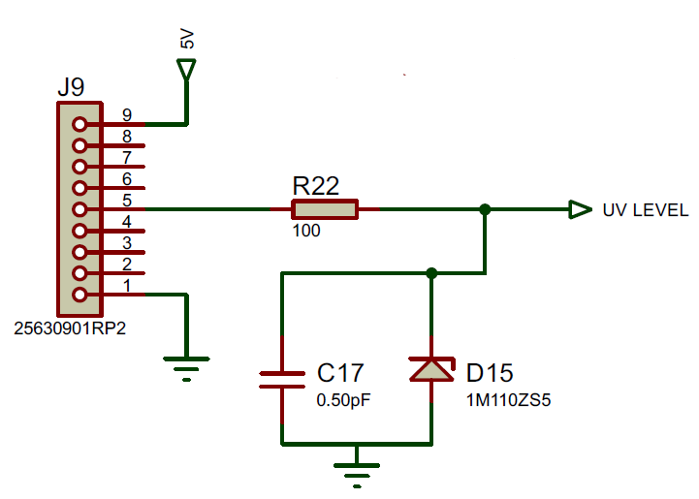
Figure 38 UV level sensor circuit layout
Figure 38 shows a nine-pin connector for the sensor with an output of 5V passing through a signal conditioning and clamping configuration.

Microcontroller
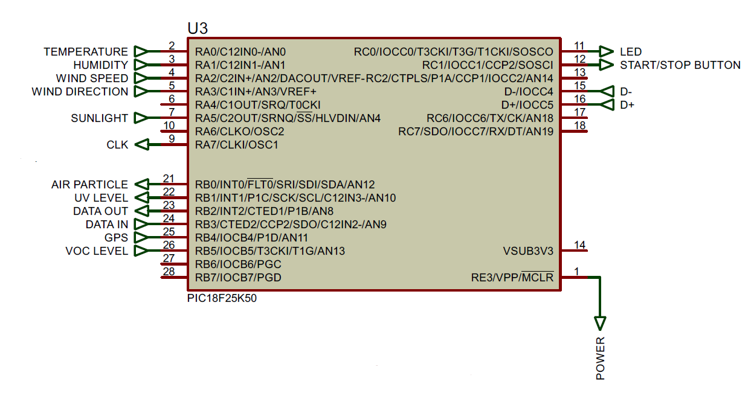
Figure 39 Microcontroller pin I/O
As shown in figure 39, the PIC18F24K50 microcontroller which utilised eight analogue inputs and 1 digital inputs. The microcontroller was connected to all the sensors in the weather station. The USB port allowed PC connection; SD card was used for data to be transferred to non-volatile memory.

Battery layout
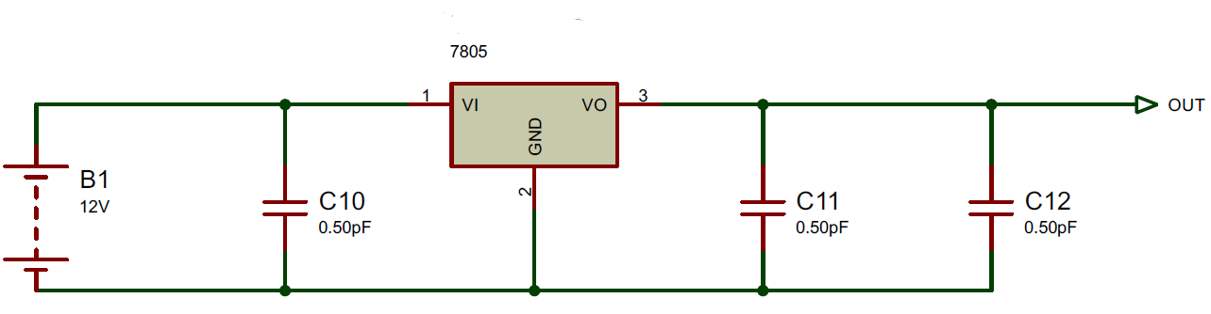
Figure 40 battery layout
Figure 40 shows the battery layout for power for the system. Due to the maximum of 5V input for the PIC, a 7805-voltage regulator was used to drop the batteries 12V. To smooth out the signal, a configuration of capacitors either side of the regulator was included. [67]

Stop/Start LED
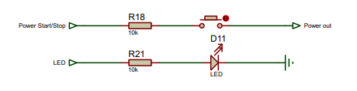
Figure 41 Stop/start LED configuration
Figure 31 shows to power the system, a Start/stop push button, when pressed, closed the circuit, and gave power was produced. The LED would illuminate and flash for 10 seconds for a total of 1 minute to show operation. Series resistors limited the amount of current to prevent damage to the components.

USB
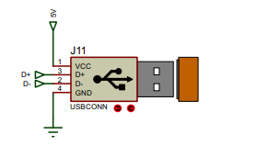
Figure 42 USB configuration
Figure 42 shows the USB port which enabled connection to a PC. To operate, 5V was required, with data lines D+ and D- sending and receiving data collected from the sensors via the PIC.

SD Card
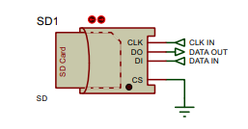
Figure 43 SD Card configuration
Figure 43 shows the SD card, which collected the data produced from the sensors. SPI protocol was used with this device and included individual I/O pins. The clock pin would determine the speed of the transfer to and from the card.

PCB
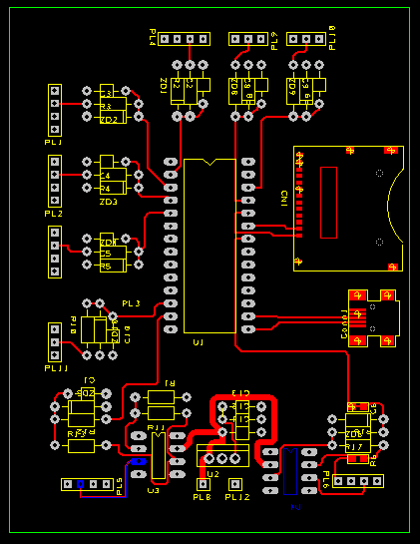
Figure 44 2D schematic of PCB circuit
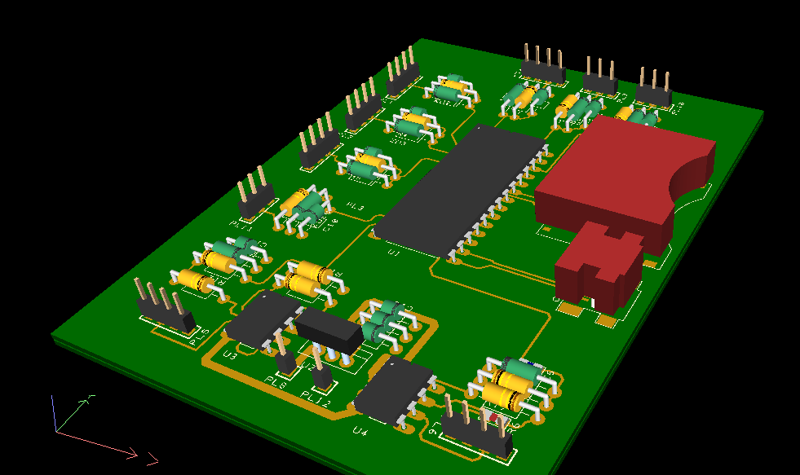
Figure 45 3D schematic of PCB circuit
Figures 44 and 45 show the completed PCB in both 2D and 3D respectively. The PCB was drawn using Easy PC software. [68] A total of four layers made up the PCB, including copper layers on both top and bottom.

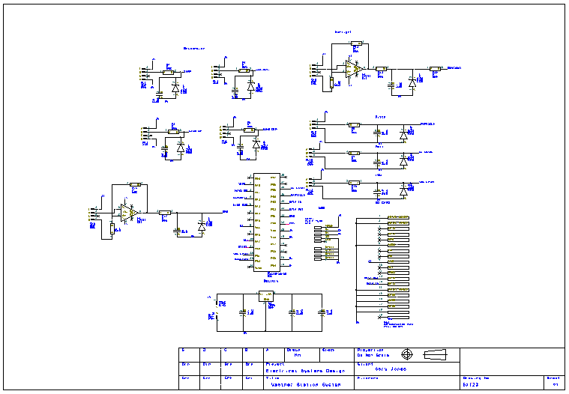
Figure 46 Engineering drawing showing PCB schematic

PCB manufacturing quote
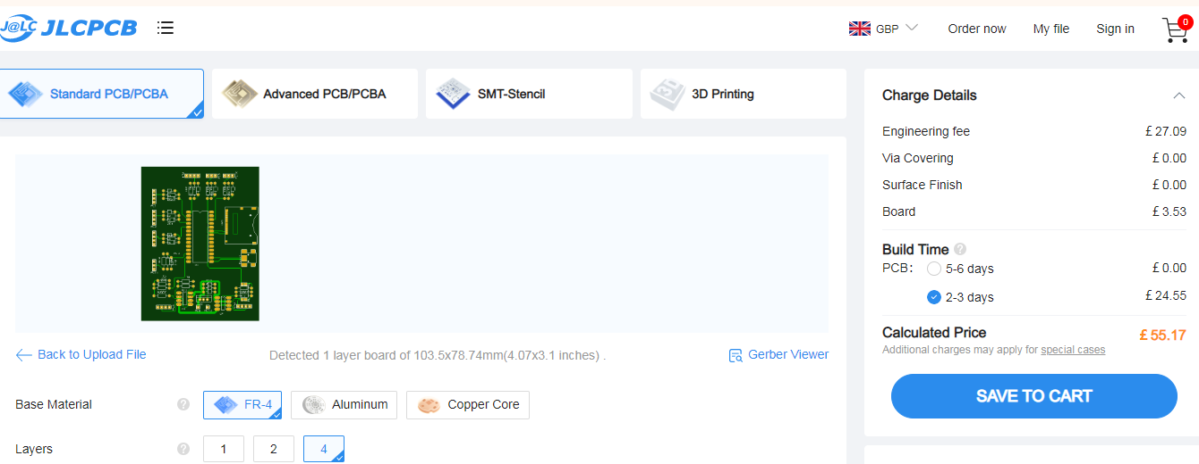
Figure 47 Quote from JLPCB for PCB manufacture
Figure 47 shows quote from PCB manufacturer JLPCB. The PCB was lead free with four layers. The company supplied a minimum of five PCB’s. With a total of £56.17 with delivery [69].

Conclusion
Component | Part No. | Manufacturer | Price | Amount | Total
Temperature Sensor | NTC015WH01 | Carel | £16.21 | 1 | £16.21
Humidity Sensor | HIH -4000 | Honeywell | £30.46 | 1 | £30.46
Wind Speed Sensor | RS-CFSFX | Renke | £200 | 1 | £200
Wind Direction Sensor | RS-CFSFX | Renke | £200 | 1 | £200
Air particle count sensor | LM393 MQ-135 | OKY | £23.12 | 1 | £23.12
Sunlight sensor | QSD2030 | ON SEMI | 25p | 1 | 25p
UV sensor | UV-405-E | FOTEK | £45.12 | 1 | £45.12
GPS | 2195768-1 | TE | £24.72 |  | £24.72
VOC level sensor | MQ-4 | WILSEN | £14.72 |  | £14.72
SD Card Port | 410-123 | DIGILENT | £13.18 | 1 | £13.18
SD Card Swissbit 512Mb | DS2A  512I81C1B | INNODISK | £28.80 | 1 | £28.80
Amphenol Connector Male/Female | ECTA 633 | AMPHENOL | £77.92 | 20 | £1558.40
Microcontroller | PIC18F24K50 | MICROCHIP | £3.12 | 1 | £3.12
Housing unit, carry case, tripod stand | FTS QD Quick Deploy | FTS | £1000.12 | 1 | £1000.12
Batteries | 12.6V | KEDANONE | £25 | 20 | £500
Usb Port | RS 175-8474 | RS | £15.97 | 1 | £15.97
PCB | NA | JLPCB | £55.17 | 5 | £55.17
Total |  |  |  |  | £3729.36
Table 39 Total price of weather station
Table 27 shows the total price of the weather station was £3729.26
Future revisions could include:
- Solar powered panels. This could double as a temperature sensor and a source of power to reduce the amount of batteries required. Weather station could be in situ longer.
- Upgrade sensors to include sleep mode. This would also aid current draw when not active.
- Wireless connection, to eliminate routing connection wires.
- CAN protocol for communication. Very robust system. Produces error free communication.
- Include RTOS software that can be linked to central database instead of SD card for reading as they happen.

References

[1] | I. Systems, “MWS-M625,” Intellisense Systems, [Online]. Available: https://www.intellisenseinc.com/products/weather-stations/mws-m625/?utm_source=bing&utm_medium=cpc&utm_campaign=uk-weather-stations. [Accessed 17 December 2022].
[2] | A. METEO, “MeteoHelix® IoT Pro - Sigfox Micro-Weather Station,” All METEO, [Online]. Available: https://allmeteo.com/meteo-shop/meteohelix-iot-pro-sigfox-micro-weather-station. [Accessed 17 December 2022].
[3] | W. a. Spares, “Ecowitt Weather Stations WS2910,” Ecowitt, [Online]. Available: https://weatherspares.co.uk/products/ecowitt-ws2910-weather-station-wifi-internet-colour-forecast?variant=42612448395480. [Accessed 17 December 2022].
[4] | I. choice, “Skywatch BL-1000 Weather station for emergency and incident response,” Skywatch, [Online]. Available: https://www.instrumentchoice.com.au/skywatch-bl-1000-weather-station-for-emergency-and-incident-response. [Accessed 17 December 2022].
[5] | Reesscientific, “Temperature Monitoring,” Reesscientific, [Online]. Available: https://www.reesscientific.com/?msclkid=cc2095bd8ee01cc74325f61cfba5d46e. [Accessed 20 December 2022].
[6] | Hakko, “B5128 Thermocouple,” Hakko, [Online]. Available: https://hakkousa.com/catalogsearch/result/?q=b5128+thermocouple+for+fr+811&404=1. [Accessed 20 December 2022].
[7] | “2d data recording,” 2d debus & Diebold, [Online]. Available: http://2d-datarecording.com/Downloads/Datasheets/Sensors-temperature/Pdf/SA-NTCxyy_5V-000.pdf. [Accessed 20 December 2022].
[8] | RS, “Temperature Sensor, RS Pro,” RS, [Online]. Available: https://docs.rs-online.com/2f27/0900766b81582e16.pdf. [Accessed 20 December 2022].
[9] | RS, “Carel NTC Temperature Probe,” RS, [Online]. Available: https://uk.rs-online.com/web/p/thermistors/4388477?cm_mmc=UK-PPC-DS3A-_-bing-_-3_UK_EN_Automation+%26+Control+Gear_Thermistors_Exact-_-Carel+-+4388477+-+NTC015WH01-_-ntc015wh01&matchtype=e&kwd-71056688914396:loc-188&gclid=943642e1328d186c1c272140d4d267fd&. [Accessed 20 December 2022].
[10] | RS, “Vaisala HMI41 Digital Thermohygrometer,,” RS, [Online]. Available: https://uk.rs-online.com/web/p/hygrometers/7354985?cm_mmc=UK-PPC-DS3A-_-bing-_-DSA_UK_EN_Test_%26_Measurement_Index-_-Hygrometers%7C+Products-_-DYNAMIC+SEARCH+ADS&matchtype=b&dat-2323680386472135:loc-188&gclid=a3ed4f744db113d71c8a2cd5f05f1bcf&gclsrc=3p.ds. [Accessed 20 December 2022].
[11] | U. Bony, “Mylar 2A473j 100V Polyester Film Capacitor Metallized 47nF Polypropylene Capacitor,” UDVA Bony, [Online]. Available: https://udvabony.com/product/metallized-polypropylene-film-47uf-capacitor-473j-100v/. [Accessed 20 December 2022].
[12] | RS, “RS PRO Sensors,” RS, [Online]. Available: https://docs.rs-online.com/0536/A700000008929666.pdf. [Accessed 20 December 2022].
[13] | RS, “DHT11 Temperature and Humidity Sensor SKU,” RS, [Online]. Available: https://docs.rs-online.com/837a/A700000007466197.pdf. [Accessed 20 December 2022].
[14] | T. Lin, “Flow Analysis and Relative Humidity (RH) Measurement,” IEEE Transactions on Semiconductor Manufacturing, vol. 34, no. 3, pp. 429 - 435, 2021.
[15] | RS, “RS PRO DT-3893 Vane Anemometer, 30m/s Max, Measures Air Flow, Air Velocity, Temperature,” RS, [Online]. Available: https://uk.rs-online.com/web/p/anemometers/1938696. [Accessed 21 December 2022].
[16] | F. UK, “SEN0259 laser range sensor,” Farnell UK, [Online]. Available: https://uk.farnell.com/dfrobot/sen0259/lidar-laser-range-sensor-tfmini/dp/3769959?gross_price=true&msclkid=76b08a382f141a7ad297e99c1389e218&CMP=KNC-MUK-GEN-SHOPPING-ALL-PRODUCTS-Test1501. [Accessed 22 December 2022].
[17] | F. 4. Chandlery, “Quantum 2 Q24D Doppler Radar With 10m Power and Data cables,” Force 4 Chandlery, [Online]. Available: https://www.force4.co.uk/item/Raymarine/Quantum-2-Q24D-Doppler-Radar-With-10m-Power-and-Data-cables/AQW?stock=13928&msclkid=5ac1e00b42161643c83d83af798f291c&utm_source=bing&utm_medium=cpc&utm_campaign=Bing%20Shopping&utm_term=4581458801389455&utm_content=. [Accessed 22 Decemeber 2022].
[18] | Renke, “Ultrasonic Wind Speed Direction Sensor,” renke, [Online]. Available: https://www.renkeer.com/product/ultrasonic-wind-speed-direction-sensor/. [Accessed 22 December 2022].
[19] | O. Group, “OMC-116 Full Metal Ultrasonic Wind Sensor,” Observator Group, [Online]. Available: https://observator.com/products/omc-116-full-metal-ultrasonic-wind-sensor/. [Accessed 22 December 2022].
[20] | NAVICO, “110WX Ultrasonic Wind Sensor,” NAVICO, [Online]. Available: https://www.westmarine.com/navico-110wx-ultrasonic-wind-sensor-17046822.html. [Accessed 22 December 2022].
[21] | Merck, “MAS-100 NT,” Merck, [Online]. Available: https://www.sigmaaldrich.com/GB/en/product/mm/109191. [Accessed 23 December 2022].
[22] | RS, “KEMET USEQGCDASF6100, Air Quality Sensor,” RS, [Online]. Available: https://uk.rs-online.com/web/p/environmental-sensor-ics/2066621?cm_mmc=UK-PLA-DS3A-_-bing-_-PLA_UK_EN_Semiconductors_Whoop-_-Environmental+Sensor+ICs_Whoop_OMNISerpNov-_-2066621&matchtype=e&pla-4575205333161816&msclkid=6c315d71a0ce1d9cf60c3ed43fea03ce&gcl. [Accessed 23 December 2022].
[23] | OKYStar, “LM393 MQ-135 DC 5 V Air Qulity Pollution Sensor,” OKYStar, [Online]. Available: https://www.okystar.com/product-item/lm393-mq-135-dc-5-v-air-qulity-pollution-sensor-harmful-gas-red-module-for-nh3-arduino-oky3339/. [Accessed 23 December 2022].
[24] | Direnc, “Air Quality / Particle Sensor Laser PM2.5,” Direnc, [Online]. Available: https://www.direnc.net/lazer-pm25-hava-kalite-partikul-sensoru-en. [Accessed 23 December 2022].
[25] | Farnell, “IPS-7100-1,” Farnell, [Online]. Available: https://uk.farnell.com/piera-systems/ips-7100-1/sensor-particle-air-5-5v/dp/4015788. [Accessed 23 December 2022].
[26] | Sunroom, “Optoelectrinics,” Sunroom, [Online]. Available: https://www.sunrom.com/c/optoelectronics. [Accessed 30 December 2022].
[27] | Farnell, “OPL800 Photodiode,” TT Electronics, [Online]. Available: https://uk.farnell.com/optek-technology/opl800/photodiode-photologic-935nm-to/dp/2353738. [Accessed 30 December 2022].
[28] | RS, “onsemi, QSD2030 Photodiode Output Optocoupler, Through Hole, 2-Pin T-1,” RS, [Online]. Available: https://uk.rs-online.com/web/p/optocouplers/1867342?cm_mmc=UK-PLA-DS3A-_-bing-_-PLA_UK_EN_Displays_%26_Optoelectronics_Whoop-_-Optocouplers_Whoop-_-1867342&matchtype=e&pla-4575205336467542&gclid=b8403924ee99128238575a8a3cfc4d2c&gclsrc=3p.ds&msclkid=b84039. [Accessed 30 December 2022].
[29] | Farnell, “Photodiode, 1 pA, 760 nm, TO-18-3,” Farnell, [Online]. Available: https://uk.farnell.com/hamamatsu/s5973/photodiode-760nm-1ghz-to-18/dp/1495575?pf_custSiteRedirect=true. [Accessed 30 December 2022].
[30] | Beamqus, “800-1700nm 2mm InGaAs PIN photodiode high reliability low dark current TO-5,” Beamqus, [Online]. Available: https://beamqus.com/product/800-1700nm-2mm-ingaas-pin-photodiode-high-reliability-low-dark-current-to-5/. [Accessed 30 December 2022].
[31] | hamamatsu, “R6800U-01,” hamamatsu, [Online]. Available: https://www.hamamatsu.com/eu/en/product/optical-sensors/phototube/R6800U-01.html. [Accessed 30 December 2022].
[32] | E. 360, “UV Sensors Information,” Engineering 360, [Online]. Available: https://www.globalspec.com/learnmore/optics_optical_components/optoelectronics/uv_sensors. [Accessed 30 December 2022].
[33] | IEEE, “IEEE Standard for Spectrum Sensing Interfaces and Data Structures for Dynamic Spectrum Access,” pp. 178 - 179, 30 Sep 2022.
[34] | S. Light, “Analog Sensors UVA Sensor PMA1110,” [Online]. Available: https://solarlight.com/wp-content/uploads/Sensors_PMA1110.pdf. [Accessed 31 December 2022].
[35] | Vernier, “UVA Sensor,” Vernier, [Online]. Available: https://www.vernier.com/product/uva-sensor/. [Accessed 31 December 2022].
[36] | Digikey, “BMI085,” Digikey, [Online]. Available: https://www.digikey.co.uk/en/products/detail/bosch-sensortec/BMI085/8634943?utm_adgroup=Motion%20Sensors%20-%20IMUs%20(Inertial%20Measurement%20Units)&utm_source=bing&utm_medium=cpc&utm_campaign=Shopping_Product_Sensors%2C%20Transducers&utm_term=&producti. [Accessed 2 January 2023].
[37] | T. measure, “Analogue 6DOF Accelerometer from Dytran,” Techni measure, [Online]. Available: https://www.technimeasure.co.uk/analogue-6dof-accelerometer-from-dytran/. [Accessed 2 January 2023].
[38] | Pihut, “SparkFun Micro Magnetometer - MMC5983MA (Qwiic),” Pihut, [Online]. Available: https://thepihut.com/products/sparkfun-micro-magnetometer-mmc5983ma-qwiic?variant=42201720750275&currency=GBP&utm_medium=product_sync&utm_source=google&utm_content=sag_organic&utm_campaign=sag_organic&msclkid=57734bf7898517fddf4f284522b99a86&utm_term=4585. [Accessed 2 January 2023].
[39] | BH, “Spektrum Aircraft Telemetry GPS Sensor,” BH, [Online]. Available: https://www.bhphotovideo.com/c/product/1367267-REG/spektrum_spma9587_aircraft_telemetry_gps_sensor.html?ap=y&smp=y. [Accessed 2 January 2023].
[40] | RS, “TE Connectivity 2195768-1 GPS Module,” RS, [Online]. Available: https://uk.rs-online.com/web/p/gnss-gps-modules/2001401. [Accessed 2 January 2023].
[41] | RS, “Quectel L70B-M39 GPS Module,” RS, [Online]. Available: https://uk.rs-online.com/web/p/gnss-gps-modules/1709178?cm_mmc=UK-PLA-DS3A-_-bing-_-PLA_UK_EN_Semiconductors_Whoop-_-GNSS+%26+GPS+Modules_Whoop_OMNISerpNov-_-1709178&matchtype=e&pla-4574861735770211&gclid=8d68f2dc00181fa8049f916eb43e78d0&gclsrc=3p.ds&mscl. [Accessed 2 January 2023].
[42] | m. Engineering, “Dev 50hz GPS CAN Sensor,” metis Engineering, [Online]. Available: https://www.metisengineering.com/store/p9/Dev_50Hz_GPS_CAN_Sensor.html. [Accessed 2 january 2023].
[43] | RS, “Seeed Studio 113020003 GPS Module,” RS, [Online]. Available: https://uk.rs-online.com/web/p/gnss-gps-modules/1793714?cm_mmc=UK-PLA-DS3A-_-bing-_-PLA_UK_EN_Semiconductors_Whoop-_-GNSS+%26+GPS+Modules_Whoop_OMNISerpNov-_-1793714&matchtype=e&pla-4574861730978108&gclid=f50c2871a1441374552d4bc31a25afc0&gclsrc=3p.ds&mscl. [Accessed 2 January 2022].
[44] | ISweek.com, “OEM Photoionization Sensor (PID Sensor),” ISweek.com, [Online]. Available: https://www.isweek.com/product/oem-photoionization-sensor-pid-sensor-2-ppm-pid-2_1921.html. [Accessed 2 January 2022].
[45] | RS, “KEMET Flame sensor Eval kit,” RS, [Online]. Available: https://uk.rs-online.com/web/p/sensor-development-tools/2055813?cm_mmc=UK-PLA-DS3A-_-bing-_-PLA_UK_EN_Raspberry_Pi_%26_Arduino_%26_Development_Tools_Whoop-_-Sensor+Development+Tools_Whoop+(2)_OMNISerpNov-_-2055813&matchtype=e&pla-4575548924769068&msclkid=. [Accessed 2 January 2023].
[46] | RS, “Nitrous Oxide Sensor Metal A0009056204 Automatic Sensor,” RS, [Online]. Available: https://www.ebay.co.uk/itm/225314155856?chn=ps&norover=1&mkevt=1&mkrid=7101533165274578&mkcid=2&itemid=225314155856&targetid=4584826055637462&device=c&mktype=&googleloc=&poi=&campaignid=412354546&mkgroupid=1299623041023876&rlsatarget=pla-4584826055637462&. [Accessed 2 January 2023].
[47] | Grandado, “5PCS Winsen MQ-4 Gas Sensor Semiconductor Sensor Meta,” Grandado, [Online]. Available: https://gbr.grandado.com/products/5pcs-winsen-mq-4-gas-sensor-semiconductor-sensor-metal-cap-flammable-gas-sensor-300-10000ppm-used-in-gas-leakage-detection?variant=UHJvZHVjdFZhcmlhbnQ6OTM1NDg1MTQ&msclkid=476618359d2216a3fb0c7b874d51e540&utm_source=bing&u. [Accessed 2 January 2023].
[48] | Digikey, “SGP40-D-R4,” Digikey, [Online]. Available: https://www.digikey.co.uk/en/products/detail/sensirion-ag/SGP40-D-R4/12820418. [Accessed 2 January 2023].
[49] | Digikey, “SVM30-J,” Digikey, [Online]. Available: https://www.digikey.co.uk/en/products/detail/sensirion-ag/SVM30-J/9959550. [Accessed 2 January 2033].
[50] | Digikey, “PS1-VOC-1000,” Digikey, [Online]. Available: https://www.digikey.co.uk/en/products/detail/amphenol-sgx-sensortech/PS1-VOC-1000/16634093. [Accessed 2 January 2023].
[51] | Farnell, “410-123,” Farnell, [Online]. Available: https://uk.farnell.com/digilent/410-123/peripheral-module-sd-card-slot/dp/2361519. [Accessed 3 January 2023].
[52] | Y. Yang, “Hardware system design of SD card reader and image processor on FPGA,” in 2011 IEEE International Conference on Information and Automation, Shenzhen, 2011.
[53] | RS, “InnoDisk 512 MB SD SD Card, Class 6,” RS, [Online]. Available: https://uk.rs-online.com/web/p/sd-cards/1839364?cm_mmc=UK-PLA-DS3A-_-bing-_-PLA_UK_EN_CatchAll-_-Ad+Group+Catch+All-_-1839364&matchtype=e&pla-4575617641061044&msclkid=34215ccc6ad8170f90fd3f784b543a59&gclid=34215ccc6ad8170f90fd3f784b543a59&gclsrc=3p.ds. [Accessed 3 January 2023].
[54] | Amphenol, “Amphenol-AirLB,” Amphenol, [Online]. Available: https://www.amphenol-airlb.de/38.0.en.150.html. [Accessed 3 January 2023].
[55] | RS, “Deutsch, DTM Automotive Connector Plug 12 Way,” RS, [Online]. Available: https://uk.rs-online.com/web/p/automotive-connectors/1839198?cm_mmc=UK-PLA-DS3A-_-bing-_-PLA_UK_EN_Connectors_Whoop-_-Automotive+Connectors_Whoop+(2)-_-1839198&matchtype=e&pla-4575205326802424&msclkid=d933c07246f81f84797fa3c671edf4dd&gclid=d933c07246f81f8. [Accessed 3 January 2023].
[56] | RS, “Lemo 1B Cable Mount Connector, 2 Contacts, Socket,” RS, [Online]. Available: https://uk.rs-online.com/web/p/industrial-circular-connectors/1305738?cm_mmc=UK-PLA-DS3A-_-bing-_-PLA_UK_EN_Connectors_Whoop-_-Industrial+Circular+Connectors_Whoop-_-1305738&matchtype=e&pla-4574930449490491&msclkid=23c85970a51d1216b21d3ac49d137edb&gclid=2. [Accessed 3 January 2023].
[57] | RS, “RS PRO Cable Mount Circular Connector, 10 Contacts, Plug,” RS, [Online]. Available: https://sa.rsdelivers.com/product/rs-pro/rs-pro-cable-mount-circular-connector-10-contacts/1444164. [Accessed 3 January 2023].
[58] | K. Meyyappan, “Optimizing gold thickness of land grid array pads for cost, performance and reliability of connectors,” in 2014 IEEE 60th Holm Conference on Electrical Contacts (Holm), New Orleans, USA, 2014.
[59] | FTS, “Quick Deploy Remote Automated Weather Station (QD),” FTS, [Online]. Available: https://ftsinc.com/product/quick-deploy-remote-automated-weather-station-qd/. [Accessed 4 January 2022].
[60] | HOBO, “HOBO® RX3000 Remote Monitoring Station Manual,” HOBO, [Online]. Available: https://www.onsetcomp.com/sites/default/files/resources-documents/18255-S%20RX3000%20Manual.pdf. [Accessed 4 January 2023].
[61] | Harvest, “ITU G2,” Harvest, [Online]. Available: http://harvest.com/products/data-loggers/itu-g2/. [Accessed 4 January 2023].
[62] | FTS, “Portable RAWS (Remote Automated Weather Station),” FTS, [Online]. Available: file:///C:/Users/A00555~1/AppData/Local/Temp/MicrosoftEdgeDownloads/3ec59ee5-7170-47d6-8863-d445c857a1c9/QD-Brochure-11-27-2018-WEB-SINGLES.pdf. [Accessed 4 January 2023].
[63] | RS, “RS PRO Illuminated Momentary Push Button Switch, Panel Mount, SPST, 16mm Cutout, Green LED, 36V dc, IP67,” RS, [Online]. Available: https://uk.rs-online.com/web/p/push-button-switches/1758474?cm_mmc=UK-PLA-DS3A-_-bing-_-PLA_UK_EN_Switches_Whoop-_-Push+Button+Switches_Whoop+(2)-_-1758474&matchtype=e&pla-4574724300583475&msclkid=cb2b5867d4e61b6342943bd279bf76a3&gclid=cb2b5867d4e61b63429. [Accessed 4 January 2023].
[64] | Kedanone, “12V 6800mah battery 18650 Li-ion 6.8 Ah Rechargeable batteries with BMS Lithium Battery,” Kedanone, [Online]. Available: https://gbr.grandado.com/products/original-18650-12v-battery-6-8-ah-6800mah-rechargeable-batterieswith-bms-lithium-battery-packs-protection-board-12-6v-charger?variant=UHJvZHVjdFZhcmlhbnQ6MTAyNTAwOTU. [Accessed 8 January 2023].
[65] | A. Sheikholeslami, “Reports on the technology and applications supported by low drop out (LDO) voltage regulators,” IEEE Solid-State Circuits Magazine, vol. 12, no. 4, pp. 15 - 18, 2020.
[66] | Pihut, “CP2102 USB,” Pihut, [Online]. Available: https://thepihut.com/products/cp2102-usb-uart-board-usb-c?variant=41373038543043&currency=GBP&utm_medium=product_sync&utm_source=google&utm_content=sag_organic&utm_campaign=sag_organic&msclkid=21d39338dcfd1d458fb3f0823d0b98c4&utm_term=4585375811816280. [Accessed 8 January 2023].
[67] | Farnell, “3 terminal 1A positive voltage regulator,” [Online]. Available: https://www.farnell.com/datasheets/2298694.pdf. [Accessed 10 January 2023].
[68] | Numberone, Easy-PC Version 26, Numberone, 2018.
[69] | JLCPCB, “JLCPCB,” [Online]. Available: https://jlcpcb.com/?_ga=2.85094489.1957519514.1669219280-139735659.1669219280. [Accessed 25 November 2022].
[70] | A. S. Inc, “Remote Sensing,” Anemometry Specialists Inc, [Online]. Available: https://www.anemometry.com/installation-maintenance/sodar-equipment-installation/. [Accessed 22 Decemeber 2022].
[71] | EC21, “VOCs Sensor (GSBT11),” EC21, [Online]. Available: https://www.ec21.com/product-details/VOCs-Sensor-GSBT11--1989038.html. [Accessed 2 January 2023].
[72] | RS, “Development Kit SD Card Slot Module for use with Store and Access On System Board,” RS, [Online]. Available: https://uk.rs-online.com/web/p/memory-development-tools/1840475. [Accessed 20 November 2022].
[73] | Swissbit, “Product fact Sheet,” [Online]. Available: https://www.farnell.com/datasheets/3170086.pdf. [Accessed 23 November 2022].
[74] | RS, “Lemo 1B Cable Mount Connector, 4 Contacts, Plug,” RS, [Online]. Available: https://uk.rs-online.com/web/p/industrial-circular-connectors/1305413?cm_mmc=UK-PLA-DS3A-_-bing-_-PLA_UK_EN_Connectors_Whoop-_-Industrial+Circular+Connectors_Whoop-_-1305413&matchtype=e&pla-4574930449493288&gclid=caa3b808e73c16567d61db72844e456c&gclsrc=3p. [Accessed 20 November 2022].
[75] | Minec, “Amphenol 88-56976x-xxx Connector,” [Online]. Available: https://www.milnec.com/amphenol-88-56976-connector/?msclkid=a744db36634615291f32b84c07153ef9. [Accessed 20 November 2022].
[76] | E. Network, “RS Components expands RS Pro connectors and cables range,” [Online]. Available: http://www.engineernewsnetwork.com/blog/rs-components-expands-rs-pro-connectors-and-cables-range/. [Accessed 20 November 2022].
[77] | RS, “Deutsch, DTM Automotive Connector Plug 4 Way,” RS, [Online]. Available: https://uk.rs-online.com/web/p/automotive-connectors/9156607?cm_mmc=UK-PLA-DS3A-_-bing-_-PLA_UK_EN_Connectors_Whoop-_-Automotive+Connectors_Whoop+(2)-_-9156607&matchtype=e&pla-4575205326803379&msclkid=cddb5ecdf0cc1f9957bb3db795c44d44&gclid=cddb5ecdf0cc1f9. [Accessed 2022 November 2022].
[78] | peli, “R60 RUCK CASE,” Peli, [Online]. Available: https://peliproducts.co.uk/products/r60-ruck-case. [Accessed 20 November 2022].
[79] | Nanuk, “NANUK 935,” [Online]. Available: https://nanuk.eu/products/nanuk-935. [Accessed 20 November 2022].
[80] | HUl, “HUL Aluminum Hard Shell Carrying Case for DJI Mavic Pro,” [Online]. Available: https://www.desertcart.ae/products/37220522-hul-aluminum-hard-shell-carrying-case-for-dji-mavic-pro. [Accessed 20 November 2022].
[81] | ABC, “AB-AV-1203 IP65 PUSH BUTTON SWITCH,” ABC, [Online]. Available: https://www.farnell.com/datasheets/2674368.pdf. [Accessed 27 November 2022].
[82] | RS, “RS PRO, 3.7V, 18650, Lithium-Ion Rechargeable Battery, 2.6Ah,” [Online]. Available: https://sa.rsdelivers.com/product/rs-pro/rs-pro-37v-18650-lithium-ion-rechargeable-battery/8801558#_. [Accessed 20 November 2022].
[83] | RS, “Samsung, ICR-18650 22P, 3.7V, 18650, Lithium-Ion Rechargeable Battery, 2.15Ah,” RS, [Online]. Available: https://uk.rs-online.com/web/p/speciality-size-rechargeable-batteries/8182983?cm_mmc=UK-PLA-DS3A-_-bing-_-PLA_UK_EN_Batteries_%26_Chargers_Whoop-_-Speciality+Size+Rechargeable+Batteries_Whoop-_-8182983&matchtype=e&pla-4574861729642703:aud-808112902&gclid=. [Accessed 4 January 2023].

