

Strategic Management (LCMB7003)

Strategic Analysis of

56 Bhog Restaurant

Subject: Digital Marketing
Student Name: Vraj Ashwinkumar Pandya
Student ID: 2244599
Lecturer: Jayalakshmi Gopalkrishnan
Module: LCMB7010

Table of Content

Introduction 1
56 Bhog’s Background 2
56 Bhog’s Mission and Objective 3
Macro Environmental Analysis 4
PESTLE Analysis 5
Micro Environmental Analysis 7
Industry Life Cycle 7
Porters Industry Five Force Analysis 8
Internal Analysis 10
56 Bhog’s Strategic Resources and Capabilities 10
Value Chain Analysis 11
Primary Activities 11
Secondary Activities 11
VRIO Analysis of Distinctive Resources and Capabilities 11
SWOT Analysis 12
Strategies to Sustain Competitive Advantages 15
Porter's General Strategy 15
Growth Strategies 16
Ansoff Matrix 16
BCG Matrix Analysis 17
CSR with Green Strategy 18
Conclusion 19
Recommendations 20
References 22

Introduction
The strategic analysis for 56 Bhog represents a comprehensive exploration of the key factors influencing the fine dining restaurant's present and future positioning in the dynamic culinary landscape, with a specific focus on its expansion within the UK. 56 Bhog, a renowned establishment based in London, has set its sights on strategic growth and sustainability, recognizing the imperative of navigating through the complexities of the competitive fine dining sector (Hopkinson, 2019). With constant changes and disruptions in today's corporate world, strategic management is essential to long-term success. 56 Bhog understands the need for a forward-thinking strategy plan to support its expansion efforts because of its rich tradition and dedication to culinary quality. This strategic analysis looks at several angles, including both external and internal factors that influence 56 Bhog's business practices. With the aid of instruments like PESTEL analysis, the external macro-environmental analysis will examine the general forces affecting 56 Bhog and interpret its political, economic, social, technological, environmental, and legal dynamics. In parallel, the microenvironmental study will examine the complexities of the restaurant business life cycle, evaluating the competing forces at work using Porter's Five Forces study.
56 Bhog's internal strategic resources and capabilities will be analyzed by means of a thorough analysis of its value chain. This chain's primary and secondary activities will be closely examined to pinpoint key skills and areas for development. This internal evaluation will be strengthened by the VRIO study, which assesses 56 Bhog's resources' uniqueness, rarity, imitability, and organizational support. By synthesizing internal and external aspects, a SWOT analysis establishes the foundation for strategic suggestions. In addition to identifying growth plans that are in line with 56 Bhog's goal, this strategic analysis will highlight the value of a green strategy and corporate social responsibility (CSR) in strengthening 56 Bhog's brand in a time when social responsibility and environmental consciousness are critical (Malaquias, 2019). This thorough synopsis paves the way for a detailed investigation of 56 Bhog's strategic environment, shedding light on the best course for wise choices and long-term expansion in the cutthroat fine dining sector.

56 Bhog’s Background
56 Bhog, situated in the vibrant culinary landscape of London, stands as a distinguished fine dining establishment renowned for its authentic Indian cuisine and immersive dining experience. Established in 2013, the restaurant has gracefully aged, gaining a reputation as a culinary gem within the capital. 56 Bhog has a rich culinary history and has grown to be a popular tourist attraction for foodies from across the world as well as locals. The restaurant's lasting success can be attributed to its dedication to providing a sophisticated dining setting and an outstanding blend of classic and contemporary Indian cuisine.
Now, 56 Bhog is home to a group of 24 knowledgeable specialists who serve as the foundation for the business. The hardworking team, which includes skilled cooks and polite wait staff, goes a long way toward providing an unmatched dining experience that is consistent with 56 Bhog's dedication to quality. Every part of the restaurant, from the front of the house to the kitchen, runs smoothly thanks to the brilliant and diverse staff. 56 Bhog has continuously shown strong financial success, striking a careful balance between providing outstanding food experiences and preserving financial viability. The restaurant's financial status reflects its strategic management approach, which prioritizes customer pleasure and operational effectiveness (CHRISTIAN, 2021). 56 Bhog's financial stability provides a strong basis for strategic objectives and positions the company well for its projected expansion inside the UK.
56 Bhog's operational markets go beyond London's boundaries, drawing in customers who are looking for a more sophisticated eating experience. The restaurant is a sought-after location for people looking for an amazing gastronomic adventure because of its dedication to authenticity, creativity, and first-rate service, which have helped it to carve out a position in the competitive fine dining business. 56 Bhog will need to pay close attention to keeping the delicate balance between tradition and innovation as it expands around the UK, drawing on its rich past and culinary expertise. The upcoming segments of this strategic study will examine 56 Bhog's operating environment in greater detail with the goal of pinpointing strategic opportunities for long-term success and expansion.

56 Bhog’s Mission and Objective

Mission
Elevating Indian food traditions with exquisite flavors and service for memorable dining.
Vision
To be the global essence of Indian fine dining, setting new standards in food excellence and cultural style.

Mission
56 Bhog is driven by a mission to transport its patrons on a gastronomic journey through the rich and diverse flavors of authentic Indian cuisine. Committed to creating a culinary experience that transcends the ordinary, 56 Bhog aims to be the epitome of fine dining, where tradition meets innovation, and each dish tells a story of heritage and craftsmanship. Our mission is to provide not just a meal but an immersive encounter with the culinary tapestry of India, celebrating its diversity and depth.
Objective
Culinary Excellence: 56 Bhog is committed to reaching and upholding the greatest calibers in the kitchen. This calls for constant innovation in menu creation, guaranteeing a tasteful harmony between classic dishes and modern presentation styles. Our objective is to end up known as a gourmet goal where each dish may be a work of craftsmanship.
Client fulfillment: A enduring devotion to client joy lies at the core of 56 Bhog's objectives. We work difficult to make a setting where visitors can appreciate fine nourishment and faultless benefit together. Our objective is to develop a given clientele that sees 56 Bhog as a gastronomic safe house instead of fair an eatery.
Development and Extension: 56 Bhog hopes to reach unused gatherings of people by presenting the soul of Indian culinary ability to modern markets within the UK. To guarantee that the 56 Bhog encounter comes to a more extensive gathering of people whereas keeping the same level of quality and realness, our objective is to deliberately open modern areas.
Social Engagement: 56 Bhog needs to be more than just an artery that serves extraordinary nourishment; it needs to be a social envoy that has influence individuals learn and esteem Indian nourishment traditions. Our objective is to get to be included within the neighborhood community by implies of social occasions, partnerships, and instructive programs, so including to the more extensive social texture.
Operational Productivity: 56 Bhog is mindful of how basic operational productivity is to achieve its objectives and mission. Our objectives are inseparably connected to receiving economical strategies, streamlining inner methods, and maximizing asset utilization. Our objective is to run as proficiently as conceivable without relinquishing the caliber of the eating involvement.
Brand Recognition: 56 Bhog wants to become more synonymous with the best Indian fine dining experience by increasing its brand recognition. Our goal is to make 56 Bhog a name associated with innovation, authenticity, and a dedication to offering a memorable dining experience.
By coordinating these goals with our overarching vision, 56 Bhog hopes to surpass our customers' expectations and leave a lasting impression on the food scene while paving the way for continued success and expansion.

Macro Environmental Analysis
56 Bhog, a renowned restaurant in London's fine dining scene, operates in a dynamic atmosphere that is impacted by a multitude of external influences. A succinct PESTEL study highlights the significance of strategic flexibility and foresight by revealing the complex nature of these variables.

PESTLE Analysis
56 Bhog, a classy restaurant in London, must negotiate a complex environment that is shaped by several outside variables. The political, economic, social, technological, environmental, and legal components impacting 56 Bhog's vital environment can be clarified with a brief PESTEL consider (Ausejo Rubert, 2021).
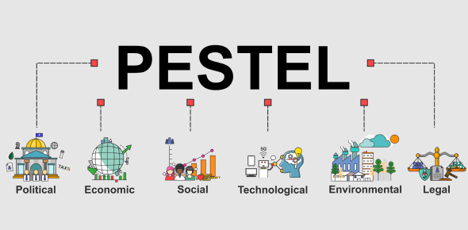

Source: PESTEL Analysis (Image source: Propofs)

Political | Economic | Social | Technological | Environmental | Legal
56 Bhog's operations hinge on political stability and strategic adherence to regulatory frameworks. | 56 Bhog navigates economic dynamics, adapting pricing and strategies to ensure resilience. | 56 Bhog anticipates and embraces societal changes, staying culturally relevant for a discerning clientele. | 56 Bhog leverages technology seamlessly for operational efficiency, meeting modern customer expectations. | 56 Bhog's commitment to sustainability strengthens its competitive position in an eco-conscious market. | 56 Bhog maintains operational integrity by rigorously adhering to legal standards and industry regulations.
Fig 2: PESTEL Analysis
Political Components: The working of 56 Bhog is closely related to political variables, which envelop everything from the soundness of the government to permitting and administrative frameworks. For the eatery to proceed working easily and give clients with a tranquil eating involvement free from unnecessary intrusions, political soundness is fundamental. Regarding political requests is more than fair a custom; it's a key need to arrange the complex administrative environment (Goodfellow, 2020).
Economic Flow: 56 Bhog's execution is altogether affected by London's financial circumstance. The city's financial wellbeing contains a critical effect on the restaurant's target clientele, influencing things like expendable salary and acquiring propensities. A keen grasp of economic dynamics is required because 56 Bhog's pricing policies, financial stability, and cost control are closely related to larger economic trends, inflation rates, and currency fluctuations (Hafner, 2021).
Social Trends: 56 Bhog is sensitive to the prevailing societal trends and tastes, having its location within the culturally diverse city of London. Social variables have a significant impact on the restaurant's menu and market positioning (Peters, 2020). These include eating habits, cultural quirks, and the growing trend of health consciousness. 56 Bhog's capacity to both foresee and adjust to societal changes guarantees its relevance and resonance with a wide range of discriminating customers.
Technological Advancements: 56 Bhog's competitive advantage is linked to technical developments. A tech-savvy customer base is a strategic asset rather than just a demographic to be considered. Utilizing digital technologies for online marketing, bookings, and cooking methods guarantees operational effectiveness and satisfies the demands of a contemporary, socially engaged clientele (Nahid, 2023). One of the main ways that the fine dining experience differs from others is the smooth incorporation of technology.
Environmental Aspects: 56 Bhog's commitment to sustainable practices becomes a strategic need as customer decision-making is increasingly influenced by environmental consciousness. The restaurant respects the principles of its eco-aware patrons by minimizing waste and using ethical suppliers. This dedication not only displays corporate responsibility but also strengthens 56 Bhog's competitive advantage in a market where sustainability is becoming a more key factor.
Legal Compliance: 56 Bhog's operational integrity is dependent on adhering to legal regulations. The restaurant operates under a legal framework that is constituted by licensing, compliance with health and safety requirements, and observance of employment rules (Lam, 2021). Fulfilling these legal requirements is not only a formality for regulations; rather, it is a strategic requirement to maintain industry standards, guarantee seamless corporate operations, and cultivate goodwill with regulators.
This brief PESTEL study highlights the complex network of outside factors affecting 56 Bhog. The restaurant's ability to proactively negotiate and adapt to the constantly changing political, economic, social, technical, environmental, and legal forces affecting its operational environment is critical to its long-term success and strategic resilience. 56 Bhog is prepared to address competitive pressures and unravel industry dynamics as it delves deeper into microenvironmental analysis. This will provide the groundwork for a strategic roadmap that guarantees sustained excellence in the fine dining space.

Micro Environmental Analysis
56 Bhog's competitive fine dining industry strategy depends on its ability to comprehend its microenvironment. This analysis examines the competitive factors influencing 56 Bhog's operational landscape by exploring the industry life cycle and utilizing Porter's Five factors framework.

Industry Life Cycle
56 Bhog works within a mature industrial life cycle within the fine dining sector. The stages of development that an industry normally goes through are categorized by the industry life cycle model, which goes from introduction to growth, maturity, and decline. Let's examine 56 Bhog's journey via this fully developed life cycle.
1. Maturity of the Fine Dining industry: 56 Bhog is a major player in the stable and clearly defined commercial landscape that is the fine dining industry. It has matured to the point where major companies are well-established and the dynamics of the industry are clear. 56 Bhog enjoys the stability that comes with being a well-established market, having gained a reputation in the food scene of London.
2. 56 Bhog's Established Position: 56 Bhog has a definite and secure place in the fine dining industry as a well-known entity. The restaurant's reputation among rivals has been cemented by its dedication to providing immersive dining experiences and fine cuisine. The industry's general stability is bolstered by 56 Bhog's standing as a prominent player in London's culinary scene.
3. Center on Reliable Development: 56 Bhog's key objective in a set up advertisement is to hold onto its position by reliably presenting modern thoughts. This advancement goes past menu things to incorporate progressed client benefit and a bigger share of the advertise. 56 Bhog gets it that to stay engaging to its target advertisement, it must continually alter and alter to the tastes of its clients.
4. Separation as a Competitive Basic: 56 Bhog recognizes the centrality of qualification considering the developing competitiveness that comes with age. The eatery points to set itself separated with special eating encounters, a wide extend of nourishment choices, and dynamic social engagement. As the industry creates, these components have become significant for protecting a competitive advantage. 56 Bhog's competitive advantage within the fine feasting industry stems from its capacity to supply unmistakable and extraordinary encounters.
5. Sustaining Competitive Advantage: Maintaining a competitive advantage becomes critical in an established industry. 56 Bhog's approach is centered on improving its market position via ongoing innovation and distinctiveness rather than merely holding onto its current position. 56 Bhog's ability to stand out in the established fine dining industry is attributed to its concentration on culinary excellence and dedication to creating an immersive dining experience.
56 Bhog's strategy is characterized by strategic agility, a dedication to innovation, and a clear appreciation of the need for distinctiveness within the mature life cycle of the fine dining business. 56 Bhog positions itself as a pioneer in changing the standards of great dining experiences in London, as well as a steady player, by skillfully managing the opportunities and challenges that come with operating in a mature market.

Porters Industry Five Force Analysis

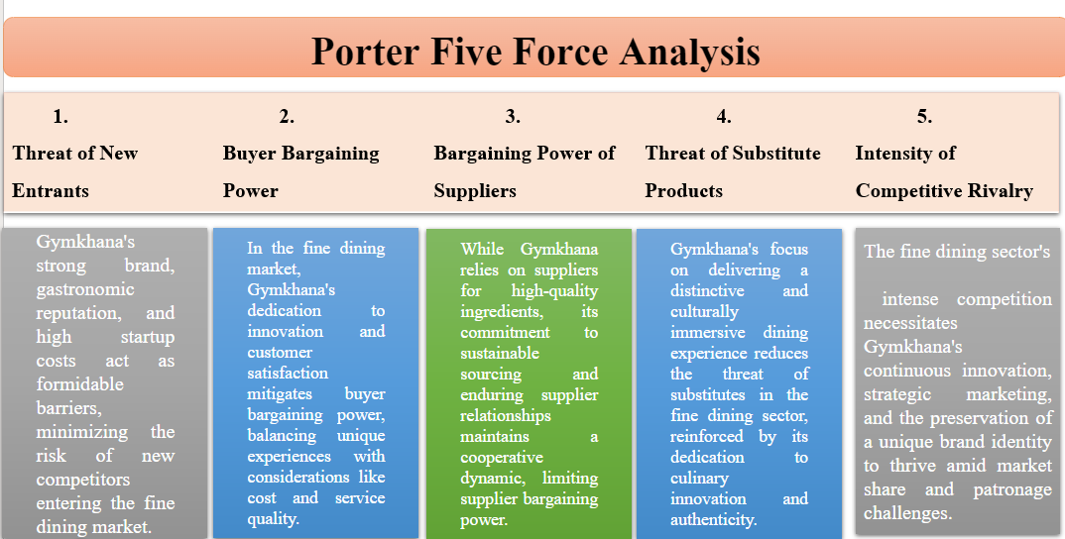
Source: Porter Five Force Analysis
Threat of New Entrants: There is not much of a chance of unused competitors entering the fine feasting showcase. Deterrents incorporate the well-known brand 56 Bhog, its gastronomic notoriety, and the tall startup costs related with the trade. In expansion, the prerequisite for culinary information and a one of a kind eating involvement raises the bar for planned rivals.

Buyer Bargaining Power: Within the fine feasting advertisement, buyers' control ranges from moderate to tall. Clients of 56 Bhog are searching for extraordinary and one-of-a-kind encounters, but they are too cognizant of things like taking a toll, level of benefit, and general esteem. 56 Bhog's commitment to continuous development and client fulfillment reduces the control of shoppers.
Bargaining Power of Suppliers: 56 Bhog has a limited amount of bargaining power since it depends on suppliers to provide genuine, high-quality ingredients. Nonetheless, the restaurant's focus on sustainable sourcing and enduring partnerships with suppliers contributes to the upkeep of a harmonious and cooperative dynamic.
Threat of Substitute Products or Services: There is a moderate risk of alternatives in the fine dining sector. Although there are other dining options, 56 Bhog's emphasis on offering a distinctive and culturally immersing experience makes its offers less interchangeable. This threat is further lessened by the restaurant's dedication to culinary innovation and authenticity.
Intensity of Competitive Rivalry: The fine dining sector is characterized by intense competition. 56 Bhog faces competition from other well-known businesses in terms of market share and patronage. Surviving fierce competition requires constant innovation, smart marketing, and upholding a unique company identity.
56 Bhog's microenvironment study concludes by showing a developed industrial life cycle with various competing dynamics (García Ruiz, 2023). Strategic thinking, creativity, and an unwavering dedication to offering a distinctive and outstanding dining experience are necessary for navigating these pressures. The strategic plan's latter sections will examine 56 Bhog's internal analysis and its resources, competencies, and competitive strategies.

Internal Analysis
The exceptional cuisine, unique brand, and committed staff define 56 Bhog's internal environment. The restaurant's dedication to acquiring premium, sustainable products and its talented chefs who create authentic Indian food are the key factors in its success. 56 Bhog crafts a distinctive dining experience that appeals to customers by putting an emphasis on operational efficiency. The restaurant's unique food selections, customer-centric attitude, and cultural involvement are its core assets (Samsa, 2023), which have established 56 Bhog as a significant participant in London's fine dining scene.

56 Bhog’s Strategic Resources and Capabilities
56 Bhog has a unique combination of strategic assets and competencies that support its success in the cutthroat fine dining market. The secret to its strategic strength lies in the skill with which its chefs create real Indian food, providing a distinctive and engaging eating experience (Gayler, 2022). 56 Bhog distinguishes itself in the market with its core competency of culinary quality. The restaurant's dedication to obtaining premium, sustainable food is a tactical advantage that fits with changing consumer tastes for morally and environmentally conscious eating. 56 Bhog places a strong focus on authenticity, but it goes beyond the food to include creating a culturally immersing atmosphere that appeals to customers looking for a comprehensive dining experience.
A crucial skill that enables 56 Bhog to provide outstanding customer service and keep its product offers consistent is operational efficiency. The restaurant's competitiveness in the fine dining industry is influenced by its capacity to manage logistics, uphold quality standards, and streamline procedures. 56 Bhog's brand embodies both culinary innovation and cultural richness, making it a powerful business tool. The brand acts as a magnet, drawing in a wide range of patrons who want to experience Indian cuisine in an upscale atmosphere in addition to dining there (Laeis, 2020). Market positioning and consumer loyalty are aided by this brand identity. 56 Bhog's success is largely due to its committed and talented workforce, which is a crucial resource. The employees' dedication to providing exceptional service is in line with the restaurant's customer-focused philosophy, which improves the whole eating experience and encourages positive word-of-mouth. 56 Bhog has a wide range of strategic resources and competencies, including culinary expertise, environmentally friendly sourcing, effective operations, a unique brand, and a highly qualified staff. By capitalizing on these advantages, 56 Bhog can meet industry obstacles, set itself out in a crowded market, and hold onto its reputation as one of London's premier fine dining destinations.

Value Chain Analysis
56 Bhog's value chain serves as a strategic framework that elucidates the order of events that culminate in the production of its distinctive culinary encounter.

Primary Activities
The main operations of 56 Bhog consist of the fundamental procedures that are used to provide its food and services. 56 Bhog guarantees a smooth process from inbound logistics, which includes procuring top ingredients, to operations, talented chefs curate authentic Indian cuisine. Effective marketing and sales techniques are combined with a well-executed eating experience to draw in and keep consumers in outbound logistics. A pleasant post-purchase experience is ensured by putting a strong emphasis on customer care, which increases customer satisfaction and loyalty.

Secondary Activities
56 Bhog's secondary operations enhance overall operational efficiency and consumer value by supporting the major functions. The restaurant optimizes administrative and logistical work by investing in state-of-the-art technologies for processing orders and reservations. The administration of human resources guarantees a knowledgeable and driven workforce, which enhances the quality of core operations. 56 Bhog's strict sourcing procedures ensure that premium foods are obtained in a sustainable manner, which is consistent with the restaurant's dedication to ethical sourcing. Together, these ancillary operations enhance 56 Bhog's value chain and produce a comprehensive and unique fine dining experience.

VRIO Analysis of Distinctive Resources and Capabilities
Through the VRIO study, which assesses the Value, Rarity, Inimitability, and Organizational support of its resources and capabilities, 56 Bhog's competitive edge is made clear. The chefs' culinary prowess adds a great deal of value and sets them apart in the industry. Adherence to sustainable sourcing is congruent with contemporary societal trends, and operational efficacy is a robust competency. Though valuable, 56 Bhog's culturally immersed brand needs constant innovation to maintain its uniqueness over time. Because of the company's commitment to fostering and coordinating these unique assets, 56 Bhog is positioned as a leader in London's fine dining scene and can maintain a competitive advantage.
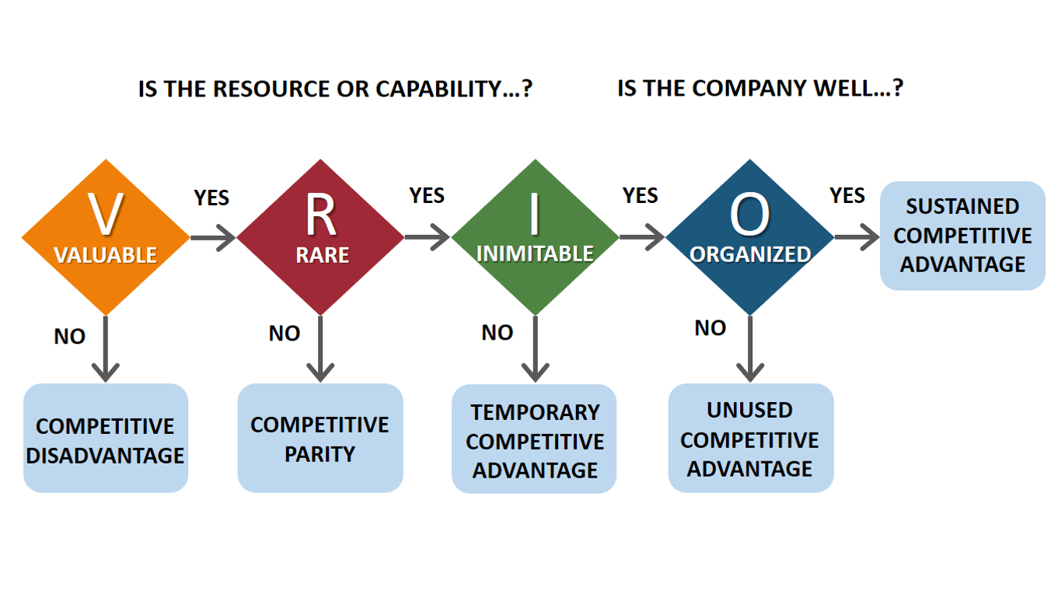

Source: VRIO Analysis (Image source: Business to you)

SWOT Analysis
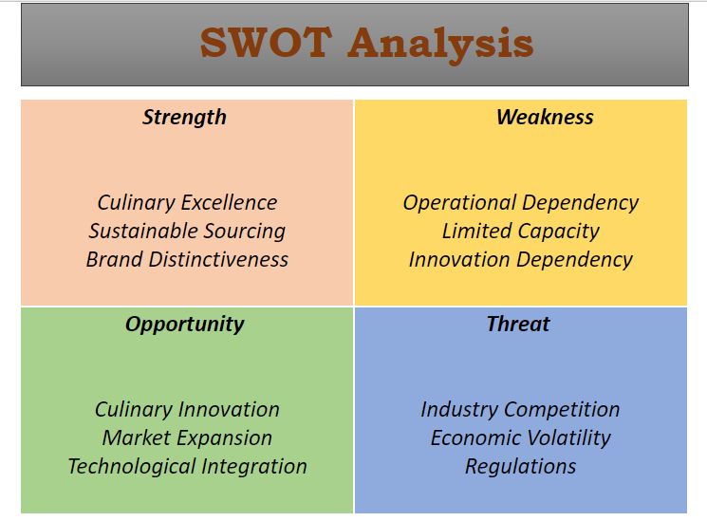
SWOT Analysis
Strength
Culinary Excellence: The kitchen at 56 Bhog is a bastion of culinary prowess, where cooks expertly prepare traditional Indian fare, creating a dining experience that is above and above the norm. This culinary expertise makes 56 Bhog a culinary destination in addition to drawing in discriminating customers.
Sustainable Sourcing: The dedication to ethical ingredient sourcing is a strength that is in line with the rising demand for food that is produced in a sustainable and ethical manner. 56 Bhog's commitment to ecologically friendly operations not only appeal to customers who care about the environment, but it also establishes the restaurant as a socially conscious business.
Brand Distinctiveness: 56 Bhog's brand is a cultural mosaic that permeates every facet of the eating experience. The restaurant's singularity is clear in everything from the environment to the cooking, giving it a particular character that cultivates buyer devotion and increases advertiser acknowledgment.
Weakness
Operational Reliance: One potential shortcoming is the requirement for vital chefs to maintain culinary excellence. 56 Bhog must ensure information exchange and progression arrangements to decrease the chance posed by any operational dependence on certain people.
Restricted Capacity: The little feasting environment includes the uniqueness of the space, but it also confines the conceivable clientele and sources of income. Expanding capacity without relinquishing the upscale environment would be an astute and an astute vital move.
Innovation Reliance: Steady development is required to preserve the brand's request. The trouble is in ceaselessly including modern perspectives whereas keeping up 56 Bhog's basic social character.
Opportunities
Culinary Advancement: Examining innovative combinations and patterns in cooking offers a chance to draw in an assortment of clientele. 56 Bhog can present chef collaborations, regular menus, or themed feasting encounters by utilizing its culinary aptitudes.
Market Extension: 56 Bhog can explore extra locales or target bunches much obliged to London's changed marketplaces. To reach a around the world gathering of people, it can be thought of growing globally to offer the particular Indian fine feasting involvement.
Technological Integration: By utilizing cutting-edge innovations for online acquiring, reservation frameworks, and client interaction, businesses can progress client comfort and operational proficiency.
Threats
Industry Competition: Advertise share is at risk due to the furious competition within the fine feasting industry. On the off chance that 56 Bhog needs to remain ahead of the competition, it must keep coming up with modern thoughts and creative marketing approaches.
Financial Volatility: Changes within the economy can influence customers acquiring designs, and fine eating is no exception. 56 Bhog may utilize value-added administrations and adaptable estimating procedures to form itself safe to economic downturns.
Regulations: Operations may be affected by changing wellbeing and security laws, especially within the post-pandemic period. 56 Bhog must keep up with any changes to the law and put suitable shields input to create beyond any doubt that supporters are safe and compliant.
Through the key administration of these components, 56 Bhog may use its preferences, amend its deficiencies, get a handle on prospects, and expect potential threats, so ensuring its progress and thriving within the ever-changing and vicious fine feasting field.

Strategies to Sustain Competitive Advantages
Maintaining a competitive edge is a dynamic task, particularly in the fine dining industry where forces of competition, industry trends, and consumer preferences are ever-changing. 56 Bhog has the option to strengthen its market position by implementing a variety of strategic analyses and frameworks.

Porter's General Strategy
Michael Porter's Generic Strategies provide a thorough framework that helps businesses create a long-lasting competitive edge. 56 Bhog may consider the following tactics:

Cost Leadership: 56 Bhog may lead the fine dining sector in costs by concentrating on operational effectiveness. This entails taking advantage of economies of scale, streamlining procedures, and improving the supply chain. 56 Bhog can offer competitive prices without sacrificing quality by adopting a cost leadership strategy that can boost profitability.
Differentiation: 56 Bhog's distinctive food experiences, ethnic atmosphere, and dedication to sustainable sourcing all help to set it apart (TOROME, 2023). This approach is reinforced by consistently changing the menu, adding chef-created specialties, and offering top-notch service. By being different, a company can develop an identity that appeals to customers looking for a unique fine dining experience.
Focus: 56 Bhog may choose to target a certain niche market, like fans of real Indian food, to implement a focused strategy. Customer loyalty can be increased by catering to the menu, atmosphere, and marketing initiatives to this demographic (Vilkaite-Vaitone, 2020). By concentrating on a certain market, 56 Bhog can become an expert in catering to that market and build a loyal clientele.

Growth Strategies

Ansoff Matrix
56 Bhog can contemplate the following growth ideas after seeing the Ansoff Matrix:
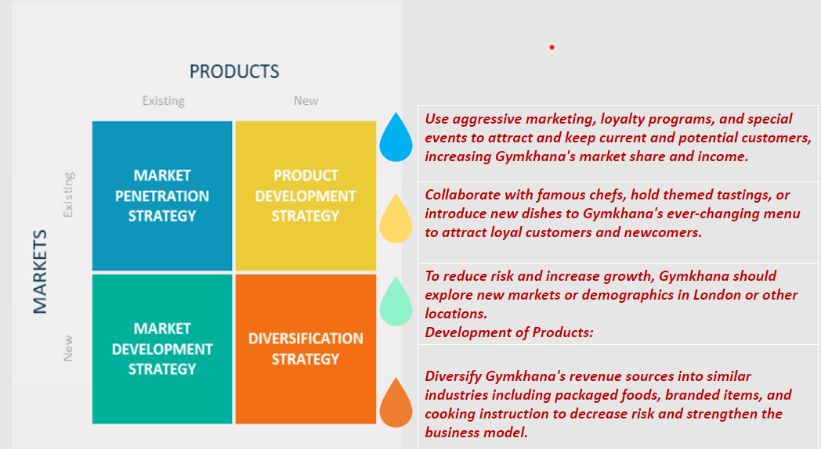
Source: Ansoff Matrix(boolkah.com)
Developing salary may well be encouraged by picking up showcase share within the show showcase by baiting in new clients whereas keeping hold of current ones.
Market Improvement: To extend 56 Bhog's reach, examine unused markets or socioeconomics in London or indeed in other cities. Extending into unexplored markets might diminish the chance included with depending as well much on a single advertisement and offer prospects for development.
Product Improvement: Bring something unused to the menu by collaborating with well-known chefs, making themed tastings, or presenting unused dishes. 56 Bhog's cuisine is continuously changing, which makes it engaging to both returning supporters and those seeking unused culinary encounters.
Diversification: Consider branching out into associated markets by giving bundled nourishments, branded products, or cooking lessons. By utilizing an assortment of income sources, enhancement diminishes chance and builds a stronger trade demonstration.

BCG Matrix Analysis
A company's item portfolio is partitioned into four categories by advertise development rate and advertise share utilizing the Boston Counseling Group's BCG Framework vital administration technique. The categories are:
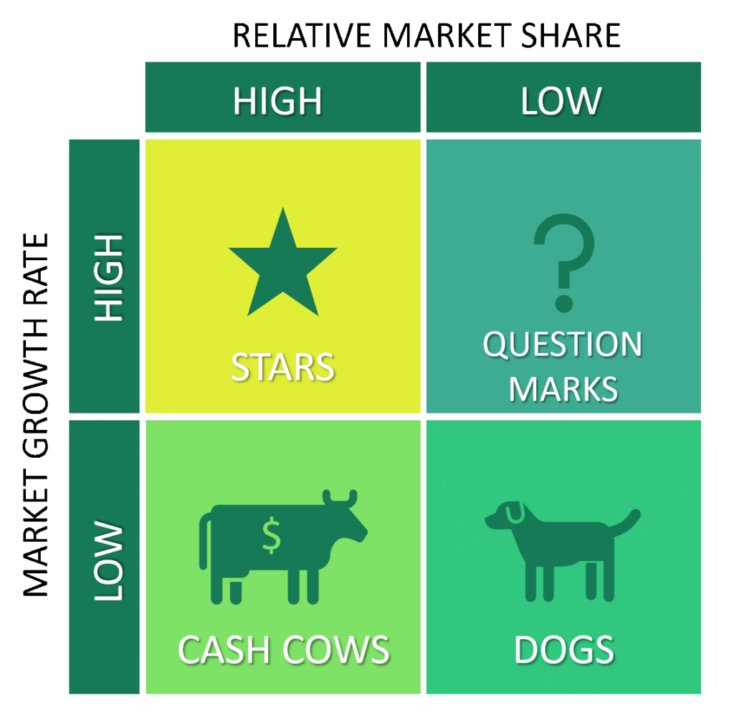

Source: BCG Matrix Model, Image source (Insight Tycoon)
Stars (High Growth, High Share)
Stars demonstrate a tall showcase share in fast-growing markets. These may well be interesting and prevalent nourishments or administrations that boost 56 Bhog's profit. Stars can end up cash dairy animals with noteworthy venture.
Cash Cows (Low Growth, High Share)
Item showcase share pioneers in set up, slow-growth markets are cash dairy animals. In 56 Bhog, this may incorporate prevalent menu things that create cash. These things are productive and dependable with small venture.
Question Marks (High Growth, Low Share)
Item address marks, or issue children, have moo advertise share in high-growth markets. Showcasing and venture may be required to choose on the off chance that these items can ended up stars or ought to be suspended. 56 Bhog ought to assess these products' future.
Dogs (Low Growth, Low Share)
Dog has limited market share in slow-growing markets. 56 Bhog may get to look at these offerings as they may not be productive. Restoring, moving, or killing these things are alternatives.
Execute BCG Framework to deliberately oversee and designate assets for 56 Bhog's item line. The lattice appears each product's position, supporting speculation, development, and divestment choices.

CSR with Green Strategy
Receiving a green technique and Corporate Social Obligation (CSR) programs makes a difference to supply an economical competitive advantage and is in line with cutting edge client desires:

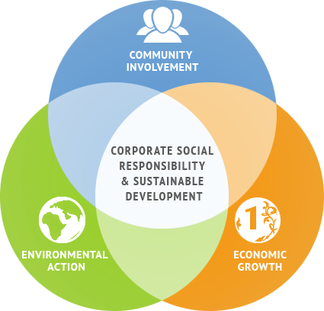
Source: Corporate Social Responsibility with Green Strategy (Image Source: Medium)
Feasible Sourcing: Boost 56 Bhog's devotion to moral fixing obtainment by prioritizing locally and naturally developed products. Catering to the increasing need for nourishment that's morally and reasonably sourced increments the restaurant's engaging quality to naturally cognizant coffee shops.
Community Engagement: Take part in community-based projects, such assisting regional farmers, attending fundraising functions, or working with cultural institutions. Having a positive impact on the community builds goodwill, improves business reputation, and draws in socially conscious customers.
Environmental Practices: Eco-friendly packaging, energy efficiency, and trash reduction are examples of initiatives that should be put into place. Adhering to environmental standards is in line with society norms, enhancing a company's reputation and drawing in eco-aware clients.
By strategically aligning with Porter's Generic Strategies, utilizing growth strategies from the Ansoff Matrix, and combining a green strategy with CSR initiatives, 56 Bhog can maintain its competitive advantage (Celikyay, 2023). Combining these tactics guarantees a comprehensive strategy that considers consumer preferences, market dynamics, and social expectations, establishing 56 Bhog as a strong and creative force in the fine dining industry.

Conclusion
The conclusion of this strategic analysis for 56 Bhog shows that a careful balancing act between culinary creativity, cultural authenticity, and strategic savvy will determine the restaurant's path to long-term success. As a premier eating destination in London, 56 Bhog boasts a diverse range of advantages, strategic assets, and specific skills that set it apart from the competition in the food industry. The restaurant’s competitive edge is demonstrated by its authentic Indian cuisine, which is crafted with culinary brilliance (Yount-André, 2021). This, together with a dedication to environmentally friendly operations and a brand that is culturally immersing, creates a distinctive eating experience that appeals to customers looking for more than simply a meal—rather, an amazing trip through flavor and culture.
56 Bhog has a full arsenal for negotiating the intricacies of the fine dining industry thanks to the strategic studies used, which range from Porter's Generic Strategies to the Ansoff Matrix and the integration of a green strategy with CSR initiatives. 56 Bhog can navigate a path that complements its own advantages and the dynamics of the industry, whether that path is through cost leadership, differentiation, market focus, or strategic growth. Potential areas for improvement were highlighted by the SWOT analysis, which emphasized the necessity of addressing operational dependencies, investigating novel culinary paths, and remaining aware of market trends and obstacles. 56 Bhog can maintain its existing market position and spur new growth avenues by utilizing its culinary expertise, embracing constant innovation, and incorporating sustainable and socially responsible methods.
Looking ahead, 56 Bhog is well-positioned to both uphold its reputation as London's premier dining venue and reinvent what constitutes fine dining. 56 Bhog can maintain its position as a leader in the culinary industry and leave a legacy by adopting an agile approach to problem-solving, welcoming innovation, and adhering to its cultural character.

Recommendations
Based on a thorough strategic study of 56 Bhog, several important recommendations are made to steer the restaurant in the direction of long-term success and ongoing excellence in the fine dining industry. 56 Bhog ought to place a high priority on a culture of constant innovation in its food selection. Incorporating chef partnerships, seasonal menus, and themed dining experiences can draw in new clients who are looking for innovative and cutting-edge culinary experiences in addition to captivating current ones. This strategy makes sure 56 Bhog stays ahead of the curve in terms of food trends and keeps its status as a popular and exciting place to eat. 56 Bhog needs to make investments in talent development and succession planning to address the operational dependency on key cooks. This entails developing the expertise of current chiefs, providing cross-training for employees, and putting in place systems for information transfer. By assembling a strong culinary team, 56 Bhog can maintain its dedication to quality and guarantee a smooth transition if staff members change. 56 Bhog ought to coordinate Key Execution Pointers (KPIs) from LinkedIn analytics to screen and assess the viability of the vital arrangement. Frequently evaluating measurements such as engagement, reach, and change rates will give profitable experiences, empowering 56 Bhog to form data-driven alterations and optimize its approach. This key use of KPIs guarantees that 56 Bhog remains dexterous and responsive to the energetic trading environment.
To increase 56 Bhog's exposure and reach current markets and investigate prospects for growth, a strategic marketing plan should be developed (Hewamana, 2021). Brand awareness can be increased by utilizing digital channels, working with influencers, and attending food events. Furthermore, assessing prospective expansion sites in London or even abroad can lead to new opportunities for development and diversification. Using innovative reservation systems, online ordering portals, and data analytics to personalize client interactions are just a few examples of how embracing technology may improve the overall customer experience (Bilgihan, 2023). Smooth and technologically advanced operations boost customer satisfaction, increase operational efficiency, and maintain 56 Bhog's leadership in contemporary eating trends. 56 Bhog should investigate new projects to enhance its corporate social responsibility and green strategy, building on its dedication to sustainable sourcing. This could entail more intensive partnerships with nearby farmers, environmental impact reduction programs, and engaged involvement in neighborhood events (Kiss, 2022). Such initiatives not only improve the well-being of society but also strengthen 56 Bhog's standing as an establishment that cares about the environment and society. By putting these suggestions into practice, 56 Bhog will be able to maintain its leading position in the fine dining sector, strengthen its competitive edge, and resiliently navigate industry dynamics. This strategic plan puts 56 Bhog in a position for continued success as well as future expansion and innovation, guaranteeing its long-lasting influence on London's food scene.

References
- Hopkinson, G.C. and Aman, A., 2019. Micro-political processes in a multinational corporation subsidiary: A postcolonial reading of restructuring in a sales department. human relations, 72(12), pp.1869-1890.
- Malaquias, R.F., Junior, D.M.B., de Oliveira Malaquias, F.F. and Albertin, A.L., 2019. Climate protection or corporate promotion? Energy companies, development, and sustainability reports in Latin America. Energy Research & Social Science, 54, pp.150-156.
- CHRISTIAN, M., HARIS, K., INDRIYARTI, E.R., WIBOWO, S. and SUNARNO, S., 2021. Service distribution strategy on business performance of Padang restaurants in North Jakarta. Journal of Distribution Science, 19(12), pp.57-69.
- Goodfellow, T., 2020. Political informality: Deals, trust networks, and the negotiation of value in the urban realm. The Journal of Development Studies, 56(2), pp.278-294.
- Hafner, A. ed., 2021. Essays on South Asian Society, Culture and Politics (I) (Vol. 8). Walter de Gruyter GmbH & Co KG.
- Peters, K. and Remaud, P.H., 2020. Factors influencing consumer menu-item selection in a restaurant context. Food Quality and Preference, 82, p.103887.
- Nahid, M.A. and Islam, M.M., 2023. MARKETING PLAN FOR ZUMP A food delivery service in Pietarsaari. International Business.
- Lam, E., Shih, E., Chin, K. and Zen, K., 2021. The double-edged sword of health and safety: COVID-19 and the policing and exclusion of migrant Asian massage workers in North America. Social Sciences, 10(5), p.157.
- García Ruiz, J.V., 2023. Business plan based on a new idea: Rural Real.
- Samsa, C., 2023. The Mediating Role of Firm Prestige in the Relationship between Perceived Quality and Behaviour Intention in Customer Cafeteria Experiences.
- Gayler, T., Sas, C. and Kalnikaitė, V., 2022. Exploring the design space for human-food-technology interaction: An approach from the lens of eating experiences. ACM Transactions on Computer-Human Interaction, 29(2), pp.1-52.
- Laeis, G.C., Scheyvens, R.A. and Morris, C., 2020. Cuisine: a new concept for analysing tourism-agriculture linkages?. Journal of Tourism and Cultural Change, 18(6), pp.643-658.
- Celikyay, M., Sonmez Cakir, F. and Adıguzel, Z., 2023. Effects of supplier orientation and competitive strategies on ICT firms’ performance. Journal of Asia Business Studies, 17(4), pp.701-720.
- Yount-André, C., 2021. Moral Orders of Multinationals: Registers of Value in Corporate Food Production. Signs and Society, 9(1), pp.89-117.
- Hewamana, H.M.R.R., 2021. SIGNIFICANCE OF BLACK-SCHOLES MODEL: WITH REFERENCE TO NIFTY-50 INDEX CALL OPTIONS. Volume IX, p.94.
- Bilgihan, A. and Ricci, P., 2023. The new era of hotel marketing: integrating cutting-edge technologies with core marketing principles. Journal of Hospitality and Tourism Technology.
- Kiss, B., Sekulova, F., Hörschelmann, K., Salk, C.F., Takahashi, W. and Wamsler, C., 2022. Citizen participation in the governance of nature‐based solutions. Environmental Policy and Governance, 32(3), pp.247-272.
- Ausejo Rubert, L., 2021. 'Lalis' Business Plan.
- Vilkaite-Vaitone, N. and Skackauskiene, I., 2020. Service customer loyalty: An evaluation based on loyalty factors. Sustainability, 12(6), p.2260.
- TOROME, S.J., 2023. A review of the history of the Karen Country Club from 1937 to 2017: Its origin, development and growth. Reviewed Journal of Social Science & Humanities, 4(1), pp.1-21.

