

Electromagnetic Radiation
Module M5X00941_Q

Will Guillaume Tell

For Prof. John Rees

by
Kenny Johnston (P148567)

Contents.
Figures. 3
1 Introduction 4
2 The Law and applicable policies 5
3 Lasers – The basics 7
4 Bibliography. 9
5 References. 10

Figures.
Figure 1: Figure 1: MoD Hebrides Range Head asset map 6

Introduction

The Law and applicable policies

The Health & Safety at Work Act (HSAW) 1974 was appended with The Control of Artificial Optical Radiation at Work Regulations (AOR) in 2010 in Statutory Instrument number 1140. The defining statement of the regulations states that:

“4.-(1) An employer must ensure that any risk of adverse health effects to the eyes or skin of employees as a result of exposure to artificial optical radiation which is identified in the risk assessment is eliminated or, where this is not reasonably practicable, reduced to as low a level as is reasonably practicable.”^{[1]}

Joint Service Publication (JSP) 390 is the overarching document issued by the Ministry of Defence (MOD) covering Military Laser Safety which states:

“The MOD has a general policy of adopting best practice from industry and meeting or exceeding UK health and safety standards.”^{[2]} (Vol. 1, para 2.1.3)

The JSP further specifies that “the MOD has a general policy that levels of laser radiation which may exit the range or facility boundaries will not cause injury to persons under reasonably foreseeable conditions.” (Vol. 1, para 2.2.1)

With regards to civilian organisations using lasers on MOD ranges, the specifies that “The private, academic or commercial organisation will have a similar duty (under the HSAW act), with additional specific responsibility for their own employees and those MOD personnel involved in their operations”

In response to the publication of the AOR QinetiQ produced a Laser Safety Instruction (SAF/INS/0160) to further explain both the requirements of the AOR and JSP 390.

Before we can summarise the requirements to be met regarding laser safety and legislation, we must understand the nature of what lasers are, how they function and what risks they pose during use.

Lasers – The basics

Laser is an abbreviation of Light Amplification by the Stimulated Emission of Radiation. As the title suggests, the process takes a light source, or pump, and amplifies the output by stimulating it.

An incoherent, conventional light source – the Sun, a light-bulb or LED - causes the spontaneous emission of photons which can be entirely random, with mixed wavelengths and directions. A Coherent or Stimulated emission is caused when an atom is excited by additional energy until it emits a photon. When this photon collides with a similarly excited atom, another photon is released and the process becomes exponential. These photons have the same energy level, frequency and direction. This is a laser.

There are three main categories of lasers: Continuous Wave (CW), Pulsed and Ultra-Fast.
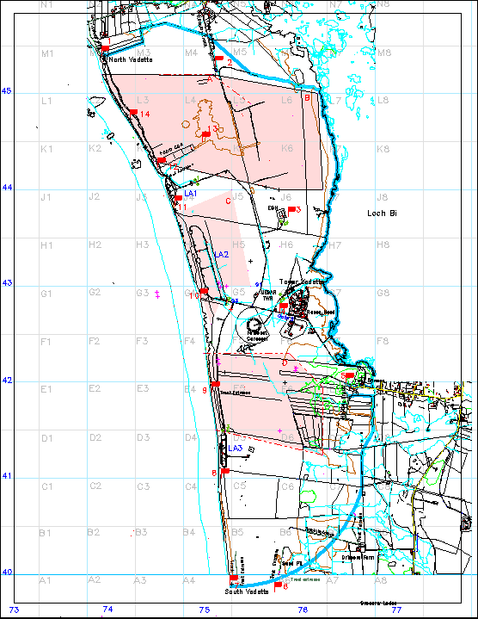
Figure 1: Figure 1: MoD Hebrides Range Head asset map

Bibliography.
- “Lasers: Understanding the Basics” Internet: https://www.photonics.com/EDU/Handbook.aspx?AID=25161, [03/07/17]

References.
- “The Control of Artificial Optical Radiation at Work Regulations 2010” Internet: http://www.legislation.gov.uk/uksi/2010/1140/made 27/04/10 [04/07/17]

- NATS Aeronautical Information Service. Internet: http://www.nats-uk.ead-it.com/public/index.php%3Foption=com_content&task=blogcategory&id=4&Itemid=11.html [02/07/17].

