

Name: Elizabeta Naydenova- 2417507, Greta Doncheva- 2411732, Ventsislava Peneva - 2411180
Module Code: LCBB5015
Module Name: Principles of Marketing
Lecture: Tushara Belendran

Table of Content
1. Introduction
2.STP Analysis, Integrated Marketing Communications, Ansoff Matrix
3. Situational Analysis – PESTEL for M&S
4. Implementation and control
5. Recommendation
6. Conclusion

1.Introduction

Marks & Spencer is one of the UK’s oldest and most respected retailers. The company was founded in 1884, when a Polish-Jewish immigrant named Michael Marks opened a market stall – the ‘’Marks” “Penny Bazar” – at Kirkgate market in Leeds, selling everyday goods priced at a penny (M&S Archive,2025).
Marks & Spencer (M&S) is one of the UK’s leading retailers, known for offering high-quality clothing, food, and home products. Established over a century ago, the company has built a strong reputation for reliability, innovation and premium value. Operating in a highly competitive retail environment, M&S serves millions of customers through it is nationwide stores, online platforms, and strategic partnerships such as it is joint venture with Ocado for grocery delivery. The brand is widely recognised for it is commitment to quality, ethical sourcing and customer service which help maintain it is long-standing position in the UK retail market.
The purpose of this report is to analyse how M&S uses key marketing concepts to remain competitive and adapt to changing customer needs. In particular, the report examines the organisation approach to segmentation, targeting and positioning, it is integrated marketing communications and the 7Ps marketing mix. These elements help explain how M&S identifies customer groups, communicates value and delivers products and experiences that reinforce it is premium brand image. In addition, a PESTEL analysis explores the external environment shaping M&S’s strategic choices, while the section on implementation and control outlines how marketing plans are executed and monitored within the organisation. Together, these sections provide a comprehensive understanding of how M&S manages it is marketing strategies to achieve it is mission of offering trusted quality, innovation and value customers.

Elizabeta Naydenova - 2417507

2.STP Analysis, Integrated Marketing Communications, Ansoff Matrix
- Marketing Strategy of Marks Spencer
Marks & Spencer is one of the UK’s best-known retailers, offering clothing, food, and home products. The brand has a long history and is trusted for its quality. However, as the retail market keeps changing, M&S has had to adjust its marketing approach to stay competitive. These sections explain M&S strategy using three ideas: Segmentation, Targeting, Positioning (STP), Integrated Marketing Communications, and the Ansoff Growth Matrix.
STP Analysis Segmentation
Marks & Spencer sells a wide range of products and divides its customers into different groups using several approaches.
Marks & Spencer segments its customers in several ways.
Demographically, they focus on people’s age, income, and family situation, traditionally attracting middle-aged and older adults, but now also appealing to younger shoppers. They mainly target middle-to upper-income customers who are willing to pay more for good quality, and their food and home products often appeal to busy families and working professionals.
Psychographic M&S attract people who value quality, reliability, and an organised shopping experience, as well as those who care about ethical and environmentally friendly products (M&S, 2024).
Behaviourally, they target customers who want convenience, such as ready-to-eat meals, and those who want long lasting clothing, while encouraging loyalty through the Sparks programme. Using a different targeting approach, M&S serves different groups through its food division, clothing and home division, and online store. They position themselves as a brand that offers high quality, stylish practical and ethically sourced products, with their slogan “Only at M&S” highlighting their unique and consistent quality. Their food is often seen as affordable luxury, helping them stand out from regular supermarkets.
- Integrated Marketing Communications
Marks & Spencer uses an integrated marketing communications strategy to deliver a consistent message across all channels, both online and offline. The company invests heavily in advertising, particularly for food and seasonal clothing, using high-quality visuals and emotional messaging to reinforce its premium positioning. M&S also engages audiences through social media platforms like Instagram, Facebook, TikTok and YouTube, partners with influencers to attract younger customers, and uses online interactions to boots engagement. In- store experiences, including layouts, signage, lighting, product presentation, and trained staff, further reflect the brand’s values of quality and comfort. Loyalty programs such as Sparks card offer personalised rewards, charity donations, and tailored communications, while direct marketing through emails, app notifications, and reminders helps maintain customer relationships and encourage repeat purchases. M&S also highlights corporate responsibility with initiatives like ethical sourcing, recyclable packaging, and Plan A sustainability projects, building trust and reputation. Partnerships, such as Ocado for online grocery delivery, extend the brand’s reach and ensure continuity across digital and physical channels.
3.Marketing Mix 7ps of Marks & Spencer
The 7Ps Marketing Mix of Marks & Spencer shows how the company plans its products and services to satisfy customer needs. Product: M&S offers high-quality clothing, food, and home items that are reliable and stylish. Price: Products are mid-to-high range, giving value for money. Place: M&S sells through stores in the UK, internationally and online. Promotion: They use advertising, seasonal campaigns, and loyalty programs to attract customers. People: Well- trained staff provide excellent service. Process: Efficient supply chain and online shopping make buying easy. Physical Evidence: Store layout, packaging, and brand image create trust (M&S, 2023).
Product:
M&S sells a wide range of products including food, clothing, footwear, and home items. Its food range has high-quality ready meals, fresh produce, baked goods, drinks, and special seasonal items, all designed to offer great taste and convenience. Clothing and footwear are made to be long-lasting, comfortable, and mix of traditional and modern styles. Home products include furniture, decorations, bedding, and kitchenware. Most items are sold under M&S own brands, helping the company maintain strong quality control. Sustainability is also important, with the use of ethical sourcing, recycled materials, and eco-friendly packaging showing M&S’s commitment to responsible and innovative product development (M&S, 2022).
Price:
M&S uses a value-based pricing strategy, meaning prices are set to match the quality offered. This usually makes M&S products slightly more expensive than those from regular retailers. Food is prices at a premium because of its quality, while clothing sits in the mid to upper-price range. Recently, M&S has tried to make some prices more attractive to younger customers. Promotions like seasonal sales, multi-buy deals, Sparks card offers, and price-matching help make products more affordable without losing the brand’s premium feel (Marks & Spencer, 2025).
Place:
M&S reaches customers through both physical stores and online services. Store are placed in convenient locations such as high streets, shopping centres, and retail parks. Online, customers, can shop for clothing, home items, and some food products. The partnership with Ocado allows M&S to offer a wider online grocery delivery service. Strong supply chain processes ensure that products, especially food, remain fresh and reliable (M&S, 2025a).
Promotion:
M&S uses different types of promotion to build brand awareness and loyalty. TV and online adverts often use high-quality visuals, and the company is especially known for its Christmas food campaigns. Social media posts, influencer partnerships, and personalised emails through the Sparks loyalty program help M&S stay connected with customers. Public relations efforts, sustainability updates, and community work also support the brand’s image as a trusted and premium retailer (Marks & Spencer, 2025).
People:
Employees play a key role in delivering the M&S experience. Staff are trained to be friendly, helpful, and knowledgeable, supporting the company’s focus on quality service. M&S values equality, diversity, and staff development. Management teams work to improve digital services and sustainability. Employees represent the brand’s commitment to trust, quality, and ethical behaviour (M&S, 2025).
Process:
M&S aims to make the customer experience smooth and efficient. Checkout options include self-service and app-based payments for convenience. The online ordering and delivery services especially through Ocado-are designed to be reliable and easy to use (Ocado,2025).
A strong supply chain keeps food consistently fresh, and the clothing returns process is simple for customers. The loyalty program also works smoothly to reward shoppers. These well managed processes help strengthen customer confidence.
Physical Evidence:
M&S physical and digital environments help communicate its brand value. Stores are clean, well-designed and visually appealing, with good highlight quality. Product packaging focuses on both premium design and sustainability. Online platforms like the website and app use consistent branding, as do store signs and displays. Modern and clean look reinforces trust, quality and professionalism.
Marks & Spencer’s marketing strategy combines its long-standing brand values with modern ideas to stay competitive. The company focuses on understanding different customer groups and uses targeted communication to reach them effectively. It also applies growth strategies, such as the Ansoff Matrix, to expand into new markets and develop new products. Looking at the 7Ps- product, price, place, promotion, people, process, and physical evidence-shows that M&S prioritizes high quality products, excellent customer service, and sustainability. These areas are key to maintaining the company’s strong reputation and keeping customers loyal. At the same time M&S is aware that the market is changing, so it continues to adapt to digital trends, improve its online shopping experience, offer competitive prices, and appeal to younger shoppers. By balancing tradition with innovation, M&S aims to stay relevant, grow its customer base, and maintain its position as a trusted and premium retailer.
Ventsislava Peneva - 2411180

3.Situational Analysis – PESTEL for M&S
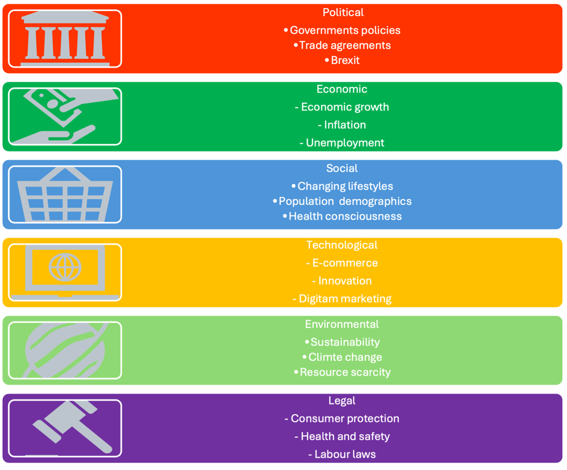

Source: Created by Greta Doncheva
The external environment plays an important role in shaping decisions for a retailer like Marks & Spencer (M&S). Using a PESTEL analysis helps explain the external factors influencing business performance and guides decisions for a marketing plan. PESTEL stands for Political, Economic, Social, Technological, Environmental and Legal factors, and it helps companies prepare for risks and opportunities in the wider environment (CIPD, 2025).
- Political factors influence M&S through government rules, trade policies, and labour regulations. Since Brexit, importing food, fabrics and clothing has become more complex, adding extra paperwork and delays (Marks & Spencer, 2025). These challenges increase costs and affect the supply chain. Government business rates and labour regulations also increase store running costs and influence employment decisions (Marks & Spencer, 2024). Following rules helps M&S plan and work safely. Labor laws can improve staff treatment and company reputation. Brexit makes importing slower and more expensive. Higher costs from taxes and rules. Supply chain problems can make it harder to get products. The marketing plan must consider these pressures and focus on efficiency and flexible sourcing to protect profits.
- Economic factors affect how much customers spend. Inflation is the rate at which the general level of prices for goods and services rises, reducing the purchasing power of money. The UK economy has faced high inflation and higher living costs in recent years, which reduces disposable income and makes people more careful with spending (Canvas Business Model, 2025). Customers may buy fewer clothes and home products, but food sales can remain steady if good value is offered. For this reason, M&S has focused strongly on growing its food business and updating stores to improve customer experience (Marks & Spencer, 2024). During economic pressure, customers want clear prices, value ranges and convenience. A marketing plan that highlights affordable quality, promotions and loyalty benefits can help increase sales in tough economic conditions.
- Social factors show how customer behaviour and lifestyle trends influence what people buy. Shoppers want quick and convenient shopping options, such as click & collect and fast delivery. People shop more online and use mobile apps. M&S has invested heavily in its app and digital navigation because many customers prefer to browse and order digitally (Marks & Spencer, 2024). There is also increased interest in sustainable and healthy products. Many shoppers want brands that act responsibly. Marketing messages need to show responsible sourcing, healthy meal options and environmental progress.
- Technological factors are important for growth. Technology supports online retail, stock management, marketing and personalised customer services. M&S uses digital tools such as mobile apps, online payments and data analytics to understand what customers want and send personalised offers. Growth in digital shopping is helping M&S reach more customers and increase app engagement (Marks & Spencer, 2024). A marketing plan that uses technology, digital advertising and automation can improve efficiency and customer satisfaction.
- Environmental factors relate to sustainability and climate commitments. Customers are more aware of environmental issues and want brands to reduce waste and offer eco-friendly choices. M&S has long promoted sustainability through its Plan A programme and aims for net zero carbon and ethical sourcing (Marks & Spencer, 2024). Communicating real progress is crucial because customers expect action, not just promises. Sustainability messages can attract eco-conscious customers and improve brand trust.
- Legal factors involve rules on safety, product labelling, data protection and employment. Retailers must follow strict UK laws, especially for food safety and labelling standards. M&S must also follow data protection rules for online customers and employment regulations across stores (Marks & Spencer, 2024). Failure to comply would damage reputation and cost money. The marketing plan must be responsible, accurate in communications and respectful of consumer rights.
The PESTEL findings guide key actions for the marketing plan. These factors suggest investing in digital growth, store improvements, value ranges and sustainability communication to build stronger sales.

4. Implementation and control
Implementation means putting the marketing plan into real action so that M&S can reach its sales targets. It turns ideas into daily tasks that staff complete, campaigns that run, and budgets that are used. During implementation, information systems collect data so managers can see what is working and what needs to change (Metz et al., 2020; Gibson, 2024). Effective implementation needs clear communication and teamwork across marketing, operations, finance, and store staff.

The control process helps M&S check progress and make improvements. There are five main stages:
- Set standards - Create clear and measurable goals. For a company like Marks & Spencer (M&S), these goals might include sales targets, online conversion rates, average basket size, and Net Promoter Score (NPS). Targets must be specific so they can show whether performance is good or bad. These goals should match the yearly marketing budget and recognise seasonal changes in retail such as Christmas and Black Friday (Marks & Spencer, 2024).
- Measure actual performance - Collect data from reliable sources. Examples include sales information from shops, e-commerce analytics, loyalty card information, and customer surveys. Data must be collected quickly so managers can react while campaigns are still running (Marks & Spencer, 2024).
- Compare performance with standards - After measuring real results, managers compare them with the planned targets. This can happen through daily dashboards, weekly marketing reports, and monthly updates for senior leaders. These comparisons show where the business is performing well and where problems exist that need action (Gibson, 2024).
- Take corrective action - If results are lower than expected, managers must make changes. For example, they may increase advertising spending, change promotions in stores, adjust product location, or redesign marketing messages. If results are better than planned, managers may invest more in successful ideas. In retail, corrective action must be fast because timing strongly affects sales, especially during seasonal periods (Gibson, 2024).
Feedback and learning - The final stage is learning from experience. Teams record what strategies worked and what did not, then update future. This continuous learning improves marketing performance over time and helps build better teamwork and shared knowledge (Marks & Spencer, 2023).
Greta Doncheva - 2411732
5. Recommendation
1. Lower some prices to attract younger customers – M&S is known for high quality but is sometimes seen as expensive. Offering more affordable option or more frequent promotions can help attract younger people and families who want good value.
2. Improve online shopping and delivery service – many people now shop online. M&S should continue to make it is website and app easier to use, with faster delivery and clearer product information. This will help them compete with online retailers.
3. increase marketing on social media – to reach younger customers, M&S should create more content on TikTok, Instagram and YouTube. Working with more influencers and posting short, fun videos can help make the brand feel modern and exciting.
4. Develop more sustainable and eco-friendly products – customers care more about the environment. M&S should continue to use recycled materials, reduce plastic packaging and promote it is eco-friendly products. Clear communication about sustainability can build trust.
5. introduction more affordable healthy food ranges – many customers want healthier optional, but still at a good price. M&S can expand it is healthy food products and offer more budget-friendly meals to compete with supermarkets.
6. improve the in-store experience – M&S stores should stay clear, modern and easy to navigate. More self-service tills and helpful staff can make shopping quicker and more enjoyable.
7. Strengthen the Sparks loyalty programme – M&S can offer more personalised rewards, such as discounts based on what customer usually buy better rewards will increase customer loyalty and encourage repeat purchase.

6.Conclusion
The analysis shows that Marks & Spencer (M&S) is a strong and trusted retailer with a long history of providing hight-quality food, clothing and home products. The company uses segmentation, targeting and positioning, effectively by focusing on customer who value quality, convenience and ethical products. M&S also uses integrated marketing communications and the 7Ps marketing mix to maintain it is premium image through strong adverting, good customer service and well-designed stores. The PESTEL analysis shows that M&S must deal with many external challenges, such as Inflation, changing customer behaviour and sustainability expectations. However, it also has many opportunities to grow by using technology, improving digital services and appealing to younger shoppers.
To improve it is segmentation, targeting, positioning and marketing mix strategic, M&S should focus on a few key actions. First the company can segment customers more clearly by age and lifestyle so it can create more targeted products, especially for younger buyers. Second, M&S should expand it is targeting strategy by offering more affordable optional while keeping it is premium quality. Third, it can strengthen it is positional by highlighting sustainability, healthy living and modern fashion to stay relevant in a changing market. Finally, improvements to the marketing mix – such as better value pricing, more active social media promotion, smoother online shopping processes and continued focus on staff training will help M&S attract new customers and build stronger loyalty.
Overall, M&S can stay competitive by mixing it is traditional strengths with modern strategies. By adapting it is STP approach and improving the 7PS marketing mix, the company can reach a wider audience, meet changing customer needs and continue to be seen as a trusted and high-quality retailer.
Elizabeta Naydenova

7.References
M&S Archive. (2025). The M&S Story Timeline - M&S Archive. Available at: https://archive.marksandspencer.com/visit/ (Accessed 9 December 2025).
M&S (2022). Our Products. [online] Our Products. Available at: https://corporate.marksandspencer.com/sustainability/our-products. [Accessed 28 Nov. 2025]
M&S (2023). Responsible Marketing. [online] Responsible Marketing. Available at: https://corporate.marksandspencer.com/sustainability/our-products/responsible-marketing. [Accessed 28 Nov. 2025].
M&S (2024). Plastics and packaging. [online] Marks & Spencer. Available at: https://corporate.marksandspencer.com/sustainability/plan-a-our-planet/plastics-and-packaging. [Accessed 28 Nov. 2025]
M&S (2025). Our People. [online] Our People. Available at: https://corporate.marksandspencer.com/sustainability/our-people. [Accessed 28 Nov. 2025]
M&S (2025a). M&S International. [online] Marks & Spencer. Available at: https://corporate.marksandspencer.com/about-us/our-businesses/ms-international. [Accessed 28 Nov. 2025]
Marks & Spencer. (2025). The M&S trusted value equation. [online] Available at: https://corporate.marksandspencer.com/newsroom/blog/ms-trusted-value-equation. [Accessed 28 Nov. 2025]
Marks & Spencer. (2025a). Offers | Sale & Discounts | M&S. [online] Available at: https://www.marksandspencer.com/c/offers#intid=gnav_LEVEL1_COMPONENT_offers [Accessed 28 Nov. 2025].
Ocado.com. (2025). M&S - All Products - Ocado The online supermarket. [online] Available at: https://www.ocado.com/categories/m-s/0b510156-4941-4b1a-af42-e626229abe5d?ds_rl=1291426&ds_rl=1290893&gad_campaignid=12581064377&gad_source=1&gclid=EAIaIQobChMIqanWjICVkQMVnpFQBh3B_S4fEAAYASAAEgJ3-PD_BwE&gclsrc=aw.ds&utm_campaign=12581064377&utm_content=non-brand&utm_medium=cpc&utm_source=google [Accessed 28 Nov. 2025].

Canvas Business Model, (2025). Marks & Spencer Pestel Analysis. Available at: PESTLE Analysis of Marks & Spencer – CanvasBusinessModel.com. (Accessed: 28/11/2025).
CIPD, (2025). PESTEL Analysis. Available at: PESTLE analysis | CIPD. (Accessed: 27/11/2025).
Gibson, K., (2024). A Manager’s Guide to Successful Strategy Implementation. Available at: A Manager’s Guide to Successful Strategy Implementation. (Accessed: 29/11/2025).
Marks & Spencer, (2023). M&S Annual Report 2023. Available at: M-and-S-2023-Annual-Report.pdf. (Accessed: 29/11/2025).
Marks & Spencer, (2024). Annual Report 2024. Available at: M-and-S-2024-Annual-Report.pdf. (Accessed: 27/11/2025).
Marks & Spencer, (2024). Data Protection and Privacy Policy. Available at: Data Protection and Privacy Policy.pdf. (Accessed: 28/11/2025).
Marks & Spencer, (2024). Full Year Results for 52 Weeks Ended 30 March 2024. Available at: Marks and Spencer Group Plc Full Year Results for 52 Weeks Ended 30 March 2024. (Accessed: 28/11/2025).
Marks & Spencer, (2024). Plan A – Our Planet. Available at: Plan A - Our Planet | Marks & Spencer. (Accessed: 28/11/2025).
Marks & Spencer, (2025). RESHAPING M&S. Available at: Marks-and-Spencer-Group-plc-Annual-Report-and-Financial-Statements-2025_INTERACTIVE_FINAL.pdf. (Accessed: 27/11/2025).
Marks & Spencer, (2025). Financial Statements 2025. Available at: SIGNED Financial Statements - Marks and Spencer plc FY25.pdf. (Accessed: 27/11/2025).
Metz, A., Burke, K., Albers, B., Louison, L., & Bartley, L., (2020). A Practice Guide to Supporting Implementation. Available at: ISP-Practice-Guide.pdf. (Accessed: 29/11/2025).

