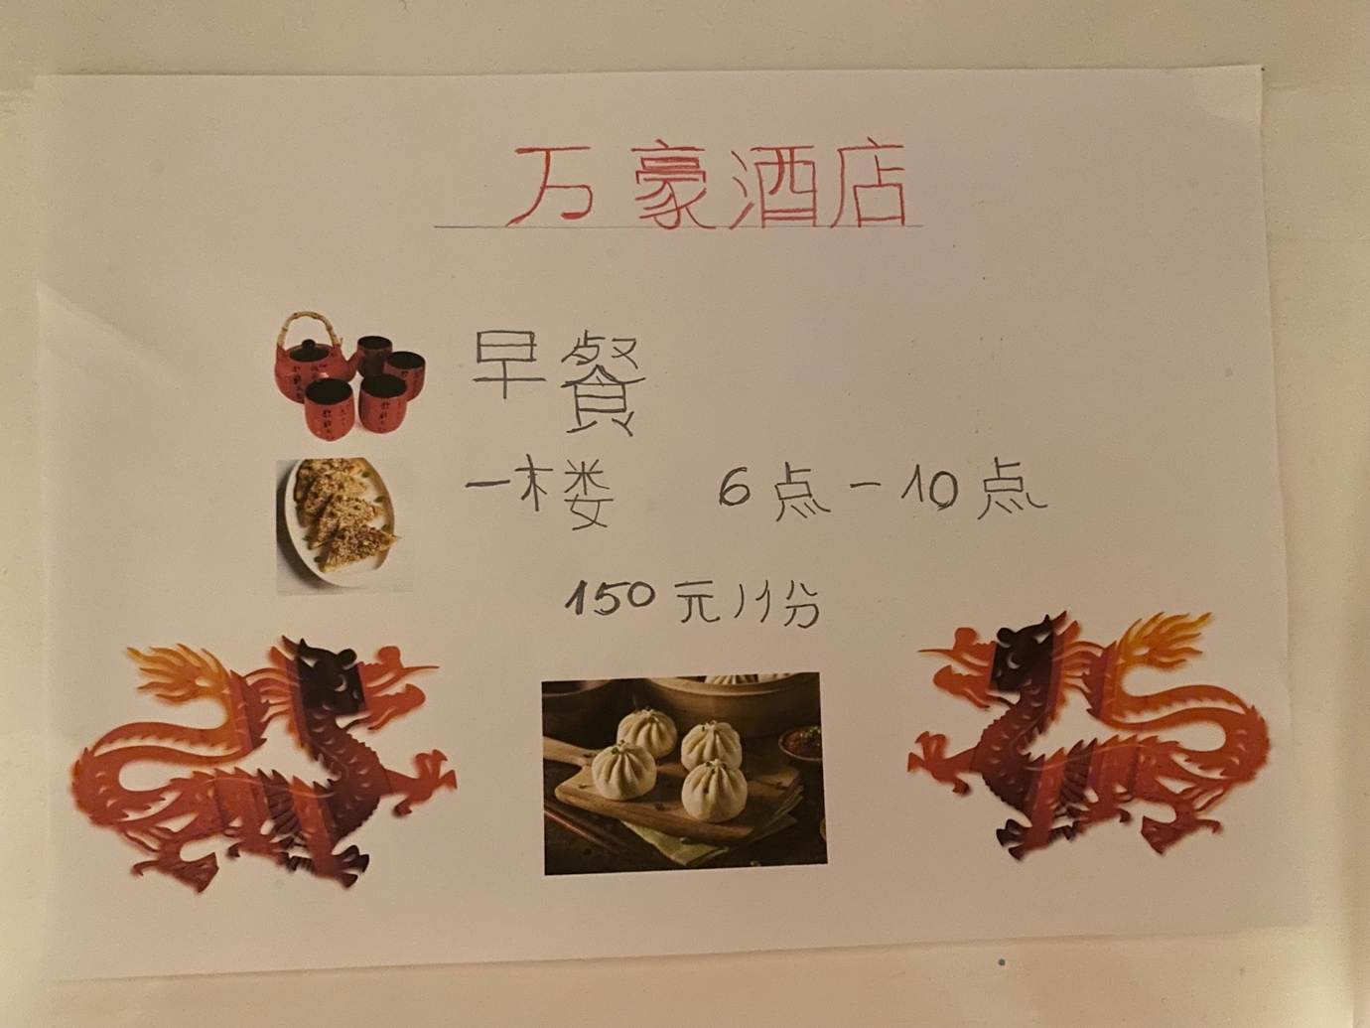

Hotel Breakfast Board

Module Name: Foreign Languages and Cultural Awareness
Module Code: BMIH5003
Student Name: Ana Maria Dobrinoiu
Student No: 2017713
Lecturers Name: Jinping Li

