
An investigation into how Online business has been boosted by the changing of customer behaviour during the Pandemic

A Dissertation submitted for the
Master of Business Administration (MBA) 2023

Submitted 10/12/2023

Student: Arcangelo Ferrigno
Student Number: 1917529
Supervisor: Anthony Burns

DECLARATION
This work has not previously been accepted in substance for any degree and is not being concurrently submitted in candidature for any degree.
Signed: Arcangelo Ferrigno (candidate)
Date: 10/12/2023

STATEMENT 1
This work is the result of my own investigations, except where otherwise stated.
Other sources are acknowledged by footnotes giving explicit references. A bibliography is appended.
Signed: Arcangelo Ferrigno (candidate)
Date: 10/12/2023

STATEMENT 2
I hereby give consent for my work, if accepted, to be available for photocopying and for inter-library loan, and for the title and summary to be made available to outside organisations.
Signed: Arcangelo Ferrigno (candidate)
Date: 10/12/2023

Acknowledgements

First, I want to thank my wife and family for their patience and support throughout this journey.
Furthermore, I would like to thank my dissertation advisor, Mr. Antony Burns, for kindly guiding me to the conclusion of this work.
Thank you very much!

Abstract

Contents Page
Acknowledgements 2
Abstract 3
Chapter 1 – Introduction 5
1.1 Opening Section 5
1.2 Background 6
1.3 Research Problem 7
1.4 Aim, Objectives and Questions 8
1.5 The Significance 9
1.6 Limitations 10
1.7 E-commerce and new retail: Evolution and Business models 10
1.8 E-commerce and New retail: Market Size and Structure 12
1.9 Other Types of Online Business 16
1.10 Research Structure 23
Chapter 2 – Literature Review 24
2.1 Shopping behaviours during the COVID-19 pandemic 24
2.2 Changes in Consumer Spending Patterns Post-COVID-19 27
2.3 The Long-Term Impact of the Pandemic on Consumer Behaviour 34
2.4 Chapter Conclusion 39
Chapter 3 – Methodology 40
3.1 Introduction 40
3.2 Research Philosophy 41
3.2 Research Approach 42
3.3 Methodological Choice 43
3.4 Research Strategy 44
3.5 Time Horizon 45
3.6 Techniques & Procedures 46
3.7 Limitations of the study 47
3.8 Ethical Considerations 48
3.9 Chapter Conclusion 49
Chapter 4 – Analysis of Results 50
4.1 Introduction 50
4.2 Demographics of the Participants 51
4.3 Theme 1 - Transition to Online Shopping 55
4.4 Theme 2 - Continuance of Online Shopping Post-pandemic and Beyond 57
4.5 Theme 3 - Enhanced Online Trust and Security 60
4.6 Theme 4 - Post-Pandemic Hybrid Behaviours 62
4.7 Theme 5 - Recommendations from Consumers 63
4.8 Theme 6 - Fluctuations in online streaming usage and subscriptions 65
4.9 Theme 7 - Hybrid Work Model as the New preferred Standard 66
Chapter 5 – Conclusions and Recommendations 68
References 69
Appendices 77
Appendix 1 - Interview Consent Form 77
Appendix 2 - Essential Demographic Questions 80
Appendix 3 - Interview Questions 82
Appendix 4 - Analysis of Emergent Themes 85

Chapter 1 – Introduction

1.1 Opening Section

The digital revolution, which began in the second half of the last century, continues to produce its effects, modifying and renewing how consumers reach and satisfy their needs.
This flow of innovation and technological improvement has redesigned how companies do their business, allowing them to experiment with new sales and customer relationship channels. Mainly thanks to the driving force of the Internet and e-commerce.
Electronic commerce (e-commerce) is ‘‘the process of buying and selling products or services using electronic data transmission via the Internet and the World Wide Web” (Grandon and Pearson, 2004).
Since December 2019, the outbreak of the COVID-19 pandemic has had an influential impact on consumer behaviours not just in the UK but around the world.

1.2 Background

As a result of the COVID-19 pandemic, lockdowns and social distancing have forced people to change their daily behaviours radically. Consumers began to shop differently by reassigning essentials and swapping the checkout line with online shopping.
The daily routine has, therefore, necessarily moved more vigorously from offline to online.
This shift has disrupted the retail sector, with many stores forced to close at the height of the lockdown, accelerating the trend towards electronic commerce as consumers shifted their spending to online (Guthrie et al., 2021).
According to Sheth (2020), people under the lockdown condition have discovered and learned new habits that will be maintained even after the end of the pandemic. This is because the adoption of digital technology is likely to cause people to change their existing habits (Sheth, 2020).
The inability to shop at the supermarket or go to work, school, restaurant, or the cinema has accelerated the spread of "In-home" services such as food delivery, home streaming, e-commerce, smart working, and distance learning. At the same time, there has been an exponential increase in the use of social networks as an alternative solution for social life, allowing users to interact and debate with each other (Trevisan et al., 2021).
According to Gu et al. (2021), the COVID-19 pandemic has also affected the lifestyles and priorities of online consumers, benefiting some industrial sectors at the expense of others. For instance, there has been a surge in the requests for health and safety devices, medical supplies, children’s products, sporting items, and entertainment goods. On the contrary, there has been a substantial budget reduction on holiday travel purchases. However, the essential purchase criteria such as price, availability and convenience have remained unchanged (Gu et al., 2021).
While the vast majority of these behavioural changes are not permanent, some of them are going to last permanently. Therefore, this pandemic scenario has mainly been characterized by two aspects: one is a change in customer behaviours that avoids crowded public gatherings, and the second is a greater propensity for digital adoption (Shashidhar,2020, cited in Sharma and Jhamb, 2020).
At the same time, the rapid migration to digital technologies has pushed companies to react, accelerating their digital transformation (Klein and Todesco, 2021). Recent data shows that a five-year leap in digital adoption by consumers and businesses has been made in about eight weeks (Baig, Hall, Jenkins, Lamarre and McCarthy, 2020).
According to McKinsey research (2020), 75% of people who use digital channels for the first time will continue to use them when things return "normal." Hence, companies must ensure that their digital channels are on par or better than those of their competition to be successful in this new environment (Baig, Hall, Jenkins, Lamarre and McCarthy, 2020).

1.3 Research Problem

The pandemic of COVID-19 has had a significant impact on all commercial operations and consumer activity. While its impact on the digital transformation of organizations has been studied, more academic attention needs to be paid to the impact of COVID-19 on consumers and consumer behaviour (Kim, 2020; Verma and Gustafsson, 2020).
Industry reports and consumer surveys show that the post-lockdown period may have been too short to detect adaptive behaviours. These were principally focused on the immediate impact on consumer behaviours. “Further studies could observe online purchasing behaviours over a longer period”. (Guthrie et al., 2021).
Covid-19 has increased the use of social media such as Facebook, Instagram, WhatsApp, Twitter and Zoom. Especially during the lockdown, comments expressing concern, such as anxiety and inhibition, have increased, thus influencing consumer decisions. Considering this, an analysis of online purchasing behaviours over a more extended period would also allow us to understand how consumers' attention has moved away from healthcare products and whether new behaviours have further changed with the impact of the post-COVID economic crisis and soaring inflation due to rising energy prices due to new tensions between Russia and Ukraine.

1.4 Aim, Objectives and Questions

This study aims to determine and describe how consumer behaviour has changed and evolved during such stressful life events as COVID-19 and how this latter played a role as the accelerator of the structural change of consumption and the digital transformation of the marketplace (Kim, 2020).
The Specific objectives addressed by this research are:
- To critically review the relevant literature regarding the shift to the online business due to a change in customers behaviour.
- To conduct semi-structured interviews with consumers to determine how the pandemic has changed the way they use online business services.
- To make recommendations on how businesses should shape their online business models to accommodate the new “normal”.
This work also aims to answer the following research questions:
- How has people’s spending changed since the end of coronavirus?
- Will the old habits return or die? Has the pandemic changed consumer behaviour forever?
- Will Online shopping be falling back towards the pre-pandemic trend?
- The pandemic has had a significant impact on where our money goes. Will the abrupt shift to online shopping last longer for some industries?
- Does increased experience and maturity in using online business affect customer behaviour in purchasing decisions?

1.5 The Significance

The research study will focus on the point of view of the final consumer towards the adoption of online business, which includes not only e-commerce but, in a broader sense, also other areas such as smart working, e-learning, food delivery and home streaming.
It will analyse the change in customers' behaviour since the pre-COVID period, highlighting the driving force the pandemic has given in adopting online businesses and "In-home" services.
This work is a qualitative research study that aims to analyse the data obtained from semi-structured interviews in order to understand better the long-term impacts of the pandemic, such as psychological, economic, regional disparities, generational changes and acceptance of technology.

1.6 Limitations

This study work, while dealing with the various facets of the impact of the pandemic on consumer behaviour towards online business, cannot draw general conclusions. The limitations mainly concern the number and origin of the people interviewed, as they mainly come from the Northwest of England. This implies that the results of this research will only partially reflect trends across the UK.
Furthermore, the results are based on the opinions of surveyed online consumers over a period of time. In a rapidly changing environment, consumer behaviours and priorities also tend to change.

1.7 E-commerce and new retail: Evolution and Business models

The birth of e-commerce dates back to the 1960s. Initially, however, electronic commerce was intended simply as the facilitation of commercial transactions electronically, using Electronic Data Interchange (EDI) as a means to facilitate this process, i.e., a data interchange system that replaced sending of documents by mail and fax (Walton et al., 1999).
Subsequently, the introduction of a technology called Electronic Funds Transfer (EFT) gave a further boost to the spread of electronic commerce since this solved the problem related to payments that until then were limited to the use of cash (Panurach, P., 1996).
However, only thanks to the spread of computers and telecommunications networks, which at the end of the 90s entered the homes of consumers, and thanks to the introduction of e-mails and web applications, e-commerce finally began to take the form of what today we know.
According to Tsai and Cheng (2011), today e-commerce can be defined as a "combination of innovative approaches, virtual applications and Internet business operations into a single and innovative enterprise solution. These interactions can lead to online shopping, order processing, transaction management, payment processing, manufacturing, inventory and customer support." (Tsai and Cheng, 2011, p.127).
Figure 1 shows the most popular business models of e-commerce.
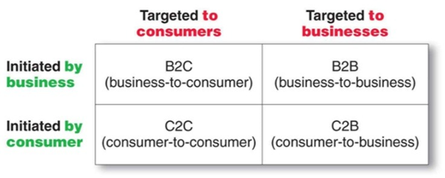 Figure 1 – Most popular types of E-commerce – Source: www.frachtbox.com

- B2B - Business to Business. It refers to transactions that take place between two companies to order goods and/or services, which online exchange updated information on price lists and products and for which the payments are made electronically (Tian and Stewart, 2006).
- C2C - Consumer to Consumer. It is a type of e-commerce in which consumers, enabled by C2C platforms, buy and sell products and services to each other online without the need for companies (Investopedia.com, 2022).
In this model, the website is the mediator of trade. As an example, eBay and Alibaba are among the best-known C2C platforms.
- C2B - Consumer to Business. It is a type of e-commerce in which individuals present their products or services to companies, and these latter make the payment (Nemat, 2011). For example, the editors of websites or blogs sell their work to companies like Amazon and earn membership revenue for successful sales.
- B2C - Business to Consumer. It is the most popular e-commerce model as it represents the retail part of e-commerce on the Internet (Investopedia.com, 2022). Here, the sale transaction is directly carried out between the company and the end consumer. The latter can compare and choose its product through multimedia and interactive catalogues.
Concerning the methods of shipping the product, a distinction can be made between direct and indirect electronic commerce. In the first case, the products that the final customer buys are physical goods that are shipped via a courier. In the second case, the products are in digital format. Consequently, the courier's presence is unnecessary as the goods are delivered and transmitted directly via the Internet (Investopedia.com, 2022).

1.8 E-commerce and New retail: Market Size and Structure

Figure 2 shows the US trend in e-commerce retail sales by US Census Bureau date. The percentage of total US e-commerce sales to total sales has steadily increased since 1999, peaking at more than 16% in 2020 during the pandemic.
Regarding 2022, the percentage is slightly down compared to the peaks of 2020, reaching around 14%, which, in any case, is several higher than the pre-pandemic levels.
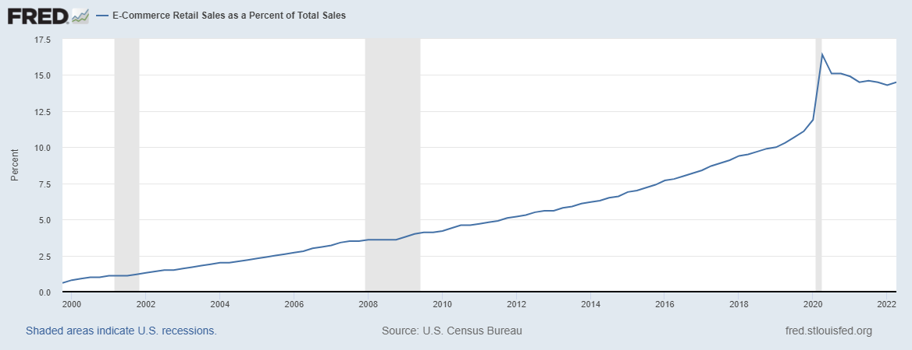
Figure 2 – E-Commerce Retail Sales as a Percent of Total Sales in US – Source: US Census Bureau
An even more de-marked trend was seen in the UK market, as shown in Figure 3. Here, we can see that a peak of 37% was reached during the 2020 lockdown periods.

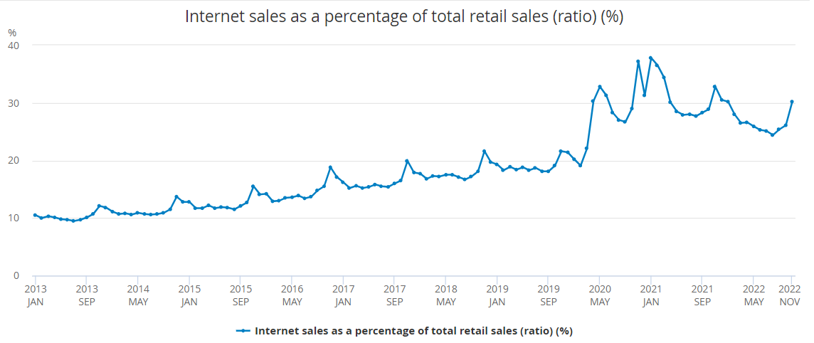
Figure 3 – E-Commerce Retail Sales as a Percentage of Total Retail Sales in Great Britain from January 2013 to November 2022 - Source: CENSUS for UK Office for National Statistics
Regarding 2022, again, the percentage is slightly down compared to the peaks in 2020. However, it is about 10% higher than the pre-pandemic levels.
As a result, the UK e-commerce revenues also saw a remarkable acceleration from £75bn in 2019 to £129bn at the end of 2021 [Figure 4].

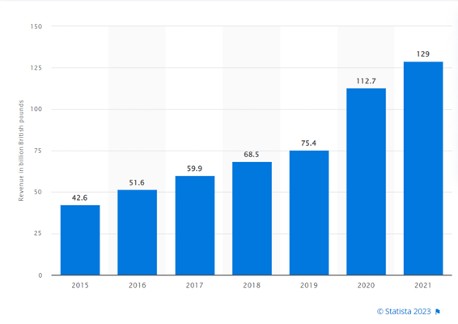Figure 4 – E-commerce revenue in the United Kingdom (UK) from 2015 to 2021 (in billion British pounds) - Source: Statista.com 2023

Figure 5 shows the Top 10 stores in terms of net sales generated in the UK in 2021.
At number one in the ranking, we find Amazon.co.uk, the largest online store in the United Kingdom, with a net turnover of 12,413.9 million pounds in 2021 (+5% compared to 2020). In second place is Tesco.com, with a net turnover in 2021 of 5,563.9 million pounds (-6% compared to 2020). In third place, we have Sainsbury.co.uk with 5,491.8 million pounds (+17% compared to 2020).
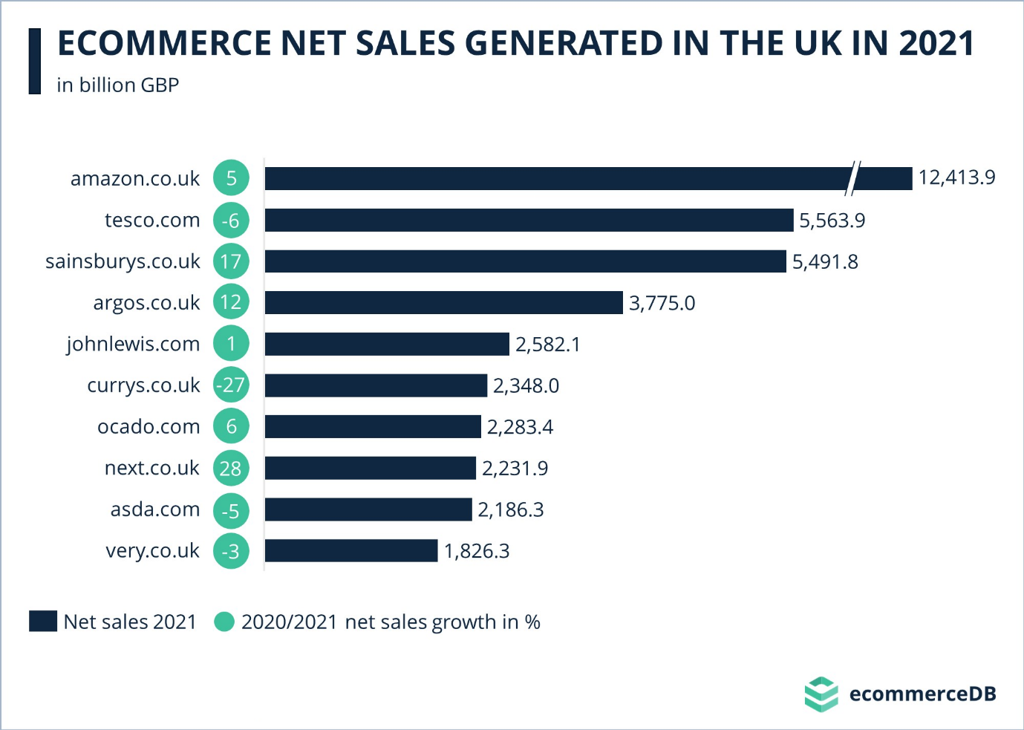
Figure 5 – Top online stores in the United Kingdom in 2021, by e-commerce net sales (in million British pounds) - Source: e-commerceDB 2023

1.9 Other Types of Online Business

So far, we have focused only on Online Businesses intended as E-commerce and New retail. However, other types of online businesses have seen a substantial acceleration in their volumes since the beginning of the pandemic. Therefore, this section aims to introduce what are also known as "In-home" services.

- Home Streaming

Home streaming is based on the technology also known as “Over the top” or simply “OTT”, which refers to film and television contents provided via a high-speed Internet connection rather than a cable or satellite provider (Oracle.com, 2023).
The three main OTT models are:

- AVOD (Ad-Based Video on Demand). With this model, consumers can watch videos for free as the businesses generate revenue with ads. The most famous example of an AVOD business is the non-premium version of YouTube (Mazsystems.com, 2020).

- SVOD (Subscription Video on Demand). With this model, users pay a monthly fee in exchange for instant access to a streaming library consisting of movies, TV shows, and other media content. Netflix, Disney+ and Amazon Prime Video are some examples of SVOD Business (Statista.com, 2023).

- TVOD (Transactional Video on Demand). Customers buy or rent videos one at a time. TVOD is also sometimes known as pay-per-view (PPV). Rakuten TV is a famous example (Mazsystems.com, 2020).

Figure 6 shows the SVOD penetration of UK households. As we can see, the overall SVOD penetration has significantly boosted since the beginning of the pandemic (2019), going from around 40% to a peak of 68% in 2022 (Ofcom, 2022).

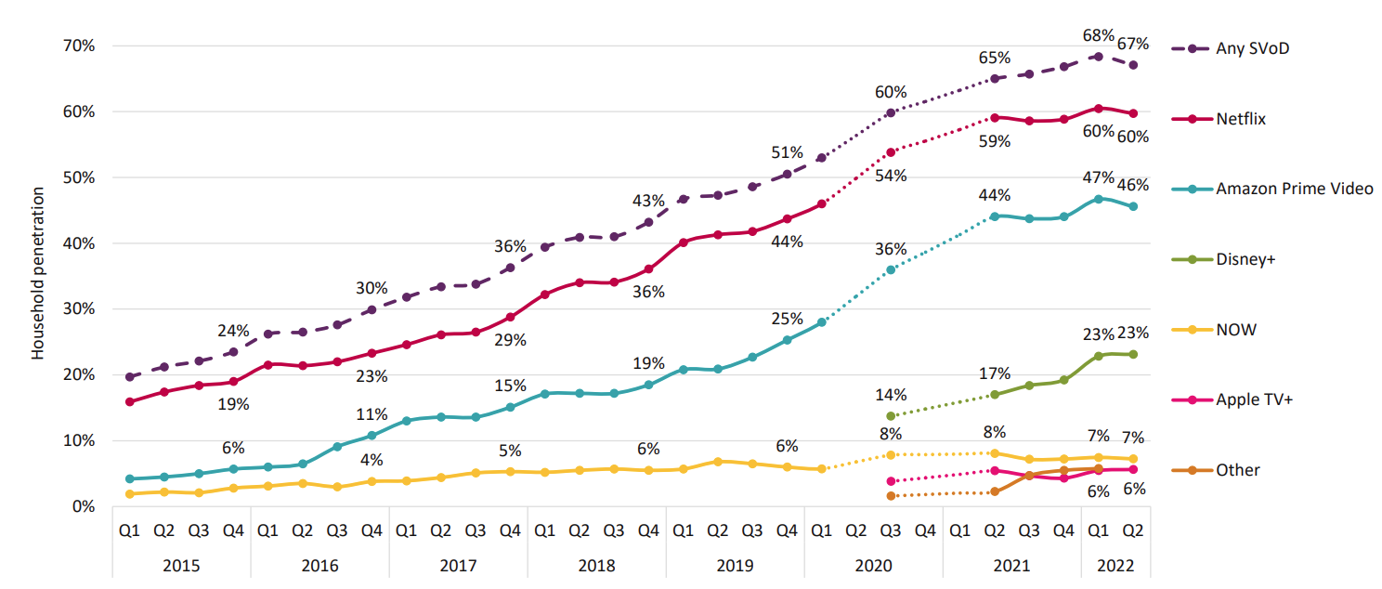
Figure 6: SVOD penetration of UK households, by provider: Q1 2015 – Q2 2022 - Source: Ofcom 2022
Note: According to Ofcom (2022), In Q2 2022, the total number of UK subscription TV and free-to-air households was 28.6 million.
According to the Ofcom UK Media Nation report of 2022, Netflix is the largest SVoD provider in the UK, with 17.1 million households (60%) subscribing, followed by Amazon Prime Video (46%) and Disney+ (23%).
Figure 7 shows that the % of households accessing two or more services was 46% in Q1 2022, equal to 13.2 million households. Also, the average number of SVOD subscriptions per SVOD home rose to 2 in Q1 2022, up from 1.6 two years earlier, before the Covid-19-related lockdowns (Ofcom, 2022).

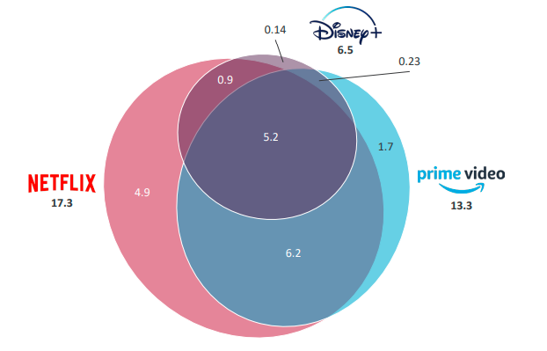
Figure 7: Households subscribing to one or more of Netflix, Amazon Prime Video and Disney+, and overlaps between them (millions) - Source: Ofcom 2022

Furthermore, we can see that 5.2 million households have signed up for all three of the most popular services, confirming a shift in consumer behaviours and how people increasingly use digital streaming platforms. The majority of Disney+ subscribers (80%) use the service in combination with both Netflix and Amazon Prime Video, with only 2% using it without either of those two services. (Ofcom, 2022).

- Food Delivery

The way the world eats is changing dramatically. According to McKinsey & Company (2021), “Just under two decades ago, restaurant meal delivery was still mostly limited to foods like pizza and Chinese. Today, food delivery has grown into a global market worth more than $150 billion, having more than tripled since 2017” (Ahuja et al., 2021).
The advent of engaging and easy-to-use apps, combined with the changing expectations of consumers, made food delivery service an essential category. This has been further boosted by physical-distancing requirements and lockdowns during the pandemic's peak, as under those circumstances, it represented the only hope of survival for the catering sector (Ahuja et al., 2021).
Led by platform-to-consumer services, such as Deliveroo, Just Eat, and Uber Eats, food delivery has expanded from takeaways to anything and everything, adding billions of dollars in potential revenue capture (D. Curry, 2023).
Figure 8 shows how the food delivery business has increased, mainly since the pandemic-related lockdowns began in March 2020.
The pre-pandemic growth rate of the US market was 3-4% per year, compared to the 7-8% growth seen since the pandemic's beginning (McKinsey & Company, 2021).
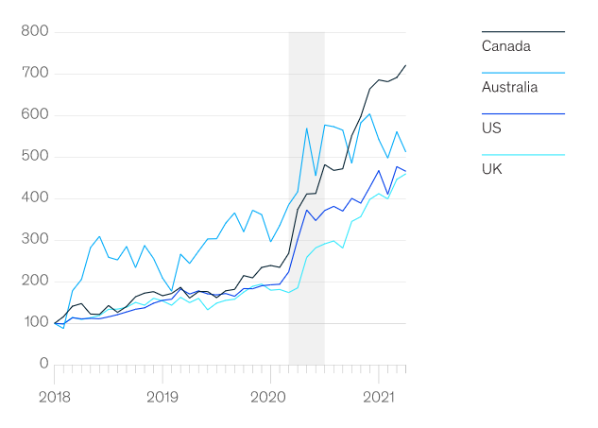
Figure 8: Normalized delivery-platform sales growth, index (Jan 2018 = 100) - Source: Edison Trends for McKinsey & Company (2021)

- E-Learning

According to the Oxford Learning College (2023), “E-learning is a learning experience or structured educational course delivered digitally or electronically. This learning method can include text, video, audio, and interactive content which provides educational material to users”.
Since the onset of the COVID-19 pandemic in 2020, digital education has become even more critical, enabling students to access essential learning materials and allowing companies to train employees remotely.
Nowadays, online education has become one of the most popular ways to learn in the UK, with 21% of British people using it (Oxford Learning College, 2023).

- Smart Working

The advance of digitization and the transition to a more knowledge-based economy have opened up the possibility of remote work and hybrid work (a mixed model working both in a central office and at remote locations) for employers and employees.
Before the outbreak of the coronavirus (COVID-19) in 2020, working from home was considered a luxury. Nevertheless, since then, the ability to work remotely has become crucial for employment decisions (Statista.com, 2022).

Figure 9 shows the share of the three ways of working for working adults in the UK. As we can see from the easing of COVID-19 restrictions (beginning of 2021), even though we have a rebound in the percentage of people who travel for work, they are now firmly under 50% of the total. Furthermore, hybrid working has overtaken “full-time” working from home (Office for National Statistics, 2022).

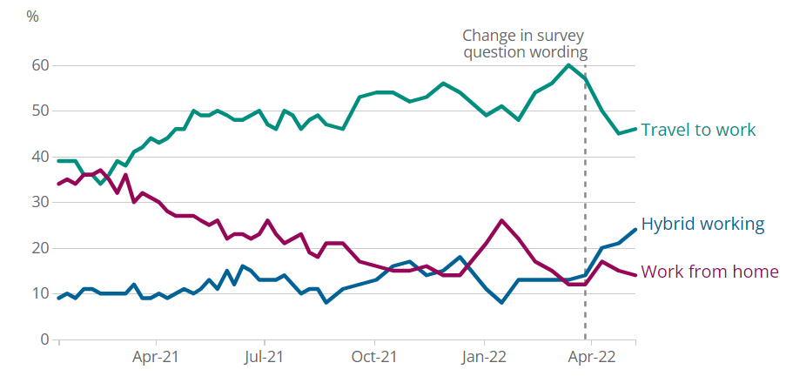
Figure 9: Percentage of working adults travelling to work, Great Britain, January 2021 to May 2022 – Source: Office for National Statistics (2022)

1.10 Research Structure

Chapter One: This chapter provides the reader with an introduction to the research topic and a clear understanding of the aims and objectives the research is trying to achieve.
Chapter Two: This chapter discusses the secondary research data available on the research topic, mainly consisting of textbooks, journal articles, websites and newspapers.
Chapter Three: This chapter is focused on the research methodology, which will offer detailed instructions on how the study should be carried out from beginning to end. In addition, it seeks to add validity and reliability to the research findings, ensuring that the study can be critically assessed and, if necessary, replicated by future researchers.
Chapter Four: This chapter will analyse the data gathered using the technique described in Chapter Three. Ten semi-structured interviews will form the basis of the primary research data set.
Chapter Five: This final chapter synthesises all the findings to conclude, addressing the implications of the results, the study's limitations, and suggestions for further research, all related to the aims and objectives stated in Chapter One.

Chapter 2 – Literature Review

2.1 Shopping behaviours during the COVID-19 pandemic

The current literature on shopping behaviours during the COVID-19 pandemic has mainly focused on the factors influencing customers' online purchasing decisions. Their findings pointed to primary factors, including the benefits of online shopping, pandemic fears, media and subjective norms:

- Moon et al. (2021) show that when circumstances are severe and vulnerable, as with COVID-19, it is more likely that consumption through offline distribution channels will decrease. (Moon et al., 2021).

- Showrav et al. (2021) provided a summary of the inefficiencies of in-store shopping during the pandemic period and how retail brands have responded to the lockdown situation by adopting some sort of online shopping convenience for their target customers. In fact, consumers have increasingly started asking for contactless payment, home delivery, virtual consultations, and the availability of basic necessities within the product line of online businesses (Showrav et al., 2021).

- Prasad and Srivastava (2021) analysed customer switching behaviour during the peak of the COVID-19 outbreak based on two characteristics: the perceived risks of infectious diseases and the benefits of online shopping as an alternative saviour continuity of life. Findings suggested that the change in risk perception led to a change in marketing policies focused on creating awareness. Furthermore, the study concluded that the new behaviours would continue even after the pandemic (Prasad and Srivastava, 2021).

- Eger et Al. (2021) demonstrated a correlation between changes in customer behaviour and fear, especially fear of health and worsening economic conditions. The results demonstrate significant differences and similarities in consumer behaviour across generations. In general, restrictions mainly affect the shopping behaviour of the oldest generation (Eger et Al., 2021).

- According to Chen (2021), the significant factors affecting online shopping in an everyday social environment, such as service quality, commodity prices and online shopping experience, were insignificant in this pandemic. This is because the public panic triggered by the pandemic became a key factor affecting online shopping.

- Alhaimer (2022) found that the penalties imposed during the pandemic on those who broke the restrictions introduced with the lockdown have had a direct and positive influence on consumer behaviour towards online purchases. He also showed that the factors influencing users' attitudes and behaviours towards online shopping in "normal" non-emergency times vary from during emergencies.

- Truong et al. (2022) identified three primary shopping modes: Online purchases, Curbside pickup, and In-store shopping. That study examines how customers' buying behaviours have changed during the pandemic, identifying that health concerns and concerns about financial conditions have played a significant role in the changes in buying behaviour.
As the pandemic progressed with new variants, people adjusted their risk-based buying behaviours, depending on whether they received the vaccine or faced financial hardship.
The research findings indicate that people who had previously contracted the virus were less likely to buy groceries in-store or even pick them up curbside than people who never contracted the virus. This is due to the more fears for health from their experience with the virus. On the other hand, people who lost their jobs tended to buy regardless of shopping mode, because they had more free time and greater stress of being home too much during the pandemic. Thus, both fears about health and financial conditions influenced consumer behaviour in a dynamic rather than one-sided correlation (Truong et Al., 2022).

Since the early stages of the pandemic, people have switched to online and at-home activities such as shopping, entertainment, and catering. This has led to decreased personal transportation to the benefit of cargo handling associated with online shopping deliveries.
Additionally, we assisted in a shift towards more spending on improving homes and investing in home offices (Unnikrishnan and Figliozzi, 2021).
Regarding “in-person” spending, although higher-income households have spent more on “in-person” shopping during the pandemic than low-income households, their ability to shop “in-person” has declined during the pandemic compared to the previous period (Brough, Freedman and Phillips, 2021). This could be due to more flexibility in lifestyle and remote working by higher-income households (Badger and Parlapiano, 2020).
Additionally, Ecola et al. (2020) reported that households with children are more likely to shop online.

2.2 Changes in Consumer Spending Patterns Post-COVID-19

With the advent of the post-pandemic era, researchers have been looking at changes in spending patterns. This section aims to analyse the current literature on how consumer spending patterns have evolved since the end of the pandemic.

- Digital Payments

A recent study by Nguyen et Al. (2021) found that the pandemic has dramatically accelerated the use of e-commerce and digital payment methods, driven by the need for health and safety precautions. Moreover, as the world slowly returns to normalcy, this trend shows no signs of slowing down. Online shopping and contactless transactions continue to be the preferred choice of consumers, as they value the convenience and efficiency offered by digital channels. As a result, online and offline consumer spending habits have been greatly influenced (Kannan & Kulkarni, 2022).
According to Rolfe (2023), digital payments are rising in e-commerce and physical store landscapes. They are projected to reach more than $15 trillion by 2027, with a CAGR (Compound Annual Growth Rate) of 16.3% over the period 2017- 2027 (Statista.com, 2022)[Figure 10].
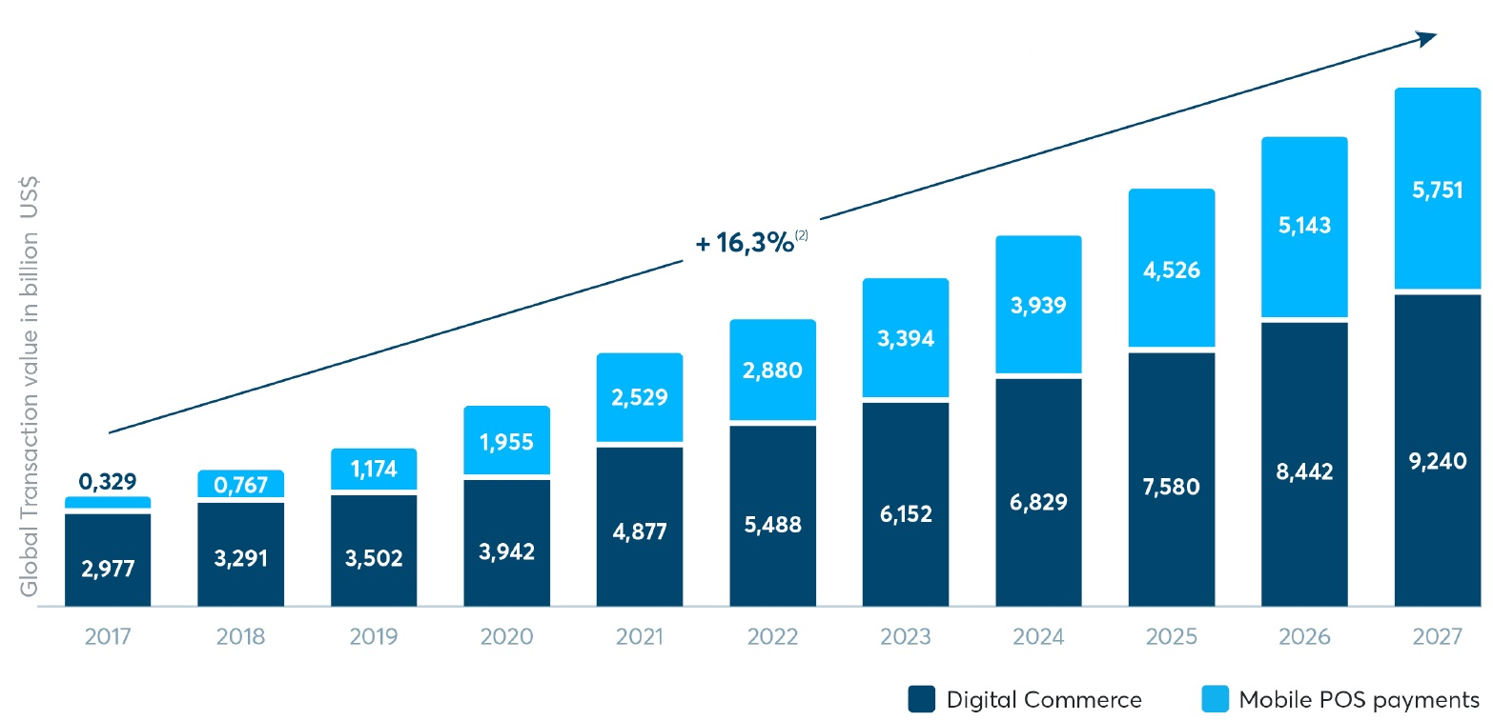
Figure 10: Digital Payments transaction trend, 2017 to 2027 – Source: (Statista.com, 2022)

- Shifts in Spending Categories

Research by Wani and Priyanka (2022) highlights that since the inception of the first lockdown, we have seen a notable shift from discretionary spending on travel and restaurants to essential items such as household expenses, groceries, cleaning products, health products, home office equipment and home entertainment.
Chen et al. (2022) highlighted a substantial shift in consumer spending categories since the conclusion of the pandemic. As restrictions eased, consumers gradually increased spending on experiences and services such as dining out, travel, entertainment, and luxury goods.
Even with many returning to offices, there is sustained interest in creating comfortable home environments (Mukherjee and Narang, 2023).

- E-commerce

As we have seen in previous sections of this chapter, the pandemic has accelerated the adoption of E-commerce and digital payment methods, mainly due to health and safety concerns. Therefore, E-commerce sectors have seen significant growth, primarily for groceries, home entertainment, and fitness equipment (Walcott, 2023).
This trend has continued beyond the pandemic, with consumers preferring online shopping for the convenience and efficiency offered by digital channels (Tymkiw, 2022).
According to Investopedia.com (2022), after the lockdown, many consumers wanted to return to physical stores, both for the in-person shopping experience and social interaction. This has led to a temporary resurgence in the trend of traditional retail towards online shopping. However, in the vast majority of the industries, physical retail has never returned to pre-pandemic levels (Tymkiw, 2022).
Therefore, while some industries have seen a decline in online shopping, the overall growth of e-commerce during the pandemic has set new standards. That is because consumers who first adopted online shopping during the pandemic continued to use it, albeit at different frequencies depending on the industry (Investopedia, 2022).
A study by the IBM Institute for Business Value (2022), in association with the National Retail Federation (NRF), found that consumers have begun to adopt a hybrid approach to shopping, combining online and offline purchases. This new “hybrid approach” consists of online searches with in-store purchases or online purchases and in-store pickup.
The study also suggested that this trend could represent the future of retail as today, more than a third of Generation Z has already opted for hybrid purchases. Furthermore, this segment of consumers was found to be more inclined to purchase from brands in line with their personal values, emphasizing transparency, ethical practices, and social responsibility. (IBM-IBV, 2022).
With the proliferation of online shopping, consumer expectations of digital experiences have increased. According to Popa, Barbu, and Ionașcu (2023), consumers have developed “Enhanced Digital Expectations” and, therefore, now demand intuitive user interfaces, personalized shopping experiences, efficient customer service, and fast shipping. Features that were once considered luxuries have now become standard.
In short, consumers want companies to come to them, and they want to shop where a better experience is offered (Popa, Barbu, and Ionașcu, 2023).
In response to these new needs and because of increased awareness of the growing acceptance of technology by consumers, companies in the commerce sector have significantly increased their investments in IT infrastructures (IBM-IBV, 2022).
Furthermore, many retailers have faced logistical challenges, which have meant that optimizing supply chains and better managing shipments have become critical priorities (Hammi, Zeadally, and Nebhen, 2023).
Customer reviews have become crucial in online shopping. According to a survey by BrightLocal (2023), more than 90% of consumers said they read reviews of local businesses. This data makes us understand the importance and centrality that reputation management has achieved through online reviews. For this reason, companies in the commerce sector are massively increasing their efforts in online reputation management. Furthermore, reviews are not only the starting point for buyers during the research phase but also an additional source of information on customers and competitors, which can provide important insights for companies (Forbes, 2022).
As online interactions have increased, so have concerns about privacy and data security. Consumers have become more discerning in sharing personal information and have prioritized platforms and services that demonstrate robust data protection protocols (Alzaidi, Saeed and Gomaa, 2022).
According to Paraschiv et Al. (2022), the use of mobile devices for online purchases has seen significant growth since the beginning of the pandemic to the point that today, the majority of online purchases are made via smartphone. For this reason, nowadays, we tend to talk about Mobile Commerce or simply M-commerce.
Figure 11 shows M-commerce as a share of total online retail by region in 2022; as we can see, over 65% of the E-Commerce transactions Worldwide are conducted over mobile devices like cell phones or tablets, with Asia-Pacific as the leading region with almost 80% (Statista.com, 2023).

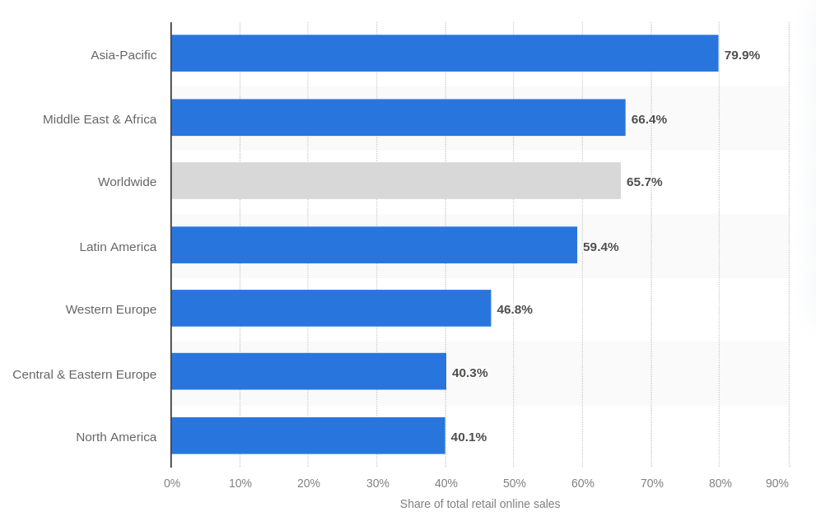
Figure 11: Retail M-commerce as a percentage of total retail E-commerce sales worldwide in 2022, by region – Source: (Statista.com, 2023)

A significant driving force for the expansion of M-commerce was the growth in the range of devices capable of carrying out mobile commerce (Investopedia, 2022).
Furthermore, introducing digital wallets such as Apple Pay and Google Pay has been fundamental, allowing customers to purchase without using physical payment cards. Last but not least, mobile commerce has proliferated thanks to resolving security problems (Investopedia, 2022).

- Dining and Restaurants

In light of recent market research by the Kantar Group (2023), it is evident that the food service industry has experienced a steady surge in online orders and deliveries due to the global lockdowns. With restrictions being lifted and restaurants reopening, numerous consumers have resumed dining out, leading to a decrease in online food orders due to physiological changes. However, the adoption and use of online food ordering apps have remained higher than before the pandemic.
The convenience and low-contact nature of take-away and delivery have significantly influenced consumer habits. However, the human desire for interaction and social experiences suggests that indoor and outdoor dining will continue to play a crucial role in the restaurant industry. In essence, the post-COVID era points to a more excellent balance between these trends (Wang et Al., 2022).

- Tourism and Travel

Online bookings for hotels, flights and other travel-related services have drastically decreased during the pandemic. However, despite some hesitancy following the relaxation of regulations, travel expenditure has significantly recovered, primarily due to the rise in consumer confidence, with domestic tourism growing faster than international tourism (Jin, Bao and Tang, 2022).
Furthermore, it has been discovered that many customers prefer to book directly through physical establishments or agencies to have greater flexibility and security regarding cancellation (Sharma et Al., 2022).

- Entertainment

During and after the COVID-19 pandemic, digital streaming platforms experienced significant growth and transformation. With people worldwide confined to their homes due to lockdowns and social distancing measures, digital entertainment has emerged as a primary source of relaxation and entertainment (BBC, 2020).
At the beginning of the post-pandemic period, with the reopening of cinemas, theatres and entertainment venues, this trend recorded a slowdown, which never translated into a reversal of the trend (Ofcom, 2022).
According to Arts Professional (2023), the arts industry is undergoing a permanent shift in release strategies and attendance habits. While live participation is gradually returning, the sports industry has recognised the value of digital enhancements for remote audiences. Although live concerts will return gradually, the success of virtual events suggests that they will continue to be a complementary channel for artists to reach global audiences (Arts Professional, 2023).

- Health

According to McKinsey & Company (2022), healthcare products, fitness memberships, and wellness services have increased since the pandemic, indicating that people are becoming more health-conscious.
People appear to compensate for physical isolation in 2023 by returning to the gym more significantly than before the pandemic (The Washington Post, 2023).
Furthermore, thanks to telemedicine, people appear to prefer home healthcare, and despite a decrease in the first half of 2022, its use is still double pre-pandemic levels (The Washington Post, 2023).

2.3 The Long-Term Impact of the Pandemic on Consumer Behaviour

The COVID-19 pandemic has caused unprecedented changes in consumer behaviour, raising questions about the lasting nature of these changes. This section aims to analyse the current literature to study the long-term impact of the pandemic to understand better the issue of the permanence of these new habits acquired by consumers.
An overview of the main areas affected will therefore be carried out.
- Psychological Impacts and Factors

According to the World Health Organization (2022), a large number of people have reported psychological distress and symptoms of depression, anxiety or post-traumatic stress due to the impact of the pandemic. The fear of the virus has been an unprecedented stressor on the mental health of many individuals (WHO, 2022).
The pandemic's impact on mental health heavily influenced spending behaviours (Di Crosta et Al., 2021).
According to Das, Sarkar and Debroy (2022), the psychological impact of the pandemic on consumers could lead to lasting changes. For example, concerns about hygiene and health awareness will likely persist for a long time, driving preferences for contactless services and cleaner environments (Das et Al., 2022).
The study by Park et al. (2022) identified two different types of purchasing behaviours generated by the pandemic: “Panic Buying”, which consists of purchasing large quantities of “basic” necessity goods, and “Revenge Spending”, which consists of purchasing expensive goods such as way to relieve your negative emotions through this type of purchase.
In essence, distressing situations such as anxiety and uncertainty could impact luxury spending and lead to sustained frugality (Park et Al., 2022).

- Economics Impacts and Factors

The lock-down, implemented with the intention of stemming the spread of the virus, has however had a negative effect on the global economy of various countries, generating a global economic recession, with some sectors affected more than others (Roy, S., 2020). In particular travel, tourism and hospitality (Singh, Jamal, and Ahmad, 2021).
The economic recession has generated unprecedented levels of unemployment and therefore governments around the world have launched stimulus packages and fiscal incentives to mitigate the economic impact (Roy, S., 2020).
Economic factors like unemployment rates, inflation, and the overall health of the economy had a consistent impact on consumer behaviours, including spending patterns and confidence in future planning (Loxton et Al., 2020).
Instead, in a diametrically opposite way, the Lockdowns have favoured greater savings for those who have been able to continue their work. This is due to limited spending opportunities (Niculaescu, Sangiorgi and Bell, 2023).
After the pandemic, the economic recovery once again influenced consumer behaviour and while many resumed spending, others remained cautious, prioritizing savings and investments. In this regard, there has been a notable increase in investments in stocks, cryptocurrencies, and real estate (Niculaescu, Sangiorgi and Bell, 2023).

- Generational Shifts

According to Min, Kim, and Yang (2021), generational differences have played an essential role in how consumers have adapted to pandemic changes, and these generational differences could influence the trajectory of behavioural changes.
While younger generations, such as GenZ (which includes people born between 1996 and 2010), have shown more excellent receptiveness to digital alternatives than older generations, including Gen Y (which includes people born between 1981 and 1995), Gen Z members were found to be less resilient (Harari, Sela, and Bareket-Bojmel, 2022). In fact, during the pandemic, Generation Z suffered the most from mental health, showing higher rates of depression and anxiety and, therefore, needed more emotional support (Schroth, 2019).
This is because Generation Z was deeply concerned about uncertainty in the future and was particularly vulnerable to job loss (Min, Kim, and Yang, 2021).
According to Harari, Sela and Bareket-Bojmel (2022), members of Gen Z showed higher levels of openness to change and self-improvement than Generation X (Gen X). However, both generations are positive about hybrid and remote ways of working.

- Regional Disparities

At the height of the pandemic, people living in urban areas with high population density suffered a lower level of healthcare availability and greater difficulties in accessing healthcare due to overcrowding in clinical facilities (Bourdin and Levratto, 2023).
According to Park (2023), political decisions and vaccination rates have played a crucial role in creating disparities between different areas and regions. It was found that the economic recovery was much more immediate in those states where the vaccination plans were more successful, with high percentages of inoculations among the population.
Furthermore, it was found that vaccination plans were more effective in areas where more rigorous social distancing measures were implemented, as here, the population was less reluctant to receive the COVID-19 vaccine (Park, 2023).
According to S&P Global (2021), countries that handled the pandemic better saw a faster recovery in consumer spending.

- Technological Adoption

The COVID-19 pandemic has given impetus to the rapid adoption of many technological solutions by people. Just think of contact tracing apps, Telemedicine, online shopping, digital payment methods, video conferencing tools and remote working technologies (Moneta and Sinclair, 2020).
According to Clipper (2020), the adoption of technology was primarily facilitated by the desire to adopt solutions to reduce the risk/fear associated with the virus, by state incentives, by the reduction of regulatory barriers and by the excellent and satisfactory results of new treatment systems at home like the Telemedicine.
Among the technologies that have caused the most discussion due to concerns about data privacy are “contact tracing apps”. These applications can help slow the spread of COVID-19 only if their adoption exceeds a certain use threshold (Horvath, Banducci and James, 2022). However, privacy concerns have generated a certain reluctance among some of the population to download and use these apps, even when concerns about the pandemic were high (Chan and Saqib, 2021).
As we have seen in the previous section of this chapter (section 2.2), adopting technologies for online shopping and digital payments has been very important in boosting the entire E-Commerce industry. Additionally, new technologies have changed consumers' interaction habits with businesses using social networks (McKinsey & Company, 2022).
During lockdowns, we saw a surge in demand for virtual events and online platforms as they became the only viable alternative to in-person meetings. According to Forbes (2022), these types of events are destined to remain even after the pandemic. Even as in-person events are happening again, the virtual event space is expected to expand by 21.4% from 2022 to 2030.
Furthermore, hybrid events are also becoming increasingly popular, requiring a platform that allows guests to interact with each other in person and online (Forbes, 2022).
Finally, the advancement of digitalization has made remote and hybrid working (a mixed model of working in a central office and at remote locations) possible for employers and employees. Working from home was considered a luxury prior to the coronavirus (COVID-19) outbreak in 2020. Nonetheless, the ability to work remotely has become increasingly crucial in employment decisions since then (Statista.com, 2022). Today, "hybrid" working has surpassed "full-time" working from home as the most prevalent flexible working mode (Office for National Statistics, 2022).

2.4 Chapter Conclusion

The COVID-19 pandemic has significantly changed consumer spending behaviours, increasing e-commerce adoption.
Initially, consumers shifted towards online motivated by necessity. However, this trend has been maintained and boosted thanks to a greater awareness of digital platforms' convenience, flexibility, and potential. Although some sectors have seen a decline in online business post-pandemic, overall online activity remains significantly higher than before the pandemic.
Today the trend traces a possible hybrid future, where new preferences merge with pre-pandemic habits.
Therefore brands and retailers will have to face the challenge and be able to intercept and adapt to these new trends, leveraging some key points such as strengthening consumer trust and providing enriched digital experiences.

Chapter 3 – Methodology

3.1 Introduction

This chapter outlines the research methodology adopted to investigate changes in behaviour since the beginning of the Covid-19 pandemic. The section will examine the justification of the chosen method, the resources that will be used with this method, the rationale of the methodology, and the influential factors surrounding the choice.
Through qualitative interviews, this research seeks to uncover in-depth personal experiences, insights, and reflections.
As we have seen in Chapter 1, the Specific objectives addressed by this research are:
- Critically evaluate the shift to the online business due to a change in customers’ behaviour.
- Conduct semi-structured interviews with consumers to determine how the Pandemic has changed how they use online business services.
- To make recommendations on how businesses should shape their online business models to accommodate the new “normal”.
The research methodology that will be outlined in the following sections of this chapter was constructed using the “Research Onion” model developed by Saunders et al., shown in Figure 12, which illustrates the different levels and stages of research that are developed through a research strategy.

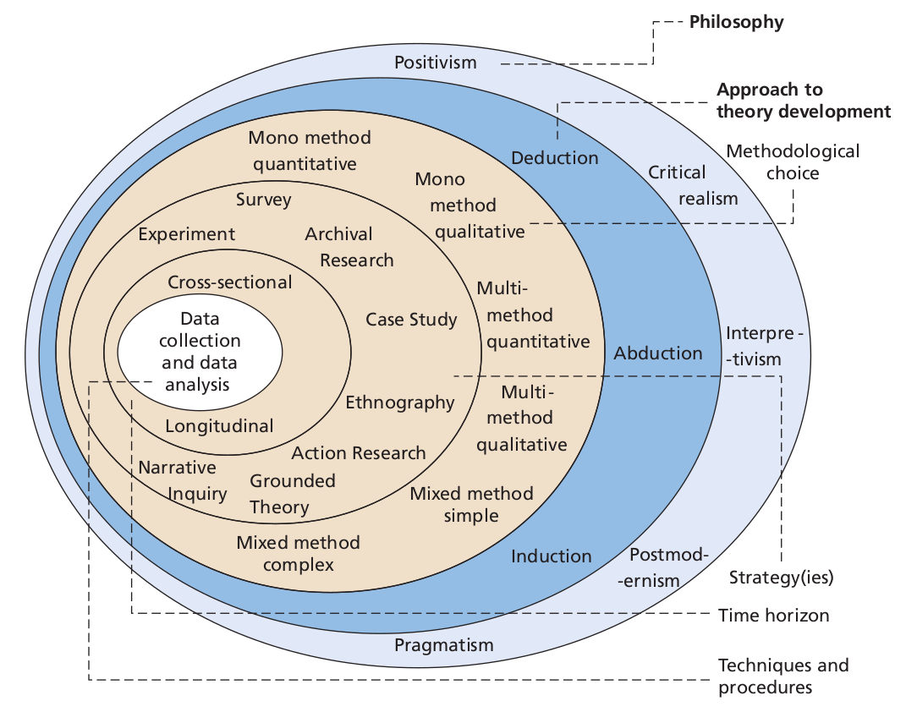

Figure 12: The “Research Onion” - Source: (Mark Saunders, Philip Lewis and Adrian Thornhill, 2019).

3.2 Research Philosophy

Research philosophy is the outer layer of the Saunders research onion which points to three research paradigms: Positivist, Pragmatist and Interpretivist (Saunders et al., 2019).
Research philosophy is linked to a set of beliefs about the nature of the investigation of reality and can be described from both an Ontological and Epistemological point of view (Bryman and Bell, 2011, p. 27, cited in Mayer, 2015).
According to Ejnavarzala (2019), “Epistemology is concerned with theories of knowledge and thus with questions such as what knowledge is, what counts as knowledge, how knowledge claims are justified, and the nature of explanations”.
Instead, according to Smith (2012), ‘Ontology’, often used by philosophers
as a synonym of ‘metaphysics’, is “the science of ‘what is’, of the kinds and structures of objects, properties, events, processes and relations in every area of reality” (Smith, 2012, p. 47). In other words, it deals with existential conditions linked to material, social, cultural and political contexts (Ejnavarzala, 2019).
For this research work, an interpretivist philosophy approach was adopted due to its flexibility and ability to dig deep in order to interpret and understand how the research participants experienced and reacted to this changing environment due to the pandemic.
“Interpretivism, also known as interpretivist, involves researchers to interpret elements of the study. It is based on the naturalistic approach of data collection such as interviews and observations” (Research-Methodology.net, 2023). It is a qualitative research method and data is expressed through words and themes rather than numerically (Bengtsson, 2016, p. 10).

3.2 Research Approach

In the direction of the centre of Saunders' research model, we locate the "Research Approach" layer, where three main approaches are available for selection: abductive, inductive, and deductive (Saunders et al., 2019):

- Deductive Approach: This method begins with a theory before turning to the data. Usually, research starts with a theory or hypothesis and seeks to test it using actual data. Deductive reasoning is primarily concerned with testing an established theory; the outcome may support or contradict the theory (Okoli, 2023).
- Inductive Approach: This method progresses from detailed observations to more general hypotheses and generalisations. Typically, data collection is the first step, and an overall theory or understanding is then developed using the data. The exploratory nature of the inductive approach makes it appropriate when there is a lack of prior theory on the subject in question (Gioia, Corley and Hamilton, 2013).
- Abductive Approach: This method incorporates parts of inductive and deductive reasoning. It alternates between theory and observations, improving both along the way. The researcher employs the most plausible interpretation for the findings, alternating between the empirical evidence and plausible theoretical models. (Dubois and Gadde, 2002).

This study employed an inductive methodology, gathering raw data without preconceived notions before looking for patterns and themes that emerged in the data. This allowed the participant's stories and experiences to help shape the findings. Semi-structured interviews offer a combination of structured questions and the ability to delve further into the conversation in response to participant responses. This makes it possible to identify concepts, themes, and patterns that come up in the data.

3.3 Methodological Choice

According to Saunders et al (2019), there are three choices outlined in the research:

- Mono Method which can use either qualitative or quantitative data;
- Mixed Method which combines both qualitative or quantitative methods to create a single dataset;
- Multi Method which combines qualitative or quantitative methods to create two independent datasets since with this method the research is divided into segments.

While quantitative research aims to quantify data, measure relationships, and derive statistically significant results, qualitative research delves into understanding the depth, context, and intricacies of human experiences and social realities (Creswell, 2003).

Considering the above, the methodological choice for this research work is the "Mono method" using semi-structured interviews (qualitative research). This is because the chosen method allows delving deeper into participants' experiences, perceptions and opinions without the distraction of managing another method and, in doing so, ensures that the research remains focused on the central questions (Kelle, 2006 and Creswell, 2003).

3.4 Research Strategy

Within the "Research Strategy" layer, among the various strategies that can be employed, Grounded Theory is the chosen approach for this study.
Grounded theory is a research methodology that involves the construction of theory through the systematic collection and analysis of data. It was first introduced by sociologists Barney Glaser and Anselm Strauss in the 1960s (Jørgensen, 2001). According to Charman (2014), it refers to a set of systematic inductive techniques for conducting qualitative research with the primary goal of theory construction based on the actual data (Charman, 2014).
Denscombe (2017) pointed out that researchers must maintain flexibility and openness, employing a "continuous comparative approach," especially as new insights give rise to additional questions and extended data scrutiny. Since this iterative theory-building process presents challenges, such as the risk of unclear and ambiguous analysis, limiting the number of interviewees to a maximum of fifteen should ensure that the research remains manageable (Cottrell, 2017).

3.5 Time Horizon

Customer interviews will be conducted as part of the study using a cross-sectional time horizon. According to Saunders et al. (2019), this type of study takes a "snapshot", meaning that data is only collected once in a brief period, which is in contrast with longitudinal studies, which collect data from the same subjects at various points, enabling the analysis of change and development over time (Kumar, 2018).
This choice is in line with the purpose of the research question, which is not to examine how participants' perspectives change over time, so in-depth data analysis is not required.
The interview process is scheduled for eight weeks, taking place in October and November of 2023.

3.6 Techniques & Procedures

In this qualitative study, primary data collection will take place through semi-structured interviews. Qu and Dumay (2011) highlighted that interviews are a fundamental method for data gathering in qualitative investigations, while Charmaz and Belgrave (2012) emphasised their popularity in grounded theory research. According to Warren (2012), the core objective of conducting interviews is to comprehend the viewpoints of others, which corresponds with this research's goal of gathering consumers' opinions in order to answer the research questions.
The use of semi-structured interviews allows for a flexible dialogue, enabling the conversation to evolve based on both the participant's insights and the researcher's interests, thereby facilitating the emergence of unforeseen themes (Roberts, 2020). Vanderstoep and Johnston (2008) argue that this semi-structured format mitigates issues related to data variability seen in informal interviews, and it avoids stifling the spontaneous discovery of information, a problem that can occur with structured interviews.
For this research work, the expectation in using semi-structured interviews is that these will generate a considerable amount of data since including open-ended questions will enable participants to express their thoughts and feelings about the research topic freely. This approach will likely facilitate a natural flow of conversation and open up new paths for investigation.
Purposive sampling was employed to select ten individuals who had experienced significant changes during the pandemic, whether personally, professionally, or socially. These individuals were diverse in age, profession, and geographic location to ensure a breadth of experiences. Additionally, Interviews were conducted via video conferencing platforms, considering the safety protocols and social distancing measures. Each interview lasts between 45 to 60 minutes, and data will be analysed using a "thematic analysis process", which has been recognised for its proficiency in managing extensive datasets (Clarke and Braun, 2006). This method is favoured in qualitative research for its capability to discover, scrutinise, and interpret patterns or "themes" within the data. (Clarke and Braun, 2017). Acknowledged for its flexibility across various epistemological frameworks and research methodologies, such flexibility in analysis facilitates a reflective, inductive method, enabling patterns to emerge during the data analysis (Clarke and Braun, 2006). Moreover, a reflexive thematic analysis is suitable because it permits the modification of codes in response to evolving thematic patterns (Byrne, 2022).

3.7 Limitations of the study

While this research addresses different aspects of how the pandemic has influenced consumer behaviour in relation to online businesses, it does not offer conclusions that can be broadly generalized. The primary constraints are related to the demographic scope of the interviewees, who are predominantly from the Northwest of England. Consequently, the findings may not be indicative of consumer behaviour trends throughout the entire UK. Furthermore, the results are based on the opinions of surveyed online consumers over a specific time frame, and in a rapidly changing environment, it is essential to note that consumer behaviour and preferences are also likely to evolve.

3.8 Ethical Considerations

An ethical review of the research proposal has been undertaken, and approval has been sought from the University of Wales Trinity Saint David via the dissertation research supervisor. An Ethics Form has been completed, which details the dissertation research proposal and its compliance with the guidance outlined in the University's Research Ethics and Integrity Code of Practice.
Each one-to-one interview will be transcribed word for word in real-time without the need for any audio/video recording, and data will be kept in password-protected cloud storage on the University Office 365 system, which will not be shared. Any USB sticks used to store or transfer data will be password protected.
Each participant will be assigned a unique identifier to guarantee confidentiality, and this list will be kept securely in a password-protected folder in compliance with the University's Research Data Management Policy.
This research activity does not include any sensitive, embarrassing or upsetting topics. Before the interviews, all participants were informed about the research's purpose and their rights. Informed consent was obtained, ensuring participants knew they could withdraw at any time without consequence. The “Interview Consent Form” can be find in the Appendix 1.
Additionally, participants will be provided with an email contact of the principal researcher so they can contact him or her for further details or information.
The aims and objectives of the project do not require data relating to children or vulnerable adults, and there is no need to carry out ethical assessments in relation to these groups.

3.9 Chapter Conclusion

In essence, the methodology chapter provides clear and detailed instructions on conducting the study from start to finish. This chapter is, therefore, a significant direct contribution to research quality, reliability, and academic integrity. It also ensures that studies can be adequately evaluated and, if necessary, replicated by future researchers.
The use of semi-structured interviews as the primary data collection method, as described in this chapter, contributes to the data's depth and richness, allowing for a nuanced exploration of participants' perspectives on the research topics. Instead, the chosen cross-sectional time horizon ensures that the research is conducted efficiently, capturing a snapshot of current opinions without requiring a lengthy data collection period. Given the nature of the research questions and its aims of exploring current perceptions and experiences, this approach is more than pertinent.
Furthermore, by adopting an inductive approach and a grounded theory strategy within a qualitative framework, this chapter has carefully justified the research choices, ensuring alignment with the research objectives and questions.
As we have seen in the previous section of this chapter, the research design outlined in this chapter has been built using the "Research Onion" model developed by Saunders et al. Below is a summary of the search choices made for each level of the model:
- Layer section - Qualitative Approach
- Layer one - Interpretivism
- Layer two - Inductive
- Layer three - Grounded theory
- Layer four - Mono Method
- Layer five – Cross Sectional

Chapter 4 – Analysis of Results

4.1 Introduction

This chapter is the core of our research, where we will analyse the data collected through the conducted primary research, consisting of ten semi-structured interviews.
Despite the small scale of the study, the very detailed responses to the sixteen open-ended questions provided a large amount of data to analyse.
Through the methodical application of "Thematic Analysis", this chapter systematically identifies and interprets themes that align with the research objectives.
This analysis has been conducted to be objective and critical and to ensure the reliability of the results. Furthermore, each interpretation has been carefully balanced with the study's limitations.
After a general overview of the demographic data of the research participants, the seven themes that emerged from the analysis of the responses transcribed during the interviews will be presented and critically discussed.

4.2 Demographics of the Participants

This section details the participants' demographic background to give more context to their responses and better understand the environment from which they are derived.
In fact, according to Sage (2023), questions regarding demographic data enable researchers to acquire critical information about their research topics. Such kinds of investigations provide a framework for survey data, assisting researchers in characterising their participants and facilitating the interpretation of their findings (Sage Research Methods, 2023).
Later in this chapter, when analysing the themes that emerged during the interviews, we will use demographic data to make further considerations.
Table 1 displays the demographic data collected from each participant before the interview through an "Essential Demographic Questionnaire", distributed along with the "Interview Consent Form".
A copy of the questionnaire is available in Appendix 2.
In order to ensure anonymity in compliance with the ethical constraints outlined in Chapter 3 (refer to Section 3.8), a participant identifier have been assigned to each participant, as indicated in the first column of Table 1.

PARTICIPANT ID | AGE | GENDER | LOCATION | EDUCATION LEVEL | OCCUPATION | HOUSEHOLD
#A | 25-34 | Male | Greater London | Post graduate degree | Digital Marketer | Living Alone
#B | 25-34 | Male | Northwest | Bachelor's degree | Electric Engineer | Living with Family
#C | 45-54 | Prefer not to say | Northwest | Post graduate degree | Product Manager | Living Alone
#D | 35-44 | Female | Northwest | Post graduate degree | Customer Support | Living with Family
#E | 25-34 | Male | Wales | Post graduate degree | Civil Engineer | Living with roommates
#F | 65+ | Male | East of England | High school | Retired | Living with Family
#G | 18-24 | Female | Northwest | High school | Student | Living with roommates
#H | 35-44 | Male | Northwest | Bachelor's degree | Solicitor | Living Alone
#I | 65+ | Male | East Midlands | Post graduate degree | Doctor | Living with Family
#L | 55-64 | Female | East of England | High school | Retired | Living with Family

Table 1: General overview of the ten interview participants.

As we can see in Table 2 and its pie chart representation, the sample broadly covers all age groups.
Moreover, 60 percent of the interviewed are within the broader age range of 18-44, while the remaining 40 percent are in the 45+ age group.

AGE
18-24 | 1
25-34 | 3
35-44 | 2
45-54 | 1
55-64 | 1
65+ | 2
Total Result | 10

Table 2: Details of the age group distribution of the interviewed sample.

Regarding the educational qualifications of the analysed sample, as reported in Table 3, we can observe that 50 percent have a Postgraduate degree. If we also include the 20 percent with a bachelor’s degree, we notice that seven out of ten participants hold a university degree.

EDUCATION LEVEL
Bachelor's degree | 2
High school | 3
Post graduate degree | 5
Total Result | 10

Table 3: Details of the education level of the interviewed sample.
In Table 4, we can find a breakdown of the residential areas of the interviewed participants. Notably, 50 percent of the interviewees originate from the Northwest of England. This finding may pose a limitation, suggesting that the research results may only partially represent trends across the entire UK.

LOCATION
East Midlands | 1
East of England | 2
Greater London | 1
Northwest | 5
Wales | 1
Total Result | 10

Table 4: Details of the residential area of the interviewed sample.
Table 6 provides us with household details. Despite 50 percent of the interviewees living with their families, the sample appears quite diverse as it covers different scenarios.

HOUSEHOLD
Living Alone | 3
Living with Family | 5
Living with room-mates | 2
Total Result | 10

Table 5: Household details of the interviewed sample.
Finally, to complete the presentation of the demographic data of the interviewed sample, Figure 6 shows the gender details. Here we can observe that 60 percent of the participants identify as male.

GENDER
Female | 3
Male | 6
Prefer not to say | 1
Total Result | 10

Table 6: Details of the residential area of the interviewed sample.

4.3 Theme 1 - Transition to Online Shopping

This theme emerged with the answers to the following questions:

Q1. Can you describe your general shopping habits before the COVID-19 pandemic?
Q2. How did your shopping behaviour change during the pandemic? Can you provide specific examples?

The analysis of the responses to the above questions has highlighted that the transition to online shopping has been based on the following three main pillars, referred to as sub-themes.

- Sub-theme 1 – Change in Consumer Perception of E-commerce
Interviewees who had never purchased or had made very few purchases before COVID-19 stated that the main reason was scepticism toward this type of shopping, as evidenced by the following statements.
“Before the COVID-19, I rarely used the Internet for shopping. I thought it was an unreliable platform, but little by little, during the coronavirus, I started making some purchases due to the needs arising from the pandemic, and I was positively surprised by this type of solution” (Participant F)
“Before COVID-19, I bought everything in stores because I did not trust e-commerce” (Participant L).
It is worth mentioning that Participants L and F are 55-64 and 65+ years old, respectively.
Moreover, from the response of Participant F, we can see that the demands associated with the pandemic meant that the initial scepticism was overcome, resulting in a pleasant experience. This latter point will be seen in depth as Sub-theme 2.
- Sub-theme 2 – The Role of Pandemic Restrictions in E-commerce Adoption
Furthermore, it has emerged that pandemic-related restrictions were critical in overcoming scepticism and preconceptions among those unfamiliar with online shopping.
“Before COVID-19, I did not even have an Amazon Prime subscription as I preferred to shop in physical stores because I thought buying a product by seeing it in person rather than on a web page was more reliable.” (Participant B)
“In my case, COVID-19 has normalized e-commerce, breaking down my prejudices and making me gain trust in it” (Participant F)
“Since COVID-19, my online shopping has increased significantly, and I continue to do so regularly. To make you understand, before COVID-19, I did not even have an Amazon account. So COVID-19 gave me the push I needed” (Participant H).
Interestingly, participants B and H, who fall into the 25-34 and 35-44 age groups, respectively, also needed that "push" generated by the pandemic restrictions to get in touch with online shopping.
- Sub-theme 3 – Pandemic-Induced Exploration and Adaptation
After starting using and exploring online shopping, people began to adapt and appreciate the benefits, as we can see from the following statements.
“During the pandemic, I started using Amazon and other e-commerce websites for the sake of convenience. Because it was easier to get products online compared to going to the physical store” (Participant E)
“As COVID-19 progressed, I realized that buying online is convenient. Especially, I feel protected by the excellent return policies” (Participant L)
“Before COVID-19, I usually went and preferred to shop in physical stores. Then, not being able to go to stores anymore because it had become dangerous and difficult, I started shopping online, especially for clothing. Additionally, I began to do much more grocery shopping online” (Participant D).

4.4 Theme 2 - Continuance of Online Shopping Post-pandemic and Beyond

This theme emerged with the answers to the following questions:

Q3. Have you noticed any significant changes in your spending patterns or priorities since the end of the coronavirus restrictions?
Q6. How often did you engage in online shopping before the pandemic, during the pandemic, and now?
Q7. Did you try any new online retailers/platforms during the pandemic? If so, what motivated you to try them?
Q9. Have you returned to in-store shopping for any products or services that you had shifted online for during the pandemic? If so, which ones?
The analysis of the responses to the above questions has found two sub-themes that explain the reason behind the will to continue using online shopping even after the end of the pandemic-related restrictions.
- Sub-theme 1 - Convenience and Economic Benefits
One reason people continue to shop online today, even though mobility restrictions implemented during the pandemic are no longer in place, is economical. In fact, most participants have stated that significantly lower prices can be found online compared to purchasing the same product in-store. See some examples below.
“Today, but already since the pandemic, I have continued to shop online because the lower prices compared to physical stores help me cope with the current crisis and inflation caused by the conflict in Ukraine” (Participant B)
“I shop online to save money and, as a result, to manage the current rise in the cost of living. I believe that the crisis and inflation, rather than diminishing online purchases, will lead to a decline in in-store shopping while boosting online transactions due to their cost-effectiveness” (Participant I)
“Honestly, I have not returned to shopping in physical stores for two reasons. One is for economic reasons, and the other is because it is convenient to have the products delivered to your home. Additionally, I find online purchases' return policies to be superior to in-store purchases” (Participant F).
From the answer of Participant F, we can also perceive other advantages of this form of shopping, such as the convenience of having products delivered directly at home and better return policies than in-store purchases.
Convenience and economic benefits have thus driven most interviewees to integrate online shopping into their routines, and they are unlikely to return to their old habits.
“Today, I continue to shop online because I usually find better prices with the advantage that the products are delivered directly to my home” (Participant C)
“I will not return to my old habits because once you try and experience the convenience and convenience of online shopping, it is hard to go back” (Participant A)
“Today, I can say that I make most of my purchases online, which was unthinkable for me a few years ago!” (Participant L).
- Sub-theme 2 - Online Shopping as a Learned Behaviour
It is important to underline how the necessity of the pandemic has led to the adoption and normalization of online purchasing behaviours:
“Before the pandemic, I practically did not use to shop online. Then, during the pandemic, I started doing it due to the needs that arose with the lockdown, and now it has become an integral part of my routine” (Participant E).
Furthermore, as we can see in the statement below, the pandemic represented for some participants a forced introduction to online shopping, which then often led to its appreciation and thus continued use:
“The pandemic pushed me to open up to a world I did not have much trust in before. Thanks to this push, I immersed myself in the new situation and have been educated to use this new tool. Nowadays, I continue to use online shopping because it is convenient for personal reasons” (Participant D).
Therefore, we can say that the adoption of online shopping is comparable to a real learning journey during which the interviewees have stated that they have acquired new skills that have helped them feel more confident in this new form of shopping:
“Online shopping has become a habit, and as a result, I have also gained more skills through experience” (Participant G)
“Now, I have learned to search for the same product in various online stores and compare their characteristics to choose the best product at the best price” (Participant H)
“I am more confident now! I have gained more knowledge about researching websites, products, and platforms and comparing prices and product features” (Participant F).

4.5 Theme 3 - Enhanced Online Trust and Security

This theme emerged with the answers to the following questions:

Q2. How did your shopping behaviour change during the pandemic? Can you provide specific examples?
Q10. How would you describe your comfort level and proficiency with online shopping platforms before the pandemic and now?
Q11. Do you believe your increased familiarity with online platforms has affected your purchasing decisions? If so, in what ways?

The analysis of the responses to the above questions has found that gaining trust in online shopping and the assurance of secure transactions were crucial in changing the minds of participants who were previously sceptical and doubtful.
“My initial concern was that I would become a scam victim, especially since some people I know have complained about sites where the products received differed from those ordered or were not delivered. However, both during the pandemic and now, I have personally witnessed the security and reliability of online shopping, at least in terms of the most popular platforms” (Participant F)
“Today, I can say that I feel more secure and have gained confidence in this type of purchase” (Participant H)
“Now I feel comfortable and make purchases even of a higher value than in the past” (Participant E).
As we can see from the response of Participant E, this greater trust means that consumers are starting to use online shopping even for higher-value items.
Furthermore, as we can see from the statements below, other factors have emerged, such as the speed of deliveries, return policies and greater security and simplification of payment methods, which have contributed to increasing the convenience and confidence of consumers for and towards online purchases:
“Important has been the simplification of payments, the speed of delivery, and the return/refund policies that protect the buyer” (Participant B).
“Once you have made a few successful purchases from the same online store, and they have your credit card information securely stored, and you have experienced no issues, you are more likely to continue shopping there in the future” (Participant C).
Last but not least, another relevant topic is the reliance on reviews for online purchases as most of those interviewed said they read reviews of websites and products before purchasing. Thus, reviews hold significant power in guiding consumer trust towards or away from a particular website or product.
“Now, I feel more at ease and relaxed; therefore, I make purchases without overthinking because I am sure everything will go smoothly. Of course, before purchasing, always look at the reviews, as they are the only tool that can help me understand if I am purchasing the product I need or if the site is reliable” (Participant G)
“I always look at reviews before making any purchase” (Participant B)
“Of course, for unfamiliar online shopping platforms, I rely heavily on reviews” (Participant D).

4.6 Theme 4 - Post-Pandemic Hybrid Behaviours

This theme emerged with the answers to the following questions:

Q4. Are there specific products or services you began purchasing online during the pandemic that you hadn't considered buying online before?
Q5. Do you believe that your shopping habits have been permanently altered by the pandemic, or do you see yourself returning to your pre-pandemic habits?
Q13. Which industries or sectors do you believe will continue to benefit from the shift to online shopping post-pandemic? And which ones do you think might see a decline in online shopping?

The analysis of the answers to the questions above has highlighted a rebalancing trend between Food Delivery and Dining at Restaurant that has begun since the restrictions on people's mobility were eliminated:
“I have reduced my use of food delivery, but I've increased my dining out at restaurants. Assume the balance is now 50-50” (Participant H)
“Nowadays, I alternate between ordering food from home and dining out” (Participant G).
Similarly, a selective return to in-person shopping has also emerged for certain product categories such as groceries and clothing:
“As for food delivery and buying clothes, I shop online less now than during lockdown because I have balanced out in-store shopping more. However, the online shopping I make for these items is still significantly higher than pre-pandemic” (Participant H)
“In terms of clothing, I prefer to buy every day and less expensive items online. For the more expensive one, I prefer to go to the store because it is more convenient to try on clothes” (Participant F).

From the response of participant F, reported above, it can be seen that the reason for the preference to buy clothes in stores lies in the greater convenience and speed of trying on clothes directly in stores. Instead, the answers below show that some interviewees prefer to shop grocery in stores because they can get the freshest products with the longest expiration date by selecting food from them. However, they still prefer to buy recurring items such as water, detergents, and so on online.
“Regarding on grocery shopping, there are products like meat and fish for which I prefer to go and choose them in person to pick products with longer expiration dates and make the best choices” (Participant E)
“When it comes to products like meat, fish, vegetables, and cheese, I prefer to go and choose them in-store. While online shopping has been helpful, it's also true that sometimes they would send you items that were nearing their expiration date, so definitely when you go to choose them yourself, you prioritize quality” (Participant C)
“Essentially, since the COVID-related restrictions have ended, I only do online grocery shopping for recurring items where the freshness of the product doesn't matter, such as bottled water or things I'm already familiar with. However, when it comes to fish, meat, fruits, and deli products, I want to see them in person before buying” (Participant G).

4.7 Theme 5 - Recommendations from Consumers

This theme emerged with the answers to the following question:

Q14. What advice or suggestions would you give to businesses that aim to improve their online services, based on your experience?

The most recursive recommendation from the majority of those interviewed was the desire for a more present and, above all, more human customer service:
“Today, I would say that online services should be more human. This means having more accessible customer service, a person who answers the phone, understands your needs, and resolves the issue promptly” (Participant C)
“I do not like interacting with chatbots when I am trying to reach customer service” (Participant I)
“It is better to interface with a person than with a chatbot in case of issues” (Participant D)
I would prefer a more present but also more easily accessible customer service without the need to go through a chatbot that most of the time is unable to resolve the issue” (Participant B).
The answers above indicate that most interviewees are against interfacing with chatbots as it would appear that the latter currently have limited problem-solving capabilities, not yet comparable to those of human technical support.
Another recurring recommendation was for free and increasingly faster deliveries especially in rural areas:
“I would like to see Delivery as fast as possible even in rural areas” (Participant I)
“I would like faster shipping with zero delivery costs without necessarily having to meet a minimum order value” (Participant D).
Going ahead with the recommendations, there is a growing desire to see more secure payment methods available even on less well-known websites:
“Even greater security in payments is never a bad thing, especially when buying from less well-known websites” (Participant F).
Finally, some interviewees suggested improving the feedback system and enriching the online catalogues to have a variety of products comparable to those in physical stores, as reported below:
“They should provide a WhatsApp number with direct contact to a human operator, making the company feel friendly and available 24/7 online. Additionally, they could enhance the feedback system based on customer testimonials who have purchased the product” (Participant A)
“Sometimes I noticed that some well-known brands with physical stores offer fewer products online compared to what's available in their physical stores” (Participant G).

4.8 Theme 6 - Fluctuations in online streaming usage and subscriptions

This theme emerged in responses to the following questions:

Q4. Are there specific products or services you began purchasing online during the pandemic that you hadn't considered buying online before?
Q5. Do you believe that your shopping habits have been permanently altered by the pandemic, or do you see yourself returning to your pre-pandemic habits?

The analysis of the answers to the above questions has confirmed that since the pandemic, there has been a surge in the usage of streaming services:
“During the pandemic, I subscribed to Netflix, and I continue to use it” (Participant F)
“During the lockdown, I subscribed to Netflix, and I continue to use it with pleasure because it makes my evenings enjoyable, as I am not a person who goes out much at night” (Participant L).
The above response of Participant L underlines that streaming services tend to be actively used by people who prefer to spend more time at home rather than going out.
Furthermore, a category of people has emerged who, despite having reduced their hours of use of the service, continue to keep their subscriptions active:
“During the lockdown, unable to go anywhere, I began watching films and TV series on Amazon Prime Video and Netflix, and this has influenced me even now as I continue to use these previously unknown services. Even though I keep the subscriptions, I now spend fewer hours on these services and have returned to going to the cinema regularly” (Participant C)
“Today, I maintain subscriptions to Netflix and Disney Plus, although my usage has decreased by half. Additionally, I noticed that the series' plots are all similar and standardized.” (Participant G).
Finally, as we can see in the following statements, two main factors have emerged that significantly impact the trend of online streaming subscriptions: the change in pandemic restrictions and the increase in the price of subscriptions.
“In my case, I subscribed to all these various streaming platforms like Netflix, Prime Video, and Disney Plus. These are all services that I wouldn't have imagined buying before the COVID-19 pandemic. However, I have reduced the hours of usage and I think I will cancel at least one of them” (Participant B)
“After the reduction of pandemic-related restrictions, I cancelled Netflix because I go out more and have less time to stay at home” (Participant H)
“I recently cancelled all my streaming platform subscriptions because these services have consistently increased their prices over the years” (Participant I).

4.9 Theme 7 - Hybrid Work Model as the New preferred Standard

This last theme has emerged in responses to the following questions:

Q15. Prior to the pandemic, did you have the opportunity to work remotely or utilize a "smart working" approach? How did your work setup change during the pandemic, and how has it affected your daily routine and work-life balance?
Q16. Now that many organizations are exploring hybrid working models, a mix of office-based and remote work, what is your personal preference? Do you believe a hybrid model offers more advantages compared to entirely office-based or fully remote work setups? Why?
The analysis of the answers to the above questions has found a preference among participants for the hybrid work model due to its flexibility:
“I believe that a 50-50 hybrid work model, where some of the work is done in person and some remotely, can be very effective, especially when the nature of the work allows it. This approach provides flexibility and adaptability to different needs and situations and can be an optimal solution for many individuals, improving the work-life balance” (Participant F).
Additionally, from the above answer, the flexibility of a hybrid working mode results in a better work-life balance.
Among the advantages that have emerged from this working model is that hybrid working can allow employees to concentrate more, especially on specific tasks that they prefer to be carried out at home since the open space of the office could sometimes be chaotic:
“A hybrid working model where you can choose days based on your needs could be the right compromise. Working from home nowadays gives you the opportunity to focus better on certain tasks and work more peacefully, as working in an open space in the office can be chaotic at times” (Participant C).
Furthermore, among the reasons for the preference for a hybrid working model, the advantages of social interactions in the workplace were broadly mentioned.
“Working entirely from home removes direct contact with people, and with this approach, there is much more difficulty in sharing information, so you do not arrive at a solution immediately as you do when you are in-person. Therefore, I think hybrid working is the best solution” (Participant D)
“I left the company I was working for because they required working solely from the office. Personally, I believe that the 50-50 hybrid model is the best compromise. This is because having some human contact is always beneficial. The risk of working from home is isolating oneself, and it may take more time to seek quick advice since communication is less immediate. Additionally, I find it enjoyable to have face-to-face conversations with colleagues” (Participant E).

Last but not least, among the advantages that emerged from applying the working model are economic savings and reduced commuting time:
“I am one of those who are in favour of the 50-50 hybrid working model because, at least for my type of work, developing trust among colleagues or those who work for or with you is crucial. With this formula, I have improved my work-life balance, certainly because you save an hour of your time for commuting, making it less stressful. You also save on petrol, commuting costs, so definitely from that perspective, it has been an improvement” (Participant B)
“Hybrid working has the advantage of allowing you to travel less during the week, reducing stress significantly” (Participant A).

Chapter 5 – Conclusions and Recommendations

References

Adiguzel, Zafer. (2019). “Examination-of-Effects-of-Competitive-Strategies-on-the-E-Commerce-Companies-in-Terms-of-Achieving-Sustainable-Competitive-Advantage”. 10.4018/978-1-7998-0035-4.ch014.
Ahuja, Chandra, Lord, and Peens, (2021), “Ordering in: The rapid evolution of food delivery”. McKinsey & Company. Available at: https://www.mckinsey.com/industries/technology-media-and-telecommunications/our-insights/ordering-in-the-rapid-evolution-of-food-delivery (Accessed: 25th Jan 2023).
Alex Rolfe, (2023), “Digital and alternative payment trends worldwide”. Available at: https://www.paymentscardsandmobile.com/digital-and-alternative-payment-trends-worldwide/#_ftn1 (Accessed:28th Aug 2023).
Alfonso, V., Boar, C., Frost, J., Gambacorta, L. and Liu, J., 2021. E-commerce in the pandemic and beyond. BIS Bulletin, 36(9).
Alhaimer, R. (2022). “Fluctuating attitudes and behaviors of customers toward online shopping in times of emergency: The case of Kuwait during the COVID-19 pandemic”. Journal of Internet Commerce, 21(1), 26-50.
Alzaidi, M. S., & Agag, G. (2022). “The role of trust and privacy concerns in using social media for e-retail services: The moderating role of COVID-19”. Journal of Retailing and Consumer Services, 68, 103042.
Anam, Sayedul & Golam Yazdani Showrav, Dewan & Hassan, Md Arif & Chakrabarty, Anuz. (2021). “Factors influencing the rapid growth of online shopping during covid-19 pandemic time in Dhaka City, Bangladesh”. 20. 1-13.
Armando, R.L.C., 2021. Disruption in the consumer decision-making? Critical analysis of the consumer's decision making and its possible change by the COVID-19. Turkish Journal of Computer and Mathematics Education (TURCOMAT), 12(4), pp.1468-1480.
Arts Professional, (2023), “Increase in post-pandemic arts attendance slows down”. Available at: https://www.artsprofessional.co.uk/news/increase-post-pandemic-arts-attendance-slows-down (Accessed: 1st Sept 2023).
Badger and Parlapiano, 2020. “The Rich Cut Their Spending. That Has Hurt All the Workers Who Count on It”. New York Times. Available at: https://www.nytimes.com/2020/06/17/upshot/coronavirus-spending-rich-poor.html (Accessed: 27th Aug 2023).
Baig, A., Hall, B., Jenkins, P., Lamarre, E. and McCarthy, B., 2020. The COVID-19 recovery will be digital: A plan for the first 90 days. McKinsey Digital, 14.
BBC, (2020), “TV watching and online streaming surge during lockdown”. Available at: https://www.bbc.co.uk/news/entertainment-arts-53637305 (Accessed: 1st Sept 2023).
Bengtsson, M. (2016). “How to plan and perform a qualitative study using content analysis”. NursingPlus open, 2, 8-14.
Bourdin, S., & Levratto, N. (2023). Regional Implications of COVID-19. International Regional Science Review, 01600176231189433. https://doi.org/10.1177/01600176231189433
Braun, V., & Clarke, V. (2006). Using thematic analysis in psychology. Qualitative research in psychology, 3(2), 77-101.
Brightlocal.com, (2023), “Local Consumer Review Survey 2023”. Available at: https://www.brightlocal.com/research/local-consumer-review-survey/ (Accessed:30th Aug 2023).
Brough, R., Freedman, M. and Phillips, D.C., (2021). Understanding socioeconomic disparities in travel behaviour during the COVID‐19 pandemic. Journal of Regional Science, 61(4), pp.753-774.
Byrne, D. (2022). A worked example of Braun and Clarke’s approach to reflexive thematic analysis. Quality & quantity, 56(3), 1391-1412.
Catherine Tymkiw, (2022). “How Shopping Habits Changed Due to COVID-19”, Investopedia. Available at:https://www.investopedia.com/how-shopping-habits-changed-due-to-covid-5186278 (Accessed:28th Aug 2023).
Chan, E. Y., & Saqib, N. U. (2021). “Privacy concerns can explain unwillingness to download and use contact tracing apps when COVID-19 concerns are high”. Computers in Human Behavior, 119, 106718.
Charmaz, K. (2014). Constructing grounded theory. Sage.
Charmaz, K., & Belgrave, L. (2012). Qualitative interviewing and grounded theory analysis. The SAGE handbook of interview research: The complexity of the craft, 2, 347-365.
Chen, (2021). “Factors affecting the consumers online shopping during the COVID-19 pandemic in China”. Revista argentina de clínica psicológica., 30(1). Available at: https://doi.org/10.24205/03276716.2020.2081.
Chen, Y. F., Ren, L., Yan, K. K., & Law, R. (2022). Fighting to lose less when closure is not an option: three-R strategies of fine-dining restaurants during the COVID-19 pandemic. Tourism Recreation Research, 1-18.
Clarke, V., & Braun, V. (2017). Commentary: Thematic analysis. Journal of Positive Psychology, 12(3), 297-298.
Clipper, B. (2020). The influence of the COVID-19 pandemic on technology: Adoption in health care. Nurse leader, 18(5), 500-503.
Cottrell, S. (2017). Dissertations and Project Reports: A step by step guide. Bloomsbury Publishing.
Creswell, J. W. (2003). Qualitative, quantitative, and mixed methods approaches.
Das, D., Sarkar, A., & Debroy, A. (2022). “Impact of COVID-19 on changing consumer behaviour: Lessons from an emerging economy”. International journal of consumer studies, 46(3), 692–715. https://doi.org/10.1111/ijcs.12786
David Curry, (2023), “Food Delivery App Revenue and Usage Statistics 2023”, Available at: https://www.businessofapps.com/data/food-delivery-app-market/#:~:text=The%20food%20delivery%20market%20has,dollars%20in%20potential%20revenue%20capture (Accessed: 25th Jan 2023).
Denscombe, M. (2017). EBOOK: The good research guide: For small-scale social research projects. McGraw-Hill Education (UK).
Di Crosta, A., Ceccato, I., Marchetti, D., La Malva, P., Maiella, R., Cannito, L., Cipi, M., Mammarella, N., Palumbo, R., Verrocchio, M. C., Palumbo, R., & Di Domenico, A. (2021). “Psychological factors and consumer behavior during the COVID-19 pandemic”. PloS one, 16(8), e0256095. https://doi.org/10.1371/journal.pone.0256095
Dubois, A. and Gadde, L.E., 2002. Systematic combining: an abductive approach to case research. Journal of business research, 55(7), pp.553-560.
Ecola Liisa, Hui Lu, and Charlene Rohr, (2020). “How Is COVID-19 Changing Americans' Online Shopping Habits?“.Santa Monica, CA: RAND Corporation, 2020. Available at: https://www.rand.org/pubs/research_reports/RRA308-6.html (Accessed: 27th Aug 2023).
EcommerceDB.com, (2023), “Top 10 online stores in the United Kingdom in 2021”. Available at: https://ecommercedb.com/news/top-10-online-stores-in-the-united-kingdom-in-2021/3899 (Accessed: 3rd Jan 2023).
Eger, L., Komárková, L., Egerová, D., & Mičík, M. (2021). “The effect of COVID-19 on consumer shopping behaviour: Generational cohort perspective”. Journal of Retailing and consumer services, 61, 102542.
Ejnavarzala, H. (2019). Epistemology–Ontology Relations in Social Research: A Review. Sociological Bulletin, 68(1), 94-104. https://doi.org/10.1177/0038022918819369
Figliozzi M, Unnikrishnan A. Home-deliveries before-during COVID-19 lockdown: Accessibility, environmental justice, equity, and policy implications. Transp Res D Transp Environ. 2021 Apr;93:102760. doi: 10.1016/j.trd.2021.102760. Epub 2021 Feb 25. PMID: 33649701; PMCID: PMC7904472.
Forbes, (2022), “Online Reviews And Their Impact On The Bottom Line”. Available at: https://www.forbes.com/sites/forbesagencycouncil/2019/01/15/online-reviews-and-their-impact-on-the-bottom-line/?sh=6d7952945bde (Accessed:30th Aug 2023).
Forbes, (2022), “Online Reviews: The Customer Reference That Never Sleeps”. Available at: https://www.forbes.com/sites/forbestechcouncil/2022/08/16/online-reviews-the-customer-reference-that-never-sleeps/?sh=636586332921 (Accessed:30th Aug 2023).
Forbes, (2022), “Virtual And Hybrid Events Are More Than Just A Covid-Era Fix”. Available at: https://www.forbes.com/sites/forbesbusinesscouncil/2022/12/20/virtual-and-hybrid-events-are-more-than-just-a-covid-era-fix/ (Accessed: 16th Sept 2023).
Gioia, D.A., Corley, K.G. and Hamilton, A.L., 2013. Seeking qualitative rigor in inductive research: Notes on the Gioia methodology. Organizational research methods, 16(1), pp.15-31.
Grandon, E.E. and Pearson, J.M., 2004. Electronic commerce adoption: an empirical study of small and medium US businesses. Information & management, 42(1), pp.197-216.
Gu, S., Ślusarczyk, B., Hajizada, S., Kovalyova, I. and Sakhbieva, A., 2021. Impact of the covid-19 pandemic on online consumer purchasing behavior. Journal of Theoretical and Applied Electronic Commerce Research, 16(6), pp.2263-2281.
Guo, W., & Luo, Q. (2023). Investigating the impact of intelligent personal assistants on the purchase intentions of Generation Z consumers: The moderating role of brand credibility. Journal of Retailing and Consumer Services, 73, 103353
Guthrie, C., Fosso-Wamba, S. and Arnaud, J.B., 2021. Online consumer resilience during a pandemic: An exploratory study of e-commerce behavior before, during and after a COVID-19 lockdown. Journal of Retailing and Consumer Services, 61, p.102570.
Hammi, B., Zeadally, S. and Nebhen, J., 2023. Security threats, countermeasures, and challenges of digital supply chains. ACM Computing Surveys.
Harari, T. T., Sela, Y., & Bareket-Bojmel, L. (2022). Gen Z during the COVID-19 crisis: a comparative analysis of the differences between Gen Z and Gen X in resilience, values and attitudes. Current psychology (New Brunswick, N.J.), 1–10. Advance online publication. https://doi.org/10.1007/s12144-022-03501-4
Horvath, L., Banducci, S., & James, O. (2022). Citizens’ attitudes to contact tracing apps. Journal of Experimental Political Science, 9(1), 118-130.
IBM Institute for Business Value (2022). "Consumers want it all". Available at: https://www.ibm.com/thought-leadership/institute-business-value/en-us/report/2022-consumer-study (Accessed:30th Aug 2023).
Investopedia.com, (2022), “Compound Annual Growth Rate: What You Should Know”. Available at: https://www.investopedia.com/investing/compound-annual-growth-rate-what-you-should-know/ (Accessed: 27th Aug 2023).
Investopedia.com, (2022), “Ecommerce Defined: Types, History, and Examples”. Available at: https://www.investopedia.com/terms/e/ecommerce.asp (Accessed: 16th Sept 2022).
Investopedia.com, (2022), “How Uber Makes Money”. Available at: https://www.investopedia.com/ask/answers/013015/how-do-ridesharing-companies-uber-make-money.asp (Accessed: 26th Jan 2023).
Investopedia.com, (2022), “Mobile Commerce: Definition, Benefits, Examples, and Trends”. https://www.investopedia.com/terms/m/mobile-commerce.asp (Accessed:31st Aug 2023).
Janusz Moneta, Lucy Sinclair (2020). “COVID-19 has accelerated digital adoption - the time to transform is now”. Available at: https://www.thinkwithgoogle.com/intl/en-gb/future-of-marketing/digital-transformation/covid-accelerated-digital-adoption/ (Accessed: 5th Sept 2023).
Jin, X., Bao, J., & Tang, C. (2022). Profiling and evaluating Chinese consumers regarding post-COVID-19 travel. Current Issues in Tourism, 25(5), 745-763.
Jørgensen, U. (2001). Grounded theory: Methodology and theory construction. International encyclopedia of the social & behavioral sciences, 1, 6396-6399.
Kannan, P. K., & Kulkarni, G. (2022). The impact of Covid-19 on customer journeys: implications for interactive marketing. Journal of Research in Interactive Marketing, 16(1), 22-36.
Kantar Group (2023), “Restaurants rebound while food delivery becomes a post-pandemic norm”. Available at: https://www.kantar.com/company-news/restaurants-rebound-while-food-delivery-becomes-a-post-pandemic-norm (Accessed:31st Aug 2023).
Kelle, U. (2006). Combining qualitative and quantitative methods in research practice: purposes and advantages. Qualitative research in psychology, 3(4), 293-311.
Kim, R.Y., 2020. The impact of COVID-19 on consumers: Preparing for digital sales. IEEE Engineering Management Review, 48(3), pp.212-218.
Klein, V.B. and Todesco, J.L., 2021. COVID‐19 crisis and SMEs responses: The role of digital transformation. Knowledge and Process Management, 28(2), pp.117-133.
Kumar, R. (2018). Research methodology: A step-by-step guide for beginners. Research methodology, 1-528.
Lo, A., Duffy, E., & Ng, S. W. (2021). “Who’s grocery shopping online and why: Cross-sectional analysis of a nationally-representative sample since the pandemic”. Current Developments in Nutrition, 5, 5140231.
Loxton, M., Truskett, R., Scarf, B., Sindone, L., Baldry, G., & Zhao, Y. (2020). “Consumer behaviour during crises: Preliminary research on how coronavirus has manifested consumer panic buying, herd mentality, changing discretionary spending and the role of the media in influencing behaviour”. Journal of risk and financial management, 13(8), 166.
Mayer, I. (2015). “Qualitative research with a focus on qualitative data analysis”. International Journal of Sales, Retailing & Marketing, 4(9), 53-67.
Mazsystems.com, (2020), OTT Business Models: A Full Breakdown on Making Revenue in OTT. Available at: https://www.mazsystems.com/en/blog/types-of-ott-business-models (Accessed: 23rd Jan 2023).
McKinsey & Company, (2022), “Social commerce: The future of how consumers interact with brands”. Available at: https://www.mckinsey.com/capabilities/growth-marketing-and-sales/our-insights/social-commerce-the-future-of-how-consumers-interact-with-brands (Accessed: 16th Sept 2023).
McKinsey & Company, (2022), “Still feeling good: The US wellness market continues to boom”. Available at: https://www.mckinsey.com/industries/consumer-packaged-goods/our-insights/still-feeling-good-the-us-wellness-market-continues-to-boom#/ (Accessed: 4th Sept 2023).
Min, J., Kim, J., & Yang, K. (2021). How generations differ in coping with a pandemic: The case of restaurant industry. Journal of Hospitality and Tourism Management, 48, 280–288. https://doi.org/10.1016/j.jhtm.2021.06.017
Moon, J., Choe, Y., & Song, H. (2021). “Determinants of consumers’ online/offline shopping behaviours during the COVID-19 pandemic”. International journal of environmental research and public health, 18(4), 1593 (Accessed: 6th Jun 2023).
Mukherjee, S., & Narang, D. (2023). Digital economy and work-from-home: The rise of home offices amidst the COVID-19 outbreak in India. Journal of the Knowledge Economy, 14(2), 924-945.
Nemat, R. (2011). “Taking a look at different types of e-commerce”. World Applied Programming, 1(2), 100-104.
Nguyen, J., Le, Q. V., & Ha, J. T. (2021). Impacts of health and safety concerns on e-commerce and service reconfiguration during the COVID-19 pandemic: insights from an emerging economy. Service Science, 13(4), 227-242.
Niculaescu, C. E., Sangiorgi, I., & Bell, A. R. (2023). “Does personal experience with COVID-19 impact investment decisions? Evidence from a survey of US retail investors”. International Review of Financial Analysis, 102703.
Ofcom, (2023), Media Nations 2022 – UK Report. Available at: https://www.ofcom.org.uk/__data/assets/pdf_file/0016/242701/media-nations-report-2022.pdf (Accessed: 23rd Jan 2023).
Office for National Statistics, (2022), “Internet sales as a percentage of total retail sales (%ratio)”. Available at: https://www.ons.gov.uk/businessindustryandtrade/retailindustry/timeseries/j4mc/drsi (Accessed: 26th Dec 2022).
Office for National Statistics, (2022), “Is hybrid working here to stay?”. Available at: https://www.ons.gov.uk/employmentandlabourmarket/peopleinwork/employmentandemployeetypes/articles/ishybridworkingheretostay/2022-05-23#:~:text=Around%20one%20in%20seven%20working,home%20and%20travelled%20to%20work (Accessed: 6th Feb 2023).
Okoli, C. (2023). Inductive, abductive and deductive theorising. International Journal of Management Concepts and Philosophy, 16(3), 302-316.
Oracle.com (2023), “What is connected TV (CTV)?”. Available at: https://www.oracle.com/uk/cx/advertising/measurement/ctv-vs-ott/ (Accessed: 23rd Jan 2023).
Oxford Learning College, (2023), “Online Education & E-Learning Statistics UK”. Available at: https://www.oxfordcollege.ac/news/online-education-statistics/ (Accessed: 4th Feb 2023).
Panurach, P., 1996. Money in electronic commerce: Digital cash, electronic fund transfer, and ecash. Communications of the ACM, 39(6), pp.45-50 (Accessed: 13th Sept 2022).
Paraschiv, D. M., ȚIțan, E., Manea, D. I., Ionescu, C. D., Mihai, M., & Șerban, O. (2022). “The change in e-commerce in the context of the Coronavirus pandemic”. Management & Marketing, 17(2), 220-233.
Park, I., Lee, J., Lee, D., Lee, C., & Chung, W. Y. (2022). “Changes in consumption patterns during the COVID-19 pandemic: Analyzing the revenge spending motivations of different emotional groups”. Journal of Retailing and Consumer Services, 65, 102874.
Park, J. (2023). Regional Disparities in COVID-19 Vaccine Hesitancy: The Moderating Role of Social Distancing and Vaccine Rollout in the U.S. International Regional Science Review, 46(5–6), 577–612. https://doi.org/10.1177/01600176221132231
Popa, A., Barbu, C. A., & Ionașcu, A. E. (2023). The New Paradigm of Online Marketing: A Study of Generation Z Consumers’ Behaviour and Their Attitude Towards Brands.
Prasad, R. K., & Srivastava, M. K. (2021). “Switching behavior toward online shopping: coercion or choice during Covid-19 pandemic”. Academy of marketing studies journal, 25, 1-15.
Qu, S. Q., & Dumay, J. (2011). The qualitative research interview. Qualitative research in accounting & management, 8(3), 238-264.
Research-Methodology.net, (2023), “Interpretivism (interpretivist) Research Philosophy”. Available at: https://research-methodology.net/research-philosophy/interpretivism/ (Accessed: 14th Sept 2023).
Roberts, R. E. (2020). Qualitative Interview Questions: Guidance for Novice Researchers. Qualitative Report, 25(9).
Roy, S. (2020). “Economic impact of Covid-19 pandemic”. A preprint, 1, 29.
S&P Global, (2021), “China’s consumer market recovery under the Covid-19 pandemic”. Available at: https://www.spglobal.com/marketintelligence/en/mi/research-analysis/chinas-consumer-market-recovery-under-covid19-pandemic.html (Accessed: 16th Sept 2023).
Sage Research Methods, (2023), “Survey: Demographic Questions”. Available at https://methods.sagepub.com/reference/the-sage-encyclopedia-of-communication-research-methods/i14203.xml (Accessed: 26th Nov 2023).
Said, M., Tahlyan, D., Stathopoulos, A., Mahmassani, H., Walker, J. and Shaheen, S., 2023. In-person, pick up or delivery? Evolving patterns of household spending behavior through the early reopening phase of the COVID-19 pandemic. Travel Behaviour and Society, 31, pp.295-311.
Saunders, M., Lewis, P. and Thornhill, A. (2019) “Research methods for business students”. Chapter 4: Understanding research philosophy and approaches to theory development. 8th ed. New York: Pearson. pp. 128-170. Available at: https://www.researchgate.net/publication/330760964_Research_Methods_for_Business_Students_Chapter_4_Understanding_research_philosophy_and_approaches_to_theory_development (Accessed: 4th Oct 2023).
Schroth H. Are you ready for Gen Z in the workplace? California Management Review. 2019;61(3):5–18. doi: 10.1177/0008125619841006.
Sharma, A. and Jhamb, D., 2020. Changing consumer behaviours towards online shopping-an impact of Covid 19. Academy of Marketing Studies Journal, 24(3), pp.1-10.
Sharma, M., Antony, R., Sehrawat, R., Cruz, A. C., & Daim, T. U. (2022). “Exploring post-adoption behaviors of e-service users: Evidence from the hospitality sector/online travel services”. Technology in Society, 68, 101781. (Accessed: 1st Sept 2023).
Sheth, J. (2020) ‘Impact of Covid-19 on consumer behaviour: Will the old habits return or die?’, Journal of business research, 117, pp. 280–283. doi:10.1016/j.jbusres.2020.05.059.
Singh, A. L., Jamal, S., & Ahmad, W. S. (2021). Impact assessment of lockdown amid COVID-19 pandemic on tourism industry of Kashmir Valley, India. Research in Globalization, 3, 100053.
Smith, B. (2012). Ontology. In The furniture of the world (pp. 47-68). Brill. Available at: https://doi.org/10.1163/9789401207799_005.
Statista (2022), “FinTech - In-depth Market Insights & Data Analysis”. Available at: https://www.statista.com/study/45600/in-depth-report-fintech/ (Accessed: 28th Aug 2023).
Statista (2022), “Hybrid work - statistics & facts”. Available at: https://www.statista.com/topics/7560/hybrid-work/#topicOverview (Accessed: 6th Feb 2023).
Statista (2022), “Market value of foodservice delivery in the United Kingdom (UK) in 2021, with forecasts for 2022 and 2025”. Available at: https://www.statista.com/statistics/1110682/uk-takeaway-delivery-market-value/ (Accessed: 4th Feb 2023).
Statista (2022), “Online Food Delivery – Worldwide”. Available at: https://www.statista.com/outlook/dmo/online-food-delivery/worldwide (Accessed: 26th Jan 2023).
Statista (2022), “Restaurant delivery and takeaway in the United Kingdom - statistics & facts”. Available at: https://www.statista.com/topics/4679/food-delivery-and-takeaway-market-in-the-united-kingdom-uk/#topicOverview (Accessed: 27th Jan 2023).
Statista (2022), “Work from home & remote work - Statistics & Facts”. Available at: https://www.statista.com/topics/6565/work-from-home-and-remote-work/#topicOverview (Accessed: 5th Feb 2023).
Statista (2023), “E-commerce revenue in the United Kingdom (UK) from 2015 to 2021”. Available at: https://www.statista.com/statistics/282162/e-commerce-annual-sales-in-the-united-kingdom-uk/ (Accessed: 3rd Jan 2023).
Statista (2023), “Retail m-commerce as percentage of total retail e-commerce sales worldwide in 2022, by region”. Available at: https://www.statista.com/statistics/806323/mobile-commerce-share-total-worldwide-region/ (Accessed:31st Aug 2023).
The Washington Post, (2023), “Gyms, pets and takeout: How the pandemic has shifted daily life”. Available at: https://www.washingtonpost.com/wellness/interactive/2023/pandemic-changes-daily-life/ (Accessed: 4th Sept 2023).
Tian, Y. and Stewart, C., 2006. History of e-commerce. In Encyclopedia of e-commerce, e-government, and mobile commerce (pp. 559-564). IGI Global.
Trevisan, M., Vassio, L. and Giordano, D., 2021. Debate on online social networks at the time of COVID-19: An Italian case study. Online Social Networks and Media, 23, p.100136.
Truong, D. and Truong, M.D., 2022. “How do customers change their purchasing behaviors during the COVID-19 pandemic?”. Journal of Retailing and Consumer Services, 67, p.102963.
Tsai, Y.C. and Cheng, Y.T., 2012. Analyzing key performance indicators (KPIs) for E-commerce and Internet marketing of elderly products: A review. Archives of gerontology and geriatrics, 55(1), pp.126-132 (Accessed: 16th Sept 2022).
U.S. Census Bureau, (2022), “E-Commerce Retail Sales as a Percent of Total Sales”, [ECOMPCTSA], retrieved from FRED, Federal Reserve Bank of St. Louis; https://fred.stlouisfed.org/series/ECOMPCTSA, November 12, 2022.
Unnikrishnan, Avinash & Figliozzi, Miguel. (2021). Exploratory analysis of factors affecting levels of home deliveries before, during, and post- COVID-19. Transportation Research Interdisciplinary Perspectives. 10. 100402. 10.1016/j.trip.2021.100402.
Vanderstoep, S. W., & Johnson, D. D. (2008). Research methods for everyday life: Blending qualitative and quantitative approaches. John Wiley & Sons.
Walcott, P. A. (2023). COVID-19: A Catalyst for E-Commerce in the Food and Beverage Service Industry Food and Beverage Service Industry in Barbados?. In Interdisciplinary Perspectives on Covid-19 and the Caribbean, Volume 1: The State, Economy and Health (pp. 293-320). Cham: Springer International Publishing.
WALTON, S.V. and GUPTA, J.N.D., 1999. Electronic data interchange for process change in an integrated supply chain. International Journal of Operations & Production Management, 19(4), pp. 372-388 (Accessed: 13th Sept 2022).
Wang, B., Williams, M., Duarte, F., & Zheng, S. (2022). “Demand for social interactions: Evidence from the restaurant industry during the COVID‐19 pandemic”. Journal of Regional Science, 62(3), 830-857.
Wani and Priyanka, (2022), “Changing Consumer Buying Patterns in the Wake of Covid-19: A Comparison of FMCG Sector in India and Belgium”. AIMS JOURNAL OF MANAGEMENT, 1.
Warren, C. A. (2002). Qualitative interviewing. Handbook of interview research: Context and method, 839101, 103-116.
WHO, (2022), "The impact of COVID-19 on mental health cannot be made light of". Available at: https://www.who.int/news-room/feature-stories/detail/the-impact-of-covid-19-on-mental-health-cannot-be-made-light-of (Accessed: 4th Sept 2023).

Appendices

Appendix 1 - Interview Consent Form



Carmarthen Business School

Interview Consent Form

Dissertation research project title: “An investigation into how Online business has been boosted by the changing of customer behaviour during the Pandemic”.
Research course:
Research investigator:
Research Participants’ name:

Dear Participant,

Thank you for agreeing to be interviewed as part of the above research project. Attached to this letter are the interview questions that I have developed, which will assess the “investigation into how Online business has been boosted by the changing of customer behaviour during the Pandemic”, museums and archives through the answers you provide to the questions posed. There are no right, or wrong answers and your opinion will be valuable to knowledge building around income generation activity in the cultural sector.

The interview should take approximately 45 minutes but there is no time constraint. Interviews will be conducted in a private meeting space and answers will remain confidential. Information recorded will contain nothing of a personal nature that would identify you, and you will not be expected to provide any personal information such as income bracket, home address, date of birth, etc. You are free to withdraw from the interview process at any time.

Academic research undertaken at UK universities require adherence to ethical procedures, which includes seeking explicit agreement from participants to being interviewed and how the information contained in their interview will be used. The following information outlines the conditions of your participation and the purpose of your involvement. I would be grateful if you would read through this, then sign the consent form to certify that you approve the following:

- the interview will be recorded, and a transcript will be produced
- All answers will be anonymised, and no identifiable information will be requested from the interviewee
- the transcript of the interview will be analysed by Arcangelo Ferrigno as research investigator
- access to the interview transcript will be limited to the research investigator and dissertation tutor
- any direct quotations from the interview, or summary content, that are made available through academic publication or other academic outlets will be anonymized and care will be taken to ensure that no identifiable information will be made public
- the interview will be recorded on a personal device, accessible only to the research investigator. The recording will be deleted as soon as the interview has been transcribed
- The transcript of the interview will be stored on the research investigator’s personal OneDrive. The transcript will be deleted on completion of the dissertation
- The storage of information will comply with UWTSD’s data protection regulations, in line with national GDPR guidance

By signing this form, I agree that:

- I am voluntarily taking part in this project. I understand that I don’t have to take part, and I can stop the interview at any time
- The transcribed interview or extracts from it may be used as described above
- I have read the Information sheet
- I do not expect to receive any benefit or payment for my participation
- I am comfortable with the arrangements outlined, and I understand that I am able to contact the researcher with any questions I may have in the future

_________________________
Printed Name

_________________________ _______________
Participant Signature Date

_________________________ _______________
Researcher Signature Date

If you would like me to share details of my findings on completion of the research, please let me know.

I thank you for your time and participation. If any questions do arise, feel free to contact me at your convenience.

Researcher Name: Arcangelo Ferrigno
Tel: +447481010586
Email: 1917529@student.uwtsd.ac.uk

Appendix 2 - Essential Demographic Questions
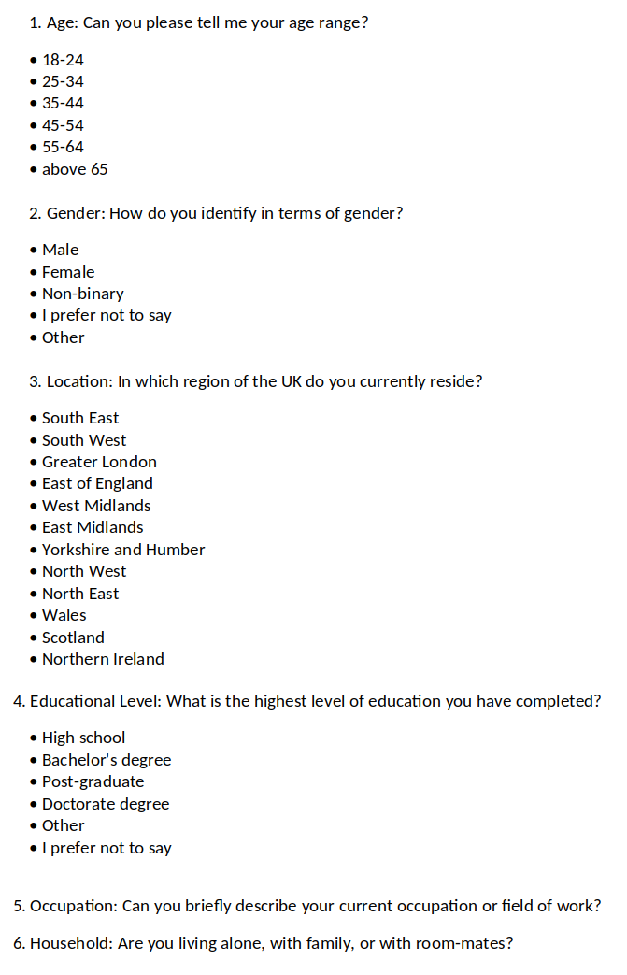

Appendix 3 - Interview Questions
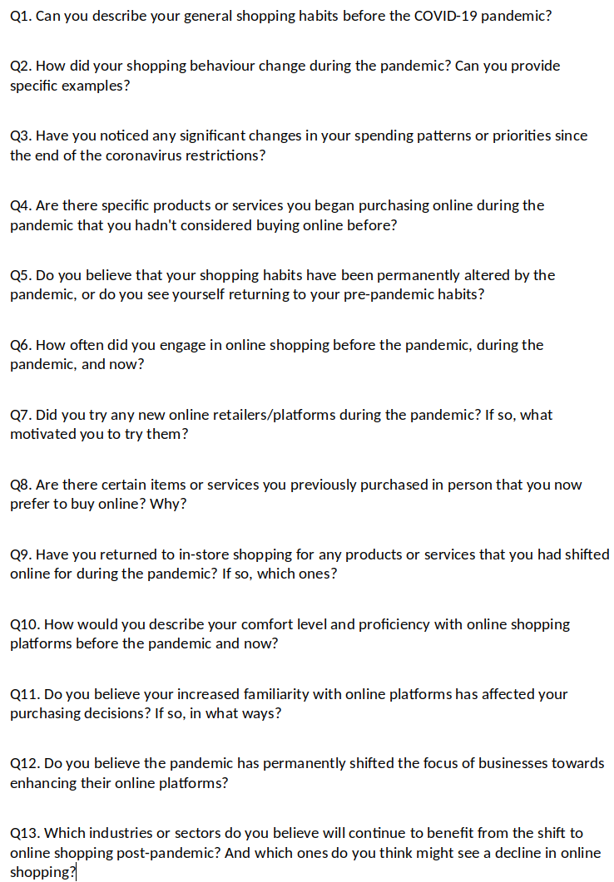
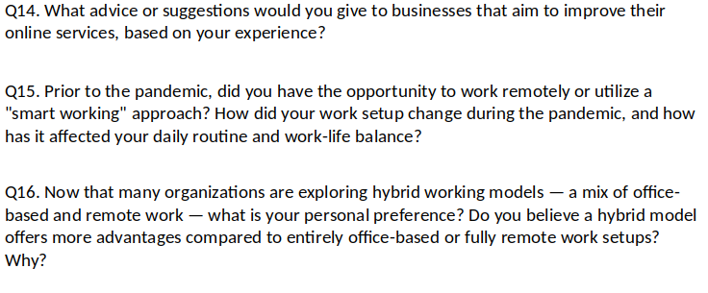

Appendix 4 - Analysis of Emergent Themes

Voices of the participants grouped (Interviewee) | Meaning Interpretation (Researcher) | Concepts/Themes identified
Before the COVID-19, I rarely used the Internet for shopping. I thought it was an unreliable platform, but little by little, during the coronavirus, I started making some purchases due to the needs arising from the pandemic, and I was positively surprised by this type of solution. (F)  Before COVID-19, I bought everything in stores because I didn't trust e-commerce. (L)  Before COVID-19, I did not even have an Amazon Prime subscription as I preferred to shop in physical stores because I thought buying a product by seeing it in person rather than on a web page was more reliable. (B)  In my case, COVID-19 has normalized e-commerce, breaking down my prejudices and making me gain trust in it (F).  Since COVID-19, my online shopping has increased significantly, and I continue to do so regularly. To make you understand, before COVID-19, I did not even have an Amazon account. So COVID-19 gave me the push I needed. (H)  During the pandemic, I started using Amazon and other e-commerce websites for the sake of convenience. Because it was easier to get products online compared to going to the physical store. (E)  As COVID-19 progressed, I realized that buying online is convenient. Especially, I feel protected by the excellent return policies. (L)  Before COVID-19, I usually went and preferred to do my shopping in physical stores. Then, not being able to go to stores anymore because it had become dangerous and difficult, I started shopping online, especially for clothing. Additionally, I began to do much more grocery shopping online.(D) | Pre-pandemic online shopping scepticism.  Pandemic necessity leading to positive e-commerce experiences.  Breaking of preconceived notions.  Increased reliance on online shopping, initiation into e-commerce platforms due to the pandemic.  Transition to online shopping due to severe pandemic restrictions and for its convenience. | (1) Main Theme: Transition to Online Shopping.  (Sub1) Evolving Perceptions of E-commerce.  (Sub2) The Role of Pandemic Restrictions in E-commerce Adoption.  (Sub3) Pandemic-Induced Exploration and Adaptation.
Today, but already since the pandemic, I have continued to shop online because the lower prices compared to physical stores help me cope with the current crisis and inflation caused by the conflict in Ukraine. (B)  Honestly, I haven't returned to shopping in physical stores for two reasons. One is for economic reasons, and the other is because it's convenient to have the products delivered to your home. Additionally, I find the return policies for online purchases to be superior compared to in-store purchases. (F)  I shop online to save money and, as a result, to manage the current rise in the cost of living. I believe that the crisis and inflation, rather than diminishing online purchases, it will lead to a decline in in-store shopping while boosting online transactions due to their cost-effectiveness. (I)  I will not return to my old habits because once you try and experience the convenience and convenience of online shopping, it is hard to go back. (A)  Today, I can say that I make most of my purchases online, which was unthinkable for me a few years ago! (L)  Today, I continue to shop online because I usually find better prices with the advantage that the products are delivered directly to my home. (C)  Before the pandemic, I practically did not use to shop online. Then, during the pandemic, I started doing it due to the needs that arose with the lockdown, and now it has become an integral part of my routine. (E)  The pandemic pushed me to open to a world in which I didn't have much trust before. Thanks to this push, I found myself immersed in the new situation and have been educated in using this new tool. Nowadays, I continue to use online shopping because it's convenient for personal reasons. (D)  Online shopping has become a habit, and as a result, I have also gained more skills through experience. (G)  Now, I have learned to search for the same product in various online stores and compare their characteristics to choose the best product at the best price. (H)  I am more confident now! I have gained more knowledge about researching websites, products, and platforms and comparing prices and product features. (F) | Shift to online shopping due to lower prices, economic factors and convenience.  Routine integration of online shopping.  The necessity of the pandemic has led to the adoption and normalization of online shopping behaviours.  The pandemic served as a forced introduction to online shopping for some, leading to a greater appreciation and continued use of e-commerce.  Enhanced online shopping skills. | (2) Main Theme: Continuance of Online Shopping post-pandemic and beyond.  (Sub1) Convenience and Economic Benefits.  (Sub2) Online Shopping as a Learned Behaviour.
My initial concern was that I would become a scam victim, especially since some people I know have complained about sites where the products received differed from those ordered or were not delivered. However, both during the pandemic and now, I have personally witnessed the security and reliability of online shopping, at least in terms of the most popular platforms. (F)  Today, I can say that I feel more secure and have gained confidence in this type of purchase. (H)  Now I feel comfortable and make purchases even of a higher value than in the past. (E)  Important has been the simplification of payments, the speed of delivery, and the return/refund policies that protect the buyer (B).  Once you've made a few successful purchases from the same online store, and they have your credit card information securely stored, and you've experienced no issues, you are more likely to continue shopping there in the future. (C)  Now, I feel more at ease and relaxed; therefore, I make purchases without overthinking because I am sure everything will go smoothly. Of course, before purchasing, always look at the reviews, as they are the only tool that can help me understand if I am purchasing the product I need or if the site is reliable. (G)  I always look at reviews before making any purchase. (B)  Of course, for unfamiliar online shopping platforms, I rely heavily on reviews. (D) | Improved trust in online platforms.  Significance of payment simplicity, delivery speed, and return policies.  The convenience of saved payment information leading to easier repeat purchases.  Reliance on Reviews for Online Purchasing. | (3) Enhanced Online Trust and Security
I have reduced my use of food delivery, but I've increased my dining out at restaurants. Assume the balance is now 50-50 (H).  Nowadays, I alternate between ordering food from home and dining out. (G)  As for food delivery and buying clothes, I shop online less now than during lockdown because I have balanced out in-store shopping more. However, the online shopping I make for these items is still significantly higher than pre-pandemic. (H)  In terms of clothing, I prefer to buy every day and less expensive items online. For the more expensive one, I prefer to go to the store because it is more convenient to try on clothes. (F)  Regarding on grocery shopping, there are products like meat and fish for which I prefer to go and choose them in person to pick products with longer expiration dates and make the best choices.(E)  When it comes to products like meat, fish, vegetables, and cheese, I prefer to go and choose them in-store. While online shopping has been helpful, it's also true that sometimes they would send you items that were nearing their expiration date, so definitely when you go to choose them yourself, you prioritize quality. (C)  Essentially, since the COVID-related restrictions have ended, I only do online grocery shopping for recurring items where the freshness of the product doesn't matter, such as bottled water or things I'm already familiar with. However, when it comes to fish, meat, fruits, and deli products, I want to see them in person before buying. (G) | Re-balancing Food Delivery and Restaurant Dining as pandemic restrictions change.  Selective return to in-person shopping for certain product categories like grocery shopping and clothes.  Return to in-store shopping for food prioritizing fresh products. | (4) Post Pandemic Hybrid Behaviours.
Even greater security in payments is never a bad thing, especially when buying from less well-known websites. (F)  Delivery as fast as possible even in rural areas. (I)  I would like faster shipping with zero delivery costs without necessarily having to meet a minimum order value. (D)  Today, I would say that online services should be more human. This means having more accessible customer service, a person who answers the phone, understands your needs, and resolves the issue promptly. (C)  I don't like interacting with chatbots when I'm trying to reach customer service. (I)  It's better to interface with a person than with a chatbot in case of issues. (D)  I would prefer a more present but also more easily accessible customer service without the need to go through a chatbot that most of the time is unable to resolve the issue. (B)  They should provide a WhatsApp number with direct contact to a human operator, making the company feel friendly and available 24/7 online. Additionally, they could enhance the feedback system based on customer testimonials who have purchased the product. (A)  Sometimes I noticed that some well-known brands with physical stores offer fewer products online compared to what's available in their physical stores. (G) | Desire for increased payment security on less well-known sites.  Desire for free and faster deliveries.  Desire for Human Interaction in Customer Service  Desire for better feedback system based on customer testimonials.  Less variety compared to the physical store. | (5) Recommendations from Consumers.
During the pandemic, I subscribed to Netflix, and I continue to use it. (F)  During the lockdown, I subscribed to Netflix, and I continue to use it with pleasure because it makes my evenings enjoyable, as I'm not someone who goes out much at night. (L)  During the lockdown, unable to go out, I started using Amazon Prime Video and Netflix to watch movies and TV series, and this has influenced me even after, as I still continue to use these services that I didn't know about before. However, even though I keep the subscriptions, today I spend fewer hours on these services and have returned to going to the cinema quite regularly. (C)  Today, I continue to maintain subscriptions to Netflix and Disney Plus, although I must say that my usage has decreased by half. Additionally, I notice that the plots of the series are all similar and standardized. (G)  In my case, I subscribed to all these various streaming platforms like Netflix, Prime Video, and Disney Plus. These are all services that I wouldn't have imagined buying before the COVID-19 pandemic. However, I have reduced the hours of usage and I think I will cancel at least one of them. (B)  After the reduction of pandemic-related restrictions, I cancelled Netflix because I go out more and have less time to stay at home. (H)  I recently cancelled all my streaming platform subscriptions because these services have consistently increased their prices over the years. (I) | Increase in the use of streaming services since the pandemic and maintained by people that spend more time at home.  Reduction in the utilization of streaming service while maintaining subscriptions.  Fluctuations in online streaming subscriptions as pandemic restrictions change.  Fluctuations in online streaming subscriptions due to increased prices. | (6) Fluctuations in online streaming usage and subscriptions.
I believe that the 50-50 hybrid work model, in which a portion of work is done in-person and a portion remotely, can be very effective, especially when the nature of the job allows for it. This approach provides flexibility and adaptability to different needs and situations and can be an optimal solution for many individuals, improving their work-life balance. (F)  A hybrid working model where you can choose days based on your needs could be the right compromise. Working from home nowadays gives you the opportunity to focus better on certain tasks and work more peacefully, as working in an open space in the office can be chaotic at times (C).  Working entirely from home removes direct contact with people, and with this approach, there is much more difficulty in sharing information, so you don't arrive at a solution immediately as you do when you are in-person. Therefore, I think hybrid working is the best solution. (D)  I left the company I was working for because they required working solely from the office. Personally, I believe that the 50-50 hybrid model is the best compromise. This is because having some human contact is always beneficial. The risk of working from home is isolating oneself, and it may take more time to seek quick advice since communication is less immediate. Additionally, I find it enjoyable to have face-to-face conversations with colleagues . (E)  I'm one of those who are in favour of the 50-50 hybrid working model because, at least for my type of work, developing trust among colleagues or those who work for or with you is crucial. With this formula, I have improved my work-life balance, certainly because you save an hour of your time for commuting, making it less stressful. You also save on petrol, commuting costs, so definitely from that perspective, it has been an improvement. (B)  Hybrid working has the advantage of allowing you to travel less during the week, reducing stress significantly. (A) | Preference for hybrid work models post-pandemic due to its flexibility.  Hybrid working to allow to be more focused on certain task as open space in the office can be chaotic at times.  Preference for a hybrid work model, recognizing the benefits of social interactions at the workplace.  Preference for a hybrid work model as a way to save money and reduce the stress. | (7) Hybrid Work Model as the New preferred Standard.

