  A Detailed analysis of one chld’s holistic development, with justification for the next steps in learning. | Abstract  The purpose of this assignment is to provide a detailed analysis of one child’s holistic development and justify their next steps in learning. For anonymity purposes, I will refer to the focus pupil as ‘Harry’ throughout this assignment. This name is in no way related to the focus pupil.  1050488  School Development and Pupil Progress
Word Count: 4651
Student Self Evaluation Form

This section repeats in brief the common assessment criteria detailed on previous pages. The extent to which these are demonstrated by you determines your mark. Using these criteria, tick the box that best indicates the level of achievement you feel you have achieved with regard to each of them.
Common Assessment Criteria Applied
Common Assessment Criteria Applied | REFER |  | D |  | C |  | B | A
 | OUTRIGHT FAIL | UNSATISFACTORY | SATISFACTORY | GOOD |  | VERY GOOD |  | EXCELLENT
1. Subject Knowledge and Understanding (which includes using research-informed literature and knowledge and understanding of the subject)
 |  |  |  | X
2. Intellectual Skills (Analysis)
2. Intellectual Skills (Analysis) |  |  |  | X
3. Pedagogic and Professional Applications (Practical Application and Deployment)
 |  |  |  | X
4. Key Transferable Skills
4. Key Transferable Skills |  |  |  | X

PLEASE COMMENT ON AREAS IN WHICH YOU FEEL THAT YOU HAVE PERFORMED WELL | PLEASE COMMENT ON AREAS you feel that you need TO DEVELOP
I feel that I have gotten to know my focus child well and able to appropriately identify realistic next steps. | I feel that this assignment was poorly structured. I feel that I should have had more of a focus within the assignment as I was trying to observe everything and all areas rather than one or two key areas.

Student’s Name | S.Copplestone | Date | 30-05-18
Student’s Signature | S.Copplestone

‘Once you begin to trust the learners and regard them as the ‘experts’ in their own learning, you begin to realise that you may have been limiting them by trying to control what work they engage in.’ (Smith 2007:18)

The purpose of this assignment is to provide a detailed analysis of one child’s holistic development and justify their next steps in learning. For anonymity purposes, I will refer to the focus pupil as Harry throughout this assignment. This alias is in no way related to the focus pupil nor his class. In this assignment, there is a focus on all areas of Harry’s education and holistic development. For the purposes of the research I have adopted the ‘Mosaic Approach’ throughout this study. This approach takes the time to listen to Harry and to gain a stronger understanding of his opinions on his own learning. Clark and Moss (2011) This approach puts Harry at the centre of the research and allows for him to be the expert and for me in turn to learn from him. This multi-method approach allows for Harry to express himself in various ways without restriction or judgement. Although this research will place a lens over his entire being; when compiling an educational profile, the research places emphasis on Harry’s development within the Literacy and Numeracy strands in his education. The data gathered is a combination of observation notes, voice recordings, interviews, teacher tracking, reflective journals and annotated samples of Harry’s work over the data collection period.

Harry is in one of two Year 5 classes and his class consists of 26 pupils. The class has a variety of additional learning needs which vary from speech and language to behavioural issues. The class has one full time teaching assistant who is a one to one with another pupil in class. This pupil is sat with Harry for the majority of Harry’s timetable and could be considered a close friend, so I have also taken into consideration the teaching assistants professional opinion on Harry with an informal interview to coincide with the research. Harry is recognised by his teacher as an average ability child and is in the higher ability group for maths. The research has been collected from an urban, large school with approximately 580 pupils. The school where the research has been gathered has recently experienced an inspection from Ofsted and were given targets in areas particularly in Numeracy and Literacy. These targets will also be taken into consideration when planning the next steps for Harry. All research methods have identified strengths and weaknesses which have been acknowledged over the course of this assignment.

When conducting this research, ethical issues were raised and considered. Anyone under the age of 18 is considered a vulnerable sample so it was critical to gain institutional approval. Before commencing my research on Harry, I sought for consent off a member of staff within the school. (Please refer to Appendix A.) As highlighted in Howlett and Cramer (2014) anonymity is vital when executing research such as this. For this reason, the school and any pupils within this assignment will have full anonymity. Pupils who Harry has included in the research that he considers friends, will be given various alias’ that are in no way an indication of their real name nor their identities. During this research period, I have ensured that my focus pupil and any other pupils’ that have been included within the research received the same treatment without prejudice regardless of gender, ethnicity, disability etc.

After acquiring the schools consent for my research, I fully disclosed the intentions of the research to Harry and he has shown his consent by using the I-pad to create his profile and adding his work. Alongside this, he has given me verbal consent and I continually gauged for ongoing assent over the data collection period to which Harry obliged. I clarified the purposes of my study and ensured that Harry was aware that he could withdraw his information at any time. I have ensured that I have adhered to the British Psychological Society Research Ethics Principles (2010) and have recognised the four principles outlined by Howlett and Cramer (2014) during the research period.
The research was primarily based on the ‘Mosaic Approach’ outlined by Clark & Moss (2011.) This approach emphasises the use of open-ended questions and increased Harry’s enthusiasm to share his work. Harry demonstrated some independence to create an e-book of his work on a password protected I-pad that only I had access to. We discussed potential ideas for the e-book and Harry suggested that he could add comments/opinions that he felt relevant to the work and at no point was pressured to have correct spelling or grammar. This project between myself and Harry was key in my research. Not only did it allow for our relationship to grow, but it also allowed Harry the freedom to express himself and share what work he was proud of using an area of learning that he was very confident in, ICT. This mosaic approach allowed me to delve into my research and gain a key insight into the inner workings of Harry’s mind and his approach to learning.

Through observation and voice recordings, the research provided rich qualitative data. This data coincides with the results from moderation which is quantitative data. All qualitative and quantitative data will be factors in Harry’s next steps. Quantitative data is important to have in a study such as this, due to qualitative data being overly impressionistic and subjective. (Bryman 2011) However, Howett and Cramer (2011) argue that qualitative data provides a better understanding of the subject matter. Over the course of the research I have immersed myself into Harry’s social setting and observed his behaviours as accurately as possible. Although Harry was aware and had agreed to being observed it would have been difficult for him to keep up an ‘act’ over 4 weeks so as time has progressed it is safe to assume that his behaviour has become a better reflection of his true self. Although he was aware that he was being observed, he was not sure precisely when the observations were taking place. I believe this to be fundamental for the validity of my findings. To encourage this, the observation periods of the research were a covert observational method. Pritchard (2005)

Howett and Cramer (2014) have suggested that interviews can be easily forgotten, and small details missed. To improve the validity of my study, I felt it important to record the interviews. As Cohen et al (2011) suggest, open ended questions allow for participants to answer with flexibility and if I deemed it necessary the researcher could probe for additional information. The interviews with Harry remained conversational. The nature of the conversation was key for Harry to feel comfortable and to not be intimidated by the questions asked. Although it is known for participants to give the researcher desirable answers, an interview alone would not have given me a good enough insight into Harry’s interests and opinions. However, the mosaic approach has allowed for us to build a better relationship so that Harry could be honest with me and I could make a professional opinion on whether his answers were valid or not. Cohen et al (2011) suggests that when interviewing children, it is better to do it within groups. However, due to the nature of the research this was not an option as a peer may have influenced Harry’s answers. To overcome this, I ensured Harry was comfortable when being interviewed and that he could stop at any time. If Harry displayed any non-verbal or verbal signs of discomfort I would immediately end the interview myself. The interview mainly focused on Harry’s opinion of his own education and his most/least favourite subjects. We have also discussed his own targets and how he feels about them. From this combination of research and evidence gathered, I can make a professional decision about his current standing within his own education and appropriate next steps. Over the course of this research, at no point have any findings been fabricated or plagiarised. All data collected has been recorded as accurately as possible. Due to the GDPR I am unable to share voice recordings due to pupils saying their real names and the school being identified.

Although there are clear limitations within the methodology, using different techniques allows for rich variety when analysing the focus pupil and can allow me to make valid judgements for his next steps. The different methods of data collection would also accommodate for any inconsistencies within the findings also. The mix of qualitative and quantitative data strengths the validity of the study. The validity is also increased by the various sources and people the data has been collected from such as his permanent teacher and himself. This would allow for any inconsistencies to be recognised and is key to the research.
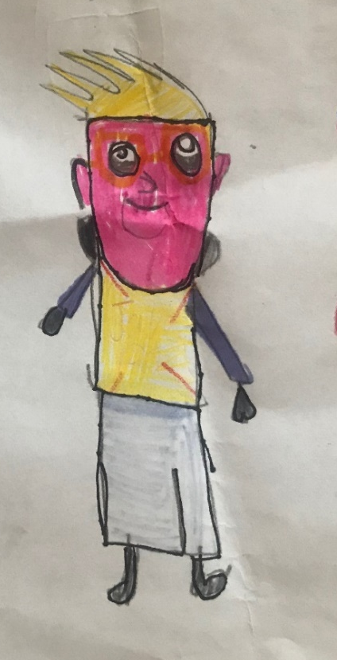
About Harry:
Harry is nine years old and has a younger sibling in key stage 2. Jack lives at home with his mother and father and does not have any pets.

Harry has a passion for ICT and will always go on the I-pads as a first choice. He has demonstrated confidence in using various apps as well as problem solving computer errors that happen in the classroom. Harry has told me that the app ‘Book creator’ helps him learn as well as ‘Garage Band.’ He mentioned ‘Kahoot’ helps him learn and using ‘J2 Blast’ has helped him with his times tables. He also told me that the use of ICT is important for his job when he is older. Through voice recordings, Harry has told me he enjoys Maths but does not like Reasoning because it is too hard. “When I see it says reasoning on the board, I just go oh no.” (Harry in audio recording.) He also feels that he is not very good at drawing or speaking Welsh.
Figure 1: Harry's self-portrait.

Harry is a confident individual who takes risks and will share his opinion with the class. He has a close group of three friends (Please refer to Appendix 2) Alex, Coby and Sam but believes he is friends with everyone in class. Harry is comfortable when working with others and participates well with activities in class. Although Harry has a passion for ICT, it can often prove a distraction and Harry will lose his focus and go off task. He can also be influenced by peers in his group, particularly Caleb who has behavioural issues. When with a group, he will attempt to show off and gain favour of peers through desired or undesirable behaviour. Individually, Harry is very polite and places importance on his relationship with adults. (Please refer to Appendix 3.) After being influenced by Caleb and Alex, Harry was sent out of the classroom with the other boys and found this funny, it was only later when Harry was on his own that he apologised and without prompt created an apology letter. This emphasises that he places importance on good relationships with peers and adults but can find this difficult at times. Harry believes he works well in a group but has mentioned that when working with a friend he is often off task.

On the tracking sheets (Please refer to Appendix 4) Harry will often be rated as orange on the RAG rating system and he will often choose this on an AfL strategy when self-assessing called ‘traffic lighting.’ Harry appears confident in Maths and often observed as being on task. Harry is also a free reader and particularly enjoys non-fiction. Harry has a strong interest in football and very knowledgeable on facts about planes and cars.

From Harry’s data I can see the levels he has officially been given by the school according to his INSERTS:
Oracy:  Level 3 with elements of Level 4. | Handling Data:  Level 3 with strong elements of Level 4. | Using and Applying: Level 3 | Welsh Writing:  Level 3
Reading: Level 3 with elements of Level 4. | Number and Algebra: Level 3 with elements of Level 4. | Using and Applying: Level 3 | Welsh Oracy:  Level 3
Writing:  Level 3. | Shape, Space and Measure:  Level 3 with elements of Level 4 | Using and Applying: Level 3 | Welsh Reading:  Level 3
A key focus on these areas for next steps.
His current class targets are to focus in class, have only two spelling mistakes in a piece of writing and his 7,8 and 12 times tables. He has also given himself a personal target which is to speak incidental Welsh.

On the voice recording, Harry has said that he enjoys writing. He explained that he is good at writing stories but prefers to write ones that he is familiar with. He goes on to explain that when it is a piece of writing he does not know, he struggles and gets stuck. Through moderation, I was able to see Harry’s levels and next steps for improvement. He is a level 3 with some elements of level 4. His independent writing was well presented, and his handwriting and presentation is good on the whole Please refer to appendix 5. A recall text type suited Harry because he was not making it up, it was something that had happened before. It would be interesting to see what Harry can do when creating a story independently and how he will overcome these challenges. It is unclear if it is due to a lack of imagination, creativity or something else entirely.

Through an informal interview, Harry explained that he does not mind speaking in front of the class and talks well. Harry is comfortable to present in a group or class setting but would not want to speak in an assembly. Through observation, Harry can communicate his opinions and ideas well within his group. Harry has been recorded saying that he loves reading and mostly likes non-fiction because of the facts and because he learns ‘new stuff.’ When reading, Harry shows good fluency and can decode words that he is unfamiliar with. When reading ‘Horrible Histories: Woeful second World War,’ Harry enjoyed discussing facts he has learnt and will often share his opinion whilst reading individually or in group reading. Harry can make inferences when reading and is able to refer to the text when asked questions.
Harry enjoys Maths and feels that he is good at it. He particularly enjoys learning about time and diagrams. He also told me his favourite and most memorable lesson was Venn diagrams because they could choose what they did. When asked what he did not like in Maths, Harry responded that long division is awful and loathes reasoning. He explained that it was too hard and every time he notices that it says reasoning on the board he worries. He was not able to explain exactly what he found difficult about reasoning questions. Harry also has good pace and is beginning to use expression when reading. When working in maths, Harry works well and understands key concepts. He is able to work systematically through problems and works particularly well with others. Harry is often enthusiastic to share his work and ideas with the class.

From observations and discussion with the teaching assistant, Harry has two distinct work types. He is either on task and does the work well or is completely off task and there is a stark contrast in his behaviour and attitude, particularly with adults. When Harry is off task it is often because there is an element of ICT within the lesson or due to certain peers being in his proximity. Regarding ICT, Harry is very passionate and confident in this subject, so it would be unwise to not take advantage of this. Harry has also told me in interviews that he loves ICT and loves using Kahoot and HWB. In Harry’s opinion, ICT helps with his learning above all else in the classroom. When asked to show me his favourite places in school, without hesitation he gestured to the laptops and the I-pads. However, this can also lead as a distraction to his learning. If Harry is on task and an I-pad is placed next to him, he cannot continue to work. This happened numerous times over the observation periods and is something Harry is aware of when discussing his own behaviour during an interview. Regarding Harry’s behaviour he is quite well behaved. He sometimes finds it difficult to focus and listen to instructions at the beginning of a lesson. This is usually due to distraction from an ALN student who is sat with him on his table whom he considers a close friend. It is in this state of mind that when Harry is then told off, he laughs and finds it somewhat humorous along with his peers to be sent out of class for unapproved behaviour. However, when given time to reflect, Harry takes responsibility for his actions and apologises. It is unclear if this is due to him genuinely being sorry or an attempt to avoid punishment. From this observation the laughter could be a sign of nervousness or a defence mechanism.

When interviewing Harry, the only issue he believes he has with literacy was his written work. He told me that he likes writing but finds it difficult to write stories that he is unfamiliar with. As story-writing fortnight is coming up as a key stage 2 approach, this will be a key time to creatively encourage Harry and his story writing. Csillag (2017) suggests that children should not write because they have been told to but rather to express what they wish to communicate. To build on this, Csillag states that it would prove beneficial for learners to communicate their writing through drawing and other forms of expression to show their understanding. She also believes that through the use of assistive technology, pupils can use word prediction and apps to dictate the story to disbar any worries or frustration of spelling words wrong. This would suit Harry’s passion for ICT and should prove an effective tool. Lastly, learners should be given things that they are interested in writing to give it a purpose. The child should be writing because they want to, not because they have been told to. Csillag (2017) This leads me to conclude that Harry and his peers should be in control of the story writing and give them responsibility and a sense of ownership. To compliment this, it would prove beneficial to encourage Harry to read some fiction. Over the data collection period, I only observed Harry reading non-fictional books. This could be why Harry struggles to write creatively when given a story writing task. It may also prove beneficial for Harry to see a wide range of fictional books and tailor his choice to one that he is interested in. (war/ football/ computers,) According to the Programme of Study for English Key Stages 2–4 (2015) Learners should be provided with opportunities to write to various audiences. This would provide Harry the opportunity to write with purpose to other peers in his school. It may also prove beneficial for Harry to be able to choose what the writing is about as he mentioned earlier that was one of the reasons the Maths lesson was his favourite. It would also help if Harry was provided with a wide range of written and dynamic stimuli to aid in his writing. This would also be desirable for the whole class.

Over the course of the research, Harry has been very positive about his work and his school life. The only significant dislike Harry displayed was to reasoning tasks. This display of negative attitude towards reasoning has made this a key area within Harry’s next steps and SMART targets in my research. To tackle Harry’s disliking to reasoning I believe it would prove effective to implement the use of ICT during reasoning tasks. This would include the use of reasoning problems with audio available to read the question to him and games that encourage logical thinking. It may also prove effective to introduce a step by step process (as a whole class approach) which will allow Harry and peers to not feel discouraged when seeing the word ‘reasoning’ on the board, but rather view it as a problem to be solved. Referring to my observation notes, Harry was very excited about this task and was focussed for most of the lesson. According to Barkley et al (2005) collaborative learning engages all pupils and through collaborative learning, our students can develop life skills that can be applied within the workplace. I observed that Harry had worked well alongside his peers and enjoyed the concept of cracking a secret code. This observation along with Barkley et al’s theory, has allowed me to deduce that it could prove beneficial to have ‘Problem Solving Partners’ that allow the pupils to be presented with a problem and for the partners to tackle it together with logical reasoning, justification and suggestions. It would also be beneficial if problem solving partners were given practical reasoning tasks to work through together and apply their mathematical talents to real-life concepts. Harry has mentioned previously that his favourite lesson was on Venn diagrams as they could choose what their Venn diagrams were about. It may improve his understanding of reasoning if Harry were tasked with creating his own reasoning problems. He would create a reasoning problem, and then present it to the class. He would be tasked to help pupils who did not understand and would expectantly result in improving his own understanding of the reasoning process and improve his confidence. It would also be useful to use reasoning problems to improve Harry’s reading and vice versa. When on ‘free reading’ Harry could be encouraged or tasked with reading reasoning problems and attempt to solve them. This combination of Literacy and Numeracy would allow Harry to discuss the problem and understand what the question is asking him. To Harry, reasoning has many negative connotations and I feel in my professional opinion that this should be a main focus in his next steps. Cotton (2013) has suggested that the use of putting pupils into sets can have serious implications to their learning. Cotton states that pupils who can choose their own difficulty will result in a happier working environment. Cotton also goes on to suggest that by focusing on the needs of specific groups within maths it naturally results in planning for individual needs. Cotton proposes that this allows pupils to become more engaged with the learning and the mathematics being taught. From this research I will implement the use of ‘Chili challenges’ that allow pupils to choose their own level of difficulty. Swann et al (2012) also theorise that pupils who are responsible for their own learning have resulted in higher engagement levels and an overall better quality of learning. A case study shown in ‘Learning without Limits’ shows a teacher who uses zones in their classroom for differentiation. This meant that pupils who were choosing the same areas were on the same level of task which allowed the Year 6 teacher to target specific learners or groups of learners. This also reduced the sense of hierarchy in the classroom because learners were choosing their own levels. In my professional opinion, the mature attitude this system encourages would not only benefit Harry but would benefit the whole class.
• select from an increasing range of checking strategies to decide if answers are reasonable
• interpret answers within the context of the problem and consider whether answers, including calculator, analogue and digital displays, are sensible
• draw conclusions from data and recognise that some conclusions may be misleading or uncertain
Source: ‘Curriculum for Wales: Programme of Study for Mathematics, Key Stages 2–4’ pg 2

From observation, Harry struggles with the reviewing of a reasoning task. Particularly using a range of checking strategies. It would be helpful if Harry were to learn different checking strategies. In partnership with the collaborative learning, partners could investigate numerous checking strategies. They could then share what worked and what did not work and agree upon a set of rules for each checking strategy.

Cowley (2010) suggests that when dealing with behaviour it is vital to set key expectations as soon as the pupils walk through the door. She suggests that rather than expecting a whole behaviour approach you choose one display of behaviour to work on. For example, I could meet with Harry in the morning and tell him that today his only focus is to not call out. Throughout the day that would be our focus and I would check in to see how he feels this is going and if he is meeting expectations. A behaviour plan like this would set clear boundaries and would allow for Harry to focus on ‘one’ behaviour rather than trying to improve in all areas. Regarding Harry’s problems with listening, it could be that he is too far away from the board and certain peers distract him on the table. Moving him closer may improve his ability to focus and allow for me to monitor him closer. Harry has responded well to positive reinforcement and will always show more focus when a raffle ticket or dojo point is available. As Grigg (2010) states, learners are far more likely to do something if there is a positive reward as opposed to something bad happening.

Overall, Harry’s teacher has explained that he has come on along a lot this year. His biggest improvement is in his writing and in his behaviour. Harry has displayed a keen excitement for learning and is capable of achieving expecting levels next year. The next steps have been very specific and has homed in on one key area. I feel this is important as too much can overwhelm a learner. Grigg (2010)

Upon reflection, I feel that I should have used more research. As an example, Harry shared with me that he did not like writing stories or reasoning. It may have improved my study if I had given him a reasoning question or a ‘cold write’ without support and observe Harry’s behaviours. How does he tackle a problem? What are his various coping strategies? I feel that this would have provided me with better intel as to how to appropriately support Harry effectively.

Although this assignment primarily focuses on one learner, in my professional opinion a lot of the interventions and targets for Harry could be beneficial as a whole class approach. The use of collaborative learning and pupils having a voice in their own learning has proven advantageous for all pupils regardless of ability, gender, FSM etc. Clark & Moss (2011) outlined that the Mosaic Approach allows for us to deepen our relationships with young children and have also acknowledged that this method of accumulating information is somewhat time consuming. However, the quality and depth of information you can achieve from this make it worth pursuing. Clark and Moss (2011) suggest that this approach results in a new shared vocabulary between adult and student and is far more participant-friendly. The execution of ‘pupil voice’ through the Mosaic Approach has widened my understanding of how important it is for us to listen to young people. This approach allows us to delve deeply with our young children and explore new ways of gathering their thoughts and feelings. I will ensure that this approach will continue in my professional practice as a teacher. It is clear from Harry’s next steps that all pupils would benefit from a lot of the interventions to be implemented in Harry’s learning. I believe that all next steps stated are SMART targets and would be achievable for Harry at the beginning of Year 6. All pupils deserve a voice and all pupils should have a say in their educational career. It is through this new understanding that we can better prepare our young people for a successful future. Donaldson (2015)
Appendices

Appendix 1: Consent Form
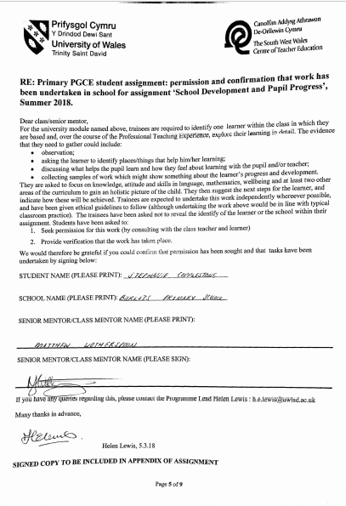

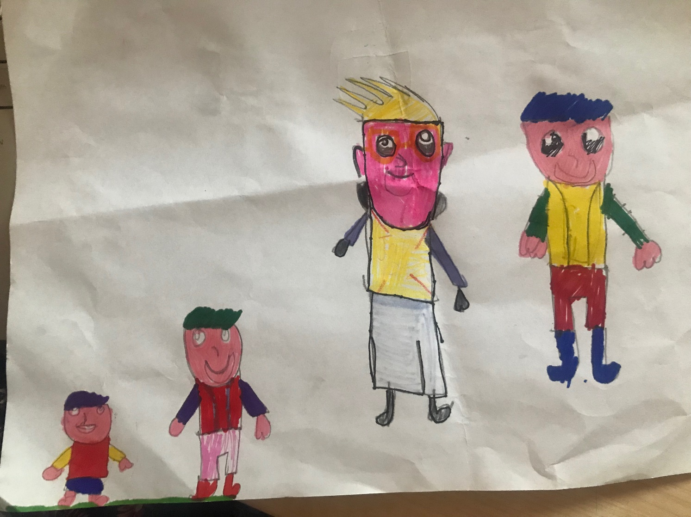
Appendix 2: A photo of Harry and his friends.

Appendix 3: Apology Letter from Harry after misbehaving in class.
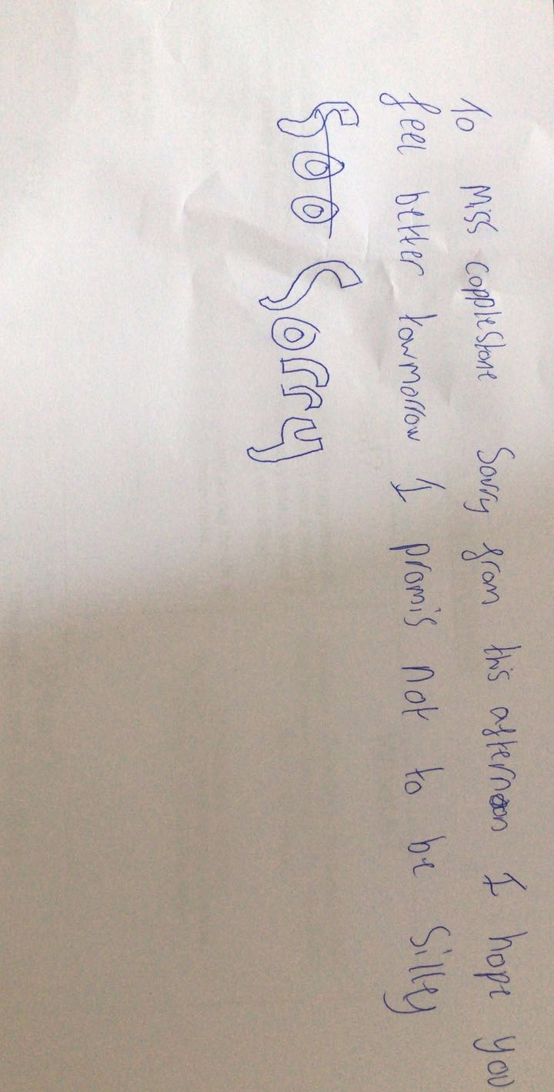

Appendix Four: Harry’s Book

Appendix Six: Reading Sample 1

References

Barkey, E., Cross, P., and Major, C. (2005) ‘Collaborative Learning Techniques: A handbook for college faculty.’ San Francisco: Jossey Bass Publishing.

Cotton, T. (2014) 2nd edition. ‘Understanding and Teaching Primary Mathematics.’ Oxon: Routledge

Cowley, S. (2010) 4th edition ‘Getting the buggers to behave.’ London; Continuum Publishing.

Clark, A. and Moss, P. (2011) 2nd edition. ‘Listening to Young Children: The Mosaic Approach’ London: NCB Publishing.

Csillag, J. (2016) Writing Tips for Kids Who Hate to Write [online video] Availble at: https://www.youtube.com/watch?v=49BYGHaSkEU [Accessed 20th May 2018]

Cohen, L., Manion, L., & Morrison, K. (2011) 7th edition ‘Research Methods in Education.’ Routledge: Oxon.

Donaldson, G. (2015) ‘Donaldson Report – Succesful Futures – Independednt Review of Curriculum and Assessmsnet Arrangements in Wales’ Available at: https://www.nasuwt.org.uk/asset/A788604C-3046-4005-A1EA0EAFF023E0DD/ [Accessed 20th May 2018]

Grigg, R. (2010) ‘Becoming an Outstanding Primary School Teacher.’ Harlow: Pearson Education Limited.

Howett, D. and Cramer, D. (2014) 4th edition. ‘Introduction to Research Methods in Psychology.’ Harlow: Pearson Education Limited.

The British Psychology Society (2010) ‘Code of Human Research Ethics.’ Available at: http://wwww.bps.org.uk/sites/default/files/documents/code_of_human_research_ethics.pdf [Accessed 20th May 2018]

Pritchard, A. (2005) 3rd edition. ‘Ways of Learning; Learning theories and learning styles in the Classroom.’ Oxon: David Fulton Publishers.

Reid, D. & Ostashewski, N. (2011) iPads in the Classroom – New Technologies, Old Issues: Are they worth the effort? In T. Bastiaens & M. Ebner (eds.), Proceedings of World Conference on Educational Multimedia, Hypermedia and Telecommunications 2011 (pp. 1689-1694). Chesapeake, VA: AACE

Smith, D. and Elliot, D. (2007) Exploring the Barriers to Learning from Crises. Management Learning, 38(5), pp.519-538

Swann, M,. Peacock, A., Hart, S., and Dummond, M. (2012) ‘Creating Learning without Limits’ New York: Open University Press.

Welsh Assembly Government (2015) ‘Curriculum for Wales: Programme of Study for Mathematics, Key Stages 2–4’ Available at: http://learning.gov.wales/docs/learningwales/publications/150717-nc-maths-en-v2.pdf [Accessed 25th May 2018]

Welsh Assembly Government (2015) ‘Curriculum for Wales: Programme of Study for English, Key Stages 2–4’ Available at: http://learning.gov.wales/docs/learningwales/publications/150717-nc-english-en-v3.pdf [Accessed 25th May 2018]

