
Programme name: Master of Business Administration
Name and code of the module: Marketing Management LCMB7024
Title of the submission: Marketing Environment Analysis of Tata Steel (India)
Lecturer’s name: Tushara Balendran
Student name : Rajveer Singh
Student ID: 2536659
Word count: 2561

Table of Contents
Introduction 3
Background information about company: Tata Steel 3
Outlining topics covered 4
Task 1 4
1.1 Definition of the Macro environment 4
1.2 Two external marketing environment actors influencing the transition of Tata Steel toward lower-carbon products 5
1.3 Opportunities and threats identified based on the analysis of 2 external actors 7
Task 2 7
2.1 Defining metrics 7
2.2 Two strategies for growth 9
2.3 Analysis of two strategies on Tata Steel’s growth to reduce threats 11
2.4 Recommending a strategic growth strategy for Tata Steel using the Ansoff Matrix 12
2.5 Proposing a competitive edge while transitioning to a lower-carbon business model for the company 12
Task 3: Critical Reflection on AI Usage 13
3.1 AI Tool disclosure 13
3.2 Evaluation of AI output 13
3.3 Analysis of AI structure and personally made outline 13
3.4 Reflecting ethical and professional implications 14
Conclusion 14
References 15

Introduction

Background information about company: Tata Steel
Tata Steel is a leading global steel manufacturing organisation, which was founded by Jamsetji Nusserwanji Tata in Jamshedpur, India, in 1907 (Tata Steel, 2026). The company currently offers services and products in over 150 nations and operates in 26 countries, making it the second-most geographically diversified steel producer. The company has several workers across five continents in the world, enabling it to maintain its crude steel capacity of 27.5 MnTPA. The vision of Tata Steel is to “be the global steel industry benchmark for ‘Value Creation' and 'Corporate Citizenship’” (Tata Steel, 2026). On the other hand, the mission of the company is to “scale the heights of excellence in all that it does in an atmosphere free from fear and, thereby, reaffirms its faith in democratic values” (Tata Steel, 2026). The founder ofTata Steel, Jamsetji Tata, strives to boost the industrial base of India through the effective use of materials and staff. Based on this vision and mission, the company recognises that while integrity and honesty are the crucial elements of a stable and strong business, profitability delivers the primary spark for financial activity.
Figure 1. Tata Steel Logo
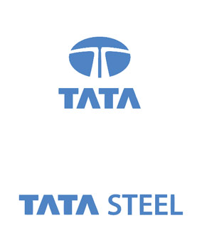
Source: (Hungama Digital Services, 2025)

Outlining topics covered
The current study has covered three main topics. The first topic is based on analysing two external marketing environment actors that are influencing Tata Steel’s transition toward lower-carbon products. The second topic discussed the strategic growth and threat minimisation approaches for Tata Steel based on the Ansoff matrix analysis. The third section is focused on reflection on the use of AI in the development of this study.

Task 1

1.1 Definition of the Macro environment
The Macro environment refers to the external environment, where external factors influence the performance of a firm or industry (Koech, 2025). In the context of the Macro environment analysis, the PESTLE analysis framework is used to assess the influence of external factors (Yitbarek et al., 2025). According to Tu and Xu (2024), the PESTLE analysis framework includes six external factors, such as political, social, legal, economic, technological, and environmental, which help to assess the external environment of businesses (Refer to Figure 2).
Figure 2. PESTLE analysis
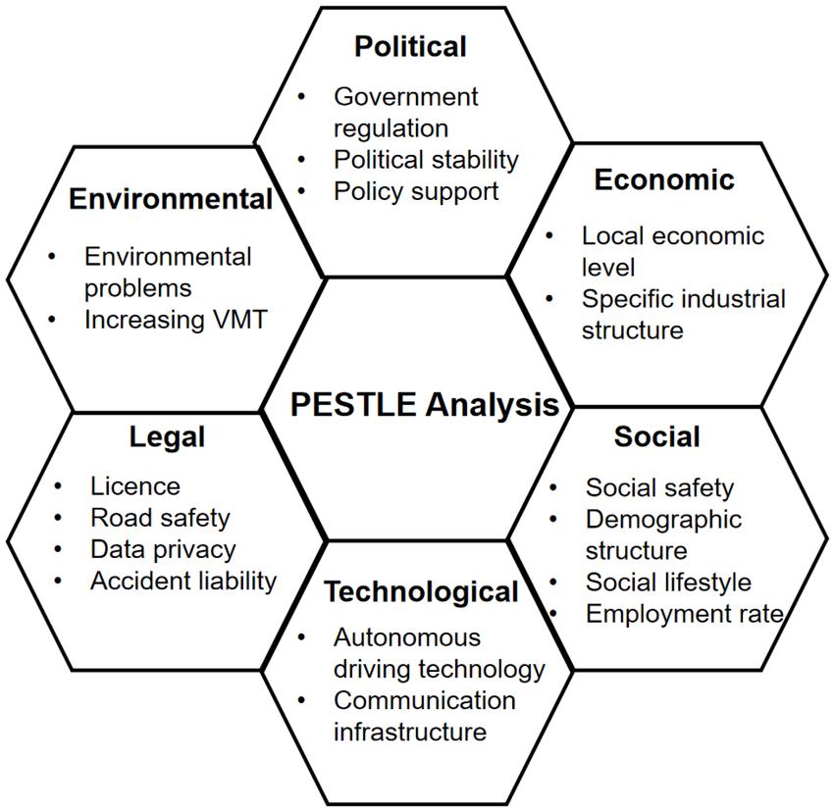
Source: (Tu and Xu, 2024)

1.2 Two external marketing environment actors influencing the transition of Tata Steel toward lower-carbon products
- Natural Environment actors
- Regulatory policies and carbon pricing: The metals and mining sector of India includes stricter regulations regarding domestic climate change. For example, the Taxonomy of Green Steel and the CCTS (Carbon Credit Trading Scheme) policies in India regarding decarbonisation are pushing Tata Steel to embrace low-emission steel-making practices (Tata Steel, 2024).
- National net-zero commitments: The national net-zero commitments of India are based on becoming net-zero by 2070 (Das et al., 2025). In response to this national target, Tata Steel has set a goal to achieve net-zero in its operations by 2045 by increasing the implementation of breakthrough technologies, such as hydrogen-based DRI (direct reduced iron) and CCUS (Carbon Capture, Utilisation, and Storage) (Tatasteel.com, 2023).
- Access to sustainable finances: The global financial community is focused on limiting the funds for high-emission assets (Hungama Digital Services, 2023). As a result, to secure lower borrowing costs and funding, Tata Steel has focused on aligning its operations with the global 2°C climate paths and maintaining transparent ESG frameworks. Moreover, the company has become the first steel producer to join the Sea Cargo Charter to decrease Scope 3 emissions (TATA STEEL, 2025).
- Circularity and raw material scarcity: Iron-making businesses rely heavily on carbon-intensive metallurgical iron ore and coal, which are responsible for around 95% of carbon emissions (Nolan, 2024). Tata Steel has scaled up its scrap-based EAF (Electric Arc Furnace) capacity in its Indian facilities, such as Ludhiana, Punjab, along with adopting higher scrap in BOF (basic oxygen furnace) to reduce its environmental footprint (Hungama Digital Services, 2024).
- Legal actors
- CCTS and Indian Carbon Market: The enactment of the CCTS in the metals and mining industry of India has created a regulatory framework, which shows that extra carbon emissions result in financial costs, leading to ethical issues (PIB, 2026). This has led Tata Steel to adopt efficient and cleaner steelmaking technologies (Tata Steel, 2024).
- Carbon Border Adjustment Mechanism: The CBAM (Carbon Border Adjustment Mechanism) taxes imposed by the EU (European Union) on steel imports can affect the export performance of Tata Steel (Kumawat and Bhanawat, 2025). Hence, Tata Steel can shift toward the export of lower-carbon products in the EU to avoid these upcoming taxes (Belavadi and Kulkarni, 2026).
- Business Responsibility and Sustainability Reporting: The BRSR (Business Responsibility and Sustainability Reporting) framework was mandated by the SEBI (Securities and Exchange Board of India), the Greenhouse Gas Protocol (GGP), the Global Biodiversity Framework (GBF), the UN SDGs, and the IFRS (International Financial Reporting Standards) S2 (erstwhile TCFD) to ensure the strict disclosure rules that are required for businesses to transparently document Scope 1, 2, and 3 emissions, driving investment and accountability into green steel products (Tata Steel, 2024). Tata Steel has complied with these rules to improve its sustainability performance.
- Subsidies and Green Steel Taxonomies: The emerging government-backed policies and federal standards for green steel have promoted green hydrogen pilot projects and the use of scrap-based EAFs to meet regulatory requirements (Tata Steel, 2024). Tata Steel has developed its EAF plant in Ludhiana to comply with these legal requirements.

1.3 Opportunities and threats identified based on the analysis of 2 external actors
Natural environment
Based on the analysis of the above natural environmental factors, such as regulatory policies, national net-zero commitments, sustainable finance access, and raw material scarcity & circularity, it can be determined that these factors have created opportunities for Tala Steel in the market. For example, the company has adopted hydrogen-based DRI & CCUS technologies, which have helped to improve its operational performance (Tatasteel.com, 2023). On the other hand, the scrap-based EAF usage also helped to reduce its carbon emissions (Hungama Digital Services, 2024).
Legal factors
The legal factors, including CCTS & ICM (Indian Carbon Market), CBAM, BRSR, and Green Steel Taxonomies, helped Tata Steel to improve its performance by complying with the legal regulations. For instance, compliance with the BRSR framework enables Tata Steel to maintain transparency in emission reporting, fostering the engagement and trust of stakeholders (Tata Steel, 2024). However, non-compliance with the CBAM can pose threats to Tata Steel in exporting its products to Europe.

Task 2

2.1 Defining metrics
According to Ștefan, Popa and Tărăban (2023), Porter’s generic strategy allows firms to operate in a competitive business environment. The metric was first developed by Michael Porter to guide firms in utilising their growth strategy for gaining a competitive advantage in the industry. As supported by Yu (2023), the components of Porter's Generic Strategy include Cost Leadership, Differentiation, Cost Focus and Differentiation Focus (see Figure 3).
Figure 3. Components of Porter's Generic Strategy
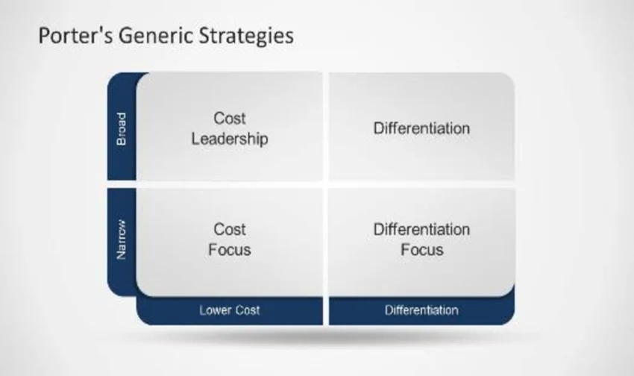
Source: (Yu, 2023)
The second matrix considered for this section is the Ansoff Matrix. The matrix supports segmentation of organisational growth options, in relation to new markets and products (Němec et al., 2023). Figure 4 shows key components of the Ansoff Matrix, which are “market penetration, product development, diversification and market development” (Research-Methodology, 2026).
Figure 4. Components of Ansoff Matrix
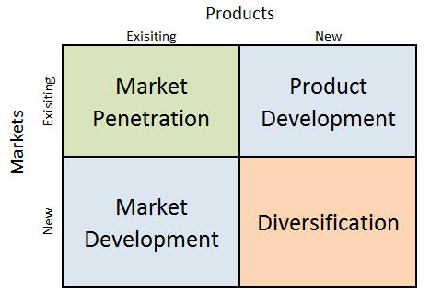
Source: (Research-Methodology, 2026)

2.2 Two strategies for growth
Porter’s generic strategy
Past studies on steel production highlight that scrap-based electric arc furnaces generate reduced carbon emissions and consume less power in steel production (Islam and Mohammed, 2025). A diversification strategy allows businesses to maintain unique positioning in their industry in meeting consumer needs. The opportunity to develop lower-carbon steel also requires the integration of carbon capture mechanisms and hydrogen-based production (Chang et al., 2023). Supported by IITB.ac.in (2026), carbon emissions from EAF steelmaking can be further reduced through hydrogen-rich DRI. The opportunity is to invest in scrap-based electric arc furnaces, which were valued at USD 1020.5 million in 2026. EAF steelmaking accounted for 50% of steel production in 2026 (Ramprasad Bhute, 2026).
Figure 5. Opportunities for investment in scrap-based steel arc in steel production
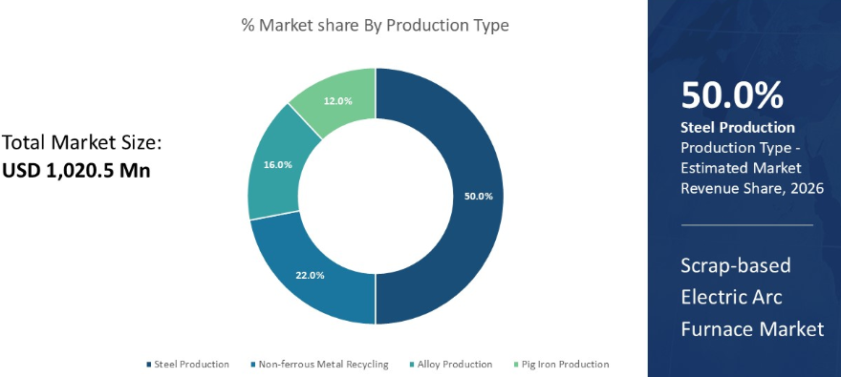
Source: (Ramprasad Bhute, 2026)
On the other hand, the steel industry in India accounted for the release of “2.6 tons of CO2 per ton of finished steel product” (GMK, 2024) (GMK, 2024). Hence, resistance to decarbonising is one of the foremost threats faced by steel-making companies. The availability of poor hydrogen infrastructure in the existing market is also perceived as another threat to reliance on hydrogen technology for steelmaking. High energy consumption and energy intensity are perceived as another threat for the steel-making plants in India. Supported by Harvey (2024), the average energy intensity of steel products (fabricated) is 24.1 GJ/t.

Ansoff growth matrix
According to Future Market Insights (2026), the low carbon steel market size was USD 1,185.8 billion across the world in 2026. The industry is currently growing at 4% CAGR from 2026 to 2034 (see Figure 6). This indicates that there is a strong opportunity and acceptance of low-carbon steel, amid climate change and greenhouse gas concerns. A product development strategy can be helpful in scaling the availability of verified lower-carbon steel for engineering, automotive and construction.
Figure 6. Opportunity to invest in low-carbon steel
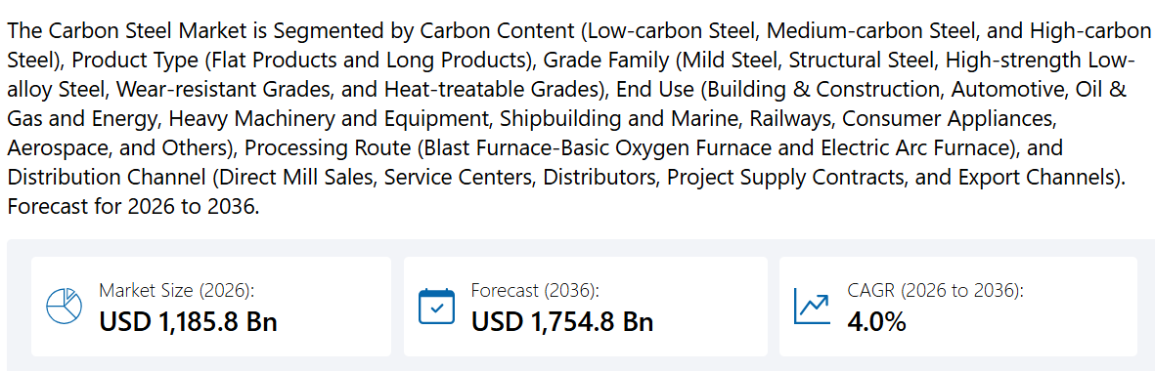
Source: (Future Market Insights, 2026)
On the other hand, World Steel Association (2024) reports that greenhouse gas emissions in the production of steel are a threat to a successful transition to low-carbon steel (or green steel). The report highlighted that every tonne of finished steel can produce 2.18 tonnes of Scope 1, Scope 2 and Scope 2 emission of CO2. All these factors collectively contribute to the threat of climate change in the Indian steel-making industry.

2.3 Analysis of two strategies on Tata Steel’s growth to reduce threats
Porter’s generic strategy
Low melting time is one of the biggest reasons for low electrical energy consumption for scrap-based steel making. By following the diversification strategy of investing in scrap-based electric arcs, Advanced Energy (2025) observed a significant reduction in energy consumption. Hence, the growth strategy minimises the resistance to adopting lower-carbon steel of Tata Steel in the global mining sector for reduced energy consumption. Considering the above evidence, Tata Steel has the opportunity to integrate carbon capture, scrap-focused electric furnaces, and hydrogen production to differentially position itself as a lower-carbon steel marker. The availability of green financing will help in tackling the infrastructure issues for hydrogen-based steel production and steel arc furnaces. Collectively, the diversification strategy to hydrogen production, carbon capture and scrap-based electric arc furnaces strengthens the competitive advantage of Tata Steel.
Ansoff growth matrix
The product development strategy will also allow Tata Steel to invest in R&D opportunities and introduce the low-carbon steel portfolio for its existing and new clients in India. Studies highlighted that there is a strong awareness of climate change and the carbon footprint of the steel-making industry. Green financing opportunities in India will help to fund R&D activities in low-carbon steel; this increases the feasibility of the growth option for Tata Steel in the Indian mining and steel industry.

2.4 Recommending a strategic growth strategy for Tata Steel using the Ansoff Matrix
The Ansoff-derived growth strategy of developing a new low-carbon steel portfolio is chosen over the diversification strategy for Tata Steel. The product development strategy would allow Tata Steel to invest in a CBAM-compliant low-carbon steel portfolio by utilising its R&D assets. On the other hand, the diversification strategy can be risky for Tata Steel because CEEW (2023) evidenced that India lacked standardised dedicated hydrogen pipelines such as ASME B31.12-2019 for EAF Steel Making. A variation in the durability of the steel might risk the acceptability of low-carbon steel developed through hydrogen technology and scrap-based electric arc furnaces.

2.5 Proposing a competitive edge while transitioning to a lower-carbon business model for the company
Grand View Research found that low-carbon steel has the potential to generate 90.3% of revenue in 2025 (Grand View Research, 2025). Tata Steel has the opportunity to expand its portfolio of low-carbon steel through R&D investment, CBAM compliance and its reliance on scrap arc furnaces. Low-carbon steel is relatively low cost and strongly suited for value-based industries such as construction, engineering, consumer goods and automotive sectors in India. Thus, Tata Steel can obtain a competitive edge by transitioning into low-carbon steel, considering its strong revenue share in 2025.

Task 3: Critical Reflection on AI Usage

3.1 AI Tool disclosure
ChatGPT was utilised as the AI tool by strictly adhering to the instructions and guidelines for the development of the overall report. Its role was primarily to assist with research, proofreading, and creative tasks. It helped me come up with search terms, compare publicly available information, and pinpoint areas that needed more investigation. After I reviewed the material, it also aided in enhancing grammar, clarity, and the overall flow of sentences.

3.2 Evaluation of AI output
I treated AI-focused outputs as initial suggestions rather than definitive evidence. Every factual claim was cross-checked against original sources, including Tata Steel-related reports, academic journal articles, government publications, and industry resources. I made sure to verify publication-focused dates, author information, numerical data, policy names, and corporate targets from the internet. If an output lacked a verifiable source, exaggerated a claim, or mixed up a company-related commitment with a national target, I either removed or corrected it. I also compared summaries with the full source material, since brief AI-focused explanations sometimes left out important limitations, timeframes, or geographical nuances. This thorough verification process helped minimise the risk of inaccuracies and ensured that the final discussion was grounded in solid evidence.

3.3 Analysis of AI structure and personally made outline
While AI played a role in discovering information and refining language, the ultimate responsibility for judgment rested with me. I chose Tata Steel, identified the key players in the natural and legal environment, interpreted their opportunities and threats, and applied Porter’s Generic Strategies and the Ansoff Matrix to the company’s context. I also determined which evidence was pertinent, assessed competing strategic-focused options, and crafted the final recommendation. Consequently, the arguments, priorities, and conclusions reflect my own evaluation of the evidence rather than an uncritical acceptance of automated-focused suggestions.

3.4 Reflecting ethical and professional implications
Using AI for marketing-focused analysis brings up some important concerns, like bias, confidentiality-related issues, fake evidence, copyright, and accountability. These risks become even more critical when I talk about sustainability, as misleading claims can lead to greenwashing. To use AI responsibly, it is essential to disclose information, judge the report's fairness, verify sources, protect confidential data, and ensure there is meaningful human oversight of the company reports.

Conclusion
Environmental pressures and legal regulations are transforming Tata Steel’s costs, opportunities, and competitive landscape. A targeted strategy for developing lower-carbon products presents the best chance to balance growth with risk reduction. Achieving success will hinge on technology-based investments, credible emissions-related data, regulatory compliance, and responsible communication with investors, customers, and communities affected around the globe. By fostering diversification, providing transparent lifecycle data, and accessing green finance, Tata Steel can enhance its differentiation and minimise transition-related risks. This strategy not only aligns with India’s goal of achieving net-zero emissions but also enhances its readiness for the Carbon Border Adjustment Mechanism. Also, it puts Tata Steel in a prime position to meet the growing global demand for reliable low-carbon steel solutions.

References
Advanced Energy (2025) Improving Scrap Steel Efficiency with Arc Furnace Optimisation Techniques, Advancedenergy.com. Available at: https://www.advancedenergy.com/en-us/about/news/blog/improving-scrap-steel-efficiency-with-arc-furnace-optimisation-techniques/ (Accessed: July 15, 2026).
Belavadi, N. and Kulkarni, G.S. (2026). Forging a zero-carbon future: Tata Steel Ltd.’s sustainability transformation in an emerging market. Emerald Emerging Markets Case Studies, 16(1), pp.1–9. doi:https://doi.org/10.1108/EEMCS-06-2025-0349 (Accessed: July 14, 2026)
CEEW (2023) Accelerating the Implementation of India’s National Green Hydrogen Mission, CEEW. Available at: https://www.ceew.in/publications/how-can-india-adopt-international-standards-for-national-green-hydrogen-mission (Accessed: July 15, 2026).
Chang, Y., Wan, F., Yao, X., Wang, J., Han, Y. and Li, H. (2023). Influence of hydrogen production on the CO2 emissions reduction of hydrogen metallurgy transformation in iron and steel industry, Energy Reports, 9, pp. 3057–3071. Available at: https://doi.org/10.1016/j.egyr.2023.01.083. (Accessed: July 14, 2026)
Das, P., Chaturvedi, V., Rajbanshi, J., Khan, Z.A., Kumar, S. and Goenka, A. (2025). A new scenario set for informing pathways to India’s next nationally determined contribution and 2070 net-zero target: Structural reforms, LIFE, and sectoral pathways. Energy and Climate Change, [online] 6, p.100192. doi:https://doi.org/10.1016/j.egycc.2025.100192 (Accessed: July 12, 2026)
Future Market Insights (2026) Carbon Steel Market Size, Demand & Forecast 2025-2035, Futuremarketinsights.com. Available at: https://www.futuremarketinsights.com/reports/carbon-steel-market (Accessed: July 14, 2026).
GMK (2024) Indian steel industry leads the world in CO2 emissions, GMK. GMK.CENTER. Available at: https://gmk.center/en/news/indian-steel-industry-leads-the-world-in-co2-emissions/ (Accessed: July 14, 2026).
Grand View Research (2025) Carbon Steel Market Size & Share | Industry Report, 2030, Grandviewresearch.com. Available at: https://www.grandviewresearch.com/industry-analysis/carbon-steel-market (Accessed: July 15, 2026).
Harvey, L.D.D. (2024). A bottom-up assessment of recent (2016–20) energy use by the global iron and steel industry constrained to match a top-down (International Energy Agency) assessment, Energy, pp. 130675–130675. Available at: https://doi.org/10.1016/j.energy.2024.130675. (Accessed: July 14, 2026).
Hungama Digital Services (2023). Tata Steel. [online] Tatasteel.com. Available at: https://www.tatasteel.com/sustainability/environment/climate-action/ (Accessed 10 July 2026)
Hungama Digital Services (2024). Tata Steel | ESG Indicators Factsheet. [online] Www.tatasteel.com. Available at: https://www.tatasteel.com/sustainability/esg-indicators-factsheet/ (Accessed: July 12, 2026).
Hungama Digital Services (2025). Logos usage & guidelines. [online] Www.tatasteel.com. Available at: https://www.tatasteel.com/media/media-kit/logos-usage-guidelines/ [Accessed 12 July 2026].
Iitb.ac.in (2026) Cobalt-based catalysts and more: Reducing carbon emissions in steel industry | IITBombay, Iitb.ac.in. Available at: https://rnd.iitb.ac.in/cobalt_based_catalysts (Accessed: July 13, 2026).
Islam, M. and Mohammed, T.U. (2025). Electric Arc Furnace as Sustainable Technology towards the Steel Manufacturing Industry. 8Th International Conference on Engineering Research, Innovation and Education (ICERIE, 2025) [Preprint]. Available at: https://www.researchgate.net/publication/394367077_Electric_Arc_Furnace_as_Sustainable_Technology_towards_the_Steel_Manufacturing_Industry (Accessed: July 14, 2026).
Koech, C.B. (2025). Strategic Analysis of Samsung Electronics. [online] GRIN Verlag. Available at: https://www.google.co.in/books/edition/Strategic_Analysis_of_Samsung_Electronic/8315EQAAQBAJ?hl=en&gbpv=0. (Accessed: July 11, 2026).
Kumawat, E. and Bhanawat, S. (2025). Strategic Adaptation to Carbon Border Adjustments Mechanism: A Case Study of Tata Steel. International Journal of Innovations & Research Analysis, 05(04(I)), pp.159–164. doi:https://doi.org/10.62823/IJIRA/05.04(I).8302 (Accessed 13 July 2026).
Němec, M., Riedl, M., Jarský, V. and Dudík, R. (2023). Analysis of Consumer Attitudes as an Important Tool for the Segmentation and Development of the Game Market in the Czech Republic. Forests, 14(3), p. 450. Available at: https://doi.org/10.3390/f14030450.(Accessed 13 July 2026).
Nolan, S. (2024). Deloitte: Green Steel is Key to Decarbonisation Efforts. [online] Scope3_Magazine. Available at: https://scope3magazine.com/supply-chain-sustainability/deloitte-green-steel-key-to-decarbonisation (Accessed 12 July 2026).
PIB (2026). CARBON CREDIT TRADING SCHEME. [online] Pib.gov.in. Available at: https://www.pib.gov.in/PressReleasePage.aspx?PRID=2223703&reg=3&lang=1 (Accessed 13 July 2026).
Ramprasad Bhute (2026) Scrap-based Electric Arc Furnace Market Size and Share, 2033, Coherent Market Insights. Available at: https://www.coherentmarketinsights.com/industry-reports/scrap-based-electric-arc-furnace-market (Accessed: July 14, 2026).
Research-Methodology (2026) Ansoff Matrix, Research-Methodology. Available at: https://research-methodology.net/theory/strategy/ansoff-matrix/ (Accessed: July 14, 2026).
Ștefan, S.C., Popa, I. and Tărăban, I. (2023). Strategic Orientation of Romanian Healthcare Organisations from a Contingency Theory Perspective Based on Porter’s Generic Strategy Model. Systems, 11(10), pp. 488–488. Available at: https://doi.org/10.3390/systems11100488. (Accessed: July 14, 2026).
Tata Steel (2024). Integrated Report and Annual Accounts 2024-25 118th year. [online] Tatasteel.com. Available at: https://www.tatasteel.com/investors/integrated-report-2024-25/climate-change-report.html (Accessed 13 July 2026).
TATA STEEL (2025). TATA STEEL - Integrated report & annual accounts 2021-22. [online] Tatasteel.com. Available at: https://www.tatasteel.com/investors/integrated-report-2021-22/natural-capital.html. (Accessed: July 12, 2026)
Tata Steel (2026). Tata Steel - Global Steel Company Pioneering in Steel Manufacturing. [online] Www.tatasteel.com. Available at: https://www.tatasteel.com/investors/integrated-report-2016-17/about-tata-steel.html [Accessed 10 July 2026].
Tatasteel.com (2023). Tata Steel Annual Report 2023-2024. [online] Tatasteel.com. Available at: https://www.tatasteel.com/investors/integrated-report-2023-24/climate-change-report.html (Accessed: July 14, 2026)
Tu, L. and Xu, M. (2024). An Analysis of the Use of Autonomous Vehicles in the Shared Mobility Market: Opportunities and Challenges. Sustainability, [online] 16(16), pp.6795–6795. doi:https://doi.org/10.3390/su16166795 (Accessed: July 11, 2026).
World Steel Association (2024) Climate change and the production of iron and steel, Worldsteel.org. Available at: https://worldsteel.org/climate-action/climate-change-and-the-production-of-iron-and-steel/ (Accessed: July 14, 2026).
Yitbarek, T.W., Wilson, J.R.U., Evans, A. and Dehnen-Schmutz, K. (2025). An analysis of macro-environment factors influencing the governance of tree planting schemes in Africa. Current Research in Environmental Sustainability, [online] 10, p.100302. doi:https://doi.org/10.1016/j.crsust.2025.100302 (Accessed: July 11, 2026).
Yu, H.C. (2023). Strategies in Corporate Finance and Risks Assessment to Improve Profitability- Taking McDonald's as an Example. Advances in Economics Management and Political Sciences, 20(1), pp. 72–80. Available at: https://doi.org/10.54254/2754-1169/20/20230175. (Accessed: July 14, 2026).

