
Skills for the Workplace
Module Assignment Submission
Student Name: | Jenna Stabler
Student Number: | 2107303
Module No: | BMSK5012
Module Title: | Understanding & Engaging in Customer Experience

Statement of Confirmation of Authenticity
By the act of making this submission, the student declares that this is the work of the student named above. The work has not, in whole or in part, been knowingly presented elsewhere for assessment, or where assessment has been built on a previous assessment, this has been identified. Where materials have been used from other sources it has been properly acknowledged. If this statement is untrue, the student acknowledges that an assessment offence has been committed.
Attention is drawn to the plagiarism and unfair practice policies of both the University and of ILM.
Permission for ILM to use this script
ILM uses learners’ submissions – on an anonymous basis – for assessment standardisation. By submitting, both the centre and the learner agree
Contents
Introduction 3
Definition of customer Value 3
How is customer value created? 3
Why is customer value important? 4
Creating customer Value 4
Customer Brand Value (CBV) 5
Customer Lifetime Value (CLV) 5
Customer Referral Value (CRV) 5
Customer Influence Value (CIV) 6
Customer Relationship Management (CRM) 6
Customer Centrality 7
Customer Loyalty v’s satisfaction 8
Customer Relationship 5 stages 8
Customer Requirements 10
Hierarchy of emotional value 11
Quality 12
Garvins Eight dimensions of Quality 13
Kano Model 14
Ways to improve process 14
Lean Thinking 15
7 Wastes 16
Conclusion 17
References 17

Introduction

In this assignment, I'll conduct a critical analysis of the variables that affect my organization's capacity to maximise customer value. I will examine the quality procedures used by my company and how well they satisfy customer needs while demonstrating my critical comprehension.

Definition of customer Value

Customers are long-term investments for businesses, and they must receive the greatest service to ensure the viability of their operations. Businesses must be able to add value for customers through good service and purchases. In order to support customer value for the things they produce better and satisfactorily, businesses must be able to use consumer preferences, provide services, and conduct market research. Companies must be able to mix a variety of factors, such as customer information, human resources, and commercial competencies, in order to satisfy customers. With the actions made by the business, it is anticipated that customers can be pleased, increasing the value of each customer.
The easiest way to describe customer value is to consider how much a customer values a certain good or service. The whole costs and advantages of a good or service are measured. Examples include the cost, the level of quality, and the benefits the good or service will provide for the specific customer. When assessing the worth of a product, buyers also take their money, time, energy, and emotions into account.
Here are some ways that businesses can raise their value to customers in order to enhance their enjoyment and experience. Consumers of today are not solely focused on cost or value. Additionally, they expect the good or service they purchase to meet a need or solve a problem. Buyers are searching for businesses that consistently provide value because they have so many buying options available to them. Customers are attracted to businesses that simplify their lives and enhance their general well-being. They will keep doing business with the company since, in their eyes, the advantages of their purchase outweigh the cost.

How is customer value created?

Customer value extends beyond financial considerations. It is often produced by the answer that a good or service offers, both to the buyer and to their company. Keep in mind that customer value is arbitrary. Every customer will pay the same price to use your goods or service because the price is fixed. But because there are so many factors involved, including the buyer's experience, the value will vary for each buyer.

Why is customer value important?

Maintaining long-term relationships with current consumers and obtaining repeat business depend on providing value to them. It's crucial to understanding the demands and expectations of customers and how they evolve over time. Building customer loyalty and boosting customer lifetime value depends on understanding how people feel about your product and the service you provide.
During my time at the Casino we valued our customers and entered them into a business relationship when they become a customer. A business relationship is a business, professional or commercial relationship between a casino operator and a customer which arises out of the business of the casino operator and is expected by the operator, at the time when the contract is established, to have an element of duration. By having a business relationship with our customers it gives us a strong connection based on trust, communication and loyalty this helps customers feel more secure and connected. This will then lead to growing customer retention and repeat customer spend.

Creating customer Value

Customers are more satisfied and have a better experience when you create value for them. Adding value for customers boosts efficiency, decreases errors, and raises price while increasing market share and loyalty. Profits rise as a result of increased market share and increased effectiveness.
To produce actual value, you must comprehend the concept of customer value, what a customer considers valuable, how a customer's value requirements evolve over time, and how to obtain customer feedback. You must understand that consumers will choose the good or service that adds the most value over rival offerings. In this article, I'll examine the various customer values that might affect businesses and how we can use them to increase customer value.
4 Categories of customer Value
- Functional
- Emotional
- Life Changing
- Social Impact

Customer Brand Value (CBV)

A strategic foundation for creating and maintaining powerful customer brand relationships is provided by customer brand value. It recognizes and assesses opportunities for business and brand development as a strategic platform.
When a business makes a significant change in the pricing or the makeup of the product, brand loyalty refers to the intense emotional commitment of the customer to certain brands. The customer's allegiance then splits in two, leading them to transfer brands. The likelihood that a client will switch brands decreases as brand loyalty among consumers grows.
The multi-billion dollar companies, such as Apple, Samsung, and Google, have a significant impact on society. Although various people have varied perceptions of your brand's value, it's crucial to understand it because it gives you a competitive edge in the market.

Customer Lifetime Value (CLV)

One of the important metrics to monitor as part of a customer experience program is customer lifetime value (CLV). CLV is a metric used to determine a customer's value to your business over the course of their whole relationship rather than simply individual transactions.
The overall value of a client to a company over the course of their relationship is known as customer lifetime value. It's a crucial statistic because it's less expensive to retain current clients than to find new ones, so boosting the worth of your current clientele is a terrific method to spur growth. Having a clear understanding of the CLV enables firms to create strategies that will both attract and keep customers while preserving profit margins.

Customer Referral Value (CRV)

Programs that reward clients for referring others have grown in popularity. Customer recommendations are currently the most effective marketing strategy. There is no better way to find new customers than through a satisfied client's recommendation. The most economical method of both attracting new business and keeping existing clients is through customer referrals.
Word-of-mouth advertising is founded on trust and customer satisfaction and occurs when happy customers tell their friends and family about a product or service. Due to the fact that it pays consumers for recommending your business to others, referral marketing is an effective strategy for promoting word-of-mouth. Businesses that actively engage in referral programs reap huge benefits by providing exclusive benefits to customers who utilize their service or goods. Offering rewards for recommending consumers, utilizing social media sharing, making it simple for all customers to share, and emphasizing recommendations from people who believe in your business are all vital when creating a referral program.

Customer Influence Value (CIV)

When social influence is a major factor in the spread of new products, a customer's worth frequently extends beyond her actual product purchase. We contend that a customer's value (CV), which is calculated as CV = PV + IV, is derived from both her influence value (IV) and her purchase value (PV). As a result, a customer's value can exceed her purchase value if she has a significant impact on others.
A whole industry may be influenced by customer behavior, and occasionally new sectors are even created. The most successful firms foresee client behavior and offer a good or service at the same time as or even before the broader public realizes that they need it.
Customers purchase goods and services and provide businesses suggestions on how to make them better. Additionally, clients can refer friends to the company. By identifying their target market, establishing the demands of that market, and creating products and services that address those needs, companies can enhance sales through customer influence value. Tick tock is an example of this. Lots of influencers use tick tock to show what products are available and is a good way for businesses to promote their services.

Customer Relationship Management (CRM)

CRM components include everything from a business's website and emails to bulk mailers and phone calls. Companies may respond to trends that help their bottom line in one method, which is through social media. Building pleasant customer experiences is the whole objective of CRM, as this will encourage repeat business and help a business build a larger network of loyal clients. CRM, or customer relationship management, is a word that is increasingly being used to describe the technological tools that businesses can use to manage their external contacts with customers at all phases during the customer lifecycle, from discovery to education, purchase, and post-purchase.
We utilize a program named Exact at my place of employment. This makes it simple for us to schedule appointments, send messages to patients to remind them of their appointments, and cancel appointments while allowing us to maintain any sensitive information about our patients.

Benefits of using CRM
Businesses may more easily access and provide customer support by organizing and centralizing customer information using a CRM system. CRM solutions are used by businesses to improve customer retention and sales and marketing optimization. It is also much simpler for organizations to track the effectiveness of various projects or campaigns, spot patterns, infer relationships, and construct aesthetically pleasing data dashboards thanks to data analytics. Customers who receive superior service are more likely to express more satisfaction as a result. So that customers do not have to keep repeating themselves, customer interactions, including complaints, are stored and are easily recalled.
Key Focus:
- Customer Retention
- Maximizing Customer Value
- Sales Growth

Customer Centrality

Understanding customers' circumstances, perceptions, and expectations is referred to as customer centrality. To increase customer happiness, loyalty, and advocacy, the customer should be at the center of all choices regarding the provision of goods, services, and experiences.
Understanding a customer's needs, wants, and preferred methods of communication is a key component of being customer-centric. If you succeed in doing so, you'll be able to develop enduring relationships with your customers and offer significant experiences to them. Unhappy customers won't make purchases from you. Moreover, a firm cannot exist without customers.
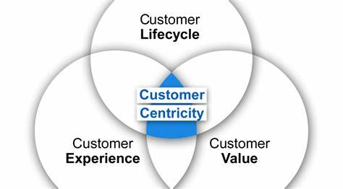

Customer Loyalty v’s satisfaction

A customer's attitude towards a brand, service, or product is gauged by their level of customer satisfaction. A customer satisfaction survey that uses a numerical scale is typically used to measure it. Customer loyalty is a collection of attitudes and behaviors that customers display to show their commitment to a product, service, or brand. Examples include making repeat purchases or preferring the brand over a rival.
A customer's level of happiness with a support encounter or a transaction is measured by their customer satisfaction. On the other side, maintaining customer loyalty requires constant effort. Over time, repeat business comes to a corporation from its loyal clients. It is a long-term assessment of the status of your customer connection rather than a short-term measurement.

Customer Relationship 5 stages

It essentially follows five stages throughout a customer's life:
- Reach
- Acquisition
- Conversion
- Retention
- Loyalty/Advocacy
Customers who have been successfully led through these five stages will become passionate brand evangelists.
Stage 1 Reach
At this step, you contact a potential customer and initiate some kind of informal initial contact.
In this phase, the following things happen:
- Advertising
- Social Media
- Search Engine Optimization
- Word of Mouth
Basically anything that brings you, your website, or your brand in front of a prospective buyer or seller.
Stage 2 Acquisition
You currently have a potential customer who is intrigued, and you are initiating your first formal contact with them. Now that you have their attention, you need to leave a lasting impression. You will lose their business if you don't offer good customer service or do something that damages their opinion of you at this point. If you don't promptly respond to emails or phone conversations, the prospect will go on and you'll lose their interest. Keep in mind that the person is probably also reaching out to other agents. This is the time to shine and prove that you are superior than everyone else.
From the perspective of digital marketing, if you have an issue, such as a poor website, you'll also lose the customer.
Stage 3 Conversation
Here is where you close the deal. All of your sales training will now be put to use. You'll need to put in a lot of effort, establish rapport, and get people to agree with you. Most people find selling or buying a property to be somewhat frightening. It's your responsibility to make things as simple as you can for them, hopefully selling for as much as you can or negotiating the best possible price.
Stage 4 Retention
Even after the sale, your job isn't done, and here is your chance to differentiate yourself from the majority of other agents in the field. You should make every effort to keep the consumer as a customer throughout the retention stage. Maintaining an existing client is always simpler and less expensive than trying to find new ones. Sending annual holiday cards or a small gift for your client's new house are both wonderful methods to develop and sustain ties with your clients.
You have the ideal chance to solicit input at this point as well. Find out what you can do to improve the experience for potential customers and how to forge closer bonds with your current customers.
Stage 5 Advocacy
With every client, this should be your ultimate objective. At this point, you've captured the client's interest, left a lasting impression, closed the deal, and delivered first-rate service. Your client is now a devoted friend and an advocate for your company. They'll recommend you to their friends and spread the word. Additionally, this is your chance to gather endorsements and testimonies.

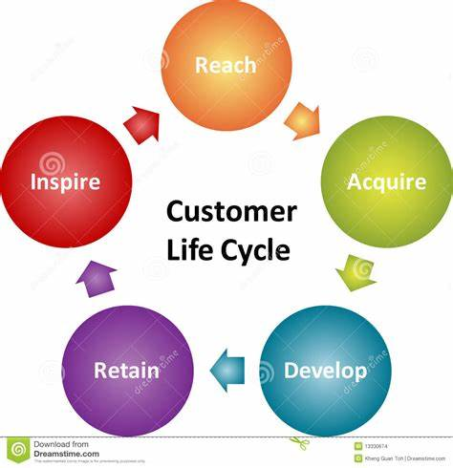

Customer Requirements

Customer requirements are the particular qualities or traits that a product should have in order to meet the customer's expectations for quality and value and be useful and appealing to them. These are fluctuating expectations that are constantly changing along with the periods, generations, technology, and trends.
Customer requirement Levels
The required levels are always changing. With time and client behavior, these numbers would continue to alter. A demand at one level may shift to a higher level depending on the competitive environment and market developments.
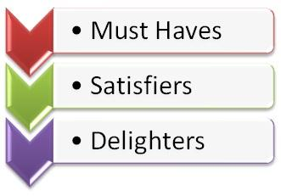
Must Haves or Expected
In the absence of certain functional requirements, the consumer won't accept the goods. Customers will express discontent if their needs are not met, but they won't express any unusual gratitude if they are. The clients expect this to be understood even when they don't voice their desires for things openly. Take a toilet at a restaurant as an example. Families or individuals from business organizations will feel that it is essential to have a loo in a respectable restaurant.

Good to have or Satisfiers
There are the specifications that clients clearly state they want. Customers will be more appreciative and satisfied if you provide better or more of these satisfaction. For instance, the assortment of sweets at a buffet could make the consumers feel entitled to at least two since they paid a lot for the buffet and happier if they get four.
Beyond Expectation or Delighters
These are the extra features that the customer may or may not have anticipated. The customer won't be unhappy if these are missing. In fact, it's possible that their absence won't even be noticed. But include these would considerably boost customer satisfaction and make them very happy. For instance, if you order a-la-carte and receive a free drink at a restaurant. The necessities that are luxuries now can become necessities in a few years.

Hierarchy of emotional value
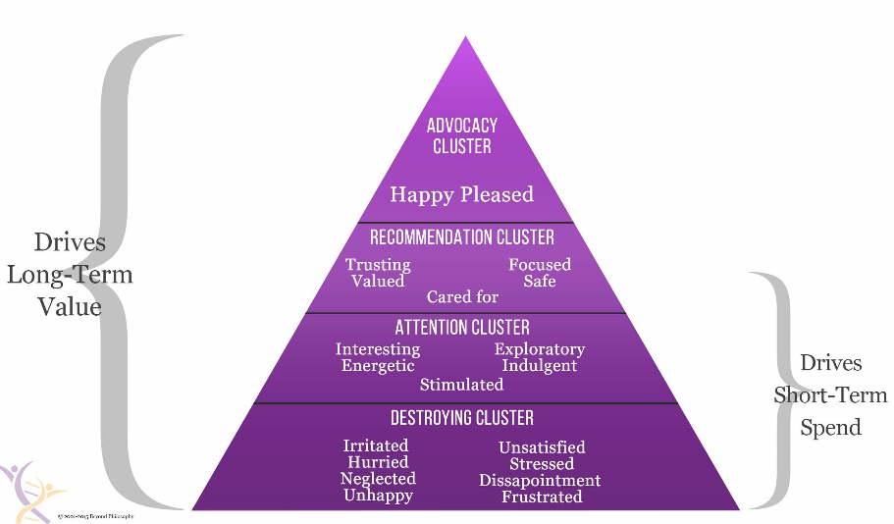
The baseline model revealed 20 emotions, which is categorized into four clusters that both create and detract from the value of an organization. The Hierarchy of Emotional Value is what it’s called. Your level of emotional involvement with clients, which we describe to as a "Emotional Signature," is measured using the Hierarchy of Emotional Value. Whether or whether it is intentional, every company has an emotional signature.

A significant portion of the client experience is emotional. A business's value is driven or destroyed by emotions, often in subtle ways. Emotions impact our desire to purchase or refrain from purchasing, the products we select from a company's inventory, the memories and stories we tell about the experience, and, probably most crucially, our level of brand loyalty.
- Advocacy Cluster
- Recommendation Cluster
- Attention Cluster
- Destroying Cluster

The Advocacy Cluster, which consists of just two emotions—Happy and Pleased—is essential to a customer’s experience. People are constantly looking for more happiness because they rarely believe they have enough of it already. A satisfying customer experience should include fixes or treats that make experience participants feel these important feelings.

Cluster of recommendations, Trusting, Valuing, Caring, Focused, and Safe are members of this group. The roots of client loyalty lie in these feelings. Additionally, they serve as the entry points that let you reach the Advocacy Cluster at the top of the pyramid.

The Attention Cluster is made up of the five emotions of Interest, Energy, Stimulation, Exploration, and Indulgence. The only group of emotions that directly influence short-term spending is this cluster. However, if you don't regularly take care of these emotions, this effect will dwindle and might even backfire.

Another crucial list of emotions is The Destroying Cluster, albeit it is a list you should try to stay away from. Irritated, hurried, neglected, unhappy, dissatisfied, stressed, disappointed, and frustrated are among the emotions that are included. Any of these emotions that are evoked during the customer experience may cost you money in the form of declined sales, missed opportunities, and increased expenses for resolving the ensuing issues. In addition, they are the only emotion group that has effects on short-term expenditure, albeit indirectly compared to the Attention Cluster.

Quality

Assuring that given goods and services, as well as the methods used to deliver them, are consistent is done through quality management, which is the process of supervising various operations and tasks inside an organization. It aids in establishing and maintaining the appropriate standard of quality within the organization. Quality Management consists of four key components, which include the following:
- Quality Planning - Determining which quality criteria apply to the project and determining how to meet them.
- Quality Improvement -The deliberate modification of a procedure to increase the certainty or dependability of the result.
- Quality control - Maintaining a process's dependability and integrity as it works to produce results.
- Quality Assurance - The organized, methodical processes required to provide enough dependability for a service or product to fulfil the needs.
The most widely used and recognized quality management system standard in the world is ISO 9001:2015. Organizations can use the specifications for a QMS in ISO 9001:2015 to create their own programs.

Garvins Eight dimensions of Quality

David A. Garvin, formerly the C. Roland Christensen Professor of Business Administration at Harvard Business School, identified eight aspects of quality that can be utilized strategically to examine the qualities of a product.
The eight dimensions of Garvin can be summed up as follows:
- Performance: Individual components of brand performance may typically be evaluated objectively.
- Features: Features are extra qualities that increase the user attractiveness of a product or service.
- Reliability is a crucial factor for users who depend on the product to always function properly.
- Conformance: Did the product come out exactly how the designer had envisioned? Customers frequently connect excellent quality with a product that perfectly fulfils their needs.
- Durability: A product's durability refers to how long it will last. It is more difficult to estimate durability when the product is repairable. The object will be used until doing so becomes uneconomical. This occurs when both the cost of repairs and the repair rate drastically rise.
- Serviceability: Serviceability is the efficiency with which a product can be repaired after a malfunction, as well as the skill and demeanor of the repair personnel.
- Aesthetics: This is the typical attractiveness of the product, frequently accounting for elements like style, colour, alternative packaging, and other sensory qualities. i.e., those that possess the essential elements of the competition's performance.
- Perceived Quality: According to indirect measurements, perceived quality refers to the standard of excellence placed on a good or service.

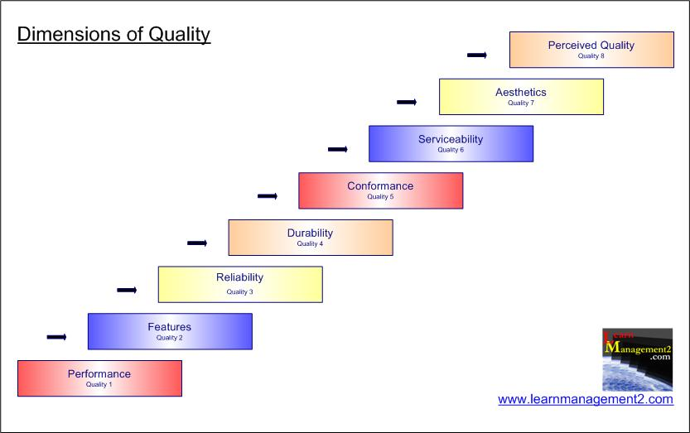

Kano Model

Noriaki Kano created the Kano model, a theory for product creation and consumer satisfaction, in the 1980s. It divides client preferences into five groups.
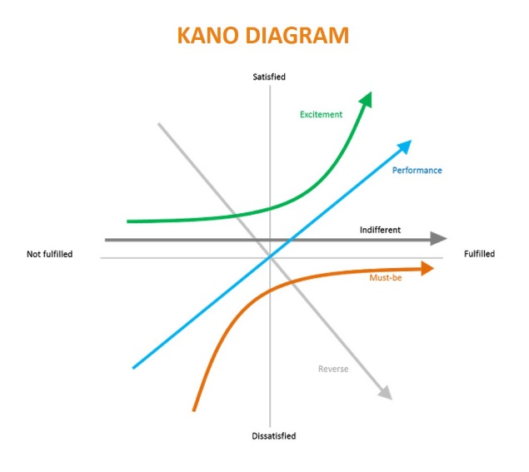

The five categories are as follows:
- Must be Quality
- One dimensional Quality
- Attractive Quality
- Indifferent Quality
- Reverse Quality
The performance of competing items also changes as consumer expectations do. From a delighter to a performance demand and finally to a basic need, attributes can change.
For instance, a mobile phone charge in 2009 would last for 12 hours. The 12-hour battery life feature has gone from being a delighter to being less than a basic need as each new generation of mobile phones has increased battery life.

Ways to improve process

The Plan-Do-Check-Act cycle is a model for implementing change, briefly explained. It is a crucial component of the Lean manufacturing concept and a necessary condition for ongoing advancements in both people and procedures.
The PDCA cycle was initially put forth by Walter Shewhart and later developed by William Deming. It has now become a widely used paradigm for ongoing improvements in management, manufacturing, and other fields.
Teams can prevent repeating errors and enhance processes with the straightforward four-stage PDCA approach.
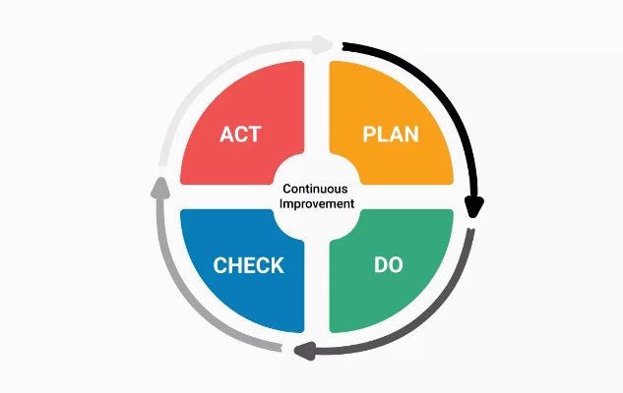

Lean Thinking

Lean is a way of looking at value creation that uses fewer resources and produces less waste. Lean is a technique that involves constant experimenting to produce perfect value with no waste. Together, lean thinking and practices take place.
The work that is done and the individuals who perform it are the foundation of lean practices. These acts both directly and indirectly produce value for the client. Workers and management learn through continuous experimenting through innovating in their work, whether it is knowledge or physical labor, for progressively greater quality and flow, less time and effort, and lower cost. Because lean thought and practice foster systematic and continuous learning, an organization that practices lean is, in comparison to its peers, highly adaptive to its ever-changing environment.
There are 5 key principles of lean they are:
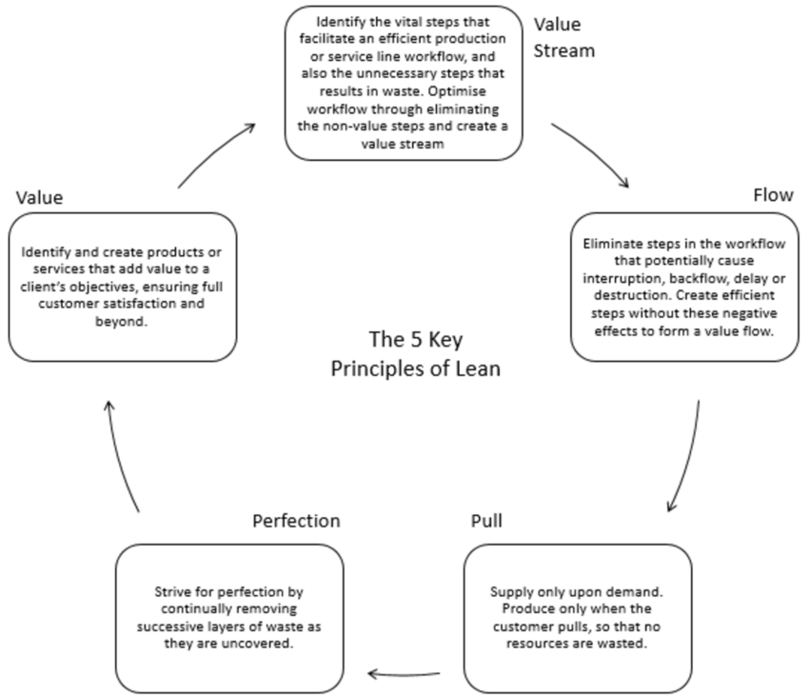
- Describe what, in the eyes of the customer, adds value.
- List each step along the entire value stream.
- Encourage the flow of acts that add value.
- Only produce what the buyer pulls precisely in time
- Pursuing perfection through the ongoing removal of layers of waste.

7 Wastes

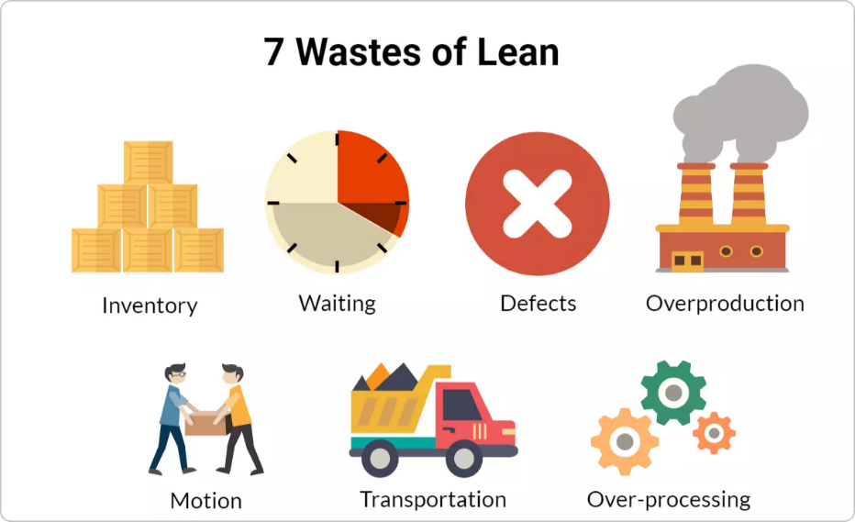
- Overproduction: Producing more than is actually required by the following procedure or client. The most harmful kind of waste since it fuels the other six.
- Waiting: Operators are waiting while machines run, equipment breaks down, necessary components don't show up.
- Motion: Operator movement, such as searching for components, tools, or papers, that is strenuous or needless
- Processing: The act of carrying out unneeded or erroneous processing, generally as a result of poor instrument or product design.
- Inventory: Possessing more stock than is required for a carefully managed pull system.
- Defects: Inspection, rework, and scrap.
- Transportation: Transporting components and goods unnecessarily, such as from a processing step to a warehouse to another processing step when the second step might be put right next to the first step.
In my current role as a receptionist we waste a lot of time scanning customer information on the system and then filing them away. I have come up with a way to improve this my implementing iPad’s with these customer forms on. This will save time and increase production.

Conclusion

The study's findings support the notion that customer value is positively influenced by consumer psychology and service excellence. Making consumers and customers feel at ease will result from focusing on the ideal service component, which will increase customer value. Although loyalty is greatly and favorably affected by customer value. More favorable consumer loyalty to the company's products will result from increased customer value. As a result, if a customer pays a high price but only receives a limited number of benefits, their loyalty will be affected.

References

Admin, R. (2021, September 18). The 5 stages of customer life cycle management. Retrieved April 25, 2023, from https://www.realtydigitalmarketing.com/customer-life-cycle-mangement/
Customer influence value and purchase acceleration in new product diffusion. (n.d.). Retrieved April 24, 2023, from https://www.researchgate.net/publication/256036441_Customer_Influence_Value_and_Purchase_Acceleration_in_New_Product_Diffusion
Eight dimensions of Quality. (2023, February 16). Retrieved April 27, 2023, from https://en.wikipedia.org/wiki/Eight_dimensions_of_quality
Hargrave, M. (2022, October 02). What is CRM? customer relationship management defined. Retrieved April 20, 2023, from https://www.investopedia.com/terms/c/customer_relation_management.asp

"Kano Model of Customer Satisfaction - Attributes of Kano Model | Business Blog". Archived from the original on 8 July 2012. Retrieved 29 April 2010.
Lean manufacturing principles (Womack and jones, 1996). (n.d.). Retrieved April 27, 2023, from https://www.researchgate.net/figure/Lean-Manufacturing-Principles-Womack-and-Jones-1996_fig1_330934998
Maza, C., & Writer, C. (2023, April 17). What is customer value? definition, formula & importance. Retrieved April 18, 2023, from https://www.zendesk.co.uk/blog/customer-value/#georedirect
Shaw, A. (2021, January 02). What is brand value? - definition, factors & calculation. Retrieved April 24, 2023, from https://www.marketingtutor.net/what-is-brand-value/#:~:text=Brand%20equity%20is%20the%20perceived%20value%20of%20a,brand%20because%20more%20people%20would%20talk%20about%20it.
Shaw, C. (2022, January 14). The 20 emotions that drive or destroy value in customer experience. Retrieved April 25, 2023, from https://www.mycustomer.com/customer-experience/engagement/the-20-emotions-that-drive-or-destroy-value-in-customer-experience
The factors that affect customer value and its impact on ... - researchgate. (n.d.). Retrieved April 18, 2023, from https://www.researchgate.net/publication/329964833_The_Factors_That_Affect_Customer_Value_and_Its_Impact_on_the_Customer_Loyalty
What is customer value and how can you create it? (n.d.). Retrieved April 19, 2023, from https://journals.sagepub.com/doi/full/10.1177/2394964320903557
What is customer lifetime value (CLV) ? (2021, November 23). Retrieved April 20, 2023, from https://www.qualtrics.com/uk/experience-management/customer/customer-lifetime-value/?rid=ip&prevsite=en&newsite=uk&geo=GB&geomatch=uk
What is plan-do-check-act (Pdca) cycle?: Kanbanize. (n.d.). Retrieved April 28, 2023, from https://kanbanize.com/lean-management/improvement/what-is-pdca-cycle
What are the 7 wastes in lean? (2022, May 26). Retrieved April 27, 2023, from https://www.lean.org/lexicon-terms/seven-wastes/
What is lean?: Lean thinking. (2023, January 27). Retrieved April 27, 2023, from https://www.lean.org/explore-lean/what-is-lean/

