

Assessment 1
Supporting Paper

Student name: RUTH SENE
Student ID: 2029258
Module name: Mental Disorders and Psychopathology
Module code: BMHP6006
Lecturer name: Bianca Sanfilippo

Contents

Introduction 2
Mental Health Disorder in the UK 2
PTSD within the ICD-10 Manual 3
Evolution of PTSD Diagnosis and Treatment 4
Current treatments (NHS) 5
Principles when working with people with PTSD 6
Recommendations for the improvement of the symptoms 6
Conclusion 7
References 8
Appendix 10

Introduction
The significance of mental health has grown exponentially in the pursuit of sustainable development in global healthcare. Considering the many variables that contribute to the deterioration of persons' mental health worldwide, it is crucial to thoroughly evaluate the current therapy and tactics used to address these health concerns. This may lead to a global increase in understanding and awareness of mental illness, along with more technical knowledge on how to effectively address these conditions and support those impacted by them, whether they are directly or indirectly affected. This is particularly significant in view of the findings from a study conducted by the World Health Organisation (2022a), which indicate that out of every eight individuals worldwide, one person is affected by a mental condition.

Mental Health Disorder in the UK
According to the WHO (2022a), mental illness refers to a substantial disruption in an individual’s behaviour, emotional regulations, and cognition, deemed to be clinically significant. In so saying, it is typical of a person suffering from a mental health disorder to also experience some form of impairment in one or more important areas of everyday functions, and to experience emotional distress. Based on the results of research conducted by the WHO (2022a), it has also been found that of every eight (8) persons in the world, one (1) is living with a mental disorder.
More specific to the context of the UK, however, is the Survey of Mental Health and
Wellbeing in England (Baker, 2021), which found that of every six persons aged 16 years or older, one would have experienced the symptoms of a common mental health problem, with women being more susceptible. The study showed that, in England, the prevalence of mental illness, regardless of the form it takes has increased since 1993. Of the survey conducted, 4.4% of the respondents were deemed to have suffered from PTSD.

PTSD within the ICD-10 Manual
The ICD-10 manual, by its very nature, seeks to collect, process and classify the information available on the diseases and therefore seeks to provide clear and precise information on the status of technical medical expertise throughout the world. From this point, a combined effort can be employed to ascertain the best treatment methods to be meted out to those in dire need of medical intervention. Having defined what a mental health disorder is, one now looks at the classification of PTSD within the scope of the manual.
Post-Traumatic Stress Disorder is an anxiety-based mental and behavioural disorder produced by frightening, stressful or otherwise distressing incidents. Additionally, PTSD may occur in days, weeks or, in some cases, even years after the disturbing event has taken place. The WHO (2022b) has indicated that, within the ambit of the ICD-10, PTSD is covered in section F43.1 beneath the Neurotic, stress-related and somatoform disorders section, which occupies F40 through to F48. To further contextualize, it must be noted that the National Institute for Health and Care Excellence, or NICE (2018), has proffered that approximately a third of those who have been subjected to traumatic experiences have been affected, or continue to be affected, by PTSD.

Post-Traumatic Stress Disorder (PTSD)
According to the UK's National Health Service (NHS, 2021), individuals suffering with PTSD often have recurring dreams and flashbacks of the traumatic incident. They also often feel irritable, alone, and guilty. These worries may be mentally exhausting and often lead to the emergence of other physical issues such as impaired concentration and sleeplessness. Furthermore, the related symptoms are often intense and enduring, particularly in terms of their effect on an individual's everyday activities.
Regarding the potential causes of PTSD, MIND (2021) said that many traumatic experiences might result in a diagnosis of PTSD. The events included in this category are (i) acts of torture, warfare, and other forms of conflict; (ii) severe vehicle accidents; (iii) the process of childbirth; and (iv) violent attacks, such as rape, robbery, and violence. The validity of MIND's statement is supported by the NHS, which further suggests that although traumatic events and experiences have a significant impact on the mental well-being of all those involved, this impact persists. unclear why some individuals develop PTSD from the situation witnessed and others do not develop the condition.

Evolution of PTSD Diagnosis and Treatment
As time progressed and technological innovations and revolutions took place, the evolution of PTSD diagnosis and treatment could be clearly examined, thus identifying possible ways to treat the condition, or at the very least it’s most debilitating symptoms. It is against that backdrop that ancient stories, according to Crocq & Crocq (2000) revealed tales of post-battle trauma and flashback-like dreams as documented by Hippocrates between 4607 and 377BC. By the 1800s however, the term “battle exhaustion” or “soldier’s fatigue” were coined to capture the “hysterical attacks” that would have been noted to occur in military personnel years after their involvement of witnessing of a traumatic event. Moving into the time of the first World War (WWI) a new term, “shell shock”, came into being and subsequently brought into medical literature by the 1950s. At this point in time, the term as included in the medical journals describes the same symptoms of what is modern day PTSD.
It is at this juncture that treatment options for PTSD (as we know it today) were being determined. At the onset, to treat “shell shock”, a range of medical practices and procedures were deemed to provide some relief of the symptoms being experienced. These included psychoanalysis (to determine the interactions between the conscious and subconscious mind in mentally unwell patients), as well as more drastic measures including electric shock. As the years went by, treatment options became more humane in nature. There, however, presented a constraint to the successful implementation of treatment, according to Stupak & Dobrocozynski (2021), given that patients would wilfully ignore the presence of trauma so as to avoid being stigmatized as a result of suffering from a mental illness. PTSD became official in the 1980s by way of the American Psychological Association through its inclusion in the Diagnostic and Statistical Manual of Mental Disorders, or DSM.

Current treatments (NHS)
Upon closer examination of the development of treatment procedures, it is important to acknowledge the significant changes that were seen in the selected possibilities. After first resorting to intrusive and painful methods like trepanation (creating a hole in the skull) and electroshock therapy, the treatment practices for this ailment saw a significant transformation with the acquisition of more information.The current approach to treating PTSD largely involves:
1. Medication - Antidepressant medicines have been extensively studied as a treatment for PTSD and are generally successful in managing symptoms such as sorrow, rage, and other PTSD symptoms (Giller, 1990). Selective serotonin reuptake inhibitors (SSRIs) are the most often prescribed class of antidepressants due to their relatively lower incidence of adverse effects. Simultaneously, these drugs may induce gastrointestinal haemorrhaging. Dizziness, along with additional adverse effects (PTSD UK, 2014).

Complementary and alternative medicine (CAM) is a therapeutic approach that involves less disclosure of the traumatic experience by the patient compared to psychotherapy. It also helps to avoid the potential adverse effects that are connected with pharmaceutical therapies. Presently, there is a lack of agreement about the most appropriate complementary and alternative medicine (CAM) technique. Nevertheless, healthcare professionals have noted favourable results in the condition of patients with post-traumatic stress disorder (PTSD) via the use of acupuncture, meditation, yoga, deep-breathing exercises, mind-body therapy, and tai chi (Song et. al., 2020).

Psychotherapy and cognitive behavioural therapy (CBT) are forms of talk therapy that may be conducted on an individual basis or in a group setting, depending on the patient's option (National Institute of Mental Health, 2019). Research has shown that a significant proportion of individuals with PTSD, ranging from 60% to 82%, achieve full recovery while engaging in Cognitive Behavioural Therapy (CBT). However, the extent of improvement is greatly influenced by factors such as the level of exposure to the traumatic event, the length of the incident, and other related variables.

Principles when working with people with PTSD
In light of the historical developments of PTSD, it is also noted that certain underlying principles have been identified when interacting with PTSD patients. These, according to NICE (2018) include:
- building trusting relationships or the employment of a person-centred approach
- involving service personnel
- gaining an awareness of discrimination and stigmatization
- ensuring privacy, confidentiality and dignity
- Respecting policy and legislation, including the Mental Health Act, the Human Rights Act, and the Equality Act of 2010.

Recommendations for the improvement of the symptoms
Having carefully examined the information presented as it relates to PTSD and its evolution in treatment and diagnosis, as well as having accounted for PTSD in the context of the UK, it is recommended that adherence to the treatment guidelines, as provided by NICE (2018), are maintained. Given the issues that discrimination and stigmatization have presented, impeding the provision of effective treatment, special consideration should also be given to eliminating instances of its occurrence.

Conclusion
In conclusion, the consideration afforded to mental health in the United Kingdom has seen significant developments throughout history, as reflected in the evolution of PTSD and its treatment. These developments can be attributed to the ICD-10 Manual which laid the foundation upon which further research could be conducted with respect to the signs/symptoms, diagnosis and treatment methods that would be deemed feasible. This in turn, has proffered great benefits as UK citizens can be afforded a better chance of leading a life of “normalcy”, despite the afflictions of mental disorders such as PTSD.

References
Baker, C. (2021). Mental Health statistics: prevalence, Services and Funding in England. commonslibrary.parliament.uk. [online] Available at: https://commonslibrary.parliament.uk/research-briefings/sn06988/. [Accessed 16 August 2022]
Crocq, M.-A. & Crocq, L., 2000. From shell shock and war neurosis to posttraumatic stress disorder: a history of psychotraumatology. Dialogues in Clinical Neuroscience, March, 2(1), pp.
47-55.
Gan, K. L. Post Traumatic Stress Disorder PTSD signs and symptoms. [Online] Available at: https://www.alamy.com/post-traumatic-stress-disorder-ptsd-signs-and-symptoms-illustrationsdepict-man-with-post-traumatic-stress-disorder-facing-difficulty-in-life-and-menimage240732267.html
Gaston, L. 2017. Limitations of Trauma-Focused Therapies for Treating PTSD: A Perspective.
[Online] Available at: http://www.traumatys.com/wp-content/uploads/2017/09/Limitations-ofTrauma-Focused-Therapies-Gaston-2017.pdf [Accessed 15 August 2022].
Giller, E., 1990. Biological Assessment and Treatment of Posttraumatic Stress Disorder.
Washington DC: American Psychiatric Press, Inc..
MIND. 2021. Post-traumatic Stress Disorder (PTSD). [Online] Available at: https://www.mind.org.uk/information-support/types-of-mental-health-problems/post-traumaticstress-disorder-ptsd-and-complex-ptsd/symptoms/ [Accessed 16 August 2022].
National Institute of Mental Health, 2019. Post-Traumatic Stress Disorder. [Online] Available at: https://www.nimh.nih.gov/health/topics/post-traumatic-stress-disorder-ptsd [Accessed 15 August 2022].
NHS, 2022. Overview- Post-Traumatic Stress disorder. [Online] Available at: https://www.nhs.uk/mental-health/conditions/post-traumatic-stress-disorder-ptsd/overview/ [Accessed 16 August 2022].
NHS, 2022. Treatment - Post-traumatic stress disorder. [Online] Available at: https://www.nhs.uk/mental-health/conditions/post-traumatic-stress-disorder-ptsd/treatment/
[Accessed 16 August 2022]
NHS, 2022. Symptoms - Post-traumatic stress disorder. [Online] Available at: https://www.nhs.uk/mental-health/conditions/post-traumatic-stress-disorder-ptsd/symptoms/ [Accessed 16 August 2022].
NHS (2021). Post-traumatic stress disorder. [online] nhs.uk. Available at: https://www.nhs.uk/mental-health/conditions/post-traumatic-stress-disorder-ptsd/overview/ [Accessed 16 August 2022]
NICE, 2018. Post-traumatic stress disorder NICE guideline [NG116]. [Online] Available at: https://www.nice.org.uk/guidance/ng116 [Accessed 15 August 2022].
PTSD UK. 2014. Medication for PTSD. [online] Available at: https://www.ptsduk.org/medicationfor-ptsd/ [Accessed 11 July 2022].
PTSD UK. 2022. Cognitive behavioural therapy (CBT) [online] Available at:
https://www.ptsduk.org/treatment-help/cognitive-behavioural-therapy-cbt/ [Accessed 11 July 2022].
Song, K. et al., 2020. Complementary and alternative therapies for post-traumatic stress disorder: A protocol for systematic review and network meta-analysis.. Medicine (Baltimore), 99(28), p. e21142.
Stupak, R. & Dobroczyński, B., 2021. From Mental Health Industry to Humane Care. Suggestions for an Alternative Systemic Approach to Distress. International Journal of Environmental Research and Public Health, 20 June.18(12).
Wahbeh, H., Senders, A., Neuendorf, R. & Julien Cayton, 2014. Complementary and alternative medicine for post-traumatic stress disorder symptoms: A systematic review. Evidence-Based Complementary and Alternative Medicine, 19(3), pp. 161-175.
WHO, 2022a. Mental disorders. [Online] Available at: https://www.who.int/news-room/factsheets/detail/mental-disorders [Accessed 15 August 2022].
WHO, 2022b. Mental and Behavioural disorders. [Online] Available at: https://icd.who.int/browse10/2010/en#/F43.1[Accessed 15 August 2022].

Appendix




Post
-
traumatic
Stress Disorder
(
PTSD)
STUDENT
NAME: RUTH SENE
STUDENT ID
:
2029258

MENTAL DISORDERS AND PSYCHOPATHOLOGY
(
BMHP6006_LON
)





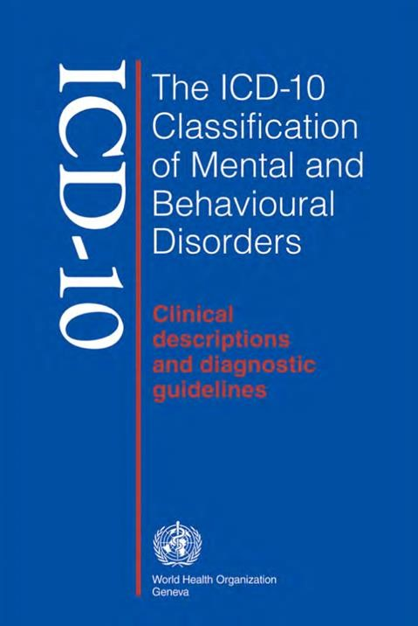
Introduction
◆
Defining Mental Illness
◆
What is PTSD?
◆
Causes of PTSD
◆
Symptoms/ Signs of PTSD
◆
Diagnosing PTSD
◆
Historical view and treatments for PTSD
◆
Current treatments
◆
Principles when working with people with PTSD
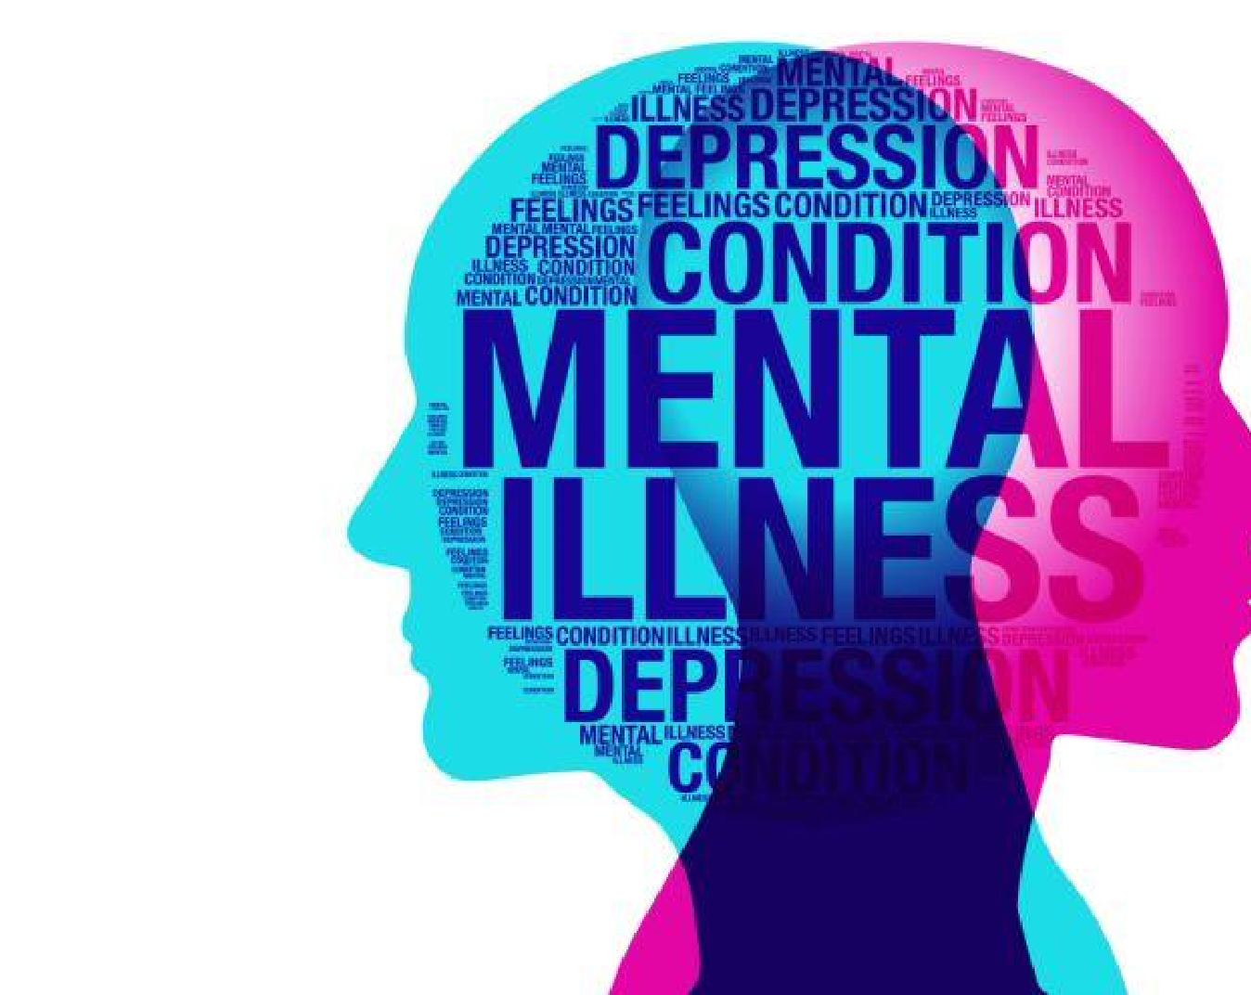
What is mental illness?
◆
A substantial disruption in of an individual’s
behaviour,
emotional regulations, and cognition that is deemed
clinically significant (WHO, 2022).
◆
Usually accompanied by an impairment of one or more
important areas of everyday functions, or emotional
distress.

What is PTSD?
◆
Post
-
traumatic
stress disorder
is an anxiety
-
based mental and behavioural
disorder produced by frightening, stressful or otherwise distressing incidents.
PTSD may occur days, weeks or even years after the disturbing event.
◆
It is
covered
in
section F43.1
of the International Classification of Disease
2010(
ICD
-
10
) manual
under the
Neurotic, stress
-
related and somatoform
disorders sections (F40
-
F48)
(
WHO, 2022b).
◆
Roughly a third of all persons who are subjected to traumatic experiences
are affected by PTSD (NICE, 2018).
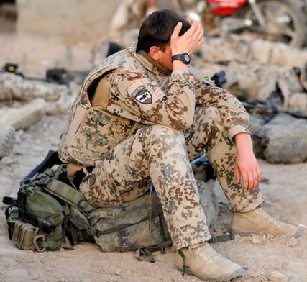
Causes of PTSD
◆
A wide range of distressing events can lead to PTSD,
including but not limited to:
◆
Torture, war and other conflicts
◆
Serious vehicular accident
◆
Childbirth
◆
Violent assaults, including rape, robbery and
battery (MIND, 2021)

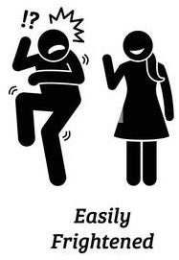

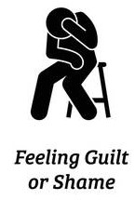
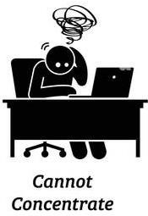
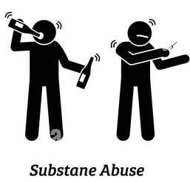
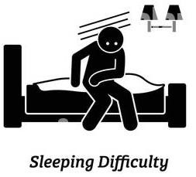
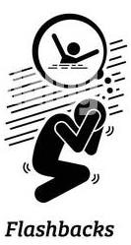
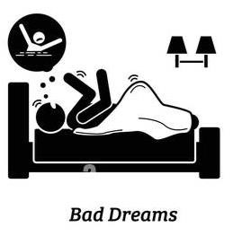
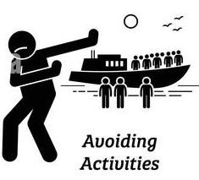
Symptoms/signs
of PTSD
(
Gan
, 2020)

Evolution of PTSD diagnosis and
treatment
◆
Ancient stories of post
-
battle trauma and flashback
-
like dreams were
documented
by Hippocrates (4607
-
377
BC
)

(
Crocq
&
Crocq
, 2000
)
◆
During the 1800s, it was known as
“
battle exhaustion” or “soldier’s fatigue
”
which is often characterized by
“hysterical attacks
” that sometimes take
place years after the traumatic event
◆
The term “shell shock” was introduced during World War 1 and was
brought into medical literature by the 1950s to describe the same
symptoms as PTSD.
◆
Treatment for shell shock ranged from psychoanalysis to drastic measures
such as electric shock
Evolution of PTSD diagnosis and
treatment (Cont’d)
◆
Treatments eventually became more humane, but patients would not
acknowledge their trauma in order to avoid the stigma associated with
mental illness during the
1950
s (Stupak &
Dobroczyński
, 2021)
◆
PTSD was officially described in
the Diagnostic and Statistical Manual of
Mental Disorders (DSM
)
by
the American Psychological
Association during
the 1980s
◆
During the 1990s, new PTSD treatments of various types emerged, including
newer medicines
, Eye
-
movement desensitization and reprocessing (
EMDR)
and new therapy approaches
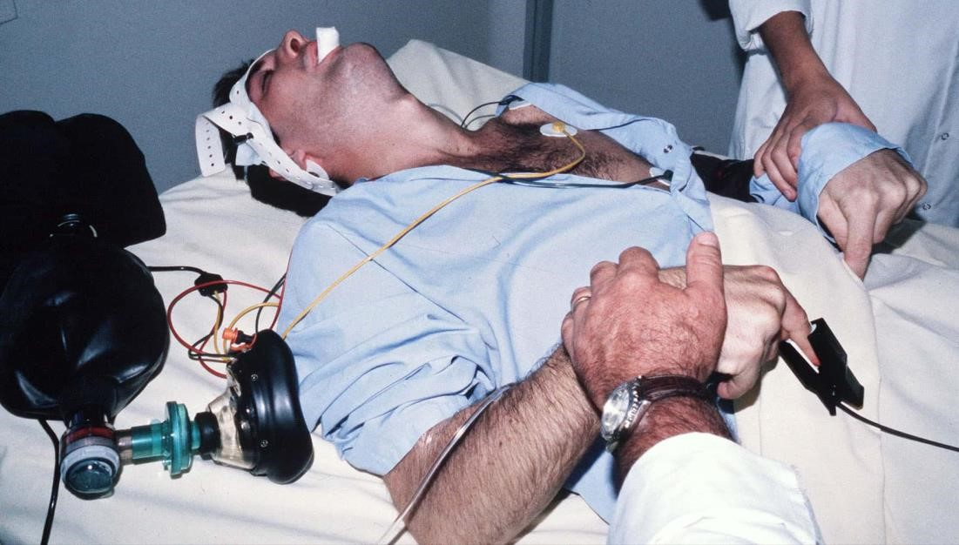

Historical Treatments
◆
Trepanation
-
surgical procedure
during which a hole is made in the skull
◆
Electroshock therapy


Historical Treatments (Cont’d)
◆
Hypnotherapy
◆
Solitary confinement
Modern Treatment
for PTSD
◆
Medications
◆
Antidepressant medication are the most researched means of treating PTSD, and are
generally effective at controlling anger, sadness, anxiety, and other symptoms of
PTSD (
Giller
, 1990
).
◆
Complementary therapy
◆
Acupuncture
,
meditation
, yoga, deep
-
breathing exercises, mind
-
body therapy, and
tai chi (Song, et al., 2020)
◆
Psychotherapy
◆
This is often referred to s talk therapy, and can be done on a one
-
on
-
one basis with a
health professional, or as part of a larger group
(
National Institute of Mental Health,
2019)
◆
Cognitive
behavioural
therapy (CBT)
◆
This method aims to treat PTSD patients by changing how they think and act (NHS
,
2022b)

Principles when working with people
with PTSD
◆
Several guiding principles have been put forward to be used in providing care
for persons with PTSD
(
NICE, 2018
):
◆
Build a trusting relationship/ person
-
centred
approach
◆
Involve service users
◆
Be aware of discrimination and stigma
◆
Ensure privacy, confidentiality and dignity
◆
Respect policy and legislation including Mental Health Act, Human Rights Act, and
Equality Act 2010
Recommendations and Conclusion
◆
In order to ensure
th
best possible outcomes for those suffering from PTSD, it is
important that health and social care practitioners:
◆
Adhere to the treatment guidelines set forth by NICE
◆
Provide care in a manner that does not stigmatise nor discriminate against those in need
of care
◆
Use complementary therapies
•
Repetitive transcranial magnetic stimulation (
rTMS
)
was found to be the most effective
complementary intervention, followed by acupuncture hypnotherapy
, meditation, and
visualization
(
Wahbeh
, et al., 2014)
.



