24/04/2026
UNIVERSITY OF WALES TRINITY SAINT DAVID
LONDON CAMPUS
Assignment 2
Professional Development Plan (PDP)

Module Name: Learning in the Digital Era
Module Code: ACCA 4025

Student Name: Mesfin Tezera
Student ID:2510889
Group:2

Lecturer’s Name: Koushik Modak

Video

https://youtu.be/lbf7DORCY68

Table of Contents
Introduction 2
Main Body 2
Conclusion 9
References 9

Introduction
Becoming a lifelong learner is a journey that connects personal growth with professional goals. By using structured frameworks and self-reflection, students can better understand their own strengths and build the skills needed for long-term success in a changing world.

Main Body
Video Presentation Link: https://youtu.be/lbf7DORCY68
Slide 1
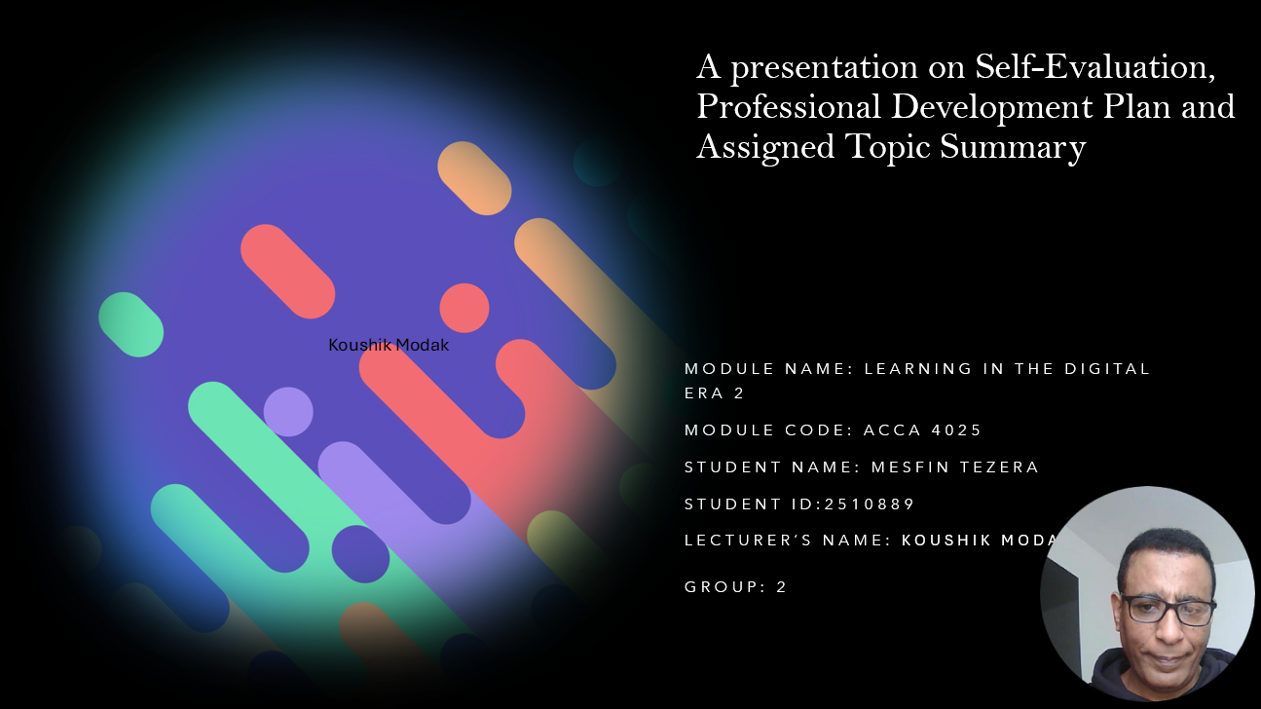

Slid 2
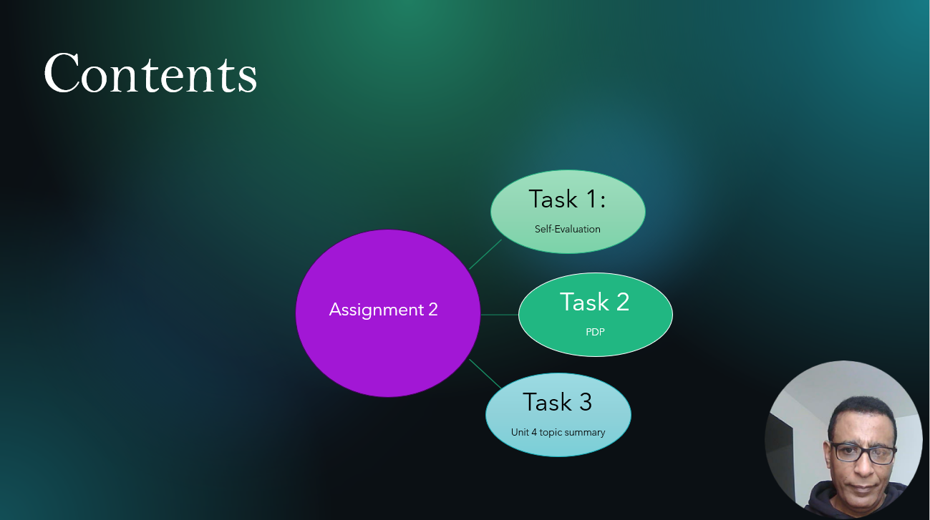

Slid 3

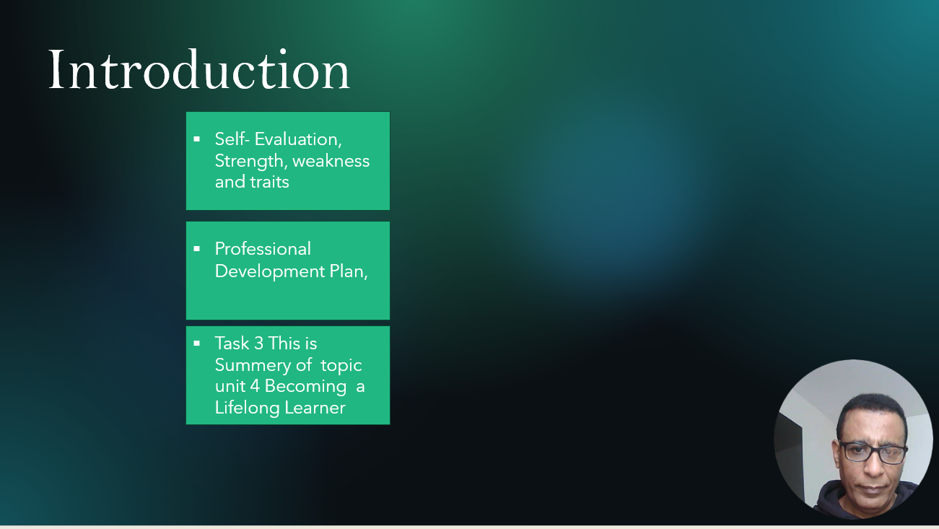

Slid 4

Slid 5
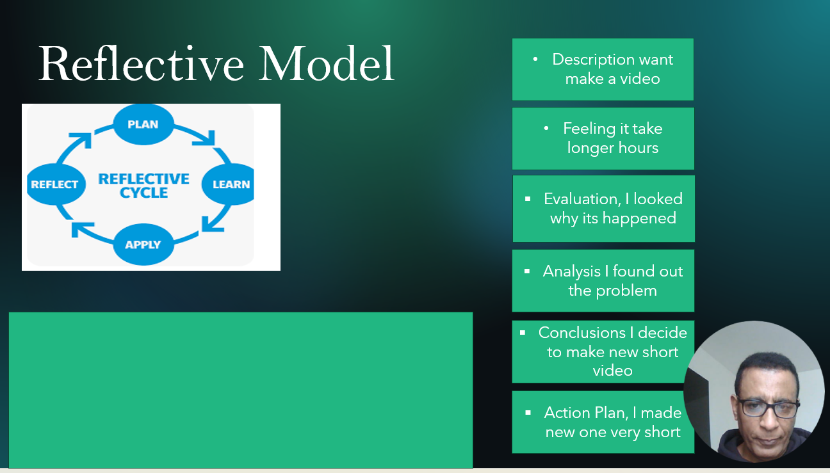
Image Reference Getting started with Reflective Practice
Brief Explanation: Describing about Gibbs' Reflective Cycle is a six-stage framework that helps people learn from an experience by thinking about what happened, how they felt, and what they would do differently next time.

Gibbs’ Reflective cycle is a very useful and systematic approach that helps student and professionals explore their experiences or literary works in a deep way. It was created to make sure, people do not just experience soothing and forget it but instead learn from it to became better in the future. When s student reads a book or story, they can use this cycle to connect the characters and themes to their own firsthand personal knowledge. This connection is important because it makes the lesson from the book feel real and relevant to daily life. The cycle is divided into stages that guide your thinking. First, you describe what happening during the event or what happened in the story. Then, think about your feelings during that time. You ask yourself if you wear happy, confused, or worried, after that, you evaluate the experience by looking at what well and what did not go so well. This leads to an analysis where you try to make sense of the situation by looking at why things happened the way they did. Once you understand the “Why” you can reach a conclusion about what else you could have done or what you learned about yourself. Finally, you create an action plan for the next time you face a similar situation.
By using this model consistently, learners can identify specific area where they need to grow. For example, student might realize through reflection that they are not very good at using modern technology. In a world that is always changing. Identifying a need for development, such as learning digital tools for a business career, is a major step toward success. Reflection alone is not enough, so student use their thoughts to create a roadmap for the future. To turn these deep reflections into a real reality, student set SMART goals. SMART stands for specific, miserable, Achievable, Relevant, and Time-bond. This farmwork helps a person avoid making vague promises to themselves. Instead of saying “I want to be better at computer “student might set a goal to finish a Perfessional Googol Data analytic course by the end of next month. This goal is specific because it names the exact course. It is measurable because you can see how many lesson are finished. It is achievable because it fits into a monthly schedule. It is relevant because it helps with a business career, and it is time -bond because there is a deal line. This level of plaining ensures that every student can see clear progress toward their professional success and keeps them motivated to keep going even the work gets difficult [1].

Slid 6
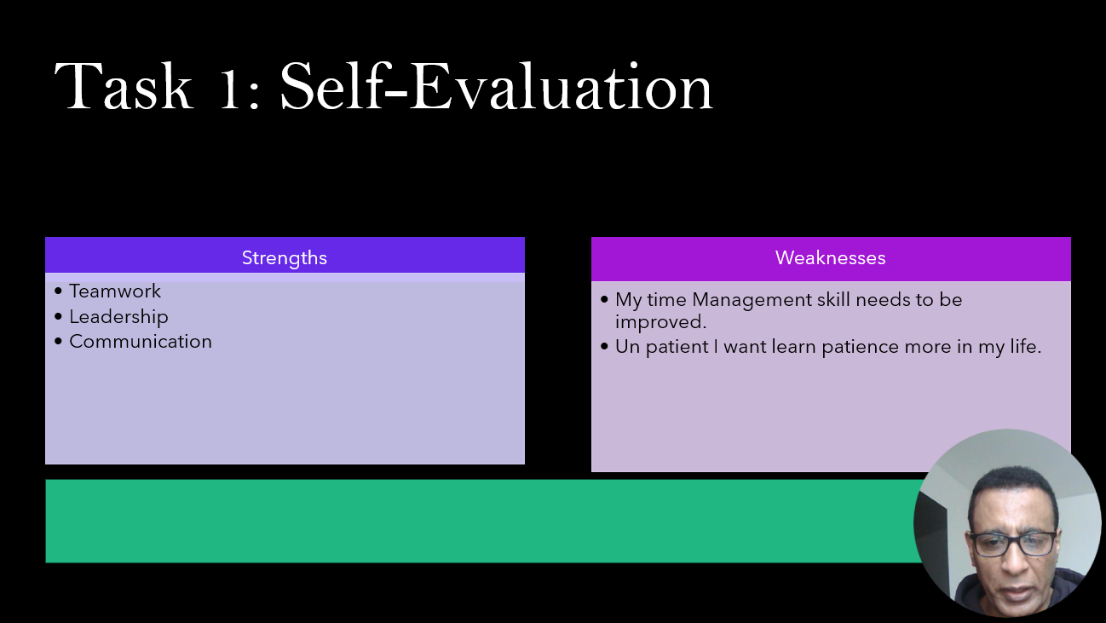
Slid 6: Self-evolution is lifelong process orientationally improving your skills, mindset, and habit to become a better version of yourself.

To become a successful lifelong learner, you must first start by knowing yourself on a very deep level. This is not soothing that happens overnight but is a continues process of discovery. Knowing yourself means understanding what makes you serious, what makes you frustrated, and what environment helps you work the best. This process requires building strong self-regulation skills. Self-regulation is the ability to control your own behaviour, emotions, and thoughts so that you can reach your long-term goals. It is the voice in your head that tells you to keep studying even when you want to watch television or play a game. To develop these skills, you must practice with real-world tasks. These are not simple tasks with easy answer found in a textbook, but challenges that force you to make your own decisions and face the consequence of this choice. When you work on soothing real, you learn how to manage your time and how to stay calm when things do not go as planned. This type of practice builds a sense of independence that is necessary for anyone who wants to keep learning through their entire life [2]

Slid 7
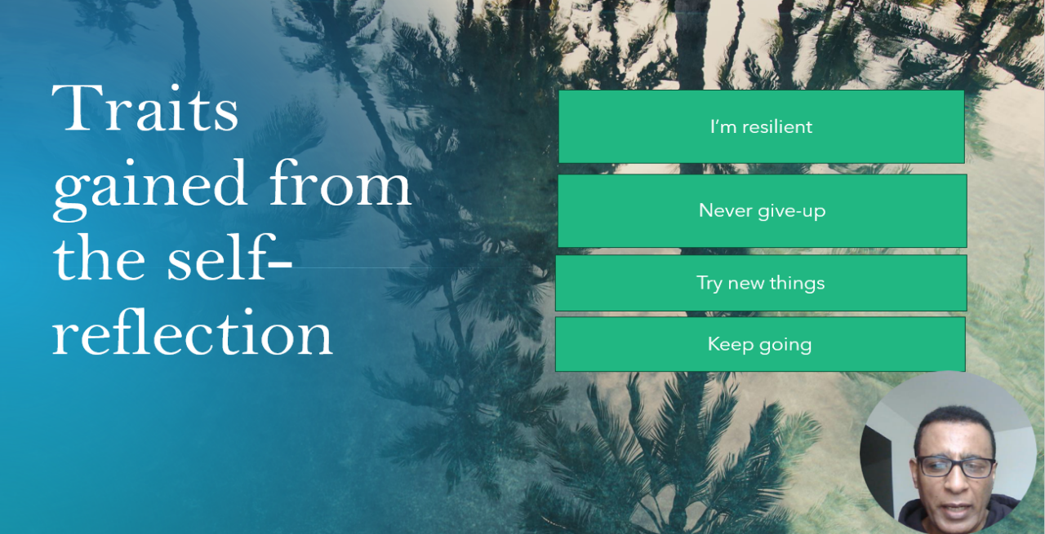
Slid 7: This is traits I gained from self-reflections deeper understanding of my own strength and weakness and which area I can make use for my development

Slid 8
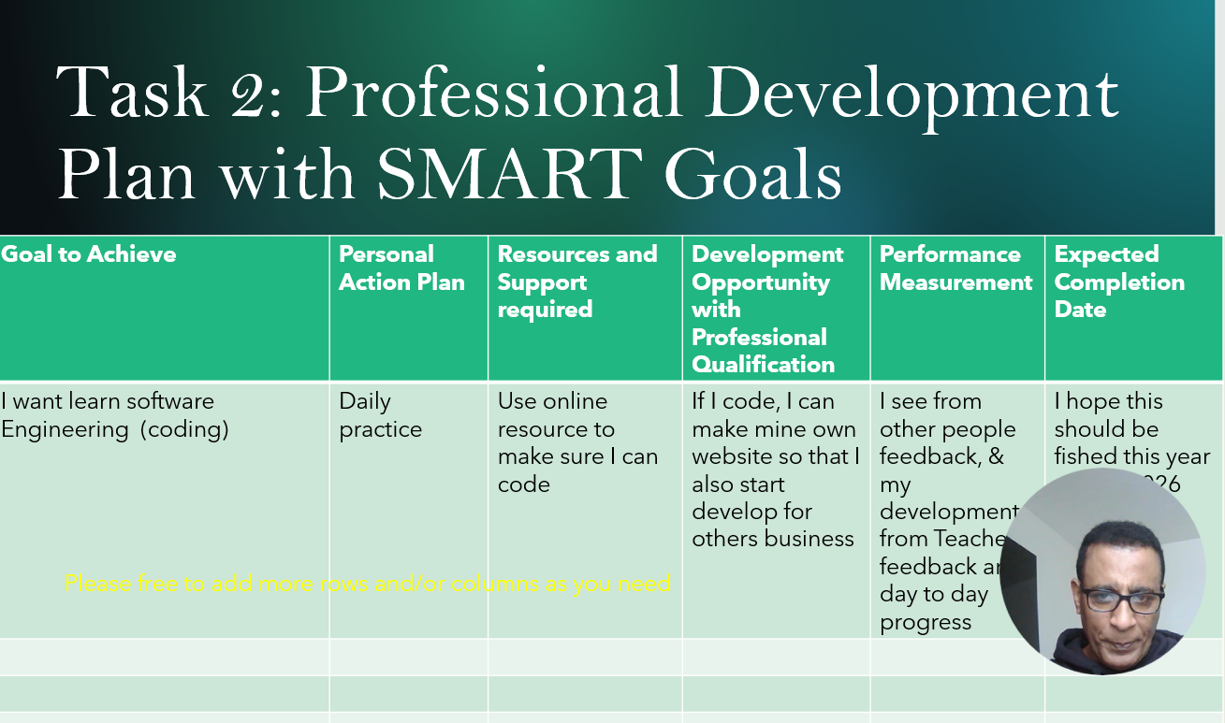
Slid 8: this is my professional Development plan which is I chosen to became Software Engineering and development of Websites when I complete my current course

Lifelong learning is a beautiful journey that begins with deep self-knowledge, which allows individuals to truly understand their personal strengths and their inner motivations. When you know why you are doing something, it becomes much easier to stay committed to the process. By developing self-regulation, a learner can set realistic goals and find the strength to overcome common obstacles like procrastination or fear of failure. This internal awareness is not something you keep hidden away; instead, it is supported by practicing critical thinking and creativity though authentic, real-world tasks that test your skills. These tasks act as a bridge between what you learn in a classroom and what you need to success in the real world. Every time you solve a problem or complete a project, you are building a stronger version of yourself.
Ultimately, a lifelong learner is someone who grows by making intentional and smart decisions every single day. They do not just let things happened to them, but instead, they take control of their path by using tools like Gibbs’ cycle to reflect on every experience. They engage with a community of other learners, sharing ideas and supporting one another in their mutual growth. This approach turns every life experience- whether it is a big success or a small mistake- into a valuable opportunity for personal and professional development. By combining the power can ensure that they never stop growing. This way of living ensures that you are always prepared for the future, no matter how much the world changes around you, because you have the tools and the mindset to adapt and thrive. [4]

Slid 9
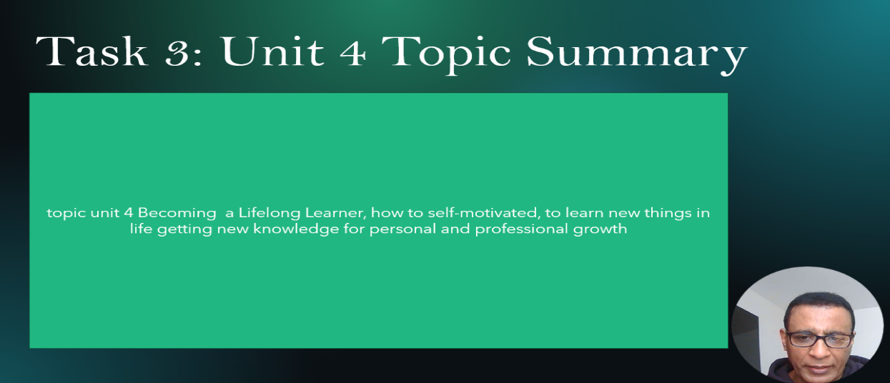
Slid 9: Becalming lifelong learning is part of personal development growth which everybody needs to develop interims to achieve their goals in long term

Summery

According to Fischer Gerhard, the traditional way of thinking about education has changed forever because we can no longer separate learning into two different boxes where one is for school and the other is for the office. In the past, people thought the school was only for gaining knowledge and the workplace was only for using it, but that old -fashioned idea does not work in our modern world. Today, every citizen is overwhelmed by a massive flood of information that is often too much for any one person to process or manage effectively. As we look Forword the future, it is becoming clear that worker will need to understand and access much more information than a single human brain could ever hope to remember or store.
Consequently, concept of lifelong learning has moved from being a nice option or a luxury for a few people to being an absolute necessity for everyone who want to help build a successful society. It is important to realize that lifelong learning is not just another name for adult classes or basic job training; instead, it is a special mindset and a permanent habit that people must develop throughout their entire lives. This shift forces us to explore new ways of gaining knowledge, such as teaching ourselves, learning exactly what we need now what we need it, working together in group, and sharing knowledge within large organizations.
Who keep learning and those who do not is growing in a way that is quite worrying. By moving beyond simple training and using smart digital environments. We can ensure that everyone has the tools they need to grow and succeed in an evolving world [5].
According to Bennetts Christine, research that used the principles of grounded theory to investigate the most important learning relationships people experience through their entire lives. In this study, the two partners involved in these informal learning connections are identified simply as the learner and the monitor. By looking closely at how this special partnership is organized, we can begin to understand the unique perspective of the learner and what makes these bonds so effective. While some of these meaningful relationships happen in formal places like schools or college, the vast majority take place in everyday setting such as within families, social groups, or local community. These personal connections lead to outcomes that are incredibly important for an individual’s personal growth and their ability to be a good citizen.
Traditional mentoring partnerships are essentially focused on the process of learning itself, which makes them an excellent source of information for anyone interested in how lifelong learning works. These alliances show us exactly what students value most when they are working with someone else to gain knowledge. We should view traditional monitoring as being just as significant and valuable as formal teaching in a classroom. This is because monitoring encouraging a type of sustainable learning that stays with a person forever. It achieves this by teaching individuals how to think deeply about their own actions and ideas through reflection. Interestedly, this style of learning seems to feed itself, as learners often feel inspired to became mentors for others in the future, creating a continues cycle of knowledge [6].
Slid 10
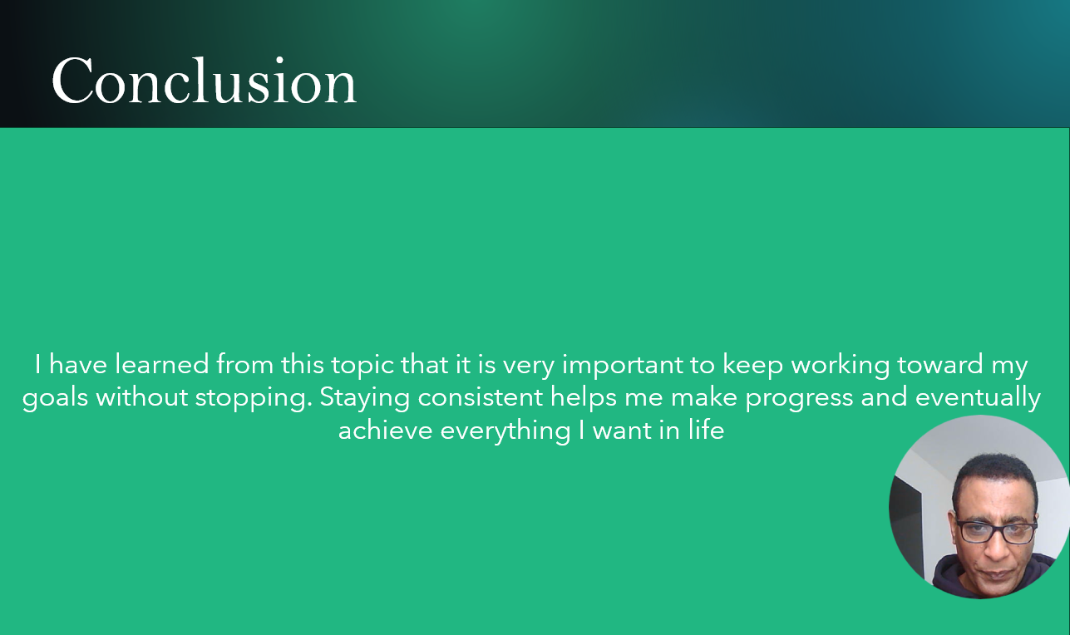

Slid 11
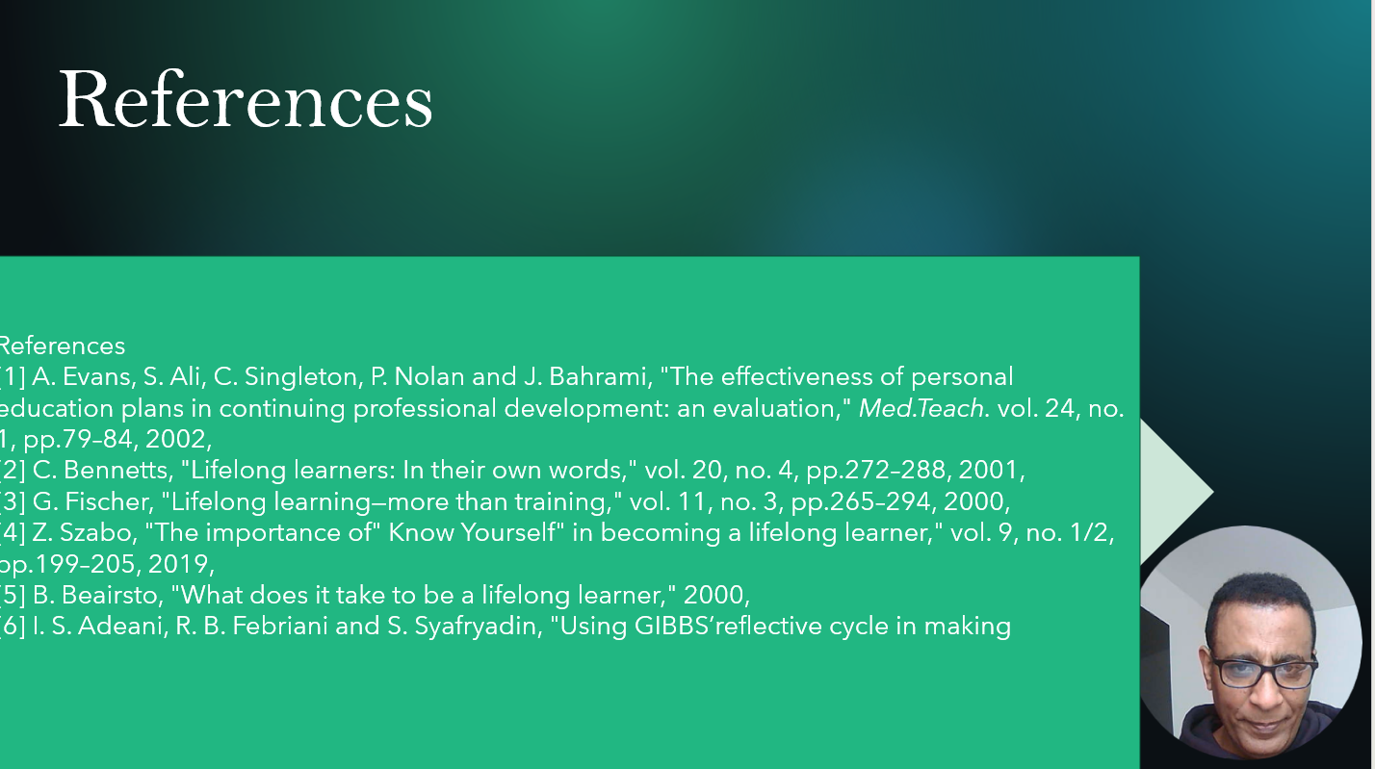

Conclusion

In conclusion, lifelong learning succeeds when you combine self-knowledge with structured reflection. By setting SMART goals and practicing self-regulation, you can overcome challenges. Using critical thinking and creativity in real-world tasks ensures you continue to grow personally and professionally.

s
Reference

[1] A. Evans, S. Ali, C. Singleton, P. Nolan and J. Bahrami, "The effectiveness of personal education plans in continuing professional development: an evaluation," Med.Teach. vol. 24, no. 1, pp.79–84, 2002,
[2] C. Bennetts, "Lifelong learners: In their own words," vol. 20, no. 4, pp.272–288, 2001,
[3] G. Fischer, "Lifelong learning—more than training," vol. 11, no. 3, pp.265–294, 2000,
[4] Z. Szabo, "The importance of" Know Yourself" in becoming a lifelong learner," vol. 9, no. 1/2, pp.199–205, 2019,
[5] B. Beairsto, "What does it take to be a lifelong learner," 2000,
[6] I. S. Adeani, R. B. Febriani and S. Syafryadin, "Using GIBBS’reflective cycle in making

=============================End==============================

