EVALUATING MANUFACTURIGNG SYSTEMS AND A STRATEGIC APPROACH ON ADOPTING

INDUSTRY 4.0

PRAVEEN R. PILLAI
UNIVERSITY OF WALES TRINITY SAINT DAVIS
Course Number: MADE L7K ACPA7000 ANDVANED MANUFACTURING (INDUSTRY 4.0)

Abstract
This report provides a critical assessment of manufacturing systems at a strategic level to identify opportunities for new and emerging technologies that will enable Industry 4.0.
This report examines the adoption of Industry 4.0 from a data perspective and the use of a common reference model.

INDUSTRY 4.0

Industry 4.0— the Fourth Industrial Revolution or 4IR— is a term widely used today to define the advancement of technology in the industrial domain; based on various use cases, this platform may also be referred as SMART Manufacturing or SMART FACTORY. The concept involves adoption of one or more technologies to optimize or/ and improve the efficiency of an industrial process, assets, and people. These digitization or even digital transformation technologies were driven by the advancement in Data handling capability, connectivity of systems from shop floor to cloud, Data analytics capability, robotics to name a few. (MCKINSEY, 2022)
In the words of German Chancellor Angela Merkel, Industry 4.0 is 'the comprehensive transformation of the whole sphere of industrial production through the merging of digital technology and the internet with conventional industry' (European Union, 2015). The term Industry 4.0 originated in Germany, but the concept largely overlaps with Smart factories, the Industrial Internet of Things, Smart industry, or Advanced manufacturing.
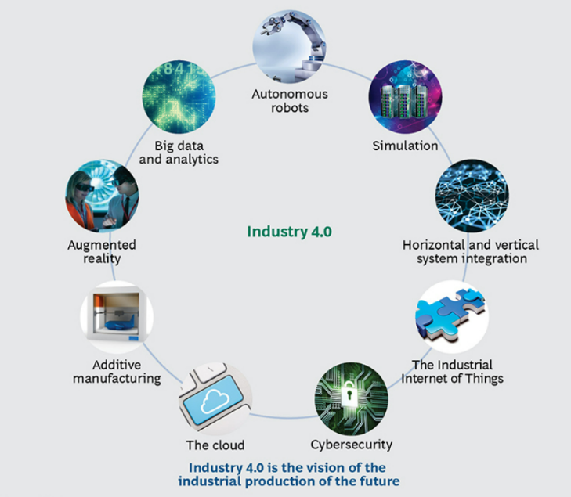
As per the report from the BCG Consulting group there are multiple technology trends that forms the foundation of Industry 4.0, and these technologies can transform business. These include Augmented Reality, Big Data and Analytics, Additive Manufacturing, Autonomous Robots, Simulation, The Industrial Internet of Things, Horizontal and Vertical System Integration, Cybersecurity, The Cloud. (Boston Consulting Group, 2015)

Figure: Nine Technologies are Transforming Industrial Production. (Boston Consulting Group, 2015)
Over the years, the technology advancement contributed to incorporate new emerging technologies into industry 4.0. State of art technologies such as 5G and Quantum computing has been added. As per Stylianos, the following emerging technologies will be key players that define new business models in industry 4.0 (STYLIANOS, 2022)

Challenges with existing Manufacturing eco-system

Disparate Systems and Database
Most large manufacturing facilities typically grow over time through mergers and acquisitions. From an enterprise perspective, this introduces several application and database systems into the portfolio, alongside. At many times, it is not feasible to remove and replace these systems due to various constraints, including financial investment, operational downtime, and operator training requirements etc.

Multiple ERPs and MES systems

Prior to the introduction of cloud-based ERP and MES systems, manufacturing companies often deployed individual ERP and MES systems based on specific use cases, such as supply chain, operations, finance, and inventory management. These systems typically have separate databases and protocols, making it difficult to integrate them with other systems, which poses a challenge for creating a single source of truth for visualization and decision-making capabilities.

Managing Operation Data is complex (AVEVA- include display)
There are various sources of operational data, including instruments, IIoT sensors and gateways, controllers, PLCs, SCADAs, and DCS systems. This data typically feeds into historians, cloud systems, or laboratory information management systems through different protocols such as OPC UA, XML or similar flat files or manual transfer. Data is processed and consumed through various tools such as spreadsheets, planning and scheduling systems, and Business Intelligence software.
Consequently, the accuracy of the original data source may become blurred over time and during the processing stages.

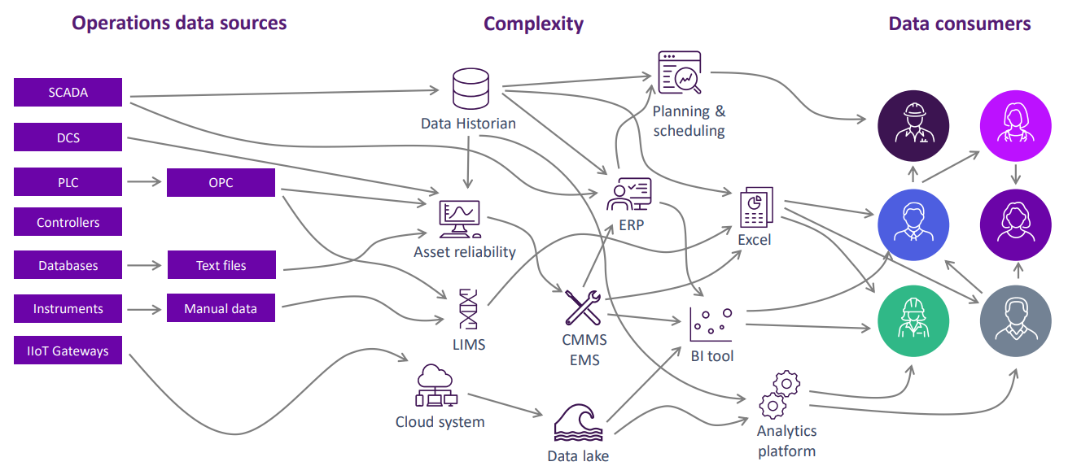
Source: AVEVA, 2021

Building Digital Manufacturing Capability
Industry 4.0 should not be viewed as an objective but a means to achieve our objectives of Smart Manufacturing. There are numerous measures that can be implemented to embrace Industry 4.0 in the manufacturing industry. This section delves into a selection of industry practices that promote this requirement.

Identify Industry4 / Industrial IoT Maturity Status
This exercise can be executed at enterprise level, company, division, or individual plant level. However, it is always advisable to implement it at the enterprise level.

IIoT Readiness Assessment
The Industrial IoT Readiness Assessment can help to comprehend the current company infrastructure in relation to the Internet of Things (IoT).

This comprises of the company's vision and strategy for IoT, willingness to invest in IoT-based infrastructure, and evolution of design for IoT in product and service management. Additionally, the assessment considers other IoT enablement capabilities.

A report can be generated from the readiness assessment, outlining the mentioned capabilities, and conforming to industry standards. This report will serve as a useful reference guide. Normally, this can be presented using spider charts. A standard illustration is provided below from NOVENTUM, 2023 an assessment organization. 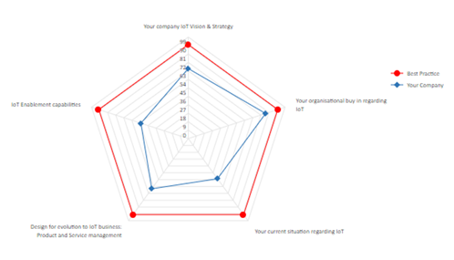
(Source: NOVENTUM, 2023)

OT/IT Convergence and Security Posture
Identifying the convergence of IT and OT, as well as establishing a secure posture, holds paramount importance in every manufacturing sector. This should involve identifying the areas where IT and OT overlap. This document should outline the necessary connections between various systems, including Human Machine Interfaces, Manufacturing Execution Systems, DCS, and SCADA systems on the OT side to improve Operational Intelligence.
On the IT side, we also have systems that offer Business Intelligence through actionable insights from reports, dashboards, trends, KPI boards, and interfaces for machine learning and predictive capabilities.
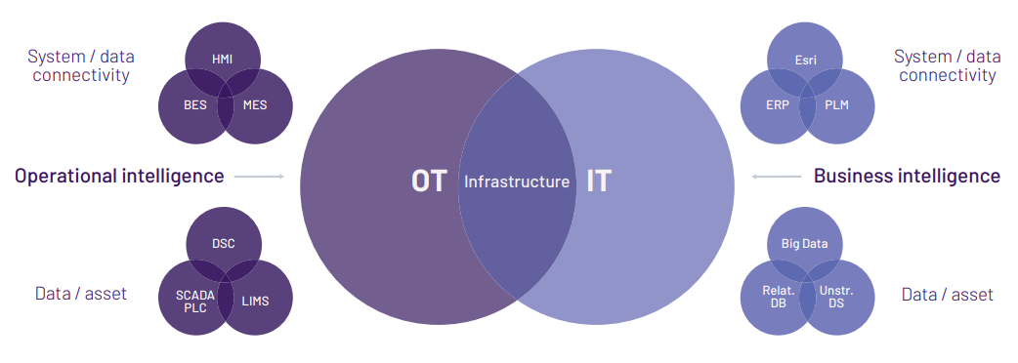
(Source: AVEVA, 2021)

Adopting Industry4.0 / Digital Manufacturing

This section examines the primary components of Industry 4.0 from an adoption standpoint.

Industry4.0 Framework
There are several Industry 4.0 frameworks to choose from. However, RAMI 4.0 is the most popularly adopted framework, which is extensively discussed in this report.
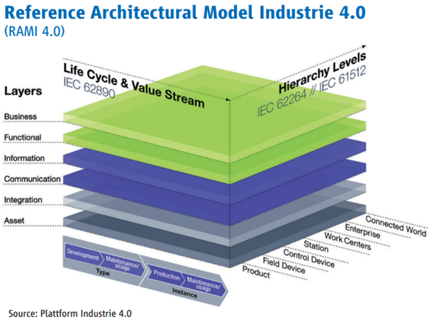
The RAMI 4.0 utilises a 3-axis model. The Hierarchy Levels Axis of ISA95 has been expanded to incorporate work pieces identified as a PRODUCT and a CONNECTED WORLD for the Connection to Internet of Things.
The Life Cycle & Value Stream Axis has TYPES and INSTANCES.
TYPES is used for design and prototyping, whereas INSTANCES refers to the actual product when it is manufactured.
The LAYERS Axis represents the virtual representation of the machine.

DATA

Data is the most crucial element for adopting Industry 4.0. The flexibility of handling enterprise level data and managing infrastructure is a technological advancement in the field on industry 4.0. Gartner Research has predicted that by 2026, about 75% of the organization will utilize the cloud platform for modelling their digital transformation journey. (GARTNER RESEARCH, 2023)

A structured approach to data would greatly shift operations from being inactive, where decisions are made based on experience and best guesses, to innovative, where data can be accessed in real time or near real time. This would enable the business to leverage prescriptive analytics, as well as machine learning and artificial intelligence capabilities.

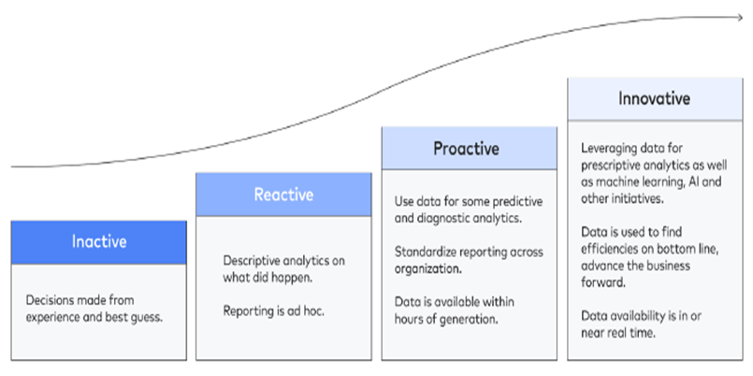

A structured approach to data
A structured approach to data is a crucial element in the path towards smart manufacturing. Data centralization should be prioritized as it is challenging to utilize data systematically without a
singular source of truth and data residing on a single platform.
After centralization, a vast amount of data is accessible to users, and data democratization frequently follows as organizations deal with the complications of granting widespread data access while preventing unauthorized usage.

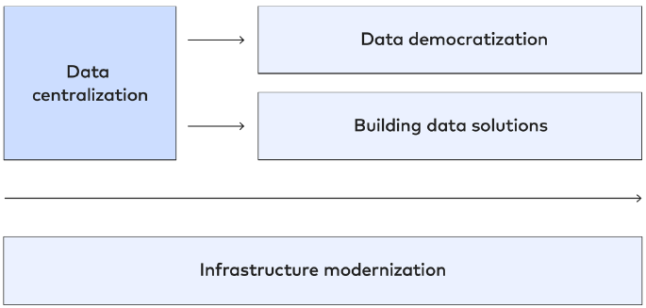
Source: FiveTran, 2023

Manufacturing Data Layer will be a central repository for all operations data that can be leveraged for Visualization and Decision Support.

DATA CENTRALIZATION
The primary objective facilitated by data centralization is to merge records from disparate data sources into centralized data models. The typical format for data routing is a follows.
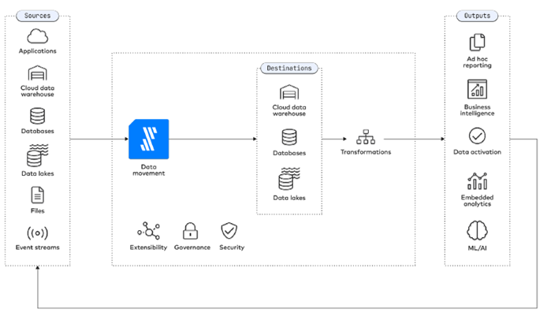
(Source: FIVETRAN, 2023)

A common Manufacturing Data Layer as mentioned in SAP digital Manufacturing architecture below would provide data centralization capability for manufacturing domain.
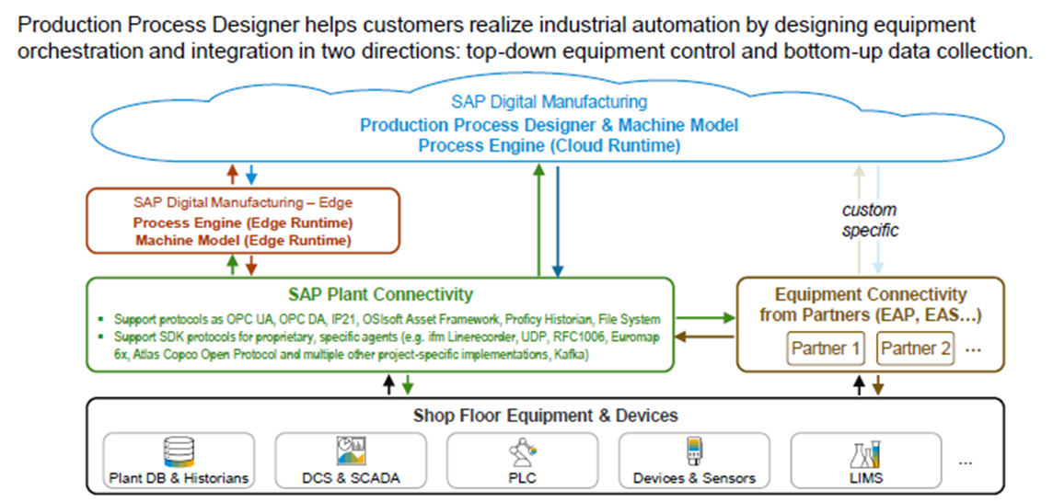
(Source: SAP, 2023)

DATA DEMOCRATIZATION
This provides the capability of sharing data between multiple use cases, visualization and further analytics.
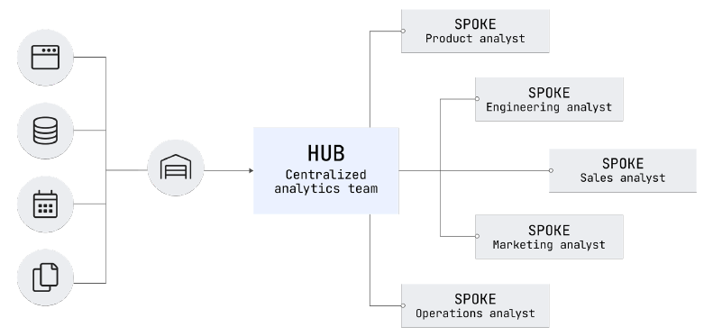
(Source: FIVETRAN, 2023)

BUILDING DATA SOLUTION
Once the data is democratized, it is possible to build multiple data solutions based on this environment.
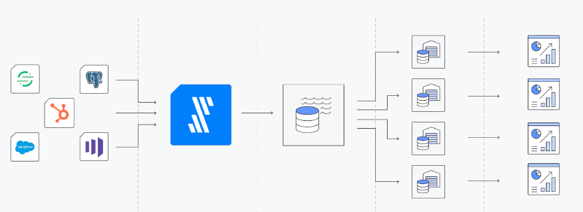
(Source: FIVETRAN, 2023)

INFRASTRUCTURE MODERNISATION
Effective manufacturing infrastructure is crucial in producing high-quality and dependable manufacturing/operational data. Many Manufacturing facilities have outdated legacy systems that do not comply with modern infrastructure and security standards. These systems are mostly either already at or approaching their end of support and must be migrated or upgraded to modern platforms.
Details of infrastructure modernization is outside the scope of this report.

DIGITAL TWIN FOR MANUFACTURING
“Digital twins can be used as a means to systematically collect, aggregate and manage data of manufacturing assets of multiple types, such as products, production devices, equipment, cells, plants and supply chains.” as defined in the Architecture Alignment and interoperability between Industrie4.0 and Industrial Internet Consortium (Industry 4.0 & IIC, 2017)
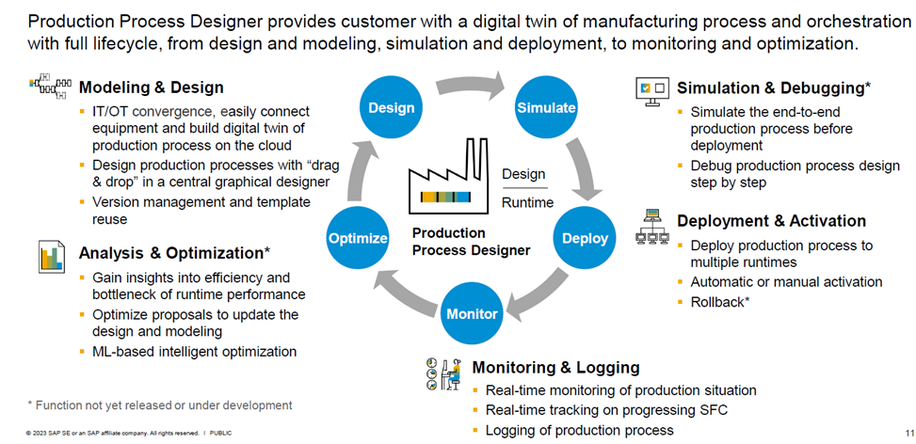
The following system provides a one-to-one mapping of physical world with digital twins. (Source: SAP Digital Manufacturing, 2023)
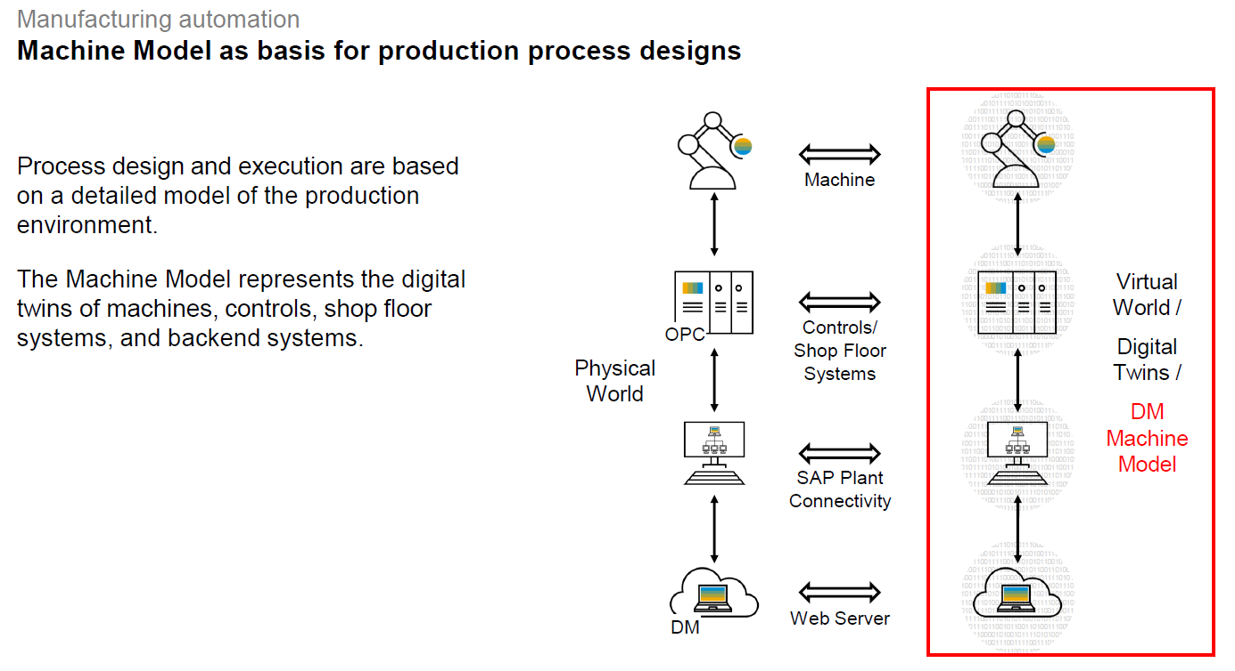

Industrial Internet of Things (IIOT)

"IIoT technologies are playing an important role in facilitating the integration of IT and IIoT, improving productivity, efficiency, and oversight in manufacturing organizations." The key technologies involved in Internet of Things include 1. Small, low-power processors 2. Latest generation sensors 3. Low consumption communication. (FRAN, 2017)

Protocols for Production Environment
Typical use case of Industrial IoT would be extraction of energy data using IIOT sensors and Gateways, feeding these data to Cloud facilities and displaying this in Dashboards as shown below (AWS, 2023)
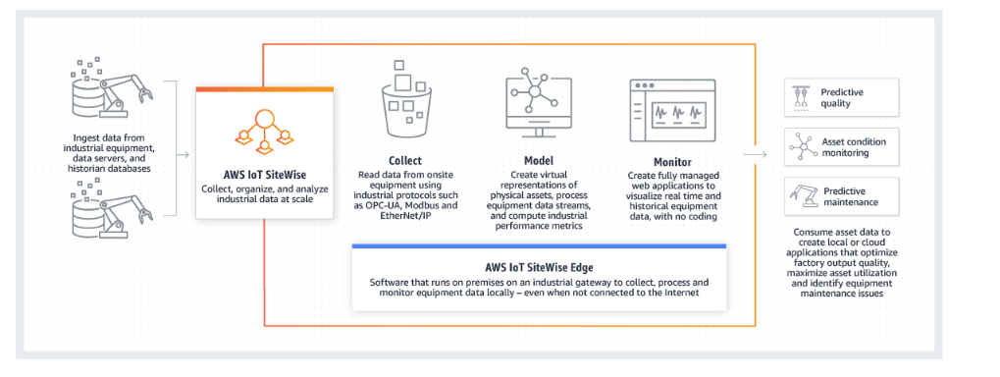
SOURCE: AWS 2023
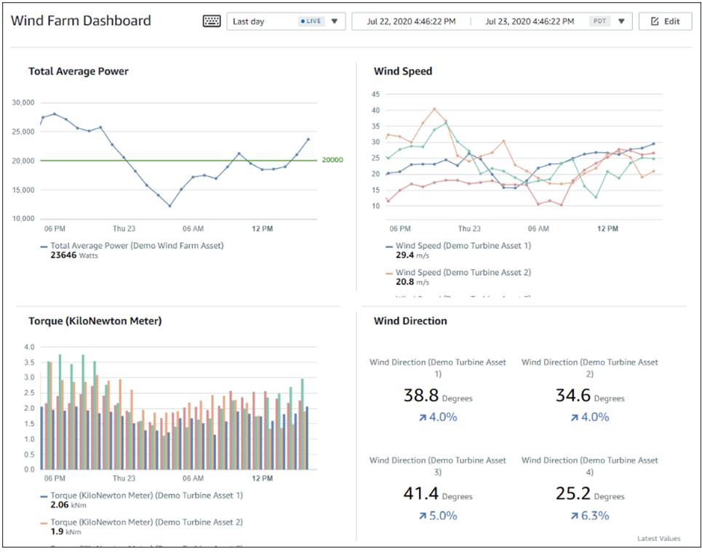
SOURCE: AWS 2023

References
- McKinsey, August 2022. What are Industry 4.0, the Fourth Industrial Revolution, and 4IR [https://www.mckinsey.com/featured-insights/mckinsey-explainers/what-are-industry-4-0-the-fourth-industrial-revolution-and-4ir ]
- Boston Consulting Group, April 09, 2015. Industry 4.0: The Future of Productivity and Growth in Manufacturing Industries (bcg.com) [https://www.bcg.com/publications/2015/engineered_products_project_business_industry_4_future_productivity_growth_manufacturing_industries]
- NOVENTUM IoT Readiness Assessment, 2023. [https://www.noventum.eu/noventum/service-tools/iot-readiness-assessment]
- AVEVA PI WORLD, Turning operations data into intelligence 2021. [https://www.aveva.com/content/dam/aveva/documents/white-papers/Whitepaper-The-Data-Driven-Foundation.pdf.coredownload.inline.pdf]
- FRAN YANEZ, 2017. THE GOAL IS Industry 4.0: Technologies and Trends of the Fourth Industrial Revolution
- Cambridge University, 2023 Smart Infrastructure: Getting more from strategic assets https://www-smartinfrastructure.eng.cam.ac.uk/system/files/documents/the-smart-infrastructure-paper.pdf , 2023
- FiveTran, 2023 [https://www.fivetran.com/blog/why-data-centralization-matters-for-retail]
- Industrie 4.0, 2017 Architecture Alignment and Interoperability https://www.plattform-i40.de/IP/Redaktion/EN/Downloads/Publikation/whitepaper-iic-pi40.pdf?__blob=publicationFile&v=1
- Errol S, 2020. Emerging Technologies: Blockchain of Intelligent Things to Boost Revenues By: Errol S. van Engelen Publisher: Business Expert Press
- Supply Chain 4.0: Improving Supply Chains with Analytics and Industry 4.0 Technologies By: Ioannis Minis, Vasileios Zeimpekis, Emel Aktas, Michael Bourlakis
- Business Models in Emerging Technologies: Data Science, AI, and Blockchain By: Stylianos Kampakis, Theodosis Mourouzis, Gerard Cardoso, Marialena Zinopoulou - Publisher: Business Expert Press © 2022]
- [Hermann, M et al (2016) Design principles for Industry 4.0 scenarios, 49th Hawaii International Conference on System Sciences]
- Gartner Research, 2023. Over 100 Data and Analytics Predictions through 2028 https://emtemp.gcom.cloud/ngw/globalassets/en/doc/documents/over-100-data-and-analytics-predictions-through-2028-1.pdf
- European Union, 2015. Industry 4.0 Digitalisation for productivity and growth https://www.europarl.europa.eu/RegData/etudes/BRIE/2015/568337/EPRS_BRI(2015)568337_EN.pdf
- AWS 2023 [https://docs.aws.amazon.com/iot-sitewise/latest/userguide/what-is-sitewise.html]

