

MODULE CODE: Digital Skills for Personal Development and Business Growth BMSW4008

ASSESSMENT COMPONENT: PORTFOLIO

STUDENT NAME: Kelly Westwood

STUDENT NUMBER:2532288
LECTURER: Phillipa Fitzgerald

DATE:16.3.2026
Contents
Task 1 3
Assessment of Digital Skills 3
References 3
Task 2 4
LinkedIn Learning Certificates for Office365 4
Task 3 5
Essay on Relevance of Excel in professional and personal life. 5
References 5
Task 4 6
7 Minute Reflective Presentation 6
References 6

My jisc report

Assessment of Digital Skills

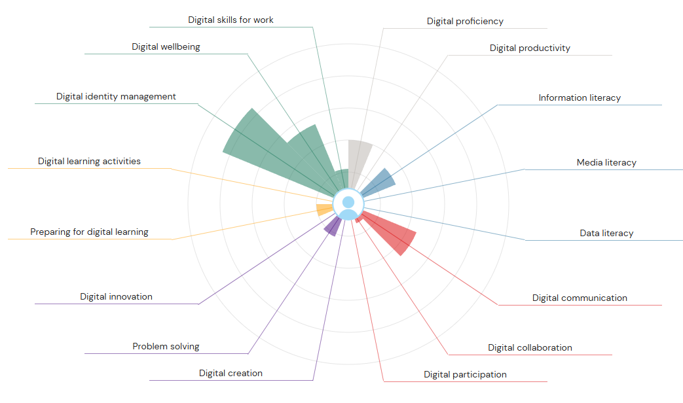
This is my jisc report as you can see from looking at my report one of my strengths is digital identity management, it is important to manage my digital identity and have a professional online presence which could also enhance my career opportunities. When talking and engaging with people online it is also important to react appropriately to certain media and other audiences, having good digital identity management also reduces the risk of fraudulent activities on my accounts there are lots of ways to strengthen digital id one is to use biometric verification simply by taking a selfie once that selfie is verified only you can access that account this is one of my favourite ways to secure my accounts and the method I use most to secure my accounts, I also find it the most convenient way to secure my accounts as no need to remember countless different passwords which is always a bonus to me, one of my other strengths is digital communication having good digital communication increases efficiency it can also reduce costs as it saves money paper, postage also travel by delivering messages etc instantly which can mean quicker decision making, it can enhance engagements and also strengthen relationships it can provide greater transparency, you make faster data driven decisions by using things like video calling/conference calls, instant messaging helps me in my job at a hotel to be able to deliver better customer service as if i have any bad reviews or complaints I'm able to quickly and efficiently deal with the issues through instant messaging or emails this helps me to reduce any bad reviews which would have a direct impact on business.
As you can see from my jisc report one of my weaknesses is media literacy I really didn't understand what this meant but after looking it up in Wikipedia I can see it's the ability to access, analyse, evaluate ,create and act using all forms of communication. It is what enables people to engage with media messages and recognise purpose and credibility, there are a few ways I can improve on my weakness in media literacy one is to actively question media content with questions such as:
Who created this message? (author, organisation, user)
What is the purpose? (inform, entertain, persuade or sell something)
What is omitted? (are there any facts missing)
There are also a few online activities I can do to help me with this weakness, another one of my weaknesses is data literacy once again I was unsure of what this meant so with a little help from google I found out that it is the ability to read, work, analyse and communicate with data which then gets used for informed decision making. Data literacy goes beyond technical skills to include critical thinking. There are four main abilities which are reading data, working with data understanding how its collected and managed, analysing data applying techniques to find the meaning also communicating with data, even after researching this on google I still don't really understand it all so I plan to do some online courses to help me to understand data literacy better and increase my knowledge and understanding of it.

Task 2

My linked in learning certificates .

Task 3

The relevance of microsoft excel in professional and personal life

Introduction

Microsoft Excel is one of the most widely used spreadsheet programs in the world. It is part of the Microsoft Office 365 package and is used by people in everyday life, students and organisations to organise and analyse information. Excel allow users to record data in tables, perform calculations using formulas and create charts to display information visually. workplaces rely heavily on digital technology,so learning how to use Excel is an important digital skill.
Excel is useful because it makes it easier to manage large amounts of information. Instead of calculating figures manually, you can use formulas that automatically update results when the data changes. This saves time and reduces the risk of errors. Excel can also be used to analyse data and support decision-making in professional and personal situations. This essay will explain why Excel is important in professional environments and personal life, and how it can help people organise and understand information
Microsoft Excel is widely used in many workplaces because it helps businesses manage data and perform calculations quickly. Many workplaces use Excel to record financial information, track sales performance and analyse data. By organising information into rows and columns, Excel allows employees to store large amounts of data in a clear and structured way.
One feature that is useful in excel is the ability to use formulas. For eg; the sum function can add numbers together automatically, while the average function calculates the average value of a set of numbers. These functions allow people and workplaces to analyse data quickly without having to calculate everything manually.
Excel is also commonly used to create reports. Charts and graphs can be used to present data visually, which makes it easier for managers and employees to understand the information. For eg, a company might create a chart to compare sales figures from different months. This helps managers see whether sales are increasing or decreasing and make decisions about the business.
Another important use of Excel in your work life is project management. people can create spreadsheets to organise tasks, set deadlines and monitor progress. This helps teams stay organised and and make sure deadlines are met. Because Excel is flexible and easy to use, it is used in many different industries including business, finance, education and healthcare.
Digital skills are becoming more important in modern society. Many jobs require employees to use digital tools to organise and analyse information. Excel is considered an essential digital skill because it helps people understand and work with data.
Learning Excel can improve a person’s ability to analyse information and solve problems. When working with spreadsheets, users must understand how data is organised and how formulas work. This makes for logical thinking and helps people develop problem-solving skills.
Students often learn Excel during their studies because it helps them manage data for assignments and research. For eg, a student may use Excel to record survey results or analyse statistics for a project. These skills can then be used when they move on to work.
Employers often look for candidates who have good digital skills, including experience using spreadsheet software. Being able to use Excel shows that a person can organise data, perform calculations and present information clearly.
Although Excel is widely used in businesses, it is also very useful in everyday life. Many people use Excel to organise personal information and manage their finances. One of the most common uses of Excel in personal life is creating a budget.
A budget spreadsheet allows individuals or families to record their monthly income and expenses. By doing this, they can see how much money they earn and how much they spend. Excel formulas can calculate totals automatically, which makes budgeting easier and more accurate.
For eg, a family might record income from wages, benefits and other sources. They might also record expenses like rent, food, electricity, gas and transport. Excel can then calculate the total income and total expenses. By subtracting expenses from income, the spreadsheet shows whether the family has money left over or whether they need to reduce their spending.
Excel can also be used to organise personal tasks. For eg, people may create spreadsheets to plan travel, track fitness progress or manage study schedules. These examples show how Excel can help people stay organised and manage their time effectively.
One of the most important advantages of Excel is its ability to help users analyse data. Data analysis means examining information to identify patterns or trends. Excel provides several tools that make data analysis easier.
Charts and graphs allow numerical data to be displayed visually. For example, a pie chart can show how a family’s expenses are divided between different categories such as housing, food and transport. This makes it easier to see where most of the money is being spent.
In professional environments, excel helps workplaces make better decisions. For eg, managers may analyse sales data to identify which products are selling well. This information can help them decide which products to promote or spend more on.
Excel therefore plays an important role in helping people make decisions based on information rather than guesses
A practical example of Excel in personal life is a household budget spreadsheet for a family of four. The spreadsheet records monthly income and expenses so a family can understand their financial situation.
Income might include wages, benefits and other sources of money. Expenses might include rent or mortgage payments, council tax, utilities, groceries and transport. Excel formulas can calculate the total income and total expenses automatically.

The spreadsheet can also calculate the remaining balance by subtracting expenses from income. This allows a family to see whether they are saving money each month or spending more than they earn.
In conclusion, Microsoft Excel is an important digital tool that is used in both work and personal life. In workplaces, Excel helps organisations manage data, perform calculations and create reports that support decision-making. Its ability to automate calculations and present information visually makes it very useful in many industries.
In personal life, Excel can help individuals organise information, manage budgets and track goals. The eg of a household budget spreadsheet shows how Excel can help families understand their finances and plan their spending more effectively.
Overall, learning how to use Excel improves digital skills and helps people work with data better. As technology continues to develop, spreadsheet software such as Excel will remain an important tool for both professional and personal growth.

References

Microsoft (2025) Microsoft Excel overview.

Kaplan (2024) Is Microsoft Excel still relevant?

High Speed Training (2022) What Excel skills are employers looking for?

Below is an example of a spreadsheet for a family of four income and expenditure.
philippa execel 2.ods

Task 4

My presentation reflecting on what I’ve learnt so far.
https://uowtsd-my.sharepoint.com/:p:/r/personal/2532288_student_uwtsd_ac_uk/Documents/Attachments/Reflective%20Presentation%20Final.pptx?d=w7d495e7b58f0458d93bc934f81a92f73&csf=1&web=1&e=aUQl4y

