,
Simulation of Digital Modulation Techniques (ACDA5008)
Digital Signal Processing and Communications

ABSTRACT
October 17, 2023
Rhys Higgins (2110763)
uNIVERSITY OF WALES TRINITY ST DAVID
WORD COUNT: 2048

The contents of this report consider the effect of AWGN, Additive White Gaussian Noise, on four Digital Modulation Schemes, ASK, PSK, QPSK, and 16-QAM with respect to the BER (Bit Error Rate) of the demodulated signal; each modulation scheme is modelled using the Simulink application in MATLAB. This report has found that the BER is directly proportional to increasing AWGN and data rate. 16-QAM was found to be the most affected modulation scheme by increasing AWGN and PSK was found to be the least influenced by AWGN.

Table of Contents
Table of Figures 1
Table of Equations 1
Introduction 2
Simulation Models 5
Results 8
Discussion 15
Binary Modulation Schemes 15
M-ary Modulation Schemes 15
Conclusion 17
References 18

Table of Figures
Figure 1: ASK Modulation & Constellation 3
Figure 2: PSK Modulation & Constellation 3
Figure 4: QPSK Modulation & Constellation 4
Figure 5: 16-QAM Modulation & Constellation 4
Figure 6: ASK Simulink Model 6
Figure 7: PSK Simulink Model 6
Figure 8: QPSK Simulink Model 6
Figure 9: 16-QAM Simulink Model 7
Figure 10: Lowpass Filter Design 7
Figure 11: AWGN Channel Setup 7
Figure 12: ASK BER to SNR Graph 8
Figure 13: ASK Model (10dB) 9
Figure 14: ASK Model (-10dB) 9
Figure 15: PSK BER to SNR Graph 10
Figure 16: PSK Model (10dB) 10
Figure 17: PSK Model (-10dB) 11
Figure 18: QPSK BER to SNR Graph 11
Figure 19: QPSK Model (10dB) 12
Figure 20: QPSK Model (-10dB) 12
Figure 21: QAM BER to SNR Graph 13
Figure 22: 16-QAM Model (20dB*) 13
Figure 23: 16-QAM Model (-10dB) 14
Figure 24: BER to SNR Graph (ALL Schemes) 14
Figure 25: 16-QAM Constellation Diagram L (10dB) & R (-10dB) 16
Figure 26: QPSK Constellation Diagram L (10dB) & R (-10dB) 16
Figure 27: 16-QPSK and 16-QAM [21] 17

Table of Equations
Equation 1: Bit Error Rate 2
Equation 2: Signal to Noise Ratio 2
Equation 3: BASK /OOK Modulation [24] 3
Equation 4: BPSK Modulation [25] 4
Equation 6: QPSK Modulation [25] 4
Equation 7: QAM Modulation [26] 5
Equation 8: M-ary Digital [19] 15
Equation 9: Shannon Hartley Limit [13] 16

Introduction

The aim of this report is to critically compare the performance of digital modulation schemes in the presence of AWGN, simulating the random noise experienced on a communications channel [1], using Simulink. The performance of each modulation scheme will be measured using the Bit Error Rate (BER), BER referring to the number of bit errors per unit time, commonly given as a percentage derived from Equation 1 [2]. System failure for BER in communications commercially is given as $10e-6$, in this report system failure will be considered at a BER of $10e-1$ [4].
$$BER=\frac{total number of error bits}{total number of transmitted bits}$$
Equation 1: Bit Error Rate
Bit Error Rate (BER) has an inverse relationship to the Signal to Noise Ratio (SNR), which is the ratio of Signal Noise to Signal Power, given in Equation 2 [3].
$$SNR=\frac{Signal Power}{Noise Power}$$
$$SNR\left(dB\right)=10\log_{10}\frac{Signal Power}{Noise Power}$$
Equation 2: Signal to Noise Ratio
The basic modulation schemes to be considered include ASK, Amplitude Shift Keying, and PSK, Phase Shift Keying; the advanced coherent multilevel (M-ary) modulation schemes considered being QPSK, Quadrature Phase Shift Keying, and 16-QAM, Quadrature Amplitude Modulation.
For ASK modulation, the amplitude of the carrier wave is shifted between two discrete levels [5, 6], see Equation 3. A carrier-less variant of ASK, OOK (on-off Keying) is often used for low-frequency RF communication, especially in low-power use cases like remote keyless entry as no power is used to transmit the binary ‘0’ data, reducing overall transmission power [7, 23].

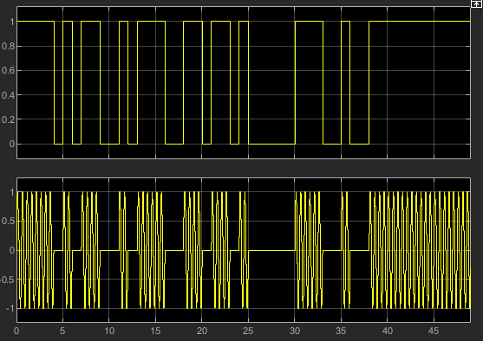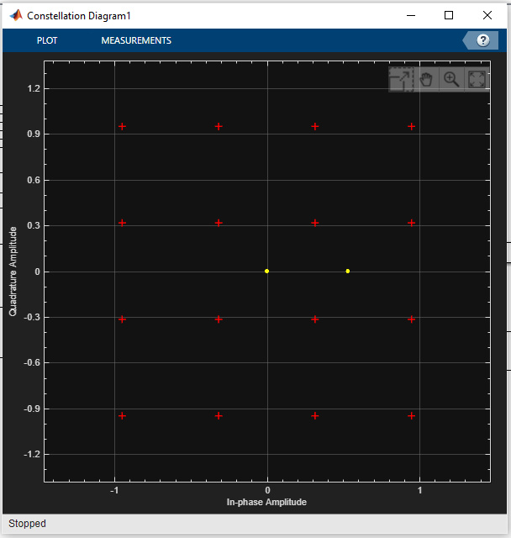
Figure 1: ASK Modulation & Constellation

$$s\left(t\right)=Acos\left(2πf_{c}t\right);Binary 1$$
$$=0; Binary 0$$
Equation 3: BASK /OOK Modulation [24]

For PSK modulation, the phase of the carrier wave is shifted between two discrete values, each value being equidistant from the carrier and representing 1 of 2 binary digits [5, 8], see Equation 4. Variants of PSK, DBPSK, are used in IEEE 802.11b-1999, GMSK and 8-PSK in 2G GSM/EDGE, and 8-PSK is in satellite broadcasting [9, 10, 11].

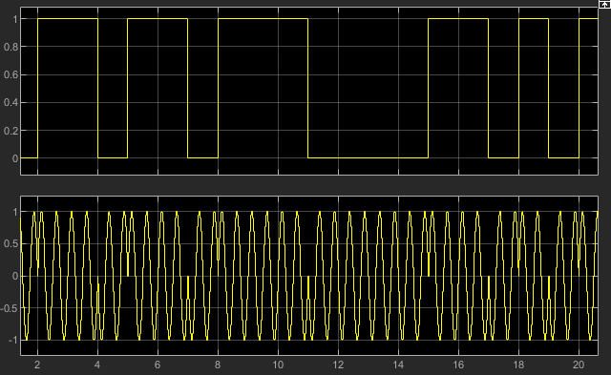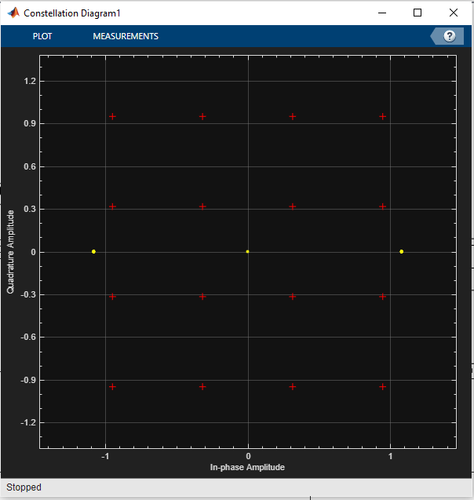
Figure 2: PSK Modulation & Constellation

$$s\left(t\right)=\cos\left(2πf_{c}t+ π\right);Binary 1$$
$$=\cos\left(2πf_{c}t\right); Binary 0$$
Equation 4: BPSK Modulation [25]

In QPSK the phase of the carrier wave is shifted between four discrete values, i.e., 90°, 180°, 270° and 360° offset from the carrier, allowing for the modulation of two bits of a data per symbol [6, 12], see Equation 5. QPSK is used in 2G GSM/EDGE and Digital Television Broadcasting (DVB-S2) [11, 13]. For QAM the amplitude of the carrier wave is permitted to shift with phase.
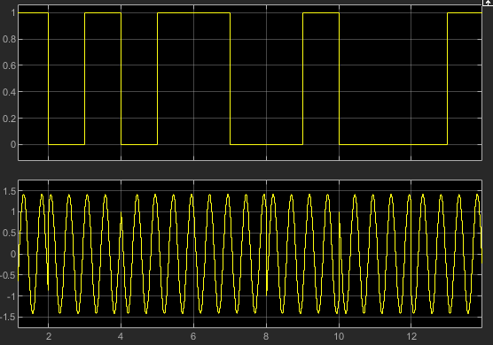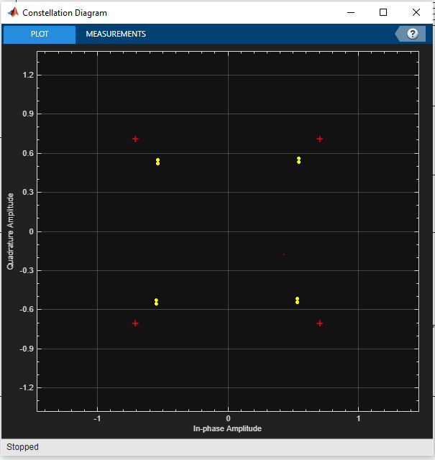
Figure 3: QPSK Modulation & Constellation

$s\left(t\right)=Acos\left(2πf_{c}t+\frac{π}{4}\right)=Binary 11$
$=Acos\left(2πf_{c}t+\frac{3π}{4}\right)=Binary 01$
$=Acos\left(2πf_{c}t+\frac{5π}{4}\right)=Binary 00$
$=Acos\left(2πf_{c}t+\frac{7π}{4}\right)=Binary 10$
Equation 5: QPSK Modulation [25]

QAM can be viewed as a combination of ASK and PSK [8], see Equation 6. QAM is widely used in wireless networking due to its high ratio of bits/symbol and robustness compared to M-ary PSK; 1024-QAM (10 bits/symbol) is used in the current 802.11ax standard [14].

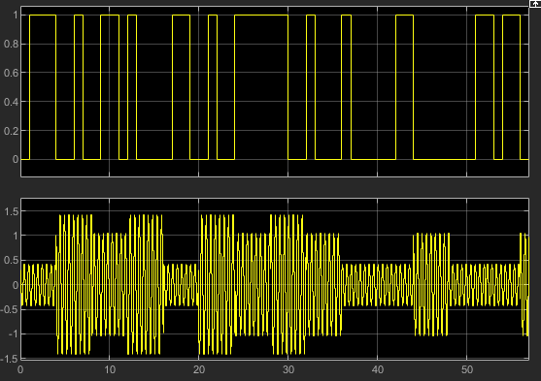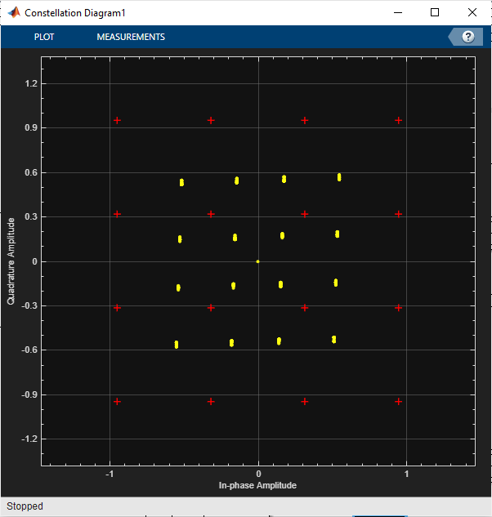
Figure 4: 16-QAM Modulation & Constellation
$$s\left(t\right)= d_{1}\left(t\right)\cos\left(2πf_{c}t\right)+ d_{2}\left(t\right)sin\left(2πf_{c}t\right)$$
Equation 6: QAM Modulation [26]

Simulation Models

Shown in Figure 5 to Figure 8 are models of ASK, PSK, QPSK and QAM modulators and demodulators which have been designed in Simulink, found within MATLAB. To ensure reliability and consistency of results, each model (where practicable) uses identical simulation parameters.
The simulation parameters used are:
- A 10Hz carrier frequency with a sample time of $f_{S}=$200Hz, satisfying the Nyquist theorem in that the sampling frequency is greater than 2x that of the modulated signal, or $f_{s}≫2W$ preventing aliasing [15].
- The carrier frequency is 10x that of the message frequency, 10Hz carrier : 1Hz message frequency.
- The simulation time is set to ~50s to allow for a total of 50 symbols in each model to be transmitted during each run.
- The Lowpass FIR, Finite-duration Impulse Response, filter design for each model is identical. An FIR filter has been used over an IIR, Infinite-duration Impulse Response, as they are stable and can be realised in hardware [16]. Each model uses a single/or multiple of the same 76-order FIR lowpass filter with the following specification: $f_{S}$ = 200Hz, $f_{PASS}$ = 1, $f_{STOP}$ = 4, $A_{PASS}$ = 1, $A_{STOP}$ = 30, see Figure 9 for filter design.
- Each model has a Bit Error Rate and Bit Error Ratio (BER) calculation block, which will be used to calculate the error rate of data received from the demodulator (RX) compared to data transmitted (TX) by the Bernoulli binary generator. The Bit Error Ratio is calculated using Equation 1.
- The testing procedure started at an SNR of 10:1 (+10dB), progressively adding noise in -5dB steps, using the AWGN block, until an SNR of 1:1000 (-30dB), or until system failure.
- At each +/-5dB test point, a total of 20 runs were conducted to ensure that there were enough BER data points for the test to be considered reliable, accurate, and fair.
- The results of each test were added to an Excel spreadsheet to creating graphs, from the mean of value calculated at each test point.
- The AWGN channel added between the modulator and demodulator on all models, to provide the spurious and random noise in the communications channel.
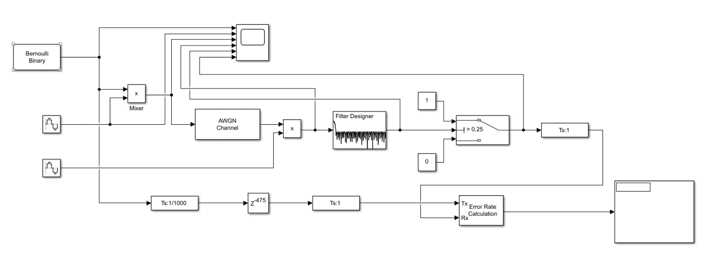
Figure 5: ASK Simulink Model

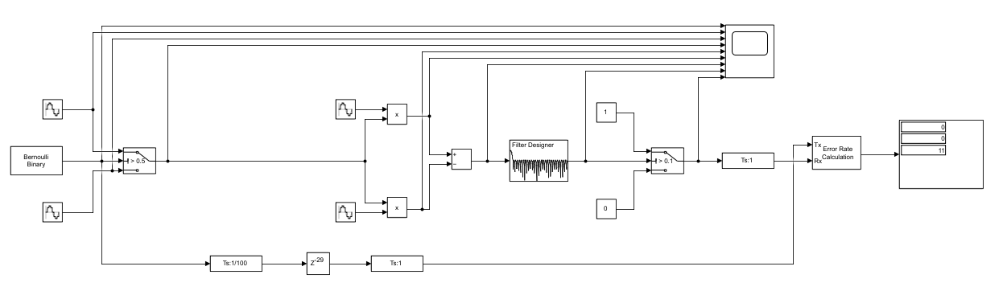
Figure 6: PSK Simulink Model
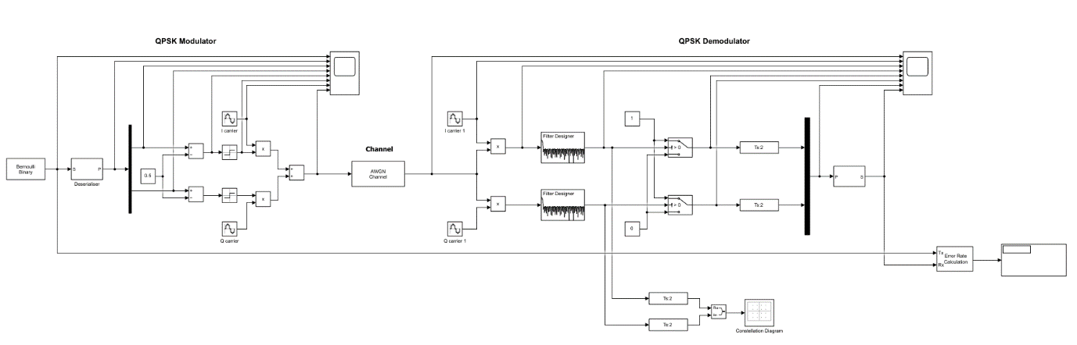
Figure 7: QPSK Simulink Model
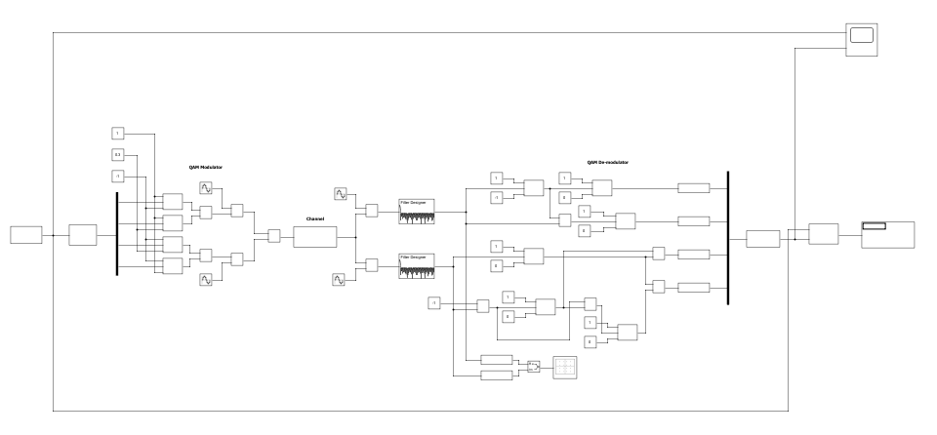
Figure 8: 16-QAM Simulink Model
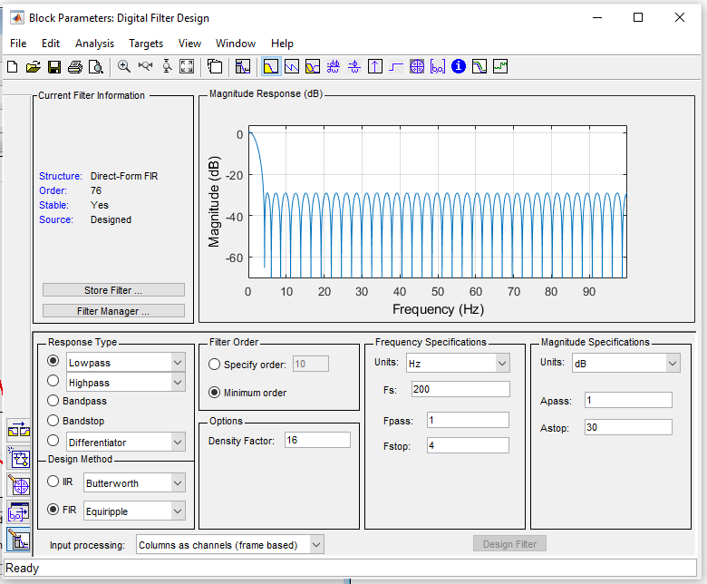
Figure 9: Lowpass Filter Design
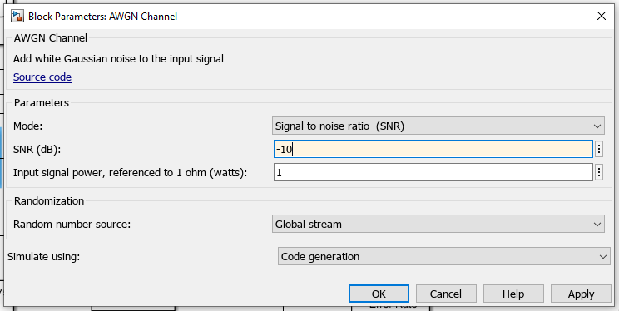
Figure 10: AWGN Channel Setup

Results

The graphs shown in Figure 11, Figure 14, Figure 17, and Figure 23 show BER with respect to SNR for the ASK, PSK, QPSK, and QAM models. The BER value plotted at each test point on each graph is the mean value taken from running the simulation 20 times per test point for varying SNR (10dB, 5dB, 0dB, -5dB, -8dB, -10dB, -12dB, -15dB, -20dB, -25dB). Figure 11, Figure 14, and Figure 17 have the standard deviation plotted for each test point to show the variation of results at each test point.
Figure 23 gives a comparison of BER between the modulation schemes covered in this report, clearly showing the better performance, in terms of BER (%) to SNR, of the PSK and QPSK models when compared to ASK and QAM models.
Figure 12 and Figure 13 show the output of the ASK model at 10dB and -10dB noise. Significant degradation of the original message can be observed in Figure 13.
Figure 15 and Figure 16 show the output of the PSK model at 10dB and -10dB noise. Some degradation of the original message can be observed in Figure 16.
Figure 18 and Figure 19 show the output of the QPSK model at 10dB and -10dB noise. Like PSK, minor degradation of the demodulated message can be observed in Figure 19.
Figure 21 and Figure 22 show the output of the 16-QAM model at 20dB and -10dB noise. Clear distortion of the demodulated signal can be observed in Figure 22. Regarding the Figure 21, it should be noted that this was taken at 20dB; 20dB was chosen as at 10dB SNR, errors were already apparent in the demodulated message.

Figure 11: ASK BER to SNR Graph
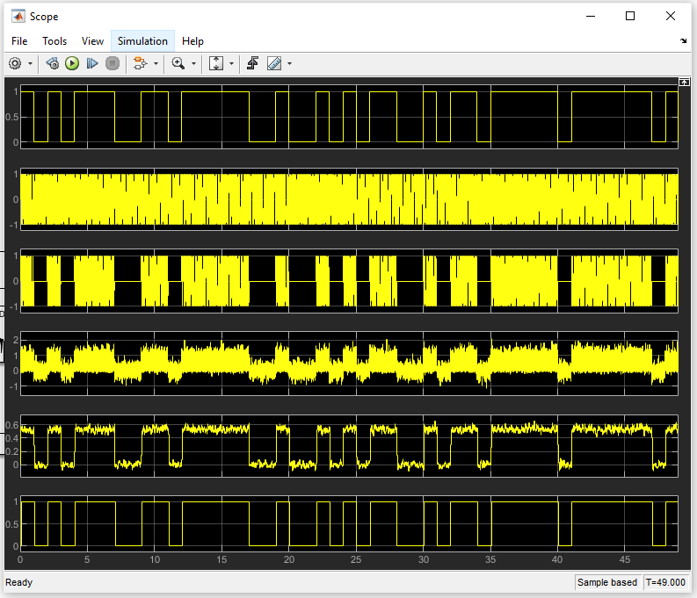
Figure 12: ASK Model (10dB)
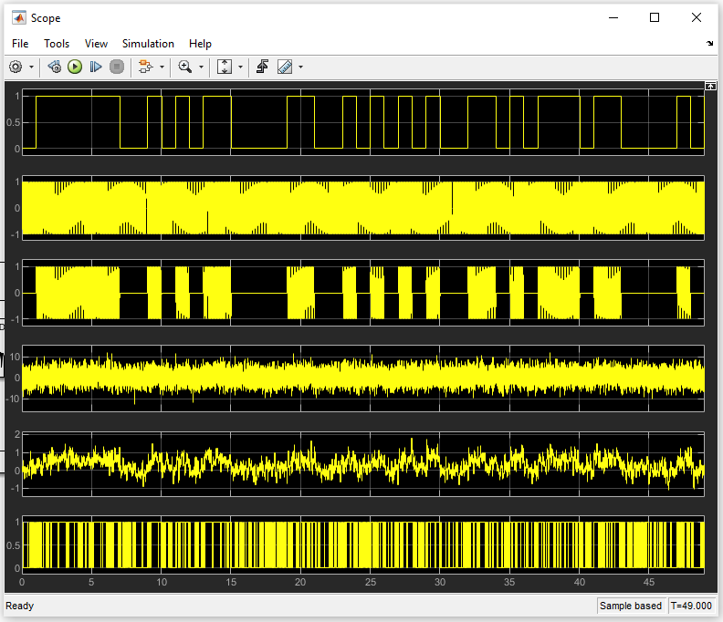
Figure 13: ASK Model (-10dB)

Figure 14: PSK BER to SNR Graph
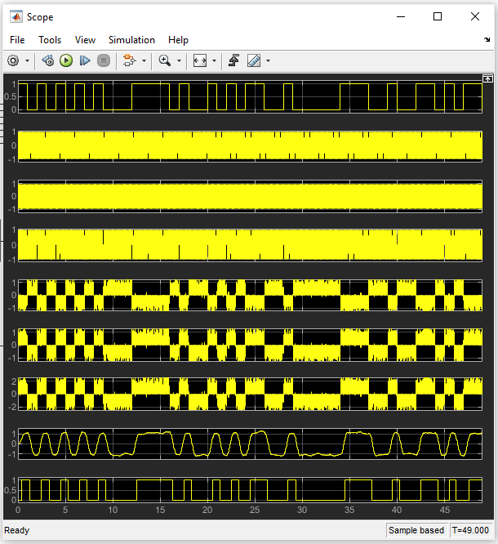
Figure 15: PSK Model (10dB)
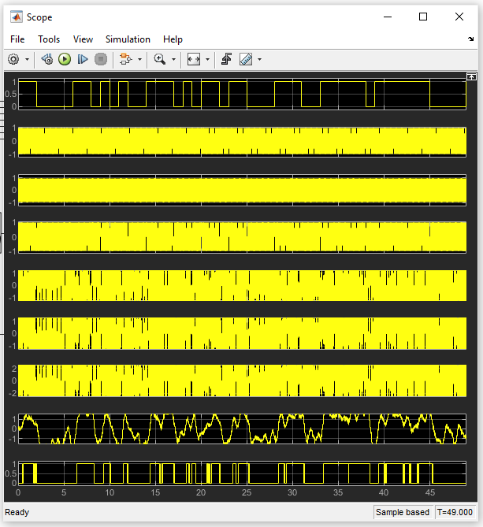
Figure 16: PSK Model (-10dB)

Figure 17: QPSK BER to SNR Graph
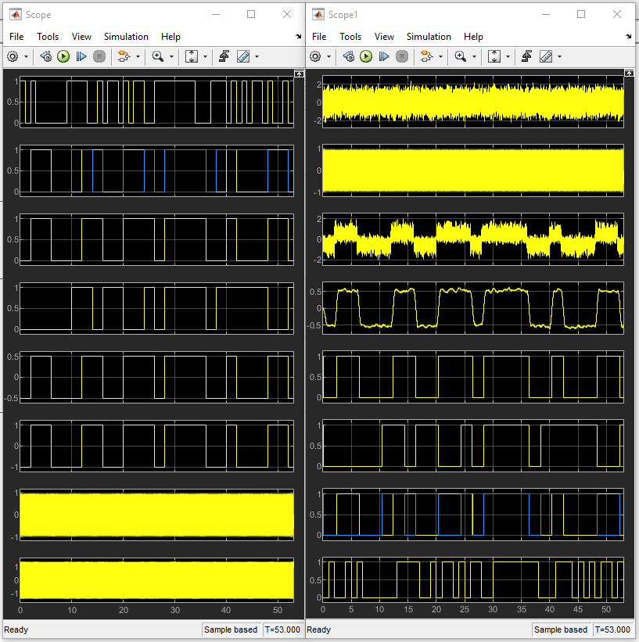
Figure 18: QPSK Model (10dB)
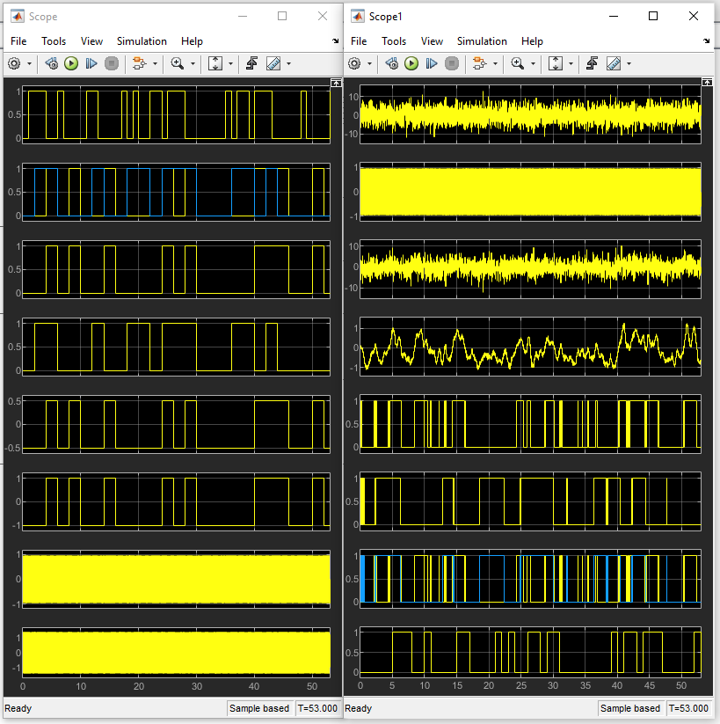
Figure 19: QPSK Model (-10dB)

Figure 20: QAM BER to SNR Graph
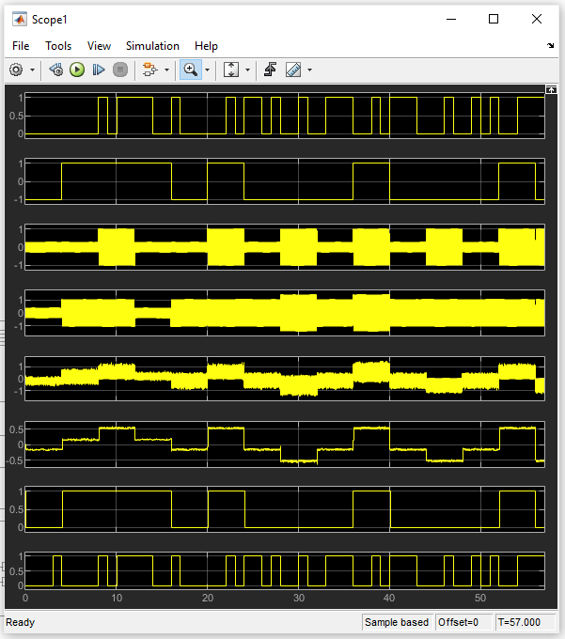
Figure 21: 16-QAM Model (20dB)
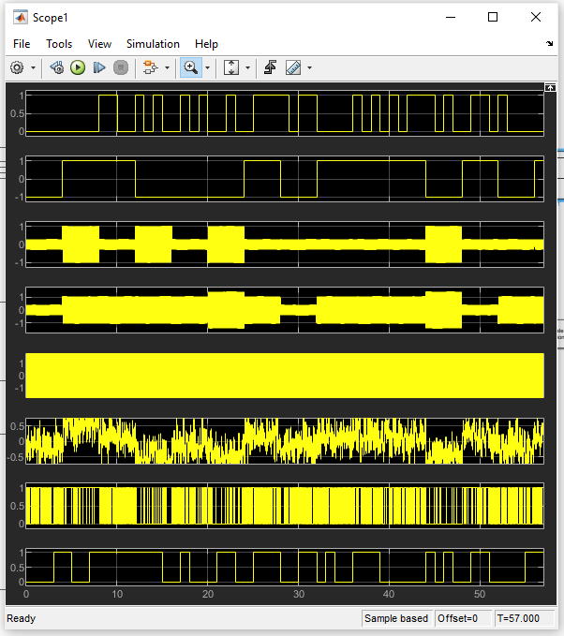
Figure 22: 16-QAM Model (-10dB)

Figure 23: BER to SNR Graph (ALL Schemes)

Discussion

Binary Modulation Schemes
In regard to Figure 11 (ASK) and Figure 14 (PSK), it is clear from the results that the PSK model had a significantly lower BER (%) with respect to SNR than the ASK model, also evidenced the steeper BER curve of ASK over PSK in Figure 23. Indeed, in Figure 23, for the ASK model, the BER reaches 1E-1, or 10%, at -6dB (SNR of 1:4) – using Equation 2. In comparison, in the same Figure, the PSK model does not reach the same BER until an SNR of 1:10 (-10dB). A significant contributing factor to the greater BER, with respect to SNR, for the ASK model is that ASK modulation is significantly more vulnerable to distortion via the channel than PSK – as the noise will be added primarily to the amplitude of the carrier signal, which is the component of the carrier waveform being modulated in ASK [1, 6].
In addition, there is greater degree of deviation of the BER result from the +10dB to -20dB test points for the ASK model than the PSK model. This can somewhat be seen when comparing Figure 11 to Figure 14, but can be better seen when comparing the data at each test point. Taking the -10dB test point, the standard deviation of results for the ASK model is 0.54, compared to 0.38 for the PSK model. Again, this is explained by the fact that ASK model is inherently more vulnerable to additive noise [1].

M-ary Modulation Schemes
Figure 17 (QPSK) and Figure 20 (16-QAM) are the respective BER curves for QPSK and QAM models. QPSK and QAM are M-ary modulation schemes, shown by Equation 7, where $M$ is the number of symbols and $N$ is the number of bits; for QPSK $M=4$ and QAM $M=16$ [17].
$M=2^{N}$ or $N=\log_{2}M$
Equation 7: M-ary Digital [19]
From these Figures, it can be seen the QPSK model outperformed the QAM model with respect to BER at decreasing levels of SNR. QPSK had a lower BER (%) than 16-QAM due to the lower number of bits per symbol of QPSK ($N=2$ or 2bps) when compared to 16-QAM ($N=4$ or 4bps); a higher bps, makes 16-QAM more desirable in terms of speed than QPSK, the trade-off that it is more vulnerable to noise due to the greater number of symbols packed more densely together, as can be seen in the constellation diagrams in Figure 25 (QPSK) and Figure 24 (16-QAM), supported by the oscilloscope outputs shown in Figure 19 (QPSK) and Figure 22 (16-QAM), where the demodulated signal of the QPSK has suffered from far less distortion than the 16-QAM signal has at -10dB.

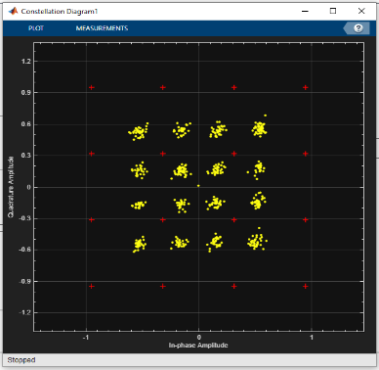
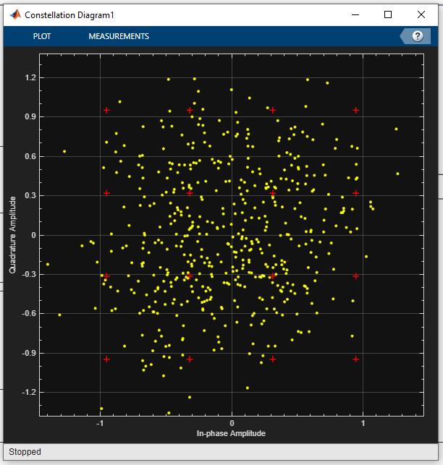

Figure 24: 16-QAM Constellation Diagram L (10dB) & R (-10dB)
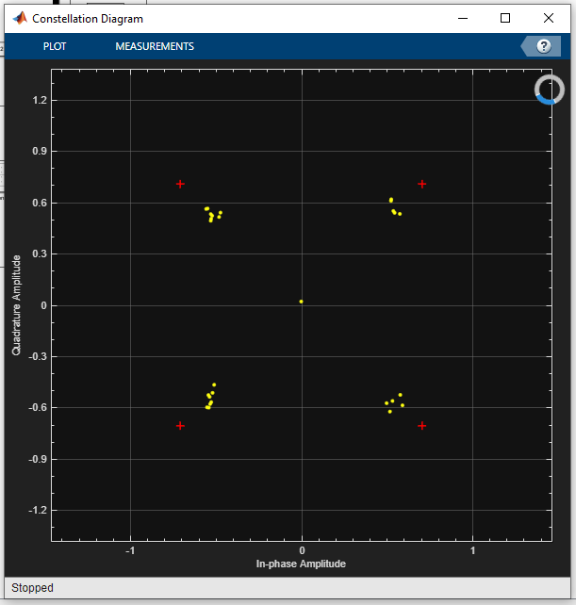
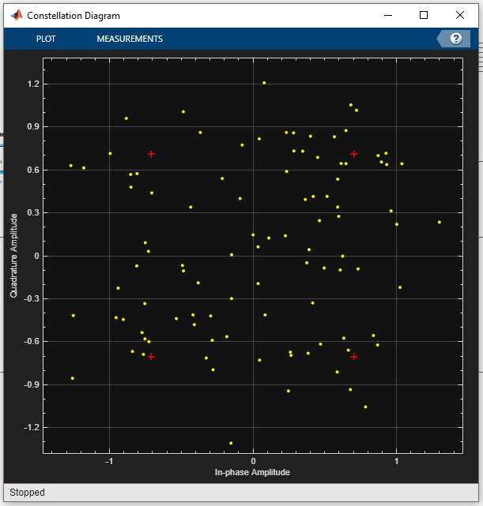

Figure 25: QPSK Constellation Diagram L (10dB) & R (-10dB)
Also, it can be seen that in Figure 20 (16-QAM) the deviation between results is greater than that in Figure 17 (QPSK), this can again be explained by the increased symbol rate of QAM, where the greater bits/symbol is directly proportional to a greater BER (%); this effect is known as the Shannon Hartley limit, which is the theoretical upper limit of capacity of an error-free digital communications system with respect to SNR and channel BW - the maximum number of M levels defined by the SNR, as shown by Equation 8 [18].
$$C=B\log_{2}\left(SNR+1\right)$$
$C=Channel Capacity in bits/s$ $B=Channel BW in Hz$
Equation 8: Shannon Hartley Limit [13]

Conclusion

In this experiment, it has been determined that the modulation schemes with the lowest BER (%) with respect to increasing AWGN are PSK and QPSK, with PSK performing marginally better overall when compared to QPSK - as shown in Figure 14 and Figure 17. In contrast, ASK and 16-QAM had a higher BER, 16-QAM being the worst performer – as can be seen in Figure 23. Also, Figure 23 shows that, at -30dB, or an SNR of 1:1000, the BER (%) across all modulation schemes is approaching 5E-1, meaning that 50% of the data is lost from the original message – showing all the modulation schemes tested will eventually fail with sufficient additive noise [19]. As expected, the AWGN had a significant impact on the demodulated message of all modulation schemes tested; at an SNR of 1:100 (-20dB), even the best performing modulation scheme, PSK, had a BER of greater than the point of system failure at 1E-1, the worst performing modulation scheme, 16-QAM, a BER of nearly 5E-1. For a high SNR channel, 16-QAM would be the best modulation scheme of those tested, due to the high data rate, followed by QPSK; for a low SNR channel, QPSK or PSK would be the best modulation scheme due to the lower BER offered in a channel with low SNR.
With a higher BER, i.e., 5E-1, the data is unrecoverable, a lower BER figure, i.e., 1E-1, may be improved upon through a better FIR filter design, which was a common design for all models in this report. Potential improvements could be increasing sample rate and tailoring the filter design for each model, the drawback to this being an increased delay in demodulation and greater system complexity [20]. Whilst outside the scope of this report, ED&C, Error Detection and Correction, like CRC, Cyclic Redundancy Check, could be used to lower the BER – at the expense of increased data length and reducing bandwidth for data [21].
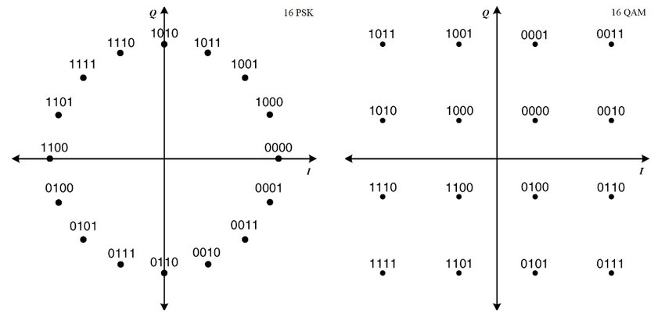
Figure 26: 16-QPSK and 16-QAM [21]
It is worth noting that the type of QAM used, 16-QAM, is not directly comparable to the type of QPSK used, 4-QPSK. The number of constellation points in 16-QAM is a factor of 4 greater that 4-QPSK, meaning that 4-QPSK will always outperform 16-QAM with otherwise identical characteristics of the modulator and demodulator circuit with regards to noise immunity from AWGN. A more fair comparison would be between 16-QPSK (M = 16) and 16-QAM (M = 16), where it is expected that the 16-QAM modulation scheme would outperform the 16-QPSK scheme, due to the more efficient spacing of the symbols in the I and Q plane, as can be seen in the constellation diagram in Figure 26 [8, 22].

References

[1] N. Sharma, et. al, "Performance Comparison of Various Digital Modulation Schemes based on Bit Error Rate under AWGN Channel", 2021. 5th International Conference on Computing Methodologies and Communication (ICCMC), Erode, India, 2021, pp. 619-623, doi: 10.1109/ICCMC51019.2021.9418396. [Online] Accessed: 01/10/2023. Available: https://ieeexplore.ieee.org/abstract/document/9418396?casa_token=S7czvh-fQc0AAAAA:rrHBhMmQOjYm8jzZm9nOuTBgcjP_jn_xQD8G1tkmiz66K45zf9SxT08R7PqAdk4gBFrvESk0KMK71w
[2] S. Bharati, “Implementation of ASK, FSK and PSK with BER vs. SNR comparison over AWGN channel”, 2002. [Online] Accessed: 01/10/2023. Available: https://arxiv.org/ftp/arxiv/papers/2002/2002.03601.pdf#:~:text=The%20ASK%20modulation%20technique%20is,generates%20a%20smaller%20noise%20bandwidth.
[3] Don H. Johnson, “Signal-to-noise ratio”, 2006. Accessed: 01/10/2023. [Online] doi::10.4249/scholarpedia.2088 Available: http://var.scholarpedia.org/article/Signal-to-noise_ratio
[4] Unknown, “Allowable short-term error performance for a satellite hypothetical reference digital path” in “Recommendation ITU-R S.2099-0”, 2016. International Telecommunication Union, Geneva. pp. 4 – 6. [Online] Accessed: 01/10/2023. Available: https://www.itu.int/dms_pubrec/itu-r/rec/s/R-REC-S.2099-0-201612-I!!PDF-E.pdf
[5] G. Smithson, “Introduction to digital modulation schemes”, 1998, pp. 2/1-2/9. [Online] Accessed: 10/10/2023. Available: https://web.archive.org/web/20040827130723id_/http://iaci.unq.edu.ar:80/materias/telecomunicaciones/archivos/infoadicional/Esquemas_de_modulacion_digital.pdf

[6] D.K Sharma, et. al, “Analog and Digital Modulation Techniques: An Overview”, 2010, pp. 551 – 553 [Online] Accessed: 10/10/2023. Available: https://citeseerx.ist.psu.edu/document?repid=rep1&type=pdf&doi=386918821d30fe5f087781d578d8ccdbd09bb3f2
[7] P. Holenarsipur, “I’m OOK. You’re OOK?”, 2009. [Online] Accessed: 10/10/2023. Available: www.analog.com/media/en/technical-documentation/tech-articles/im-ook-youre-ook.pdf
[8] M. Barnela and D. S. Kumar, “Digital modulation schemes employed in wireless communication: A literature review”, vol. 2, no. 2, pp. 15–21, 2014.Accessed: 11/10/2023. [Online] Available: https://citeseerx.ist.psu.edu/document?repid=rep1&type=pdf&doi=995dd33254530d4a079dff1d7cc6598e83f3f02f
[9] Unknown, “IEEE Std 802.11b-1999, Part 11: Wireless LAN Medium Access Control (MAC) and Physical Layer (PHY) specifications: Higher-Speed Physical Layer Extension in the 2.4 GHz Band”, 2000. [Online] ISBN: 0-7381-1812-5. Accessed: 12/10/2023. Available: www.ieeexplore.ieee.org/stamp/stamp.jsp?tp=&arnumber=817038
[10] Unknown, “2nd Generation (GERAN) Introduction”, ETSI. Accessed: 12/10/2023. Available: www.etsi.org/technologies/mobile/2g
[11] Unknown, “3GPP TS 5.004 B17.0.0 (2022-03) Technical Specification GSM/EDGE Modulation”, 2022. [Online] Accessed: 12/10/2023. Available: www.portal.3gpp.org/desktopmodules/Specifications/SpecificationDetails.aspx?specificationId=2708
[12] B. Chirag, et. al, “Comparative performance analysis of various digital modulation schemes in the AWGN channel”, 2017, pp. 2. [Online] Accessed: 13/10/2023. Available: https://ieeexplore.ieee.org/document/8244913

[13] Unknown, “ETSI TR 102 376 V1.1.1 (2005-02): Digital Video Broadcasting (DVB-S2)”, 2005. [Online] Accessed: 13/10/2023. Available: https://www.etsi.org/deliver/etsi_tr/102300_102399/102376/01.01.01_60/tr_102376v010101p.pdf
[14] Unknown, “IEEE Std 802.11ax-2021, Wireless LAN Medium Access Control (MAC) and Physical Layer (PHY) Specifications”, 2022. [Online] Accessed: 11/10/2023. Available: www.ieeexplore.ieee.org/stamp/stamp.jsp?tp=&arnumber=9442429
[15] Unknown, “Nyquist and Shannon's Sampling Theorems”, National Instruments, 2023. Accessed 11/10/2023. Available: https://www.ni.com/docs/en-US/bundle/ni-fgen/page/siggenhelp/fund_nyquist_and_shannon_theorems.html
[16] Unknown, “FIR Filter Design”, Mathworks.com, 2023. Accessed 11/10/2023. Available: https://uk.mathworks.com/help/signal/ug/fir-filter-design.html
[17] I. Jacobs, "Comparison of M-ary modulation systems", Bell System Technical Journal, vol. 46, no. 5, pp. 843-864, May-June 1967, doi: 10.1002/j.1538-7305.1967.tb01717.x. Accessed 17/10/2023. [Online] Available: https://ieeexplore.ieee.org/abstract/document/6769660?casa_token=7KjpXYfonr4AAAAA:EzhwxqP7bpG4mkRtK54oqYkxo0ec1h5XyyO5vg2gK0PITd72trAIUkRjzgOButkdlV4ydO5iQG5ybQ
[18] K. Hamid, et. al, “Performance Evaluation of Digital Modulation Techniques on DS-WCDMA”, July 2013. [Online] Accessed: 17/10/2023. Available: https://www.researchgate.net/profile/Ibrahim-Khider-2/publication/317032621_Performance_Evaluation_of_Digital_Modulation_Techniques_on_DS-WCDMA/links/622dfb433c53d31ba4c1299d/Performance-Evaluation-of-Digital-Modulation-Techniques-on-DS-WCDMA.pdf
[19] G. Breed, “Bit Error Rate: Fundamental Concepts and Measurement Issues” in “High Frequency Electronics”, 2003. Accessed 11/10/2023. [Online] Available: https://highfrequencyelectronics.com/Jan03/HFE0103_Tutorial.pdf

[20] Unknown, “Introduction to Filters: FIR versus IIR”, 2020. Accessed: 17/10/2023. Available: https://community.sw.siemens.com/s/article/introduction-to-filters-fir-versus-iir
[21] A. Davis, “Forward Error Correction” in “Wireless and Networking Designline”, EETIMES.com, 1998. Available: https://www.eetimes.com/forward-error-correction/
[22] Abu-Baker, et. al., “The Impact of Hamming Code and Cyclic Code on MPSK and MQAM Systems over AWGN Channel: Performance Analysis.”, 2021. 8. 9-15. 10.13189/ujeee.2021.080102. Accessed: 17/10/2023. [Online] Available: https://www.researchgate.net/publication/350621597_The_Impact_of_Hamming_Code_and_Cyclic_Code_on_MPSK_and_MQAM_Systems_over_AWGN_Channel_Performance_Analysis
[23] I. Glover, P. M. Grant, “Bandpass Modulation of a Carrier Signal” in “Digital Communications”, 2010. Pearson Education Ltd. pp 391 – 399. [Online] Accessed: 17/10/2023. Available: https://books.google.co.uk/books?hl=en&lr=&id=qaUUCXBSBEwC&oi=fnd&pg=PR19&dq=digital+communications&ots=-cN_wx51UL&sig=l5Dj1lM-jfz9CJfZ4zozc97miDc&redir_esc=y#v=onepage&q=digital%20communications&f=false
[24] S. Mosey (2023), “Digital Modulation” [PowerPoint Slides] Accessed: 18/10/2023. Available: https://moodle.uwtsd.ac.uk/course/view.php?id=1984
[25] S. Chen (2007), “ELEC3028 Digital Transmission – MODEM” [PowerPoint Slides] Accessed: 18/10/2023. Available: https://www.southampton.ac.uk/~sqc/EL334/MODEM-L4.pdf
[26] S. Mosey (2023), “Lecture 10 Advanced Modulation (1)” [PowerPoint Slides] Accessed: 18/10/2023. Available: https://moodle.uwtsd.ac.uk/course/view.php?id=1984

