Information Engineering

Student name: Horatiu Butunoi
Student number: 1918671
Lecturer name: Suneth Fernando

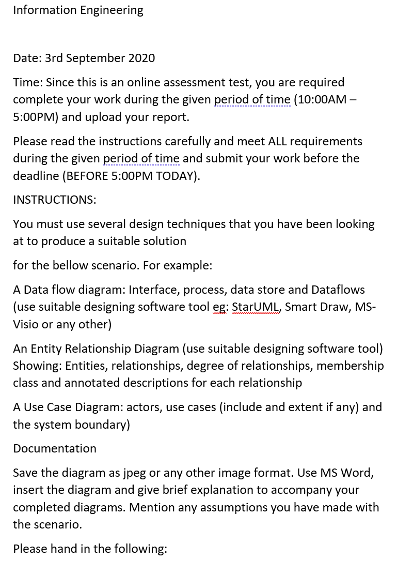



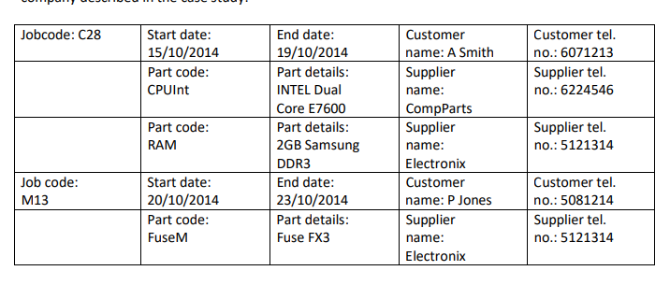

Dear Suneth,

Attached please find a copy of the required diagrams to complete the given issue. I believe them to be accurate to my abilities. Hope that suffices

Thank you,
Horatiu



