

County Lines gangs and vulnerable people: An investigation into what makes vulnerable people more at risk of exploitation and how this can be combated.

Luke Tamplin
2117851
BSc (Hons) Professional Policing Practice

Acknowledgements
I would like to reflect upon my three-year programme and place my thanks to all who have supported me not only academically in the form of university tutors and my area training officers. I particularly thank my partner for her moral support throughout this process, as she has had to also live with the stresses that the programme has brought whilst working full time and juggling family commitments. Furthermore, her support has allowed me to the opportunity to pursue a career as a Police Constable, as I took a considerable pay drop to do so and without her support then it would have been extremely difficult to pursue this career.

Declaration
This work has not previously been accepted in substance for any degree and is not being concurrently submitted in candidature for any degree.
Signed: L. Tamplin
Date: 28/06/2024

STATEMENT 1
This dissertation is being submitted in partial fulfilment of the requirements for the degree of BA.
Signed: L. Tamplin
Date: 28/06/2024

STATEMENT 2
This dissertation is the result of my own independent work/investigation, except where otherwise stated.
Other sources are acknowledged by footnotes giving explicit references. A bibliography is appended.
Signed: L. Tamplin
Date: 28/06/2024

STATEMENT 3
I hereby give consent for my dissertation, if accepted, to be available for photocopying and for interlibrary loan, and for the title and summary to be made available to outside organisations.
Signed: L. Tamplin
Date: 28/06/2024

STATEMENT 4
I hereby give consent for my dissertation, if accepted, to be available on the university’s IT system to those who have consent to use the system.
Signed: L. Tamplin
Date: 28/06/2024

Abstract
The aim of this dissertation was to investigate what makes vulnerable people more prone to exploitation from County Lines gangs. The researcher carried out a thorough critical analysis of current academic literature on the topic of County Lines and vulnerable individuals and investigated ways in which exploitation of these people can be combated.
To aid this research project, online surveys were made available on social media to gather the general public’s knowledge on the subject and ways in which they thought the exploitation of vulnerable people by County Lines gangs could be combated. The findings of the research support a good amount of literature analysed in the literature review section of the dissertation, whilst some conflicts with it.
The main themes identified throughout this project included a lack of education on County Lines, risk factors that aid in the exploitation of vulnerable individuals and tackling individuals’ base vulnerabilities in order to prevent exploitation. The dissertation achieved it’s aim in answering the question: “What makes vulnerable people more susceptible to exploitation from County Lines gangs and how can this be combated?”.

Contents
1. Chapter 1: Introduction 7
1.0 Introduction 7
1.1 Background 7
1.2 Rationale 8
1.3 Aims and Objectives 8
1.4 Structure 9
1.5 Conclusion 9
2. Chapter Two: Literature Review 10
2.0 Introduction 10
2.1 County Lines and Vulnerable People 10
2.2 Risk Factors for Exploitation 12
2.3 Forms and Methods of Exploitation 13
2.4 Prevention of County Lines Exploitation 14
2.5 Conclusion 16
3. Chapter 3: Research Methodology 17
3.0 Introduction 17
3.1 The Research Onion 17
3.1.1 Research Philosophies 18
3.1.2 Approaches 18
3.1.3 Strategies 18
3.1.4 Choices 18
3.1.5 Time Horizon 18
3.2 Techniques: Data collection and data analysis 18
3.2.1 Data collection 18
3.2.2 Survey Design 19
3.3 Sample & Data Analysis 19
3.4 Reliability and Validity 19
3.5 Limitations 19
3.6 Ethical Considerations 20
3.7 Conclusion 20
4. Chapter 4: Analysis of Results 21
4.0 Introduction 21
4.2 Theme One: Risk Factors 21
4.2 Theme Two: Reducing Risk 22
4.3 Theme Three: Are young people more susceptible to exploitation? 23
4.4 Theme Four: Education 24
4.5 Theme Five: How can exploitation be combated? 26
4.6 Conclusion 26
5. Chapter 5: Conclusion and Recommendations 28
5.0 Introduction 28
5.1 Main Findings 28
5.2 Recommendations 29
5.3 Limitations 30
5.4 Future Research 31
5.5 Conclusion 31
6. References 32
7. Appendices 37
7.1 Appendix One – Copy of Questionnaire 37
7.2 Appendix 2 – Questionnaire Answers 40

Chapter 1: Introduction

1.0 Introduction
The aim of this dissertation is to investigate what makes vulnerable people more susceptible to exploitation from County Lines gangs and how can this be combated. This chapter aims to is to provide a background on the dissertation subject as well as a rationale. It will outline the aims and objectives of the project, as well as provide a structure.

1.1 Background
This topic is worthy of discussion as there is a clear issue of exploitation involving vulnerable people in the distribution and supply of drugs in the UK and these are often involved in what is called ‘County Lines’. County Lines are sophisticated and organised forms of criminality, whereby the networks involved distribute drugs from one area of the UK to others. These types of gangs use mobile phone lines and often use children and vulnerable people to distribute the drugs into the areas. This places young and vulnerable people at risk, as the criminals controlling these lines will use several tactics to encourage and force the vulnerable individuals to distribute the drugs for them, which can involve violence and intimidation tactics (National Crime Agency, 2019).
The common age of young people involved in County Lines is usually aged between 15 and 16 years old and the recruitment to these gangs can often occur in school’s and streets in deprived areas. However, vulnerable people of all ages are known to be exploited by these gangs as their vulnerabilities allows gang members to excise control over them. There is often high reward promised to individuals involved in County Lines, and as they are often from deprived areas, the promise of high financial earnings and materialistic possessions can easily sway them (SafeguardingHub, 2023).
Following being recruited by County Lines’ networks, vulnerable people are now placed at high risk of violence from other gangs who wish to steal the drugs from them and will often use violence to do this. Also, if any drugs are taken by another gang or intercepted by the police then this could mean that the vulnerable individual is then responsible for the loss, and they are then forced to commit further offences on behalf of the gang or risk serious harm (SafeguardingHub, 2023).

1.2 Rationale
The researcher’s rationale for investigating this subject is due to the ever-increasing number of vulnerable individuals being exploited by County Lines gangs. Research published in 2019 by the Children’s Commissioner found that an estimated 27,000 children in England identified as gang members (Children's Commissioner, 2021). Whilst there is a substantial amount of research available on County Lines gangs, there seems to be a lot less on how the exploitation of vulnerable people can be stopped. Therefore, it is justified to conduct this research as this dissertation will provide further insight into the exploitation of vulnerable people and could offer educational awareness to potential victims.

1.3 Aims and Objectives
The aim of this dissertation is to investigate County Lines gangs and their exploitation of vulnerable individuals, specifically looking at ways in which exploitation can be combated. There is also a potential to provide recommendations on how to stop exploitation of vulnerable people.
These aims will be achieved by completing the following objectives:

- To investigate and analyse current academic literature on County Lines gangs, vulnerable people and ways in which exploitation can be stopped

- To undertake an appropriate research approach in order to gain an understanding on the public’s knowledge of County Lines gangs

- To analyse primary data collected in order to establish themes in regard to County Lines gangs and the exploitation of vulnerable individuals

- To provide recommendations, should they be needed, on combating the exploitation of vulnerable people

1.4 Structure
This dissertation will be separated into five chapters in order to ensure that each objective is achieved. Chapter one has provided a background on the dissertation subject as well as a rationale for research and aims and objectives.
Chapter two will comprise of a literature review which will analyse current academic research on County Lines gangs and their exploitation of vulnerable people. It will help identify risk’s that make individuals vulnerable to exploitation.
Chapter three will identify the most appropriate method for primary research for this project.
Chapter four will analyse the primary data collected through the method identified in the previous chapter. This chapter will help to identify themes found during the research.
Finally, chapter five will bring the dissertation to an end by deliberating and reviewing the aim of the research project. The main findings will be discussed along with limitation to the research and any recommendations identified.

1.5 Conclusion
Chapter one of the dissertation has introduced the research subject, providing a background, rationale and has also identified the aim and objectives of the project. The following chapter will comprise of a literature review, analysing current academic literature on the dissertation subject.

2. Chapter Two: Literature Review

2.0 Introduction
The aim of this chapter of the dissertation is to review and analyse current available academic literature on how vulnerable individuals are more susceptible to exploitation from county lines gangs, focusing mainly on methods to combat this. It will also look at the current education available for individuals on exploitation and its effectiveness, possibly identifying any gaps and highlighting the need for more in-depth approaches. Additionally, this chapter aims to achieve the first objective of the dissertation, which is as follows:

To research and analyse available literature concerning vulnerable people being exploited by ‘County Lines’ gangs.

This objective will be reached by scrutinising literature obtained from online databases such as the University of Wales Trinity Saint David’s (UWTSD) e-learning online library database and Google Scholar, which is an online search engine able to filter for peer-reviewed and verified academic sources. Sources consist of academic journals, professional textbooks, government publications and other accredited sources. Consistently used search terms used to narrow down relative literature included ‘county lines’, ‘county lines and young people’, ‘county lines and vulnerable people ‘county lines and exploitation’, ‘vulnerability’ and ‘county lines education’.

2.1 County Lines and Vulnerable People
County lines gangs and their recruitment of vulnerable people has become a major issue in the last decade. In 2015, Her Majesty’s Inspectorate of Constabulary (HMIC), defined a vulnerable person as one who is in need of special care, protection or support due to age, disability or risk of neglect or abuse. They reported that during a 12-month period, 10.7% of all crimes in England and Wales involved a vulnerable person (Her Majesty's Inspectorate of Constabulary , 2015)​ ​. Factors to vulnerability in adults often includes drug addiction and mental health problems and in children can range from poverty and family breakdowns to behavioural and development disorders​ (O'Hagan & Edmunson, 2021). However, Windle et al​ (2020)​, highlight the lack of comprehension vulnerable people, especially young individuals, have on exploitation. Many refuse to see themselves as vulnerable to exploitation from these gangs, preferring to class themselves as resilient due to the fact that they are earning their own money.

In 2019, a qualitative study undertaken by Moyle found that vulnerable individuals found working for county lines gangs was preferable to other activities that generated income, despite being initiated into it with violence and intimidation​ (Moyle, 2019). The study draws predominantly on the interviews with 18 individuals, 14 of whom had worked on behalf of out-of-town dealers (OTD) and 4 of whom had purchased drugs from these dealers. The 14 individuals who had worked directly for the OTD’s had all worked as drug runners and 7 of these had also ’rented’ their accommodation out which is known as being ’cuckooed’. All interviewees had factors of vulnerability, with the majority being unemployed and relying on benefits, some experiencing homelessness and most having mental health problems and/or learning disabilities (Moyle, 2019). As found by Windle et al (2020), Moyle (2019) also highlights these individuals lack of insight on exploitation. Despite all participants having many traits of vulnerability, the majority saw their situations as “mutually beneficial”, with some also believing their reputations helped reduce their risk of exploitation by OTD’s.

Additionally, county lines gangs recruit many young individuals into their criminal enterprises as they are easy to control, cheap to employ and are seen as less likely to be detected by law enforcement​ (Williams & Finlay, 2019)​. Children aged between 15 and 17 years old form the bulk of vulnerable individuals involved in county lines gangs. A report by the National Crime Agency (NCA) found that 65% of the UK’s police forces reported the exploitation of children by county lines gangs (National Crime Agency, 2017). Due to the rapid rise in child exploitation, the government has now deemed it as a form of child abuse therefore requiring a response from multi-agency partnerships. However, Firmin et al (2019) calls attention to the lack of national strategy available for children and adolescents being harmed outside of their families.

Choice of location for county lines gang activity relies heavily upon on gang members views that less urban areas will have more naïve people. Their vulnerability comes in the form of knowing little about gangs and their dealings, making it easier for gang members to exploit them (Jaensch & South, 2018). Data from the National Crime Agency (2015) suggests that dealers also target these places due to high unemployment and deprivation, again, giving them access to more individuals more vulnerable to exploitation.

2.2 Risk Factors for Exploitation
In 2017, the NCA conveyed that 74% of UK police forces reported the exploitation of vulnerable people by county lines gangs. This included individuals with both mental and physical health issues as well as children and young people​ (National Crime Agency, 2017)​. Coliandris​ (2015)​ identified circumstances such as homelessness, experiences of trauma/abuse, financial problems, and mental health issues as some of the main risk factors for involvement in county lines criminal organisations.

A study undertaken by Havard et al (2023) found county lines gangs recruitment of girls and young women to be specific to their gender, with their purpose being that law enforcement were less likely to suspect them of offences. This sample highlighted the link between coercive control and young girls and women involved in gang activity. Gendered inequality comes into play here as coercive control is seen as an extension of it (Stark & Hester, 2019). Females in gangs are found to be at a higher risk of violence and exploitation due to hyper masculinity and objectification of women being what’s “normal” in street culture (Valdez, 2007).

Children and young people form the majority of vulnerable individuals exploited by county lines gangs. They are lured in by the offer of money and living a certain lifestyle, often seeing older gang members as people to “look up” to and this makes them easy targets for recruitment. Others may become involved due to other family members, such as siblings and parents, already being part of the gang (O'Hagan & Edmunson, 2021). Children, however, can have a lack of insight in recognizing that they are being exploited as evidenced by Robinson. A sample undertaken by Robinson et al (2019), reported on the knowledge that some young people knew they were being “used” but questioned how they would otherwise make money if not through county lines labour.

Vulnerable adults are often coerced using similar tactics used to exploit children and young individuals. Adults with physical and mental disabilities are exploited, along with those who are already addicted to drugs. These addicts are exploited easily as dealers can establish a “debt bondage” between them, whether it be real or perceived (The Crown Prosecution Service, 2022). Women are found more likely to be sexually exploited rather than subjected to physical violence such as that of their male counterparts. O’Hagan and Edmunson (2021) report that the girls are coerced into feeling beholden to gang members for providing them with protection and financial stability. Overall, many risk factors that vulnerable people have that make them easy targets for county lines gangs.

2.3 Forms and Methods of Exploitation
Over the years, county lines gangs have built upon and improved their methods and forms of exploitation. One such method that has emerged in recent years is that of “cuckooing”. The Crown Prosecution Service (CPS) defines “cuckooing” as members of county lines networks using violence or coercion to occupy the abode of a vulnerable individual (The Crown Prosecution Service, 2022). Using forms of exploitation such as threats and violence, gang members infiltrate vulnerable people’s homes to use as they wish. However, Spicer et al (2019) found this not to be the case, instead reporting that their methods of taking over someone’s property were much more sophisticated. As stated previously, some vulnerable individuals see working for county lines gangs as worth the risk, however this is not usually the case when it comes to being “cuckooed”. According to Moyle (2019), dealers may request to stay for a short period with the promise of drugs and then refuse to vacate the property. This then leaves the individuals who have been exposed to “cuckooing” at a higher risk of further exploitation, as it increases their risk of criminalisation as well as exacerbates their social segregation and vulnerabilities (Spicer, et al., 2019).

Another method of exploitation is that of “debt bondage” which the CPS (2022) states is when a debt, whether it be a real one or a perceived one, is used to coerce individuals into carrying out labour for their criminal enterprises. This form of exploitation is used widely, especially amongst young vulnerable individuals. They are enticed into county lines gangs with offers of money, food, clothes and even improved status but are then made to feel that they owe their exploiter a debt (Stone, 2018). A study by Havard, et al., (2023), found that “debt bondage” is prevalent with females as it aids gang members in coercing young girls and women into sexual activity. Should any of the young girls get caught or have drugs removed from them, whether that be by law enforcement or rival gangs, they were held personally responsible and forced to ‘pay back’ their debt in many ways, one of the main ones being through sexual activity.

Coercion is also seen to be one of the major forms of exploitation deployed by county lines gangs, both interpersonal and impersonal coercion. Interpersonal coercion occurs directly and affects individuals whereas impersonal coercion is associated with the environment and factors such as poverty and the effects of gang related violence. A widely used instance of interpersonal coercion is that of grooming (NSPCC, 2023). Young individuals are given money and lavish gifts such as phones and expensive clothes/trainers and are often lured into this via social media. Atkinson-Shepard et al (2023), points out the discrepancy in past literature on exploitation, due to the rise in social media usage over past years. Social media is seen as a new coercive environment in which interpersonal and impersonal coercion merge. Furthermore, additional research by Brewster et al (2021), found that due to the Covid-19 pandemic, online exploitation became a lot more prevalent. Social media platforms such as Instagram and Snapchat were used to promote the dealers wealth, aiding in their ability to attract and groom young individuals. Professional practitioners interviewed in this sample spoke on the increase of suicide attempts by young people due to being exploited online. Despite findings in this report, there remains little insight into the role social media plays in county lines criminal activity.

2.4 Prevention of County Lines Exploitation
One of the main themes found throughout the literature concerning prevention was the need to enforce measures that aim to prevent vulnerable individuals from becoming involved in county line gang activity. Windle et al (2020), reports on the long-term impacts county lines involvement can have on young people due to facing adverse childhood experiences (ACEs). ACEs is known to increase a person’s risk for both physical and mental health problems in their future, as well as increase their risk of further exploitation. However, Moyle and Coomber (2012), suggest that many children and young people involved in county lines already have experienced ACEs prior to being recruited by gang members, which has therefore made them more vulnerable to exploitation. This only further strengthens the pattern that has been found throughout the literature that suggests that the most successful way exploitation of vulnerable people by county lines gangs can be combated, is by tackling these individuals’ base vulnerabilities.

In another study, Hayman et al (2024), brings forth the suggestion of education in the prevention of exploitation. They suggest that modification of the vulnerable persons behaviour and environments can reduce the opportunities for gang members to exploit them. The sample included 122 participants, however, over 90% were female and white which is a not a representative sample of the UK population. Therefore, they found little evidence that education would make a difference in reducing the risk of exploitation. In comparison, Hargreaves et al (2023), completed a review on a County Lines 12-week education programme run by the Liverpool Football Club Foundation and saw positive results. The programme involved 14 secondary schools in Liverpool and involved collaborative work between funders and partners of the foundation in improving participants knowledge on county lines. They also aimed to change individuals’ attitudes on county lines and other criminal activity such as knife crime and exploitation. The programme saw major success, especially in high attendance levels and engagement suggesting that the content and method of delivery was effective in helping these young individuals to make positive changes (Hargreaves, et al., 2023).

Olver and Cockbain (2021), argue that the implementation of current legislation is imperative in reducing the risk of exploitation, rather than introducing new legislation. Participants of this study underlined people’s lack of understanding on legislation such as the Modern Slavery Act 2015, claiming it is being underused and suggested using it to its full potential before implementing any new legislation. Research by Williams and Finlay (2019), express the vitality in organisations working together to achieve prevention of exploitation. Raising awareness amongst frontline-staff social services, healthcare and education is key. Foundations also mention this in their Building the Foundations strategy (Foundations, 2023). Funded by the UK government, the aim of Foundations is to ensure vulnerable children have good relationships in their lives in order to prevent crisis. This again ties in with theme of tackling people’s vulnerabilities in order to reduce the risk of exploitation. Foundations believe that strengthening familial relationships aids in reducing the risk of future mental health problems as well as giving children and young people better chances in life (Foundations, 2023).

2.5 Conclusion
To conclude this literature review, it is evident that there is a variety of research available on county lines and the exploitation of vulnerable people. This literature review has emphasised the sheer number of exploited individuals by county lines gangs, especially the number of children and young people (National Crime Agency, 2017). It has also stressed the importance in trying to reduce childhood vulnerabilities, therefore reducing risk factors, for now and in their futures, to being exploited by criminals and gangs. Education of vulnerable young people was found to be successful in some instances (Hargreaves, et al., 2023), and whereas the education of individuals on the frontline was mentioned, there was very little evidence on whether this does indeed reduce vulnerable people’s risk of exploitation. The literature review did outline other gaps in the research, including the fact that many sample studies undertaken were found to have inconsistencies due to limited range in participants as many individuals involved in county lines are reluctant to discuss their experiences for fear of retribution from dealers.

3. Chapter 3: Research Methodology

3.0 Introduction
This chapter aims to identify the most appropriate research approach required to conduct the research project on county lines and their exploitation of vulnerable individuals.
Typically, there are two main types of research: primary and secondary. Bryman (2016) describes primary research as information that is collected by an individual for a specific purpose. Secondary information is that which is obtained from previous studies by another researcher for their own intent and purposes. To further build on available literature and contribute to existing debates, primary research will be the most effective.

3.1 The Research Onion
One of the most popular methods used in academic research is that of “The Research Onion” by Saunders et al, (2016).
Figure 1.1 highlights the researchers chosen research process.

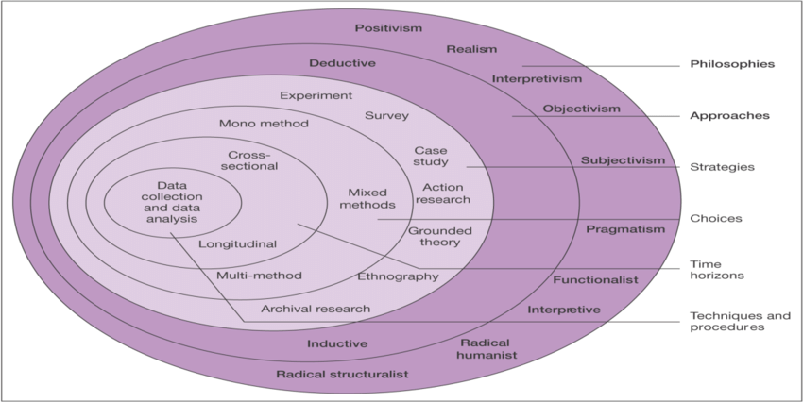

(Saunders, et al., 2016)

3.1.1 Research Philosophies
The first “layer” covers research philosophies. The approach that will be taken for this project is “Interpretive” as Saunders et al, (2019), states that this is a good method in enhancing an already existing academic understanding of a subject.

3.1.2 Approaches
The next “layer” is the approaches. An inductive approach will be used for this research project. Bryman (2016), states that this method involves the researcher basing their theory on their findings and observations, whereas a deductive approach does the opposite, with the researcher looking for specific findings that will either prove or disprove their theory.

3.1.3 Strategies
The third “layer” is one for strategies. Questionnaires/surveys will be created via GoogleDoc and subsequently shared via social media platforms, such as Facebook and Instagram, in order to have a wide and diverse sample range via the general public, which Dewaele (2018), states strengthen the ecological legitimacy of the resulting database.

3.1.4 Choices
The next “layer” is choices. This study will use a mixed method design. This combination method allows for a more complete analysis of the research subject as the qualitative and quantitative methods complement one another (Migiro & Magangi, 2011). A quantitative method will be used in this research project as the researcher will be converting data from the questionnaires/surveys into percentages.

3.1.5 Time Horizon
The final “layer” helps the researcher to identify how long their research is going to take to collect. There are two different types of research designs, longitudinal and cross-sectional (Kesmodel, 2018) . A cross-sectional study comprises of observing previously collected data from a specific point in time to another. Since the questionnaires will be distributed over a short period of time, a cross-sectional study is the most appropriate time horizon.

3.2 Techniques: Data collection and data analysis

3.2.1 Data collection
Primary research is the process of collecting direct data on a specific subject and for this project, questionnaires will be used to do this. There are many advantages as well as disadvantages to using questionnaires as a form of primary data collection. Advantages include the collection of high-quality data if planned properly, as well as getting more honest answers from the public due to the mantle of anonymity. However, disadvantages can include confusion to participants caused by the questions, resulting in subpar answers as well as barriers such as language and poor literacy skills (Marshall, 2005). To prevent this, a brief description on the subject of the dissertation project will be included as the beginning of the questionnaire as well as the researcher’s student email address for any questions relating to the project.

3.2.2 Survey Design
The online questionnaire will contain a mix of both open-ended and closed questions. This is to ensure a more diverse range of data. Whilst closed-ended questions are seen as the better option for online surveys as they are seen as less cognitively demanding, they can be more biased as they are not providing participants with an option to express their own thoughts and feelings. Whereas open-ended questions, whilst more complicated to use for online surveys, can provide more detailed and informative responses (Connor Desai & Reimers, 2018).

3.3 Sample & Data Analysis
Ghauri & Gronhaug (2005), highlight the importance of not having too large of a sample size as it does not allow for comparison. The target sample size for this project is between 50-75. The questionnaire will be distributed on social media for views on the public. The gathered data will then be analysed through the GoogleDocs survery tool as this will allow for several advantages such as easy to view results and ready-made charts depicting results in percentages.

3.4 Reliability and Validity
Valid data is that which is accurate and peer-reviewed, with reliability coming from consistent results from obtained from data being consistently collected (Fitzner, 2007). As stated above, questionnaires are found to be dependable sources of data collection as they are a simple way to gather short response from participants, are less time consuming and can easily be kept anonymous.

3.5 Limitations
Due to the nature and sensitivity surround the topic of county lines, it is inevitable that there will be limitations experienced by the researcher. One such limitation will be the lack of participation from young, vulnerable individuals who are seen to be the ones most commonly exploited by county lines gangs due to the university’s ethics policies. The short time frame in which the questionnaire will be live on social media could also be a limitation. This is due to the researchers own time limitations as well as deadlines for university work. Another such limitation could be the general populations lack of knowledge on county lines gangs and how they operate. This will hopefully be combated by the inclusion of a small brief on county lines gangs at the start of the questionnaires.

3.6 Ethical Considerations
Prior to undertaking this research project, an in-depth ethics form was completed and submitted. As stated in the ethics form, all primary research gathered will be voluntary with the participants right to withdraw their consent at any time clearly stated within the questionnaires. All participants will also be informed on the nature of the research as well as how their data will be used for the dissertation project. Anonymity and confidentiality of participants will be kept throughout, and all information will be stored on a password protected device.

3.7 Conclusion
This chapter of the dissertation has outlined the most suitable form of research methodology appropriate for this dissertation as well as achieved the second objective for this dissertation. The next chapter will present these findings, analysing the data in order to further explore county lines and their exploitation of vulnerable individuals.

4. Chapter 4: Analysis of Results

4.0 Introduction
The previous dissertation chapter outlined the methodology and methods used in this research. During this chapter, the researcher will present and analyse data collected via primary research. This was done in the form of an online questionnaire in which 60 individuals participated. Data analysis is the process of collecting and combing through data in order to establish patterns and/or themes. For this research project, data was collected and analysed via Google Docs using their online survey tool. The questionnaire was then shared online via social media platforms such as Facebook and Instagram. Consent to use participant’s answers in this dissertation was gained in the first question of the survey. A brief overview on County Lines gangs and how they operate was provided at the beginning of the questionnaire for any participants unaware of them beforehand.

4.2 Theme One: Risk Factors
The sixth question asked in the questionnaire, was if participants believed there were certain risk factors that increased the chance of individuals being exploited by County Lines gangs. The resulting data, shown below in Figure 2.1, found that 86.7% of participants agreed that certain risk factors attribute to individuals’ vulnerability to exploitation by County Lines gangs. Participants were also asked in question number 7 if they believed circumstances such as homelessness, experiences of trauma/abuse, financial problems and mental and physical illnesses made up some of these risk factors. For this, shown below in Figure 2.2, the majority of participants selected all of the aforementioned circumstances as risk factors. This data is in line with research identified in the literature review, whereby Coliandris (2015), highlights these circumstances as being major risk factors in individuals found to be recruited using exploitation into County Lines gangs.

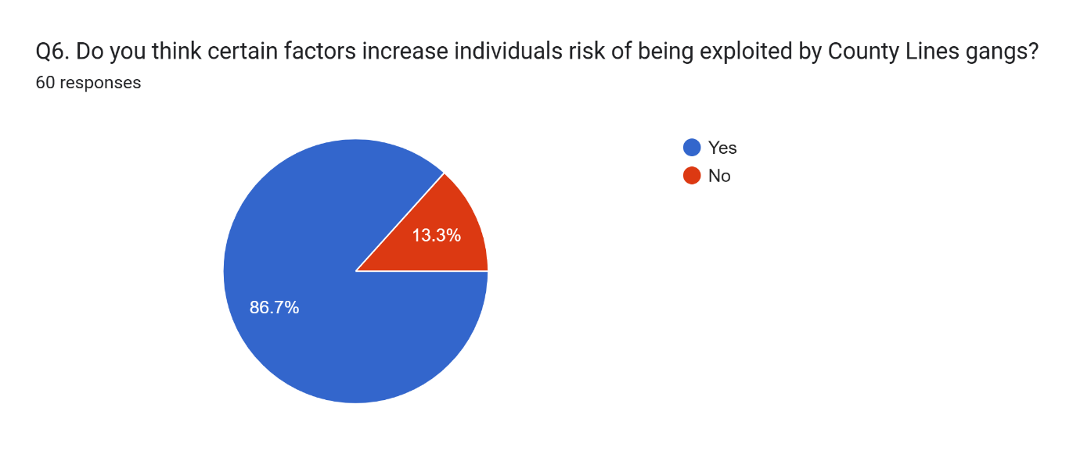

Figure 2.1 – Pie chart showing participants answers for question 6

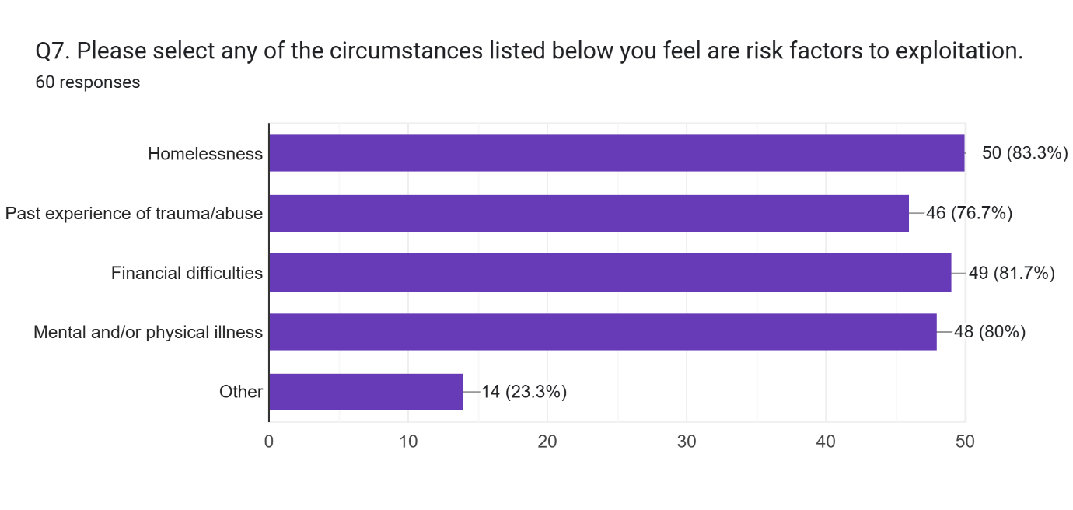

Figure 2.2 – Bar graph showing participants answers for question 7

4.2 Theme Two: Reducing Risk
Following on from the previous theme, participants were asked in question eight if they believed there were ways in which individuals’ risk of exploitation could be reduced. Of the 60 participants, 75% responded that they believed there were ways in which individuals’ risk to exploitation from County Lines gangs could be reduced. 20% concluded that the risk could not be reduced and the remaining 5% were unsure, all shown below in Figure 2.3. This correlates with much of the research analysed within the literature review. Hayman et al (2024), suggests education to be a major factor in reducing the risk of exploitation. In contrast, Moyle & Coomber (2012), believe that reducing individuals’ base vulnerabilities is key in reducing risk.
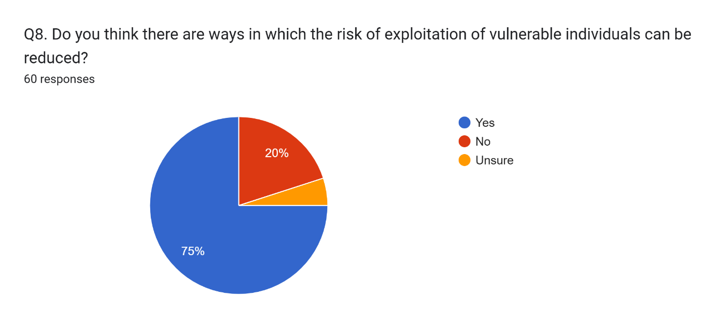

Figure 2.3 – Pie chart showing participants responses to question 8

4.3 Theme Three: Are young people more susceptible to exploitation?
When asked this question, which was the fourth in the questionnaire, 80% of participants answered yes. 11.6% stated they were unsure and the remaining 8.3% saying no, depicted below in Figure 2.4. Regarding a specific age range in question five, seen below in Figure 2.5, 36.7% believed individuals between the ages of 12-18 to be more susceptible to exploitation, with 45% choosing the ages of 18-25 and the remaining 18.3% choosing 25+. Whilst research analysed in the literature review confirms that most of the vulnerable individuals recruited into County Lines gangs are between the ages of 15-17 years old (Williams & Finlay, 2019), it doesn’t necessarily mean that they are more susceptible to exploitation. Previous findings found vulnerable adults just as susceptible to exploit due to mental and physical health issues, as well as drug use (O'Hagan & Edmunson, 2021).

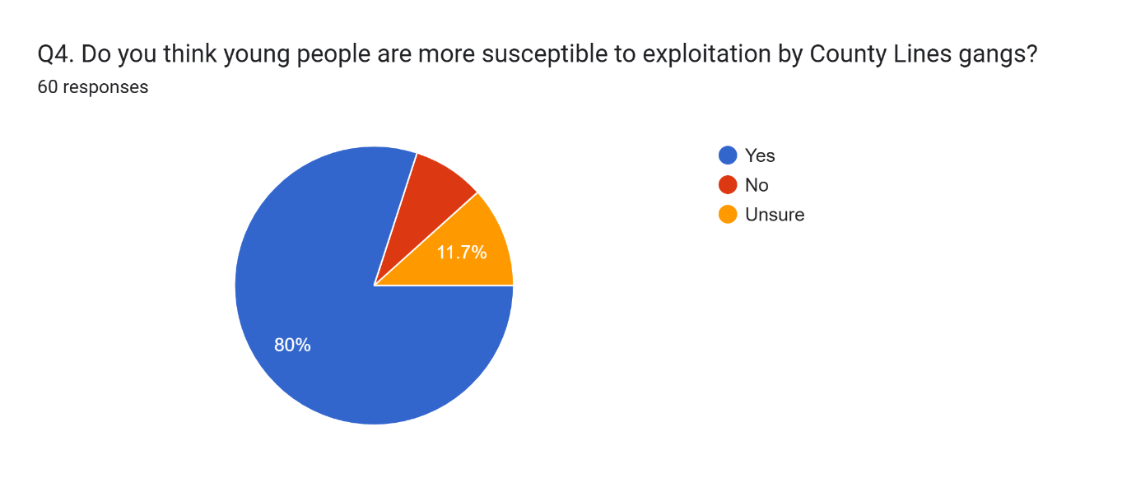

Figure 2.4 – Participants answers to question 4

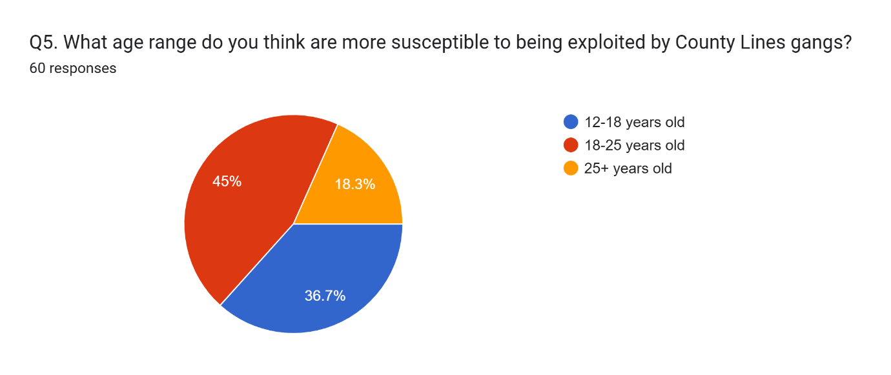

Figure 2.5 – Participants responses to question 5

4.4 Theme Four: Education
When asked whether they believed education on County Lines would help to reduce the risk of people being exploited in question nine, 96.6% of participants said yes, with the remaining participants being unsure, shown below in Figure 2.6. This majority percentage coincides with a review undertaken by Hargreaves et al (2023). The review was of a 12-week programme run for secondary school students by the Liverpool Football Club Foundation, aiming to provide education on County Lines and they had positive results with high attendance and engagement levels. Additionally, only 28.3% of participants in the primary research were aware of current education provided on County Lines in question ten, whether that be through schools or charities etc. The third question asked of participants in the questionnaire was whether they were aware of County Lines gangs, and what they do, prior to reading the brief at the beginning of the questionnaire. Shown below in Figure 2.7, only 55% of participants answered yes to this question, with the remaining 45% answering that they were unaware of these gangs. The answers to these questions truly highlight the lack of awareness of County Lines gangs most of the public have, also showing that there is not enough education being provided on it.
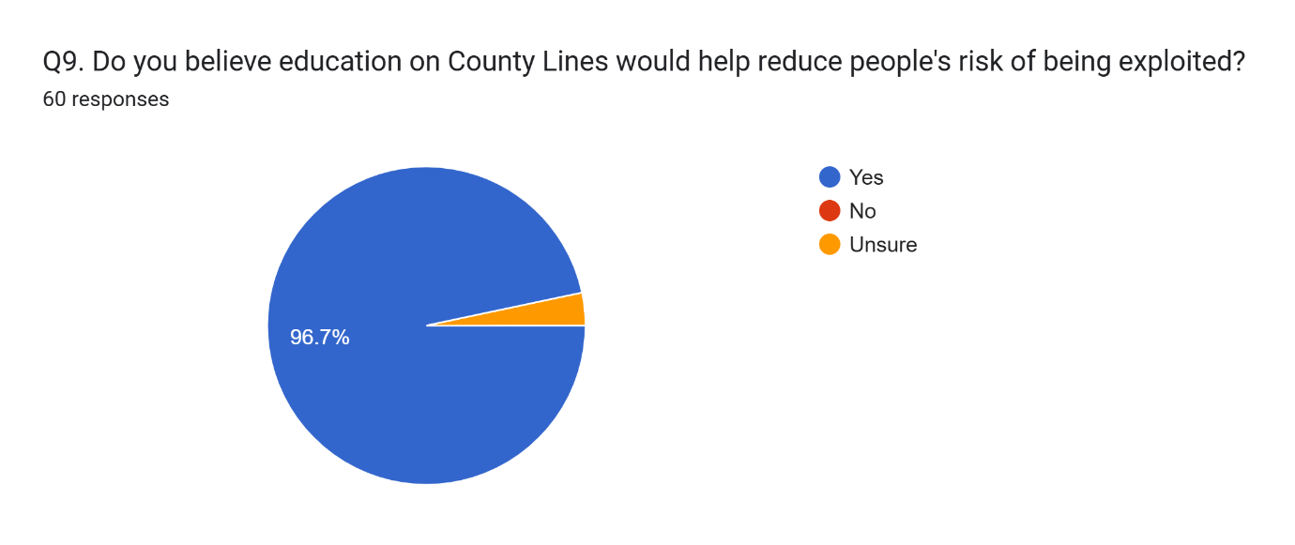

Figure 2.5 – Participants answers to question 9

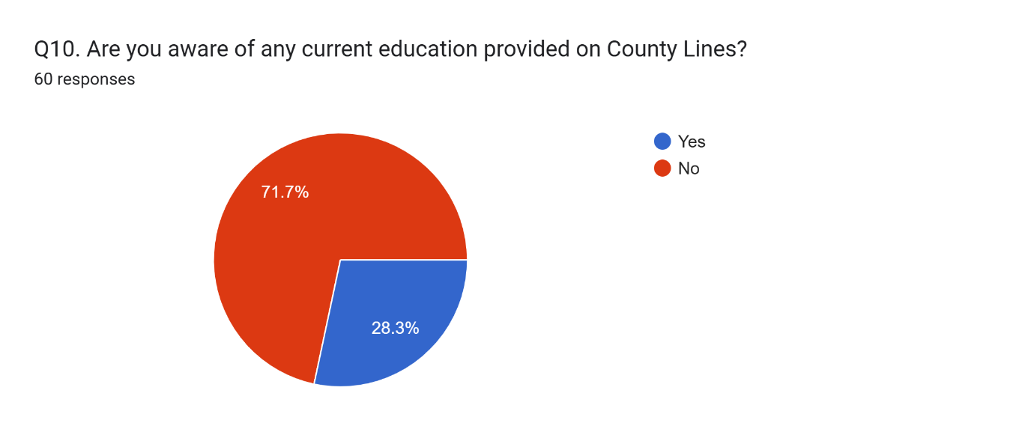

Figure 2.6 – Participants answers to question 10

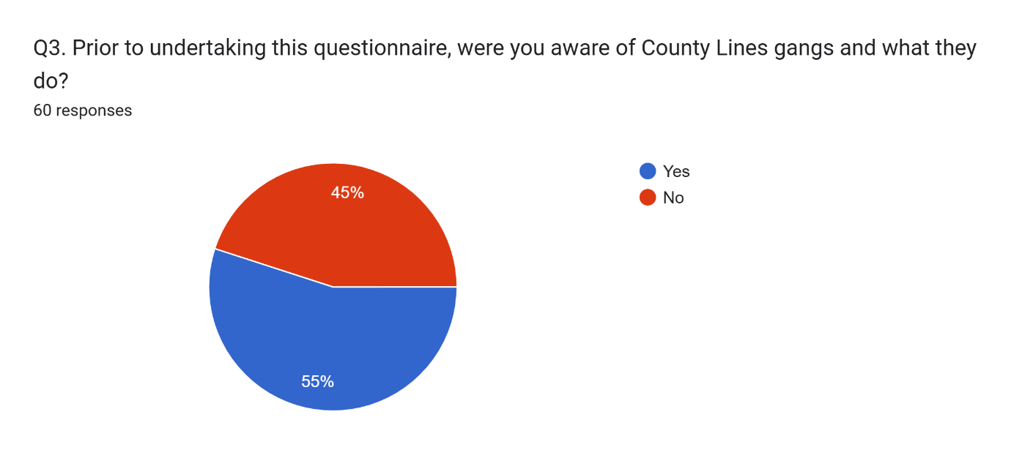

Figure 2.7 – Participants answers to question 3

4.5 Theme Five: How can exploitation be combated?
Participants were asked in question eleven to provide an opinion on how they thought exploitation of individuals by County Lines gangs could be combated. When analysing the data, it was found that 46 participants had highlighted education as the main way to combat exploitation. Other answers included information being provided in GP surgery’s, schools, hospitals etc. Not many of the answers provided an outlook in combating the exploitation of adults, most answers were centred around children. This provides the assumption that many people believe the best chance of reducing risk is when these vulnerable individuals are young. This data correlates with findings in the literature review, whereby Williams & Finlay (2019) express the importance of inter-agency working in reducing young people’s vulnerabilities, therefore reducing their risk of exploitation. The strategy of the UK government funded charity Foundations is also to tackle vulnerabilities in children in order to give them a better chance in life and reduce their risk of future mental health problems (Foundations, 2023).

4.6 Conclusion
This chapter of the dissertation has successfully achieved the aim of the project. In conclusion, the data collected from this study has identified the general public’s lack of awareness regarding County Lines gangs and how they operate. Research found in the literature review suggested that there was an adequate amount of education available on County Lines, however this data suggests otherwise. Public perception on combating exploitation is highly focused on the increase of education overall. The next chapter will achieve the final objective of the dissertation.

5. Chapter 5: Conclusion and Recommendations

5.0 Introduction
The previous chapter of the dissertation analysed data found within this research project through online surveys and expressed the main findings. This final chapter will seek to conclude and provide recommendations on the dissertation subject as well as highlight any limitations and need for further research.

5.1 Main Findings
Throughout the research project there have been three main findings, with many supporting research found in the literature review. To begin with, whilst there is a variety of literature available on the subject of County Lines and the exploitation of vulnerable people, there seems to be very little education on this available to the general public. This is supported by primary data collected, which showed that of 60 survey respondents, only 28.3% were aware of any education provided on county lines, as seen in Figure 2.6 below.

Figure 2.6 – Pie chart showing participants answers to question 10
Secondly, there are many different risk factors that have been found that make people more susceptible to exploitation. Coliandris (2015) identifies circumstances such as homelessness, experiences of trauma/abuse, financial problems and physical and mental health issues as some of the main risk factors. This was also supported by primary data collected, shown in the below Figure 2.2, whereby of 60 participants, majority of them agreed that these circumstances were main risk factors. Whilst there seems to be some support found for young people suffering from vulnerabilities such as this, a lot less was found for adults suffering from the same.

Figure 2.2 – Graph showing participants responses to question 7

Finally, following on from identified risk factors, the main way in which vulnerable individuals’ risk of exploitation can be combated was found to be tackling these vulnerabilities as early on as possible. Both primary data and secondary research concluded that the most successful way to prevent exploitation is ideally childhood intervention, in order to prevent them from developing said vulnerabilities.

5.2 Recommendations
From this research project, there are many different recommendations which can be made in relation to combating the exploitation of vulnerable people. These recommendations are made purely from the researchers own perspective following their primary findings which have been linked in with data found throughout the research project.
The first recommendation that can be made is an increase in education on County Lines. With County Lines becoming an ever-increasing criminal enterprise and their exploitation of vulnerable people being astoundingly high, education is vital. Local police forces and schools need to be providing children and parents with information on these criminal gangs and ways in which they exploit people, especially young people. There should be more awareness made on social media platforms, which is one of the main ways of communication these days, especially with young people. However, education should not just be aimed at people at risk of being exploited, but also towards the general public and professionals working in settings with vulnerable individuals.
Another recommendation is increased support for vulnerable individuals, especially adults. Whilst undertaking this research project, there seems to be a lot of data on the importance of providing support to children who may be susceptible to exploitation, but little on providing the same support to vulnerable adults. Research showed that these adults can be just as vulnerable as children, however, primary data showed public perception is the opposite.
The last recommendation to be made is a crackdown on children’s involvement in county lines gangs. This recommendation can be linked in with the others, as more education and support can aid in this. More parental supervision is needed, especially with young people using social media platforms which is an easy way for gangs to recruit. More opportunities in the community for positive activities can prevent children becoming enticed by offers from gang members. One of the key findings in relation to preventing exploitation of vulnerable children is them having positive relationships in their lives. Having clubs and support outside of school times and providing them with good role models can be essential.

5.3 Limitations
There were some limitations to this research project. One of these limitations was the time scale and size of the project. Due to this research being done alongside working full time, there were many more options that could have been explored, especially when collecting primary data, that was unfortunately not possible.
Another limitation was the sensitive subject of the project. Ideally, data collected from primary research would have involved individuals involved in county lines gang activities, however, this was unlikely due to the nature of the survey distribution. Having such individuals take part may have provided significant additional primary data, but again, was not really possible for this project.

5.4 Future Research
County lines gangs and their exploitation of vulnerable people is becoming more and more frequent and it is a subject on which the researcher feels there is not enough data on. There were a lot of limitations found in secondary data due to small sample sizes or participants not of an inclusive representative etc. Whilst there was much data on the different risk factors that make vulnerable individuals susceptible to exploitation, there was not much on methods to combating these vulnerabilities, specifically for vulnerable adults. The researcher feels that a lot of the data surrounding this subject is focused mostly on how to prevent children from exploitation, which on one hand is a very positive thing. It does, however, overlook vulnerable adults and what can be done to reduce their risks of being exploited.

5.5 Conclusion
In conclusion, this dissertation has brought attention to county lines gangs and their exploitation of vulnerable people, focusing on what can be done to combat this. The researcher has presented key findings on what makes vulnerable people more susceptible to exploitation, highlighting current research on prevention methods whilst also identifying gaps in the literature. These gaps and recommendations have been outlined in this chapter, along with the need for future research. Future research could provide much needed expansion on current knowledge and also help to reduce the overall risk of exploitation from criminal gangs which would be hugely beneficial.

References
Atkinson-Shepard, S., Dando, C., Ormerod, T. & Robinson, B., 2023. Coercion and crime: Convergences, divergences and 'county lines'. Criminology and Criminal Justice, 1(1), pp. 1-20.

Brewster, B., Robinson, G., Silverman, B. W. & Walsh, D., 2021. Covid-19 and child criminal exploitation in the UK: implications of the pandemic for county lines. Trends in Organized Crime, 26(1), pp. 156-179.

Bryman, A., 2016. Social Research Methods. 5th ed. London: Oxford University Press.

Children's Commissioner, 2021. Children will keep dying on our streets until there is a joined up public health response to gangs. [Online]
Available at: https://www.childrenscommissioner.gov.uk/news/children-will-keep-dying-on-our-streets-until-there-is-a-joined-up-public-health-response-to-gangs/
[Accessed 20 November 2023].

Coliandris, G., 2015. County lines and wicked problems: Exploring the need for improved policing approaches to vulnerability and early intervention. Australasian Policing, 7(2), pp. 25-35.

Connor Desai, S. & Reimers, S., 2018. Comparing the use of open and closed questions for Web-based measures of the continued-influence effect. Behavior Research Methods, 51(1), pp. 1426-1440.

Dewaele, J.-M., 2018. The Palgrave Handbook of Applied Linguistics Research Methodology. 1st ed. London: Palgrave Macmillan.

Firmin, C., Wroe, L. & Lloyd, J., 2019. Safeguarding and exploitation - complex, contextual and holistic approaches. [Online]
Available at: https://tce.researchinpractice.org.uk/wp-content/uploads/2020/02/Safeguarding-and-exploitation-complex-contextual-and-holistic-approaches.pdf
[Accessed 14 January 2024].

Fitzner, K., 2007. Reliability and Validity A Quick Review. The Science of Diabetes Self-Management and Care, 33(5), pp. 775-780.

Foundations, 2023. Building The Foundations. [Online]
Available at: https://foundations.org.uk/wp-content/uploads/2023/06/Foundations_Our-Strategy-2023-2027_DIGITAL_AW-v4.pdf
[Accessed 30 January 2023].

Ghauri, P. N. & Gronhaug, K., 2005. Research Methods in Business Studies: A Practical Guide. 3rd ed. London: Pearson Education.

Hargreaves, F. et al., 2023. County Lines and the power of the badge: the LFC Foundation's approach to youth intervention. Safer Communities, 22(2), pp. 91-105.

Havard, T. E., Densley, J., Whittaker, A. & Wills, J., 2023. Street gangs and coercive control: The gendered exploitation of young women and girls in county lines. Criminology & Criminal Justice, 23(3), pp. 313-329.

Hayman, C.-M., Stubbings, D. R., Davies, J. L. & Payne, L., 2024. Can education influence the public's vulnerability to county lines?. Crime Prevention and Community Safety, 1(1), pp. 1-20.

Her Majesty's Inspectorate of Constabulary , 2015. PEEL: Police effectiveness (vulnerability). [Online]
Available at: https://assets-hmicfrs.justiceinspectorates.gov.uk/uploads/police-effectiveness-vulnerability-2015.pdf
[Accessed 7 January 2024].

Jaensch, J. & South, N., 2018. Drug Gang Activity and Policing Responses in an English Seaside Town: 'County Lines', 'Cuckooing' and Community Impacts. Journal of Criminal Investigation and Criminology, 69(4), pp. 269-278.

Kesmodel, U., 2018. Cross-sectional studies - what are they good for?. Methodology in Clinical Epidemiological Research in Obstetrics and Gynecology, 97(4), pp. 388-393.

Marshall, G., 2005. The purpose, design and administration of a questionnaire for data collection. Radiography, 11(2), pp. 131-136.

Migiro, S. & Magangi, B., 2011. Mixed methods: A review of literature and the future of the new research paradigm. African Journal of Business Management, 5(10), pp. 3757-3764.

Moyle, L., 2019. Situating Vulnerability and Exploitation in Street-Level Drug Markets: Cuckooing, Commuting, and the "County Lines" Drug Supply Model. Journal of Drug Issues, 49(4), pp. 739-755.

Moyle, L. & Coomber, R., 2012. A Rapid Appraisal of the Illicit Drug Market in Southend-on-Sea, Essex, Plymouth: Plymouth Drug and Alcohol Research Unit.

National Crime Agency, 2015. NCA Intelligence Assessment. [Online]
Available at: https://nationalcrimeagency.gov.uk/who-we-are/publications/359-nca-intelligence-assessment-county-lines-gangs-and-safeguarding-2015/file
[Accessed 23 January 2024].

National Crime Agency, 2017. County Lines Violence, Exploitation & Drug Supply. [Online]
Available at: https://nationalcrimeagency.gov.uk/who-we-are/publications/234-county-lines-violen-ce-exploitation-drug-supply-2017/file
[Accessed 14 January 2024].

National Crime Agency, 2019. County Lines Drug Supply, Vulnerability and Harm. [Online]
Available at: https://nationalcrimeagency.gov.uk/who-we-are/publications/257-county-lines-drug-supply-vulnerability-and-harm-2018/file
[Accessed 20 November 2023].

NSPCC, 2023. Protecting children from county lines. [Online]
Available at: https://learning.nspcc.org.uk/child-abuse-and-neglect/county-lines
[Accessed 1 February 2023].

O'Hagan, A. & Edmunson, C. J., 2021. County lines: The exploitation of vulnerable members of society. Forensic Research & Criminology International Journal, 9(2), pp. 47-57.

Olver, K. & Cockbain, E., 2021. Professionals' Views on Responding to County Lines-Related Criminal Exploitation in the West Midlands, UK. Child Abuse Review: Supporting professionals in safeguarding children, 30(4), pp. 347-362.

Robinson, G., McLean, R. & Densley, J., 2019. Working County Lines: Child Criminal Exploitation and Illicit Drug Dealing in Glasgow and Merseyside. International Journal of Offender Therapy and Comparative Criminology, 63(5), pp. 694-711.

SafeguardingHub, 2023. County Lines - how gangs recruit children. [Online]
Available at: https://safeguardinghub.co.uk/county-lines-part-2/
[Accessed 20 November 2023].

Saunders, M., Lewis, P. & Thornhill, A., 2016. Research Methods for Business Students. 7th ed. Essex: Pearson Education.

Saunders, M., Lewis, P. & Thornhill, A., 2019. Research Methods for Business Students. 8th ed. London: Pearson Education.

Spicer, J., Moyle, L. & Coomber, R., 2019. The variable and evolving nature of 'cuckooing' as a form of criminal exploitation in street level drug markets. Trends in Organized Crime, 23(1), pp. 301-323.

Stark, E. & Hester, M., 2019. Coercive Control: Update and Review. Violence Against Women, 25(1), pp. 81-104.

Stone, N., 2018. Child Criminal Exploitation: 'County Lines', Trafficking and Cuckooing. Youth Justice, 18(3), pp. 285-293.

The Crown Prosecution Service, 2022. County Lines Offending. [Online]
Available at: https://www.cps.gov.uk/legal-guidance/county-lines-offending
[Accessed 12 January 2024].

Valdez, A., 2007. Mexian American Girls And Gang Violence - Beyond Risk. 1st ed. New York: Palgravve MacMillan.

Williams, G. A. & Finlay, F., 2019. County lines: how gang crime is affecting young people. Archives Of Disease In Childhood, 104(8), pp. 730-732.

Windle, J., Moyle, L. & Coomber, R., 2020. 'Vulnerable' Kids Going Country: Children and Young People's Involvement in County Lines Drug Dealing. Youth Justice, 20(1-2), pp. 64-78.

7. Appendices

7.1 Appendix One – Copy of Questionnaire
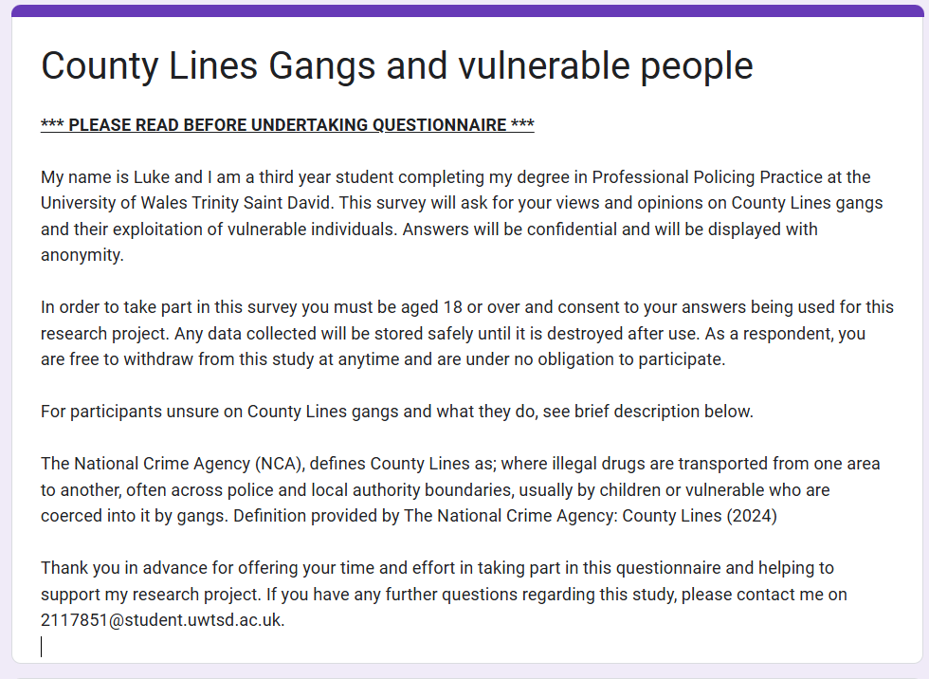

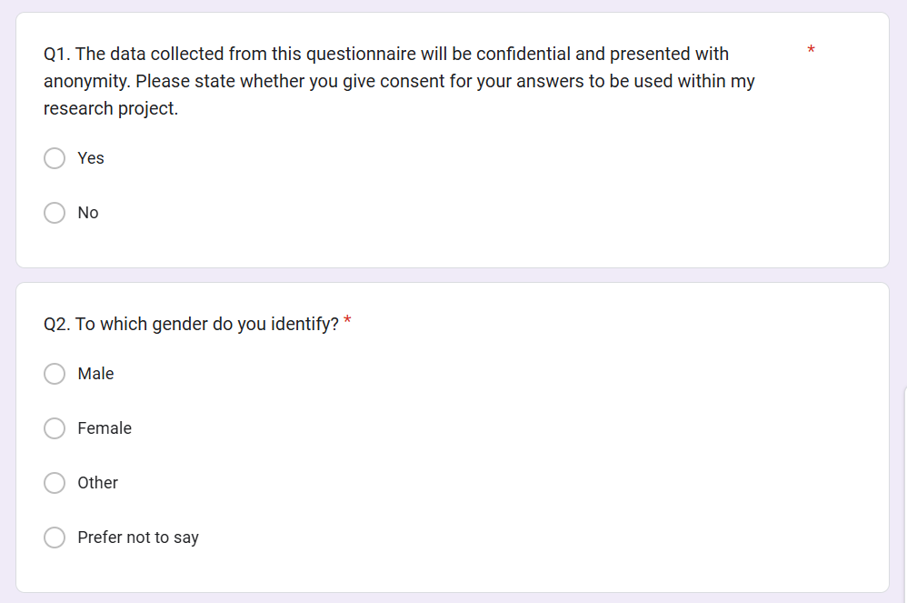

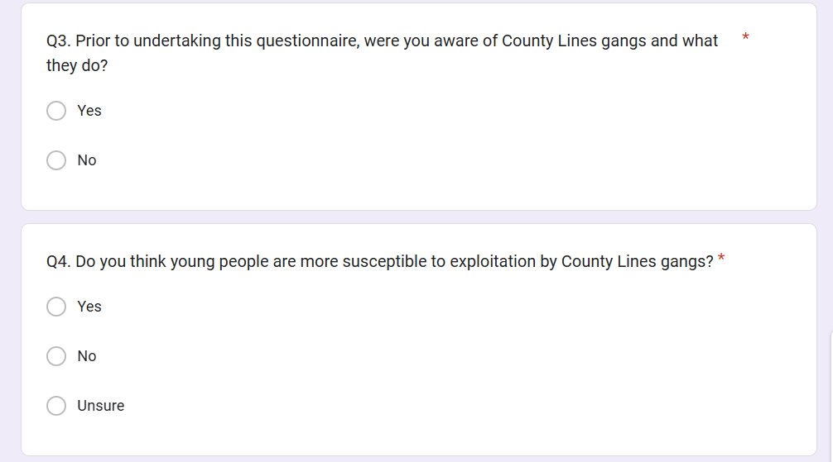

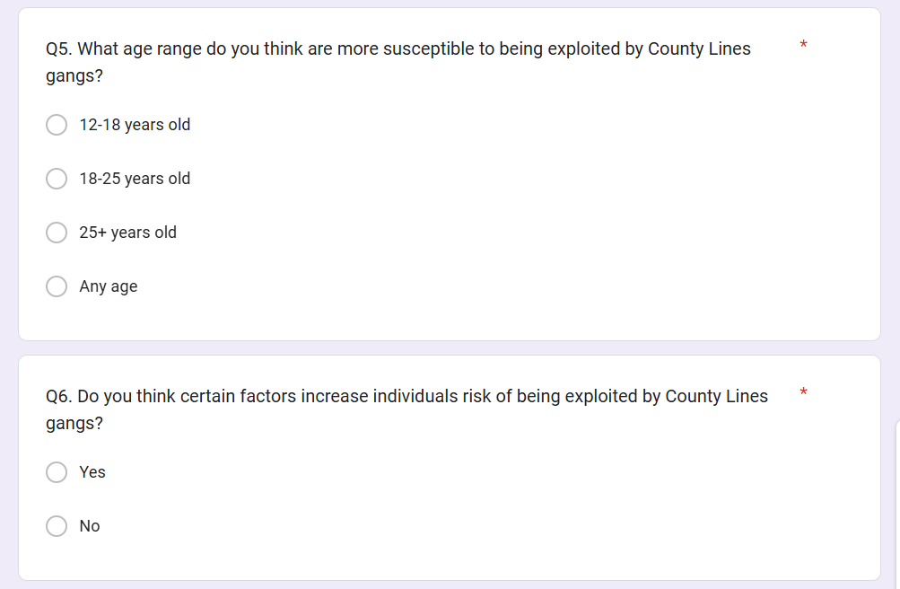

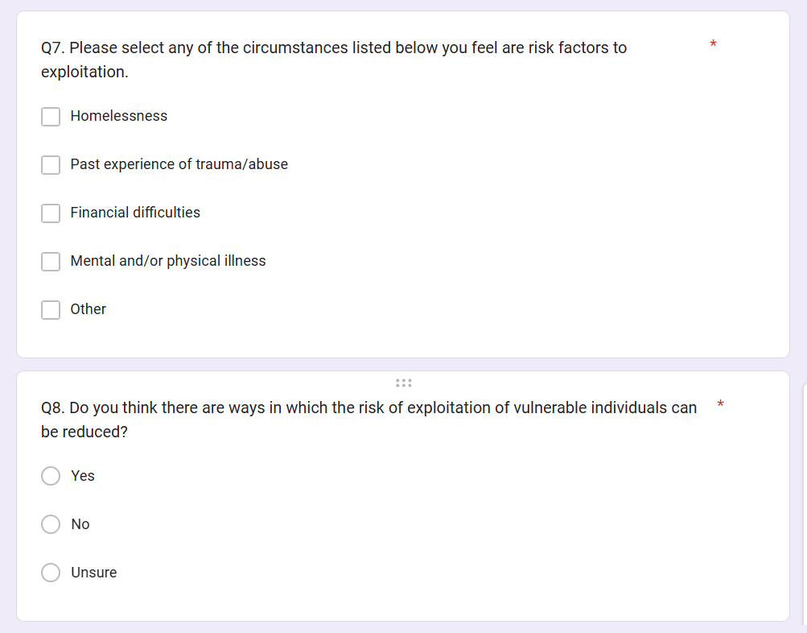

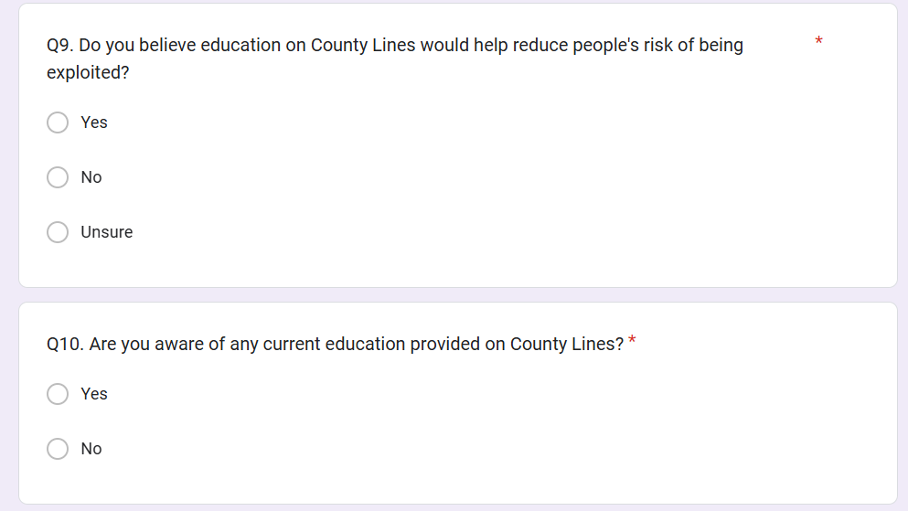

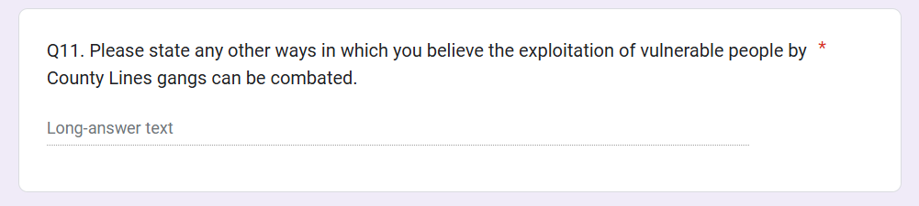

7.2 Appendix 2 – Questionnaire Answers


