University of Wales Trinity Saint David
BSc (Hons) Cloud Computing

Module: Academic and employability skills
Assignment 1

Student Name: Ivaylo Ivanov
Student Number: 1906314

Module Tutor: Koushik Modak

Table of content
Brief introduction........................................................................................... 3
Presentation key points...................................................................................6
Skills evaluation …............................................................................................7
Self evaluation................................................................................................. 8
Short and long term goals................................................................................9
Action plan for personal and professional skills..............................................10
Application......................................................................................................11
Time management and organisation..............................................................12
Conclusion.......................................................................................................13
References...................................................................................................... 14
Appenidces......................................................................................................16

In today’s report, we will look into what it takes and means to have good employability skills. In layman’s terms it would translate into the skills that one has and acquires in time, that would be crucial in an employment and academic environment, such as: Being able to sell yourself and your ideas, being on point with the presenting of your own thoughts, the ability to assess your strengths and weaknesses. Additional clarity will be given in the text below.

Brief introduction.
My name is Ivaylo Ivanov, and I come from a small south-eastern European country called Bulgaria.I am currently living in the United Kingdom with my wife and 4 year old son. My educational background is in a professional high school of organic and inorganic chemistry, graduating in 2012. I would consider myself a man of many interests, some of them including: technology, arts, economics, reading, software, psychology.
Being very curious since I was a small boy, technology was always a field of huge interest for me. And it was about that time in the late 90’s and early 00’s, with the advent of the internet, there was more than enough fuel for curiosity to go around.
When I was a teenager, I developed a deep love for the art of drawing. Without having any previous background, I decided that I want to learn how to draw. My family could not afford to send me to private art lessons, and I was already in high school, so moving to an art school was not an option. So, armed only with youtube videos, and small tutorial books, taking around 3-4 hours every day for about two years, I got to a place where I could create things of my imagination with good precision. Deciding not to go forward with the field, I still practice it as a hobby. Art is a unique way to express emotions, feelings and it has great therapeutic capabilities.

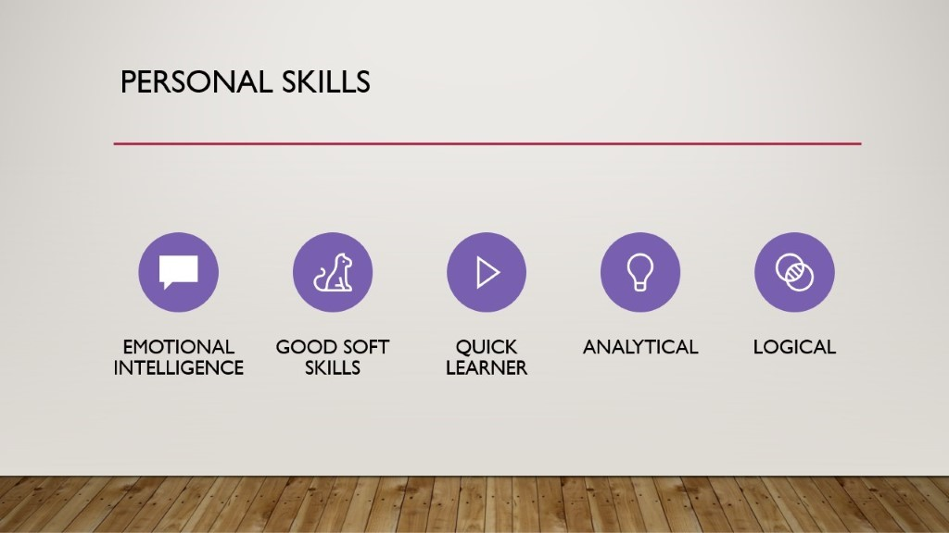
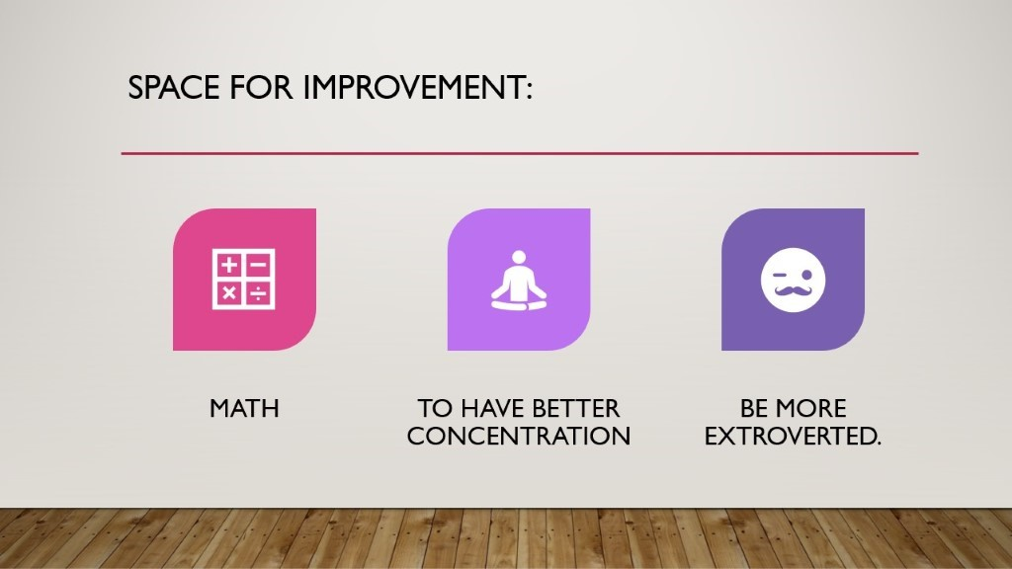

Presentation key points
Taking notes and inspiration from great presenters such as: Steve Jobs, former CEO of Apple, Craig Federighi, and Eric Schmidt, there are a few things that are a necessity for a great presentation such as:

Being well prepared- According to Larry Kim (2018 ), it is always well advised, to have excellent knowledge of the topic that the presentation is aimed at. Doing so, will substantially increase one’s confidence in getting the point across to the public, minimizing the chances of the presenter having to blush and stutter if questions arise after the presentation is over.
Keeping the slides light- There cannot be enough emphasis on this point. Nobody wants to sit through a presentation that is so text heavy, that it would put even the most interested people in the public through a boring journey, leading to a dull and sleep-enhancing experience. Keeping things simple, and talking of memory is much easier to consume.
Always rehearse – Rehearsing the material is always crucial for a smooth and pleasant experience. We all have seen or been the person who prepared a great presentation, but upon coming in front of a public and opening the slides, only to find that from either the pressure of the spotlight or other reasons, the presenter will struggle to keep the flow of the presentation, often making awkward pauses, skipping material, or even forgetting chunks of the material all together. A few solid rehearsals would surely take care of this issue.
Show passion for the material- There is nothing more daunting than a presenter who is not interested in the material that he presents. And it is always noticeable. If the presenter shows passion for the material, it will always the conveyed to the public, which in turn will make the audience passionate about the theme.
Keep it light – To put it in simple words, when presenting material, ideally everyone listening will be interested, and their attention will not drift off to a more interesting place, such as their phone. Presenting In a simplified and light manner is always easier to consume by the audience. Using short, straight forward sentences without additional clutter, joking occasionally will ensure that you convey your point and most of the people will listen.

Skills evaluation

As many real life skills translate into academia and vice versa, we will try to revise the most notable skills that are needed in higher learning and in an employment environment.
HE. learning skills
Time management - As yours truly is writing this assessment paper two days before the deadline, there cannot be enough emphasis given on how important it is to be able to manage this very precious resource called time. We all live in an era where everyone has to balance between personal, family life, career, having fun and education. Many people choose to walk the fine line of finishing tasks just before deadlines, which for the most part is never advisable. Knowing how to delegate your time like a budget is like budgeting your monthly income and expenses. Failing to do so can lead to so can lead to unneeded panic and stress.
Preparation- Taking time to go through material that has been given in lectures can have an enormous impact. Most of the time just listening and writing in lectures is not enough.
Listening and understanding - This would seem too straightforward, but listening and comprehending most of the time requires constant concentration. We have all been in a situation that we would listen to someone presenting in class to only find our thoughts drifting towards a different place.

Employment skills

Selling yourself- In simple terms employment is basically an individual selling his free time to a company for a set price. With that being said, the first thing you must do in front of a potential employer is to sell yourself. You have to present yourself in a manner that would be appealing to the company you will apply to work for. You have to show your biggest strengths, skills, the knowledge that you have of the job at hand. Coming from that angle is vital for your successful application.
Be a team player- Most companies are compiled of teams, be it large or small. The ability to join and blend in a team and provide your skills and experience needed for that team to excel in what it is doing. A good example is a policy that most airline companies now employ called “crew resource management”. First implemented by United Airlines (2014) It means that when a situation occurs, everybody on a flight team gather and give their know how on how the situation can be resolved. Previously, the most senior pilot would give the resolution on how the situation should be dealt with. The CRM philosophy has proven to be better, saving many flights from disaster.
Problem solving – You don’t have to be a top manager from the start of your career, but showing the ability to lead and motivate a team, is crucial in a crucial skill to have in an employment environment.

Self evaluation
Going through the test that was provided in the moodle platform (http://mindtools.com), I received an overall score of 40 pts. For good measure, I also conducted a similar test on another website called http://123test.com which gave a score stated below.
Result of mindtools.com evaluation test:
Leadership and management skills score: 8 out of 15.
Problem solving and decision making score: 8 out of 15.
Communication skills score : 9 out of 15.
Time management score: 10 out of 20
Personal mastery score : 6 out of 10

Result of 123test.com evaluation test:
Openness to experience: 66/100 %. Range: Middle
Conscientiousness (Work ethic): 04/100%. Range: low
Extraversion: 58/100%. Range: Middle
Agreeableness: 69/100%. Range: Middle
Natural reactions: 74/100%. Range: High

When conducting these tests, I tried my best to give the most honest answers possible. My personal belief is that they have been fairly accurate in the results that they has provided. At first glance it is visible that there is a lot of space for improvement. There is one result that really got my attention, the “conscientiousness” result. It is quite a surprising that I managed to get such a low score. A more detailed description of the score stated that, I am a spontaneous and disorganized, which is in fact very true. In the Powerpoint presentation, in the place for improvement slide, I added a point which states that I would like to have better concentration when doing tasks in work and in everyday activities. It would be safe to say that the scores translate somewhat accurately to my own perception of the strengths and weaknesses that I possess.

Short and long term goals.
It is always well advised to have long term and short term goals, doing so gives one a plan for execution and an overall frame to follow.
I have set my personal short term goal in the following overview.
- To develop my basic skills in the programming language Python to a state in which I can write code proficiently.
- Start a beginner’s course in Amazon web services, so I can build a basic understanding of the platform of Amazon cloud computing.
- Gain more knowledge in the following academic year to help me in preparation for a future job that I would like to start
- Use the previous and new experience that I have, to set my “foot in the door” with an entry level IT job, such as a helpdesk operative, which will surely help to build up my CV for future job prospects
- Start working out. Physical fitness is a thing that I have always had a passion about, but have placed in lower priority in recent times.
Long term goals
- To graduate from UWTSD Bsc. Cloud computing with honours in 2022
- To have enough real world experience in IT and software development so that I can start climbing the corporate latter.
- Get a job in either software development or Big data engineering
- Buying a new family home
- Becoming financially independent, so that I can provide a good future my child and family

Action plan for personal and professional skills

Every person has skills and characteristics that they would like to improve upon, so that they can be a better part of a team or in their own community. Here are several personal traits that I would like to improve:
Better mathematical skills- I personally consider this to be my Achiles heel. It is a very crucial skill to have if you want to excel in the IT field. I have enrolled in online math courses which have helped, but there is a long way to go.
Have better concentration-As a person with ADHD it is often times very hard for me to concentrate on even the most basic of tasks. I would very often find myself daydreaming, dozing off, mentally moving to a different place and having mental hazes. It is a condition which is manageable with perseverance and working on techniques to better the state of mind . Working on extroversion – I would consider myself an “introverted extrovert”, which would mean that I am quite talkative in situations, that I feel comfortable in. I can be the life of the party, with a group of friends is very easy for me. But if I am put in a place where I would have to talk in a place with strangers, I am more than reluctant to do so. Having made several presentations in my lifetime has really helped me cope with that fear. At first it was hard to think of the presentation material without going into bursts of anxiety. It is always a good solution to go out of your comfort zone to overcome some of your issues, which I plan to do in the future.

Application
There is nothing more daunting than losing your personal or work data. Since I was in high school my teacher thought me the importance of having backups of your data in other storages, which I have followed since.
Using the 3-2-1 data backup rule is essential In the protection of your digital belongings. It is always best advised to keep a backup file in 3 different places and two different storage platforms. One for example being a hard drive, a SSD (solid state drive) and I like to keep a copy In a cloud based storage space (techtarget.com(2019)). I personally have 50gb of iCloud storage handy for backups on all my devices. Using an Apple phone and a MacBook allows me to automatically backup all my files in the cloud storage, so that I can have access even if the files are lost on one of these devices. For extra safety, I also keep valuable files on a separate solid state hard-drive.
A good example of the value of additional backup is a disaster that happened to my old phone. After serving me for more than three years, all of a sudden it stopped charging, also to add insult to injury the screen stopped working. It was at that point that I was thankful that everything on that phone was backed up everyday to iCloud, doing so saving me from a lot of pain, most notably my personal contacts and family photos. I managed to get a new phone and transfer everything without retaining any losses.
Other often occurrences in the loss of data include: Physical damage to the storage device, which makes it hard to recover any data if not backed up prior. Lots of people lose files due to gullibility, to put it more clearly- they delete their own or their relative’s files, due to the lack of knowledge or other reasons.
In recent years another threat has appeared to plague multiple internet users, called “ransomware”. It is a comparatively new type of virus, with the first notable appearing in 2013 under the name CryptoLocker. It was at the time at the forefront of file encryption technology, deployed in various ways such as: executable files via spam emails and exploit kits, targeting personal and business users alike. After the downfall of Cryptolocker, Cryptowall came to prominence in 2014 with unbreakable encryption. It is also very hard to trace back to the author of the malware, because it’s mostly delivered through I2P proxy. (Sophos,2015)

Time management and organisation
Time management is very much like budgeting your personal finances. Most of the times both are a limited resource and failing to manage it correctly could lead to severe issues.
Here are a few useful ways that everyone can implement in their daily lives which for sure will make time management easier.
Creating a daily plan. Taking half an hour every day to list out the tasks that have to be done will add structure to your day, without a lot of hassle. (Rousse, 2019)
Do one task at a time. It has been disproven that multitasking is an efficient way to get. Many people would consider it to be an efficient way to get things done, but research shows that it is even harmful to our health. (Mcmillan, 2016)
Do not procrastinate. This might seem easier said than done but making a habit of getting things done in a timely and orderly manner is not so hard to achieve.
Exercise often. Sports are a great way to relieve stress. Research shows that short intense workout sessions are as beneficial as longer ones, so set aside a little time for a quick workout to release that stress! (Toggl, 2019)
Have enough sleep. Taking 8 hours of sleep every day is the biggest performance enhancing drug one can take. It is crucial for normal brain bodily and cognitive functions. It reliefs stress and enhances overall performance. (Withwort, 2018)

For myself I have found that some of the above mentioned techniques really help with my better time management. Being adamant about a healthy sleeping pattern of no less than 7 hours a day ensures that I can be productive throughout the day, without feeling drowsy or cognitively incapable. Also, I try to do one task at a time, rather than doing all too many at once, which allows me to focus better to the task at hand and not thinking a little bit about multiple ones. If I can manage to work, study, have a family it means that I am doing an okay job.

Conclusion
As a whole, all of the above mentioned skills are crucial for one’s self development and personal as well as professional success. Most of the point could be translated into all walks of life, aiding anyone who is willing to imply them to their portfolio of skills. I have personally benefited quite a lot by using these skills in my professional and academic life. But life is a work in progress, so settling down with what you have is never enough. Striving for greatness with perseverance will always bear fruit in the long run.

References:

Andino, G. (2014), United Flight 232: Surviving the Unthinkable
Available at: http://www.nycaviation.com/2014/07/disaster-miracle-united-flight-232/34639
(Accessed: 30 December 2019)

Kim, L. (2018), How to improve your presentation skills
Available at: https://www.wordstream.com/blog/ws/2014/11/19/how-to-improve-presentation-skills
(Accessed: 30 December 2019)

MacMillan, A. (2016), 12 reasons to stop multitasking now
Available at: https://www.health.com/condition/adhd/12-reasons-to-stop-multitasking-now
(Accessed: 30 December 2019)

Rousse,M. (2019), 3-2-1 backup strategy
Available at: https://searchdatabackup.techtarget.com/definition/3-2-1-Backup-Strategy
(Accessed: 30 December 2019)

Sophos (2015), The current state of ransomware
Available at: https://news.sophos.com/en-us/2015/12/17/the-current-state-of-ransomware-cryptowall/
(Accessed: 30 December 2019)

Toggl (2019), 27 Management Tips to Work Less and Play More
Available at: https://toggl.com/time-management-tips/
(Accessed: 29 December 2019)

Whitworth, G. (2018), What do you want to know about healthy sleep?
Available at: https://www.healthline.com/health/healthy-sleep
(Accessed: 30 December 2019)

Appendices:



