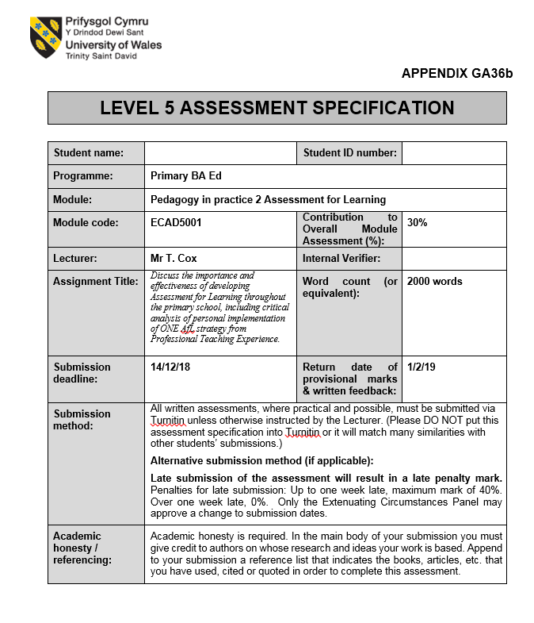

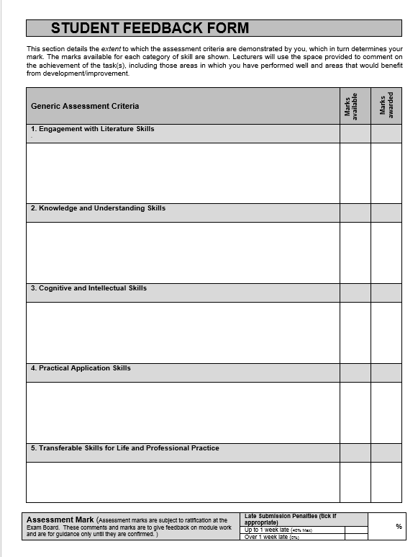
Discuss the importance and effectiveness of developing Assessment for Learning throughout the primary school, including critical analysis of personal implementation of one Assessment for Learning strategy from Professional Teaching Experience.
Assessment for Learning (AfL) is a teaching approach that involves the use of feedback to adapt and enhance learners’ performance. It provides teachers with various strategies to ‘decide where the learners are in their learning, where they need to go and how best to get there’ (ARG, 2002, p.3). AfL allows learning to become visible and gives children an understanding of how they can reach their targets (Hattie, 2009). It has been developed over time, from Assessment of Learning, which revolved around summative assessments of students’ progress and achievements, into what is now Assessment for Learning which many writers link to ‘formative assessment’ (Marsh, 2007, p.25). Formative assessment was first introduced in 1971 by Hastings, Bloom and Maddaus as a means of helping create summative assessments. In 1998, after reviewing a multitude of studies, Black and William, the ‘fathers’ of AfL, concluded that in order to raise academic standards in children, AfL must be implemented in all schools across the UK (Black and William, 1998). Furthermore, in 2002, ARG proposed ten main principles of AfL, including that it must be ‘central to classroom practice’ (ARG, 2002, p.3), consolidating its importance. Meaningful feedback, however, is the key principle for successful formative assessment. Sadler (1989) stresses that is vitally important that feedback is used to help close the gap between learners, highlighting just how necessary it is. Conversely, John Hattie states that ‘feedback is not ‘the answer’ to effective teaching and learning’ (Hattie, 2009, p. 177) and in some instances it may be a wasted exercise if the children do not understand the issue being addressed (Hattie, 2009, p. 177). He does, however, accept the benefits of its correct implementation, stating it must be ‘clear, purposeful, meaningful and compatible with students’ prior knowledge’ (Hattie, 2009, p.177). Swaffield, is of the opinion that research can be a waste of time, since people respond to feedback in different ways (Swaffield, 2008, p.64). Despite this, feedback must be effective since it has such an important role in the modern teaching environment.
Research suggests that formative assessment can raise achievement levels in schools. ‘Inside the black box’ (Black and William) states that studies ‘produce significant, and often substantial, learning gains’ (Black and William, 1998, p.3) when using formative assessments. Additionally, a TGAT report has shown that in cases where the assessment is in line with the curriculum, children experience increased motivation due to the possibility of achieving a short- term objectives (TGAT, 1987, p.10). Baranek (1996) states that ‘High student achievement comes from students who are motivated…’ (Baranek, 1996, p.3), highlighting the great benefit of increased motivation in students. However, Ninomiya disagrees with the practicing of formative assessment - it ‘tends to cause alienated learning’ (Ninomiya, 2016, p.88) - as they believe that learning then revolves around meeting the next set of targets, as opposed to a meaningful teaching and learning experience. Although this may be an important consideration, the benefits of children having an aim to direct their learning certainly outweigh the negatives.
For AfL to be effective in primary schools, it must be implemented in every lesson. The new curriculum in Wales states that ‘Assessment is a vital and integral part of learning and teaching and so needs to be fundamentally linked to the curriculum’ (Donaldson, 2016, p.6).The document ‘How to develop thinking and assessment for learning in the classroom’ (DCELLS, 2010) supports teachers in Wales and aids the integration of AfL throughout the curriculum. However, despite the release of this document in 2010, a report was published in 2014 that claimed, ‘current assessment and evaluation arrangements are unsatisfactory’ (OECD, 2014, cited by Donaldson, 2015, p.9). There is clearly progress left to be made towards the successful implementation of AfL. This can hopefully be achieved with the introduction of ‘Successful Futures’.
Black and William (1998) highlighted the four essential elements of AfL by which the various strategies used since its introduction can be categorised. During, Professional Teaching Experience (PTE), one of these strategies involved the use of ‘Exit Cards’, which evokes the Quality of questions/quality of talk element. It is said that ‘talk is arguably the true foundation of learning’ (Alexander, 2008, p.9) and through relevant questioning, appropriate discussions (‘talks’) can be prompted. Additionally, Black and William state that the interaction between student and teacher ‘is at the heart of pedagogy’ (Black and William, 1998, p.16). In this respect, ‘Exit Cards’ were a great way to encourage students to talk at the end of the lesson, discuss their ideas and consolidate their understanding. During several lessons, students were asked to read their answers out loud (most Class 4 students were eager to do so), allowing further assessment to take place while they engaged with different questions and answers from their peers. In ‘Building Learning Power’, Guy Claxton states that ‘good learners like questions’ (Claxton, 2002, p.25), and outlines 4Rs that help develop the mind’s learning power. One of those Rs, ‘Resourceful’, includes questioning - teachers who consistently ask relevant questions will find that their students thrive and achieve more (Claxton, 2002, p.25). This theory is supported by research which showed that good questions lead to ‘higher levels of academic achievement’ (Samson, Strykowski, Weinstein and Walberg, 1987 cited by Hattie, 2009, p. 182). However, Hattie suggests that it is more important for teachers to listen to their students’ questions. In ‘Unlocking Assessment’, Swaffield implies that teachers should talk less and listen more, as listening allows the teacher to assess the child’s understanding (Swaffield, 2008, p.76). Mercer et al (2004) showed that when students are actively involved, their ability to learn increases (cited by Swaffield, 2008, p.76). Therefore, in future placements, the writer would adapt ‘Exit Cards’ to encourage the students to pose a question to their teacher or fellow students.
The ‘Exit Cards’ were used in various ways to promote different learning styles. They were used individually, in pairs and in groups throughout PTE and were sometimes adapted to suit attainment level. The writer used Blooms Taxonomy model (1956) to assist in the creation of the ‘Exit Cards’, and they proved to be a great way to encourage higher order thinking skills. Research by Hattie has shown ‘that higher order questions are more effective on both direct and unrelated materials’ (Hattie, 2009, p.183) implying that the benefits these skills have on learning extend beyond just the lesson they are used in. Schoenfeld (1985) suggested that students presented with lower order thinking questions may deem them ‘unfair, illegitimate or even meaningless’ (Schoenfeld 1985, quoted in Gipps, 2002, p.80) as they do not allow children to expand their learning. However, an article on ‘Classroom Questioning’ by K. Cotton (1988) states that there is no conclusive research to suggest higher order thinking questions are more beneficial than lower ones; in fact research suggests they are equally effective. Despite inconclusive research, the majority of Class 4 students enjoyed the higher order thinking questions, especially the ‘Evaluate’ ones in relation to Water Sanitation. Simple recall questions did not engage students and in instances where the answer wasn't immediately known, the students have up. It was not the case that the writer presumed these students were incapable of grasping higher order questions, which would be a misapplication of Blooms Taxonomy, often used by teachers to 'justify reduced expectations about students' capacity to think’ (Case, 2013, p3) Instead, the children were put into mixed ability pairs to answer evaluative questions, which the writer found to be the best method to promote learning. It is clear, through research, that there are academic benefits for both the higher attainment child, and the lower, as well as a potential increase in the social skills of both (MUSE, date unknown, p3).
Throughout PTE, the above AfL strategy was often adapted into ‘Enter Cards’ to allow pupils to activate their prior knowledge and consolidate their learning. John Watson, behaviour psychologist, presented the 'Recency and Frequency’ theory (Watson, 1913) suggesting that if information is used and embedded more frequently, then the accuracy of recall will increase. Therefore, by consolidating students’ learning with questions at the start/end of the lesson, it is more likely the information will be retained in their long-term memory. This theory was, however, criticized on the basis that is was inadequate in accounting for learning (Gengerelli, 1928, cited by Weibell, 2011). Despite this claim, Class 4 students were able to accurately recall information from previous lessons to answer the 'Enter Cards’ and the majority were able to use the information learned throughout the lesson to answer the 'Exit Cards’. Unfortunately, there was no opportunity to test the students’ ability to retain information long term, as PTE only covered a 4 week period.
'Constructivist’ learning theory is a means of explaining how people build knowledge and understanding through their experiences - in the teaching environment this involves the above method of using good questions to activate prior knowledge and assess understanding. Brooks (1999) said ‘As long as there were people asking each other questions, we have had constructivist classrooms’ (cited by Doudin, 2016, p. 9). There are many (social) constructivist theories based around the development of language and understanding through the use of ‘talk’. By implementing ‘non-judgemental questioning, tutors can lead the student to construct new comprehension and acquire new skills.’ (Brooks and Brooks, 1993, cited by Doudin, 2016, p. 24) - thus, through answering relevant questions about the learning material, students are able to build their knowledge and form new connections within their learning.
A different, more humanistic approach would involve students asking themselves questions, and therefore being more self-directed. Research has shown (Huangs, 1991) that self-questioning is more effective in lower attainment children (cited by Hattie, 2009, p193), than teacher-led questioning, which provides some justification for the humanistic approach. However, the writer is of the opinion that in order to ensure the question accurately assesses a child's learning, it should be written by the educator.
To encourage the widespread use of ‘Exit Cards’ in schools, they could be adapted into verbal exit cards for Foundation Phase students. This would involve the teacher asking the class (or small groups of students) one question which would be answered verbally, promoting a full class discussion and allowing students to develop ideas from one another. Students could even use an iPad (on websites such as NearPod) to answer the question, which could present relevant pictures or videos to engage pupils further.
Overall, the 'Exit Cards’ strategy of assessing students through questioning has proven successful. It can be easily adapted to suit the attainment level of the learner, and can promote healthy group discussions within a classroom. To ensure maximum effectiveness, teachers must be trained to create relevant, purposeful questions - as Hattie remarked, 'Training in questioning matters’, following research which indicated that achievement increased when teachers had been trained in questioning (Hattie, 2009, p183). This method of assessment may be overlooked in favour of a peer/self-assessment system, however the writer is of the opinion that questioning is more beneficial in the long run. Various learning skills can be developed through questioning, which allows students to become 'resilient learners' (Claxton, 2002, p23). Through this development, students can begin to participate actively in their own learning journeys, whilst nurturing a 'Growth Mindset’ (Dweck, 2014) and beginning to embrace feedback from their teachers. There is a strong driving force behind AfL implementation, with Donaldson's 'Successful Futures’ and it's four 'purposes’, which will encourage children to become 'ambitious, capable learners’ (Donaldson, 2015, p29) who are actively involved in their own learning and who can engage in an effective and meaningful way with AfL.

Reference list
Alexander, R. (2008) Towards Dialogic Teaching: Rethinking classroom talk. 4th Ed. North Yorkshire: Dialogos.
Assessment Reform Group (2002) Research- based principles to guide classroom practice. Available at: https://www.aaia.org.uk/content/uploads/2010/06/Assessment-for-Learning-10-principles.pdf (Accessed: 12 November 2018).
Baranek, L. (1996) The Effect of Rewards and Motivation on Student Achievement. Masters thesis. Available at: http://scholarworks.gvsu.edu/theses/285. (Accessed: 13 November 2018).
Black, P. and William, D. (1998) ‘Assessment and Classroom Learning’ Assessment in Education: Principles, Policy and Practice, 5(1), pp. 7- 74.
Black, P. and William, D. (1998) Inside the black box: Raising standards through classroom assessment. London: GL Assessment.
Case, R. (2013) ‘The Unfortunate Consequences of Blooms Taxonomy’, Social Education, 77(4), pp. 196-200. Available at: https://tc2.ca/uploads/PDFs/Critical%20Discussions/unfortunate_consequences_blooms_taxonomy.pdf (Accessed 30 November 2018)
Claxton, G (2002) Building Learning Power. Bristol: TLO Limited.
Department for Children, Education, Lifelong Learning and Skills (2010) How to develop thinking and assessment for learning in the classroom. Cardiff: Welsh Assembly Government.
‘Developing a Growth Mindset with Carol Dweck’ (2014) Stanford+connects. Available at: https://stanfordconnects.stanford.edu/watch/developing-growth-mindset/ (Accessed: 1 December 2018)
Donaldson, G. (2015). Successful Futures. Crown Copyright. Available at: https://gov.wales/docs/dcells/publications/150225-successful-futures-en.pdf (Accessed: 28 November 2018).
Doudin, M. (2016) The Constructivist Theory of Learning. Cyberjaya: Multimedia University (MMU) Faculty of Creative Multimedia.
Gipps, C. (200) ‘Sociocultural Perspectives on assessment’, in Wells, G. and Claxton, G. (ed.) Learning for Life in the 21st Century: Sociocultural Perspectives on the Future of Education. Oxford: Blackwell Publishers LTD.
Hattie, J (2009) Visible Learning. London: Routledge.
Marsh, C. (2007) ‘A critical analysis of the use of formative assessment in schools’ Education Research for Policy and Practice, 6, pp.25-29. DOI: 10.1007/s10671-007-9024-z
Mulitgrade School Education (Muse) (2002-2004) Mixed Ability Grouping- Training Module. Available at: https://www.ea.gr/ep/muse/data/training.htm (Accessed: 30 November 2018)
Ninomiya, S (2016) ‘The Possibilities and Limitations of Assessment for Learning: Exploring the Theory of Formative Assessment and the Notion of “Closing the Learning Gap”’ Educational Studies in Japan: International Yearbook, 10, pp. 79-91. Available at: https://files.eric.ed.gov/fulltext/EJ1130292.pdf. (Accessed: 13 November 2018).
Sadler, D. (1989) ‘Formative Assessment and the Design of Instructional Systems’. Instructional Science, 18, pp. 119-144.
Swaffield, S (2008) Unlocking Assessment. Abingdon: Routledge.
Task Group on Assessment and Testing (1987). Report of the Task Group on Assessment and Testing. Available at: http://www.educationengland.org.uk/documents/pdfs/1988-TGAT-report.pdf (Accessed: 12 November 2018).
Weibell, C. J. (2011). Principles of learning: 7 principles to guide personalized, student-centered learning in the technology-enhanced, blended learning environment. Available at: https://principlesoflearning.wordpress.com (Accessed: 1 December 2018).

