Team Leadership & Systems Integration – John Hopkins (P151371)

Our philosophy is to approach this task with simplicity and functionality in mind. We hope this will allow us to design and build a device that performs well and requires little human interaction. To achieve this our group has focussed efforts in key areas and has worked to integrate them in a design which we believe will allow simple assembly and a relatively low cost. We’re satisfied that this design will be both successful and competitive.

The main aim with our device is to be able to reliably convert sufficient power and torque into movement through the driven wheels. Our chosen motors should do this with ease meaning our main challenge will be in assembling a successful drivetrain.

Our proposed design comprises of a well packaged device relying on driven wheels on the surface of the pipe in order to propel it upwards. The power will be generated by a small 9V battery powering a single motor which will be torqued up using gears. The appeal of this design is in its simplicity; with the few components required being mounted directly to the case, made from thin aluminium plate, it is not only easy to assemble and cheap but will hopefully provide good reliability. The ‘body’ also allows for easy attachment of the pressure switch on the top of the device, somewhere to mount the chain neatly and adequate room to tuck the wires neatly inside the device. The bolt-on parts also enable us to disassemble the device if required between heats with the use of basic tools. We ruled out methods such as gluing parts or 3D printing as we feared any damage may prove catastrophic. With regards to the wheels we decided that one driven and two idler wheels would suffice. The wheels would be of a soft rubber construction; this would provide traction and the natural spring of the rubber would offer a small tolerance to ensure the wheels never lose contact with the pipe in the event of a small change in diameter of the pipe during the ascent or slight inaccuracies in the construction of the device.

The proposed design features some aspects we are unsure will be kept following the prototyping stage. The lightweight but soft aluminium body may prove to be too soft to properly tighten the fixings such as on the axles and are therefore open to switching to a thin steel plate construction if necessary. We are also aware of the potential slippage of the drive belt which may result in us rectifying the issue with a direct drive from the motors however this is unfavourable as it would affect the packaging of the device.

With regards to the designing of the device we opted for sketches as we felt they better allowed us to express our ideas though we do plan on producing a CAD prototype in the future.

We are currently looking at a cost of around £18 in total which leaves us slightly under budget and allows for some changes to be made if necessary.

Control, Robustness, Reliability and Payload – Sam Williams 1701794

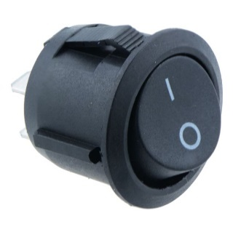
As a team, we have considered many different design and function ideas. As mentioned previously, we have tried to keep the design from being over engineered and intricate, which may hinder the reliability and robustness of the external pipe crawler device. This simplicity would benefit the team in making parts like the battery interchangeable when drained, as well as potentially adding more parts such as an extra power source and motor to the initial design. In terms of wiring the device, the use of solder to make electrical connections, as well as insulated electrical connectors where applicable is the most feasible idea. The wiring would need to be tidied and fixed away from any moving parts to decrease the chance of entangling the wires within the climber, potentially destroying the climber as well as posing a significant health and safety risk. A simple on/off switch incorporated into the wiring would be best suited to offer power the devices motor and commence the devices’ climb. Something similar to that shown in Figure 1 would be ideal and are easily affordable, priced between 50p-£2.
Price - £0.99 (Ebay, 2019)
We considered different methods of gearing in order to multiply torque from the motors to the pulleys. The group considered direct gearing from the output shaft of the motor connected directly to a gear attached to the drive pulley. Another gearing concept implemented a belt/chain drive using a sprocket/pulley system similar to that found on motorcycles and mopeds. However, the team decided against such intricate, possibly problematic designs. Instead opting for a direct drive approach between the motor and pulleys. Elaborate parts such as belts and gear cogs can result in weakness and oppurtunities for parts to fail.
In terms of how the descent should be completed once the device has climbed the pipe, the team contemplated using a free-fall method. This method would employ a button fastened to the top of the device, protruding the top of the device enough to be pressed against the apparatus when at the top of its climb. Once pressed, the power supply to the motor would be cut, hence allowing gravity to descend the pipe crawler to the ground. However, this concept would not allow for a controlled descent and may result in damage to the external pipe crawler. However, it may be better applied to reverse the polarity to the motor. Reversing the polarity would change the direction that the motor rotates, therefore making the device crawl in the opposite direction. As a team we believe this to be much more beneficial for such a small change. The concept of using a button/two-way switch at the top of the device is still the same, but instead of the device freefalling from the power being cut, the device will change direction and climb back down the pipe, resulting in a more controlled descent, reducing the risk of damage from impact with the ground, which, in turn, would improve its reliability and extend the devices’ life in service.
The device needs to employ some form of impact protection for when the device comes in contact with the ground at the bottom of its descent. This protection would need to be attatched to the bottom of the device, as the bottom will be the first point of contact with the ground. We surveyed several different types of impact protection including air bags, rubber and foam. Although each method could be utilised, as a team we believe that attaching a thick layer of sponge to the bottom of the device is the simplest, most cost effective way to absorb some of the energy of the impact. As well as being lightweight, the sponge would be the first point of contact and would absorb some of the impact’s energy, resulting in less energy being transferred to the device and its components. Although using air bags would give the team more options in terms of adjusting air pressure and therefore adjusting the amount of protection, the risk of air leaking from the bags, as well as popping under impact outweighs the positive aspects of this method.
A payload must be attached to the device in the form of a 290g chain (Screwfix Direct Ltd, 2018) (Institution of Mechanical Engineers, 2018). Although the motor or motors would need to produce enough torque to ascend the weight of the device and the payload, the attatchment of the payload to the device is very simple. Including a hook to the device is easily done, as well as lightweight and inexpensive. A small piece of removable wire rope between two fixed points could also be implemented into the device as a means of attatching the payload, and bears the same benefits as the hook method. Both methods would obvously need to be able to withstand the weight of the payload without bending, snapping, or damaging the device. I believe the cable method to be more useful to the design. While both methods are very similar in terms of difficulty, price and weight, the cable is fixed between two points. Therefore the load applied by the payload would be shared between the two points. This equates to the fixed load being split into two, meaning less strain being applied than that of a single attatchment point. Although the payload could be attached anywhere on the device, I believe that it would be more beneficial for the payload to be attatched at a centrepoint. If the payload were attached at a corner edge, or off-centre, the weight of the chain may impact the devices ability to climb in a straight line and become unbalanced.

Power generation and storage – Owain Phillips 1809853

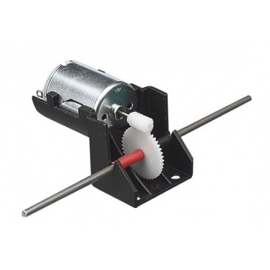
Many different motor options could be utilised in this design project. The main factors needed from a motor would be of course a good amount of power, but also it must not be too heavy or this could mean the power to weight ratio of the whole assembly may to high to get the desired results. The ideal motor would be lightweight, fairly inexpensive and have a good amount of torque, this would mean the pipe crawler would easily be able to overcome the initial inertia, and have a good start. A motor with a high RPM would be very useful as this would mean less torque would be needed and therefor a less powerful motor could be used, this would also decrease the weight of the motor assembly. With weight being a huge factor in this project as the pipe climber will be climbing vertically, increasing the power to weight ratio of the product is paramount and is not something that can be overlooked as this may totally ruin the chances of the climber even getting up the pipe.
Probably the easiest way of converting the power from the motor into useable energy would be to use a worm gear in the assembly, this would allow the transfer of the rotation along one axis to another. The motor and gearbox shown the right is a very good solution as it comes with a worm gear and is already attached to the motor. This product is from Hobby Tronics online shop and costs £3.50 so is a very viable piece of kit for use in the pipe climber. The description on the website is as follows; “A robust worm-drive gearbox powered by an MM28 motor. Ideal applications where an easy to fit, high torque output is required. Great for student based projects including robots and buggies. The unit has been designed so that the output shaft can be 'clicked' in and out for modification. E.g. cutting down to size. The motor is snap fitted into its cradle to engage the gear and worm.” The details of the product are: 1 - 6V DC, 0.1A to 1A depending on load, Driveshaft length: 12.5cm, Driveshaft diameter 3mm, Gearbox ratio: 42:1, Overall dimensions of box + motor: 35(W) x 40(H) x 60(L)mm.
The battery is also another vital component in the assembly, if the battery cannot produce the power required the aims of the pipe climber will not be met, but batteries are also fairly heavy considering their size. AAA batteries are probably the smallest type of battery that could be used, but to create sufficient amounts of power multiple batteries may be needed. A standard alkaline battery can only store around 2800 mAh at the top end of the product market so these would be expensive, where as a lithium battery can produce one and half times this for the same weight.
Using the equation P=VI where P is power(watts), V is voltage(Volts), and I is current(amps), I have created a table to find out which type of battery would be the most powerful and have the best power to weight ratio.
Battery Type | Voltage (V) | Current (A) | Power (W) | Power to weight (W/kg)
Alkaline AAA | 1.5 | 1.2 | 1.8 | 156.5
Lithium-ion AAA | 3.6 | 0.35 | 1.26 | 168
Alkaline AA | 1.5 | 2.8 | 4.2 | 182.6
Lithium-ion AA | 3.6 | 0.84 | 3.02 | 201.3
Alkaline C | 1.5 | 8 | 12 | 250
Alkaline D | 1.5 | 18 | 27 | 192.9
Alkaline 9V | 9 | 0.55 | 4.95 | 110
Lithium 9V | 9 | 1.2 | 10.8 | 240
Alkaline 4.5V | 4.5 | 6.1 | 27.45 | 249.5
From this table there are 2 clear contenders for the most desired battery. Both the Alkaline 4.5V and Alkaline C battery have very similar power to weight ratios, but the C type battery is the lighter of the 2, at around half the weight. This would be the most ideal battery to have for the pipe climber if we are focusing on power to weight.

Mechanical drive and propulsion - Jonathan Lloyd-Williams 1805620

Our group has settled on various design aspects for the pipe crawler. We have decided that our design will integrate a three wheel system. Two wheels will be used for stabilising, whilst the other will be driven directly off the motor. By keeping the design simple in this respect, we are able to control costs, weight and required power. A simple sketch shown below shows a rough layout of the pipe crawler assembly. These wheels will be driven from the motor via a belt drive system. We’ve decided to use soft rubber wheels on the device. Rubber has a high coefficient of friction compared to other materials and we believe it will also help the tyre better stay in contact with the pipe. We will be using a rubber drive belt and metal gears to gear up the motor to the driven wheel. We hope that these will be durable enough and will minimise mechanical loss.

The assembly will consist of two plates spaced at approximately 24mm apart. In between the plates will be the driven wheel, which will be driven directly off the motor, attached to the outside of the plate. On the opposite plate, the battery will be mounted, along with the ON/OFF switch, and the mounting point for the button to reverse the direction of the motor. This arrangement has been chosen in order to evenly distribute the weight throughout the assembly. Arms shall extend off of the plate and around the pipe, providing mounting points.

As the weight of the design increases, more torque is needed for it to be able to effectively climb the pipe, we must ensure that the combined weight of all components does not become too much for the chosen motor to be able to effectively function. Mounted to the plates via bolts will be arms that extend out around the copper piping and allow mounting of the two stabilising wheels. The button used to reverse the direction of the motor will be bolted vertically at the top of the assembly to a third smaller ¬ shaped plate, which will then be bolted to a side plate. This mounting position has been chosen so that when the crawler reaches the top of pipe, the button will make contact with the plate at the top of the pipe, and begin the crawlers decent.

The choice of battery will be a 9v Duracell lithium battery that will be placed in a battery holder with terminals in order to allow for easy wiring and easy attachment to the plate. The wiring will be routed over the top of the crawler in order to keep it clear from the rotating parts. This battery has been chosen at it will store sufficient power to supply the motor. The battery will be one of the last components to be purchased, as depending on the overall costs of the rest of the materials purchased, it may be advisable to purchase a rechargeable battery in order to ensure the battery remains useable throughout the period required. As mentioned within the project specification, all components must be within the given price range (Institution of Mechanical Engineers, 2018). If enough capital is left unassigned when all other components have been purchased, it may also be advisable to purchase a second rechargeable battery, so that there is always a charged battery to hand.

Final Design Proposal
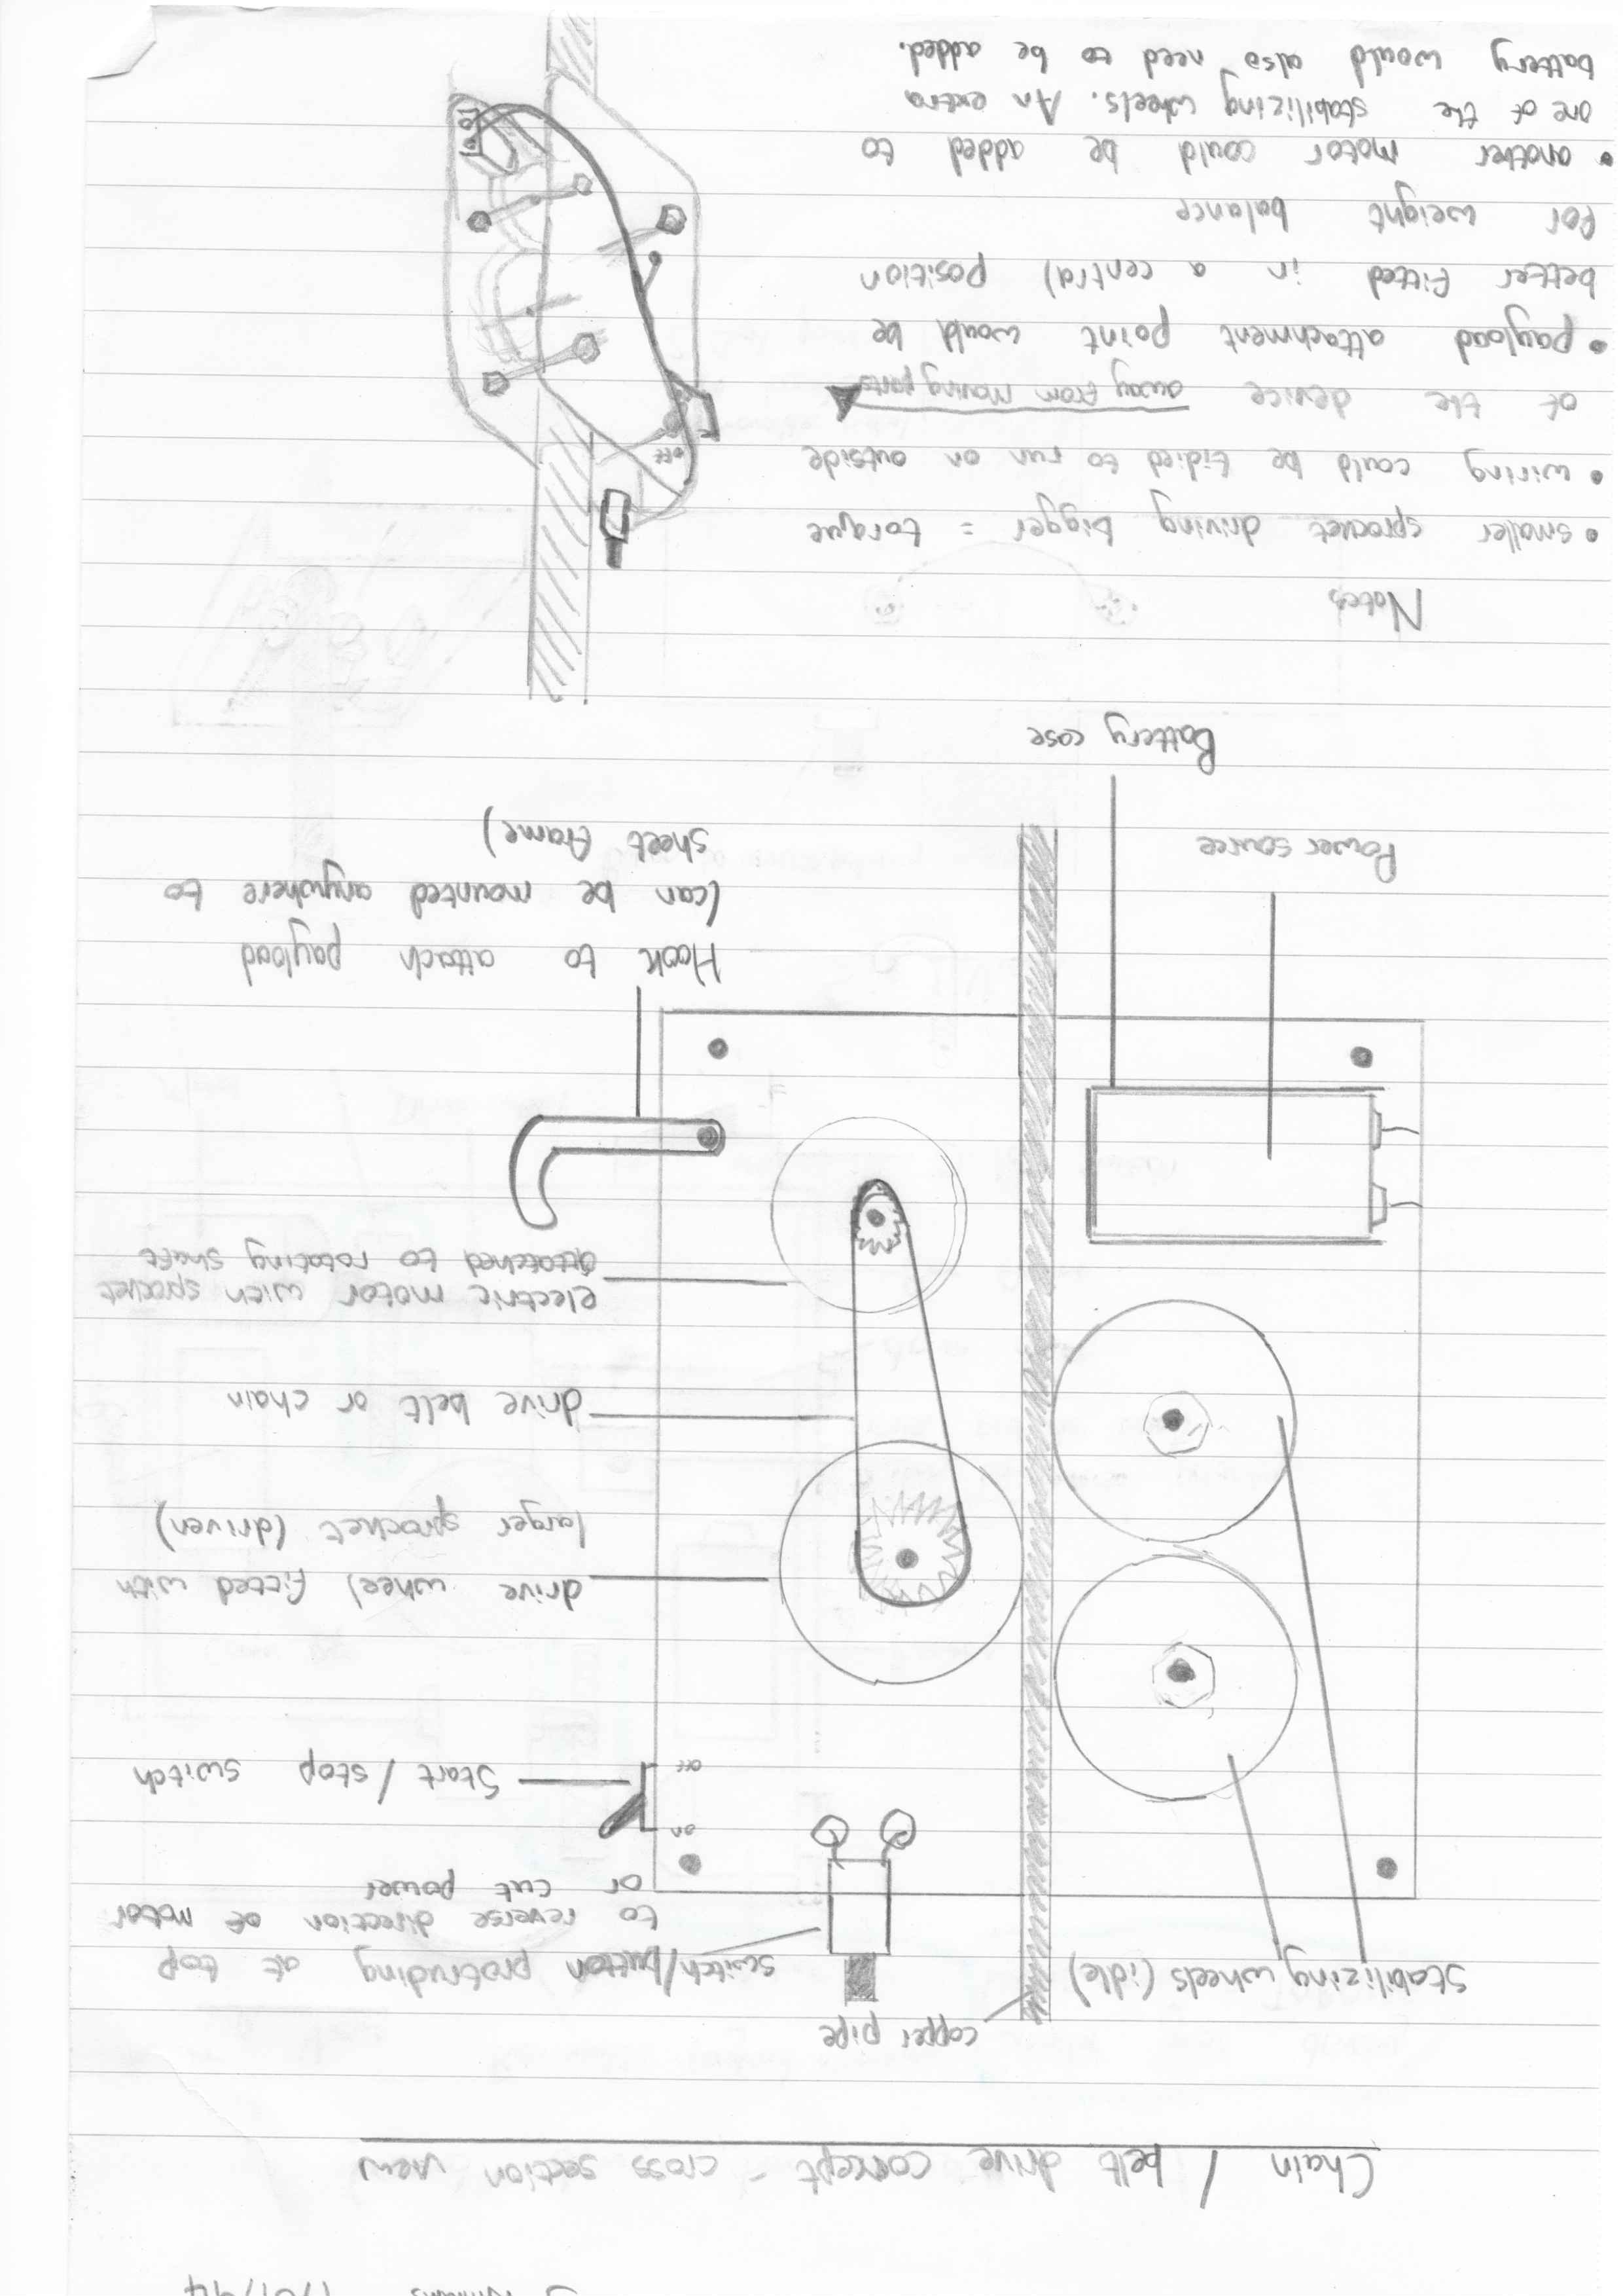
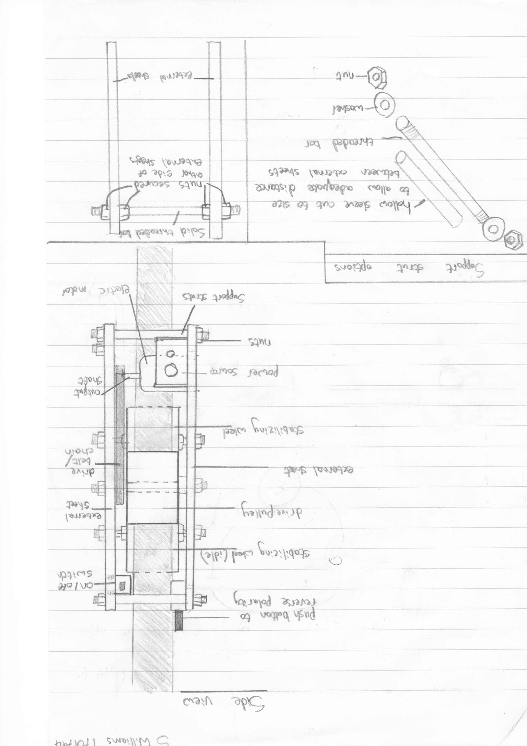
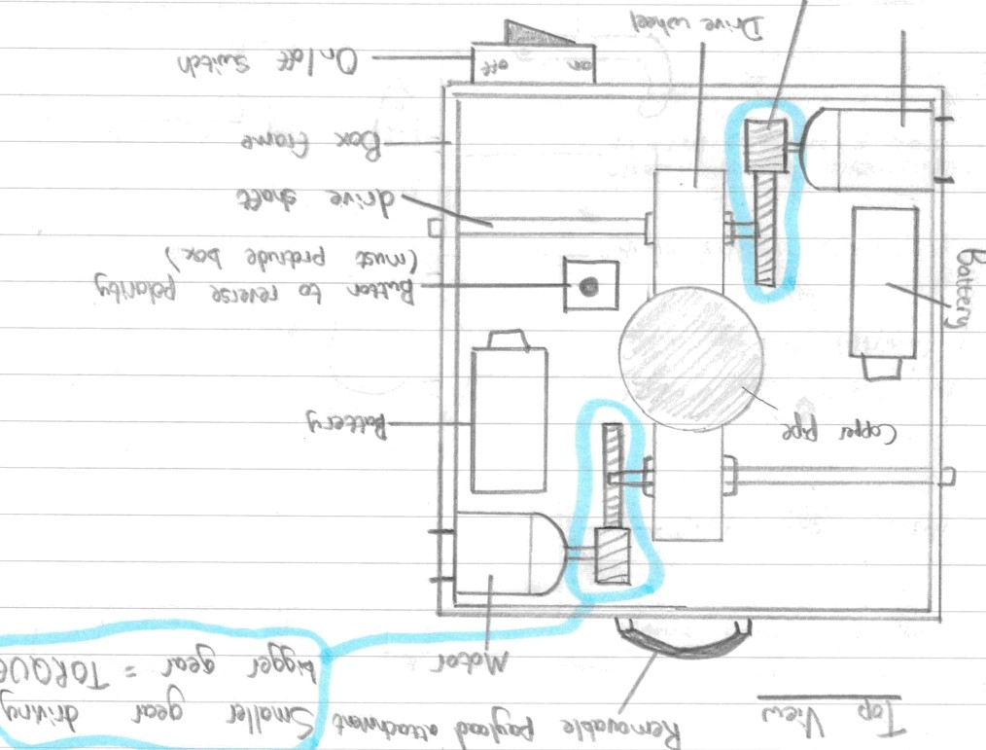
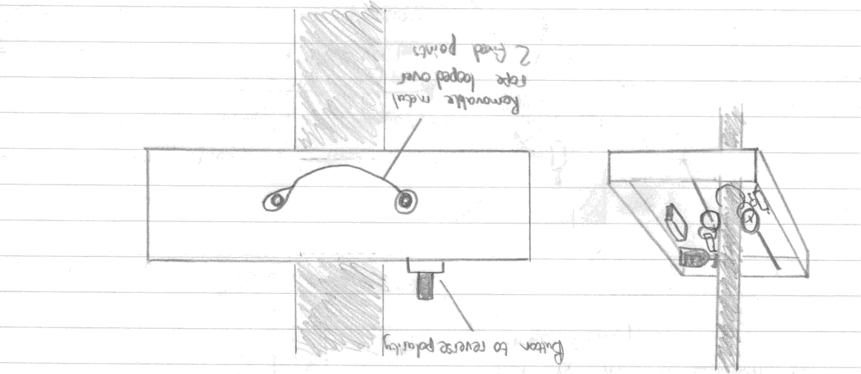
Alternante Designs
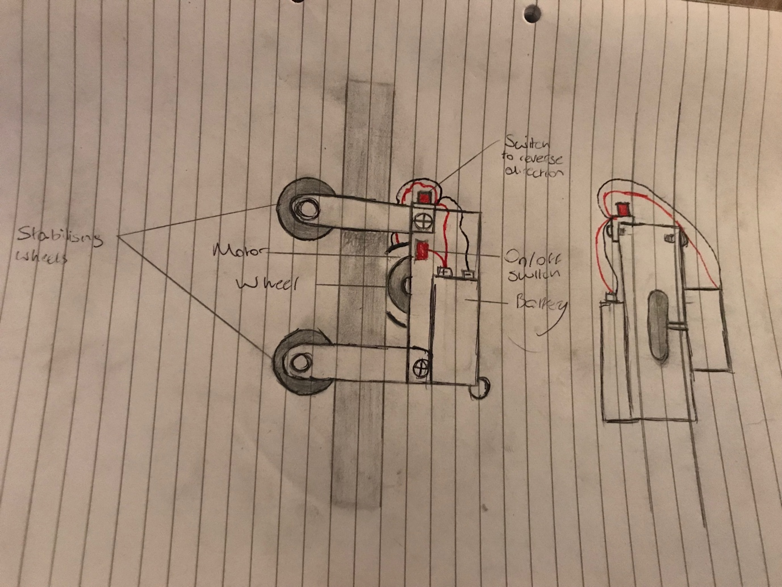

References
Ebay, 2019. Ebay. [Online]
Available at: https://www.ebay.co.uk/i/252345336766?chn=ps&var=551190573827
[Accessed 1 February 2019].
Institution of Mechanical Engineers, 2018. Design Challenge Project Specification and Rules, London: Institution of Mechanical Engineers.
Screwfix Direct Ltd, 2018. Chains: Screwfix. [Online]
Available at: https://www.screwfix.com/p/side-welded-chain-3mm-x-2m/66371

