
THE IMPACT OF WORK-RELATED STRESS IN THE UK


SERENA PARTRIDGE
2027003
JONATHAN WYATT
BMSW4004

Executive Summary

This report will examine the impact of work-related stress in the UK, introducing the concept of what work-related stress is. It will further go on to look at the case of how work-related stress is evident in the UK, the financial impact it has.
It will also look at the causes of work-related stress and the effects it has on the physical, mental and psychological health of the British population.
A PESTLE analysis will then be carried out identifying the range of external factors that contribute to stress in the workplace; with key solutions being identified through a Grid analysis.

Table of Contents
Executive Summary 1
Table of Contents 2
INTRODUCTION 3
THE CASE STUDY 4
CAUSE AND EFFECT 5
A PESTLE ANALYSIS 7
A GRID ANALYSIS 8
CONCLUSION 9
REFRENCES 10

INTRODUCTION

The purpose of this report is to explore work-related stress within the UK.
Work-related stress is defined, according to Raby (2021), as “the overwhelming feeling a person suffers when they cannot meet the high demands and pressures within their employment and the employee feels that they cannot cope”.
There are various factors that can contribute to work-related stress, this report will identify just some of those factors and the effect they have on employees.
A PESTLE analysis will identify outside influences that contribute to work-related stress, then using Grid analysis a solution can be identified to help reduce stress in the workplace.

THE CASE STUDY

Work-related stress is a global issue, it is not a short-term problem. Stress related to work has become an ever increasingly part of working life due to the evergrowing demands and pressures faced to fulfil ones role, and in some cases this can lead to serious health concerns.
According to Statista (2021), in 2020 a survey was carried out and four-fifths of the participants confirmed that the most common stress within the UK is work-related. The majority of the population in the UK are also struggling with financial stress.
A survey of UK organisations also shows that from 2019 to 2020 there was a rise in stress-related absences from work. The main factor contributing to this was work-related politics in regard to both genders, 35 percent of men and 38 percent of women.
In the United Kingdom a share of companies have reported an increase of 37% of stress-related absences. Statista (2021). It was identified that customer service in the UK was the role that had the highest levels of stress reported. This could be due to the fact the customers themselves are stressed and unhappy, therefore exerting their own frustrations onto the employee attending to them.
14.7 billion U.S. dollars each year accounts for the UKs healthcare expenses towards stress related illnesses, that is more than 5.5million admitted inpatients displaying symptoms of stress related illnesses. Chest pain, also a symptom of anxiety was the most common symptom physically identifiable because of stress. This also accounted for 943 thousand admissions to hospital.

CAUSE AND EFFECT

Cause and effect is “the relationship between two things when one thing makes something else happen.” lumen (2021). In other words, identifying what happened and the impact (effect) it has by asking “why?”. Why did that happen? What caused that to happen? And so on until the issue has been identified, and therefore a solution can be created.
For this report a visual diagram has been used to display the causes and effects in the form of a fishbone diagram (also known as the Ishikawa diagram).
The Ishikawa diagram was created in the 1960s by Kaoru Ishikawa and was also called the fishbone diagram as it was noticeably shaped like a fish. Wong (2011).
The main problem would be represented as the ‘fish head’, the factors that contributed to the main problem would then be branched along the body, thus showing as a fishbone.
This would allow all factors to be easily seen, making it easier to identify the causes of the problems, making it a very effective tool to identify cause and effect.
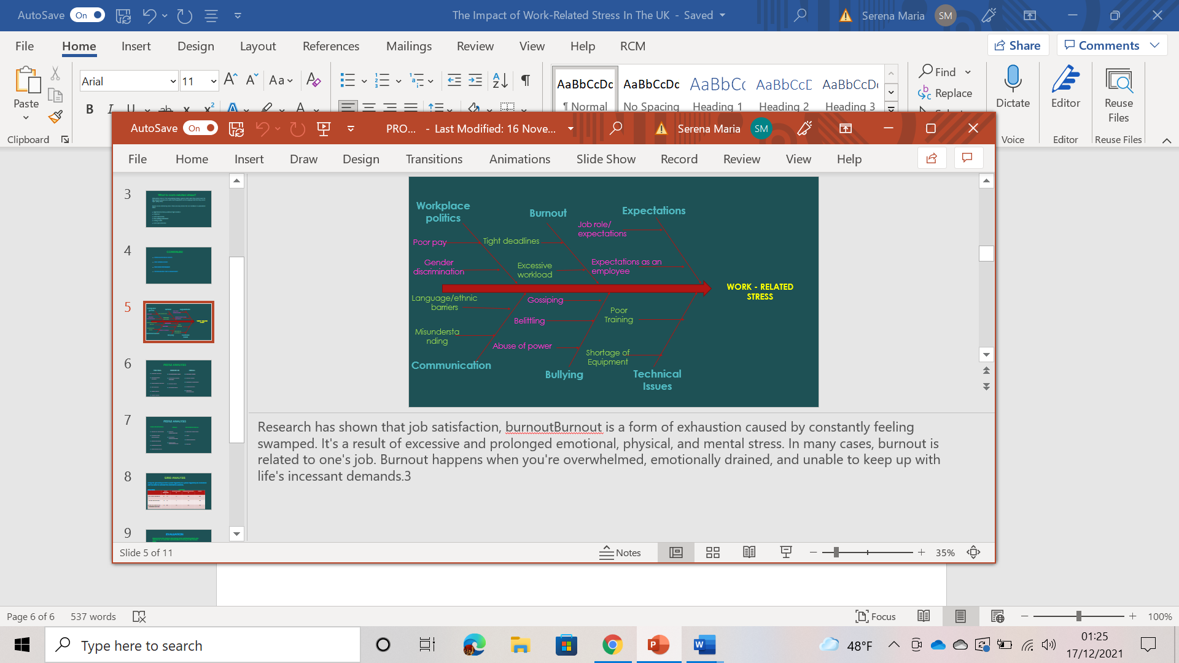
Appendix 1.

As appendix 1 shows, there are many factors that can contribute to work-related stress. Upon closer examination, the cause and effect of these factors will show how these issues can affect an employee causing work-related stress.
Burnout is described as “a state of physical and emotional depletion, burnout is a result of prolonged exposure to stressful working environments”. Khamisa et al, (2015).

According to the Maslach Burnout Inventory, there are three elements to of burnout:
- Emotional exhaustion: depleted emotional energy, feeling that their own emotional resources are insufficient to cope with the pressures endured.

- Depersonalisation: exorbitant detachment from fellow collegues, isolating themselves and treating people in the workplace as objects instead of people.

- Reduced personal accomplishment: reflecting at their own work in a negative way, criticising and feeling incompetent. Feeling inadequate and incapable of achieving goals.
Emotional exhaustion was the main contributor for burnout using the Maslach Burnout Inventory. O’Driscoll & Cooper (2002). Being overworked, having an excessive workload, meeting tight or short deadlines as well as being short staffed all add to reasons why burnout may occur.
Expectations and lack of clarification, within the job. The lack of clear boundaries or conflicting roles can cause stress. Michie (2021).
Responsibility for others can be very stressful, monitoring their performance and communicating effectively so that the role is being fulfilled to the correct standard, possibly meeting set targets. The employee inevitably lacks job satisfaction due to increasing pressures placed upon them, being in charge of other people would be a responsibility they will not be able to meet.
Lack of training, absence of promotions, job insecurity contributes to stress. As well as managers that are demanding, critical and unsupportive then add to the growing pressure. Thus, causing an emotional distress and exhaustion. In some cases, this progresses to anxiety or also known as a ‘panic attack’. If ongoing can lead so serious health issues.

A PESTLE ANALYSIS

The PESTLE analysis model was created by Francis Aquilar in 1967.Lucidity (2021). It is a framework used to identify the Political, Economic, Social, Technological, Legal and Environmental factors that could impact a business. It is formed by the construction of six pillars, and this can be used in any industry.
PESTLE Analysis us used globally and is easy to understand, thus making it easy to observe all the external factors that may influence a business.
PESTLE analysis provides a basic idea of the macro environmental conditions and factors of the organisation. Yiksel (2012).
Although there is not just one factor that contributes more to work-related stress, by knowing the company and keeping up to date with global affairs, this information can be used to implement changes required to reduce stress at work.
Political factors may include Tax policies, Trading policies and Labour law. CFI (2021).
Economic factors may consist of inflation and interest rates as well as economic growth patterns.
Social factors can include cultural trends, demographics, and employee expectations.
Examples of technological factors are research and development, communication, and adaptation skills.
Legal factors are worker compensation, customer dissatisfaction and workplace discrimination.
Environmental factors are also relevant and can include working conditions, trust and support.
Using PESTLE analysis can help identify the primary contributing factor to work-related stress, with the modern working environment in the UK being under the pressure and influence of many elements. Despite each factor playing its own role in creating work-related stress, it seems that there 3 key problems: skill development, clear objectives, and communication. Developing the skills of workers equips them with the right tools to complete their roles to the highest standard, which means that there is an improvement in performance and quality of the output. This can lead to benefit the organisation who may experience increased profits and boost customer satisfaction, whilst also benefitting employees as they feel more comfortable within their roles and valued by the organisation who encourage this development. Moreover, a lack of clear objectives can build the pressure on employees within the work setting and setting these objectives can in turn create a healthy organizational culture for staff to thrive within. Wilson (1989). However, communication seems to be the overriding contributor to work-related stress in the UK, being considered a technological factor yet being a prime element across all areas. Within a hierarchal structure bottom level employees often find it harder to gain information, only hearing of it once it filters through or sometimes not hearing of it at all. Mallet-Hammer [2015]. This breakdown in communication can create high-stress situations for employees once it leads to misunderstandings and disagreements; a domino-effect which can destroy interpersonal relationships within the workspace, stunt the development of skills and render the objectives set useless as they no longer have the means to achieve these goals together. Therefore, communication is the major factor in work-related stress in the UK as it oversees the extent of how much other factors can lead to stress, without effective communication as the first step to a constructive work environment the other contributing factors cannot be addressed.

A GRID ANALYSIS

Grid Analysis was a tool created by George Kelly in 1955 as a framework to help make a decision by ranking the alternative factors. In using grid analysis to weigh up solutions to each factor against each other, an appropriate plan for the solution to the prime problems can then be identified.
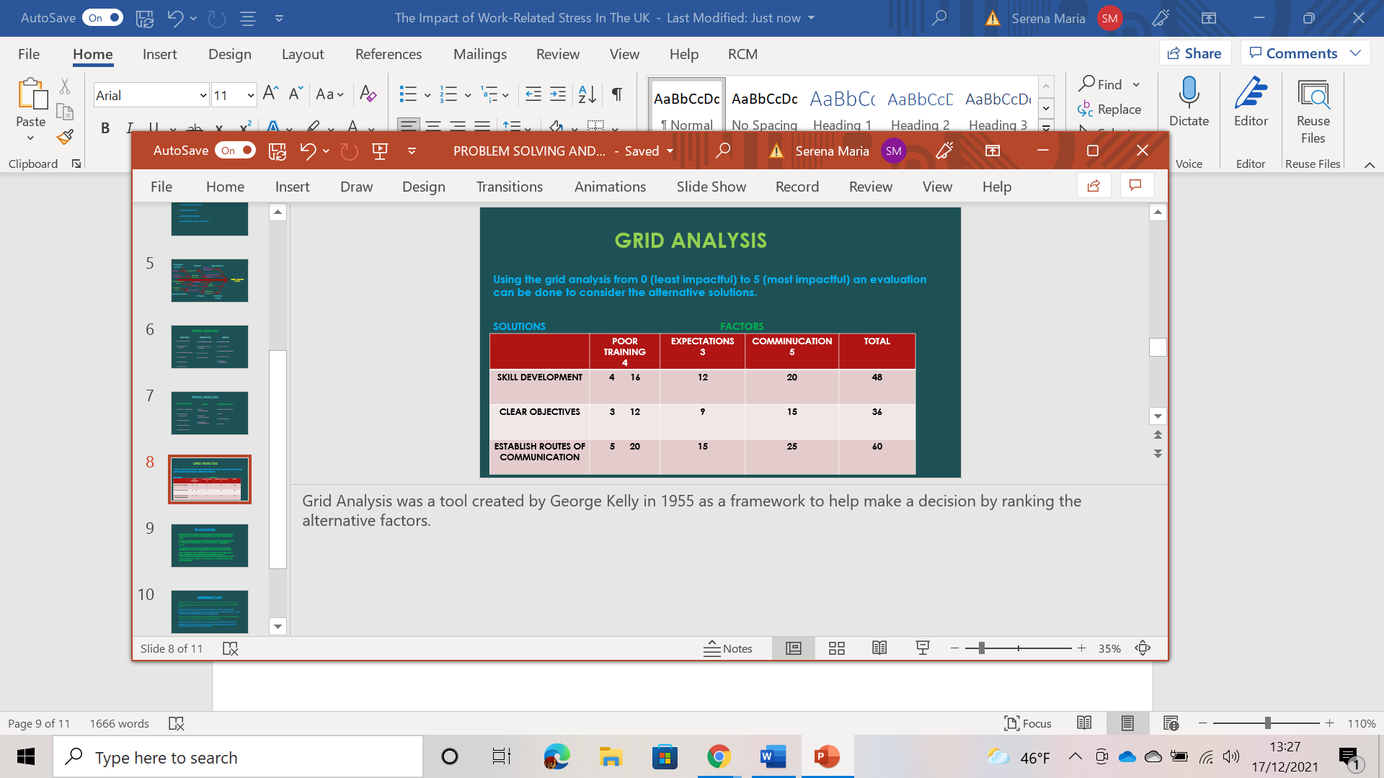

Appendix 2.

With establishing routes of communication as the key solution to reducing work-related stress, it would be ideal to remove barriers to communication which can either be environmental or personal. Environmental barriers concern the nature of the work setting and organisation itself whilst personal barriers reflect the individual worker. Adu-Oppong, A.A. and Agyin-Birikorang, E (2014). Realistically, it would be difficult for a larger organisation to place emphasis on removing the personal barriers so would prioritise removing environmental barriers by managing communication channels within the hierarchal structure to ensure that it flows effectively and without restriction. This may be achieved through ensuring that all parties within the communication process are listening and using the appropriate methods of communication. Furthermore, personal barriers would still need to be addressed and this would be best achieved through the use of departments such as HR, who manage the people side of the organisation. Once these two forms of barriers are removed the focus can then move to other solutions such as setting clear objectives and developing the skills of employees.

CONCLUSION

Upon evaluation, it is clear that work-related stress in the UK is a result of various internal and external factors with each cause also having its equal consequences on both the organisation and more significantly its staff. From job dissatisfaction to burnout, work-related stress only carries disadvantages and must be addressed.

REFRENCES

Adu-Oppong, A.A. and Agyin-Birikorang, E., 2014. Communication in the workplace: Guidelines for improving effectiveness. Global journal of commerce & management perspective, 3(5), pp.208-213. [PDF} https://www.researchgate.net/profile/Akua-Adu-Oppong/publication/304782482_COMMUNICATION_IN_THE_WORKPLACE_GUIDELINES_FOR_IMPROVING_EFFECTIVENESS/links/57a8550108ae73e6e132670b/COMMUNICATION-IN-THE-WORKPLACE-GUIDELINES-FOR-IMPROVING-EFFECTIVENESS.pdf [Accessed 17th December 2021]
CFI, 2021. PEST Analysis [online] https://corporatefinanceinstitute.com/resources/knowledge/strategy/pest-analysis/ [Accessed 12th December 2021].
Khamis, N, Oldbenberg, B, Peltzer, K, Ilic, D., 2015. Work Related Stress, Burnout, Job Satisfaction and General Health of Nurses. Environmental Research and Public Health. 12(1).pp.653-666.
Lumen, 2021. Cause and Effect essays [online] Available at: https://courses.lumenlearning.com/englishcomp1coreq/chapter/cause-and-effect-essays/ [Accessed 15th December 2021.
Mallett-Hamer, B., 2005. Communication within the Workplace. [PDF]https://minds.wisconsin.edu/bitstream/handle/1793/41715/2005mallett-hamerb.pdf?sequence=1 [ Accessed 17th December 2021].
Michie, S. 2021. CAUSES AND MANAGEMENT OF STRESS AT WORK. OCCUPATIONAL & ENVIRONMENTAL MEDICINE.v59(1).pp67-72.
O’Driscoll, M.P. and Cooper, C.L., 2002. Job-related stress and burnout.
Raby, A, 2021. Work related stress [online] Available at: https://www.bupa.co.uk/health-information/mental-health/stress-workplace [Accessed 10th December 2021].
Statista, 2021. Stress in the UK – statistics and facts [online] Available at: https://www.statista.com/topics/6735/stress-in-the-uk/ [Accessed 16th December 2021].
Wilson James Q. 1989. Bureaucracy. New York, NY: Basic Books.
Wong, K.C., 2011. Using an Ishikawa diagram as a tool to assist memory and retrieval of relevant medical cases from the medical literature: Journal of Medical Case Reports [e-journal] pp1-3. https://doi.org/10.1186/1752-1947-5-120 .
Yuksel, I., 2012. Developing a Multi-Criteria Decision Making Model for PESTEL Analysis. International Journal of Business and Management. 7(24). p52.

