

LOCATION: SWANSEA | LLEOLIAD: ABERTAWE
LEVEL 4 | LEFEL 4
EXAMINATION PERIOD | CYFNOD ARHOLIADAU
January 2021 | Ionawr 2021

MODULE CODE: ACBA6000
CONSTRUCTION MANAGEMENT

TIME: 2 HOURS
ANSWER ALL OF SECTION A AND ONE QUESTION OUT OF TWO QUESTIONS GIVEN IN SECTION B

Equipment or materials required – Calculators
Adnoddau neu ddefnyddiau sydd eu hangen - Calculators

Section A

QUESTION 1 (25 marks)

The table below shows the contractors project budget and profit distribution for a new contract. Interim payments are paid monthly in arears minus a 10% retention. Half of the retention is payable with the final certificate and the other 50% payable 6 months later.

Month | 1 | 2 | 3 | 4 | 5 | 6 | 7 | 8 | 9 | 10
Value of work (£000) | 2 | 3 | 4 | 8 | 9 | 9 | 8 | 5 | 4 | 2
Profit (% of value) | 6 | 6 | 6 | 6 | 6 | 6 | 6 | 10 | 10 | 10

- Determine the net monthly cash flows
(15)

- Calculate the simple interest charge on locked up capital for an agreed interest rate of 12%.

(10)

QUESTION 2 (25 marks)

Delay occurred in the previous activities of this job. For this reason we have to reduce the total duration of works in the last part of our arrow diagram shown below. We talked with all subcontractors and calculated normal time, normal cost, crash time and crash cost for every activity as shown in table below. We also know that indirect costs are estimated in £150/week.
10

10

11

14
40

15

12

13

 | Normal time | Normal cost | Crash time | Crash cost
10-11 | 5 weeks | £10,000 | 4 weeks | £15,000
10-12 | 10 weeks | £24,000 | 8 weeks | £28,000
11-13 | 6 weeks | £15,000 | 5 weeks | £16,000
11-14 | 8 weeks | £14,000 | 7 weeks | £15,000
12-14 | 6 weeks | £25,000 | 4 weeks | £29,000
13-15 | 10 weeks | £28,000 | 8 weeks | £38,000
14-15 | 5 weeks | £20,000 | 4 weeks | £20,500

Answer the following questions:
- The project manager is convinced the cheapest way to reduce the total duration for 2 weeks is with activities 10-12 and 14-15. Do you agree with him? (show your calculations)
(10)

- We need to reduce the total duration for 3 weeks. Which activities would you choose? (justify your choice)

(10)

- How much is the total project cost?
(5)

QUESTION 3 (25 marks)

The diagram below presents an arrow network without event numbers but showing the duration for each activity in days:

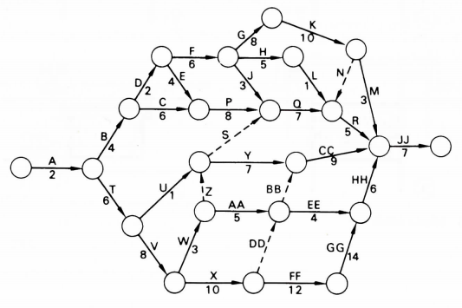

- Number the events.
(3)
- Calculate the earliest and latest event times.
(10)
- Identify the activities that are critical.
(6)
- Calculate the total float and free float of the non critical activities
(6)

Section B

CHOOSE ONE OF THE FOLLOWING QUESTIONS TO ANSWER

QUESTION 1 (25 marks)

The construction site shown illustrates the layout of equipment building materials and access roads for the erection of a low-rise building.

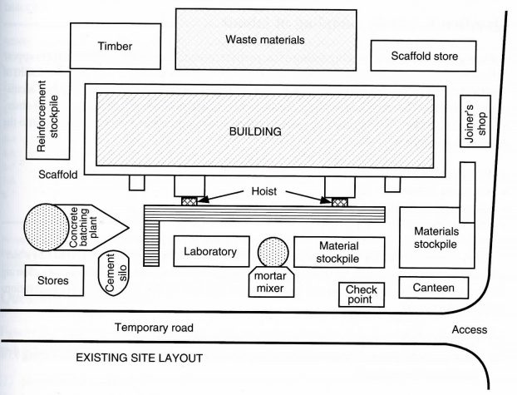

  - Comment on and critique the present site layout of equipment, building materials and access roads for the erection of a low-rise building.
(10)
  - Suggest an improved site layout with justification (sketches are advised).
(15)

QUESTION 2 (25 marks)

  - You have been asked to produce a total project budget for a client who wants to build new offices in a nearby town as their current accommodation is too small and outdated. You need to explain to the client what costs will be need to taken into consideration when arriving at the total project budget. Give examples where possible.
(15)

  - The client needs to understand if his project is a success. To achieve this you have been asked to consider Key Performance indicators. Describe what they are and suggest possible KPI’s justifying their inclusion.
(10)

Diwedd/End

Page Break

