


We Build Better People
(Griffiths, 2022)

Sarah Chislett - 1810559 University of Wales Trinity St David
Word Count - 3836
Date - 18th February 2024

Briefing Paper – Supporting Learning

I Sarah Chislett confirm that the work enclosed is my own

Glossary Of Terms

AGC – Alun Griffiths (Contractors) Ltd
SLT – Senior Leadership Team
LM – Line Manager
PESTLE – Political, Economic, Social, Technological, Legal, Environmental
HRBP – HR Business Partner
MD – Managing Director
L&D – Learning and Development
LNA – Learning needs analysis
AI – Artificial Intelligence
VR – Virtual Reality
RIDDOR – Reporting of injuries, diseases and dangerous occurrences regulations.

Table of Figures

- Balance scorecard
- Kolb learning model
- Kolb leaning styles
- Kirkpatrick evaluation model

Introduction
Alun Griffiths (Contractors) Ltd is a construction company based in South Wales with over 50 years of positive experience within the local community. The success of AGC has been evident with liberal growth in the business moving to more geographical areas within Wales and Southwest England (AGC, 2024a).
Whilst the investment in the business has manifested over the years, the investment in people has been negligent, focusing only on mandatory training (CIPD, 2017). The main focus for AGC has been business growth, allowing the expansion of work, the amount of people employed, and the amount of profit that it can produce in a year. However, this has not come without challenge, with employee performance issues and health and safety issues raised due to the lack of quality training. Garton (2017) indicates that you can improve productivity by simply stopping the underinvesting in human capital.
In 2018 AGC was taken over by Tarmac since this acquisition took place the overall headcount of AGC has more than doubled (AGC, 2024b). Since Covid hit in 2020 there has been a slight decline in attrition. Employees are indicating that they are leaving due to not having the career progression and longevity in their role, the great attrition still presenting as an issue for AGC (McKinsey, 2022).
Research from Schrage et al, (2020) suggests that targeting investment is fast becoming a key principle in making people more valuable in organisations. If employees feel valued, they are often happier and more productive in work with less probability of them looking to leave (Indeed, 2023).
A main focus in the last 18 months has been on mandatory training for employees. Line managers often allude to them being too busy to attend training. LM may not always understand the benefits that can come with training instead choosing to spend their time focusing on building the business and increasing profitability. This is a longstanding cultural issue that AGC is presented with, however with more engagement there is potential that this issue could be reversed.
When considering the internal and external factors affecting an organisation, the use of a SWOT or PESTLE supports in understanding imminent risks. Batista, (2023) describes a PESTLE analysis as a way to review impacts and maximise opportunities which is something that AGC need to improve on. Often AGC is reactive when it should be proactive.
Internally, due to lack of people investment in the Learning & Development function, the basics such as a Learning Needs Analysis, which Hayden (2023a) describes as a systematic process to analyse the gaps between learners and organisation goals, has not been done.
Job profiles are also fictional or verbally briefed which causes inconsistency across the business and when it comes to managing a process, there is little or no evidence to support what an employee is currently hired to do. Bosley (2019) quotes that job profiles are crucial in establishing roles and responsibilities but also creates a sense of value and supports with maximising employee performance.
There are varying external factors affecting AGC, the biggest factor for AGC would be the exposure to the change in technology. In 2023, AGC was given approval for a HR and payroll system (Itrent, 2024). This investment was welcome news for many, as AGC is perceived as an ageing business with outdated systems (2024c).
This was however, the first time that the business recognised that there was a skill issue with many employees and how they use technology. Itrent (2024) will allow employees to have access to their data at the touch of button, which surely could only be seen a supportive solution.
AGC recognises that over time technology has changed and that’s why the business has received such investment. With a committed aging workforce and the implementation of a tech smart system, this could be considered a challenge like AGC have never faced before.
Technology design and training would need to be a key consideration for many of these employees (Mayhorn, 2012). Technology is emerging and the use of artificial intelligence, virtual reality and developing HR systems are already being used in many organsiation’s (So, 2018).
Literature from Scorgie et al, (2024) suggests that safety training is a key activity worldwide, therefore it could be wise for AGC to align their safety training using VR. If AGC fail to keep up with this technical era, they are quickly at threat of become an outdated organisation with omitted opportunities, with potential of future workforce not being attracted, which will cause a further obstacle for AGC.
As part of the investment for a system there has also been investment to the L&D team with three new roles being brought into the team. L&D Manager an early in careers coordinator and a health and safety coordinator. Brassey et al (2019) indicated that there were 5 components of a L&D strategy
- Attract and retain.
- Motivate and engage.
- Build an employer brand.
- Create a values based culture
- Develop people capabilities.

Through the recent investment in the L&D, there is a pressing need to develop a strategy which is inclusive of a LNA and the above components. If successful implemented AGC could be closer than ever to closing the gap with current and new employees, whilst supporting with the overarching business strategy ‘We build better’ (AGC,2024d).

Findings
Since Covid-19 many employees are now looking for more from the workplace. Research from McRae et al (2024a) suggests that there will be desire for more creative benefits, EDI to be embedded into organisation’s culture and the confidence that AI is not going to remove roles but actually support and redefine existing roles.
McRae et al (2024b) also endorses organisations review of cross functional training. How can AGC break the traditional career path in favor of supporting changing career direction, retraining and making it easier for employees to work for as long as they wish? Instead of their ability or skillset to rule when they should retire form their working career, which is often the case for some employees in AGC due to years of physicality within manual roles.
HR news (2021) published that by not investing in employees, AGC could begin to have issues with attrition, which has already happened. AGC could see a decrease in productivity which poses the question, is AGC delivering upon a basic element of its employment which employees now expect to have – investment and training?
Gallup (2016) completed a survey with 87% of millennials citing that L&D opportunities play a contributing factor in if they apply for a job, and with 42% of AGC being classed as an ageing workforce, this could be a major factor to consider in future recruitment.
People crave learning, and as businesses progress and change, it is up to the employer to successfully understand what employees need to learn and how that training can be implemented, whilst being mindful that not every employee is the same and that people will learn differently (Feder, 2023a).
Hayden (2023b) confirms that’s research is continually advancing on how people learn and by gaining a better understanding of this, it will in turn result in businesses being more successful. By doing so AGC should see an improvement in internal succession, attrition and employee satisfaction.
Marshall (2024) implies that L&D could be a key component in steadying the ship by helping to focus on business goals. Over the last 18 months AGC has recognised the importance of investment in employees and to show its commitment to employees AGC has added training to the balance scorecard which is a set of business objectives for all AGC employees (AGC, 2024e).
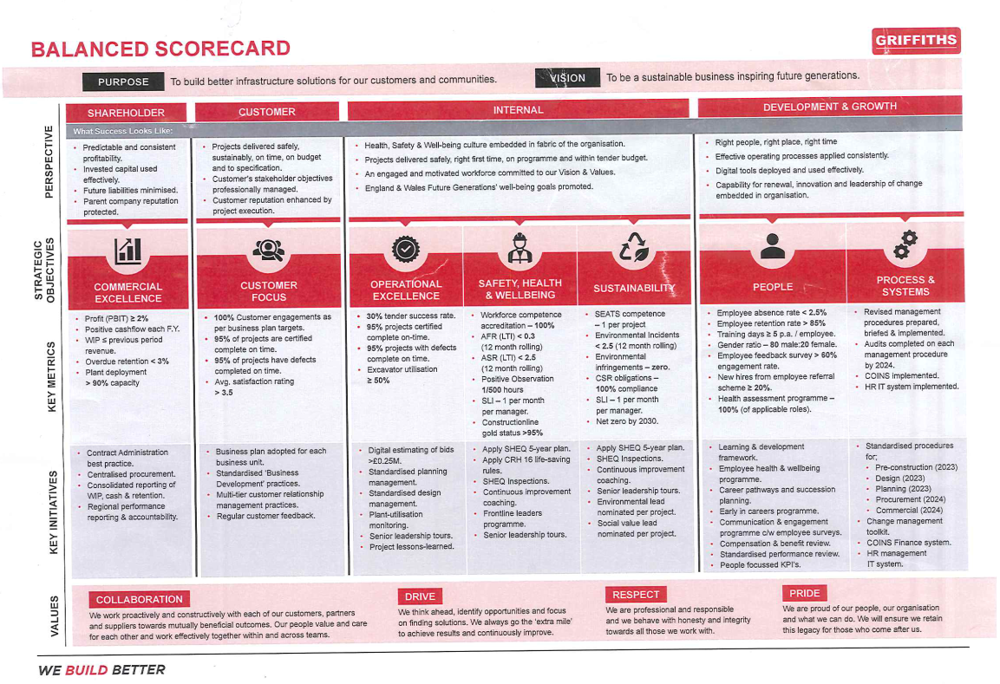 (AGC, 2022)
From the earlier PESTLE, AGC understands that upskilling the workforce on technology is a significant task. CIPD (2017) describes technology as a key component of working lives.
With emerging trends and benefits to learning, AGC needs to really understand where they are with L&D and the scope of where they can take the L&D function. Hayden (2023c) described having a L&D strategy as a key part of a business which can outline how to build capabilities and competencies of workers.

Emerging Technologies
Changing technology looks different for everyone. Some organisations could be very futuristic in their use of technology but for AGC, this could be considered a complex process to alter and adapt to. Currently AGC employees 890 employees and 42% of them are over the age of 50 which CIPD (2022) class as older workers.
With technology growing at a rapid pace, for many it is often considered a challenge to keep up with the latest trends. Kuiken (2022) describes how the rapid change in technology means that organisations need to react quickly and formalise new boundaries with trust and continuous learning to ensure the future success of businesses.
Emerging technologies in the workplace include the use of AI, VR and the metaverse (Marr, 2022). Tulsaini (2023a) describes a modern workplace as being a hub of learning. The benefits of AI and VR include quick answers to questions, ability to track your progress and the ability to engage in activities with risk free consequences (Tulsaini, 2023b).
Development of technology can have a significant impact on everyone but for organisations that are outdated in their Infrastructure the challenge is immense. AGC could use this change in technology as a positive for the business and its employees.
The implications of this change could provide a huge benefit, especially through the use of VR training in the health and safety sector. Construction is a dangerous industry and to be able to review potential treats in a safe environment could be a positive to demonstrate the concerns of not acting in a safe manner when on a construction site.
Furguson (2020) describes the use of VR as an option of being present or a physiological presence of being somewhere. If employees could see firsthand or feel the threat of completing an act unsafely, would this make them rethink their potential actions? Last year there were 26 preventable incidents in health and safety (AGC, 2023), out of those 26 incidents two were RIDDOR reportable, if employees had been trained on VR this potentially could have changed the outcome.
Technology will of course come with potential disadvantages. The reliance on technology could result in job losses, potential security issues and if there are issues with the technology, that could have a detrimental impact on the training (BBC, 2024). However, there seems to be enough advantages leaning towards the technological change to encourage a move into the modern world of working.
If AGC were to implement VR they would need to consider retraining, investment in L&D but most importantly there would need to be a cultural change and this change would need to come from the top down, stakeholders would be critical in making this change.
Impacts on Stakeholders
As with any change understanding why is imperative, and without engaging key stakeholders there is always a chance that the change may not be successful.
Stakeholders are critical as a group of individuals who have an interest or concern in a change (BBC, 2024). Main stakeholders at AGC would be considered the SLT. Each SLT member has their own group of direct reports who report to them. By having a reporting line there is a vested interest in things being done correctly.
By involving stakeholders, you will see things from their perspective and they will be able to discuss concerns or threats from a business perspective and in turn the stakeholders will feel as though the business in engaging them and they will feel as though there is transparency which helps build trust to achieve the same end goal (Indeed,2022).
L&D is key in respect of engagement of key stakeholders. If you do not consider how the increased emphasis on L&D and investment in employees is important to stakeholders and the wider employees, including the benefits that can come from this process, then stakeholders may not fully engage themselves in the process. Hayden (2023) confirms that without aligning to key business objectives you may not get the stakeholder support you need. For AGC we know that this can be done through the commitment of the balanced scorecard.
For AGC it is critical that this change in culture towards investment through L&D with emerging technologies starts now. Young (2023) describes the importance of L&D in organisational change and by listening, viewing and reacting to behaviours, AGC can align its policies to its value and mission and naturally, a positive cultural change could follow if it is led by AGC stakeholders.
By sharing the change through the company’s vision, linking it back to the strategy and the business objectives, AGC can not only make a change, they can make a difference. However, If AGC does not consider the importance of making the change, will this continue to contribute to attrition? Nonetheless, ultimately AGC should consider how long they can continue to be successful if they do not invest in their key stakeholders – their employees (Bedwell, 2018).

Theories and methods
There are many learning theories, the main ones include cognitive, behaviourism, constructivism, humanism, and connectivism with additional learning theories being supported with transformative, social and experimental (Feder, 2023b). The importance of understanding these learning theories is so that organisations can help understand its learners better.
In 1984 Kolb introduced a learning model that was based on a four stage cycle with four different learning styles (Mcloed,2023a). Below is an image representing these four stages
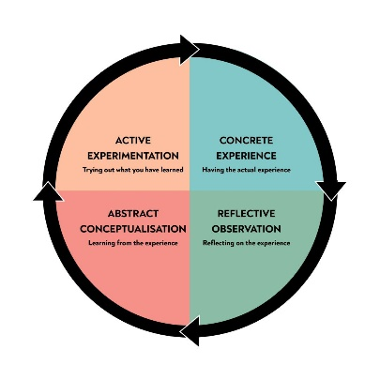 (Mcloed, 2023b) 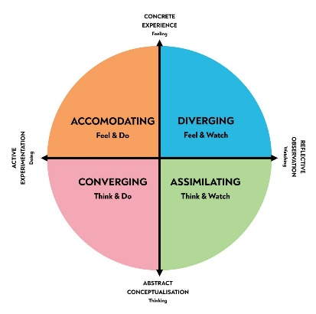 (Mcloed,2023c)
Kolb referred to the first cycle as a one that every learner would touch as they progress through each stage, whereas the second cycle is known as the reflective cycle and learners can join any at any point depending on how they like to learn (Mcloed, 2023d). This is something AGC could consider if it implements a LNA for its employees.
As AGC has not invested in learning except mandatory learning up to this point, it would be important to understand from the learners (employees) how they would like to approach learning. Do employees currently have any thoughts on the change and implementation of the HR and Payroll system and actually do they already know their preferred learning style?
Organisations can sometimes underestimate the knowledge held within its people who may have joined the business from competitors and have prior experience that could be used to benefit the business now and in the future. Leonard and Martin, (2019) describe these people as Nextperts, experts sharing their knowledge to other individuals.
What AGC now need to consider is how they are going to use this information and implement it into a live training plan, one that would positively impact all employees and one that AGC can see the benefit of. Training plans are used to develop competencies, however to develop this plan through stakeholder analysis of each employee, the LNA will need to be implemented to understand what is available and to who, a training plan whether a business plan or an individual plan (for those employees who may need more specific training, such as non-digital learners) will help support the learning and keep them on track with their development (St-Jean, 2023).

Evaluation of Learning
When you complete any type of training it is important to know that the employee has left feeling like they have increased their knowledge. Koopman (2021) describes evaluation of learning as determining your success in the activity. A common model in the evaluation of learning is the Kirkpatrick Model, originally used in the 1950’s. This model entails a 4-stage approach reaction, learning, behaviour and approach (Image below).
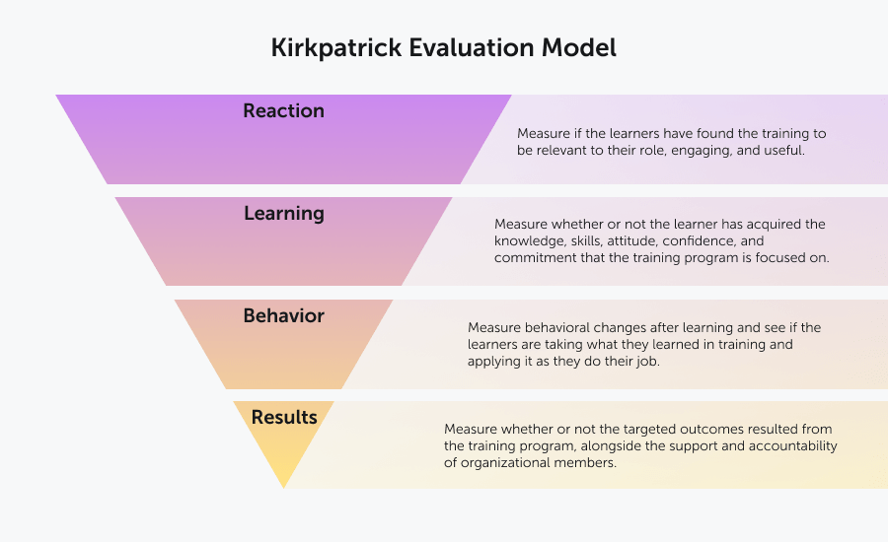(Valamis, 2023).
Whilst in theory this model looks effective, it may be worth considering that this model is now over 60 years old and the ways in which employees learn and adapt change (Mindtools, 2024), so it may not be relevant for all employees. For AGC with the pending implementation of a new technological system, it could be worth considering how they evaluate the success of this project. If AGC can take learning from this, then it could support with applying the use of VR for health and safety training.
Another way of evaluation learning could be though the use of eLearning. Research shows that eLearning is a powerful and cost-effective evaluation tool (LinkedIn, 2024) having many benefits such as being employee led, low cost, time efficient and environmentally friendly (Tamm, 2023). AGC should however be mindful of the technical divide between younger and older workers Becker et al (2012).
Griffiths and Inman (2017) describe eLearning as activity based and given the previous research into how people learn differently this approach may be suitable for some employees but not all employees at AGC.

Conclusion
Based on the literature reviewed, best practice and the analysis of the findings for this paper it is unmistakable to see that AGC needs to make a change in supporting learning for its employees.
As competitors continue with their advances and technologic platforms time is of the essence for AGC, with Balfour Beatty (2017) talking about Robots in less than 30 years AGC is still working on outdated systems.
Craig, (2018) cites that investment in employees is important for attrition, and retention as it fosters a culture of unafraid innovation and change, however investment in employees can’t be the only significant task, getting the process right needs to be the priority.
If through the current investment in the L&D, AGC can implement a strategy to incorporate, training for all abilities, the introduction of emerging technologies and potentially for AGC the use of VR for health and safety training with the critical element of self-evaluation then this could give the business a competitive advantage.
If AGC continues as they are, with little infrastructure within L&D and no focus on emerging technology then employees would continue to feel underinvested in. There could also be issues with attrition which could continue to grow, productivity could continue to fall and ultimately AGC will continue to fall behind the times.

Recommendations
Following on from the research completed for this briefing paper, AGC could consider two recommendations in improving supporting learning.
- AGC to complete a full LNA and provide job specifications for roles. This will help AGC understand exactly where each employee is and what the focus needs to be to support their employees learning.

- AGC to introduce the use of VR when completing health and safety training and eLearning afterwards to evaluate the learning experience. By implementing the use of VR there is better chance of employees being engaged in the process and stopping them from committing unsafe activities. This training could support with decreasing workplace incidents which in turn means less money being spent on retraining or corrective actions and this money could be reinvested elsewhere in the business.

Implementation for recommendations

Reference List
Balfour Beatty (2017) A digital future for the infrastructure industry. Available at:https//www.balfourbeatty.com/media/244600/balfour-beatty-innovation-2050.pdf (Accessed: 28th January 2024).
Battista, M. (2023) PESTLE Analysis. Available at: https://www.cipd.org/uk/knowledge/factsheets/pestle-analysis-factsheet/ (Accessed: 6th December 2023).
BBC (2024) Business Stakeholders. Available at: https://www.bbc.co.uk/bitesize/guides/z6scbdm/revision/1/ (Accessed: 28th January 2024).
BBC (2024) Advantages and disadvantages of using new technology for businesses. Available at: https//www.bbc.co.uk/bitesize/guides/z4bjjhv/revision/6 (Accessed: 8th January 2024).
Becker, K., Fleming, J., & Keijsers, W. (2012). E-learning: ageing workforce versus technology-savvy generation. Education & Training (London), 54(5), 385–400. https://doi.org/10.1108/00400911211244687
Bedwell, N. (2018) Why employee stakeholders are the secret to your organisations transformative success. Available at: https://www.forbes.com/sites/forbesagencycouncil/2018/11/05/why-employee-stakeholders-are-the-secret-to-your-organizations-transformative-success/?sh=57254c24130a (Accessed: 4th January 2024).
Bosley, A (2023) Job Design. Available at: https://www.cipd.org/uk/knowledge/factsheets/job-design-factsheet/ (Accessed: 4th February 2024).
Brassey, J. Christensen, L. Van Dam, N. (2019) Essential components of a successful L&D strategy. Available at: https://www.mckinsey.com/capabilities/people-and-organizational-performance/our-insights/the-essential-components-of-a-successful-l-and-d-strategy (Accessed: 18th December 2023).
CIPD (2017) The future of technology and learning. Available at: https://www.cipd.org/en/knowledge/reports/future-technology-learning/ (Accessed: 6th January 2024).
CIPD (2019) Addressing employer underinvestment in training. Available at: https//www.cipd.org/globalassets/media/comms/news/addressing-employer-underinvestment-in-training_tcm18-61265.pdf (Accessed: 8th January 2024).
CIPD (2022) Understanding older workers. Available at: https://www.cipd.org/uk/knowledge/reports/understanding-older-workers/ (Accessed: 28th December 2023).
Deloitte (2020) Opportunity Marketplace. Available at: https://www.deloitte.com/global/en/our-thinking/insights/topics/talent/technology-and-the-future-of-work/importance-of-investing-in-employees.html. (Accessed: 28th December 2023).
Dorothy, L. and Martin, J. (2019) How your organisation's experts can share their knowledge. Available at: https://br.org/2019/12/how-your-organizations-experts-can-share-their-knowledge (Accessed: 4th February 2024).
E-student (2023) 10 Major advantages of eLearning. Available at: https://e-student.org/advantages-of-e-learning/ (Accessed: 28th January 2024).
Feder, M. (2021a) 5 Educational Learning theories and how to apply them Available at: https://www.phoenix.edu/blog/educational-learning-theories.html (Accessed: 4th February 2024).
Feder, M. (2021b) 5 Educational Learning theories and how to apply them Available at: https://www.phoenix.edu/blog/educational-learning-theories.html (Accessed: 4th Feb).
Furgeson, A (2020) Virtual reality and safety training. Available at: https://www.safetyandhealthmagazine.com/articles/19440-virtual-reality-and-safety-training (Accessed: 4th February 2024).
Gallup (2016) How millennials want to live and work. Available at: https://www.gallup.com/workplace/238073/millennials-work-live.aspx (Accessed: 28th December 2023).
Garton, E. (2017) The case for investing more in people. Available at: https://hbr.org/2017/09/the-case-for-investing-more-in-people (Accessed: 4th February 2024).
Griffiths (2024) Sustainability. Available at: https://griffiths.co.uk/sustainability-2/ (Accessed: 12th January 2024).
Griffiths (2024a) We Build Better. Available at: https://griffiths.co.uk (Accessed: 12th January 2024).
Griffiths (2024b) We Build Better. Available at: https://griffiths.co.uk (Accessed: 12th January 2024).
Griffiths (2024c) We Build Better. Available at: https://griffiths.co.uk (Accessed: 12th January 2024).
Griffiths (2024d) We Build Better. Available at: https://griffiths.co.uk (Accessed: 12th January 2024).
Griffiths (2024e) We Build Better. Available at: https://griffiths.co.uk (Accessed: 12th January 2024).
Griffiths, D., & Inman, M. (2017). Is it time to take learning design to task? Journal of Adult and Continuing Education, 23(2), 226-249. https://doi-org.ezproxy.uwtsd.ac.uk/10.1177/1477971417733270
Hayden, D (2023) Learning Needs Analysis. Available at: https://www.cipd.org/uk/knowledge/factsheets/learning-needs-factsheet/ (Accessed: 4th February 2024).
Hayden, D. (2023) Learning theories that impact on design. Available at: https://www.cipd.org/uk/knowledge/factsheets/learning-theories/ (Accessed: 4th February 2024).
Hayden, D. (2023a) Learning and Development Strategy. Available at: https://www.cipd.org/uk/knowledge/factsheets/strategy-development-factsheet/(Accessed: 6th December 2023).
Hayden, D. (2023b) Learning and Development Strategy. Available at: https://www.cipd.org/uk/knowledge/factsheets/strategy-development-factsheet/(Accessed: 6th December 2023).
Hayden, D. (2023c) Learning and Development Strategy. Available at: https://www.cipd.org/uk/knowledge/factsheets/strategy-development-factsheet/(Accessed: 6th December 2023).
Health and Safety Executive (2024) RIDDOR. Available at: https://www.hse.gov.uk/riddor/ (Accessed: 28th January 2024).
HR News (2021) The importance of employee learning and development. Available at: https://hrnews.co.uk/the-importance-of-employee-learning-and-development/ (Accessed: 28th January 2024).
Indeed (2022) What is Stakeholder management? Available at: https://BBC (2024) Business Stakeholders. Available at: https://uk.indeed.com/career-advice/career-development/what-is-stakeholder-management (Accessed: 28th January 2024).
Indeed (2023) Valuing Employees: 15 ways to make them feel valued. Available at: https://www.indeed.com/career-advice/career-development/valued-employees (Accessed: 28th January 2024).
Koopman, K. (2021) How to evaluate the effectiveness of your learning experience. Available at: https://elearningindustry.com/how-to-measure-the-effectiveness-of-your-learning-experiences (Accessed: 4th January 2024).
LinkedIn (2024) What are the most effective eLearning evaluation methods and tools. Available at: https://www.linkedin.com/advice/3/what-most-effective-e-learning-evaluation (Accessed: 28th January 2024).
Marr, B. (2022) 5 biggest gaming trends in 2022. Available at: https://www.forbes.com/sites/bernardmarr/2022/02/28/the-five-biggest-gaming-technology-trends-in-2022/?sh=2da6cb425fc7 (Accessed: 4th February 2024).
Marshall, H. (2024) The role of Learning and Development in 2024: back to basics. Available at: https://www.peoplemanagement.co.uk/article/1857292/role-learning-development-2024-back-basics (Accessed: 14th January 2024).
McKinsey (2022) Why employees are quitting and what to do about it. Available at: https://www.mckinsey.com/featured-insights/themes/why-employees-are-quitting-and-what-to-do-about-it (Accessed: 8th January 2024).
McKinsey (2023) Tech at the edge: trends reshaping IT and businesses. Available at: https://www.mckinsey.com/capabilities/mckinsey-digital/our-insights/tech-at-the-edge-trends-reshaping-the-future-of-it-and-business (Accessed: 12th January 2024).
Mcloed, S. (2024a) Kolb’s learning styles and experimental learning. Available at: https://www.simplypsychology.org/learning-kolb.html (Accessed: 14th February 2024).
Mcloed, S. (2024b) Kolb’s learning styles and experimental learning. Available at: https://www.simplypsychology.org/learning-kolb.html (Accessed: 14th February 2024).
Mcloed, S. (2024c) Kolb’s learning styles and experimental learning. Available at: https://www.simplypsychology.org/learning-kolb.html (Accessed: 14th February 2024).
Mcloed, S. (2024d) Kolb’s learning styles and experimental learning. Available at: https://www.simplypsychology.org/learning-kolb.html (Accessed: 14th February 2024).
McRae, R. Aykens, P. Lowmaster, K. Shepp, J. (2024) 9 trends that will shape work in 2024 and beyond. Available at: https://hbr.org/2024/01/9-trends-that-will-shape-work-in-2024-and-beyond (Accessed: 28th January 2024).
MHR (2024) Itrent HR and Payroll software. Available at: https://mhrglobal.com/uk/en/itrent (Accessed: 28th January 2024).
Mindtools (2024) Kirkpatrick’s model. Available at: https://www.mindtools.com/ak1yhhs/kirkpatricks-four-level-training-evaluation-model (Accessed: 28th January 2024).
Mindtools (2024) Learning Styles. Available at: https://www.mindtools.com/addwv9h/learning-styles (Accessed: 28th January 2024).
S., & Kolb, D. A. (2009). Are there cultural differences in learning style? International Journal of Intercultural Relations, 33(1), 69–85. https://doi.org/10.1016/j.ijintrel.2008.11.002#
Scorgie, D., Feng, Z., Paes, D., Parisi, F., Yiu, T. W., & Lovreglio, R. (2024). Virtual reality for safety training: A systematic literature review and meta-analysis. Safety Science, 171, 106372-. https://doi.org/10.1016/j.ssci.2023.106372
Shackleton-Jones, N., & Schank, R. (2019). How people learn: designing effective training to improve employee performance. Kogan Page.
So, G (2018) How to deal with a rapidly advancing technology and an aging workforce. Available at: https://www.insightsforprofessionals.com/hr/learning-and-development/rapidly-advancing-technology-ageing-workforce (Accessed: 4th February 2024).
Stewart, J., & Cureton, P. (Eds.). (2014). Designing, delivering and evaluating learning and development : essentials for practice. Chartered Institute of Personnel and Development.
St Jean, E. (2023) How to create an employee training plan. Available at: https://www.techtarget.com/searchHRSoftware/tip/How-to-create-an-employee-training-plan-with-template (Accessed: 4th January 2024).
Thompson, L.F. & Mayhorn, Christopher. (2012). Aging Workers and Technology. The Oxford Handbook of Work and Aging. 10.1093/oxfordhb/9780195385052.013.0113.
Tulsiani, R. (2023a) Artificial Intelligence and virtual reality: reshaping the corporate learning paradigm. Available at: https://elearningindustry.com/artificial-intelligence-and-virtual-reality-reshaping-the-corporate-learning-paradigm (Accessed: 4th February 2024).
Tulsiani, R. (2023b) Artificial Intelligence and virtual reality: reshaping the corporate learning paradigm. Available at: https://elearningindustry.com/artificial-intelligence-and-virtual-reality-reshaping-the-corporate-learning-paradigm (Accessed: 4th February 2024).
Valamis (2023) The Kirkpatrick’s model. Available at: https://www.valamis.com/hub/kirkpatrick-model (Accessed: 28th December 2023).
Young, J. (2023) Organisational climate and culture. Available at: https://www.cipd.org/uk/knowledge/factsheets/organisation-culture-change-factsheet/ (Accessed: 4th January 2024).



