Joshua Lewis – 1805618
BA Business & Management
BMSP4005 – Distinctiveness & Regeneration
Jessica Shore/Anthony Burns

Report
Llanelli Case Study & Regeneration

Contents:
Page 3....................................................... Introduction
………………………………………….... Historical Developments
Page 4……………………………………. Existing Assets
Page 5……………………………………Structures
…………………………………………...Stakeholders & Interest groups
Page 6…………………………………... Local Development strategies
………………………………………….. Regeneration Ideas
Page 7&8…….………………………. Regeneration ideas (continued)
Page 8…………………………………. Conclusion
Page 9 …………………………………. Reference list

Introduction
Throughout this report, I will be appraising the case study location of Llanelli. Firstly, I will be considering a range of different topics allowing me to achieve a fair reflection of the town. Different aspects I will consider are historical developments, changing fortunes of the town, existing assets, structures and economic character, key stakeholders and interest groups within the area and what strategies are currently enforced to develop the area.
Secondly, I will be using my own appraisal to outline 3 new ideas that could potentially be enforced to encourage regeneration in the area. Within these ideas I aim to encourage sustainable principles to support both short- and long-term changes in the town. Also, my ideas for future regeneration will be based on my prior appraisal.
I will use a mix of primary and secondary research to gather evidence needed to produce new fresh ideas to aid in the regeneration of the town.
- Historical Development
Llanelli is the largest town situated in Carmarthenshire with a population of approximately 35000 people. Llanelli is a coastal town in the south eastern area of Carmarthenshire and the Welsh language is still widely spoken. Throughout the 19th century Llanelli Town was well known nationwide for its strong ties with coal mining, tinplate and steel industries. (Llanelli town council, 2019) The town had plenty of local resources and brilliant sea access ports. Industries expanded rapidly provided many jobs for local people. People were also drawn to the area through the promise of employment. As a result of these factors Llanelli’s economy was very strong. (Shore, 2019).
Unfortunately, as the UK entered the de-industrialisation period the demands for coal, tin and copper declined heavily. Resulting in a knock-on effect locally of which unemployment in the area increased leading to lack of surplus cash in the area. Shops start struggling to operate and are forced to close. Social implications also begin to rise throughout this period with anti-social behaviour, poor health and drug abuse becoming more common. After all these implications hit the area it can be a very tough struggle to turn things around. (Shore, 2019).

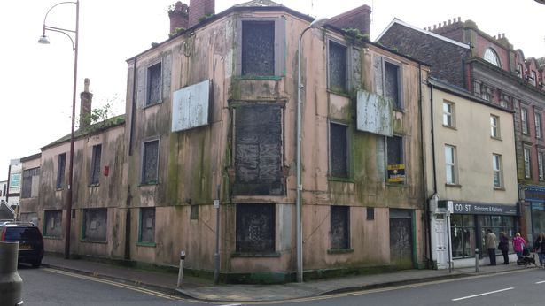

(Wales Online, 2019)

Existing assets
Although Llanelli’s economy has been on the decline, there are many existing assets in the area which could be beneficial for regeneration. A number of these assets include the Trostre shopping centre, Parc y scarlets, the wetlands centre and the coastal path.
From the primary research we conducted in Llanelli town centre, it is apparent that there is a strong feeling among locals that Trostre Retail Park has played a part in the decline of the town centre. The locals feel that because the bigger chain stores have moved over to Trostre, the town centre has been left with smaller number of footfalls which has caused the quality and range of shops to decrease. Independently run shops are struggling to stay open while Trostre is dragging the trade out of the town centre.
Although Trostre has had a role to play with the decline of the town centre, it is still an asset to Llanelli. Trostre continuously draws people into the town form surrounding areas whereas they may have gone elsewhere. I believe that it is beneficial for the town centre that people are still using Llanelli to shop instead of heading somewhere else. As the town centre goes through the regeneration process and begins to improve, the footfall of customer may begin to gradually move back to the shops in the centre as they improve.
Parc Y scarlets, home to the Scarlets rugby team is a great asset to the local area, over a rugby season they can draw average attendances of over 8,000 people on match day. The highest attendance in the 17-18 season was over 14,000. (Record breaking attendance, 2019) Although a high percentage of this number will be locals, many will travel into the area for the event. People attending the events will more than likely be spending money locally which has a positive effect locally.
The Llanelli wetlands centre is another brilliant asset that the town has. The wetland centre was opened in 1991 and is made up of 250 acres of land, a further 200 acres next to the original site was developed later. The salt marshes have been developed to create slightly different habitats to home different types of birds. Originally the land was unused farmland. The site has already gone through its regeneration process and has been an excellent success in the area. In 2014 the centre recorded 24,000 visitors annually. Continued success saw over 70,000 visitors visit the site last year alone (Rees, 2019). This regeneration project is a good example how successful other regeneration projects could be for the area.
The millennium coastal park is another great addition to the town, similar to the wetland centre the millennium coastal park was regenerated from a twelve mile stretch of industrial wastelands. The land which was transformed into recreational area for the general public is 1000 hectares in area and cost around £35 million to develop.
There are several economic and social benefits that are driven from the existing assets of the town, tourism that have been brought to the area through these sites alone has had a positive effect on local economy. Encouraging more tourism will result in the creation of more jobs locally.

Structures
Llanelli already has a range of structures in place some developed and some in need of regenerating. The town centre of Llanelli consists of a large indoor shopping centre along with many more shops outside. The shopping centre also benefits from having direct access to a 450-space multi-storey carpark. Although a large percentage of shops in this are empty there is huge potential to regenerate this area.
From our field visit to Llanelli you can instantly see that the town centre is struggling. The first thing I noticed as I walked through town was the lack of quality shops and how run down the area looked. Most of the retail space consists of charity shop, second-hand shops, banks and Betting shops. This doesn’t help draw people into the town centre as these shops cannot compete the shops based over in Trostre.
Fortunately, the structures are in place and just need to be developed, with a good regeneration plan the town centre could easily start competing again with local retail parks.
Stakeholders & Interest groups
A stakeholder refers to anyone that would have a vested interest in a project and can influence its success. When carrying out a development or project it is important to identify the stakeholders as early as possible. In Llanelli an example of stakeholders would be client’s organisation, local authorities, neighbours/residents, customers, community groups and local specialist organisations. Not all stakeholders will carry the same views, so it is important to identify different expectations. When carrying out a project it is important to manage the stakeholders effectively. A stakeholder map could be used to assess:
- The likely impact of the development on the stakeholder.
- The issues that they will have an interest in.
- Their likely position.
- Their ability to influence the development.
- Their potential impact on the development.
- Potential mitigating actions. (Bonner, 2019)
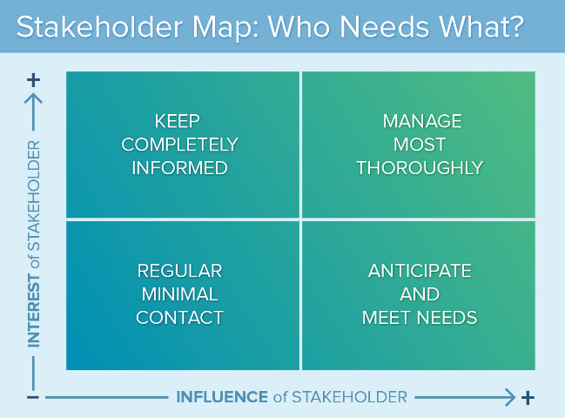
Depending on what the project is you would determine who the more important stakeholders are.
This Map gives an indication of how to manage your stakeholders. In terms of interest and influence.

(Stakeholder, 2019)

Local Development Strategies
There are already some local developments in motion for the Llanelli area, the welsh government are working with the town council to improve and regenerate the area. One of those developments is a project called ‘opportunity street’ for this regeneration programme Llanelli council have been allocated £1 million over a three-year period to refurbish three vacant premises in Stepney street Llanelli. They are aiming to bring these properties back into use to use for affordable housing units along with commercial space in the town centre. This project is focused on tackling local issues such as poverty, local housing needs and commercial space to attract new interest. (Llanelli town council, 2019.)
Research shows that residents of the area think parking in the town centre is one of the main issues. They think that charging for parking in the town centre car parks encourages people to shop elsewhere. For example, nearby retail parks such as Trostre offer parking for free. Business owners in town think that by offering free parking in the town centre would encourage more visitors who may not normally visit.
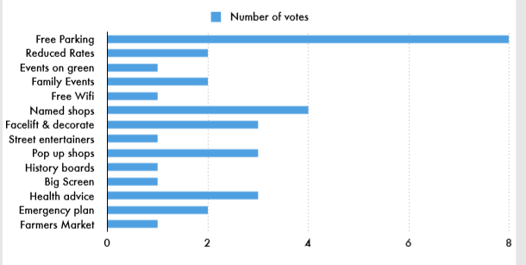
This research that was collected by the local authorities also shows that locals think that named shops, reduced rates, facelift/decoration and pop up shops are the best ways to improve the town centre.

(Llanelli town council, 2019)

Regeneration Ideas
My first regeneration idea is not a totally new idea, it is to build off the work that has already been done by the council. It would be to further develop the town centre. Work has already been carried out on some premises to update and modernise shops. I would ideally like to continue with this work as many shops and the whole of the town centre. I believe by modernising shops and facilities in town it will encourage more business to invest and open shops in that area.
Expanding on this point I would aim to draw in a mixture of bigger branded companies and mix them with independently owned shops. I believe this is the best way to encourage more consumers into the area. Offering a range of different products and services in town would be beneficial to the customers. Encouraging local businesspeople to operate in the town centre would help unite the community and make more people want the town centre to be successful.
It may be a challenge to get business to invest in the town centre, but I believe by offering some sort of incentive while the town goes through its regeneration process could be a big help. Possibly offering reduced rates for a set period to help businesses operate would be ideal while it gives the town a change to build its reputation.
To incentivise customers to shop in the centre of town, I believe that offering free parking permanently is a must. To be able to compete with the likes of Trostre and for the town to have any chance of becoming successful we need customers. Most importantly we need customer to be happy and to make them want to shop in the town centre.
Many of the retail spaces in town have multiple floors. This space is ideal if it is not needed by the business to use as office or flats. Being able to utilise the space to its full potential is most important and if you can tackle more than one issue it is a must.
The new facilities in the town centre next to the main shopping areas at Eastgate are a prime example of what must be done. It is modern and has a nice atmosphere, it also benefits from having a cinema and several restaurants.
It is important to not only offer a shopping experience but to have entertainment as well, already having a new cinema is great, but I think there is potential to open another entertainment facility. I think ten-pin bowling and arcade facilities could further give the town centre a boost. With such a big local population there is a chance to offer new and exciting facilities for people of all ages.
I think that there is potential for shops to open through the evening as well. Extending these opening hours would be beneficial for the customers who may want call after work or go in the evening. With the entertainment facilities so close to the shops there is a great possibility that they will help each other generate more business, Customers who are going out shopping in the evening might be tempted to eat out as well and similarly customers who have gone out to the restaurants or cinema might also spend money elsewhere.
In town there is the indoor market which has huge potential to draw in customers. In the research there was plenty of interest for a farmer’s market. I would propose using the facilities in the indoor market and turning that into the farmers market. I think that fresh produce would appeal to lots of people locally and visitors. For the shops that are already in the market such as the games shop, shoe repairs and so on. I would propose moving them into a nice newly updated retail space. Personally, I think they would have a lot to gain from having a nice retail space outside on the street. I think It would be ideal to have all the farmers market and maybe small butchers located together.
Research shows customers are interested in events and pop up shops, the outdoor space in the town centre has great potential to host these. On weekends or special occasions pop up shops or suitable events could be held in town, all with the aim of getting more people into town.
It is important that business work with the customer and create a friendly atmosphere within the community, For the town to be successful it is important that customers are felt valued.
As mention earlier there are many existing assets in Llanelli, a new regenerated town centre would top all of these off nicely.
My next idea is to improve the area is to tackle crime and drug use. Steve Harrison says, “if we drive out crime, we will probably find that we have solved social inclusion and achieved regeneration” (Harrison, 2019) I believe this theory can be implemented to help the regeneration process in Llanelli. Anti-social behaviour and drug abuse make up over 40% of the crime rate in Llanelli, over the last these figures have raised. Many offenders in the area are youngsters. I believe if the younger age group are targeted early then these figures can be reduced over time and eventually help the regeneration process.
I think that charitable organisations and local councils can work together to come up with new innovative ways to develop youngsters into respected members of the community rather than them turning to crime. Under educated and less fortunate young adults turn to crime because they believe there is nothing out there for them. Working with these young adults to show them they have a purpose in the community could be very influential and create a knock-on effect.
I think that new programmes could be started to engage with people which will later turn them away from drug use and criminal activities. The only way to do this is giving them new opportunities they didn’t think were open to them. Finding out what they are passionate for helping them get started.
Working along side schools and colleges would be ideal to be in touch with these youngsters before they leave education. If they could be put on the right path starting form a young age, I think this will reduce drug abuse and crime in the area.
This could also be beneficial for creating more jobs in the area, Skilled workers would be needed such as social workers and if you could employ locally then they would be able to engage with the young adults because they might have a better understanding of what they are going through.
Lower crime rates in Llanelli can only be seen as a bonus, creating a nicer area and community for people is all part of the regeneration process.
Conclusion
Overall, I think Llanelli is heading the right direction for positive change. With all the existing assets the town has I really think it gives a good platform for the rest to build around. There is plenty of good facilities in town to draw in tourism and no doubt these numbers will only increase through further regeneration.
With the addition of the regenerated town centre then I think that unemployment and poverty in Llanelli will continue to decrease. With all the help that the welsh government has pledged to increase regeneration projects throughout wales including Llanelli, there is great potential for the area to become successful once again.

REFERENCE LIST
Llanelli town council, 2019. About Llanelli. http://www.llanellitowncouncil.gov.uk/about-llanelli/
Shore, J. (2019). Economic downturn, presentation, ‘History’ Uwtsd.
Shore, J. (2019). Economic downturn, presentation, ‘what went wrong’ Uwtsd.
https://www.walesonline.co.uk/news/local-news/abandoned-derelict-buildings-llanelli-stories-12830298
Record breaking attendance. (2019). Retrieved from https://www.scarlets.wales/en/team-news/articles/record-breaking-attendances-at-parc-y-scarlets/
Rees, 2019. (2019). Regenerating a former industrial area. Speech, Llanelli wetlands centre.
Bonner, T. (2019). Project Management Stakeholders. [online] Bright Hub PM. Available at: https://www.brighthubpm.com/project-planning/93262-stakeholders-in-project-management/ [Accessed 15 May 2019].
stakeholder map. (2019). [image] Available at: https://www.smartsheet.com/what-stakeholder-analysis-and-mapping-and-how-do-you-do-it-effectively [Accessed 15 May 2019].
Llanelli Town Council. (2019). the town centre we want (p. 3). Llanelli community partnership.
Llanelli town council, (2019). The toen we want (p. 7). Llanelli community partnership.
Harrison, S. (2019). crime % regeneration. Retrieved from https://www.theguardian.com/society/2000/nov/23/regeneration.localgovernment

