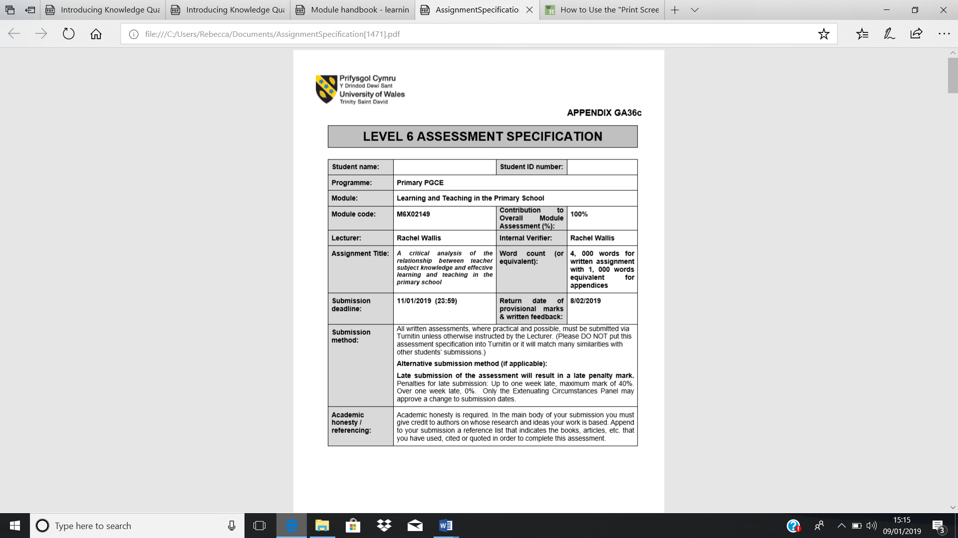
Rebecca Radcliffe
1300777

A critical analysis of the relationship between teacher subject knowledge and effecting learning and teaching in the primary school.
It is vital to grasp an understanding of the types of content knowledge available in the development of teachers to enhance student progress to the maximum. Commonly, pre and in-service teachers can have misconceptions and inhibited knowledge which can challenge their response and confidence to their students which will negatively affect their ability to create a challenging learning environment for their young students, (Haidair 1997, as cited in Kleikman, 2013). This is why throughout this essay I shall be drawing on literature surrounding subject knowledge and how it is important for teachers to develop their pedagogical content knowledge. Following this, I will be using examples from my PTE experience to indicate various aspects of the Welsh Curriculum which have been used and how I must develop areas of my content knowledge and pedagogical knowledge due to certain situations in lessons which could have been improved.
The school which I was able to have my first teaching experience will be regarded to as school X and the learners will be identified as learner 1, learner 2 and so on due to confidentiality. School X was in an affluent area including 235 pupils aged 3-11, and most pupils live in the catchment area which gave a very small percentage of 2% of pupils receiving free school meals which was well below the Welsh average. A very little amount of 3% of children having additional learning needs which is also below the average for Wales. Very few pupils had English as an additional language as the report in 2014 by Estyn showed, (estyn.gov.wales, 2014).
There has been many ideas surrounding the level of teachers education and maximising learners opportunities because there is such importance in optimising equal chances for every child, especially as now there is a new curriculum in Wales, Sir Graham Donaldson, (2015) which provides four purposes which teachers must prioritise in their role. These being to create ambitious, capable learners so that they are ready to learn throughout their lives, secondly having enterprising, creative contributors who are ready to play a full part in life and work, thirdly enhancing healthy and confident individuals whom are ready to lead fulfilling lives as valued members of society and lastly to create ethically informed citizens. For these purposes to be fulfilled it is vital for a teachers subject knowledge to be at a high level but it is not always how it sounds, as according to (Schulman, 1986 as cited in Kleikman, 2013) ‘the teacher not only understands that something is so, the teacher must further understand why it is so’. Meaning, a teacher must understand what they are teaching but also they must learn and develop effective ways of delivering this information to the learners and this comes from experience and practice which are vital in effecting learning and teaching in the classroom. As (Hattie, 2009) says that many ‘educational studies have found evidence that the quality of learning experiences and opportunities offered by the teacher affect the learners motivation and learning which shows the importance of quality of teaching, therefore quality of subject knowledge’.
The key ideas in this area are that there are two types of subject knowledge being content knowledge (CK) and pedagogical content knowledge (PCK) and these both affect student progress and success, (Kleikman, 2013). Content knowledge is having the understanding of the subject matter being taught whether it being Mathematics, Literacy or so on. This can differ between teachers from studying at a high level in University on a specific subject or attaining knowledge in Mathematics or Literacy which was learnt at school, (Brunner et al, 2008 as cited in Kleikman, 2013).
The other type of teacher knowledge is pedagogical content knowledge, and this is the knowledge needed to make subject matter more accessible, (Schulman, 1986 as cited in Kleikman, 2013). Included in this category subject knowledge is being able to understand whether a learner is grasping the topic, therefore identifying many conceptions and misconceptions in the classroom and responding to these. Secondly, the teacher must have ways in which they deliver the information needed, (Bell, 2008 as cited in Kleikman, 2013). The importance of these are significant and are gained through various resources, (Grossman 1990, as cited in Kleikman, 2013) which are a mixture of experience and taught information.
The Knowledge Quartet whom (Rowland, 2009) spoke about is helpful in reflections and feedback in the teaching progress especially in training teachers. To briefly explain this there are four members of the knowledge quartet which are vital in pedagogical content knowledge procedures. Firstly, the Foundation of teaching is important where teachers understand the content of what is being taught and having knowledge of how children learn and how they can be taught which is also known as pedagogy. Teachers must also be able to identify pupil errors and use accurate terminology. Secondly, is Transformation which is essential for teachers to model, demonstrate and explain to learners so they can understand. This includes appropriate resources and materials to support the lesson. Thirdly, is the Connection, and this is all about teachers being able to bring different concepts, ideas and processes together. It is vital for teachers to build on prior learning and move this forward to enable further learning. A teacher must know when the right time to make progressive steps. Lastly, is Contingency, this is being able to respond to learner’s ideas, questions and difficulties. Also, if a lesson is not working a teacher must be able to deviate from these plans and to change opportunities to increase the learning. There also must be chances to offer different answers and questions if needs are altered, therefore allowing lower abilities to take part and to enhance the higher abilities.
In research by (Askew et al, 1997, as cited in Rowland, 2009) there are different types of teachers which can affect the learning opportunities. A ‘connectionist’ is the most beneficial orientation of a teacher as they have a large amount of knowledge on their subjects they teach and they have great passion for their pupils to learn. This category of a teacher would follow the knowledge quartet in their lessons and have experience in teaching effectively using their content knowledge and their pedagogical content knowledge. The other two types of teachers would be ‘discoverists’ and ‘transmissionists’ which seem to be less effective in studies. This is relevant to the way a child grasps an idea, as a child may respond to a learning queue and this will point to their nature of their knowledge construction. Following this, it may or may not be what the teacher has expected but the child’s evidence of their description will be initialised by a teacher’s iniquity. The teacher’s response to this is what great teaching is all about, being a ‘connectionist’, (Rowland, 2009). This can be evidenced by a ‘constructivists’ view of children’s contributions being extremely valuable in the lesson as the wrong thing to do would be ignoring or having lack of interest in what children have to say in the consequence of the teaching experience, although as (Brown 1993, as cited in Rowland 2009) said, ‘the capacity to listen diminishes with anxiety’ which does represent the fact that trainee teachers may find this harder but it will come with experience.
Before this time little was known about how teacher education affected the ongoing development of both content knowledge and pedagogical knowledge but it has been known that is has a big impact on the learner’s attainment. Shulman, (1980) was the first to identify characteristics of good teachers surrounding content specific knowledge and this was through the ‘missing paradigm of research on learning and instruction’. Schulman believed and wanted to portray that teacher’s knowledge and understanding of a subject was important but it was not enough to enhance good practice, he believed and researched that the way the teacher delivers that information to the learner was essential as well. Therefore, today it is vital for pre and in-service teachers to develop their knowledge in both areas through learning opportunities, (Russell 2001, as cited in Kleikman 2013). As pedagogical content knowledge is the transformation of subject knowledge in the classroom to enable effective interaction between the learner and teacher it must be gained through learning sources, (Frkiedrichsen 2009, as cited in Kleikman 2013) which are the teacher’s own learning experiences, a teacher’s education and professional development program and teaching experiences. Being the reason for pre and in-service teachers to take part in these learning opportunities otherwise there can be misconceptions and fragmented knowledge which can harm their responses to the learners and delay their ability to create a challenging environment, (Haidar 1997, as cited in Kleikman 2013).
Another perspective of effective teaching and content knowledge would be the Danielson’s Framework for Teaching, (Coe, 2014) which includes planning and preparation, classroom environment, instruction and professional responsibilities. Going along this general framework will enhance teaching quality, especially instruction as this is at the heart of all frameworks of teaching giving effective questioning and assessment, it is also vital to review previous learning, provide model answers for students, giving enough time to embed skills securely and to scaffold forward learning and therefore this gives a very successful instruction. The evidence for this importance of pedagogical content knowledge can be given by Hill et al (2005), as cited in Coe, (2014). This research investigated the importance of teachers ‘PCK’ in Mathematics and it was found that the level of the knowledge that the teacher knew about this particular subject was increasing the effectiveness of the students who were learning it. Also, a difference between a high and low scoring PCK gave a difference of a whole year of learning for the student which is extremely significant as this includes abilities for the teacher to use their lesson time effectively, manage the classroom resources efficiently, and to give a clear boundary for behaviour.
In addition, the University of North Carolina, (Hattie, 2012) began to give a difference between ‘expert’ and ‘experienced’ teachers. It is known that all teachers must strive to be ‘expert’ and this can be developed through the five dimensions of teaching. These being ‘high levels of understanding of the subject they are teaching, can take learning through a desirable outlook to improve results, can monitor learning and give effective feedback, can impact the surrounding attributes of learning such as motivation and self-regulation and finally providing evidence of all of this’. In Visible Learning, (Hattie, 2012) it says that subject knowledge actually has little effect on students progression which is going against Schulman’s view, (1986). Explaining this, it is saying that ‘expert’ teachers differ how they organise their knowledge by being able to see deeper into the subject which they are teaching and can understand when a learner is learning. This can be known as more of a belief in teaching which can be controlled to enhance learning and an ‘expert’ teacher can have more integrated knowledge as they can combine the introduction of the new subject with the learners prior knowledge, they can also bring in other elements of the curriculum which enhances learning as it becomes one continuum, they can make their lessons unique by challenging and combining different elements depending on the needs of the children, they can recognize a sequence of events which enables them to have a greater amount of strategies in increasing learning. The five dimensions is mainly about the impact which teachers have on learners and less about their opinions and views, (Kennedy 2010, as cited in Hattie, 2012).
The Knowledge Quartet, (Rowland, 2003) is a comprehensive tool in enhancing good practice in the classroom which was shown in the study of trainee teachers, (Turney 2007, as cited in Rowland, 2009). It was found that the teachers Mathematics teaching was significantly improved when they used this to monitor and get feedback on their teaching abilities. A part of the Knowledge Quartet is the way in which we connect ideas together with familiarity and these were captured from Piaget’s idea of a ‘schema’. This can be explained by adding knew knowledge to old knowledge which is known as ‘assimilation’ and this is when new experiences challenge experience which have already been formed, in other words ‘learning’. Contingency is also vital as (Koshy 2000, as cited in Rowland 2003) found that, ‘a teaching style which encourages children to discuss their methods with the teacher and other children is less likely to be more effective in exposing misconceptions’. Therefore, this helps to pick out behaviours which are directed towards students after a deliberate judgement which is especially important for trainee teachers to help their language strategies. Therefore, after discussing the different perspectives on teacher’s subject knowledge I am going to talk about how my subject knowledge in my first placement affected my teaching.
As of the importance of following the National Curriculum, (Donaldson, 2015) it is known by teachers and governing bodies that the current aims are to, ‘promote the spiritual, moral, cultural, mental and physical development of pupils at the school and of society. Secondly, to prepare pupils at the school for the opportunities, responsibilities and experiences of later life’. Therefore, as a trainee teacher I should be evaluating my performance in the classroom and analysing whether the learners are obtaining information. Especially concerning the LNF and DCF framework, as there must be a high level of competence in these areas therefore needing frequent opportunities to develop, extend and apply these across the curriculum, (Donaldson, 2015).
In a Numeracy lesson I was focusing on developing the learner’s subtraction skills in a form of problem solving. As shown in the Foundation Phase Framework, ‘being able to take away objects to find how many are left, and to solve simple problems in a practical situation that involve simple addition and subtraction up to 5’. As shown in Figure 1, this is what the plan was intending to do. My Foundation Knowledge which is the first category out of the Knowledge Quartet, (Rowland, 2009) was good as I understood the concept which I was teaching but I did not quite grasp the learner’s abilities as I had differentiated the questions between the lower ability, middle ability and higher ability but selected some learners in the incorrect category. This could have caused an issue as (Wragg and Brown, 2001 as cited in Rowland, 2009) said that building up their learning in some sort of order of progression is necessary for learners to benefit to the full. To overcome this issue, the fourth part of the Knowledge Quartet was used, (Rowland, 2009) as my contingency in the classroom helped to initialise a plan to identify the issue that various learners were finding the questions too difficult. Therefore, when this became a problem I was able to thin on my feet and respond to the consequence, (Rowland, 2009).
Following this, the Transformation, (Knowledge Quartet) of the lesson was good as I used a scaffold to show how subtraction works. I was successful in achieving this knowledge as my class teacher had shown me previously how beneficial it is in teaching young children subtraction and addition. In Schulman’s (1986), as cited in (Rowland, 2008) observation he says that the ‘knowledge base for teaching is distinguished by the capacity of a teacher to transform the content knowledge he or she possesses into forms that are pedagogically powerful’. This is explaining that it is important to have a profound understanding of primary school mathematics, especially in the foundation phase as this is more of an abstract subject, (Rowland, 2009). Therefore, being able to show the learners subtraction through using the Numicon shapes was very helpful, and I also gave examples of the procedure, (e.g: 5-2=3). This gave the children the ability to navigate their mathematical language and symbols which will need to be embedded before they reach the higher part of the school, (Haylock 1982, as cited in Rowland, 2009). In the third part of the Knowledge Quartet is Connection. As it was Christmas time I used questions which revolved around this theme and the children were extremely engaged because of this. Also, linking this to the LNF, (Donaldson, 2015) was connecting more Oracy into the task and reading skills as the children had to use their skills in this area of learning. This lesson was planned thoroughly but it showed the Schulman’s belief, (1986) was indeed correct of teachers not only being a master of the subject but explaining why something is done in such a way.
Following from this, another lesson which I took in the Mathematical Development outcome was to represent numbers up to 20 in the ordinal representation, as seen in Figure 2. I understood that in the Foundation Phase Framework, (Donaldson, 2015) that there was on objective stating, ‘to recite numbers up to 20, forwards and backwards and from different starting points’. To assess how my subject knowledge affected the learners in this lesson would be that my Foundation Knowledge was somewhat good as I knew how to count up to 20, although the pedagogy of how to teach this to young learners was slightly harder for me. The lesson was not just about counting up to 20 but ordering these digits from smallest to largest and I connected this lesson with a book we had been reading called The Three Billy Goat’s Gruff. Therefore, the children found this more engaging as they were ordering goats which connected the literacy part of the day together, (LNF, Donaldson). As Maths is an abstract subject in the early years it was important to use Iconic Representations, (Rowland, 2009) as this allowed the children to link it with understanding of the world. The way I Transformed this to the learners was help from the scaffolding of the Numicon to represent the numbers to help the children in identifying and ordering. The children with the lower ability found it difficult when I would ask a question about the place value, (e.g. how many tens and units in the number 18?). Furthermore, I did not have the pedagogical content knowledge to teach the children about place value for an age of 4-5. I understand it myself, but to teach it was slightly different. Therefore, my Transformation in this aspect of the lesson could have been improved and as I evaluated at the end to come up with a strategy to teach children place value. As Wragg and Brown, (2001), as cited in Rowland, (2009) state, an especially important part of teaching is to ask questions and this was helpful in this lesson as it showed misconceptions in the learner’s ability to give a definition to place value of ordinal numbers. I realised that it is vital to look for behaviour in Mathematics to indicate whether the pupils are making connections.
Following this, using my Contingency strategies when I faced a problematic issue of the lower abilities not being able to understand place value, I asked the higher abilities to show the lower abilities what they had learnt. This was not part of the lesson but as I thought on my feet that this change in the lesson could allow learners to develop their confidence and Oracy in a ‘share and pair’ scenario. This then allowed the literacy to be developed for the children also, (LNF, Donaldson). As ‘the contrast between the psychological aspects of learning and the understanding of the logical structure of the content of a subject like Maths can be looked at what it means to count’, (Rowland, 2009) shows the importance of Mathematical Development I realised that I needed to improve my PCK on aspects such as Transforming place value to the learners and my pedagogy for counting. As Schulman (1986) said, ‘a professional is capable not only of practicing and understanding his or her craft, but of communicating the reasons for professional decisions and actions for others’.
Another area of learning which I enjoyed working on was the Language, Literacy and Communication Skills. This came through a lot in the classroom as the LNF is vital for learners to engage in, (Donaldson, 2015). Literacy in the Foundation Phase includes Oracy, reading and writing which I tried to cover most days. On this particular day, (See Figure 3) I focused on a range of skills as we went outside on a hunt to find ‘Granny’s teeth’ and this used Oracy. Following this, we went inside and wrote a letter to Granny to inform her that we had found her teeth and this included writing. I followed the guidelines in the Foundation Phase Framework of, ‘producing pieces of emergent writing and being able to use correct initial consonant by beginning to apply phonic knowledge’, (Donaldson, 2015).
In my views this lesson was good as I had a solid Foundation Knowledge of writing letters and using a nursery rhyme, ‘we are going a bear hunt’ to use the Oracy on the outside learning section. Although, my understanding of the phonics was somewhat lower than a practiced teacher which prohibited the learners when it came to the emergent writing section. It is vital as (Graham, 2001) stated that, ‘children in very early stages of learning can write to benefit from an approach which enables them to recognize that they have intention as writers’. This is important as children will feel more connected to what they are writing about and it is more purposeful. As, (Wells, 1987 as cited in Graham, 2001) said, ‘children are active meaning makers, a view of a learner which is very different from that of the passive child copying letters’. This is evidence showing the purpose of emergent writing. Following the Knowledge Quartet, (Rowland, 2009) my Foundation knowledge could have been improved as my knowledge of sounds was not as good as it should be, this was known as children were not grasping the sounds which I was speaking which gave the ‘Transformation’ side of things are negative effect. Following this, my teacher showed and helped me the correct way to sound the phonics which enabled me to improve my outcomes.
Another aspect of this lesson which could have been improved was giving the children examples of letter writing which is part of the Transformation category in the Knowledge Quartet, (Rowland, 2009). The children struggled to understand the format of a letter as they did not have enough examples to give them a better understanding. Coming to the Connection category, (Knowledge Quartet) as I used an imaginative purpose following the reading of Little Red Riding Hood, it allowed the children to write in a role which gave them a real need and purpose, (Graham, 2001). It allowed them to be excited and engaged which helped them to reach their full potential in this aspect. As for the Contingency in this aspect I could relate to whether a child was grasping the writing objective especially when a child asked a question about how some sounds had the same letter. This was brilliant, and I could respond to the emergent writing and monitor this child’s development. This was because I could see that the child’s invented spellings were logical and the strategies were developing through stages. As, (Gentry 1982, as cited in Graham, 2009) sates, ‘pre-communicative is being an imperfect match between sound and written symbols to then more or less fully accurate spelling’. Following this, the plenary then included the question which this child asked and I used the phonics song to show some sounds that were the same and the different letters that were used. This brought in the LNF, (Donaldson, 2015) as the children used Oracy in discussion.
In addition, as (Donaldson, 2015) stated, ‘the ICT steering group reported to the Welsh Government that digital competence is as important in the 21st century as Literacy and Numeracy’. Therefore, I focused on giving the children opportunities to develop this. On a particular lesson I used a theme from the Foundation Phase Framework, (Donaldson, 2015) of ‘understanding what algorithms are and how they are implemented as programs on digital devices, and that programs execute by following precise and unambiguous instructions’. To transform this to the children I used a resource called Bee bot which is a toy that needs instructions to navigate across the floor to a destination. I connected this to the theme of ‘Little Red Riding hood’ to get Granny home to her cottage. It also connected with Oracy as the children needed to communicate with their partners saying, ‘go forwards, or go backwards’, (LNF, Donaldson). As my subject knowledge on Bee Bot was not as sufficient as that of a practicing teacher, I struggled to Transform the aspect of the lesson over to the learners being, ‘developing the problem solving skills and givingchildren an understanding of the ways in which we can use computers to control or automate the world around us’. Therefore, I realised I needed to improve my Foundation knowledge of this subject of ‘Programing’, (Sharp, 2014). As the children found it hard to stay focused because in their mind they were playing with a toy and it was ‘play’, I took it upon myself to end the lesson and discuss what forwards, backwards and so on means. I used my Contingency to realise the children were not engaged and to develop their Mathematical and Geographical understanding instead.
To conclude there is much emphasis on how teachers must use their subject knowledge on managing their classrooms, organizing activities and planning lessons, (Schulman, 1986) but there is a missing paradigm in the thought of behaviour and additional needs with students. Therefore, following this I believe the Knowledge Quartet, (Rowland, 2009) can be used to help navigate better teaching especially using the Contingency section as this is at the heart of success in the learning environment to never ignore a child’s inquisition. I understand what aspects of my subject knowledge need to be improved and that good teaching is about being passionate, enthusiastic and to act in a values-led and intelligent way, (Day, 2004, as cited in Hattie, 2012). It is vital to have a passion for the subject you are teaching, the students you are teaching and the curriculum. Enhancing the subject knowledge in both what you are teaching and how you teach it can lead to successful lives for pupils, thus the importance to strive to improve this to the maximum throughout trainee and practiced teachers.

References
Coe R, (2014). What makes great teaching.
Donaldson G, (2015). Successful Futures: Independent Review of the curriculum and Assessment: arrangement in Wales.
Donaldson G, (2015). Foundation Phase Framework.
Graham J, Kelly A, (2001). Writing under Control. Teaching writing in the primary school.
https/www.estny.gov.uk
Hattie J, (2012). Visible Learning for Teacher’s. Maximising Impact on Learning.
Kleikman T, Richer D, Hunter M, (2013). Teacher’s Content Knowledge and Pedagogical Content Knowledge. The role of Structural Differences in Teacher Education.
Rowland T, Turner F, (2009). Developing Primary Mathematics Teaching. Reflecting on Practice with the Knowledge Quartet.
Schulman, (1986). Those who understand: knowledge growth in teaching; Educational Researcher.
Turvey K, Potter J, Sharp J, (2014). Primary Computing and ICT. Knowledge, understanding and practice.
Appendices
Figure 1
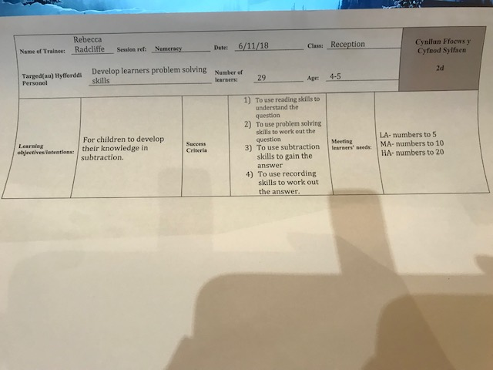
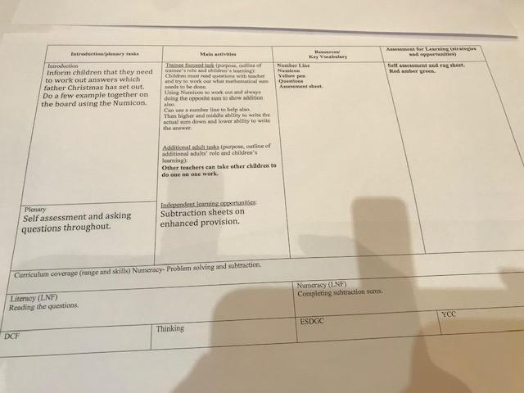

Figure 2
Name of Trainee: | Rebecca Radcliffe |  |  | Session ref: |  | Numeracy |  | Date: |  | 12/11/18 |  |  | Class: | Reception |  |  | Cynllun Ffocws y Cyfnod Sylfaen  2d
Targed(au) Hyfforddi Personol |  |  | To allow learners to develop their knowledge on ordinal numbers |  |  |  |  | Number of learners: |  |  |  | 29 | Age: | 4/5 |  |  | Cynllun Ffocws y Cyfnod Sylfaen  2d
Learning objectives/intentions: |  | To improve and develop skills in counting up to 20 in an ordinal representation of the Three Billy Goats Gruff |  |  |  |  | Success Criteria |  | - To identify the digit of numbers  - To understand which number is smaller or larger and what order they come in  - To place numbers of 1-20 in the correct order from smallest to largest  - Representing the number with a Numicon shape to illustrate the place value (tens, units)  - To record results in their books by using the correct formation for the digits and good writing skills |  |  |  |  | Meeting learners’ needs: |  | Lower ability learners- Order numbers up to 5 and if needed can look at number line. Also if struggling with writing down digits the starting dot and yellow pen technique can be added.  Middle ability learners- Order numbers up to 10 and if needed can look at the number line. Also support can be given for writing digits.  Higher ability learners-Ordering numbers up to 20 and look at place value and how many tens and units are in each number. Then writing this in their books.
Introduction/plenary tasks |  |  |  |  | Main activities |  |  |  |  |  | Resources/  Key Vocabulary |  |  |  | Assessment for Learning (strategies and opportunities)
Introduction  Gathering the focus group together and counting up to 5, 10 and 20. Then showing the learners the billy goats gruff which have been given a number and explaining that these need to be put in order from the lowest number to the highest. Then showing the children the Numicon which represents the number and asking the learners to do it themselves, or pair and share. And then asking some hot questions, (how many tens and units in this number, why do you think this? Can you show me? |  |  |  |  | Trainee focused task (purpose, outline of trainee’s role and children’s learning):  Sitting the children down and putting the billy goats gruff on the table in a mixture. Following this, the children must put them in an ordinal number of smallest to biggest. Then the children need to get the correct Numicon for each number of the goat and place this underneath. They can use a number line to help them. Questions will be asked about the tens and units and the Numicon can be used to represent this.  Following this children must write it down in their books : numbers going up. |  |  |  |  |  | . Billy Goats Gruff ordered up to 20.  . Number line  . Numicon  . Ipad for Photos  . Smallest to largest  . Place Value  . Tens/ Units  . Can you show me the Numicon for this number? Why is there a certain amount of tens and units. Show me, Prove it to me, Explain to your friend.  . Show me you know by writing it down in your book. |  |  |  | Using peer assessment  Using the tracking sheet, (green, amber and red).
Additional adult tasks (purpose, outline of additional adults’ role and children’s learning):

TA can help the lower ability children with ordering the numbers and showing them the Numicon relation.
Plenary  After each focus group I will ask children how they found it: easy, medium or hard. Also asking questions along the way to understand the depth of the children’s knowledge on this subject. |  |  |  |  | Independent learning opportunities:  If children are succeeding to a high level they can ask questions about what goes higher than 20.
Curriculum coverage (range and skills)
Children are able to recite numbers up to 20, forewards and backwards and from different starting points. Children are able to understand the tens and units.
Literacy (LNF)  There is oracy included as instructions need to be listened to by learners. Also, questioning involved a good communication skill. |  |  |  |  |  |  |  |  |  |  | Numeracy (LNF)  Sorting numbers in an ordinal fashion up to 20 and understanding the place value.
DCF  Taking photos on the Ipad. |  |  |  |  | Thinking  Children need to think about the order which numbers go in and how to record this in their books. |  |  |  |  |  | ESDGC |  |  |  | YCC
Figure 3
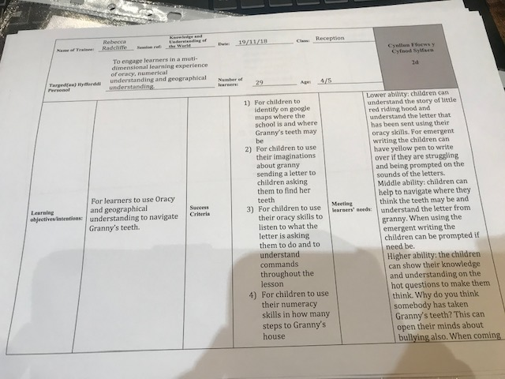
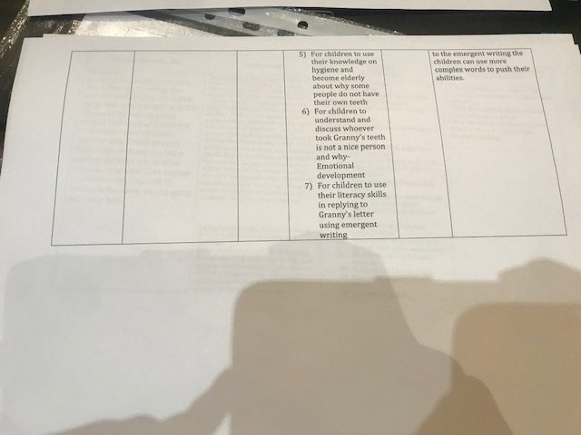
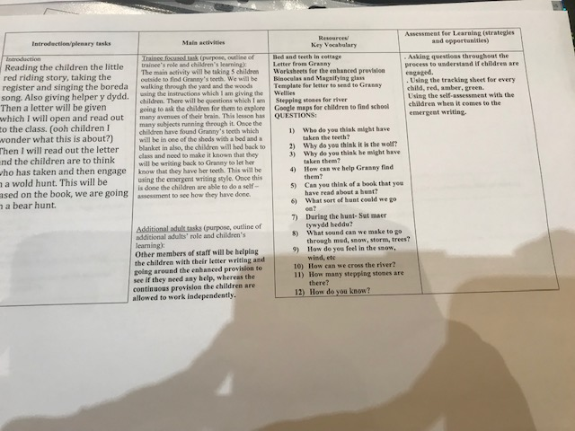
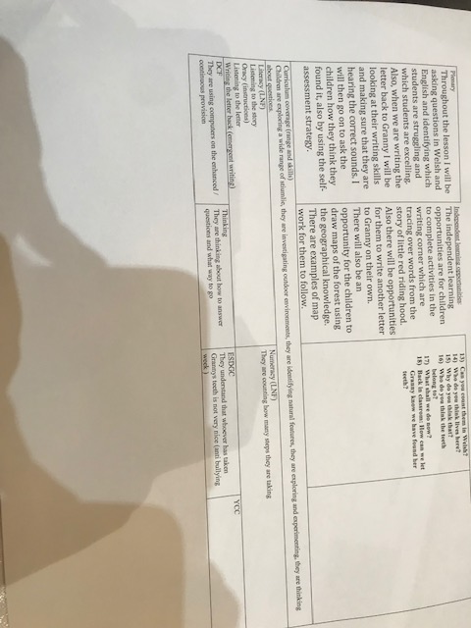

Figure 4


