

Assessment 1 – Reading Task Template
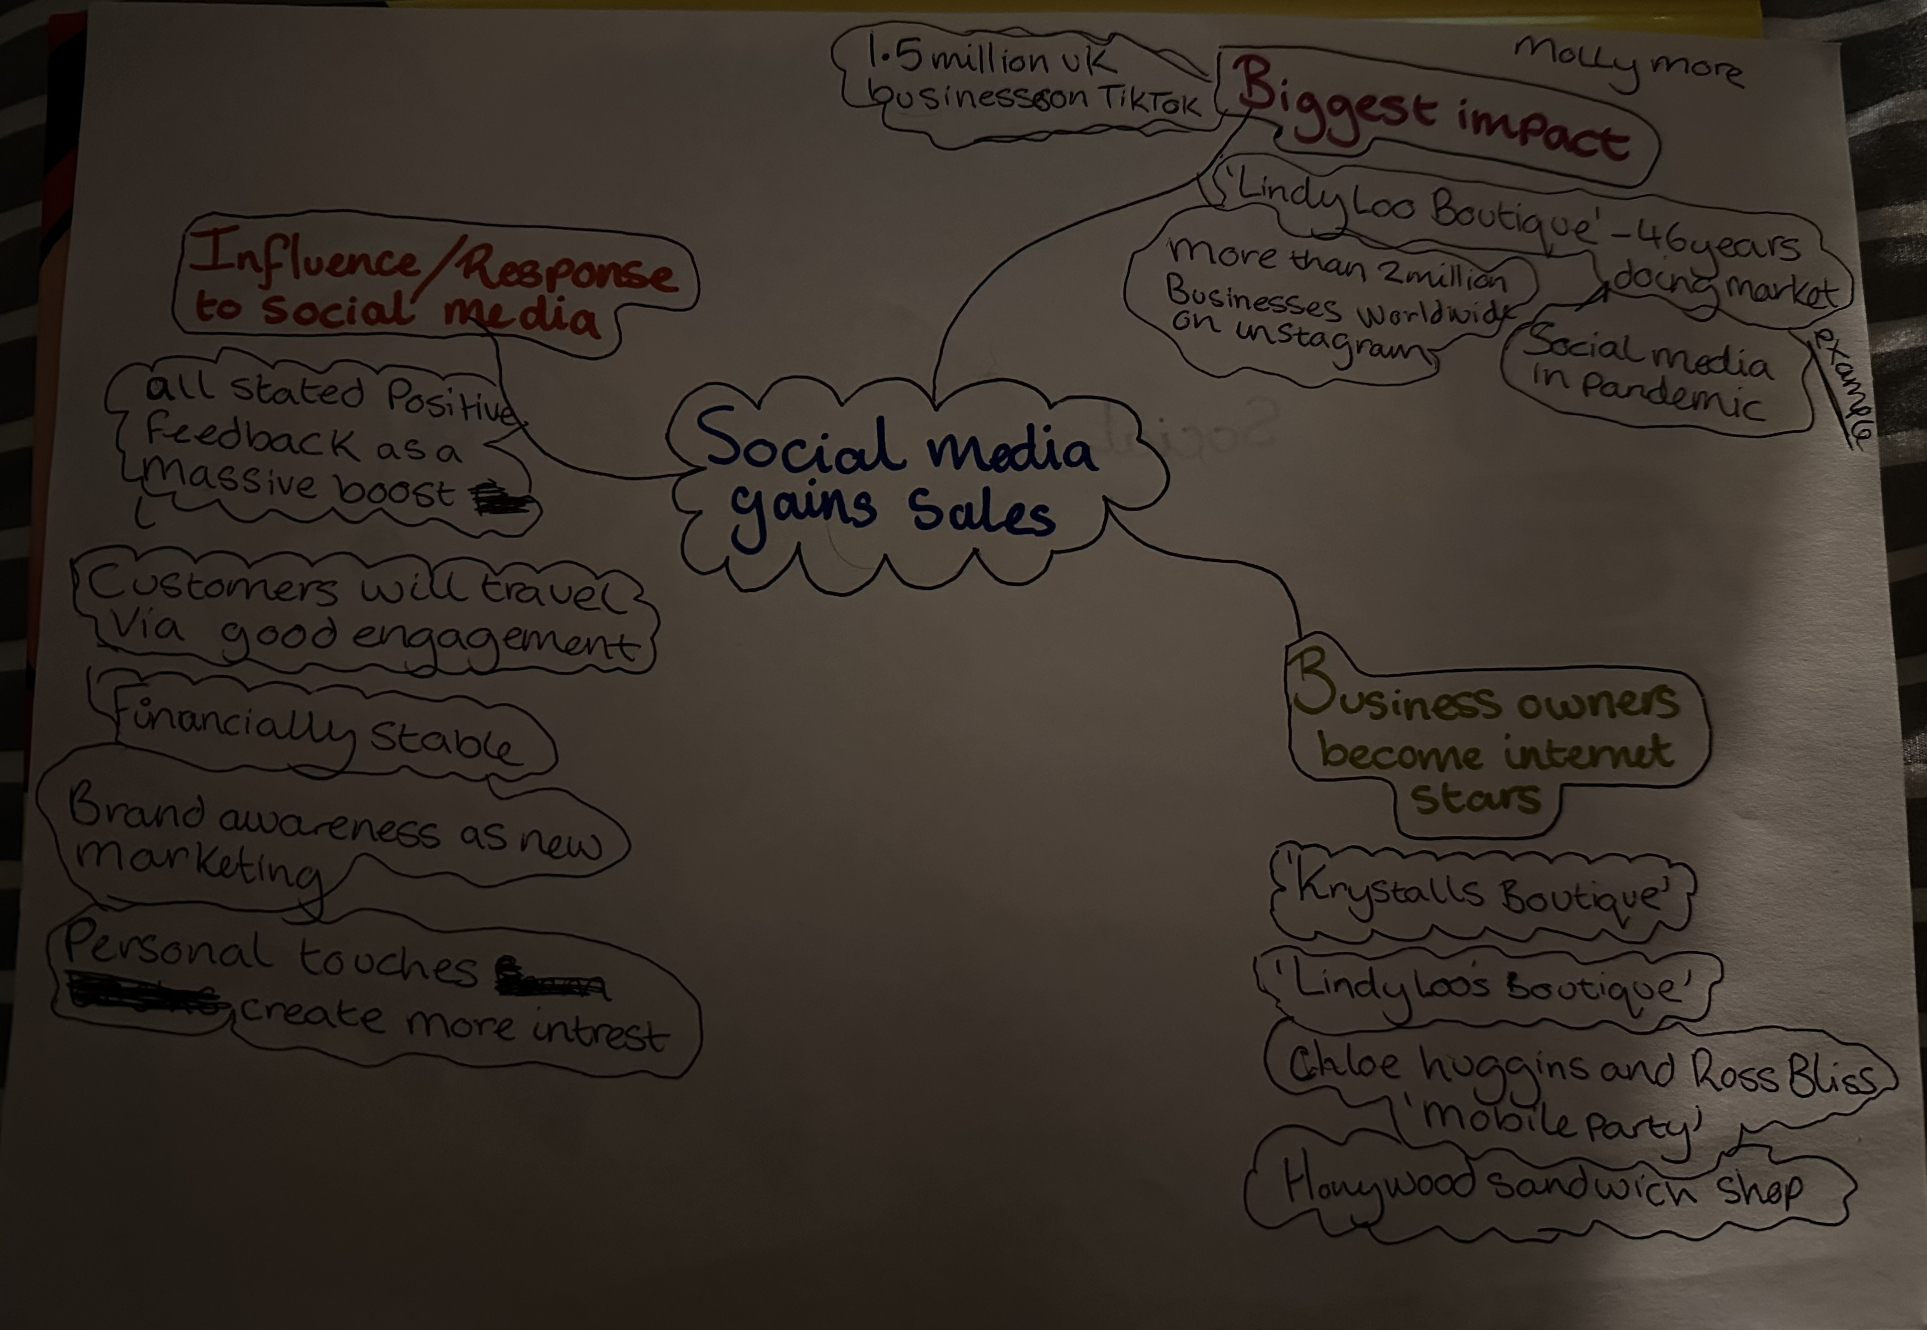
PART 1: Upload your photo of your A3 in-class notes here:

PART 2:
- Answer every question below in 1-3 full sentences.
- Use your own words. Do not use generative AI to answer these questions.
- Include a specific detail from the text when asked.
REMINDER
- The main idea is the overall message of the whole text.
- A key point helps to explain the main idea.
- A specific detail or example from the text shows that the key point is true.

- What is the main idea of the whole text?
The main concept is about how social media has helped businesses grow financially and as a brand in general too.
It discusses in depth how different businesses have developed and branched out as whole since they have started using social media as an alternative advantage.

- What is one key point that supports the main idea, and which specific example from the text shows this?
Personal touches on social media from businesses makes them grow in popularity as well as giving exposure.
‘Honywood Sandwich Shop’ is a prime example of how they grew due to their videos they post on TikTok alongside their customers also posting their content online. Word of mouth via social media boosted their exposure.
With them posting on social media it has help them garner more customers further out, where some have travelled down to try the food out themselves. The owner said that a customer travelled three hours for a burger due to shared content of their products.
This shows us how social media engagement helps things grow in popularity for a business.

- What is a different key point that supports the main idea, and which specific example from the text shows this?
Another point would be an example of ‘Lindy Loo’s Boutique,’ she goes to explain how she was selling clothes on the market for 46 years and utilised social media during the pandemic for her business.
This boomed her to new avenues where she could close her stall from the markets and move it fully online and access a bigger audience of new customers.
This helped show us the difference financially between having a business being on the markets in London, Essex, and Kent to eventually how she used social media as a platform to help make her business grow. It has helped her to grow into a new bigger direction financially and her brand image for further opportunities of growth.

- Which part of the text do you think is most important, and why?
The last part of the text extract is the most important part, as it draws the conclusion down that social media is an essential tool for other businesses to reach out to a wider market. As well as how interpersonal relationships of how some of these businesses grew makes them more so relatable.

Reflection:
- What did you find difficult in this task (including in-class components), and why was it difficult?
I found mind mapping into separate categories as a new challenging task for me. As instead of branching multiples ways out with none of them linking to each other. I would categorise them into subjects related those areas, which meant I was scanning more specifically then just jotting down multiple different things that might have not helped me later with any work-related tasks.

- What helped you with this difficulty, and how did it help you?
Working collaboratively with my other classmates as then I could bounce any questions I had on what they might have thought would be helpful and learning from what they would look for too with making it simpler instead of long and complicated points.

