Module Name: Foreign Languages & Cultural Awareness
Module code: BMIH5003
Student Name: Persima Barreto
Student ID: 2243324

Task 1

Table of Contents
Introduction 3
Component 1 - Professional reflection 3
Component 2 - Training plan 4
Component 3 - Student self-reflection 6
Conclusion 7
References 8
Component 4 – Training presentation 10

Introduction
This research aims to communicate effectively in spoken and written language among the Delta Hotels by Marriott Swindon. This research is mainly focusing on the Italian language for hospitality companies and professional businesses. This research will discuss the cultural misunderstanding that occurs between food and beverage employees in Delta Hotels By Marriott Swindon.

Component 1 - Professional reflection
Food and beverage employees are facing cultural misunderstanding in Delta Hotels by Marriott Swindon when an Italian-speaking guest orders food. An Italian guest has been asked for affogato in the cafe and she wants to mean traditional expresso along with vanilla. The food and beverage employee could not understand the Italian language properly and was given a normal coffee institute. Guests have received black coffee instead of Espressos with vanilla. At that time, the guest was disapproved of this kind of misunderstanding. Cultural miscommunication mainly defines the significance of language proficiency and cultural awareness for handling guest experiences in international hotels. As commented by Abramson and Moran (2018), cultural misunderstanding mainly occurs due to the differences between customers, language, communication style and traditions.
As a placement student of Delta Hotels by Marriott Swindon, I have defined that misunderstanding can occur for handling diverse guest environments. To prevent this kind of misunderstanding, I have to develop my communication skills which are mainly relevant to the hotel's aspects and basic proficiency for handling various key languages that are mainly spoken by the guests. Developing cultural awareness with the help of self-education and training is helping to develop an understanding of handling guests' behaviours, preferences and expectations (Christiansen et al., 2020). By achieving those skills, I want to develop my understanding of guests' culture and nature in Delta Hotels by Marriott Swindon to develop their satisfaction rate and experience level. It needed proper listening and clarifications to detect cross-cultural interactions effectively and help define misunderstandings (Aririguzoh, 2020). Cultural misunderstanding mainly occurs in the hotel industry due to different factors and language barriers leading to misinterpretation of handling the guest's request and their preferences. Different types of communication styles and cultural norms, social etiquette and personal space are resulting in discomfort for the guests and their staff members. Cultural misunderstanding mainly occurs because of different service expectations. Determining cultural misunderstanding in the hotel industry is based on cultural sensitivity training for the communication channels, staff for managing their preferences and handling accommodation services regarding cultural expectations (PATEL, 2024). An inclusive working environment and diverse workforces are developing staff awareness and developing an understanding of managing cultural preferences and decreasing the rate of misunderstanding. To prevent cultural misunderstanding, I have to develop language proficiency those are mainly relevant to the development of cultural awareness and handling self-education and training programs.
My adaptability skills, patience and empathy are helping me to determine cross-cultural interactions effectively (Hofstede et al., 2010). It is needed to determine cross-cultural interactions, decreasing the assumption rate for handling cultural backgrounds and handling diverse perspectives. By determining these behaviours and skills, I can make a welcoming and inclusive environment for the guests. Cultural misunderstanding mainly occurs among the hotel industry in the time of providing dinner services and I was observing as a placement student in Delta Hotels by Marriott Swindon. I have realised that the impact of proper understanding regarding cultural awareness is handling offers developing knowledge and handling diverse guests.

Component 2 - Training plan
Defining cultural Misunderstanding
As a placement student of Delta Hotels by Marriott Swindon, I have seen that they are facing cultural misunderstanding regarding language barriers mainly not knowing the Italian language. Most of the employees in the hotel are facing a lack of proficiency in the Italian language which is leading to miscommunication, and potential dissatisfaction between guests. It is creating frustration and disappointment among the guests and employees are not responsible properly for handling cultural proficiency. In the time of simple interactions, mainly for inquiries and greetings and asking for the amenities, they are facing language barriers that are creating a negative impact on guests' perceptions of handling service quality and hotel attentiveness.
This cultural misunderstanding mainly occurred because of the impact of language skills in the hospitality industry (Deresky, 2017). Employees of Delta Hotels by Marriott Swindon need to be adequate for handling language proficiency in an effective way along with guests for handling cultural backgrounds delivering positive guest experiences and handling potential misunderstandings. To detect the issues, the hotel needs to implement effective language training programs for developing employee proficiency and handling key languages. By implementing effective staff members and handling translation services, employees can develop their understanding for guest satisfaction development purposes.
Training Plan
Staff training plans can be determined to detect issues related to language barriers for all employees. This plan is going to focus on the development of Italian language proficiency, communication skills and cultural awareness. Language training is needed for the staff, Delta Hotels by Marriott Swindon is offering Italian language courses and workshops for interested employees. It is based on language learning resources for handling language apps, online tutorials and textbooks (Hampden-Turner and Trompenaars, 2020). They are conducting conversational practice sessions along with the employees to make proper interactions among Italians and people playing for handling primary guest interactions.
Delta Hotels by Marriott Swindon is providing training to their employees regarding cultural awareness for handling training sessions that mainly focus on Italian customers, culture and etiquette. They are delivering effective insights for handling Italian dining preferences, social norms and communication styles (Hofstede et al., 2010). The training plan needs to be based on effective communication skills and handling resources. Proper training is needed among the employees for handling effective communication techniques that are based on handling clarity of speech, active listening and nonverbal communication (Nedelko and Brzozowski, 2020). Delta Hotels by Marriott Swindon is conducting a role-play exercise for handling guest interactions and managing proper practice regarding communication skills and practising language for delivering a supportive environment. Delta Hotels by Marriott Swindon needs to handle regular feedback mechanisms for determining effectiveness controlling training programs and developing improvement areas.
Employees require resources and help to learn languages and cultures (Piwowar-Sulej, 2021). Implementing multilingual signs and guest informational materials properly handles major languages and Italian guests. Delta Hotels By Marriott Swindon can improve employees' language, communication, and cultural awareness to handle Italian-speaking customers and future scenarios by implementing such staff training programmes.

Component 3 - Student self-reflection
The Gibbs reflective cycle is based on an effective framework that helps individuals deliver effective experiences. It helps individuals define various stages which include feelings, descriptions, analysis, evaluation and action plans. This model is helping individuals develop their understanding of developing strengths and developing different areas. In the hospitality industry, cultural awareness plays a significant role in handling staff interaction, guest satisfaction and providing service quality.
Description
Delta Hotels by Marriott Swindon manages guests from different areas and those are based on different cultural backgrounds expectations and preferences. As a placement student, I have developed this understanding and I have observed cultural barriers among the gays to behaviours, dietary preferences and spoken languages that are needed for handling and getting services for meeting the needs of the customer.
Feelings
I have faced empathy, curiosity and discomfort at the same time in the time of doing a placement in this hotel. Hospitality staff is facing uncertainty and anxiety in managing communication with their guests (Pieper et al., 2021). In my opinion, it defines the need for self-awareness and cultural sensitivity.
Evaluation
This stage defines the significance of cultural awareness regarding staff dynamics and guest experiences that develop inclusivity and manage misunderstanding. I have developed my understanding of different protocols, communication styles and amenities for handling cultural preferences and developing guest satisfaction rates. This model is developing my understanding regarding hospitality experiences that are developing growth and overall learning and growth opportunities.
Analysis
Defining cultural interaction and different outcomes is handling healthcare professionals for defining challenges, patterns and opportunities for development purposes. I have improved cross-cultural communications and handling cultural misunderstandings handling different factors including stereotyping, language barriers and biases.
Conclusion
It provides an effective and reflective analysis for handling cultural awareness and controlling competency in the hospitality industry. Defining cultural diversity is a challenge that has been defined and those are creating challenges for delivering trust and developing personalised guest experiences.
Action Plan
Depending on the above reflection, hospitality professionals are developing a proper action plan for developing cultural competence and cultural awareness. This is based on developing cross-cultural communications delivering additional training programs and implementing effective strategies for handling cultural diversity for controlling organisational culture and service delivery (Ingham-Broomfield, 2021).
By implementing Gibbs' reflective model for defining cultural awareness among Delta Hotels Marriott Swindon is delivering effective understanding for handling employee development and guest interactions. Implementing cultural awareness is delivering an effective environment, managing relationships with stakeholders and handling guest satisfaction rates to deliver success in the hospitality business in a developing globalised world (Adeani et al., 2020). Gibbs's reflective model provides a proper understanding of cultural awareness in the hotel industry based on different stages to define employees' experience and guest interaction.

Conclusion
Gibbs's reflective model has been used in these research studies to define the experience of the learner. The cultural misunderstanding has been described in this research study regarding the language barrier. A proper training plan has been made to provide communication skills regarding the Italian language among the employees.

References
Abramson, N.R. and Moran, R. 2018 Managing Cultural Differences: Global Leadership for the 21st Century. 10th Ed. Abingdon: Routledge.
Adeani, I.S., Febriani, R.B. and Syafryadin, S., 2020. Using GIBBS’reflective cycle in making reflections of literary analysis. Indonesian EFL Journal, 6(2), pp.139-148.
Aririguzoh, S., 2022. Communication competencies, culture and SDGs: effective processes to cross-cultural communication. Humanities and Social Sciences Communications, 9(1), pp.1-11.
Christiansen, B., Branch, J.D. and Karmowska, J. 2020 Cultural Factors and Performance in 21st Century Businesses. Hershey : IGI Global.Maheshkar, C. and Sharma, V. 2018 Handbook of Research on Cross-Cultural Business Education. Hershey: IGI Global.
Deresky, H. 2017 International Management: Managing Across Borders and Cultures: Text and Cases. 9th Ed. Harlow: Pearson Education Ltd.
Hampden-Turner, C. and Trompenaars, F. 2020 Riding the Waves of Culture. 4th Ed. London: John Murray Press.
Hofstede, G., Hofstede, G.J. and Minkov, M. 2010 Cultures and organizations: software of the mind. 3rd Ed. New York: McGraw-Hill.
Ingham-Broomfield, B., 2021. A nurses' guide to using models of reflection. TheAustralian Journal of Advanced Nursing, 38(4), pp.62-67.
Nedelko, Z. and Brzozowski, M. (eds) ‘Recent advances in the roles of cultural and personal values in organizational behavior’ in Ordóñez de Pablo, P. 2020 Advances in Human Resources Management and Organizational Development Book Series. Hershey: IGI Global.
PATEL, D.H.D., 2024. Clarity amidst Confusion: An In-Depth Analysis of Miscommunication and Practical Solutions. Vidhyayana-An International Multidisciplinary Peer-Reviewed E-Journal-ISSN 2454-8596, 9(5).
Pieper, M., Roelle, J., vom Hofe, R., Salle, A. and Berthold, K., 2021. Feedback in reflective journals fosters reflection skills of student teachers. Psychology Learning & Teaching, 20(1), pp.107-127.
Piwowar-Sulej, K., 2021. Human resources development as an element of sustainable HRM–with the focus on production engineers. Journal of cleaner production, 278, p.124008.

Component 4 – Training presentation

Introduction
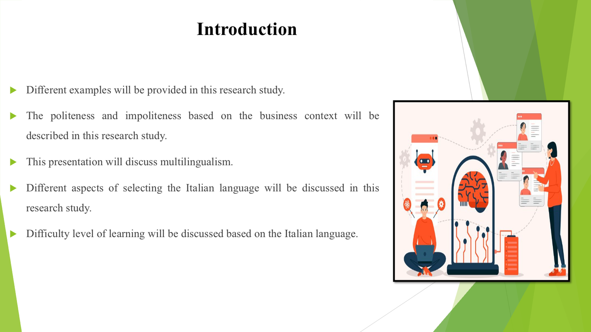
Speaker’s Note: This presentation will discuss multilingualism. Different aspects of selecting the Italian language will be discussed in this research study. The politeness and impoliteness based on the business context will be described in this research study. Difficulty level of learning will be discussed based on the Italian language. Different examples will be provided in this research study.
Benefits of Multilingualism
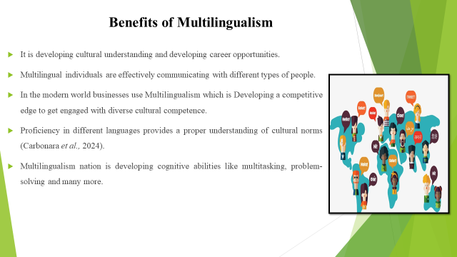
Speaker’s Note: Multilingual individuals are effectively communicating with different types of people, controlling language barriers and providing proper connections to manage cultural backgrounds. It is developing cultural understanding and developing career opportunities. Proficiency in different languages provides a proper understanding of cultural norms, and facilities and provides a proper perspective to manage a proper relationship (Carbonara et al., 2024). Multilingualism nation is developing cognitive abilities like multitasking, problem-solving, and memory retention that are contributing to cognitive flexibility and brain growth. In the modern world businesses use Multilingualism which is Developing a competitive edge to get engaged with diverse markets and provide cultural competence.
The place is the chosen language is spoken
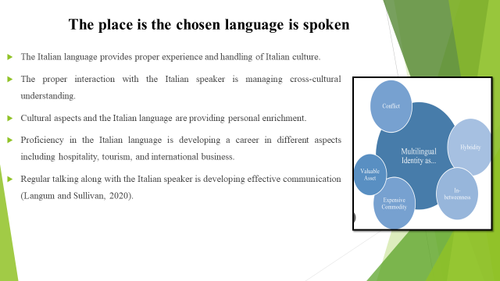
Speaker’s Note: Proficiency in the Italian language is developing a career in different aspects including hospitality, tourism, and international business. The proper interaction with the Italian speaker is managing cross-cultural understanding and handling the learning of the Italian customers and their social norms. Cultural aspects and the Italian language are providing personal enrichment, handling literature providing personal growth with the help of cultural exploration. Regular talking along with the Italian speaker is developing effective communication and language skills that improve comprehension and fluency (Langum and Sullivan, 2020). The Italian language provides proper experience and handling of Italian culture that is based on tradition and authentic interaction.
Difficulty level for learning the language
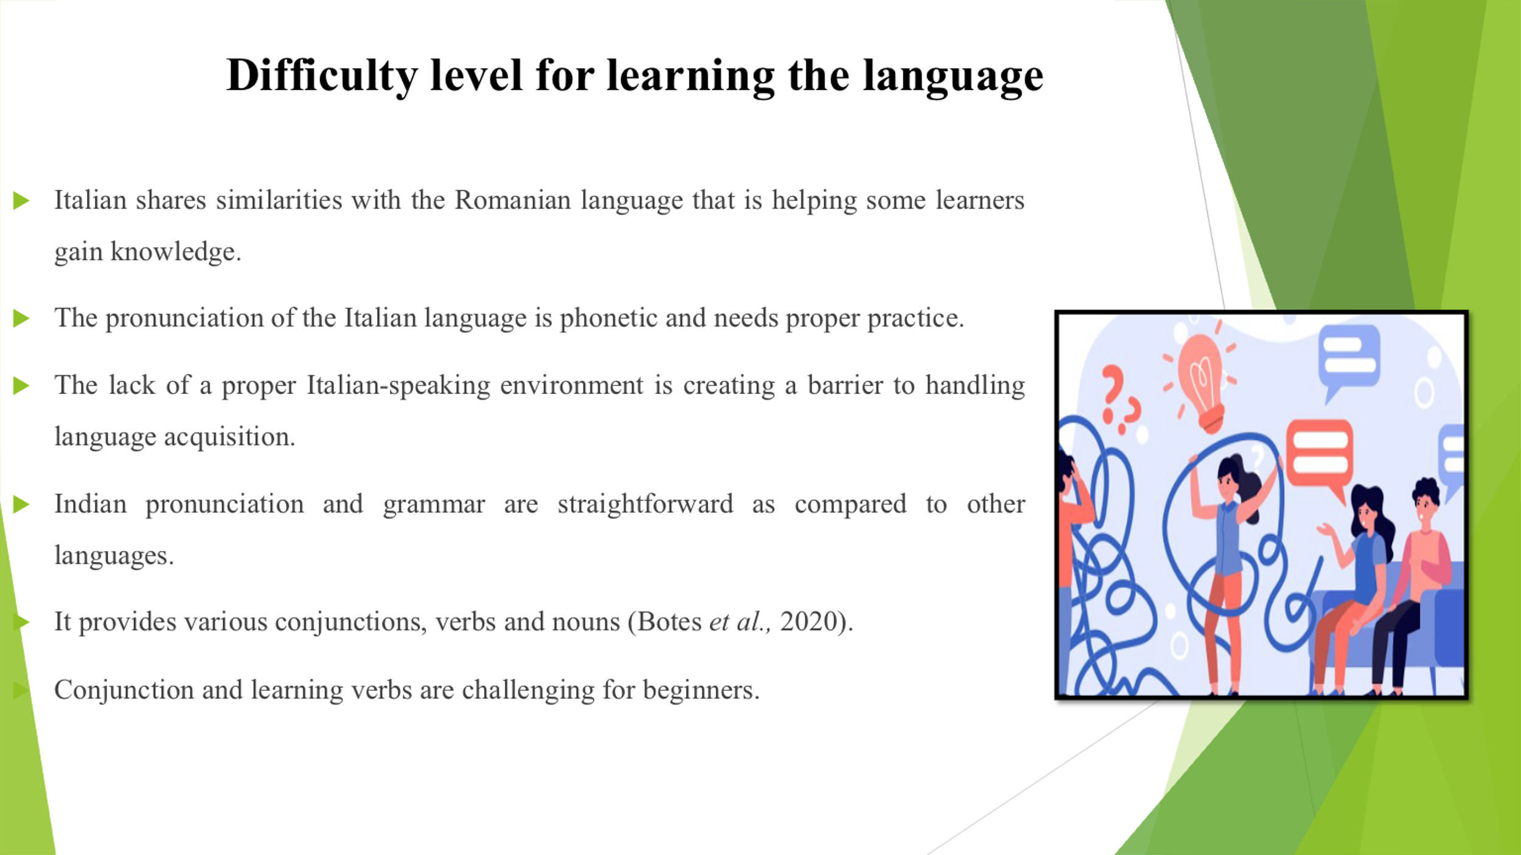
Speaker’s Note: The pronunciation of the Italian language is phonetic and needs proper practice. Italian shares similarities with the Romanian language that is helping some learners gain knowledge. Indian pronunciation and grammar are straightforward as compared to other languages. It provides various conjunctions, verbs and nouns (Botes et al., 2020). Conjunction and learning verbs are challenging for beginners. The lack of a proper Italian-speaking environment is creating a barrier to handling language acquisition.
Discussion on politeness in a business context
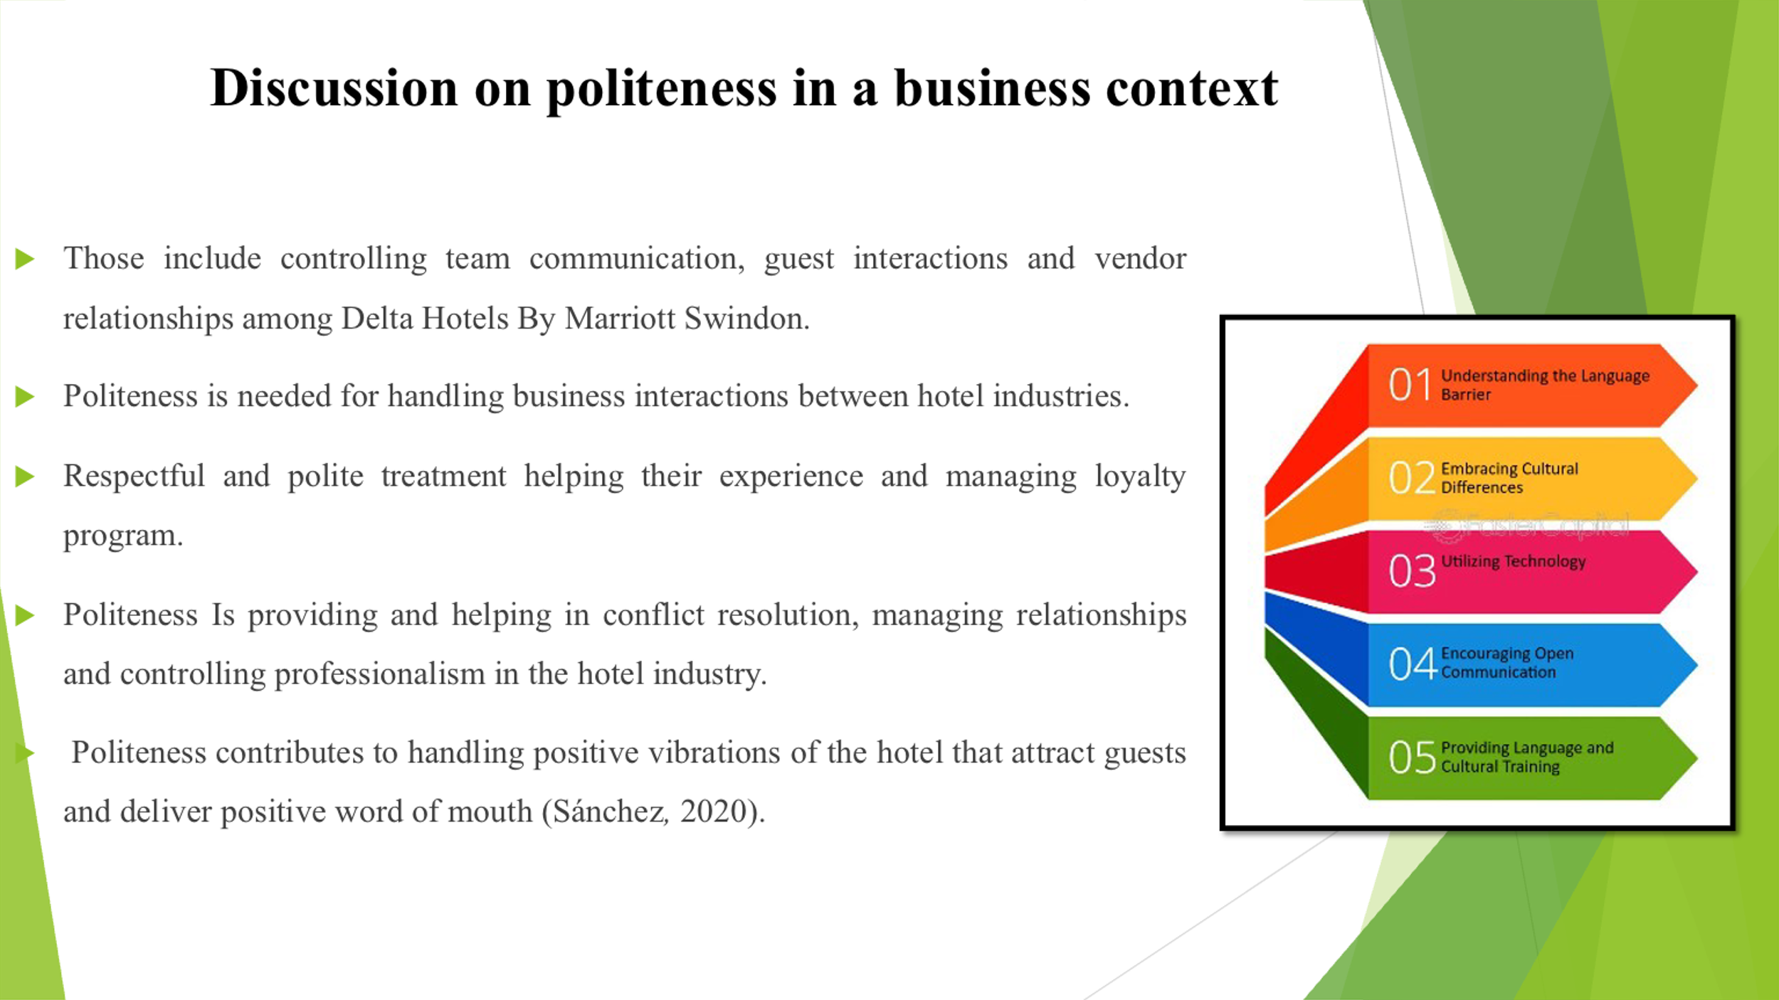
Speaker’s Note: Politeness is needed for handling business interactions between hotel industries. Those include controlling team communication, guest interactions and vendor relationships among Delta Hotels By Marriott Swindon. Respectful and polite treatment helping their experience and managing loyalty program. Politeness contributes to handling positive vibrations of the hotel that attract guests and deliver positive word of mouth (Sánchez, 2020). Politeness Is providing and helping in conflict resolution, managing relationships and controlling professionalism in the hotel industry.
Discussion on impoliteness in a business context
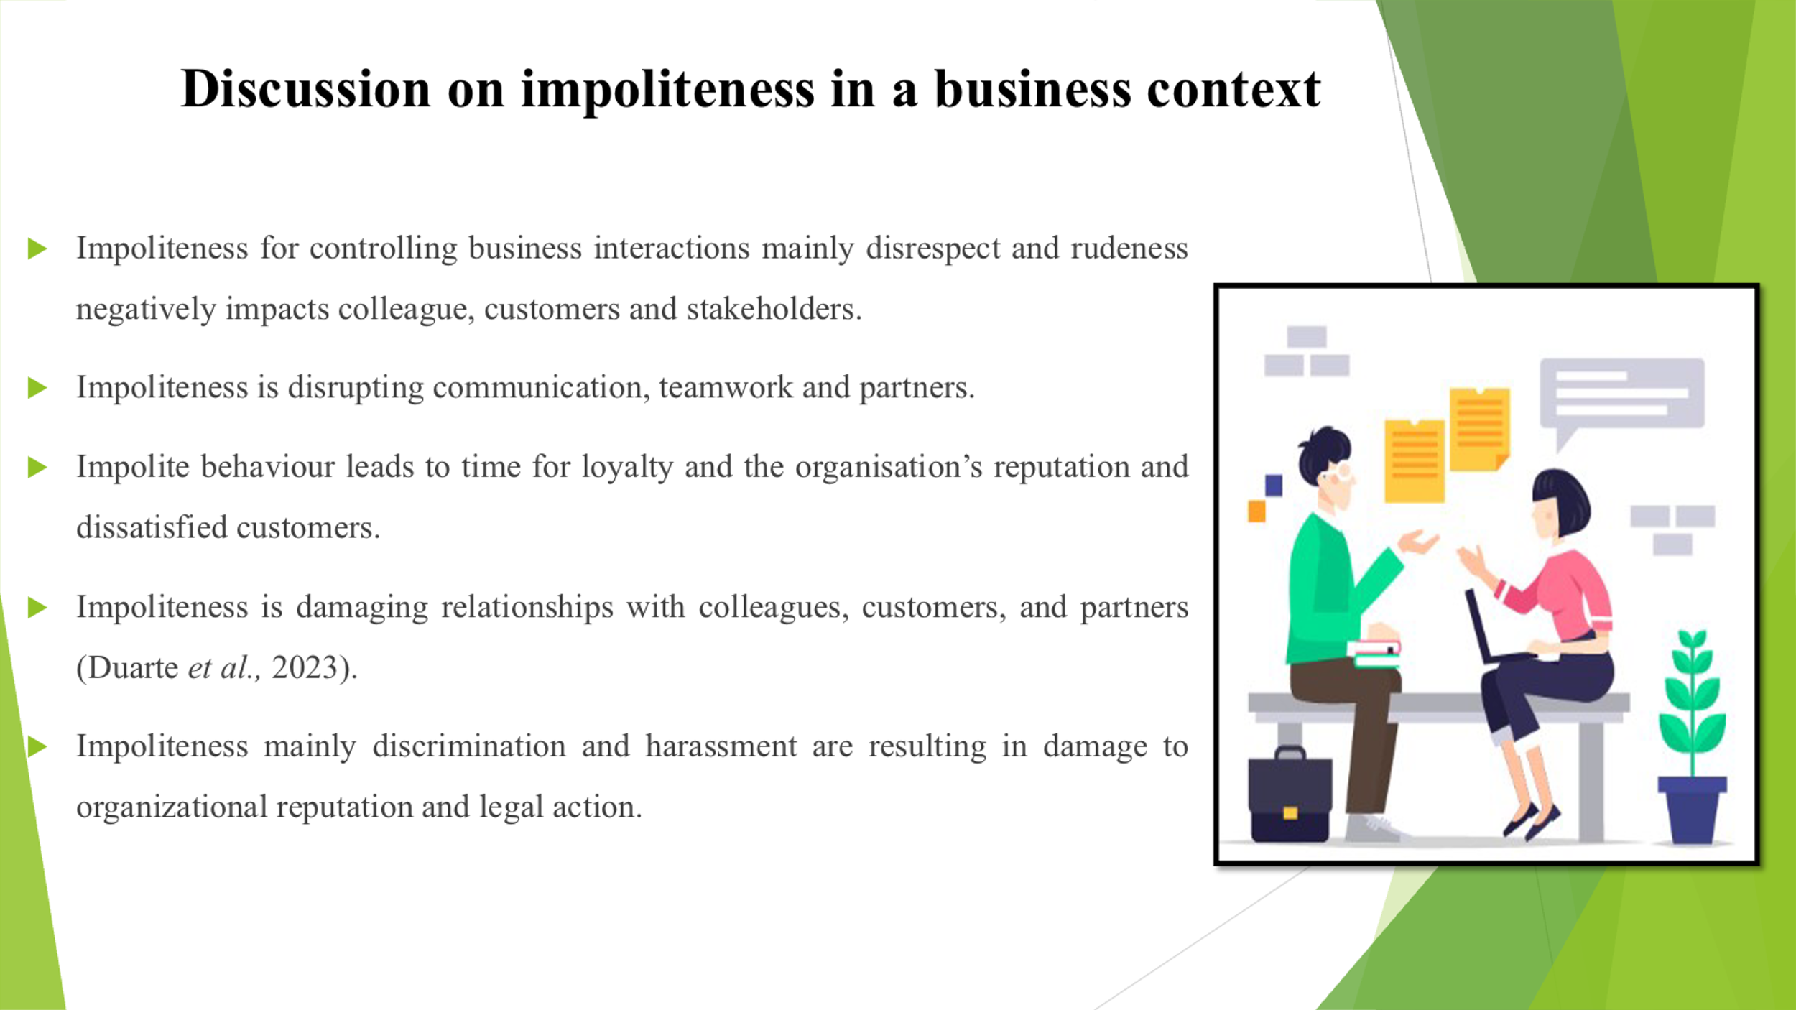
Speaker’s Note: Impolite behaviour leads to time for loyalty and the reputation of the organization and dissatisfied customers. Impoliteness for controlling business interactions mainly disrespect and rudeness creates a negative impact on colleague’s customers and stakeholders. Impoliteness is damaging relationships with colleagues, customers, and partners (Duarte et al., 2023). Impoliteness mainly discrimination and harassment are resulting in damage to organizational reputation and legal action. Impoliteness is disrupting communication, teamwork and partners.

