MODULE NAME: Problem Solving and Decision Making
LECTURER’S NAME: Xavier Matieni
STUDEN NAME: Jeaneth t Arze Flores
STUDENT’S ID: 2324316
University of Wales Trinity Saint David (London Campus)

Sage care
- Introduction
This is the continuation of the first part of my assessment which was a presentation. The aim of this part (2) is to briefly analyse the main problem and evaluate two alternative solutions to it. In the first part the objective was to assess the main causes of the lack of communication that were impacting the collaboration and communication within the team. The case study was based on my company called, SAGE CARERS COMPANY ltd. I have had to critically evaluate the situation we are still enduring in our everyday operations. The team and management have demonstrated some hurdles in terms of communicating simple tasks and timetabling staff and this has led to other side effect such as stress, burnout, and manipulations of all sorts. The environment has deteriorated in terms of collaboration and the management team are overwhelmed because there is no support in place.
As an operational staff member, I believe we as I care we know more about the clients than the management because we are dealing with them on day-to-day basis. In terms of patients’ needs, we are aware of what they want, how they are doing and what time the service has to be provided. Conversely to the management which has demonstrated their limitations, lack of understand, no matter how much we explain to them, they don’t want to listen or the don’t want to now.
- Two alternative Solutions
To circumvent this issue which prove challenging, two alternative solutions are being proposed. The first one is the effective communication, and the second one is training and staff development. Let’s dive into some of the limitations impacting the health care sector and then after we will expand on the two alternative solutions.
2.1 Lack of effective communication in healthcare
According to National library of medicine (2024), poor communication can negatively impact staff satisfaction and increase their burden consequently leading to Mental health and burnout, evoking anxiety, depression, and stress. some common communication barriers stem from language and cultural differences, gender differences, emotional disconnect, use of jargon, and conflict.

  - . Effective communication
According to Mishra and Mishra (2009), effective communication, collaborating, and coordinating are important contribution factors in achieving success in an Agile team project. They proceed in defining communication as imparting or interchanging thoughts, opinions, or information by speech, writing, or signs. Collaboration is defined as working together to accomplish a task and discussing with each other to solve difficult problems. Effective collaboration, on the end, includes both individually focused tasks and interactive group work. They concluded with coordination, which is one of the manager responsibilities, is the harmonious adjustment or interaction of different people, things to achieve a goal or effect.

2.3. Staff training or staff development
Staff training refers to the process a company implements to improve its employee’s skills, knowledge and abilities. This process is essential for the company’s success, a growth in employee strength, keeping the employees up to date on relevant information and makes processes run smoother. Sara De la Torre (2024)

- Risk Analysis
Risk analysis is a process of identifying the potential problems that could affect a company or organization in a negative way. This process’s scope of this process is to mitigate those risks. Kinza Yasar (2023)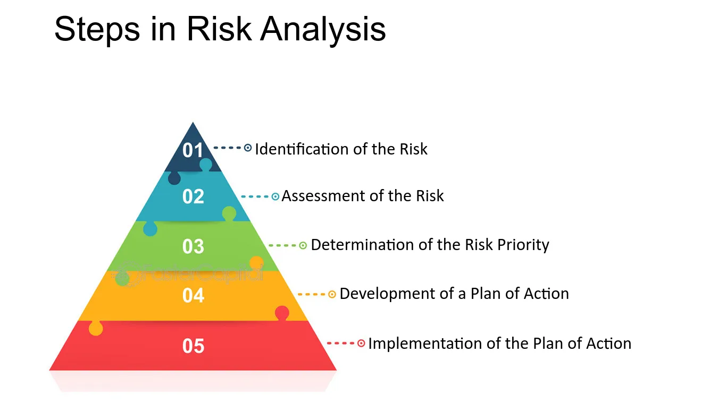
In the of Sage Care lack of effective communication occurs frequently and the reasons differ:
- The office does not relay the instructions properly and with enough respect sometimes
- In case of an issues the carers take most of the blame
- New staff take the clients of the more experienced staff sometimes
- At times when we double up on a client, conflicts arise in front of the client
- When we file a complaint, the office ignores it
- Protective equipment is falling short sometimes
- Different cultures / different ideas clash at times
The risk in all the scenarios mentioned above have consequences like:
- The image of the organisation suffers
- Clients can become upset / neglected
- Carers can leave the company / short staff
- Clients can opt in for a different company
- Social services can be involved in certain scenarios
- Investigations can be initiated

- Implementing The decision
- Weigh the evidence and send email to the managers to be taking action before the situation deteriorates.
- Request clients to give feedback about the service they are receiving from the office and the cares.
- Lisen more and Thake action for every complain, this is good form company and client and staff.
- For the office to effectively plan and timetable staff’ rota and to minimise risks and predict them beforehand.
- Cooperate and good collaboration within the team to deliver a service of quality.

- Measure effectiveness of your implementation
- Client Satisfaction
- Team Satisfaction
- Cycle time
- Continual improvement
- Output Quality
- Feedback for carers

- Put simply, the focus of the evaluation of the implementation process problem were resolved the steps involved in planning implementation must be addressed early in the process.

- Conclusion
- In my previous assignment, I utilized the fishbone diagram to identify the factors and causes of ineffective communication in healthcare. In this report, I propose two alternative solutions: staff training and development, and the integration of emotional intelligence with effective communication. By implementing these solutions in collaboration with top management and involving patients, the team can deliver high-quality service, ensuring the satisfaction of both patients and carers.
.

- References
- Mishra D. and Mishra A. (2009) Affecting communication, effective Communication collaborating, and Coordination in extreme Programming: Human-Centric Perspective in a Small Organization. Human Factors and Ergonomics in Manufacturing, vol.19 (5) 9438-456
- http://www.ncbi.nlm.nih.gov.pmc [accessed11/08/2024]
- Sara De la Torre (2024) Staff Training https://www.iseazy.com/glossary/staff-training/ (Accessed 18 August 2024)
- Kinza Yasar (2023) Risk Analysis https://www.techtarget.com/searchsecurity/definition/risk-analysis#:~:text=Risk%20analysis%20is%20the%20process,avoid%20or%20mitigate%20those%20risks. (Accessed 18 August 2024)
- Steps in risk Analysis https://fastercapital.com/content/What-is-Risk-Analysis.html (Accessed 18 August 2024)
6.The university of Melbourne (Australian university):PRV12150 (Accessed 18 August 2024)

