Module Code : BMSW4011

Assessment title : Business Plan

Student Name : Sarah Leonard

Student Number : 2512418

Lecture : Melanie Squire

Word Count : 1093

Contents page
1.Company’s name and products we supply.
2.My story and why I am I passionate about this business.
3.Type of business
4.Mission statement
4.1 WT Kiddy Care Aims
4.2 WT Kiddy Care Objective
4,3 My USP
5. Location
6.Human Resources
7.Marketing Strategy
7.1 Target Audience
7.2 Positioning for my target and secondary target audience
7,3 Marketing ideas and examples,
8. Market research
8.1 Primary research
8.2 Secondary research
9 Financial Overview
9.1 Excel spreadsheet incomings outgoings
10. Critical Feasibility of WT Kiddy Care
11. Pestle Analysis
12. SWOT Analysis
13. Reference List
14. Reference List
15. AI Statement.

1,Company’s name and products we supply.

The company’s name will be WT Kiddy Care.

WT Kiddy Care will be Domiciliary care agency for children who live in the community of the Cardiff and vale area, according to (Donnellan et al., 2022) We will provide support for children that live at home with their loved ones but need support with personal care, medication, (Ames et al., 2023)or just for their families to have a little time to recharge, this service will be available 24 hours a day 365 days a year. we will provide care for children from the age of 1-18 years old.

2. My story of why I am passionate about this business.

I have been in the care sector since 1996, I started as a care assistant at the age of 16 I progressed to a night senior carer at the age of 17, At 18 I moved to Domiciliary Care according to (Foster and Blamires, 2023) I progressed within 6 months to become a team leader followed by a care coordinator role. I then went into respite for adults with metal health issues as an deputy manager after a few months, I progressed further and become a registered manager of a domiciliary care company while doing this I gained my level 5 QCF Higher Diploma of Education in Health and social care leadership and management (Glasby, 2026),I own an domiciliary care business for adults. I want to expand the business to be able to care for children that have extra needs to be able to live in the community with their families.

3,Type of business ownership
WT Kiddy care will be a limited company I have chosen it to be a limited company as if the business gets into debt (Reis, 2022) or sued then our personal assets are protected the only risk will be what the company owns often on some cases clients prefer working with limited companies. It signals stability and seriousness. You can pay yourself through a mix of salary + dividends, (Christoffersen, Plenborg and Seitz, 2023) which can be more tax-efficient than paying income tax on all profits as a sole trader. According to (Mazen and Yasar Alhuneti, 2024) limited liability company's creditworthiness is compromised due to the limited liability of its partners, resulting in reduced security for its creditors. To safeguard the interests of these creditors, it becomes necessary to enhance control measures.

4. Mission Statement.
Having 30 years’ experience in the care sector myself and team ourselves on providing the best care in south Wales we give outstanding person-centred care , (Roberts and Abery, 2023)

4,1 WT Kiddy care, Care aims.
Why aims are important with in the business (Behrens, Rauner and Sommersguter-Reichmann, 2022)
1) To always provide a top quality and respected service.
2) To develop and maintain high standards at all times.
3) To always promote respect and compassion for every client we have and every member of staff we employ.
4) To comply with all legislatives requirement and provide a continually improving domiciliary care settings.

4.2 WT Kiddy care, Care objectives
1) To promote personal centred care plans are completed, agreed and implemented within 4 weeks from their care start date with reviews done every 6 months or sooner if needs change.
2) To support all clients to achieve or maintain independence goals throughout there care and support with progress monitored every month and recorded in care reviews.
3) review and develop outcome-based goals for all clients within 4weeks of service commencement.
4) To ensure that we recruit and train highly hardworking carers within the first 4 weeks this to complete mandatory introduction training before working with completing monthly refresher training.

4.3 My USP
we pride ourselves on being the best of the best and giving the highest standard of care in south Wales (Ames et al., 2023)
- Being a family run business this help our clients to trust us like an extended family. (Chami, 2025)

5 My location.
This is my Adult domiciliary care office it is based in a prime area of wentloog road, Rumney ,Cardiff, this office will be used as a shared office for adults and the children domiciliary care companies.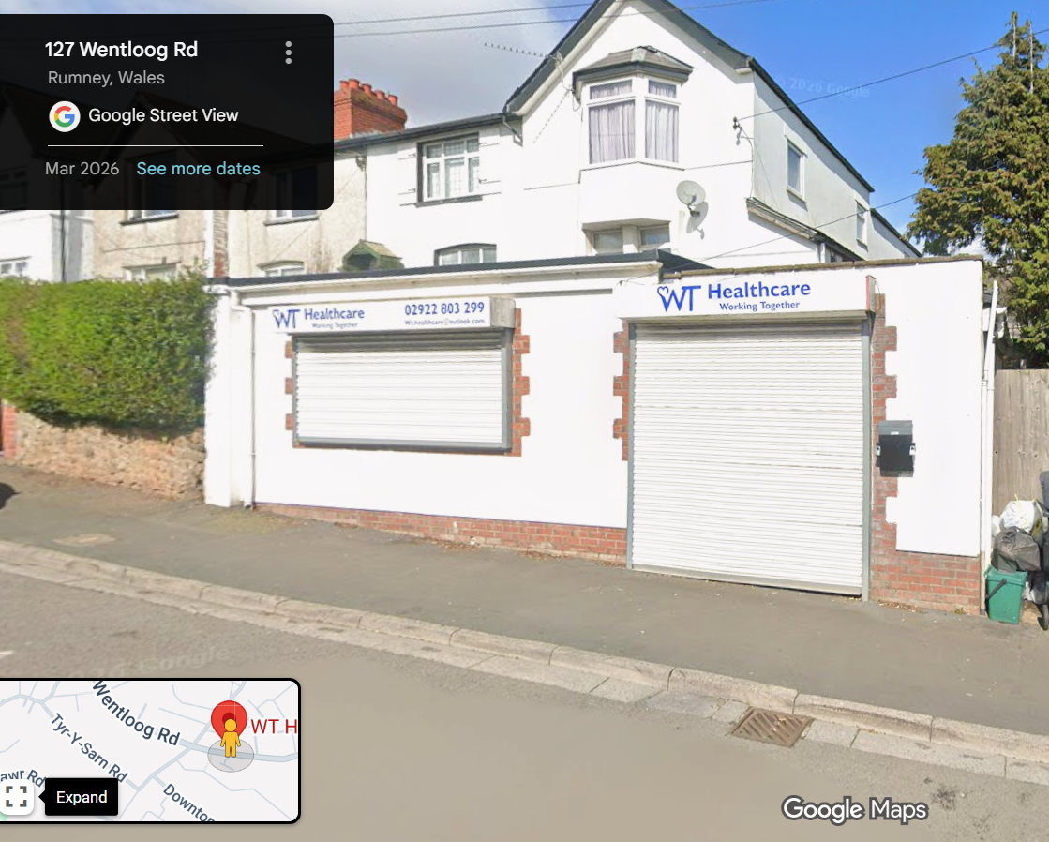

6.Human Resources.

This is my organization structure chart of the company.
According to (MarkTremaine-MacombGov, 2023) an organization structure chart shows the correct structure within a business.
As a small private care company, the structure of the company has Directors-Registered manager-Deputy Manger-Care coordinator-Team Leader-Senior Carers-Carers.

7.Marketing Strategy .

7 My target Audience.
My Core target audience will be According to(Tres et al., 2024) a target audience is what you need to build a secure business with the correct clientele.

7.1 Secondary Target Audience

7.2 Market Strategy positioning for my target and secondary target audience.
Parents and Guardians
Local Authorities
Social Workers
SEN departments
The secondary Audience will give you extra support to receive care packages.
Extended Family
Charities and Support Groups.

7,3 Segmentation,
Early Years with 0-5 medical needs.
School Age 6-11 with disability needs
Autism and behaviours Age 6-11
High dependency care for all ages this provides tailor staffing training for all different clients.

7,4 Marketing Advertisement
BUSNIESS FLYER
These will help promote the business with marketing of the business. (Hokmabadi, Rezvani and de Matos, 2024)
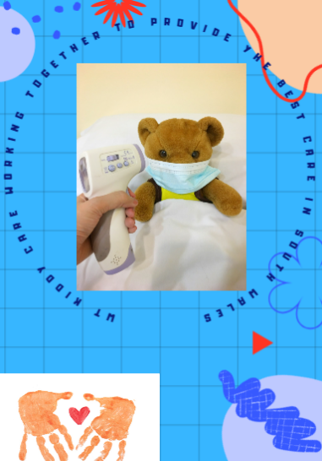

BUSNIESS CARD


8. Market research
Primary research.
Unmet needs in the local market while talking to the local authorities and Dewis independent payments there is only 5 providers in the Cardiff area.
By meeting the local authorises ceiling rate
lower rate is £25.31 the highest is £27.00 per hour.

8,2 Secondary research.
By applying and being registered on the CIW site,
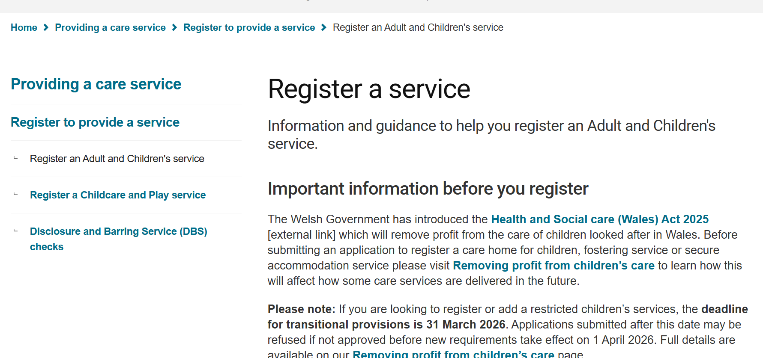

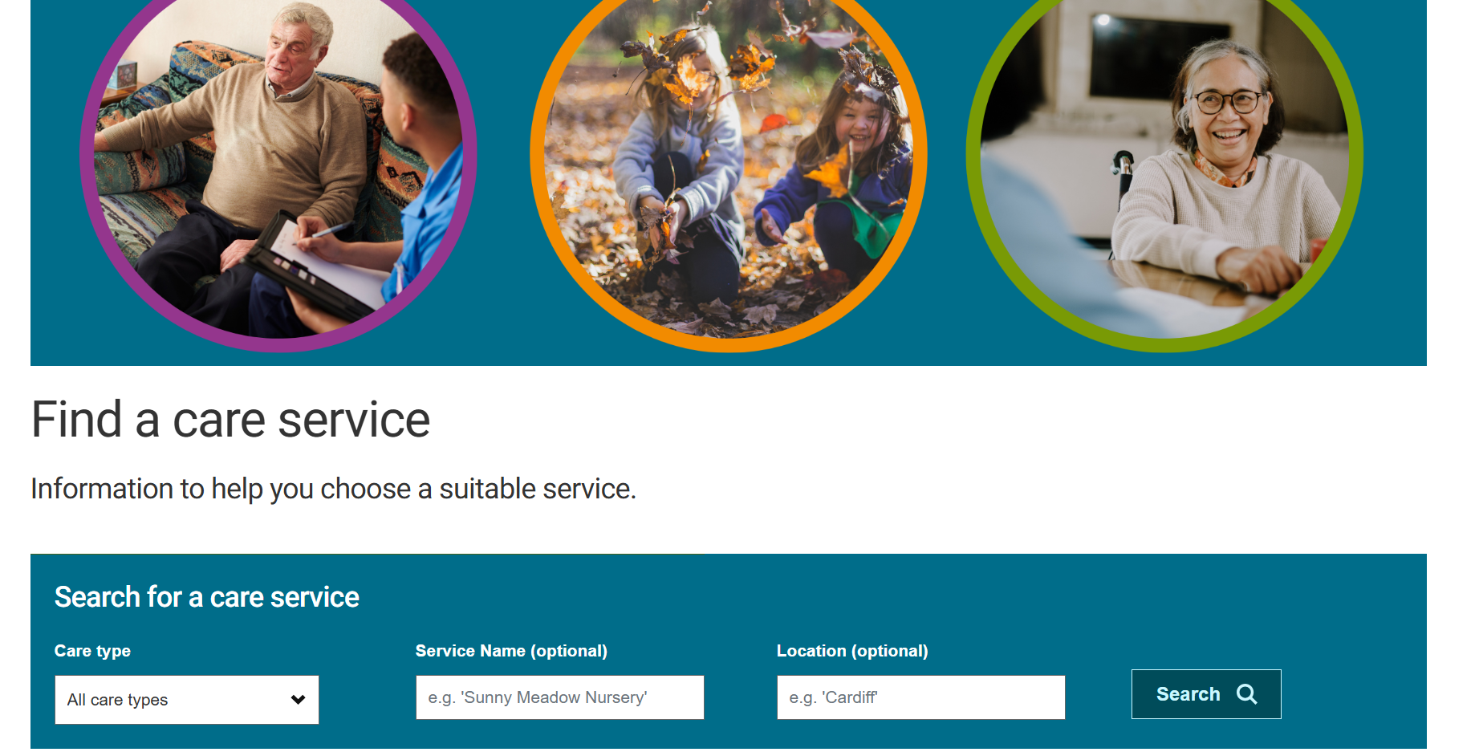

9.Financial Overview
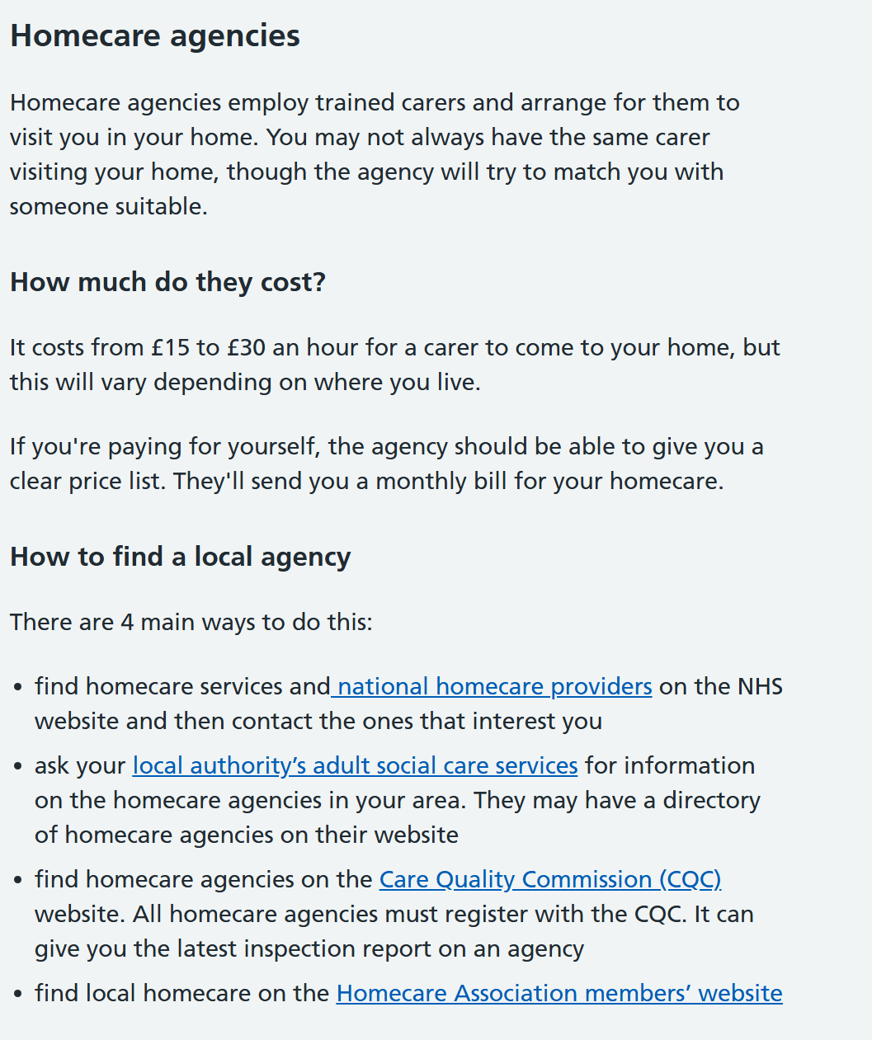

9.1 EXCEL SPREADSHEET (Abdullah Al Maruf et al., 2022)

Overall, by looking at the excel spread sheet.
WT Kiddy Care will generate around £39k around per month.
With an outcome of between £24k-£25k per month
with a profit of £14k-£15k a month

10. Critical Feasibility of WT Kiddy Care

WT Kiddy Care will be a very feasible and valuable service in the Cardiff and vale area.as with needs of home care growing. But even with the needs growing to make this successful WT Kiddy Care will still have challenges the greatest Challenges are staffing, regulation, and financial sustainability. With careful Planning this business has strong potential.

10.Pestle Analysis.

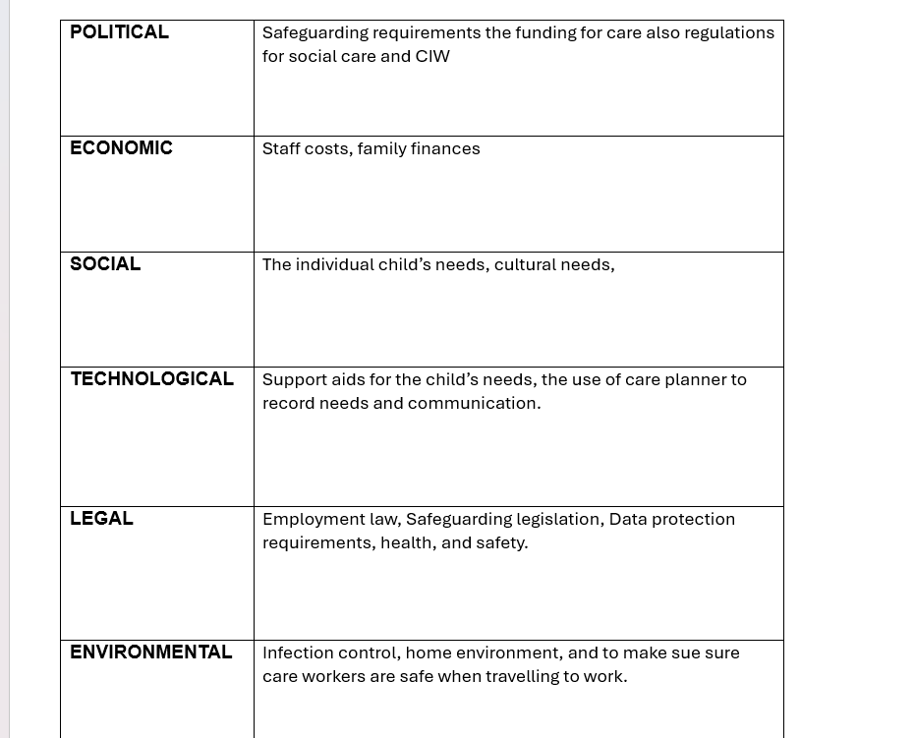

11.SWOT Analysis.

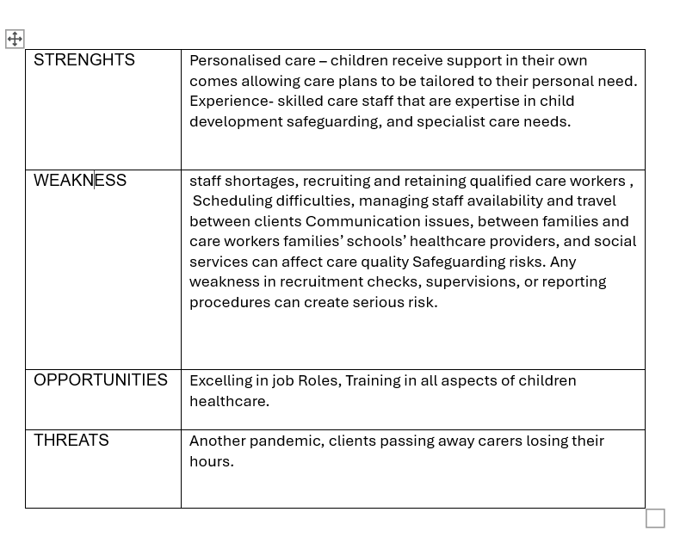

13.Reference List
1,Abdullah Al Maruf, Paul, R., Imam, M.H. and Babar, Z. (2022). A SYSTEMATIC REVIEW OF THE ROLE OF SQL AND EXCEL IN DATA-DRIVEN BUSINESS DECISION-MAKING FOR ASPIRING ANALYSTS. A SYSTEMATIC REVIEW OF THE ROLE OF SQL AND EXCEL IN DATA-DRIVEN BUSINESS DECISION-MAKING FOR ASPIRING ANALYSTS, 01(01), pp.249–269.Avialble at doi:https://doi.org/10.63125/n142cg62.
2,Ames, S., Delaney, R., Houtrow, A.J., Delgado-Corcoran, C., Alvey, J., Watt, M.H. and Murphy, N. (2023). Perceived Disability-Based Discrimination in Health Care for Children with Medical Complexity. Pediatrics, 152(1). Available at doi:https://doi.org/10.1542/peds.2022-060975.
3,Behrens, D.A., Rauner, M.S. and Sommersguter-Reichmann, M. (2022). Why Resilience in Health Care Systems is More than Coping with Disasters: Implications for Health Care Policy. Schmalenbach Journal of Business Research, 74. Available at Doi: https//doi.org/10.1007/s41471-022-00132-0.
4,Chami, R. (2025). What Is Different About Family Businesses? New Mathematics and Natural Computation, (22), pp.1–25. Available at Doi: https://doi.org/10.1142/s1793005726500584.
5,Christoffersen, J., Plenborg, T. and Seitz, M. (2023). Compensation Shifting from Salary to Dividends. European Accounting Review, 33(5), pp.1951–1980. Available at Doi:https://doi.org/10.1080/09638180.2023.2226724.
6,Donnellan, W.J., Hirons, A., Clarke, K., Muinos, C. and McCabe, L. (2022). Exploring Resilience in UK-Based Domiciliary Care Workers before and during the COVID-19 Pandemic. International Journal of Environmental Research and Public Health, 19(23), p.16128. Available at Doi https://doi.org/10.3390/ijerph192316128.
7,Foster, M., and Blamires, J. (2023). Child and Family Centred Care. Journal of Pediatric Nursing, [online] 71(1). Available at Doi:https://doi.org/10.1016/j.pedn.2023.05.006.

14.Reference List

8,Glasby, J. (2026). Understanding Health and Social Care. Bristol University Press, [online] (4). Available at Doi:https://doi.org/10.51952/9781447379430.
9,Hokmabadi, H., Rezvani, S.M.H.S. and de Matos, C.A. (2024). Business Resilience for Small and Medium Enterprises and Startups by Digital Transformation and the Role of Marketing Capabilities—A Systematic Review. Systems, 12(6),p.220.https://plus.google.com/
10,MarkTremaine-MacombGov (2023). Welcome to Macomb County, Michigan. [online] Macomb County. Available at: https://www.macombgov.org/.
11,Mazen, A. and Yasar Alhuneti (2024). The Control over Limited Liability Company Operations: A Comparative Study. Deleted Journal, (16.3), pp.681–694. Available at Doi:https://doi.org/10.62271/pjc.16.3.681.694.
12,Reis, R. (2022). Debt Revenue and the Sustainability of Public Debt. Journal of Economic Perspectives, 36(4), pp.103–124. Available at Doi:https://doi.org/10.1257/jep.36.4.103.
13,Roberts, M.A. and Abery, B.H. (2023). A person-centered approach to home and community-based services outcome measurement. Frontiers in Rehabilitation Sciences, 4. Available at Doi:https://doi.org/10.3389/fresc.2023.1056530.
14,Stefanie G. Ames, MD, MSCorresponding Author; Rebecca K. Delaney, PhD; Amy J. Houtrow, MD, PhD, MPH; Claudia Delgado-Corcoran, MD; Justin Alvey, MD; Melissa H. Watt, PhD; Nancy Murphy, MD (2023). American Academy of Pediatrics. [online] American Academy of Pediatrics. Available at: https://publications.aap.org/.
15,Tres, D.A., Martini, R.G., Toso, B.R.G. de O. and Zanatta, E.A. (2024). Vídeos educativos sobre os cuidados domiciliares à criança em uso de traqueostomia: avaliação pelo público-alvo. Ciência, Cuidado e Saúde, [online] 23. Available at Doi:https://doi.org/10.4025/ciencuidsaude.v23i0.68267.

15 AI Acknowledgement.
I confirm that I have used screenshots of CIW site as part of materials as my own work.
I confirm that I have copies of my drafts, notes, and other resources I used, which I may be asked to provide in evidence.

Module Code : BMSW4011

Assessment title : Reflective Essay

Student Name : Sarah Leonard

Student Number : 2512418

Lecture : Melanie Squire

Word Count 499

AI Acknowledgement.
I confirm that I have not presented any AI generated materials as my own work.
I confirm that I have copies of my drafts, notes, and other resources I used, which I may be asked to provide in evidence.

Reflective Essay.
While reviewing my business plan, I genuinely believe that WT Kiddy care has the potential to be a highly successful business adventure,
When completing the excel spread sheet to calculate the incoming and outgoing expenses of the business for the first year, I found that the growth of the business would comfortably cover the starting cost with in the excel spread sheet findings has showed a steady increase in profit over the time line, this has strengthened my confidence in the viability of the business idea.
My experience within the care sector is a major advantage when considering the sub-contracting opportunities with Cardiff council and Dewis independent payment , throughout this business plan I have developed key skills that will help me within the future doing this business plan for example my communication skills to engage with professionals has grown.
I have spoken with Cardiff council and Dewis independent payments which as slightly improved my confidence to communicate professionally when needed.
Speaking with the local authorities this has helped me identify a clear gap in the market with the feedback highlighting how many children within the Cardiff and the vale area requires additional support at home, and how the demand for childcare and homecare services is growing. Within this feedback this has strengthened my understanding of the opportunity that is needed in the community by working on my business plan.
Working on my business plan has started to help me developed my critical thinking, it has encouraged me to think about and analyse the feasibility and sustainability of the business, and to think about the decisions I need to make the business work, I have had to consider the risks it could involve, resources, staffing ,training, also the long term planning this has deepened my understanding of expanding my business in the care sector.
After identifying the gab in the market for home-care childcare this has shown me that WT Kiddy Care must differentiate itself from other care providers, to make WT Kiddy care stand out we will need to offer flexible, personalised care packages tailored to children with complex needs. This will give us a more of a strong commitment quality of care for all children we look after.
Overall after completing this business plan, I am confident that I would invest in WT Kiddy Care as I can clearly see the potential of growth over the years predictions and especially as it aligns with my adult domiciliary care business, Expanding into child focus domiciliary care agency feels like a natural progression, and the market research shows such strong demand for home care support for children in the Cardiff and vale area. This gives me confidence in both feasibility and long-term sustainability of the business.

