Personal Brand and Employability Portfolio

Module code: BMHP5015
Module title: Changemakers Building your Personal Brand for Sustainable Employment
Programme: BSc Health and Social Care
Student name: Hinna Hussain
Student number:2419356

Task 1 Personal Brand
My personal brand is the values, qualities and behaviours that I am communicating to others. I want to build a professional identity as a Healthcare Support Worker that is based on compassion, reliability and respect. Goffman (1959) describes how these characteristics are able to influence other people’s perception by presenting themselves, emphasizing the need for self-consistency in their behaviour.
In that regard, I want to be seen as being open to people, ready to learn and responsive to others needs. I believe that being able to listen and being respectful to others is a part of my work ethic and my professional image. But it's not enough to know these attributes, they must be exhibited on an ongoing basis. I therefore, need to bring examples from my studies and daily life which illustrate my communication, co-operation and feedback skills. Now these examples will help me to give a convincing presentation of my capabilities to the next employer.
I want to build my confidence in professional communication and have more hands-on experience in healthcare settings. According to Bandura (1997) successful experiences are an important source of self-efficacy. To that end, I will look for volunteering opportunities, be a good group player and ask for positive comments from students and supervisors. I will also have a professional internet presence and keep my CV up to date with my growing skills.
Overall, I hope that this branding will help employers and coworkers see me as reliable, caring assistance and a thirst for knowledge. When I align my professional presentation with professional behaviour, I am able to create my own personal brand that helps me to further develop as a Healthcare Support Worker.

Task 2 Network Map

Figure 1 My personal network and the roles of my connections

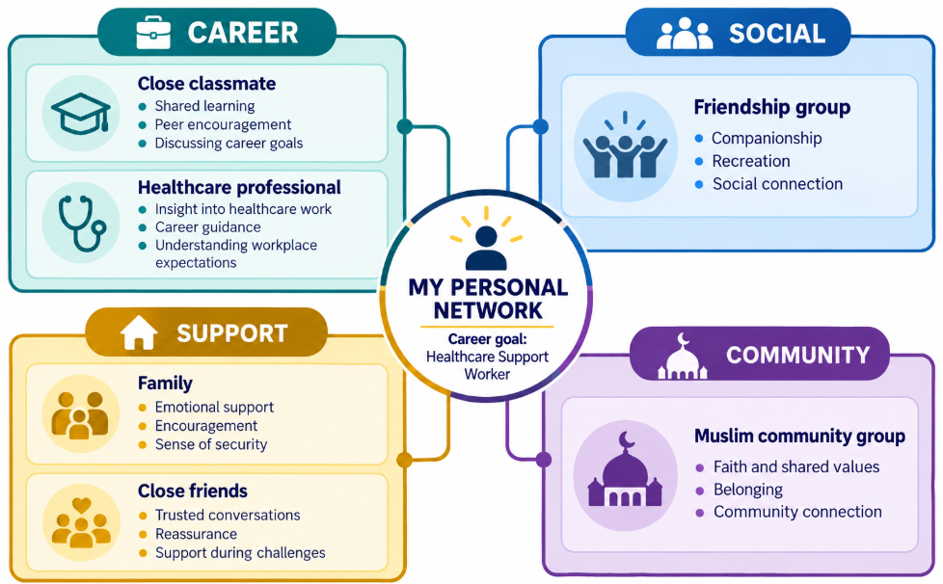

A social network is important because it connects people, bridges geographic gaps, and opens doors to new career, educational, and personal opportunities (Putnam, 2000). My current network is a hybrid one. It consists of close ties and relationships with people in my education, healthcare and religious network. Bonding social capital comes from family and close friends with familiarity and trust. Putnam (2000) draws a distinction between bonding connection, which help strengthen relationships within familiar social groups and bridging connections, which link people across social lines and groups. I have opportunities for social interaction in my social friendship group and opportunities for feeling part of my Muslim community as well as opportunities to go out and engage with people outside my social group in my Muslim community group.
I have one close classmate and one health care professional in my career network. He is a classmate who I can connect with to share learning and career goals. A healthcare contact may be able to provide information about the expectations in the workplace and the role of a healthcare support worker. But this interaction is not necessarily a link of social capital unless the relationship offers access to differences in institutional power or resource (Szreter and Woolcock, 2004).
A glaring concern of my professional life is the lack of size of my network. If I have one health care contact, I would have less options and advice to choose from. In response to this, I will be attending university careers events and meet more people from the wider university community as well as volunteering in care settings. I will also look for tutors’ advice and make suitable professional connections on the internet. These would expand my career network, as well as support me as I moved towards becoming a healthcare support worker.

Task 3 Blog

Beyond the Care Checklist. Meeting the Needs of Older People

They say a meal served isn’t a meal consumed. And not all questions answered are concerns understood. Good care involves checking whether the support provided actually meets an older person’s needs. When working in older people's care, we can only tell part of the story when a task is completed. The quality of the care for the elderly people relies on whether the person feels heard, has meaningful choices and receives support which meets their needs.

Healthcare support workers assist to make care plans a reality. It takes judgement, observation and respectful communication to get this right. Which makes communication a critical pillar for elderly care. For senior citizens, communication is not as straight forward compared to other younger counterparts. Communication is made difficult by hearing loss, visual impairment and memory problems, unfamiliar surroundings. However, the needs of older people must not be considered as a homogeneous group. Therefore, there is a need to be direct but respectful to the other person and minimize distractions while determining the best way to communicate.

One way to do that is to have a list of activities and their description well understood, prior to starting a caregiving activity. This clarity gives opportunity for questions and respectfully check for understanding. The failure to speak does not mean that they agree with you. If someone is not co-operative, they might be frightened, uncomfortable or unable to explain the problem.

Understand the attributes of good care. Inadequate time, competing demands or poor coordination cannot be solved by Compassion. Staff should have clear responsibilities, effective handovers, be supervised, and have confidence that their concerns are heard. When care is consistently rushed, managers must address the underlying pressures. These organisational improvements should ultimately be judged by the difference they make to residents’ everyday experiences.

The key question is: did the support meet this person’s needs, respect their choices and preserve their dignity? Asking this throughout each shift helps staff assess whether their actions are making a meaningful difference and keeps individual wellbeing at the centre of care.

Task 4 Equality and Diversity Quiz

- The plan focus lies on addressing discrimination and inequitable workforce experiences, ensuring that the NHS is a place where staff are valued, included and can progress. The six impact actions are linked to fair employment and staff retention and improved patient care (NHS England, 2023a).

- The plan demands that organisations undertake equal pay analysis, that they have a plan for equal pay improvement that is monitored to the board and that they put in place the recommendations contained in the Mend the Gap, such as effective flexible working. Progress is proposed to be measured by the annual reduction in pay gaps (NHS England, 2023a).

- Intersectionality acknowledges that factors like race, sex and disability work together to create experiences of disadvantage that are not always apparent when considered individually. The analysis of Crenshaw (1989) elucidates the need for studying discrimination in one category not missing the experience of people who may be facing overlapping inequalities.

- Psychological safety enables staff to ask questions, acknowledge mistakes and raise concerns without fear of humiliation or punishment. This helps them to learn, work effectively with other staff and to spot problems for patients early (NHS England, n.d.).

- The plan seeks to provide full induction, pastoral support and equal opportunities for training and promotion. These will support international recruits to settle into employment and develop their potential (NHS England, 2023b).

- Chief executives, chair and board members should have measurable goals for EDI and be individually and collectively held accountable for delivery. In that regard, they cultivate an inclusive approach and ensure fairness is embedded as a part of the organisation's culture and decision making (NHS England, 2023a).

- The plan needs to include regular effective wellbeing conversations between managers and staff to identify needs and support appropriate responses. This is as part of its broader work on workforce health inequalities (NHS England, 2023a).

- Analysing workforce data can highlight inequalities which an overall average might fail to show, such as pay disparity or progression or if someone has experienced bullying. It can be used to direct interventions and to measure if outcomes are improved for different groups of staff (NHS England, 2023a; 2023b).

- Flexibility can overcome the barriers faced by employees who wish to combine working and caring for others, disability or religious requirements. NHS Employers (2024) highlights measuring policies for differential impact and not having access to flexibility is not an exclusion in itself.

- Organisations should review the information on bullying and harassment by protected characteristic, establish a target to reduce bullying and harassment and put in place a plan to achieve that. This allows prevention to be measured, and enables identifying populations that are disproportionately impacted (NHS England, 2023b).

Task 5 A Letter to My Younger Self
Dear Younger Me,
Looking back at your childhood, I wish I could sit beside you during the difficult moments and remind you that you do not have to understand everything immediately. When your wellbeing feels low, struggling does not mean you are weak or incapable. It means something needs attention, kindness and support.
Over the course of my life and career development, I have come to learn that the first step in emotional intelligence is to identify my emotions. While I understand that sometimes it can be easier to deny sadness, frustration or worry, I would hope that you would stop and use language to describe the emotion. What did happen, what you need and whether or not your initial interpretation gives you a full picture? Being aware of your emotions enables you to act in a considered manner, instead of reacting to distress.
I would also want to remind you that others might not be able to see what you're going through. Talk to trusted adult like a family member, close friend or teacher. It is not necessary to have the words right. It is okay if there are no words to describe what you are feeling or going through. In those moments, you can always begin with “I am having a difficult time” and it is my believe that the family member would help you understand the emotion and the situation better.
Resilience would have enabled you to learn that one difficult time does not make the rest of your life. I see resilience now as “adapting, looking for support, taking small steps when life gets tough. Space in your life should be devoted to rest, familiarity, enjoyment of those around you and your favourite activities.
I can't guarantee that all the problems will go away fast. I will be more understanding towards your feelings. Be patient with yourself, accept support and allow yourself to grow at your own pace. You should feel the same compassion towards others that you hope you can show them.
With care,
Your Older Self

Task 6 Career Development Gantt Chart
Figure 2 Proposed timeline towards employment as a Healthcare Support Worker
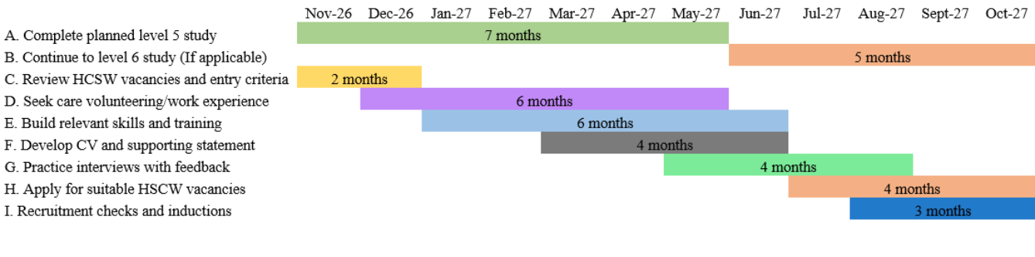

Task 7 Managing Change in a Care Home

Introduction
As a care home manager, I would implement a scheme of a personalised communication and companionship programme to ease the social isolation of residents. The programme would offer meaningful interactions based on individual preferences, recognising NICE’s (2013) emphasis on meaningful activity and maintaining personal identity in care homes.
Planning and Implementation
In Weeks one and two I would be asking residents, relatives and staff what their communication preferences were, their interests and current relationships. A small provision would be provided for each person who agrees to be part of the scheme, containing an outline of what they would like to do, what they would like to say and at what time, or time of day, they would like to do it, along with any other accessibility needs they may have, and who they would like to interact with.
From the third to sixth week, I would run the programme with a small number. Each consenting resident would receive a brief companionship plan covering preferred activities, suitable conversation times, accessibility needs and people they wish to contact. Participation would be voluntary and residents would be free to refuse or adopt different activities.
I would use NHS England (2018) Change Model to set out a clear purpose, engage staff and track progress. A weekly review would look at participation not just increased attendance, residents feedback and staff workload. Findings would inform changes prior to broader implementation.

Skills Required
The task requires communication and active listening skills to grasp the will of the residents, and leadership and organisational skills to ensure that delivery takes place. I would find emotional intelligence helpful should I receive any distress and conflict resolution skills would be helpful when discussing competing responsibilities. Staff will also be made aware of consent, confidentiality and professional boundaries.
Barriers and Solutions
One key challenge is staff resistance. Staff might consider the programme as extra work. To address this issue, I would ensure that they are involved in creating manageable routines, ensuring agreed time and reviewing staffing pressures and not just adding jobs.
In addition, some residents may be unable to participate in communication. I would direct the staff to make adjustments to activities, with the use of visual cues, quieter areas and residents' preferred languages and, where necessary, referring for specialist advice.
Moreover, activities may be limited due to lack of resources. In that regard, I would look to build on existing materials and carefully planned community partnerships, as this is supported by NHS England (2023c) when they talk about meaningful activities and community connections.
Conclusion
Overall, the programme would see companionship planned for within care. It would be successful if residents chose to use it, and if staff and regular checks are made on the meaningfulness of interactions.

References
Bandura, A. (1997) Self-efficacy: The exercise of control. New York: W.H. Freeman.
Crenshaw, K. (1989) ‘Demarginalizing the intersection of race and sex: A Black feminist critique of antidiscrimination doctrine, feminist theory and antiracist politics’. Available at: https://scholarship.law.columbia.edu/faculty_scholarship/3007/
Goffman, E. (1959) The presentation of self in everyday life. New York: Doubleday.
National Institute for Health and Care Excellence (NICE) (2013) Mental wellbeing of older people in care homes. Quality standard QS50. Available at: https://www.nice.org.uk/guidance/qs50
NHS Employers (2024) Guidance on reviewing flexible working policies. Available at: https://www.nhsemployers.org/system/files/2024-11/guidance-on-reviewing-flexible-working-policies-2870.pdf
NHS England (2018) The Change Model Guide. Available at: https://www.england.nhs.uk/wp-content/uploads/2018/04/change-model-guide-v5.pdf
NHS England (2023a) NHS equality, diversity, and inclusion improvement plan. Available at: https://www.england.nhs.uk/wp-content/uploads/2023/06/B2044_NHS_EDI_Workforce_Plan.pdf
NHS England (2023b) NHS equality, diversity and inclusion improvement plan actions. Available at: https://www.england.nhs.uk/long-read/nhs-equality-diversity-and-inclusion-improvement-plan-actions/
NHS England (2023c) Providing proactive care for people living in care homes: Enhanced health in care homes framework. Available at: https://www.england.nhs.uk/long-read/providing-proactive-care-for-people-living-in-care-homes-enhanced-health-in-care-homes-framework/
NHS England (n.d.) Improving patient safety culture: A practical guide. Available at: https://www.england.nhs.uk/long-read/improving-patient-safety-culture-a-practical-guide/
Putnam, R.D. (2000) Bowling alone: The collapse and revival of American community. New York: Simon & Schuster.
Szreter, S. and Woolcock, M. (2004) ‘Health by association? Social capital, social theory, and the political economy of public health’, International Journal of Epidemiology, 33(4), pp. 650–667.

