Title- Contemporary Developments in Employment Relations
Course Title/Module: Post Graduate Diploma in Human Resources Management
Name-Caru Hopkins
CIPD Member Number-1080594

Question 1)
  - What is meant by Employee Relations? Employee relations which was previously known as industrial relations, is concerned with the contractual, emotional, physical and practical relationship between employer and employee. The term employee relations is increasingly used due to recognition of the fact that much of the relationship is actually non-industrial. As discussed on the CIPD website (2019) Employee relations has replaced industrial relations as the term for defining the relationship between employers and employees. Today, employee relations is seen as focusing on both individual and collective relationships in the workplace, with an increasing emphasis on helping line managers establish trust-based relationships with employees. A positive climate of employee relations - with high levels of employee involvement, commitment and engagement - can improve business outcomes as well as contribute to employees' well-being. Indeterminacy of employment relations is that it is Moveable, Ever changing, Fluidity and Not set in stone. Employment relations are a corner stone of any worthwhile company. To ensure organisations get the most from their employees it is advisable that they ensure they have strong and reliable employment relations. Strong employee relationships makes the staff feel valued and appreciated. To distinguish between labour and labour power is to analysis the changing relationships of the employer and employee. Employees are now buying themselves more labour power, which is their capacity to do the job. To sell yourself to the employer is to take ownership of yourself and the power you will bring to the company. Labour on the other hand is the work itself. Many employees can be capable of the labour however that can be overshadowed if they do not have the labour power. Some factors which would impact the relations are such things as bad employee relations-if staff do not feel valued or are over-worked they are more likely to either call into work, get signed off with stress or go into work however not performing to their highest ability, therefore being half-hearted in the work they do. The impact this would then have could be that the employees decide to take industrial action. Industrial action is when workers either go on strike or take other action, like refusing to work over their contracted hours which is known as “action short of a strike”. Industrial Action tends to happen when the union members are in dispute with their employers, and these disputes cannot be solved through negotiations. An example of work conflict within a large organisation is Royal Mail’s ongoing conflict with the Unions. Along with the pension dispute, they include reviewing an agreement put in place when Royal Mail was privatised that rules out things like zero hours contracts and selling parts of the business, Royal Mail (2019).

  - There are two main approaches to employee relations, those being; Unitarist and Pluralist. A managerialist stance which assumes that everyone in an organization is a member of a team with a common purpose and tend to see organisations as one big family. This approach is all about profit, and believes that the conflict must be held back and/or prevented. The other is Pluralist. This approach believes that organisations contain a variety of groups each seeking to maximize their share of profit. They argue that the conflict and sharing of these ideas are legitimate. Alan Fox’s (1966) argument was against the Unitarist approach, it states it simply teaches that there is only one interest and focus of loyalty in the workplace, when in fact ogranisations are made up of a number. He goes on to say that the unitarist approach can resemble a football team in that it encourages and promotes strong team spirit, with all of them working towards a common goal. The Unitarist approach implies that what’s good for the organisation is good for the employees. The Pluralist approach is the opposing view that what is an advantage for the organisation tends to have a disadvantage to the employees. The pros and cons of both approaches are set out in the below table:

Table 1, Pros and Cons of Untarism
Pros | Cons
The team works together by being integrated | Ignore the diversity of beliefs and opinions of staff
Focus is largely on the leadership and management | The managers tend to be controlling
Charismatic Leaders | Create a culture whereby they promote the command and control approach

Table 2, Pros and Cons of Pluralism
Pros | Cons
Exchange of ideas and healthy criticism | Difficult to manage and govern
Keep their own opinions | Possible hostility amongst members
High tolerance of each other

  - There are many other factors that may impact employment relations such as Management Styles, the attitudes of management, employee voice and culture of the organisation. The generations are also having an impact on employment relations, the younger the workforce is getting and therefore they are expecting more than previous generations. AI is also a factor on impacting employment relations.

Question 2)
2.1- As discussed on the GOV.co.uk website (2019); all employees have an employment contract with their employer. A contract is an agreement that sets out an employee’s:
- employment conditions
- rights
- responsibilities
- duties
These are called the ‘terms’ of the contract. Employees and employers must stick to a contract until it ends (eg by an employer or employee giving notice or an employee being dismissed) or until the terms are changed (usually by agreement between the employee and employer). Ain order to create a contract of employment there has to be 5 main key stages, those being Offer of Employment, Acceptance of Employment, Intension to create legal relations, Consideration and Certainty. A standard contract of employment would contain the employee’s and company name, their official job title, the salary agreed, their start date, the hours in which they are required to work, details of any overtime that may be required, holiday entitlement along with location and details of any benefits such as pension, healthcare and courtesy car etc. Within an employment contract there are two sets of terms, these are Express and Implied Terms. So the Express terms of a contract would include the above details such:
Table 3, Details of a standard contract- Gov.uk
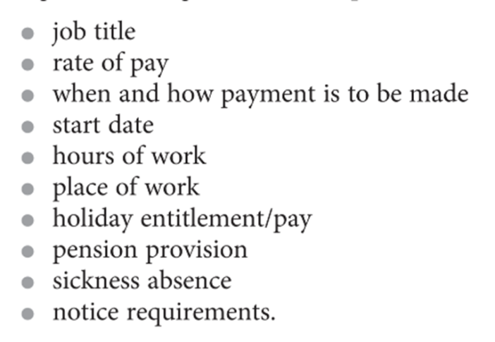
Along with the Express terms there are also Implied terms, implied terms are those that whilst are not written down, they still need to be followed. An example of an implied term is that all employers must legally provide a safe environment for all their employees. Other implied terms are such things as salary, the employer has right to pay their staff at least the minimum working wage along with equality between both males and females in the work place, this is such things as their wages, hours they are expected to work and to ensure there is no discrimination between males and females. The right to a minimum period of notice is also an implied term, whereby the employer cannot end a contract on a whim, the employer is entitled to a realistic notice period in order for them to look for and find new employment. As discussed by Jill Gracey (2017), essential elements of a contract are that employers are required to provide an employee with a written statement of certain terms such as the job title along with a brief description of the role, remuneration and so on.

2.2- There are many sources of employment law, both UK and EU. ACAS is one of the main sources of UK employment relation law-making. ACAS stands for Advisory, Conciliation and Arbitration Service and provides fee and impartial information and advice to employers and employees on all aspects of workplace relations which underpin business success, ACAS (2019). Along with this, they also provide notably high quality training to employers and are recognised as Britain’s leading impartial authority on workplace relationships and effectiveness. It is therefore their job to advise on the constant changes made within law-making such as employee rights, paternity and maternity leave regulations, flexible working and so on.
2.3- Some of the main developments in both individual and employment law are the changes in maternity and paternity leave regulations. Shared Paternal Leave (SPL) came into play in April, 2015. Whereas, prior to this fathers would receive up to 2 weeks of paternity leave after being employed by their company for at least 26 weeks, they are now able to share up to 50 weeks of leave and up to 37 weeks of pay between them and their partners. Mothers are still legally required to take the initial two weeks off after birth to allow for recovery however they can cut their leave short in exchange for shared paternal leave. Another development is the rights that Agency Worker now have.

Question 3)
2.4- Trade unions are groups of employees who join together to maintain and improve their conditions of employment (Unison, 2019) A trade union is considered a very important part of an organisations terms and conditions with many candidates looking for businesses with one in place. The three main Trade Unions throughout the UK are Unite, Unison and GMB. As discussed in Gov.co.uk (2019) a trade union is an organisation with members who are usually workers or employees. It looks after their interests at work by doing things like:
•negotiating agreements with employers on pay and conditions
•discussing big changes like large scale redundancy
•discussing members’ concerns with employers
•going with members to disciplinary and grievance meetings
Due to the developments in both individual and collective employment right, there are many reasons and advantages as to why employees decide to join a union. The advantages for the employees are more support, be it that an employee has been called to an investigation meeting, querying their pay or feels as though they are being targeted or discriminated against. The role of the union is to attend these meetings with the employee to ensure a fair and just meeting takes place. They also feel that they will receive better terms and conditions if they are part of a union with such things as 0 hour contracts being fought against. If an employee decides to take on the role as trade union representative they will be entitled to and provided with full training. They will receive a reasonable amount of time off, fully paid to attend courses required. One of the main reasons why employees tend to join a trade union is for the feeling of security. Being a part of a union is also having someone there to look over contracts of employment, terms and conditions and so forth.

There are however reasons as to why employees do not wish to join the unions or feel disadvantaged once they have joined. One of the disadvantages is that each employee has to pay a fee to be a part of the union; it is not a free of charge service. And whilst the support that comes with a Union guarantees a feeling of security, there are circumstances whereby an employee does not want to strike but feel they have to by being a part of it otherwise they are accused of crossing the picket line, this can then create a negative atmosphere between the employees and their colleagues, therefore leading to them striking in the first instance. This also leads to the feeling of lack of individual control. The employee/s may feel that decisions are being made for them by the union reps and the union as a whole. The table below shows both the advantages and disadvantages for the employer:

Advantages of joining a Trade Union | Disadvantages of joining a Trade Union
Will receive more funding for training | Time off-strike action
The efficiency may improve | Loss of productivity
Employees may work better with the feeling of being safe | Us and them culture being created

The Trade Union Council was established in 1868 and in the last 10 years Industrial action has seen a large decline since it was first established (Statesmen, 2018). In order for a TUC to be introduced into a company, a TUC representative must ask an Organisation to be recognised voluntarily. If the Organisations say’s no they can still apply via Central Arbitration Committee (CAC) if they have more than 21 employees.

Question 4)
3.1- Employee Involvement is whereby managers introduce practices directly with employees to gain their ideas. This is classed as individual, whereby they speak directly to employees on an individual basis such as one-to ones. Employee Participation is classed as collectivism, whereby the employees participate in organisational decision making. And finally Employee partnership is whereby it involves direct employee involvement, including the employers, stakeholders and unions. There are several examples of employee involvement in the workplace. Sometimes they may be missed or forgotten. Some examples are Downward Communication, whereby the flow of information and messages from a higher level inside an organization to a lower one. Newspaper and house journals, many organisations have their own newspapers or newsletters informing the employees of changes to the business. Another is upward problem solving, which is a form of direct employee voice that enables employees to identify work-related issues and concerns, and make suggestions to management that may in turn lead to organizational improvement. These are all forms of voice mechanisms. Employee participation examples would be things such as Works council and European works council. Employee voice or EV as it is known is a form of employee voice and participation. By allowing employees to have their voice heard, it allows them the opportunity to express their concerns and influence the actions of the management. There are many ways by which employees can participate and influence, such examples are: Departmental meetings, whereby employees have monthly departmentals with their manager and peers. This allows a discussion on current affairs and allows the team to discuss any concerns they have with managers. Others are appraisals and one to ones. These meetings are typically held every six months between the employee and their manager where - they discuss the workload and the progression of the employee and set new goals for the next six months and discuss ways in which work can be improved and progression can be made. These forms of two way communication between the employee and employer and vice versa is important for the employee to feel there are having a say in their own progress.
3.2-Within organisations there are both union and non-union forms of employee representation. The form of non-union representative is information and consultant representative who is been selected from the members of subsequent information and consultation body. These representatives have the rights to provide protection against dismissal, whilst not being part of a union. Examples of non-union representations would be health and safety representatives. As discussed by ACAS, Representatives of employee safety appointed in workplaces where no union is recognised, or where groups of workers are outside the scope of union recognition. The representatives are covered by the Health and Safety (Consultation with Employees) Regulations 1996 (2019). Despite not being unionised they would be entitled to the same rights as those who are part of a union such as paid time off to carry out their duties, paid time off for training, the provision of facilities to help them perform their duties, protection against dismissal and detriment. Another form of non-unionised is Pension representatives. These are workplace representatives, elected for the purpose of consultation over charges to pension arrangements. TUPE representatives are another form of non-unionised representation. TUPE stands for Transfer of Undertaking-Protection of Employment. When there are no TU recognised for collective bargaining purposes, non-union employee representatives must be informed and consulted.
The main type of unionised representation within a workplace is the Trade Union. These are in place to fight for the rights of the employee and can undertake the tasks of collective bargaining. Collective bargaining is a process of negotiation between employers and a group of employees aimed at agreements to regulate working salaries, working conditions, benefits, and other aspects of workers' compensation and rights for workers. Processes such as this are important tasks for the TU representative and those non-unionised representatives are associated with employee forums. Companies such as Tata Steel which is unionised hold such things as town hall meetings to discuss issues raised by the union.
3.3- It could be argued that there is a very important link between Employee Voice (EV). As discussed by Taylor (2014), The decline in trade union membership and activism the country has witnessed over 25 years has played an important part, in that new institutional arrangements have been put in place to ensure the employees are protected against unfair treatment and undue health risks while they are at work- for example, this would be in the form of a Health and Safety Rep. A report was produced for ACAS, MacLeod and Clarke’s Concept of Employee Engagement: An Analysis based on the Workplace Employment Relations Study. It was produced by David MacLeod and Nita Clarke in 2009 and reported there is growing evidence that links employee engagement to organisational success and this study of the WERS dataset adds to this. We found that at organisations with higher scores on the enablers of engagement, employers tended to be more positive about both labour productivity and financial performance (2019). ACAS also reports that Employee voice is the key to better productivity. They note how employee voice is linked to higher levels of employee engagement, lower staff turnover and better business outcomes. So therefore it could be argued that employee voice is of great importance to organisation performance. Applebaum et al (2011) reports how by the employees actively informing decision making, the workforce are more motivated and develop higher skills.

Question 5)
4.1- Conflict and misbehaviour at work are not the same thing. The definition of conflict as discussed in ACAS (2019) is Disputes and conflict in the workplace. Conflicts at work take many forms. It might be an individual with a grievance, a problem between an employee and a manager or conflict between two co-workers. However misbehaviour is defined as Action or conduct that is inappropriate, improper, incorrect, or unexpected. Misbehaviour can also be known as a lesser version of sabotage- Can occur on an individual or collective basis. Such behaviours as damaging property such as work laptops, purposely blocking the toilets or misuse of the work laptop for personal use. It can be argued that conflict is in fact essential in some areas as it allows people to question decisions and work towards changes being made. Understanding conflict is more vital than trying to stop it happening altogether. According to Bloisi (2007), “Conflict is a term which means a disagreement between two or more parties as for example, individuals, groups, departments, organizations, countries- who perceive that they incompatible concerns” .
There are two different perspectives when it comes to conflict. Those being Unitarist and Pluarist perspectives. The Unitarist view of conflict vastly differs from those of a Pluralist. Whilst the Unitarists view is that conflict is disruptive, fractual and avoidable, the Pluralist via is that conflict is inherent to within the employee relationship. There are two different types of conflict, Organised and Unorganised. Organised being such things as Strikes such as those organised by the TU, protests and boycotts whereby the employees work together to stop working in order to resolve conflict with the employer. Work- to-rule is another form of organised conflict whereby the employee follows the rules and hours exactly, therefore reducing output and efficiency. (REF) Unorganised forms of conflict are such things a theft from a company whereby employees steal. This can range from stationery to money from the till or hours from the company whereby they fiddle their timesheets or lie about what times they are clocking in and out. Absence is another form of unorganised when the employee extends their duration of sickness in order to delay their return to work, or in some cases lie altogether in order for them not to have to attend at all. There are many sources of conflict which can come from both the situation the employee is in and from the person themselves. The table below discusses two sources of conflict and the reasons behind those conflicts:

Table 4, Sources of conflict
Organisational sources of conflicts | Interpersonal sources of conflict
Competition over scarce resources | Errors made by the individual
Uncertainty over responsibility | Faulty communication and/or lack of understanding
Inter-dependence | Personal characteristics or traits
Reward systems that pit people against one another
Power differentials

Whilst conflict is presumed to be very much Covert, whereby it is plain for all to see there are times when it is also Overt, hidden away. Covert conflict would such things as Work to rules, sabotage, theft, pilfering, absenteeism and slow performance. Hidden conflict can be such things as strikes, boycotts, pickets, sit-ins and bans. These sources of conflict can be done without the input of the trade unions. The types of Industrial conflict are shown in the table below:

Table 5, Forms of Industrial Conflict
Covert Conflict | Overt Conflict
Work to rule | Strikes
Absenteeism | Boycotts
Sabotage | Pickets
Turnover | Sit-ins
Slow Performance | Bans

When there is conflict, it is not just a case of individuals not getting along or having controversial arguments in the workplace. The signs of conflict can vary however some examples are:
- Lack of cooperation, whereby the do not cooperate with their colleagues.
- Rudeness and sarcasm
- Talking behind others back
- Blaming others/passing the buck
- Argumentativeness
- Anger/Intimidation
- Harassment, discrimination and bullying

Official Industrial Action such as strike action is when the strike itself has been authorised by the trade union. This therefore results in the employees being protected against dismissal due to the protection from the union they are a part of. Employees are therefore more inclined to strike against the employers and take a stand for their rights- (SLIDES) Unofficial industrial action however, does not protect the employee from dismissal. They are therefore at risk of dismissal, such action such as unauthorised sit-ins and boycotts could end up in the employees losing their jobs. Both misconduct and misbehaviours can be dealt with on a range from an informal chat, whereby the manager or HR takes the employee to one side and sits down to advise them their behaviour is not acceptable, thereby giving them a chance to redeem themselves to disciplinary whereby the employee is issued with either one or two verbal warnings, followed up with one written, which can stay on the employees record for 6-12 months, which then can lead to dismissal from the company altogether. (THE EMPLOYMENT ACT 2008)

Strike action does not only take place in the UK. European countries also take a stand against employers when they feel they are being unfairly treated in regards to remuneration, working conditions, zero hour contracts and so forth. Below shows which European country strikes the most, the results may surprise you.
Table 6, Where do European workers strike most often?
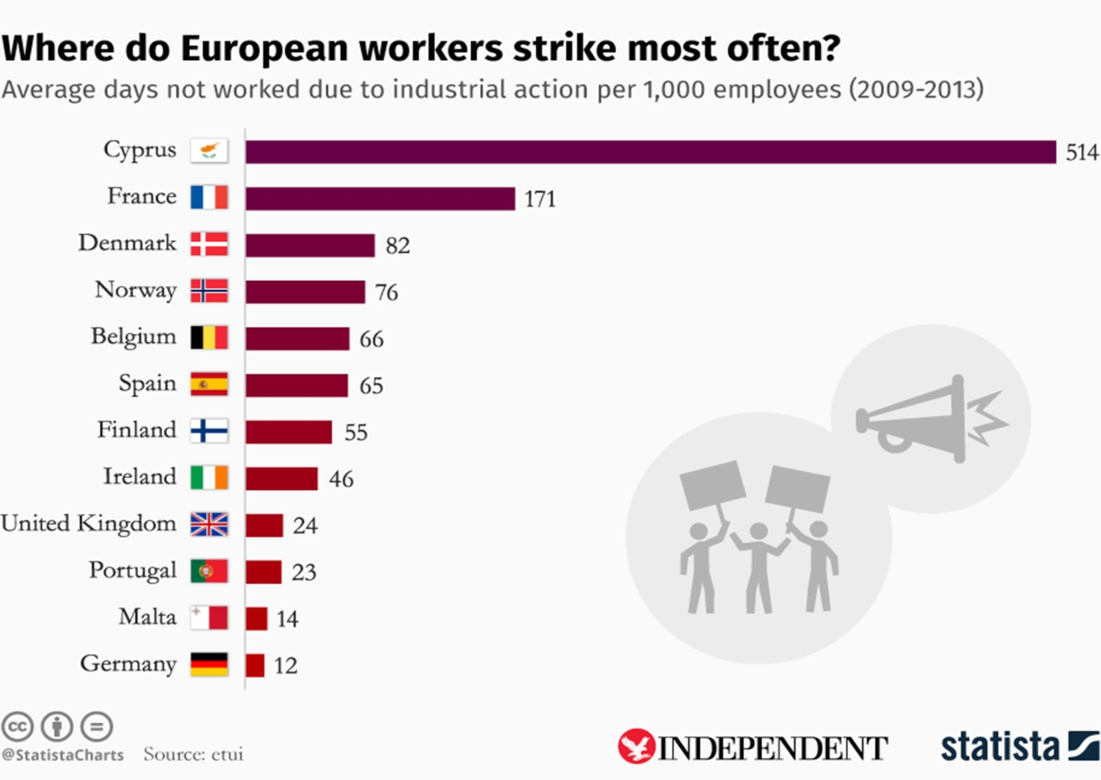

Published photos and videos on news channels of strikers picketing outside factory gates are usually seen as something from the archives. Statistics show an almost perennial decline in formal strikes. In the month of January 2018 there were 9,000 recorded working days lost due to strikes – a tiny fraction of the 3m recorded in January 1979. That number is huge. Despite this however the number of informal strikes has increased with private sector working days being lost from strike action. The figures stood at 231,000.00 working days lost in January 2018. That is 146,000.00more days than in January 2017. Reasons for being such things as zero hour contracts. As discussed in the conversation (2018), workers at a McDonalds UK, went on strike in 2017, in both Cambridge and Crayford, in relation to reduced hours, affecting their ability to make a living wage. This led 96% of union members, numbering around 40, to vote for strike action. Cyprus is at the top of the European list for days lost to striking. France lost days to protests and strikes also, with many of them turning violent. In December 2018, the Yellow Vests looted and set fire to the streets of Paris in response Emmanuel Macron and his economic reforms which affected the poorest workers and pensioners alike. After the spike in violence, Mr Macron offered a package of concessions worth more than 10 billion euros (£8.5b) aimed at boosting the incomes of the poorest workers and pensioners.

Question 6)

When dealing with grievances or disputes in the workplace, it is important that managers are fully equipped in their knowledge and approach in order to ensure the issues are dealt with professionally and without further disruptions. Active listening is an important factor when it comes to dealing with grievances or disputes in the workplace. Managers must ensure they actively listen to the grievance and the employees they affect. The line managers are considered the main “actors” whom deal with these disputes.
ACAS states that Many potential disciplinary and grievance issues can be resolved informally, ACAS (2019), however if they cannot there are polices that must be followed. If the quiet word does not work then the grievance must be investigated then proceed with company procedure, upgrading the line managers skills and mediation. Some advice that can be given to line manager when dealing with conflict at work is to follow best practice. An informal conversation would be helpful to all involved. And if that does not solve the issue then it would be advisable to refer the line manager and employee to policy/ either the organisations policies or ACAS. This would inform them of the steps to follow. To advise all parties involved of the perimeters of what’s expected, such as mutual respect between all individuals, the non-bullying policies and remind them of the core values of the company and expectations. Another idea could be either coaching by the line manager themselves or encouraging staff members to coach each other. By asking them what they think would be the best thing to do. Possibly provide a buddying up system or send employees on coaching courses/qualifications. To guide and/or mentor could be a possibility. Regular communication and ensure the line manager is fully supported on the process. Another suggestion is to possibly set up surgeries on how to advise, coach and guide. Line managers can attend surgeries on the skills for effective grievance and dispute handling procedures.

Whilst mediation, conciliation and arbitration are all options for managers and employees in dealing with work conflict, it is important to distinguish between the three in order to obtain the best results. As discussed in ACAS (2019) medication is whereby both parties seek to rebuild and repair an employment relationship through an impartial and independent intermediary. Mediation is informal and not usually legally binding. It's confidential and both parties enter into it voluntarily. Conciliation essentially operates in the same way as mediation, except it is used where a complaint about employment rights has been made to an employment tribunal. And finally, Arbitration. Arbitration is a little different from the other two in that the impartial third party is asked to make a decision on a dispute. The two sides present evidence to an arbitrator, who makes a decision that they have agreed in advance to abide by. In this way, it can be seen as a confidential alternative to a tribunal or court of law. As with the mediation and conciliation, arbitration is voluntary. The usefulness of all three of these are that they are voluntary, therefore the employees are not being coerced into attending and are giving the indication that they are willing participants. Mediation is useful as whilst it is not informal, it takes the pressure of all involved to have an open and honesty chat. Arbitration however is more formal and the arbitrator is required to make the decision, this is useful as it means no one will be required to attend a tribunal.

Word Count

Reference
Taking part in industrial action and strikes (Online) Available at: https://www.gov.uk/industrial-action-strikes Accessed 14 March 2019
Royal Mail facing threat of strike action as union vows to fight for workers job security (Online) Available at: https://www.mirror.co.uk/news/royal-mail-facing-threat-strike-10385738 Accessed 14 March 2019
Essentials of an Employment Contract (Online) Available at: https://www.legal-island.com/articles/uk/features/basics/mar/sept/essentials-of-an-employment-contract/ Accessed 13 March 2019
Contracts of Employment (Online) Available at: https://www.cipd.co.uk/knowledge/fundamentals/emp-law/terms-conditions/contracts-factsheet Accessed 12 March 2019
Joining a Trade Union (Online) Available at: https://www.gov.uk/join-trade-union Accessed 9 March 2019
Non-Union Representation in the Workplace (Online) Available at: http://m.acas.org.uk/media/pdf/9/o/Non-union-representation-in-the-workplace-advisory-booklet.pdf Accessed 9 March 2019
Employment Markets and Regulations in Resourcing and Talent Management,2014, Taylor. S, London, Chartered Institute of Personnel and Development.
MacLeod and Clarke’s Concept of Employee Engagement: An Analysis based on the Workplace Employment Relations Study (Online) Available at: http://www.acas.org.uk/media/pdf/7/6/08140-MacLeod-Clarkes-Concept-of-Employee-Engagement.pdf Accessed 7 March 2019
Disputes and conflict in the workplace(Online) Available at: http://www.acas.org.uk/index.aspx?articleid=1662 Accessed 12 March 2019
Don’t blame trade unions for their declining membership (Online) Available at: https://www.newstatesman.com/politics/staggers/2018/06/don-t-blame-trade-unions-their-declining-membership Accessed 12 March 2019
About trade unions (Online) Available at: https://www.unison.org.uk/about/what-we-do/about-trade-unions/ Accessed 12 March 2019
Employee Voice (Online) Available at: https://www.cipd.co.uk/knowledge/fundamentals/relations/communication/voice-factsheet Accessed 17 March 2019
Employee relations: an introduction (Online) Available at: https://www.cipd.co.uk/knowledge/fundamentals/relations/employees/factsheet Accessed 1 March 2019
(Online) Available at: file:///C:/Users/Caru/Downloads/Non-union-representation-in-the-workplace-advisory-booklet.pdf Accessed 1 March 2019
New Task Force for employee engagement (Online) Available at: https://www.gov.uk/government/news/new-task-force-for-employee-engagement Accessed 1 March 2019
Employee voice is the key to better productivity (Online) Available at: http://www.acas.org.uk/index.aspx?articleid=5640 Accessed 1 March 2019
file:///C:/Users/Caru/Downloads/Building-productivity-in-the-uk.pdf Accessed 2 March 2019
The European countries that strike the most (Online) Available at: https://www.independent.co.uk/news/world/europe/the-european-countries-that-strike-the-most-french-strikes-industrial-action-map-a7063926.html Accessed 2 March 2019
New styles of strikes and protest are emerging in the UK (Online) Available at: http://theconversation.com/new-styles-of-strikes-and-protest-are-emerging-in-the-uk-94528 Accessed 2 March 2019
How striking McDonald’s workers are taking on the fast food giant (Online) Available at: https://theconversation.com/how-striking-mcdonalds-workers-are-taking-on-the-fast-food-giant-83260 Accessed 3 March 2019
Discipline and grievance - Acas Code of Practice (Online) Available at: http://www.acas.org.uk/index.aspx?articleid=2174 Accessed 18 March 2019
Mediation, conciliation, arbitration: What's the difference? (Online) Available at: http://www.acas.org.uk/index.aspx?articleid=4130 Accessed 18 March 2019

