University of Wales Trinity Saint David

Motorsport Engineering

Contemporary Powertrain

ACHA6006

Analytical Assessment Of Engine Internal Components

William Hare

2219871

Contents
Introduction 3
Methodology 3
Force Calculations 3
Kinematic Analysis 3
Inertia Force 4
Gas and Net Force 4
Stress and Fatigue 4
Results 5
Original 5
At 9000 RPM 7
Material Comparison 9
Connecting Rod 9
Gudgeon Pin 9
Connecting Rod Bolt 9
Discussion 10
Increased Engine Speed 10
Connecting Rod 10
Gudgeon Pin 10
Connecting Rod Bolts 10
Material Selection 11
Enhancing Fatigue Resistance 11
Conclusion 12
References 13

Introduction
This report analyses the forces experienced by components of the Ford 1.6 Sigma engine during its operating cycle. By applying pressure data and kinematic equations, the stresses and fatigue safety factors of the connecting rod, gudgeon pin, and conrod bolts will be assessed. Understanding these loads is crucial for optimizing component design, preventing premature failure, and avoiding unnecessary over-engineering (Jaggi, 2022). Additionally, extrapolating data to 9000 RPM will assess the impact of increased engine speeds on durability, followed by a redesign to restore or enhance safety margins. The study aims to provide a quantitative engineering justification for structural considerations in high-performance engine design.

Methodology
This report will make use of an excel spreadsheet of pressure data from 1000 RPM to 6000 RPM with pressure values across 720 degrees of crank angle. In addition to the pressure data, engine specifications were also provided for use along with specifications of the components.

Force Calculations
To determine the forces on the piston and connecting rod assembly, the piston motion must first be found using the crank angle in degrees (CA) along with the connecting rod radius (R) and length (L) (Ge, 2022). Piston motion refers to its reciprocating movement inside a cylinder (Desnica, 2014). From this, the crankshaft's angular velocity is calculated by multiplying the engine RPM by π and dividing by 30, yielding the crank angle in radians per second (Palacin, 2021). Radians per second is preferred over RPM as it is a direct SI unit, simplifying calculations (Prata, 2000).

Kinematic Analysis
Using the angular velocity of the crankshaft, the velocity and acceleration of the piston at various crank angles are determined using kinematic equations. With the engine RPM, the angular velocity of the crankshaft can be determined in radians per second. The piston velocity equation which is needed to find the acceleration is given by:
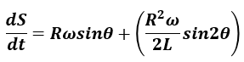
(Figure 1. Velocity Equation)

Where:
- R is the crank radius
- ω is the angular velocity of the crank shaft
- ϴ is the crank angle in radians
- L is the length of the con rod
It is found by differentiating displacement with respect to time. Similarly, the acceleration of the piston is determined by differentiating velocity with respect to time. The piston acceleration can be seen below:
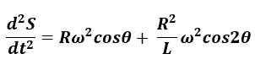
(Figure 2. Acceleration Equation)

Inertia Force
Inertia force is the force that arises due to the resistance of a body to a change in its state of motion, as described by Newton’s First and Second Laws of Motion (Qian, 2021). It is a fictitious force that appears when analysing motion from an accelerating reference frame (Zhang, 2009). It appears as:
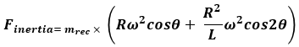
(Figure 3. Inertia Force)

It shows the acceleration equation multiplied by the reciprocating mass. When analysing a connecting rod in an internal combustion engine, inertia forces play a crucial role in determining the stress of the component (Holst, 1924). In the case of this report, the inertia force is used alongside the gas force to calculate the net force acting on the components.

Gas and Net Force
The gas forces acting on the piston are calculated using cylinder pressure data. The force due to gas pressure is given by:
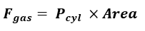
(Figure 4. Gas Force)
Where:
- P is the cylinder pressure in pascals (Bar x10⁵),
- is the piston crown area ($A=π{bore}^{2}/4)$.
The gas force in a connecting rod comes from the combustion pressure acting on the piston head inside an engine cylinder. This force plays a crucial role in power generation, stress analysis (Muhammad, 2019).
The net force is the subtraction of the gas force from the inertia force. Net force is the total force acting on an object after all individual forces are combined. It determines an object's acceleration and overall motion (Haider, 2018).

Stress and Fatigue
The equations provided below relate to the fatigue analysis and failure criteria for mechanical components subjected to cyclic loading. The equations are:

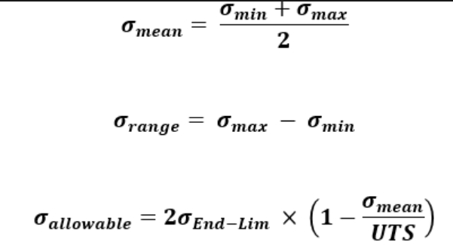
(Figure 5. Calculated Stresses)

The image shows equations for mean, range, and allowable stresses, crucial for calculating a component's safety factor. Mean stress is the average stress over a full load cycle, used in fatigue analysis to assess fluctuating load effects (Dowling, 2004). Range stress, the difference between maximum and minimum stress, indicates the severity of cyclic loading (Srawley, 1976). Allowable stress is the maximum a component can endure before fatigue failure, helping in design to avoid failure (Sonsino, 2009). The fatigue safety factor, found by dividing allowable stress by range stress, ensures components can withstand cyclic loading, a primary cause of engine failure (Marrey, 2018).

Results
The results provide key insights into the structural behavior of Ford 1.6 Sigma components. By calculating forces, stresses, and fatigue safety factors, we assess their mechanical integrity. Extending RPM to 9000 highlights the impact of higher speeds on longevity and necessary design modifications for reliability. These findings ensure an optimal balance between durability and efficiency, aligning with the research objectives.
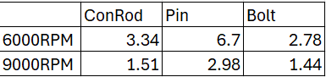
(Figure 6. Fatigue Safety Factors)

Table one shows the fatigue safety factors of the original study compared to the safety factors of the altered studies. Originally taken at 6000RPM, the safety factors are higher compared to that of the test conducted at 9000RPM.

Original
In the Goodman diagram, the x-axis represents mean stress, and the y-axis shows alternating stress. The red Goodman line indicates the failure limit based on Ultimate Tensile Strength (UTS), with points above it signifying failure. The blue line (Upper Endurance Limit) marks the safe operating limit for fatigue resistance. A dashed black line outlines the component's UTS, while the yellow vertical bar represents the actual operating stress conditions.

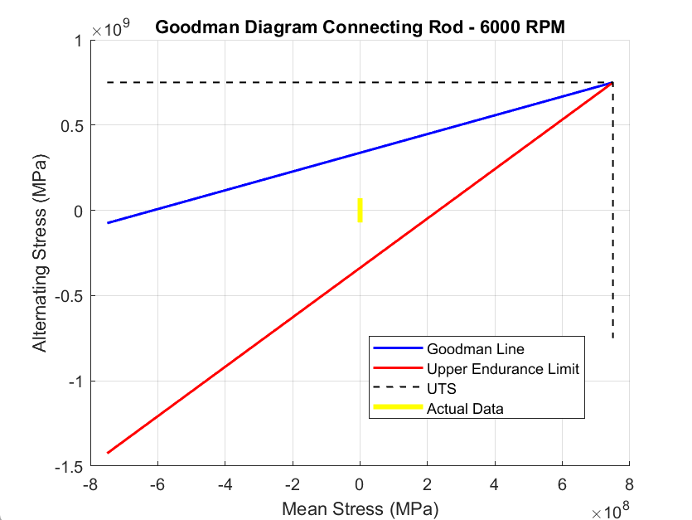
(Figure 7. Conrod Goodman Diagram)

The rod is well within the safe region, indicating no risk of fatigue failure. Its UTS of 750 MPa is shown by the black dotted line on the diagram. The actual range falls in the negative mean stress region, meaning it experiences primarily compressive loads. With a safety factor (SF) of 3.34, the alternating stress is 3.34 times lower than the fatigue failure limit per the Goodman criterion. This SF (typically 2–4 for fatigue applications) suggests a well-balanced design, ensuring durability while minimizing excess material use (Parkash, 2013).
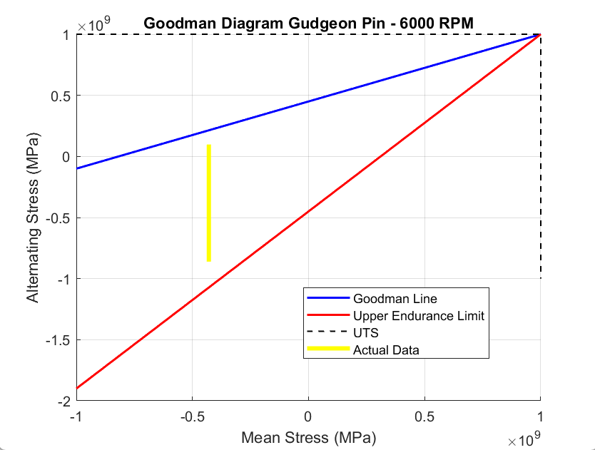
(Figure 8. Pin Goodman Diagram)

The pin is well within the safe region, indicating no risk of fatigue failure. Its UTS of 1000 MPa is shown by the black dotted line on the diagram. The actual range falls in the negative mean stress region, meaning the gudgeon pin experiences primarily compressive loads. With a safety factor (SF) of 6.7, the operating stress is 6.7 times lower than the allowable limit per the Goodman criterion. While this high SF ensures reliability and longevity (Leira, 2005), it may also suggest potential for weight reduction or material optimization.

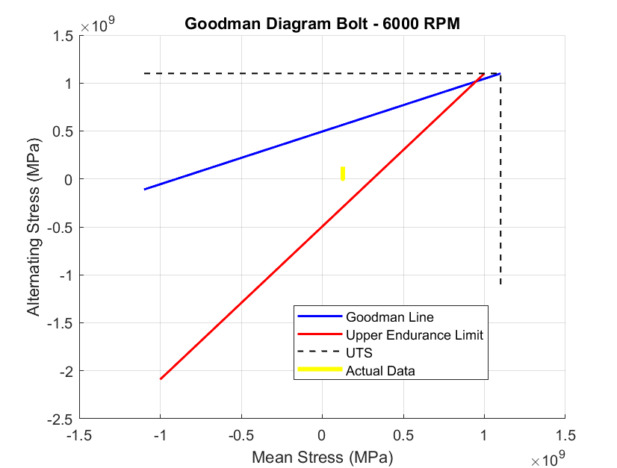
(Figure 9. Bolt Goodman Diagram)

The bolt is well within the safe region, indicating no risk of fatigue failure. Its UTS of 1100 MPa is shown by the black dotted line on the diagram. The actual data (yellow vertical bar) lies in the positive mean stress region, meaning the bolt experiences both tensile mean stress and alternating stress. With a short yellow range, the alternating stress is relatively low compared to the mean stress, which is typical for bolts, as they mainly experience preload tension with minor cyclic variations (Patterson, 1990).

At 9000 RPM

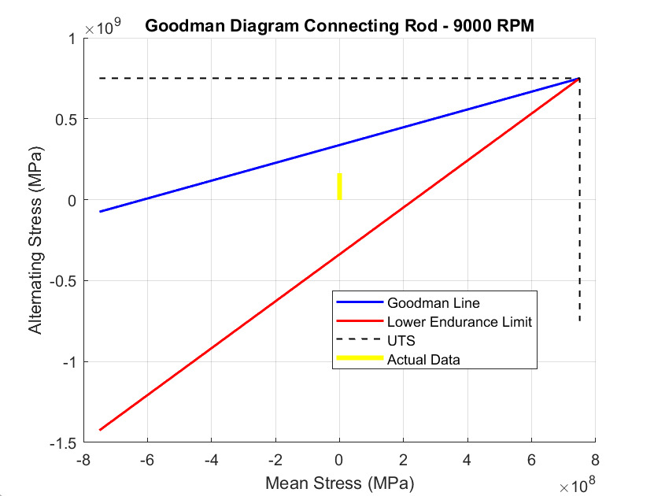
(Figure 10. Conrod Goodman Diagram)

With the increase to 9000 RPM, the alternating stress on the connecting rod has risen, causing the data range on the Goodman diagram to shift upward, nearing the Goodman failure line. A safety factor of 1.51 indicates the component is closer to its fatigue limit, meaning additional loading, material imperfections, or stress concentrations could lead to premature failure (Wei, 2021). This suggests the connecting rod is at higher risk of fatigue failure at 9000 RPM, and a redesign with a stronger material or larger cross-section may be necessary for durability (Cecchel, 2022).
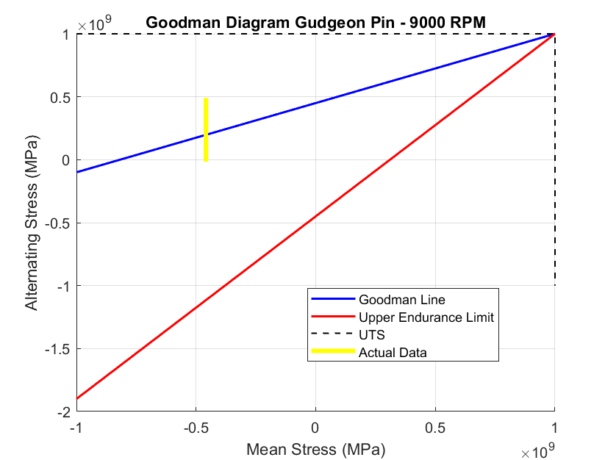
(Figure 11. Pin Goodman Diagram)

For the gudgeon pin, increased RPM has raised the alternating stress, with some of the range now above the Goodman line (upper endurance limit). The yellow line being above the blue line indicates the alternating stress exceeds the endurance limit, meaning the component won't have infinite fatigue life but may survive a limited number of cycles (Tang, 2024). If cycles are too high, fatigue failure could occur, making life estimation necessary (Toasa Caiza, 2022). With a safety factor of 2.98, the gudgeon pin is still in a reasonable fatigue-safe range, though its margin has decreased from an SF of 6.7 at 6000 RPM. While failure isn't imminent, prolonged operation at 9000 RPM could lead to accelerated wear, requiring monitoring and possible design optimization for high-speed durability (Kashyzadeh, 2025).

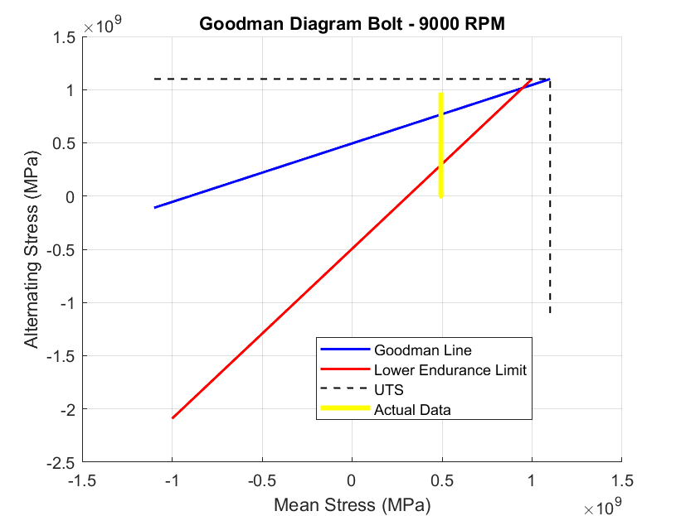
(Figure 12. Bolt Goodman Diagram)

From figure 12, the bolt is subjected to stresses exceeding both the upper and lower endurance limits, suggesting potential failure within a finite number of cycles due to cyclic loading (Mao, 2022). The bolt's safety factor drops to 1.44, placing it near the failure boundary on the Goodman diagram. The increased alternating stress at 9000 RPM moves the data close to, and even above, the Goodman failure line, indicating a high risk of fatigue failure. With such a low SF, there is little margin for error. A higher-strength material or increased preload may be necessary to prevent failure at high speeds (Jiang, 2022).

Material Comparison
The material choice for components is crucial in balancing strength, weight, and fatigue resistance. Aluminium, with a UTS of 470 MPa and an endurance limit of 40%, is lightweight, improving engine efficiency but offers lower strength and fatigue resistance, suitable for high-revving, low-stress applications (Tawfik, 2021). Steel, with a UTS of 1100 MPa and an endurance limit of 50%, balances strength, durability, and cost, making it ideal for general-purpose and high-performance engines (Francis, 2021). Titanium, with a UTS of 1400 MPa and an endurance limit of 50%, provides the best strength-to-weight ratio, enhancing performance in extreme applications at a higher cost (Han, 2023).

Connecting Rod

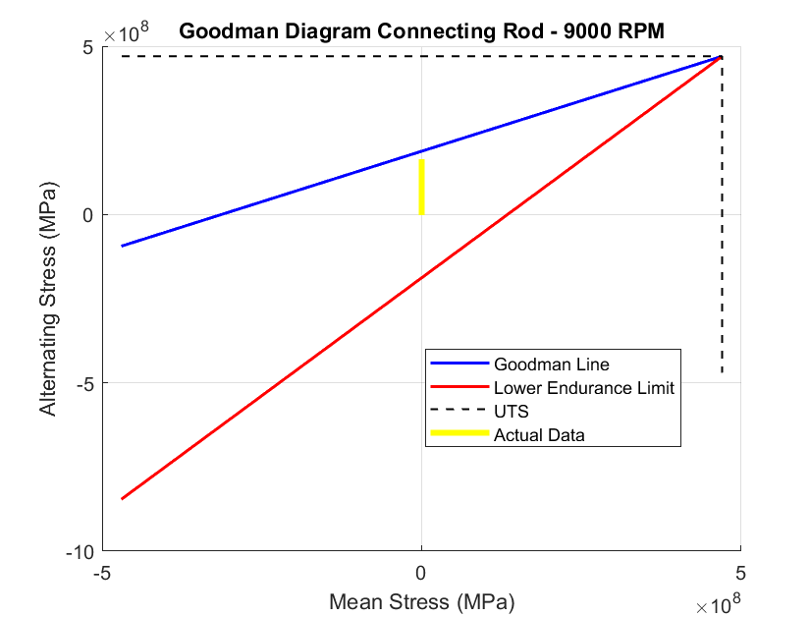 | 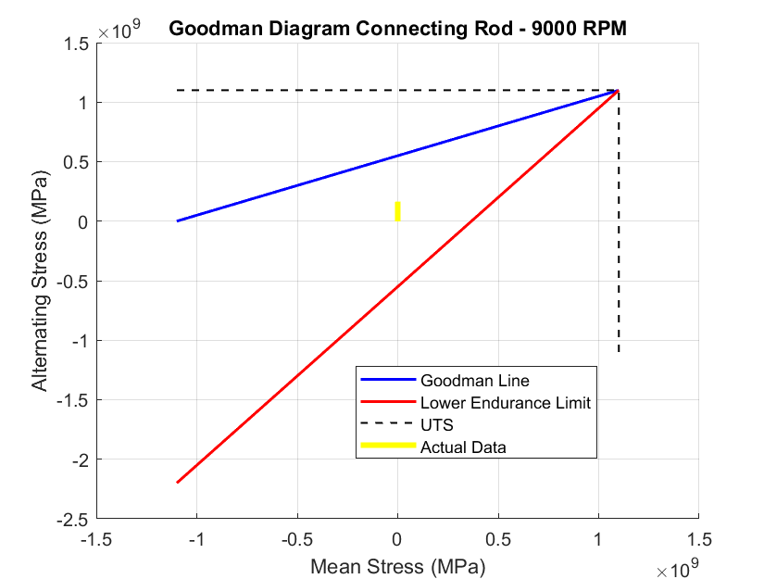 | 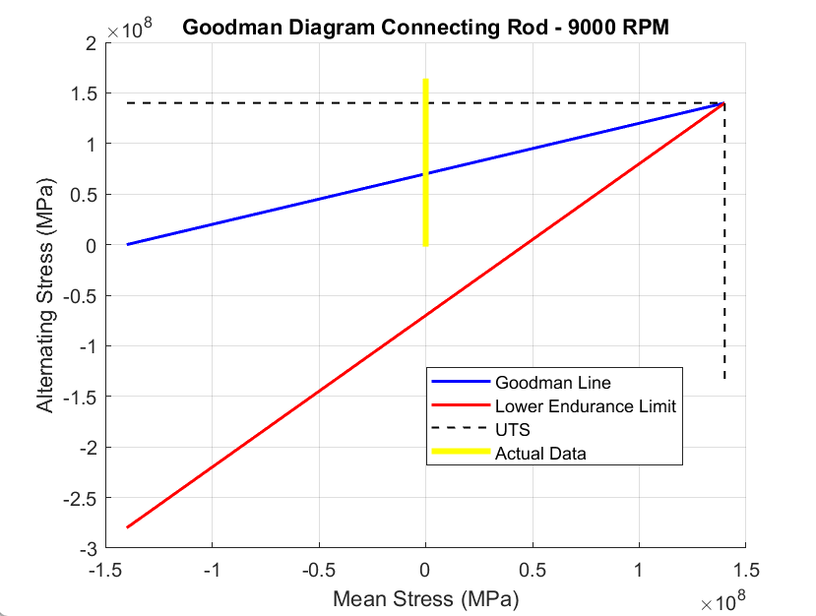  (Figure 13. Conrod Goodman Diagrams for Aluminium, Steel and Titanium respectively)

Gudgeon Pin
(Figure 14. Pin Goodman Diagrams for Aluminium, Steel and Titanium respectively)
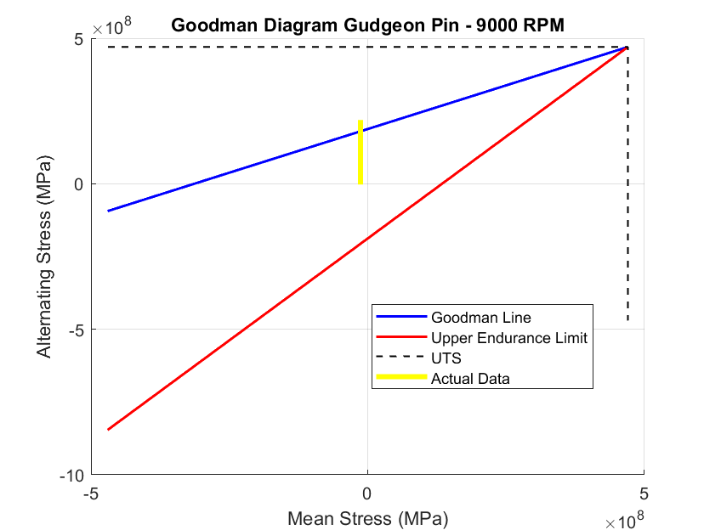 | 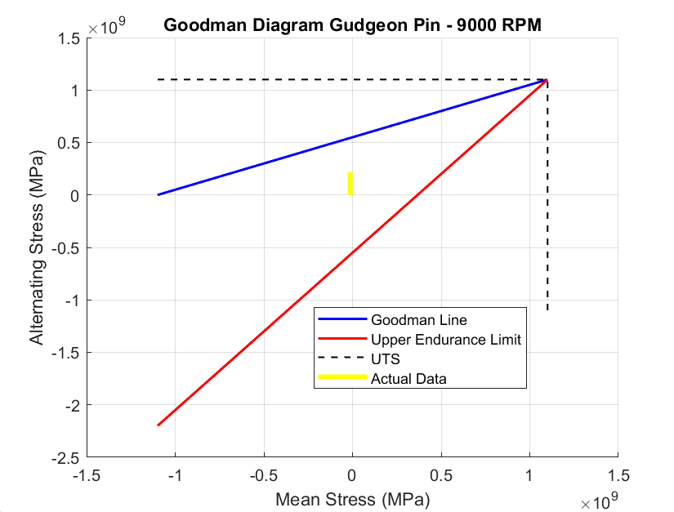 | 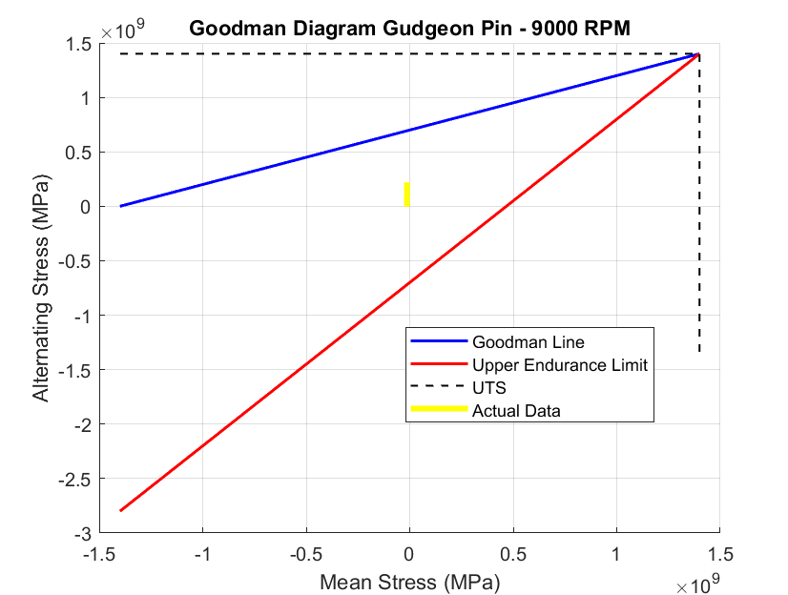

Connecting Rod Bolt
(Figure 15. Bolt Goodman Diagrams for Aluminium, Steel and Titanium respectively)
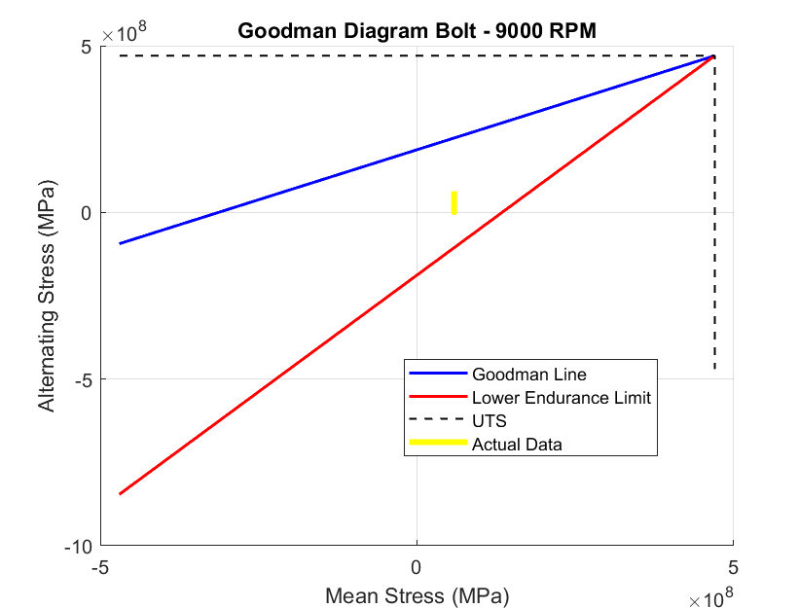 | 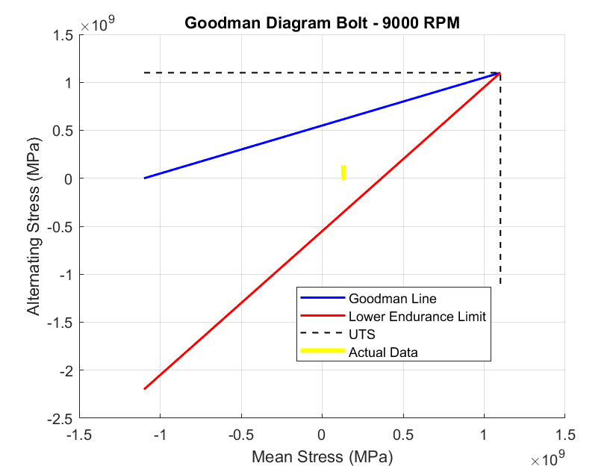 | 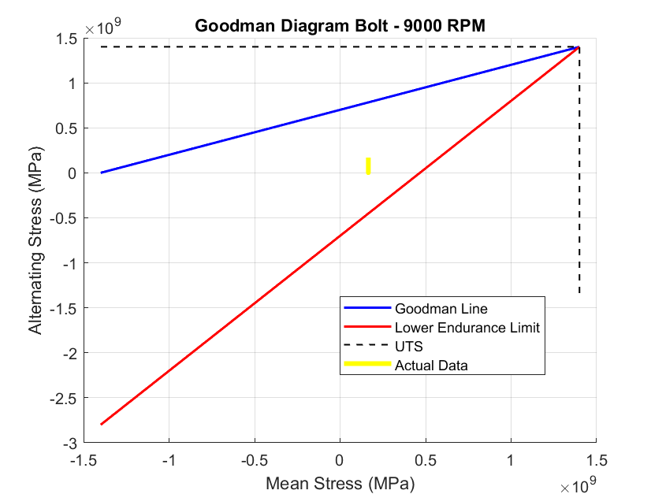

Based on the graphs for the three components analysed, steel is the most suitable material for each piston cylinder component. Steel shows lower alternating stress than Aluminium and Titanium, with a similar mean stress, indicating better fatigue resistance and higher damping capacity, allowing it to absorb and dissipate stress more effectively (Reddy, 2021). Additionally, steel has greater stiffness and elasticity, meaning it deforms less under load (Christudasjustus, 2022).

Discussion
The analysis of the components using Goodman diagrams provides critical insights into the fatigue performance of these components at varying engine speeds and material choices (Nicholas, 1966). By evaluating the components at 6000 RPM and 9000 RPM, as well as exploring different material alternatives, the study highlights how stress variations and material properties influence component durability and performance.

Increased Engine Speed
At 6000 RPM, all three components exhibit safety factors that indicate they are operating within acceptable fatigue limits. However, as the engine speed increases to 9000 RPM, a significant rise in alternating stresses is observed, reducing the fatigue safety factor for each component. This shift is evident in the Goodman diagrams, where the stress points move closer to the failure boundary, particularly for the connecting rod and conrod bolts.

Connecting Rod
The connecting rod experiences both tensile and compressive forces throughout the engine cycle (Nainaragaram Ramasamy, 2025). At 6000 RPM, it remains well within the safe operating region, suggesting a conservative design that prioritizes durability (Ismail, 2021). However, at 9000 RPM, the alternating stress increases, shifting the actual data closer to the Goodman failure line. The safety factor drops to 1.51, indicating a potential risk of fatigue failure under prolonged operation at high RPMs. The results suggest that to ensure reliability at 9000 RPM, the connecting rod may require a material upgrade or a redesign incorporating increased cross-sectional thickness to withstand higher stresses.

Gudgeon Pin
The gudgeon pin primarily undergoes compressive loading (Kumaraswamy, 2023). At 6000 RPM, the Goodman diagram shows a substantial margin of safety, with a safety factor of 6.7. This high value suggests that the component is over-engineered for this operating condition. At 9000 RPM, however, the alternating stress increases, lowering the safety factor to 2.98. While this value still indicates a reasonable safety margin, it highlights a notable reduction in fatigue life. If the engine is intended to operate consistently at high speeds, optimizing the gudgeon pin’s design or material selection may be necessary to prevent excessive wear and fatigue damage (Wang, 2023).

Connecting Rod Bolts
The conrod bolts play a crucial role in maintaining the integrity of the connecting rod assembly by sustaining high tensile loads (Jia, 2021). At 6000 RPM, the safety factor is sufficient to ensure long-term reliability. However, at 9000 RPM, the bolts exhibit the most pronounced reduction in safety factor, dropping to 1.44. This places them dangerously close to the failure boundary, indicating a high likelihood of fatigue failure over time (Zhang, 2024). The Goodman diagram shows that the actual stress range exceeds the upper endurance limit, confirming the necessity of a design change. To improve fatigue resistance, potential solutions include increasing the preload on the bolts (Kong, 2022), using a higher-strength material (Varshney, 2021), or applying surface treatments such as nitriding to enhance hardness and wear resistance (Çakmak, 2023).

Material Selection
To further enhance component durability, alternative materials—aluminium, steel, and titanium—were assessed at 9000 RPM. Each material presents distinct advantages and disadvantages in terms of strength, fatigue resistance, and weight.
- Aluminium has a lower ultimate tensile strength (UTS) of 470MPa, and endurance limit as shown by CJ (2022). Compared to steel and titanium whose UTS are 1100MPa and 1400MPa respectively, aluminium components exhibit higher alternating stresses, making them less suitable for high-speed applications (CJ, 2022). While aluminium offers significant weight savings with a lower density (Li, 2022), its lower fatigue resistance increases the likelihood of failure under sustained cyclic loading (Wang, 2023). This is due to aluminium having a much lower elasticity modulus (Zhu, 2021)
- Steel demonstrates a balanced combination of strength, fatigue resistance, and cost-effectiveness (Wang, 2022). Across all components, steel shows lower alternating stresses than aluminium and titanium, making it the optimal choice for ensuring durability at high RPMs as seen by the actual stress ranges in the Goodman diagrams. The higher damping capacity of steel also enhances its ability to absorb and dissipate cyclic stresses, reducing the risk of fatigue failure allowing a longer life span (Kam, 2021).
- Titanium provides the highest strength-to-weight ratio, making it a suitable option for performance applications due to having a hexagonal close-packed crystal structure, which gives it excellent fracture toughness and fatigue resistance (Zhao, 2022). However, its high cost and manufacturing challenges as titanium does not exist naturally, make it less practical for mass production (Subasinghe, 2022). While titanium components exhibit strong fatigue resistance, allowing a longer life, steel remains the better overall choice due to its superior balance of strength, affordability, and manufacturability, all properties sought after when optimising a component.

Enhancing Fatigue Resistance
Given the increased stress levels at higher RPMs, several engineering strategies can be employed to enhance the fatigue resistance of the connecting rod, gudgeon pin, and conrod bolts to extend the components operating life:
- Surface Treatments: Techniques such as nitriding can increase the surface hardness and wear resistance of the components, particularly for the connecting rod bolts, which are at the highest risk of fatigue failure meaning they are the most likely to fail (Maleki, 2021).
- Optimized Geometry: Increasing the cross-sectional area of the connecting rod and bolts can help distribute stress more evenly, reducing localized stress concentrations that contribute to fatigue failure (Tejero, 2023).
- Material Upgrades: Using higher-grade steels with improved fatigue resistance can extend the lifespan of the components, particularly in high-performance applications (Liuyi, 2023).
- Preload Optimization: For conrod bolts, increasing the preload can help reduce alternating stress levels, improving their fatigue life (Jiang, 2022).
- Improved Surface Finishes: Polishing can reduce surface imperfections that act as stress concentrators, thereby enhancing fatigue performance (Ye, 2021).

Conclusion
The Goodman diagram analysis highlights the impact of increased engine speed on the fatigue life of the connecting rod, gudgeon pin, and conrod bolts. At 6000 RPM, all components remain well within their fatigue limits, but at 9000 RPM, the safety margins decrease significantly, particularly for the conrod bolts, which approach the failure boundary (Hu, 2021). Among the materials assessed, steel provides the best balance of strength and fatigue resistance, making it the most suitable choice for high-performance applications because it can withstand higher stresses without breaking (Tayebi, 2021). To ensure component reliability at elevated RPMs, engineering solutions such as material upgrades, surface treatments, and geometric optimizations should be considered. By implementing these enhancements, the durability and performance of these critical engine components can be significantly improved by altering the materials resistance to stresses, reducing the risk of premature failure and enhancing overall engine longevity (Aghareb Parast, 2021).

References
Aghareb Parast, M.S., Jamalkhani Khameneh, M., Azadi, M., Azadi, M., Mahdipanah, M.H. and Roostaie, S., 2021. Effect of plasma nitriding on high‐cycle fatigue properties and fracture behaviors of GJS700 nodular cast iron under cyclic bending loading. Fatigue & Fracture of Engineering Materials & Structures, 44(8), pp.2070-2086.
Çakmak, G., Subaşı, M.G., Sert, M. and Yilmaz, B., 2023. Effect of surface treatments on wear and surface properties of different CAD-CAM materials and their enamel antagonists. The journal of prosthetic dentistry, 129(3), pp.495-506.
Cecchel, S., Razavi, N., Mega, F., Cornacchia, G., Avanzini, A., Battini, D. and Berto, F., 2022. Fatigue testing and end of life investigation of a topology optimized connecting rod fabricated via selective laser melting. International Journal of Fatigue, 164, p.107134.
Christudasjustus, J., Larimian, T., Esquivel, J., Gupta, S., Darwish, A.A., Borkar, T. and Gupta, R.K., 2022. Aluminum alloys with high elastic modulus. Materials Letters, 320, p.132292.
CJ, A., S, G., Mohan, D.G. and S, S., 2022. Predicting the ultimate tensile strength and wear rate of aluminium hybrid surface composites fabricated via friction stir processing using computational methods. Journal of Adhesion Science and Technology, 36(16), pp.1707-1726.
Desnica, E. and Mikić, D., 2014. Various approaches to kinematic analysis in the process of design of piston mechanisms. Annals of Faculty Engineering Hunedoara–International Journal of Engineering, Romania, 7, pp.63-68.
Dowling, N.E., 2004. Mean stress effects in stress-life and strain-life fatigue (No. 2004-01-2227). SAE Technical Paper.
Francis, R. and Byrne, G., 2021. Duplex stainless steels—alloys for the 21st century. Metals, 11(5), p.836.
Ge, Y., Chen, L. and Feng, H., 2022. Optimal piston motion configuration for irreversible Otto cycle heat engine with maximum ecological function objective. Energy Reports, 8, pp.2875-2887.
Haider, A.A., Kumar, A., Chowdhury, A., Khan, M. and Suresh, P., 2018. Design and structural analysis of connecting rod. International Research Journal of Engineering and Technology, 5(5), pp.282-285.
Han, X., Ma, J., Tian, A., Wang, Y., Li, Y., Dong, B., Tong, X. and Ma, X., 2023. Surface modification techniques of titanium and titanium alloys for biomedical orthopaedics applications: A review. Colloids and Surfaces B: Biointerfaces, 227, p.113339.
Holst, C.P., 1924. The Connecting Rod and Crank Mechanism and Its Inertia Forces. Brill Archive.
Hu, Y., Qin, Q., Wu, S., Zhao, X. and Wang, W., 2021. Fatigue resistance and remaining life assessment of induction-hardened S38C steel railway axles. International Journal of Fatigue, 144, p.106068.
Ismail, I., Abdelrazek, E., Ismail, M. and Emara, A., 2021. Enhancing the Durability of Connecting Rod of a Heavy-Duty Diesel Engine. International Journal of Automotive and Mechanical Engineering, 18(2), pp.8728-8737.
Jaggi, V.A., 2022. Affecting over-engineering with elements and factors of frugal innovations. Delft University of Technology.
Jia, D., Cai, C., Li, Y., Deng, X., Lei, J., Deng, W. and Ji, H., 2021. Research on optimizing the axial force of thread connection of engine connecting rod. Engineering Failure Analysis, 130, p.105771.
Jiang, C., Xiong, W., Cai, C.S., Zhu, Y. and Wang, J., 2022. Preload loss of high-strength bolts in friction connections considering corrosion damage and fatigue loading. Engineering Failure Analysis, 137, p.106416.
Kam, M. and Saruhan, H., 2021. Vibration damping capacity of deep cryogenic treated AISI 4140 steel shaft supported by rolling element bearings. Materials Testing, 63(8), pp.742-747.
Kashyzadeh, K.R., Ghorbani, S. and Kasimovich, A.A.M., 2025. Common causes of failures in the industrial bolt and nut connections. Engineering Failure Analysis, p.109431.
Kong, Q., Li, Y., Wang, S., Yuan, C. and Sang, X., 2022. The influence of high-strength bolt preload loss on structural mechanical properties. Engineering Structures, 271, p.114955.
Kumaraswamy, J., Ch Siva Ramakrishna, S. Ramasubramanian, Rahul Mishra, D. T. Sakhare, K. Karthik, S. Baskar, and Krishna Kant Pandey. "Design and Analysis of Gudgeon Pin to Minimize Stress Concentration by Selecting Different Material Through FEA." In Conference of Innovative Product Design and Intelligent Manufacturing System, pp. 339-352. Singapore: Springer Nature Singapore, 2023.
Leira, B.J., Igland, R.T., Baarholm, G.S., Farnes, K.A. and Percy, D., 2005, January. Fatigue safety factors for flexible risers based on case specific reliability analysis. In International Conference on Offshore Mechanics and Arctic Engineering (Vol. 41960, pp. 211-217).
Li, G., Li, X., Guo, C., Zhou, Y., Tan, Q., Qu, W., Li, X., Hu, X., Zhang, M.X. and Zhu, Q., 2022. Investigation into the effect of energy density on densification, surface roughness and loss of alloying elements of 7075 aluminium alloy processed by laser powder bed fusion. Optics & Laser Technology, 147, p.107621.
Liuyi, T.A.N.G., Ranran, W.E.I., Feng, W.A.N.G., Wenyan, Z.H.A.N.G., Qin, B.I.E., Zhijin, T.I.A.N. and Yuan, M.E.I., 2023. Construction of safety evaluation index system for high-grade steel pipeline.
Maleki, E., Bagherifard, S., Bandini, M. and Guagliano, M., 2021. Surface post-treatments for metal additive manufacturing: Progress, challenges, and opportunities. Additive Manufacturing, 37, p.101619.
Mao, J., Lin, B. and Wu, Z., 2022. Fatigue Endurance Limit of Fasteners in Automotive Application (No. 2022-01-0260). SAE Technical Paper.
Marrey, R., Baillargeon, B., Dreher, M.L., Weaver, J.D., Nagaraja, S., Rebelo, N. and Gong, X.Y., 2018. Validating fatigue safety factor calculation methods for cardiovascular stents. Journal of biomechanical engineering, 140(6), p.061001.
Muhammad, A., Shanono, I.H. and Shanono, I.H., 2019. Static analysis and optimization of a connecting rod. International Journal of Engineering Technology and Sciences, 6(1), pp.24-40.
Nainaragaram Ramasamy, M., Slíva, A., Govindaraj, P. and Nag, A., 2025. Topology Optimization and Testing of Connecting Rod Based on Static and Dynamic Analyses. Applied Sciences, 15(4), p.2081.
Nicholas, T. and Zuiker, J.R., 1996. On the use of the Goodman diagram for high cycle fatigue design. International Journal of Fracture, 80(2), pp.219-235.
Palacín, J. and Martínez, D., 2021. Improving the angular velocity measured with a low-cost magnetic rotary encoder attached to a brushed dc motor by compensating magnet and hall-effect sensor misalignments. Sensors, 21(14), p.4763.
Parkash, O., Gupta, V. and Mittal, V., 2013. Optimizing the design of connecting rod under static and fatigue loading. International Journal of Research in Management, Science & Technology, 1(1), pp.39-43.
Patterson, E.A., 1990. A comparative study of methods for estimating bolt fatigue limits. Fatigue & Fracture of Engineering Materials & Structures, 13(1), pp.59-81.
Prata, A.T., Fernandes, J.R.S. and Fagotti, F., 2000. Dynamic analysis of piston secondary motion for small reciprocating compressors. J. Trib., 122(4), pp.752-760.
Qian, W., 2021. Star Mass Inertia Dictates the Speed of Light. Journal of High Energy Physics, Gravitation and Cosmology, 8(1), pp.184-194.
Reddy, K.V., Naik, R.B., Reddy, G.M., Chakravarthy, P., Janakiram, S. and Kumar, R.A., 2021. Damping capacity of aluminium surface layers developed through friction stir processing. Materials Letters, 298, p.130031.
Sonsino, C.M., 2009. A consideration of allowable equivalent stresses for fatigue design of welded joints according to the notch stress concept with the reference radii r ref= 1.00 and 0.05 mm. Welding in the World, 53, pp.R64-R75.
Srawley, J.E., 1976, January. Wide range stress intensity factor expressions for ASTM E 399 standard fracture toughness specimens. In Conf. of Am. Soc. for Testing and Mater., Committee E-24 (No. E-8654).
Subasinghe, H.C.S. and Ratnayake, A.S., 2022. General review of titanium ores in exploitation: present status and forecast. Comunicaçõe Geológicas, 109.
Tawfik, M.M., Nemat-Alla, M.M. and Dewidar, M.M., 2021. Enhancing the properties of aluminum alloys fabricated using wire+ arc additive manufacturing technique-a review. journal of materials research and technology, 13, pp.754-768.
Tayebi, M. and Nematzadeh, M., 2021. Effect of hot-compacted waste nylon fine aggregate on compressive stress-strain behavior of steel fiber-reinforced concrete after exposure to fire: experiments and optimization. Construction and Building Materials, 284, p.122742.
Tejero, F., MacManus, D., Matesanz García, J., Swarthout, A. and Sheaf, C., 2023. Towards the design and optimisation of future compact aero-engines: intake/fancowl trade-off investigation. International Journal of Numerical Methods for Heat & Fluid Flow, 33(4), pp.1319-1335.
Toasa Caiza, P.D., Sire, S., Ummenhofer, T. and Uematsu, Y., 2022. Low cost estimation of Wöhler and Goodman–Haigh curves of Ti‐6Al‐4V samples by considering the stress ratio effect. Fatigue & Fracture of Engineering Materials & Structures, 45(2), pp.441-450.
Varshney, D. and Kumar, K., 2021. Application and use of different aluminium alloys with respect to workability, strength and welding parameter optimization. Ain Shams Engineering Journal, 12(1), pp.1143-1152.
Wang, H., Li, H., Zhao, Y., Liu, X., Peng, J., He, L., Liu, J. and Zhu, M., 2023. Fatigue failure mechanism of aluminium alloy riveted single-shear lap joints. Engineering Failure Analysis, 146, p.107055.
Wang, Lilin, Chunyue Huang, Liye Wu, Xiaobin Liu, Xianjia Liu, and Huaiquan Zhang. "Stress-strain analysis and optimization of TSV interconnect structure parameters under thermal cyclic load loading based on bp neural network." In 2023 24th International Conference on Electronic Packaging Technology (ICEPT), pp. 1-6. IEEE, 2023.
Wang, P., Wang, B., Liu, Y., Zhang, P., Luan, Y.K., Li, D.Z. and Zhang, Z.F., 2022. Effects of inclusion types on the high-cycle fatigue properties of high-strength steel. Scripta Materialia, 206, p.114232.
Wei, W., Li, X., Liu, J., Zhou, Y., Li, L. and Zhou, J., 2021. Performance evaluation of hybrid WOA-SVR and HHO-SVR models with various kernels to predict factor of safety for circular failure slope. Applied Sciences, 11(4), p.1922.
Ye, C., Zhang, C., Zhao, J. and Dong, Y., 2021. Effects of post-processing on the surface finish, porosity, residual stresses, and fatigue performance of additive manufactured metals: a review. Journal of Materials Engineering and Performance, 30, pp.6407-6425.
Zhang, Z., He, Z., Yang, B., Wang, Y., Xiao, S., Hou, M. and Guo, T., 2024. An improved Goodman-Smith fatigue limit diagram for railway vehicle base metals and welded structures. International Journal of Fatigue, 182, p.108160.
Zhang, Z., Xie, Y., Zhang, X. and Meng, X., 2009. Analysis of piston secondary motion considering the variation in the system inertia. Proceedings of the Institution of Mechanical Engineers, Part D: Journal of Automobile Engineering, 223(4), pp.549-563.
Zhao, Q., Sun, Q., Xin, S., Chen, Y., Wu, C., Wang, H., Xu, J., Wan, M., Zeng, W. and Zhao, Y., 2022. High-strength titanium alloys for aerospace engineering applications: A review on melting-forging process. Materials Science and Engineering: A, 845, p.143260.
Zhu, S.P., Ai, Y., Liao, D., Correia, J.A., De Jesus, A.M. and Wang, Q., 2021. Recent advances on size effect in metal fatigue under defects: a review. International Journal of Fracture, pp.1-23.

