plant & asset engineering
Evaluating the Effectiveness of Chosen Maintenance Strategies for Dedicated Equipment

Word Count: 2,685
Nathan Mackechnie (2116209)
Sony UK Technology Centre

ACMA6007 | UWTSD

Table of Contents
Acknowledgements 1
List of Figures 2
List of Tables 3
List of Graphs 4
1. Introduction 5
2. Maintenance Strategies 6
2.1. Types of Maintenance Strategies 6
2.2. Why Maintenance is Important – Morbi Bridge Disaster 7
3. Investigation of a Maintenance Approach at Sony UKTec 8
3.1. Top Load Carton Former - Overview 8
3.2. Current Maintenance Strategy - Preventative Maintenance 9
3.2.1. Details & Reasoning for Current Preventative Maintenance Strategy 9
3.2.2. Pros of the Current Preventative Maintenance Strategy 11
3.2.3. Cons of the Current Preventative Maintenance Strategy 12
3.2.4. Improvements to the Current Strategy 13
3.2.4. Implementation Considerations for the Suggested Improvements 15
3.2.5. Change Management Implications 16
4. Conclusion 17
5. Recommendations for Further Work 17
References 18

Acknowledgements
I thank Justin Shepherd, Mechanical Production Engineer, and Nathan Steele and Marcus Jones, Production Engineering Managers, for their invaluable support and guidance throughout this project. Their expertise and insights have significantly contributed to the development of this report.

List of Figures
Figure 1- Raspberry Pi Models (NextPCB, 2024) 5
Figure 2 - Morbi Bridge Collapse (Pandey, 2022) 7
Figure 3 - Line 2 Layout Diagram 8
Figure 4- Top Load Carton Former 8
Figure 5 - Eight Pillars of TPM (4Industry, 2024) 14
Figure 6 - ADKAR Chanage Management (Jamieson, 2022) 16

List of Tables
Table 1- Types of Maintenance Approaches (Afolalu et al., 2024) 4
Table 2 - Current Preventative Maintenance Strategy 7

List of Graphs
Graph 1 - Pi 5 Variant Downtime Cost Per Minute
Graph 2 - Type of maintenance for the Top-Load Carton Former 2024
Graph 3 - Occurrence of breakdowns and average downtime 2024

Introduction
Maintenance is an essential task in manufacturing, ensuring efficient operation. As Salonen and Delervd (2011) state, without proper maintenance, machinery's performance will deteriorate over time, resulting in increased downtime, higher repair costs, and potential disruptions in production.
Sony UK Technology Centre (Sony UKTec) is an electronics manufacturer in Pencoed, Wales. It is the primary manufacturer of Raspberry Pi products, as illustrated in Figure 1 below (NextPCB, 2024).

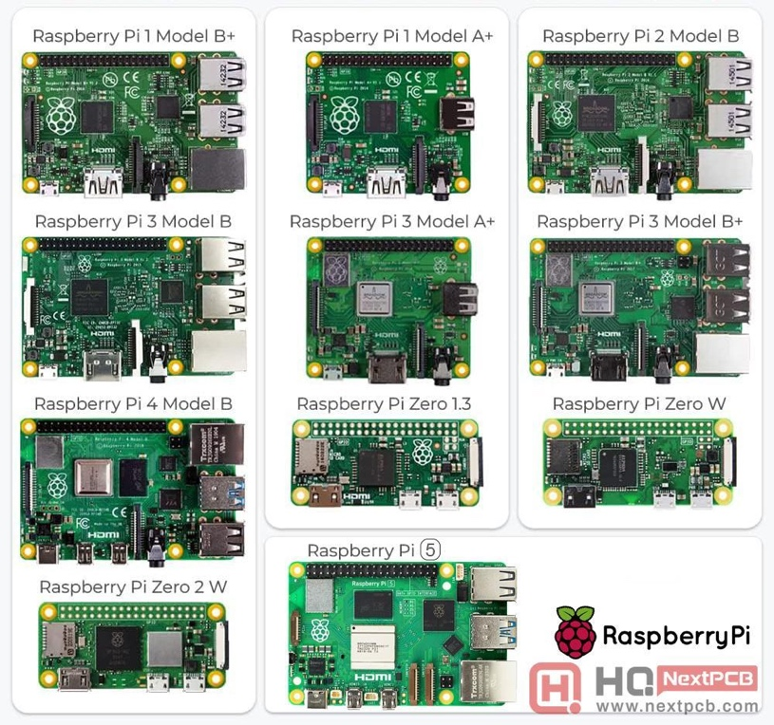
Figure 1- Raspberry Pi Models
Since the introduction of the Raspberry Pi in the early 2010s, demand for these products has grown significantly, necessitating increased production capacity and efficiency. In response, Sony UKTec has implemented automated processes across its production lines, resulting in faster throughput and reduced reliance on manual labour. This report aims to critically evaluate the maintenance practices for one of the key pieces of equipment at Sony UKTec: the Top Load Carton Former, which is used in the automated production of Raspberry Pi units. This report will assess the current maintenance strategy, identify areas for improvement, and propose a more comprehensive maintenance approach.

Maintenance Strategies
Different maintenance strategies exist, each providing various benefits. The following sections outline these approaches and explain their importance.

2.1. Types of Maintenance Strategies
Different maintenance strategies exist because operational requirements, assets and risk factors vary across industries. Table 1 presents seven types of maintenance strategies (Afolalu et al., 2024).

Table 1- Types of Maintenance Approaches
Maintenance Strategy | Description
Breakdown | A reactive approach that occurs only after a failure occurs, resulting in downtime and higher costs
Preventative | Scheduled maintenance to prevent failures before they happen
Centralised | A team or department who are responsible for maintenance across multiple areas
De-Centralised | Handling local issues within departments, responsible for own area
Outsourced | Maintenance is done externally by a third party, often a specialist for the specific equipment
Condition-Based | Maintenance is performed based on real-time condition monitoring
Reliability-Centred | A strategy that focusses on asset criticality, optimising cost effectiveness and reliability

These different strategies have different advantages and limitations. Multiple maintenance strategies are typically adopted for the best results (Zhao, Gao, and Tang, 2022). The following section will discuss a fatal example of poor maintenance, highlighting the importance of proper maintenance.

2.2. Why Maintenance is Important – Morbi Bridge Disaster
When an organisation neglects or improperly conducts maintenance, overall safety can be compromised. The Morbi pedestrian suspension bridge collapse in Machchhu Pichu, pictured in Figure 2, is a fatal example of why maintenance practices are vita (Pandey, 2022).

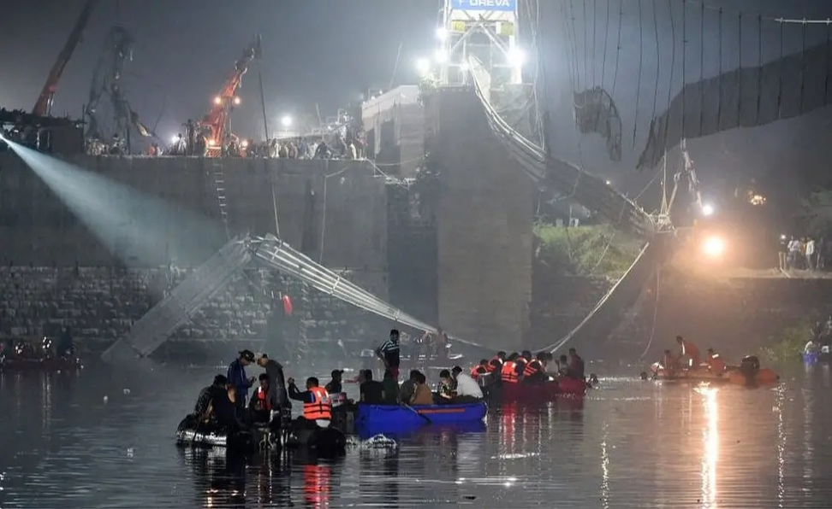
Figure 2 - Morbi Bridge Collapse

Two days after reopening from maintenance, the bridge collapsed, resulting in 141 fatalities and many more injuries. The maintenance involved replacing the wooden deck with aluminium. The aged and rusted structural supports, such as the cables, bolts, and anchors, were neglected, and no assessment was made of how the new decking might affect the bridge's structural performance. The added weight and neglected structural components led to catastrophic failure (Hakimian, 2022).
Investigations revealed that no assessments were conducted to evaluate the impact of the new decking or the condition of the existing supports. Additionally, local authorities had not authorised the bridge’s reopening (Shah, 2022).
This failure highlights the importance of adhering to correct maintenance protocols, conducting thorough inspections, and assessing the implications of replacing components with materials of different specifications.

Investigation of a Maintenance Approach at Sony UKTec
Automation at the Sony UK Technology Centre has progressed significantly, with the Raspberry Pi production lines being the most automated. Figure 3 shows the second of the three Raspberry Pi production lines at the Pencoed site.

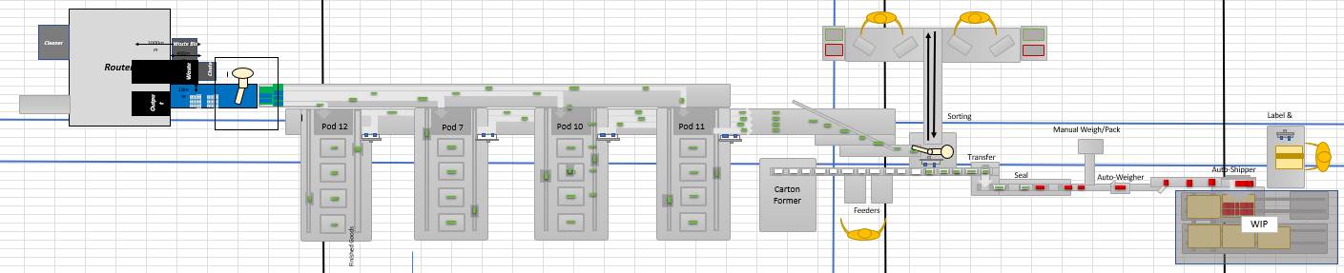
Figure 3 - Line 2 Layout Diagram
This production line uses various equipment, including routers, conveyors, test pods, pick-and-place machines, and packaging machines. The following section will discuss the current maintenance strategies for the 'Top Load Carton Former' used on Line Two and highlight potential improvements.

3.1. Top Load Carton Former - Overview
This equipment is essential in automating the packaging process and is used on all three of the Raspberry Pi lines. Its primary function is to form cartons for the product to be placed in.
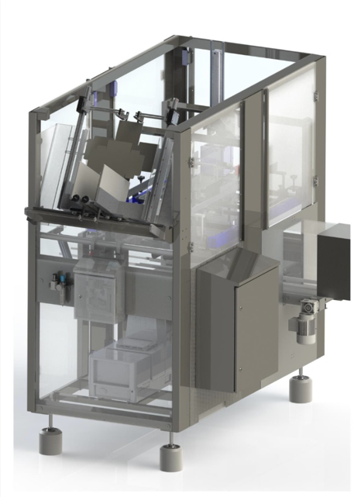
Figure 4- Top Load Carton Former
An operator stacks the unfolded carton into the feeder. It is then fed on a chain, glue is applied, and a piston pushes the carton down a shaft, folding the box and placing it onto the conveyor. Further down the line, a single-arm pick-and-place robot picks up the product and places it into the empty carton. This machine is essential to the production line; any breakdowns can cause bottlenecks and downtime for the whole line.

3.2. Current Maintenance Strategy - Preventative Maintenance
Sony's production engineering team maintains this piece of equipment. All maintenance is logged using Limble, a maintenance management system. The following section will discuss the current maintenance strategy.

3.2.1. Details & Reasoning for Current Preventative Maintenance Strategy
The primary maintenance strategy for the carton former is preventive maintenance (PM), which involves scheduled inspections, lubrication, adjustments, and part replacements to minimise breakdowns. Maintenance tasks are carried out daily, weekly, monthly, and six-monthly to ensure the machine operates efficiently and reliably. The details of the PM are listed in Table 2.

Table 2 - Current Preventative Maintenance Strategy
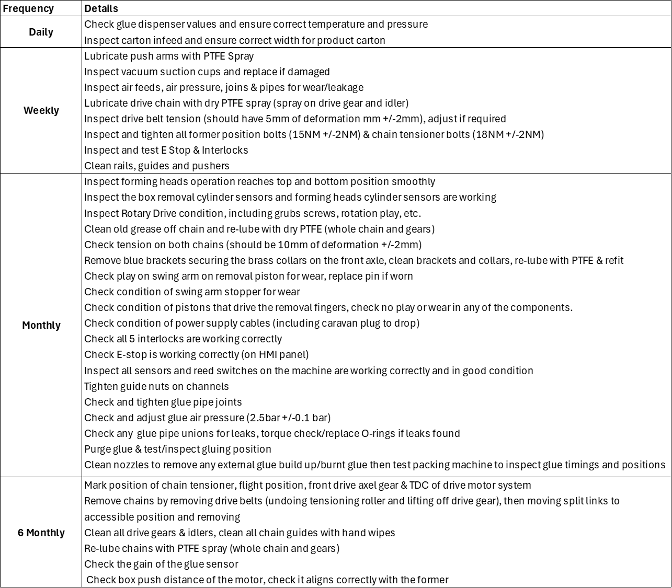

PM actions have been historically implemented to reduce unexpected downtime, maintain consistent performance, extend equipment lifespan, improve safety and compliance, and control costs. PM is planned and expected, allowing for accurate production scheduling by the planning team and planning by the production engineering team.
Graph 1 highlights the significance of minimising downtime, which displays the downtime cost per minute for each Raspberry Pi 5 variant.

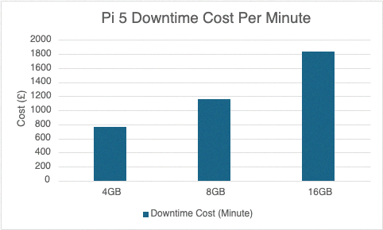
Graph 1 - Pi 5 Variant Downtime Cost Per Minute

The 16GB Pi 5 is the most expensive variant, with downtime costs exceeding £1,800 per minute. This reinforces the importance of reducing breakdowns to mitigate financial losses and sustain production efficiency.
Overall, this strategy is crucial in Sony's fast-paced manufacturing environment, where PM is coordinated with the production planning team. This ensures minimal disruption while maintaining reliability and performance.

3.2.2. Pros of the Current Preventative Maintenance Strategy
One key benefit of PM is that it introduces predictability into the maintenance schedule, allowing for better resource allocation, reduced unexpected failures, and cost control (Al Ameeri, Ab Rahman, and Muhamed, 2023). Graph 2 shows the equipment's split between preventative and breakdown maintenance for the past year.

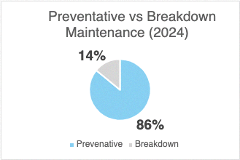
Graph 2 - Type of maintenance for the Top-Load Carton Former 2024
By prioritising PM, Sony has significantly reduced the requirement for breakdown repairs. Spare parts are purchased by the maintenance schedule, allowing for accurate planning against long-lead-time components, decreasing downtime, and reducing the high costs of emergency purchases (Shokri et al., 2025).
Scheduled Inspections of components such as pistons, chains, and motors improve detection of potential failures before they happen (Assis and Marques, 2021). Lubrication of mechanical parts reduces wear, extending the lifespan of critical components. For the carton loader, this is essential for pistons, rotary drives, and chain systems. Evidence of this can be found on Limble, showing that the mean time before failure (MTBF) is 711.1 hours.
Regular checks on E-stops, interlocks, and sensors ensure the equipment is safe and compliant with workplace safety regulations, safeguarding the carton's former users.
Overall, the preventative maintenance strategy ensures predictability, optimises resource allocation, reduces unexpected failures, and controls costs. Routine inspections and maintenance, such as lubrication, extend component life span and performance. Planned safety checks ensure the equipment remains compliant and safe for operator use.

3.2.3. Cons of the Current Preventative Maintenance Strategy
With PM, significant resources are required to carry out the work, manage the schedule and inventory, and analyse data. Li, Ran, and Zhang (2022) highlight the potential for over-maintenance. This can mean that parts are replaced prematurely, and additional manual labour is required to maintain. This can result in unnecessary costs due to wasted resources and time.
Although PM is planned, the top-load carton former still requires complete isolation. This leads to downtime during three-shift operations (24 hours) and can disrupt operations if they are not effectively aligned with production demands.
While PM reduces breakdowns, thirteen have been reported this year, showing that unexpected failures still occur, as shown in Graph 3.

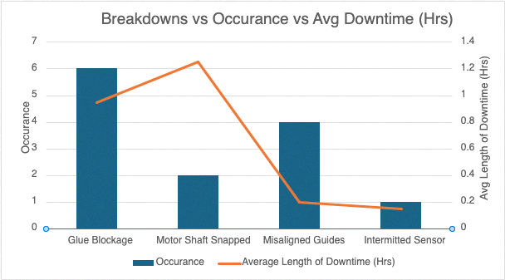
Graph 3 – Occurrence of breakdowns and average downtime 2024
This suggests that the current PM strategy does not fully address some failure modes, indicating that further refinements are required.
Overall, PM requires significant resources to carry out maintenance actions, manage schedules, inventory and analyse data, mainly when applied to many types of machinery across a production site. Unnecessary maintenance is likely to happen, leading to wasted resources and time. While the PM is planned, disruption remains due to the machine requiring complete isolation. Breakdowns are reduced. However, failures are still present, highlighting the need for further refinements.

3.2.4. Improvements to the Current Strategy
The current PM strategy could be enhanced by adjusting the interval frequency based on failure trends. For example, Graph 3 shows six breakdowns related to glue blockages, causing an average of 5.7 hours of downtime. By increasing the PM frequency for the glue system from monthly to bi-weekly, these failures are more likely to be identified early, reducing the risk of breakdown and downtime.
Introducing a Total Productive Maintenance (TPM) approach is another improvement that would strengthen the current strategy. Figure 5 shows the eight pillars of TPM (4Industry, 2024).

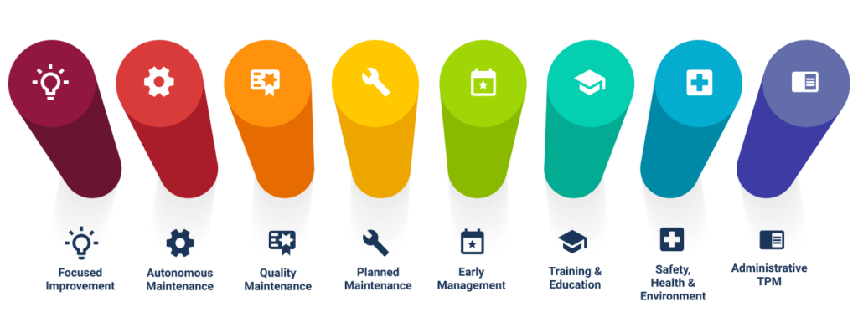
Figure 5 - Eight Pillars of TPM
TPM is a proactive strategy aimed at improving equipment reliability and reducing downtime. The image illustrates the eight pillars of TPM, which work together to enhance maintenance efficiency and overall performance. These pillars include Autonomous Maintenance, Planned Maintenance, Quality Maintenance, Focused Improvement, Early Equipment Management, Training and Education, Safety, Health and Environment, and Office TPM. Each pillar contributes to a holistic approach to continuous improvement in maintenance practices. TPM encourages operator involvement to maximise overall equipment effectiveness (OEE) (Wan Saidin, 2015). In the case of the Carton Former, operators could be trained to perform monitoring tasks and daily inspections, improving fault detection and easing the technician's workload.
Alongside PM, Condition-Based Maintenance (CBM) could be implemented by fitting sensors to key components to collect real-time data (Mohammed, Abdulateef and Hamad, 2023). For instance, temperature sensors could monitor glue conditions, and flow sensors could ensure correct glue dispensing. CBM is efficient as it monitors actual component condition, meaning parts are only replaced when necessary. Teixeira and Lopes (2022) highlight that CBM reduces unnecessary maintenance, saving on labour and spare parts costs.
Overall, the current PM strategy could be improved by adjusting maintenance intervals based on failure trends. Through operator involvement, TPM would enhance overall equipment reliability and reduce technicians' workload. Additionally, CBM using sensors could capture live data, highlighting failures and ensuring performance is maintained while unnecessary maintenance is reduced.

3.2.4. Implementation Considerations for the Suggested Improvements
Implementing the proposed improvements will improve the current maintenance strategy; however, careful consideration of costs and resources is necessary (Ye et al., 2009).
Adjusting PM frequency will require additional resources, increasing labour and parts costs (Doostparast and Kolahan, 2015). However, by reducing the likelihood of breakdowns, the costs associated with downtime and reactive repairs are lowered, helping to offset the additional resource costs.
Successful TPM will require pilot programmes to refine analytical techniques and financial investment in training programmes to develop operators' basic maintenance skills. This will involve experienced technicians working with the on-site development team to build structured sessions. Operations standards must also be created for maintenance procedures and regularly updated. As TPM promotes a culture of Kaizen (Plescaci, 2022), the company must ensure financial investment is available to support improvements; otherwise, the TPM approach will not be practical (Dureja et al., 2011). A key benefit is the reduction of low-value-added tasks for technicians, allowing them to focus on higher-priority work while operators take on the basic actions.
To implement CBM, an initial investment in sensor technology will be needed, along with ongoing costs and resources to maintain the sensors. Data must also be captured and accessible to technicians, requiring input from the software development team to design and build dashboards. This may require additional fees for software licenses and training.
An external specialist could implement the improvements if internal resourcing is an issue. For example, implementing CBM could involve engaging a specialist to install sensors and manage data monitoring and analysis. Outsourcing this task reduces the burden on internal teams and provides immediate access to expert knowledge and a broad range of industry experience (Lam and Chua, 2009). On the other hand, outsourcing may limit the development of key skills internally, potentially creating long-term dependency on external providers and reducing the organisation's ability to respond independently to future maintenance challenges (Dabhilkar and Bengtsson, 2008).
Overall, implementing these improvements will require additional resources and financial investment. A cost-benefit analysis will clearly identify the long-term value by comparing upfront costs against expected gains such as reduced downtime, increased equipment lifespan, improved productivity, and lower reactive maintenance expenses.

3.2.5. Change Management Implications
Effective change management must be considered to ensure successful implementation (Bassi and Shinde, 2024). Change disrupts established routines, which can be met with resistance from employees (Trader-Leigh, 2022). Some employees may feel uncertain about the changes, especially when required to learn new systems or take on new responsibilities. In the case of TPM, operators may not understand the value of the maintenance activities or feel unsupported, leading to a decline in motivation and a risk of non-compliance.
Initial capability can often be an implication, with employees struggling to adapt to new systems. The ADKAR model in Figure 6 highlights this (Jamieson, 2022).

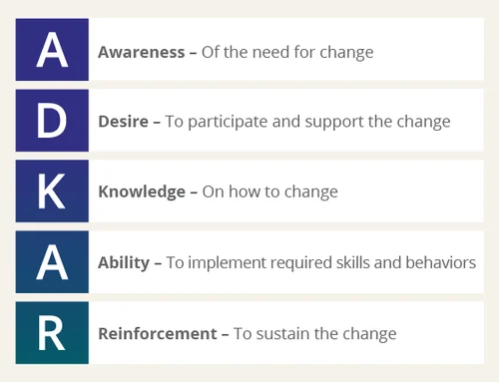
Figure 6 - ADKAR Chanage Management

This model highlights knowledge and ability as two critical factors in successful change. This model further strengthens the requirement for structured training and operation standards.
Change fatigue is a risk when organisations implement too many changes at once or fail to show early success. Employees can become disengaged by change if overwhelmed or the benefits are not visible (Cox et al., 2022). This aligns with William Bridges' Transition model, highlighting that people require time to adjust to change Samuel and Tsapayi, 2023).
Overall, effective change management is required to improve the current maintenance strategy. Employee engagement and clear communication are critical to the success of improvements. Sony should consider key models like ADKAR and Bridges' Transition model; the Sony development team could do this.

Conclusion
The current maintenance strategy for the Top Load Carton Former at Sony UKTec has effectively reduced downtime and controlled costs through PM. However, there are further opportunities for improvement. Short-term recommendations include increasing the frequency of specific maintenance tasks, particularly those related to the glue system, to address recurring breakdowns. Prioritising training and development is crucial as a first step before pursuing medium-term improvements. This will ensure that operators and technicians possess the necessary skills and knowledge to implement new maintenance practices effectively. In the medium term, TPM will encourage operator involvement and enhance equipment reliability, while CBM should be introduced to monitor key components and optimise maintenance schedules. Long-term recommendations focus on establishing a robust change management strategy to facilitate the transition to these new maintenance practices, addressing potential resistance, and ensuring sustainable improvements. By adopting a more proactive, data-driven approach, Sony UKTec can reduce unplanned downtime, extend equipment lifespan, enhance operational efficiency, and achieve long-term cost savings. Successful implementation will require careful planning, resource allocation, and clear communication to ensure smooth adoption and sustained improvements.

Recommendations for Further Work
Accurate cost analysis, including cost-benefit analysis and return on investment (ROI) calculations, should be conducted to justify investments in TPM, CBM, and increased PM frequencies. Implementing change management strategies, using models such as Kotter’s (Kotter, 2012) or Lewin's (Burnes, 2004), will ensure smooth adoption while training staff in new practices and enhancing employee engagement. Further exploration of maintenance theories like Reliability-Centred Maintenance (RCM) and Predictive Maintenance (PdM) can optimise the maintenance strategy. Additionally, tracking equipment performance metrics such as MTBF and OEE will provide insights into maintenance effectiveness. Environmental sustainability and safety must remain priorities in any new strategies, alongside the development of KPIs for monitoring performance and cultivating a culture of continuous improvement. These steps will refine the maintenance approach, reduce downtime, enhance cost efficiency, and ensure long-term operational success.

References

4Industry. (2024). A Complete Guide of the 8 TPM Pillars. [Online]. 4industry.com. Available at: https://4industry.com/manufacturing-glossary/8-pillars-of-tpm/ [Accessed 5 April 2025].

Afolalu, S.A., Akinlabi, E.T., Akinlabi, S.A., Salawu, E.Y., Udo, M.O., Ajayi, O.O. (2024). Maintenance strategies and procedures: an overview. 2024 International Conference on Science, Engineering and Business for Driving Sustainable Development Goals (SEB4SDG). IEEE, pp. 1–8. [Online]. Available at: https://doi.org/10.1109/SEB4SDG60871.2024.10630278 [Accessed 24 February 2025].

Al Ameeri, T.A., Ab Rahman, M.N., Muhamad, N. (2023). Analysing effective and ineffective impacts of maintenance strategies on electric power plants: A comprehensive approach. Energies (Basel), 16(17), pp. 6243-. [Online]. Available at: https://doi.org/10.3390/en16176243 [Accessed 24 February 2025].

Assis, R., Marques, P.C. (2021). A dynamic methodology for setting up inspection time intervals in conditional preventive maintenance. Applied sciences, 11(18), pp. 8715-. [Online]. Available at: https://doi.org/10.3390/app11188715 [Accessed 24 February 2025].

Bassi, D., Shinde, A. (2024). Barriers to successful change management. Management in healthcare, 8(3), pp.271–283.

Burnes, B. (2004). Kurt Lewin and the Planned Approach to Change: A Re-appraisal. Journal of management studies, 41(6), pp.977–1002. [Online]. Available at: https://doi.org/10.1111/j.1467-6486.2004.00463.x [Accessed 7 April 2025].

Cox, C.B., Gallegos, E., Pool, G.J., Gilley, K.M., Haight, N. (2022). Mapping the nomological network of change fatigue: identifying predictors, mediators and consequences. Journal of organizational change management, 35(4/5), pp.718–733. [Online]. Available at: https://doi.org/10.1108/JOCM-12-2021-0369 [Accessed 6 April 2025].

Dabhilkar, M., Bengtsson, L. (2008). Invest or divest? On the relative improvement potential in outsourcing manufacturing. Production planning & control, 19(3), pp.212–228. [Online]. Available at: https://doi.org/10.1080/09537280701830144 [Accessed 7 April 2025].
Doostparast, M., Kolahan, F., Doostparast, M. (2015). Optimisation of PM scheduling for multi-component systems - a simulated annealing approach. International journal of systems science, 46(7), pp.1199–1207. [Online]. Available at: https://doi.org/10.1080/00207721.2013.815822 [Accessed 31 March 2025].
Dureja, J.S., Sachdeva, A., Sharma, V.S., Dogra, M. (2011). TPM – A Key Strategy for Productivity Improvement. Journal of Engineering Science & Technology, 6(1), pp.1–16. [Accessed 6 April 2025].

Hakimian, R. (2022). Early theories for India footbridge collapse. New Civil Engineer. (3017), pp. 13-. [Online]. Available at: https://librarysearch.uwtsd.ac.uk/discovery/fulldisplay?docid=cdi_proquest_reports_2770357263&context=PC&vid=44WHELF_UWTSD:44WHELF_UWTSD_VU1&lang=en
[Accessed 24 February 2025].

Jamieson, J. (2022). Prosci's Top 10 Tactics for Managing Resistance to Change. [Online]. prosci.com. Last Updated: 2025. Available at: https://www.prosci.com/blog/prosci-top-10-tactics-for-managing-resistance-to-change [Accessed 6 April 2025].

Kotter J.P. (2012). Leading Change. [Online]. Harvard Business Review Press. Available at: https://www.google.co.uk/books/edition/Leading_Change/xpGX1EWL_EMC?hl=en&gbpv=0 [Accessed 7 April 2025].

Lam, W., Chua, A.Y.K. (2009). Knowledge outsourcing: an alternative strategy for knowledge management. Journal of knowledge management, 13(3), pp.28–43. [Online]. Available at: https://doi.org/10.1108/13673270910962851 [Accessed 7 April 2025].

Li, X., Ran, Y., Zhang, G. (2022). Optimisation of equal-cycle maintenance strategy considering imperfect preventive maintenance. Proceedings of the Institution of Mechanical Engineers. Part E, Journal of Process Mechanical Engineering, 236(4), pp. 1392–1402. [Online]. Available at: https://doi.org/10.1177/09544089211063852 [Accessed 24 February 2025].

Mohammed, N.A., Abdulateef, O.F., Hamad, A.H. (2023). An IoT and Machine Learning-Based Predictive Maintenance System for Electrical Motors. Journal Europeen des Systemes Automatises, 56(4), pp.651–. [Online]. Available at: https://doi.org/10.18280/jesa.560414 [Accessed 31 March 2025].

NextPCB. (2024). What Is Raspberry Pi? Models, Features, and Uses. [Online]. nextpcb.com. Available at: https://www.nextpcb.com/blog/what-is-raspberry-pi-models-features-and-uses [Accessed 13 March 2025].

Plescaci, D. (2022). Kaizen Costing – A Continuous Improvement Strategy of the Organisations. CECCAR Business Review, 3(2), pp.30–41. [Online]. Available at: https://doi.org/10.37945/cbr.2022.02.04 [Accessed 6 April 2025].

Salonen, A., Deleryd, M. (2011). Cost of poor maintenance: A concept for maintenance performance improvement. Journal of quality in maintenance engineering. 17(1), pp. 63–73. [Online]. Available at: https://doi.org/10.1108/13552511111116259 [Accessed 24 February 2025].

Shah, J. (2022). Morbi bridge collapse | Nail the villains: Fixing culpability in the Morbi tragedy is still a work in progress. Quick action needs to be taken to punish the guilty. New Delhi: Living Media India, Limited. [Online]. Available at: https://librarysearch.uwtsd.ac.uk/discovery/fulldisplay?docid=cdi_proquest_miscellaneous_2732447954&context=PC&vid=44WHELF_UWTSD:44WHELF_UWTSD_VU1&lang=en [Accessed 24 February 2025].

Shokri, A., Toliyat, S.M.H., Hu, S., Skoumpopoulou, D. (2025). Integrating spare part inventory management and predictive maintenance as a digital supply chain solution. Journal of modelling in management, 20(3), pp. 1003–1029. [Online]. Available at: https://doi.org/10.1108/JM2-05-2024-0131 [Accessed 24 February 2025].

Teixeira, H.N., Lopes, I.S. (2025). Supporting condition-based maintenance implementation: a methodology. Journal of quality in maintenance engineering, 31(1), pp.48–82. [Online]. Available at: https://doi.org/10.1108/JQME-07-2023-0067 [Accessed 31 March 2025].

Trader-Leigh, K.E. (2002). Case study: identifying resistance in managing change. Journal of organizational change management, 15(2), pp.138–155. [Online]. Available at: https://doi.org/10.1108/09534810210423044 [Accessed 6 April 2025].

Wan Saidin, W.A.N., Kasim, N.I., Musa, M.A., Mohamad Noor, N. and Razali, A.R. (2015). Improvement of Overall Equipment Effectiveness (OEE) through Implementation of Total Productive Maintenance (TPM) in Manufacturing Industries. Applied Mechanics and Materials, 761(Recent Technologies in Design, Management and Manufacturing), pp.180–185. [Online]. Available at: https://doi.org/10.4028/www.scientific.net/AMM.761.180 [Accessed 31 March 2025].

Ye, Z., Strong, C.K., Shi, X., Conger, S.M., Huft, D.L. (2009). Benefit–cost analysis of maintenance decision support system. Transportation research record, 2107(1), pp.95–103. [Online]. Available at: https://doi.org/10.3141/2107-10 [Accessed 31 March 2025].

Zhao, J., Gao, C., Tang, T. (2022). A review of sustainable maintenance strategies for single component and multicomponent equipment. Sustainability, 14(5), pp. 2992-. [Online]. Available at: https://doi.org/10.3390/su14052992 [Accessed 24 February 2025].

