Student Self Evaluation Form

This section repeats in brief the common assessment criteria detailed on previous pages. The extent to which these are demonstrated by you determines your mark. Using these criteria, tick the box that best indicates the level of achievement you feel you have achieved with regard to each of them.

Common Assessment Criteria Applied
Common Assessment Criteria Applied | REFER |  | D |  | C | B | A
 | OUTRIGHT FAIL | UNSATISFACTORY | SATISFACTORY |  | GOOD | VERY GOOD | EXCELLENT
1. Subject Knowledge and Understanding (which includes using research-informed literature and knowledge and understanding of the subject) |  |  |  |  |  | X
2. Intellectual Skills (Analysis) |  |  |  |  | X
3. Pedagogic and Professional Applications  (Practical Application and Deployment) |  |  |  |  |  | X
4. Key Transferable Skills |  |  |  |  |  | X
PLEASE COMMENT ON AREAS IN WHICH YOU FEEL THAT YOU HAVE PERFORMED WELL |  |  |  | PLEASE COMMENT ON AREAS you feel that you need TO DEVELOP
I have written an honest and critical account on my research lesson study.  I have identified areas for development within my subject knowledge. |  |  |  | Analysis of data.

Module Code: ECPP7001

Module Title: The Enquiring Teacher

Student No: 1701091

Word count: 6238

Contents

Introduction Page 4

Literature Review Page 5

Lesson Study Design Page 8

Ethical Considerations Page 10

Lesson Study Analysis Page 11

Research Findings Page 15

Conclusions Page 16

Recommendations Page 17

References Page 19

Appendices Page 21

- Consent Letter Pg. 22
- Observational Schedule Pg. 23
- Field notes Pg. 24
- ARC Model Pg. 25
- Consent and Assent forms Pg. 26
- Lesson Plan 1 Pg. 27
- Observations Schedule 1 Pg. 28
- Focus Interview 1 Pg. 29
- ARC Lesson 1 Pg. 30
- Lesson Plan 2 Pg. 31
- Observation Schedule 2 Pg. 32
- Focus Interview 2 Pg. 33
- ARC Lesson 2 Pg. 34

Write a critical and analytical essay that discusses your practitioner research ‘lesson study’ in relation to a chosen field.

Can we improve pupil involvement by giving choice in activities?

Instilling motivation to learn, and the ability to keep children on task for the duration of a lesson is a key feature that all teachers strive to achieve during their practice. How to improve pupil involvement has become an area of great interest for many. It was noticed
during Professional Teaching Experience (PTE), how young children are often quickly distracted in the classroom, and the need to engage all learners for the duration of the lesson is essential to ensure full understanding of the subjects taught. When consulting field notes it became apparent that children were losing focus and the ability to stay on task, even for short periods of time. It was therefore decided to investigate how a child’s motivation and interaction with a given task can be altered by a choice of activity. The intention of this research was to question whether the independence to choose an activity, gave the children more focus and ownership of their task, thus, allowing them to achieve the learning objective through intrinsic motivation.

When discussing and sharing PTE experiences, it became obvious that fellow student practitioners were experiencing similar issues with class involvement and pupil engagement. It was soon realised that a child’s motivation to learn was an area that sparked a desire for further investigation. Questions such as, what enthuses a child to learn, and how do they learn best were openly discussed. Intrinsic motivation was an area of particular interest, and it was suggested that if a teacher could access their class using methods to enhance their children’s intrinsic motivation, they would be able to enthuse, inspire and motivate their learners beyond their expectations. This study will therefore investigate if there is a correlation between intrinsic motivation and the freedom to choose activities.

The research took place across two schools. The first (school A), a medium sized inner city primary school in an area of high deprivation. The second (school B), a medium sized primary school in a more affluent area on the outskirts of a town. The initial research was carried out at school A, in a reception class of 24 pupils. There was a mixed range of abilities within the class, and the children’s capacity to sit and focus for any length of time was limited. As this was a foundation phase class, the children were provided with a choice of provisions every day, and would work in a carousel fashion moving around the activities during their morning and afternoon sessions. The focus group activities however, were always planned and differentiated specifically for the children, so it was interesting to let the children choose these activities. In contrast, the order of the day in school B was structured similarly to the juniors, although still in foundation phase, the year two class did not have free choice or carousel activities throughout the day.

Literature review
Deci and Ryan (1985) define intrinsic motivation as a motivation that arises for personal goals. Completing a challenge for the satisfaction of accomplishment, or simply for the feeling of achievement, no reward necessary. As it comes from within, intrinsic motivation occurs for different reasons in different people. Emotional feelings can have a huge impact on a child and their motivation. When people are motivated intrinsically, it is said that they experience enjoyment and an interest in what they are doing. They also feel in control and have a higher level of confidence as stated by Deci and Ryan (2000).
“Intrinsic motivators have a profoundly greater effect on engagement, it’s through intrinsic interests that people achieve great things.” Iain Lancaster (2017).
There is plenty of evidence to suggest that giving pupils more control in the classroom leads to better motivation. Teacher guidance is of course important, and needed to keep children on track within a lesson. However, giving pupils the opportunity for some choice and control over their learning is arguably the best way to promote engagement in the classroom. Lancaster (2017), suggests for example that by allowing your pupils to choose what problems they tackle within a lesson, or to have control over the type of assignment they produce, gives the class a sense of control over their studies which motivates them to do more. James Nottingham (2013) agrees with this, suggesting that children are more likely to be engaged when they are involved in the planning of their learning. Nottingham is a great believer in the previewing of topics, allowing children to make decisions about what they would like to know about a particular topic, and what they thought they should know about the subject. This simple strategy, generates an element of control which ignites an interest within the area to be studied.
Similarly, Lancaster (2017) in his contribution to the journal Teach Thought stated that in giving teachers and pupils greater autonomy in choosing a curricular focus, educators are able to improve student engagement. The journal also suggests that only intrinsically motivated students will be truly challenged and fulfilled during their schooling experience.
Furthermore, Dweck (2007) proposes a positive correlation between intrinsic motivation and having a growth mindset. Dweck has stated that intrinsically motivated students are much more likely to have a growth mindset. An individual with a growth mindset believes that any success they achieve is as a result of hard-work, not simply talent or ability. If this correlation is correct, it could be argued that teachers should be able to encourage and nurture a growth mindset in all their students by enhancing their intrinsic motivation within the class. Of course, this can be achieved in a number of ways, the offer of choice, being one. In contrast, Dweck (2007) suggests that there is also a correlation between those having a fixed mindset and being extrinsically motivated, and states that those extrinsically motivated individuals are less likely to succeed.
Although this study is concerned with intrinsic motivation, it is also important to acknowledge other forms of motivation. Extrinsic motivation refers to a person being motivated by an external factor or outcome. This could be to achieve a certain grade in an exam, or simply for the praise or reward from a teacher or a parent. As described by Ryan and Deci (2000) extrinsic motivation has an external factor that drives a person to do something as it leads to ‘separable outcome.’
The Self Determination Theory (SDT) has also been strongly linked with intrinsic motivation as it is concerned with an inner satisfaction, a drive and an emotional response when achieving something.
The motivation of Self Determination Theory learners can depend on their eagerness for more information, and their desire to apply this newly acquired information to new situations. This slightly contrasts with intrinsically motivated learners who are consistently self-guided, therefore they are more enthused, excited and have more confidence. It is true to say that intrinsic motivation is personal, and differs greatly from individual to individual.
The human race is an inquisitive being, and a desire to learn comes deep from within. These desires of course, can be classed as motivation. Everyone has intrinsic motivation, it is the what and the why that varies. Deci & Ryan (2000) suggest that some people are intrinsically motivated for activities, whereas, others are not. Similarly, not everyone is motivated for a particular type of work. This is where the importance of knowing your students, and what motivates them as individuals comes into play, giving them some autonomy over their learning will not only help with their intrinsic motivation, and subsequently with their educational outcomes but will also help with planning for future classes. Erwin (2004) discusses the Choice Theory developed by William Glasser. Bearing some similarities to Maslow’s hierarchy of needs, this theory focusses on the explanation of behaviours based on internal motivation for meeting five basic human needs. These needs are; to survive, to love and belong, to gain power, to be free and to have fun. We do not however, share the same amounts of these needs. For example, one person may have a high need for freedom, with varied quantities of the other four needs. The behaviour of this person is likely to be different to someone who has a high need for love and belonging. It is obvious therefore, that a teacher displaying signs of high survival needs (security and order) would conflict in a typical class of students with a high need for freedom or fun. Erwin (2004) considers these needs and describes how it is possible to create conditions in the classroom to ensure all the individual needs are met without conflict. Erwin suggests that if you can assess which of the five basic needs motivates your students most, you will be able to manage their learning by tailoring your teaching to their specific needs. ‘An understanding of the basic human needs provides a solid foundation for creating and managing a high-quality learning environment.’ Erwin (2004:19). Concurring with this, Gilbert (2002) discusses the necessity to incorporate pupil interests and hobbies into lesson plans in order to maximise the learning potential for each student. He suggests a naturalistic approach can motivate just about everyone as you can link any lesson to individual preferences such as animals, plants and the environment. Imagination, and knowledge of your students is all you need. For example, Gilbert discusses a scenario of how an English lesson on Macbeth could be improved for some students by asking what animals the characters would be if they were cast in a Disney re-make. This could create a great dialogue on characterisation, and would also demonstrate understanding of the story. This illustrates how creativity and adaptability in one’s lessons can motivate and engage all learners.
Edwin Locke (2016) suggests that individual goal setting can consistently improve student performance, and is extremely effective in securing commitment. Locke also states that by getting the pupils to choose and set their own goals, student motivation is encouraged further, and will lead pupils to achieve their own self-determined goal. This is certainly an area for development and future research.

Explanation of lesson study
The chosen methodology for this research was to conduct a lesson study. This is a form of action research established by Peter Dudley, which involves professionals working together to improve teaching and learning. This particular research involved working with a colleague where elements of teaching were observed and a particular pedagogic focus or enquiry was discussed and implemented. In this case the focus was investigating a child’s involvement when given a choice of activities to achieve a learning objective. A cycle of planning, teaching, observing and reflecting was employed in order to improve the teaching and learning within the classroom. This type of collaboration has been successfully used for many years, and as Dudley (2014) states, teachers change their teaching to better support learning as a result of lesson study.
During this lesson study, a lesson was planned, taught and observed in school A. On completion of this first lesson, observations and reflections were considered, along with feedback from the focus group interview. From these findings, the second lesson in school B could be planned, reshaped and the ideas and techniques employed could be improved upon. Participant observational research offers a distinct way of collecting data, this is usually an eye witness account reporting on the activities or behaviours that unfold during the observational period. This method was chosen for the research, as the observer could infiltrate the classroom in a natural way, giving a true representation of the classroom dynamics and behaviours. However, there were limitations to this method, such as observer perceptions. When observing the lessons, would each observer perceive what they saw in the same way? To ensure a fair and similar approach, a mock observation was trialled. The observers watched an exemplar lesson taken from a training video and made observations about the children’s involvement during the lesson. This proved to be a successful way of ensuring standards and fair practice. An awareness of Landsberger’s Hawthorne effect was also important when carrying out this study as this could affect the overall results. To minimise the effects of this, the target children were not aware that they were being individually observed, the observer took a non-participant role within the class and situated themselves at a distance to the children. To support these observations, an adapted version of the Leuven involvement scale was used in conjunction with field notes (see appendix 2). This involvement scale focussed on the levels of activity over a period of time. Moreover, it referred to how focused and involved the children were when completing the chosen activities. The process was started by assessing the levels of involvement using the scales 1 to 4, where 1 is no activity and 4 is fully engrossed in activity. Target pupils were observed individually over two minute intervals, and were scored according to the levels on the adapted scale. Reasons for adjusting the Leuven scale were to give a simplified and more precise focus for the intended research. It is thought that pupils need to be functioning at level 3 and 4 for learning to be effective. It is however, completely natural for these levels to change during the school day, especially when working within the foundation phase where concentration levels are known to be lower.
The observation schedule used, lasted for just fifteen to twenty minutes of a one hour lesson. Each target child was observed at two minute intervals, and their levels of involvement recorded. A less intense class observation was also conducted in the form of field notes carried out by the research teacher (see appendix 3). This overall observation was intended to give an overview of how the class worked as a whole when given the ability to choose their tasks. On completion of the lesson, three children of varying attainment were involved in the focus group interviews. The interviews were deemed to be a suitable method as they gave an interesting insight in to what impact these lessons have had on the children’s learning, and provided a pupil voice on the subject of choice within the classroom. ‘Pupils have a vital role to play in working with professionals to improve the quality of their learning experiences’ Welsh Government (2011:5). The decision to interview children of differing attainment was made to give a more accurate view of the session for all learners. These focus group interviews took place in the class room immediately after the sessions to ensure the children were able to give their honest views and remember the activities without being prompted or guided in any way.
The interview style was a semi-structured group interview, with the questions specifically planned, and tailored for the age of the children. By organising a group interview, the children were kept at ease, and were perhaps more likely to enter into a full discussion about their lesson, as they could agree or disagree with their peers. However, as witnessed during the reception class and the year two class interviews, there was a tendency to just agree with what another child had said. Interviewing such young children was not without its’ challenges. Failure to gain parental consent for the original three target children on each occasion caused initial difficulties, and other, less vocal children were required to take part. This led to the children giving somewhat limited responses. Also, when questioned, certain children appeared to give answers that they thought the interviewer wanted to hear, rather than giving an honest opinion.
A range of information was collected during this research, the methods used; interviews, observations and reflections indicate that this was exclusively qualitative data. Mackey & Gass (2016) describes qualitative research as descriptive data that does not include the use of statistical procedures. Qualitative research can also include a natural or holistic representation with fewer participants. In this study, a very small number of students were involved, and all the research was conducted within the children’s natural school environment. Participant observations, field notes, interviews and an adapted version of the Leuven scale formed a significant part of the research content. Equal priority was given to the different types of data when analysing the content as this would give a most precise view of the two lessons. Furthermore, as this was such a small project, the use of all data gathered was necessary to acquire a complete picture of the study.
The post teaching reflections (see appendix 4) were captured using an adapted version of the Assisted Reflective Conclusions model (ARC). All aspects of the lessons were considered. Overall feelings of the lessons, intentions and factors that influenced the lessons in any way were discussed. The relationship between the prepared resources and the effectiveness of the learning was highlighted and considerations were given to any changes that needed to be made in order to ensure effective teaching and learning for future lessons. Attention was paid to how the class reacted to the lessons, in particular, being given the independence to choose their activity, as this was vital information for the study.
Ethical Considerations
During this lesson research, ethical considerations were applied, and guidance from BERA (ethical guidelines for educational research) and UWTSD (research ethics and integrity code of practice) was sought. Approval from both the University and the schools involved had been acquired prior to the research commencing through the university ethics approval form. Letters were sent out to parents and guardians requesting consent (see appendix 1) for their children to take part in the study. During the two research lessons assent was requested at the start of the lesson and before the children were interviewed. In both schools, the class teachers signed forms showing agreement and to say they had witnessed the assent being requested (see appendix 5). The children were able to opt out at any time, and the data of any children who did not give consent was not used in the study. The children were reminded throughout, that they were able to opt out at any time. Body language and behaviour was also considered as assent along with verbal assent. The research lesson took place in the usual classroom with the class teacher and all assistant staff present. The focus group interviews were also held in the classroom with all the usual teaching staff present, and each child was asked to colour in a smiley face to show assent (see appendix 5). All participants of the research were anonymous, and the original data collected was destroyed on completion of the study. Any voice recording equipment used was the property of the school, and all files were deleted on completion of the interviews when transcripts had been typed. All school policies were adhered to when on and off sight.
Lesson Study Analysis
Lesson 1
This first lesson was an introduction to money for a reception class of 24 pupils. The learning objective was ‘Beginning to understand the value of money’, and the success criteria was for the children to recognise how coins differ in appearance, and to show an understanding of the value of the coins. The children were given a choice to complete one of three activities (see appendix 6). Activity 1: Paper rubbings. The children could make rubbings of the money to illustrate the difference in the appearance of the coins. The children were to discuss the size, colours, designs and values of the coins. They could then add the values together. Activity 2: Making money. The children could make their own money, using shapes and coloured card. They had to design and put a value on their coins. The children were to discuss the differences in real money with their own designs, and to try adding their money together. Activity 3: Coin sorting. The children were given purses with amounts written on them. They had to put the correct amount of money in each purse, using different combinations of coins. They were encouraged to discuss their choices, along with the values and the appearances of the coins.
Each task was explained to the children during the introduction on the carpet. They were then put into their usual groups for maths and started the activities. All resources were of similar interest, and placed on the tables prior to the start of the session. The children were able to choose freely. Initial observations showed the children enthusiastically choosing their activities, and their levels of involvement were high. How they made their choices however, differed from table to table. It was documented that the class teacher, although not intentionally, was influencing the choice on her table by repeating the choices in front of the children. Each child sat with the class teacher chose the last activity that was mentioned. Some children chose the activity closest to them on the table and other children were observed choosing the same activity as their friends.
All children in this class achieved the learning objective during the lesson, by completing their chosen activity and showing understanding of the subject material when questioned during the plenary. It was clear that the session had been thoroughly enjoyed by all. Furthermore, it was interesting to note that not all, but a large majority of children opted for the more creative tasks offered. This information will be valuable when planning for this class in the future.
The behaviour of one child was particularly fascinating during the lesson as they failed to rotate in the usual carousel format, instead choosing to remain at the focus task table throughout the hour lesson. Looking at the observation schedule below, the level of involvement for this child was constantly high for the entire session, they were also observed getting involved with other children, drawing them in to conversation about the task, and showing them what they had done.
09:30  09:45  10.10  10.11  10.13  10.15  10.17  10.19  10:21  10:23  10:25 | Child: C – Money making activity  Straight into activity on maths table although child’s group have not been called. Child stays at table when new group are called.  Observation starts  Child continues to work at table, fully engaged with activity.  Runs around table to get more card.  Sat fully concentrating – shouting out self-praise.  Looking around but still cutting.  Talking to another child explaining what to do.  Talking while colouring.  Showing work to friend.  Finishes task | Grouping  SG  SG  SG  SG  SG  SG  SG  SG  SG  SG  SG | Level of involvement  4  4  4  3  4  3  4  3  4  4  3

This display of interest could have been due to intrinsic motivation caused by the freedom to choose the activity. Alternatively, this child may have enjoyed the activity so much that they were intrinsically motivated to complete the task, and help others. When considering the literature, one could argue that this was a result of intrinsic motivation. However, evidence to suggest whether it was the ability to choose that made the impact is uncertain. Given the young age of the pupils concerned, the high levels of involvement were remarkable, and a considerable difference in the engagement of most students was noticed. When looking at the children’s responses during the focus group interview (see appendix 8), it was clear that the children enjoyed being able to choose their activities. All three children agreed that they had worked better during the session because they had chosen the task. When asked if they would like more choice in all their lessons, the answer was a unanimous yes.

When planning the second lesson in school B, it was decided that consideration had to be given to the influence of the teacher. As stated in the post lesson ARC reflection (see appendix 9), although unintentional, the tone of voice, or how the teacher spoke about something impacted on the children in the class. It was also noted that the naming of each task and the positioning of the activity on the tables had an impact on how the children made their choice. It was decided to simplify this decision-making process so the children would go with their choice only, and would not be swayed by the teacher or their friends. This would give a better representation of whether it was their independence to choose that drove their motivation. When introduced to the class, the activities would be referred to as A, B and C so no title would influence a decision. It was agreed that the three resources would be placed on the table at the front of the classroom for the children to collect individually. Again, this was to minimise any influential effects for the children.

Lesson 2
The second lesson was on the topic of place value for a year 2 class of 28 children in school B. The learning objective was to read and write numbers to 100, and to demonstrate an understanding of place value up to 100. The success criteria for all pupils was to identify numbers to 100, and for some children to demonstrate an understanding of place value (see appendix 10). The majority of pupils had met the learning objective by the end of the lesson, as they had completed the task and shown understanding by writing their techniques, methods and explanations in their jotter books.
As with lesson 1, the children were introduced to the topic and the activities whilst sat on the carpet during the beginning of the session. The three activities were similar in appearance and style. Each had challenges and incorporated the use of a hundred square. As planned the activities were introduced to the children as A, B and C. However, on the morning of the lesson it was noticed, that the activities had been colour coded, this had not been agreed when planning the lesson, and influenced the children immensely in their choice of activity. The children were directed to their tables. Instead of placing the activities on the top table as suggested in the planning stages, the primary research teacher for this lesson held up the activities and called out “so who wants the blue job?” The majority of the class jumped up to get the blue job, and only a handful of children opted for the other tasks, and this was largely due to the fact that all the ‘blue jobs’ had gone. Although the start of this lesson did not go to plan, and the non-bias influence to choose had been somewhat unintentionally sabotaged. The children were focussed and motivated for the majority of the time. They had still chosen the activities for themselves no matter what the reasons, and the motivation to complete the task set was the main focus for the research, not how the children came to choose their task. However, it is important to note that by choosing an activity because of its colour, and not for the activity itself, there was a strong possibility that the children would lose focus more quickly than the children who chose the activity for the particular challenge.
Looking at the observation schedule for the three students, it is clear that the pupils were initially enthusiastic with the task set. One child in particular, started off at immense speed as if it were a timed challenge. Interestingly, when the pupil had completed the task in record time, and showed the teacher, it became clear that the work was incorrect, and the pupil had to start again. One would imagine that the child’s enthusiasm would now waiver somewhat, however, the opposite was true. This pupil sat down, confidently informed their colleagues that they had incorrectly completed the task, and then proceeded to re do the activity with as much enthusiasm as they had done previously.
Overall, a positive response for the implementation of choice was received during the focussed group interview, although one child suggested it was difficult to make the choice. When questioned on whether they would like to have more choice in all their lessons, the children were unsure, child B said yes, however child A and C responded with sometimes (see appendix 12). Child A proceeded to explain that it was difficult to choose, although when asked why a particular activity had been chosen, Child A replied that their favourite colour was blue, and it was clear that they had not deliberated on the choice at all. When asked if the children felt they had worked better because they had chosen their activity, the response was a concrete yes. Interestingly, when asked for the reason why the children thought that they had worked better during this session, they stated it was because they had chosen a task that they “could actually do”, or that it “looked easy”. Of course, without completing each of these tasks, they would not know which activity was the easier. The fact that they had been given the independence to choose, gave them the confidence that they had picked the best, most fun, or easiest option. This certainly demonstrates Nottingham (2013) and Lancaster’s views on the positive outcomes of allowing pupils to choose their activities within a lesson. This young class of year two pupils had a prescribed level of autonomy over this one session, this gave the whole class a sense of control over their studies. As a result, they were motivated to do more, and the class behaviour had also improved.

Discussion of research findings
The ability to choose, clearly promotes a more positive work ethic with a majority of children. Indeed, all children in the study achieved the lesson objectives, and felt that they had worked better during the session due to the choosing the activity. Moving forward, it is clear that when planning, delivering and reflecting, children should be involved in all stages to ensure maximum engagement. Locke (2016) suggests goal setting as a great strategy to further motivate students. This combined with an element of choice, along with Nottingham’s (2013) theories on the previewing of a subject to gain prior knowledge would be highly effective in the classroom.
The research methods used were simple and effective, although the scale of the research was arguably too small. Having only one lesson with each class meant that individual progress was not really seen. This also limited the amount of data collected, and the reliability of the collated information could be questioned. A control lesson delivered prior to the lesson study would have given a clearer insight in to the effects of the implementation of choice. Alternatively, one half of the class could have acted as a control with no choice of activities, this however could have been seen as unfair in practice, and given the young ages of the children, it was possible that they would have become upset. Of course, for lesson studies carried out in schools by actual teaching staff these problems would not be such an issue. Interviews with more of the children involved would have been preferable, although on this occasion, not possible due to the lack of consent forms returned.
The results acquired during this lesson research certainly mirrored the theories and thoughts of the literature studied. Erwin’s (2004) ideas of getting his students to take responsibility for their own learning, and giving them the choice of how they completed their work and in what order certainly appealed to students within senior schools. This also improved overall attainment and behaviour of his classes. Positive behaviour and good overall engagement was observed during the lesson study across the two schools, this suggests that allowing the choices had made a difference to both sessions.

Conclusions
The stimulus of this research paper was to answer the question: Can we improve pupil involvement by giving choice in activities? The results of this research have shown that we can indeed improve involvement, along with encouraging and promoting other benefits such as confidence and self-belief.
This lesson study research has affirmed that there indeed is a positive correlation with choice and motivation. Allowing certain autonomy over learning increases a child’s confidence improving their motivation and thus raising their dedication to the task ahead. Although this study was limited by its small size, the results were unanimous. However, it is important to note that giving choice is not the only factor that can influence and motivate learners. Locke (1996) states that by goal setting pupils can increase commitment in their work dramatically. Although, by self-setting these goals, they may not be set as high as the class teacher would assign, however, they are achievable nevertheless. This in turn gives the pupil confidence, higher self-esteem and motivates them to set more goals which continuously propels them forward in their studies and encourages depth of learning. By enabling pupils to be a part of the goal setting process along with giving them some control over their studies we can begin the process of internalising the motivation that will aid the attainment to achieve their own determined goals.
Much of the literature researched during this study focused on the senior schools, and the impacts of these initiatives within the ‘middle school’ setting. This possibly highlights a gap in primary research, and perhaps an opportunity for future studies.
Ideally, the opportunity to further this research would have been welcomed. Teaching just two lessons in very different schools did not give enough prospects to develop and improve the teaching and learning for any particular class. The fact that the second ‘improved’ lesson was in a different school meant that there was no real visible progress made. Had the lesson studies continued over a term for example, it is possible that the results would have been more remarkable, with greater substantial evidence and of course, a much truer representation of the overall success of the initiatives introduced. The limitations of carrying out a study like this in the foundation phase is that there is always a degree of choice for the pupils throughout the day, and the reception class in particular had a strong pupil voice in planning their enhanced provisions. This study implemented across a whole school would have given a much clearer insight into the actual effects of choice within the classroom.
The type of choice given to the children could also be varied which would make an interesting future study. In this study, the freedom to choose an activity was given to the children, however, what if like Erwin (2004) we allowed the children to decide their topics, or the order in which they study, or perhaps the way they choose to present their work? It would certainly be interesting to see how individual motivations would be effected if these different choices were offered.
During the process of this lesson study research, the value of working cooperatively with a colleague to further ones’ professional development, and to improve teaching and learning within the classroom is paramount to success in practice. The experience of conducting a lesson study has been invaluable, and it is without doubt a practice to be continued and implemented throughout my teaching career.
This research has illustrated that although educators are unable to teach students how to be motivated, the tools required to improve and nurture confidence and a growth mindset can be developed in all individuals. This has been confirmed by Dweck (2007). By giving consideration to all the elements discussed within this study, such as, choice, goal setting and previewing, it is possible to create highly successful and motivated classrooms.
These learned strategies together with the results of this study will be taken forward and applied to all my future teaching experiences. Pupil voice will be at the heart of planning, and ways of moving forward and developing lessons will be discussed with the class. Feedback, flexibility and adaptability will be a priority to ensure engagement and success of all learners. The opportunity to go forward with these strategies, and to implement them into a new class is exciting, and I am sure, will be rewarding.

Recommendations
Moving forward, the values of incorporating pupil voice in to the planning of lessons is clear. As Nottingham (2013) stated, allowing students to preview topics and develop an interest before starting them leads to better involvement overall, and gives that sense of control to the students. This strategy should certainly be encouraged in all classes, and the good practice shared between schools.
If given the opportunity to repeat this research, a whole school project would be suggested involving research and input from a cross section of classes. This would be on a much greater scale, and over a prolonged duration, but would give substantial data in favour of choice and pupil voice. Of course, this is in no way pioneer research, and elements of these theories are currently being implemented in schools across Wales, particularly in schools where the new Donaldson (2015) curriculum has been implemented. ‘Ambitious capable learners’, are motivated learners, who have the drive and passion to carry them throughout their education. By incorporating these motivational strategies into all lessons, it will be possible to create and encourage more capable learners than ever before.
The future of education is looking innovative and exciting with pupil voice and wellbeing becoming much more of a main focus. With a collaborative ethic to develop and improve learning and teaching, teachers in Wales will potentially change the face of Welsh education and I am thrilled to be a part of it.

References

BERA https://www.bera.ac.uk/promoting-educational-research [Accessed on 3rd April 2018]
Deci, E. L, & Ryan, R. M. (1985). Intrinsic Motivation and Self-Determination in Human Behaviour. New York: Plenum.
Deci, E. L, & Ryan, R. M. (2000). The "what" and "why of goal pursuits: human needs and the self-determination of behaviour Psychological Inquiry. Retrieved from https://selfdeterminationtheory.org/SDT/documents/2000_DeciRyan_PIWhatWhy. pdf.
Denscombe, M. (2007). The Good Research Guide. (3rd ed). Open University Press.
Donaldson, G. (2015). Successful Futures: Independent Review of Curriculum and Assessment Arrangements in Wales Crown Copyright available at: http://gov.wales/topics/educationandskills/schoolshome/curriculum-for-wales-curriculum-for-life/why-we-are-changing/successful-futures/?lang=en [Accessed on 8th April 2018]
Dweck, C.S. (2012). Mindset; How You Can Fulfil Your Potential. Robinson.
Dweck, C.S. (2007). The perils and promises of praise. Kaleidoscope, Contemporary and Classic Readings in Education.
Dweck, C.S. (2007). The secret to raising smart kids. Scientific American Inc.
Dudley, P. (2014). Lesson Study: a Handbook lesson study UK. NCSL. Available at www.lessonstudy.co.uk [accessed on 2nd April 2018]
Erwin, J.C. (2004). Classroom of Choice: Giving Students What They Need and Getting What You Want. Association for the Supervision & Curriculum Development.
Gilbert, I. (2002). Essential Motivation in the Classroom. New York, NY: RoutledgeFalmer
Griffith, A. & Burns, M. (2012). Engaging Learners. Crown House Publishing
Hopkins, D. (2008). A Teacher’s Guide to Classroom Research. Open University Press.
Lambert, M. (2013). A Beginner’s guide to Doing Your Education Research Project. Sage
Lancaster. I. (2013). Teach Thought, we grow teachers. Retrieved from https://teachthought.com [Accessed on 10th April 2018]
Leavers, F., Daems, M., De Bruyckere, G., Declercq, B., Moons, J., Silkens, R., Snoeck, G., and Van Kessel, M. (2005) Siks-Ziko. Leuven University, Belgium: Research Centre for Experiential Learning Leuven University.
Mackey, A, & Gass, S. M. (2016). Second language research: Methodology and design (2nd ed). New York, NY: Routledge.
Nottingham, J. (2013). Encouraging learning. New York: Routledge
Pintrich. P.R and Schunk D.H. (1996). Motivation in Education; Theory, Research and Applications. Prentice-Hall, Inc.: New Jersey
Welsh Government. (2011). Pupil Participation- Good Practice Guide. Crown Copyright. Retrieved from www.servicesforeducation.co.uk [Accessed on 4th April 2018]

Appendix 1

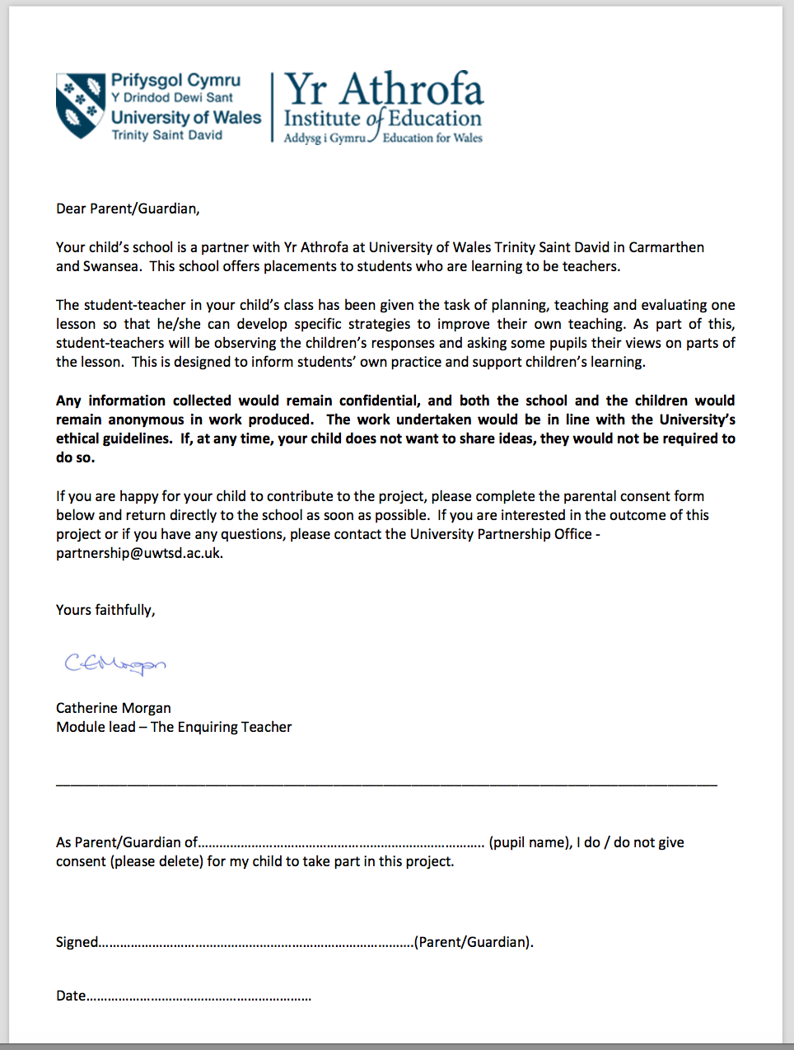

Appendix 2
Observation Schedule
Tracking observations Date:
No of Adults present :
No. of children:
Time | Description of Activity | Grouping | Level of Involvement
 | Child A
 | Child B
 | Child C
Grouping Level of involvement
WG – Whole Group 1- No activity
SG – Small Group 2- Frequently distracted
P – Pair 3- Fairly continuous activity
I – Individual 4- Absorbed in activity

Appendix 3

Field Notes

LO:____________________________________________________________Date:_______

Success Criteria:_____________________________________________________________

Group:______________________________

Name | Skill 1 | Skill 2 | Skill 3 | Comment | AFL

Appendix 4

Model Beirniad Wedi Adfyfyrio (BWA)

Assisted Reflective Conclusions (ARC) Model

Dyddiad/Date:

Digwyddiad critigol (Ffocws)/Critical incident (focus):
Profiad/ Experience

Teimladau/
Feelings
Beth yw eich teimladau ynghylch y profiad?
“What are your feelings regarding the experience?”
Cofio a Deall/
Remember and Understand
“Can you list any factors that influenced the learning /experience?”

“What were the elements of the learning experience that were disappointing?”
Gwerthuso a dadansoddi/
Evaluate and analyse

What was the relationship between the resources prepared and the effectiveness of the learning?

“What will you keep the same to ensure effective teaching and learning in the next lesson?”

How did the children react to being given a choice of activities?

Casgliadau a chamau gweithredu/
Conclusions and actions

How will you use your reflection today to move forward?

What is the most important piece of feedback gained?

Beth ydych yn mynd i’w wneud nesaf?
“What will you do next?”

Y profiad newydd / Transformed experience

Appendix 5

Consent and assent forms used

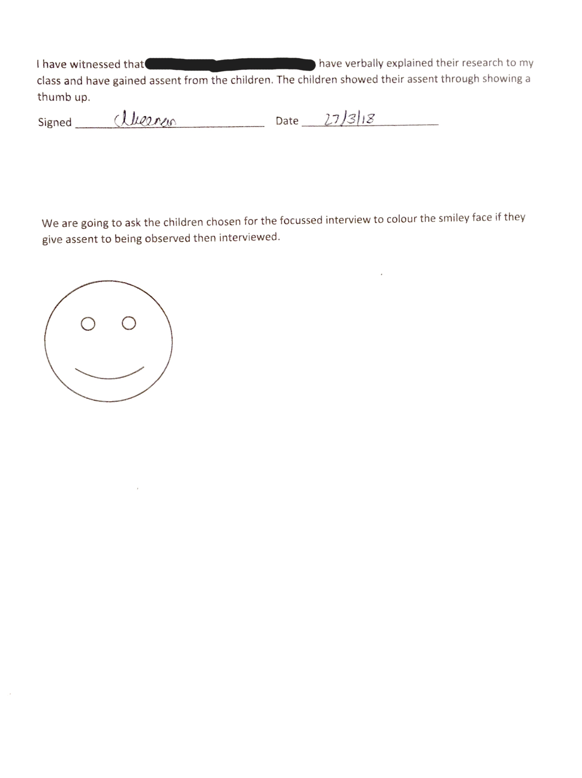

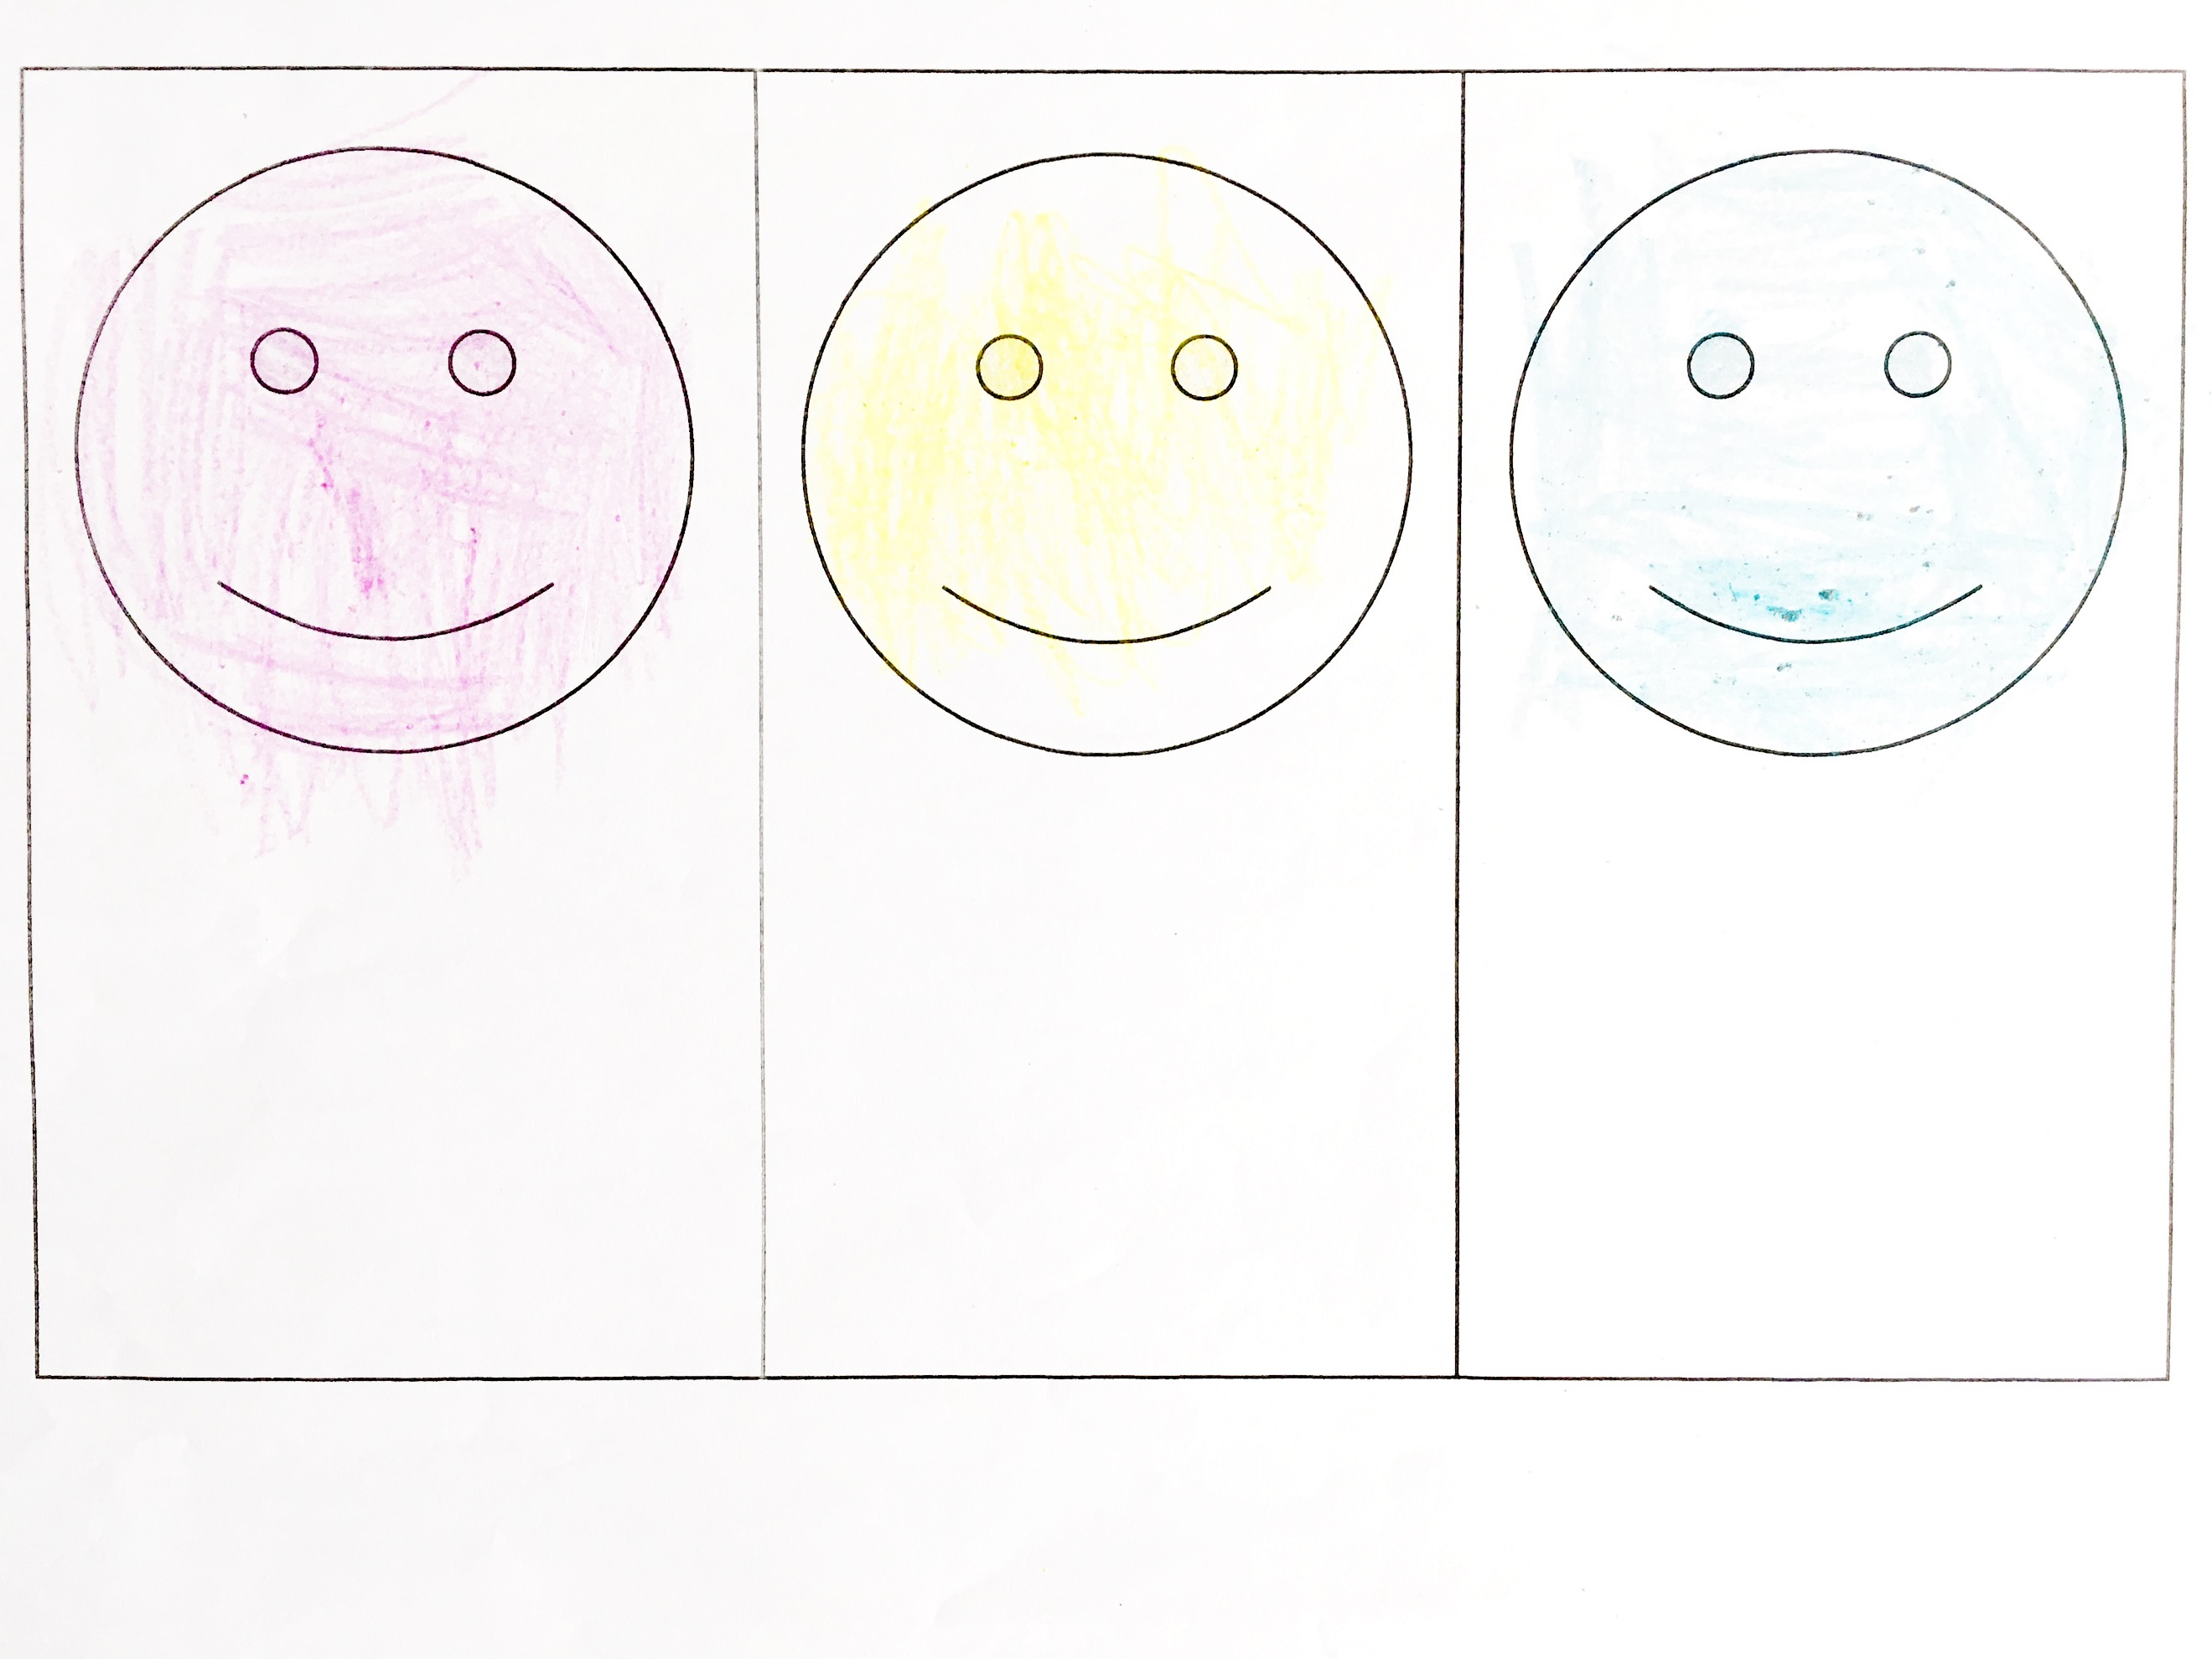

Appendix 6

Lesson plan1
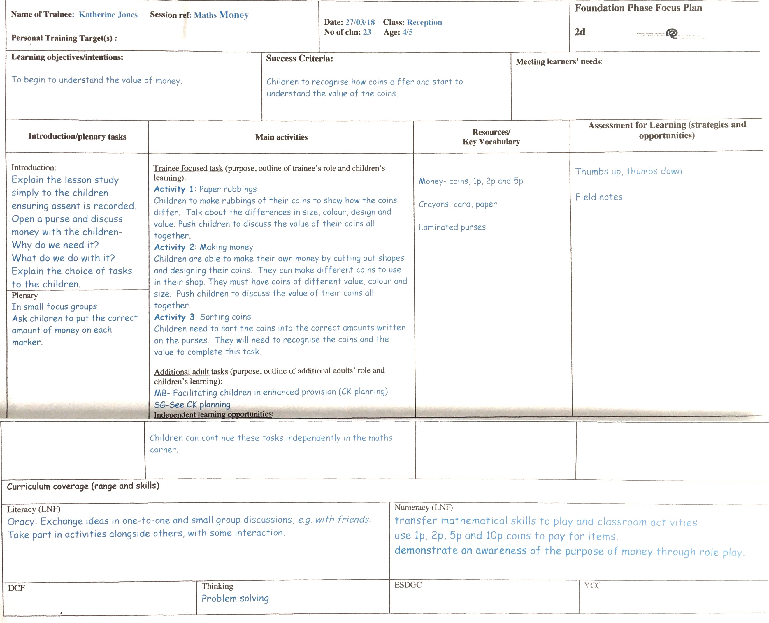

Appendix 7
Tracking observations Date:27.03.18
No of Adults present: 5
No. of children: 24
Time | Description of Activity | Grouping | Level of Involvement
09.30  09.32  09.34  09.36  09.38  09.40  09.42  09:44  09:46 | Child:A - Money making activity – picked the one in front of them.  Sorting out resources they need.  Needed direction but fully concentrating.  After every step asks teacher for what to do next.  Distracted by the other group.  Watching other children.  Keeps stopping to ask the teacher.  Teacher talking to another child.  Finishes off task | SG  SG  SG  SG  SG  SG  SG  SG  SG | 3  4  3  2  1  2  1  3  3
09.55  09.57  09.59  10.01  10.03  10.05  10:07  10:09  10:11 | Child: B – Rubbing activity – Picked the one he saw another child was doing.  Straight into activity.  Looking for different coins – asking teacher to check.  Fully engaged in activity.  Choosing different coins.  Looking at other children for support.  Fully engaged.  Finishing task | SG  SG  SG  SG  SG  SG  SG  SG  SG | 4  4  4  4  4  4  4  4  4
09:30  09:45  10.10  10.11  10.13  10.15  10.17  10.19  10:21  10:23  10:25 | Child: C – Money making activity – had already made up his mind.  Straight into activity on maths table although child’s group have not been called. Child stays at table when new group are called.  Observation starts  Child continues to work at table, fully engaged with activity.  Runs around table to get more card.  Sat fully concentrating – shouting out self-praise.  Looking around but still cutting.  Talking to another child explaining what to do.  Talking while colouring.  Showing work to friend.  Finishes task | SG  SG  SG  SG  SG  SG  SG  SG  SG  SG  SG | 4  4  4  3  4  3  4  3  4  4  3
Grouping
WG – Whole Group
SG – Small Group
P – Pair
I – Individual

Level of Involvement
1 – No activity
2 - frequently distracted
3- Fairly continuous activity
4 – absorbed in activity

Appendix 8

27/03/18

Focussed Interview Transcript- School A

Child A

T: Did you enjoy the lesson?

C: Yes

T: Why?

C: (shrugged, don’t know)
T: What do you think about being able to choose your activities?
C: It is fun.
T: Why did you choose this activity?
C: No answer
T: What made you make that choice?
C: For fun
T: Do you think you worked better today because you chose the task?
C: Yes
T: Why do you think that?
C: No answer
T: Would you like more choice in all your lessons?
C: Yes
T: Why do you think that?
C: No answer
T: How do you think I could make this lesson better?
C: Don’t know

Child B

T: Did you enjoy the lesson?

C: Yes, it was fun.

T: Why?

C: Because it was like doing magic
T: What do you think about being able to choose your activities?
C: I liked it.
T: Why did you choose this activity?
C: It was like doing magic
T: What made you make that choice?
C: Don’t know
T: Do you think you worked better today because you chose the task?
C: Yes
T: Why do you think that?
C: It was my task.
T: Would you like more choice in all your lessons?
C: Yes
T: Why do you think that?
C: I like to choose.
T: How do you think I could make this lesson better?
C: Do more magic.

Child C

T: Did you enjoy the lesson?

C: Yes

T: Why?

C: I liked choosing
T: What do you think about being able to choose your activities?
C: It was fun
T: Why did you choose this activity?
C: It looks good
T: What made you make that choice?
C: I wanted to try it
T: Do you think you worked better today because you chose the task?
C: Yes
T: Why do you think that?
C: Don’t know
T: Would you like more choice in all your lessons?
C: Yes
T: Why do you think that?
C: It’s fun and it’s what I want to do
T: How do you think I could make this lesson better?
C: Things we can choose.

Appendix 9

Model Beirniad Wedi Adfyfyrio (BWA)

Assisted Reflective Conclusions (ARC) Model

Dyddiad/Date: 27/03/18

Digwyddiad critigol (Ffocws)/Critical incident (focus):
Profiad/ Experience

Teimladau/  Feelings  Beth yw eich teimladau ynghylch y profiad?  “What are your feelings regarding the experience?” | This lesson went very well. All children were engaged in the tasks set. The class were excited and enjoyed the session.
Cofio a Deall/  Remember and Understand  “Can you list any factors that influenced the learning /experience?”  “What were the elements of the learning experience that were disappointing?” | The teachers input when initially explaining the tasks influenced the children’s decisions when choosing their task. The children would often choose the last task the teacher mentioned. Also, the children were more likely to choose the task closest to them on the table. They would also choose a task because their friend had chosen the same one.
Gwerthuso a dadansoddi/  Evaluate and analyse  What was the relationship between the resources prepared and the effectiveness of the learning?  “What will you keep the same to ensure effective teaching and learning in the next lesson?”  How did the children react to being given a choice of activities? | The resources had a huge impact on the learning. Children often opted for the more creative task when given the choice.  Keep the short introduction, to ensure the children understand the activities. Give examples of your expectations.  Very well, all children were engaged and motivated throughout the session. One child in particular stayed on the maths table for the whole session despite his group finishing within the first half of the session.
Casgliadau a chamau gweithredu/  Conclusions and actions  How will you use your reflection today to move forward?  What is the most important piece of feedback gained?  Beth ydych yn mynd i’w wneud nesaf?  “What will you do next?” | I am aware that as a teacher I have influenced the class more than I realised, although not intentionally, my tone of voice and how I spoke about a certain task had a huge impact on the choices that were made and the learning that took place.  For the next research lesson I have identified that there is a need to name the tasks A,B,C or 1,2,3 rather than referring to them as coin making or coin sorting etc, as unintentionally I have influenced the children by talking about the individual tasks.  Introduce the activities and explain the different tasks for the children to choose. Name each activity A,B,C so not to influence the children’s decision with informative or exciting names.  Organise resources –perhaps using boxes for children to choose, this will keep the tables more organised and less chaotic.
Y profiad newydd / Transformed experience

Appendix 10
Name of Trainee: | Lesson 2 |  |  | Session ref: |  | Research |  | Date: |  | 29.03.18 |  |  | Class: | Year 2 |  |  | Cynllun Ffocws y Cyfnod Sylfaen  2d
Targed(au) Hyfforddi Personol |  |  |  |  |  |  |  | Number of learners: |  |  |  | 28 | Age: | 6 – 7 |  |  | Cynllun Ffocws y Cyfnod Sylfaen  2d
Learning objectives/intentions: |  | Read and write numbers to at least 100.  Demonstrate an understanding of place value up to at least 100. |  |  |  |  | Success Criteria |  | All children will be able to identify numbers to at least 100.  Most children will be able to read and write numbers to at least 100.  Some children will be able to demonstrate an understanding of place value. |  |  |  |  | Meeting learners’ needs: |  | Children will be sat in mixed ability groups. Adult will be sat at each table for LA children. Each table will have access to concrete apparatus, and their jotters.
Introduction/plenary tasks |  |  |  |  | Main activities |  |  |  |  |  | Resources/  Key Vocabulary |  |  |  | Assessment for Learning (strategies and opportunities)
Introduction  Explain to the children we are conducting research and introduce Miss Jones and ask will they give their assent. Ask the children to show thumbs up if they are willing to take part.  Explain that today they have three choices of activities. They can choose any activity they would like to do.  Introduction  LO: Read and write numbers to at least 100.  Demonstrate an understanding of place value up to at least 100.  Introduce the children to the three different activities.  Explain you want the children to show their workings out in their jotters. They can write on the sheet.  Go through each activity step by step.  Explain each sheet has a challenge if they have completed the main activity they can complete at the end. |  |  |  |  | Problem on sheets – everyone working towards the same problem –accessing different ways to achieve the objective. – Concrete, pictorial or abstract.  Differentiated – children to choose the way they achieve the problem whether it is Concrete, pictorial or abstract.  Children are given a choice of three different activities.  Activity one  Total 100  Children using the 100 square find pairs of numbers that total 100. How many different pairs can they find? How could you organise your answers to know that you have found all the possibilities? Can you find a pair for every number?  Squares  Using a 100 square children will be challenged to find the pattern of the addition.  Draw a 2 by 2 square on the hundred square. Add the numbers in opposite corners. What do you notice? Is it the same for a different 2 by 2 squares?  Make your own hundred square.  Children draw their own hundred square. They need to identify the multiples of 10, 5 and 2.  Can you colour all the multiples of 10 in one colour? What about the multiples of 2 or 5? Do you notice a pattern? |  |  |  |  |  | Resources  Three activity sheets.  Hundred squares.  Deans.  Hundred bead bar. |  |  |  | Think pair share.  Lolly lotto.  How many different pairs can you find? How could you organise your answers to know that you have found all the possibilities? Can you find a pair for every number?  What do you notice? Is it the same for a different 2 by 2 squares?  Can you colour all the multiples of 10 in one colour? What about the multiples of 2 or 5? Do you notice a pattern?
 |  |  |  |  | Miss Davies/ Miss Jenkins to support LA children.

Plenary
Interview with three focussed children.
Curriculum coverage (range and skills)
Mathematical Development

Identify steps to complete the task or reach a solution.
Select appropriate mathematics and techniques to use.
Select and use relevant number facts and mental strategies.
count sets of objects by grouping in 2s, 5s or 10s

Read and write numbers to at least 100.
Demonstrate an understanding of place value up to at least 100.

Literacy (LNF) |  |  |  |  |  |  |  |  |  |  | Numeracy (LNF)  Use checking strategies to decide if answers are reasonable.  Read and write numbers to 100.
DCF |  |  |  |  | Thinking |  |  |  |  |  | ESDGC |  |  |  | YCC

Appendix 11

Tracking observations Date: 29/03/18
No of Adults present:4
No. of children: 28
Time | Description of Activity | Grouping | Level of Involvement
10:13  10:15  10:17  10:19  10:21  10:23  10:25  10:27  10:29  10:31  10:33  10:35 | Child A  Straight in to activity  Talking to friends about activity  Takes work to show teacher- has misunderstood, work not correct  Got up from chair | WG  mixed  abilities | 4  3  3  4  4  3  4  4  1  4  4  4
10:12  10:14  10:16  10:18  10:20  10:22  10:24  10:26  10:28  10:30  10:32  10:34 | Child B  Starts activity with enthusiasm  Completed first part of task- waits for instruction from teacher  Talking with friend about task  Distracted by others on table | WG  mixed  abilities | 4  4  3  4  1  3  3  4  3  2  3  4
10:13  10:15  10:17  10:19  10:21  10:23  10:25  10:27  10:29  10:31  10:33  10:35 | Child C  Starts activity  Gets out of seat  Not at seat  Sits down, back on task  Left table to look at Easter bonnets  On task  Slightly distracted, but continues to work  Working well | WG  mixed  abilities | 3  1  1  3  3  1  4  3  3  3  4  4
Grouping Level of involvement
WG – Whole Group 1- No activity
SG – Small Group 2- Frequently distracted
P – Pair 3- Fairly continuous activity
I – Individual 4- Absorbed in activity

Appendix 12
29/03/18

Focussed Interview Transcript- School B
Child A

T: Did you enjoy the lesson?

C: Yes

T: Why?

C: I like writing and I like maths.
T: What do you think about being able to choose your activities?
C: It was hard.
T: Why did you choose this activity?
C: I couldn’t choose, I wanted to do all of them.
T: What made you make that choice?
C: I like colouring and writing
T: Do you think you worked better today because you chose the task?
C: Yes, I did good explanations as well.
T: Why do you think that?
C: We can choose something that we can actually do
T: Would you like more choice in all your lessons?
C: Sometimes yes, sometimes not.
T: Why do you think that?
C: It was difficult to choose.
T: How do you think I could make this lesson better?
C: I liked it as it was, more writing, more writing.

Child B

T: Did you enjoy the lesson?

C: Yes

T: Why?

C: Because we get to colour in the squares.
T: What do you think about being able to choose your activities?
C: No, it was easy
T: Why did you choose this activity?
C: I chose the blue because I wanted to colour in the squares.
T: What made you make that choice?
C: I wanted to colour in.
T: Do you think you worked better today because you chose the task?
C: Yes
T: Why do you think that?
C: I liked doing the colouring
T: Would you like more choice in all your lessons?
C: Yes
T: Why do you think that?
C: I liked it.
T: How do you think I could make this lesson better?
C: More colouring in.

Child C

T: Did you enjoy the lesson?

C: No

T: Why?

C: It was a little hard.
T: What do you think about being able to choose your activities?
C: Not sure
T: Why did you choose this activity?
C: I like blue.
T: What made you make that choice?
C: (shrugged)
T: Do you think you worked better today because you chose the task?
C: Yes
T: Why do you think that?
C: because it looked a bit easy.
T: Would you like more choice in all your lessons?
C: Sometimes.
T: Why do you think that?
C: Don’t know
T: How do you think I could make this lesson better?
C: Don’t know

Appendix 13

Model Beirniad Wedi Adfyfyrio (BWA)

Assisted Reflective Conclusions (ARC) Model

Dyddiad/Date: 29.03.18

Digwyddiad critigol (Ffocws)/Critical incident (focus): Research
Profiad/ Experience

Teimladau/  Feelings  Beth yw eich teimladau ynghylch y profiad?  “What are your feelings regarding the experience?” | I felt the lesson did not go very well. The children were engaged but I didn’t explain the activities very well and because of this children kept changing their minds at the beginning of the lesson.
Cofio a Deall/  Remember and Understand  “Can you list any factors that influenced the learning /experience?”  How did the use of resources impact the learning?  “What were the elements of the learning experience that were disappointing?” | We had decided before the lesson that I would try and not influence the children in their choice. The children were supposed to pick from three choices that I would lay on the table. But as I had moved the children to their seats before they made their choice. I called out the colour of the first choice and majority of the class got up to choose that colour. I had influenced the children’s choice.  As I had colour coded the resources (blue, red and yellow). Most of the children chose the blue activity. We later found out in the focused interview that this was the children’s favorite colour.  As there were three different activities, my attention was torn between the different children and this meant that some had started the activity wrong. This meant that the children’s motivation wasn’t as high as I had wanted.
Gwerthuso a dadansoddi/  Evaluate and analyse  What was the relationship between the resources prepared and the effectiveness of the learning?  “What will you keep the same to ensure effective teaching and learning in the next lesson?”  How did the children react to being given a choice of activities? | As I had colour coded the resources the children were able to see clearly what they were picking. The children had individual sheets to complete. This however didn’t give the children an opportunity to collaborate with their peers as they some were sat next to someone that were completing a different activity.  Getting the children on activity as soon as possible.  The children in the class were excited to be given a choice. They were all motivated at the start and all the children rushed to start their activity. Throughout the lesson most of the children were engaged.
Casgliadau a chamau gweithredu/  Conclusions and actions  How will you use your reflection today to move forward?  What is the most important piece of feedback gained?  Beth ydych yn mynd i’w wneud nesaf?  “What will you do next?” | Although the children were more engaged in the lesson. I feel that if they had collaborated in their learning they would have learnt more effectively. (Vygotsky).  That the teachers influence in children’s choices is very apparent in the lesson. I felt that the way it is presented activities can also enthuse a class. The activity that was the most popular I felt that I had engaged the children more when explaining it. This as a step forward for my teaching is to enthuse the children in all activities and lessons so they are more engaged.  Giving choice in the activity worked for some of the children but not all. As the children had three very different activities and my time was split three ways. I will still look to include choice in my lesson but vary the activities slightly as to not confuse the children in their learning.
Y profiad newydd / Transformed experience

