

Designing a Carbon Dioxide
Dosing System

Rhys Miller
P140808
Instrumentation & Control
M7X01643
1. Abstract
An acceptable solution has been developed which can control the levels of CO2 in a
pre-determined environment using CO2 injection via diffuser. The solution will be used to treat the output water from a plant with a set flow rate and up to a possible pH of 10.
The research conducted covers the background information needed such as the chemical reaction that takes place between CO2 and water as well as the range of PID controllers and how Kp, Ki and Kd can influence the output.
The development process of the system and transfer functions using MATLAB and Simulink is also covered showing the components and configurations used as well as the produced output graphs showing the stability of the system.
Table of Contents

1. Abstract 2
2. Introduction 4
3. Brief Literature Review 5
3.1. Types of Control Systems 5
3.2. Controlling pH levels in Water using Carbon Dioxide 6
4. Materials & Methods 7
4.1 Selection of Components 7
4.1.1. pH Sensor 7
4.1.2. Gas Valve 8
4.2 Discussion of Possible Disturbances 9
4.3 System Block Diagram 9
4.4 Development of Transfer Functions 10
5. Testing & Results 14
6. Further Improvements 17
7. Conclusion 18
8. References 19

2. Introduction
Control systems are used throughout water treatment to ensure that the produced water contains as few impurities as possible while being safe to drink. Sometimes, this requires that impurities are added so that the acidity or alkalinity of the water is modified to be within the allowed tolerance. For example, Carbon Dioxide is one of the additives used in water treatment to improve the pH levels from being high in alkaline to being pH neutral. However, if too much Carbon Dioxide is added, the water can become too acidic for consumption. Because of this, a control system is used to ensure that only small doses are added when necessary.
This report will cover the development process of creating a control system which will add Carbon Dioxide to treated water to improve the pH levels for consumption.

3. Brief Literature Review
3.1 Types of Control Systems
There are multiple types of control systems that are used for industrial applications so that the process can be efficiently and quickly be carried out while eliminating any errors or deviations that may occur. The different types of control systems deal with these deviations differently from each other as they use different formulae from each other, but can also be combined to form another type of controller which is arguably more efficient.
These controllers are influenced by three main factors depending on the type of controller:
Kp – The Proportional Gain, Ki – The Integral Gain, and Kd – The Derivative Gain. These values can be modified within the controller to determine the output as well as how it will perform. [1].
Proportional gain is applied by looking at the output and measuring the total deviation from the
desired point. The error is corrected by directing the output in the opposite direction in proportion to the size of the deviation. For example, if the deviation was a gradual increase of +5V from the desired value, then -5V would be gradually applied starting from when the deviation occurs until the error is corrected.
Integral gain is applied by looking at the output and measuring the time since the initial deviation. The error is corrected by using the total time passed to determine the value needed. For example, for every second that the voltage is above the desired value, an increasing negative voltage will be applied until the error is corrected.
Derivative gain is applied by looking at the output and measuring the total time of the deviation.
The error is corrected by applying the opposite value to the deviation for the duration of the deviation. For example, if there was a rise in voltage which lasted 5 seconds, then derivative gain would be applied until the voltage has settled.
Below is an example which illustrates the response of Proportional, Integral and Derivative gain.[2]
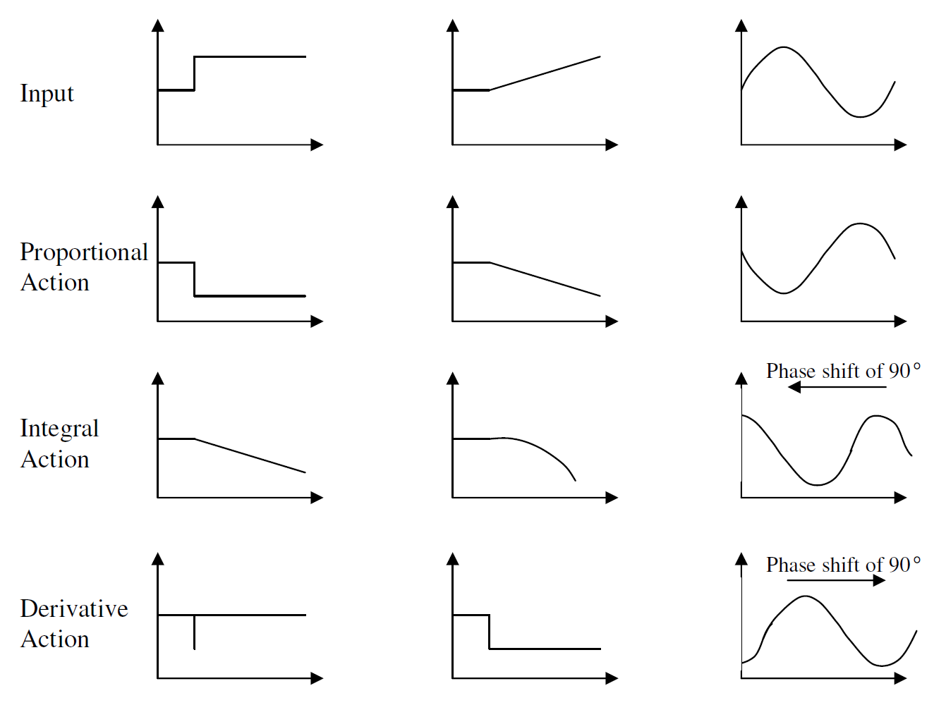
There are different types of controllers such as P-Type, PI-Type, PD-Type & PID-Type. These controllers all make use of the different factors Kp, Ki and Kd to control the output. [3]
P-Type controllers make use of Kp to control the output so it remains steady and predictable. However, using only Kp means that it has a slow response time to deviations and can be unstable due to the total time spent producing the desired output versus the total time spent producing an undesired output.
PI-Type controllers make use of Kp as well as Ki to control the output to ensure that errors do not stay present for long periods of time. Because of this, they can return the output to the initial desired point, giving the name “Reset Controllers”. The problem with these systems is that while the error can be corrected more swiftly, it can overshoot and as a result make the output somewhat unstable.
PD-Type controllers make use of Kp as well as Kd to control the output so that it is regulated and remains constant. These systems have an improved transient response as it can correct overshoot quicker than PI-type controllers. However, because Integral is not used, the initial deviation can take longer to correct.
PID-Type controllers make use of Kp, Ki and Kd to control the output so that it makes use of all the advantages present in each factor for a very fast response time with very little overshoot. Because all three gains are used, they can be modified for a stable output. The problem with these systems is that they can be difficult to setup as they need to be configured according to the applications.

3.2 Controlling pH levels in Water using Carbon Dioxide
In Water Treatment, many chemicals are used to control the pH levels of water depending on where in the process that the chemical is added. For example, Acid injections are used to treat water that is high in alkaline while Neutralising filters are used to treat water which is highly acidic.
Carbon Dioxide is now commonly being used to lower the alkalinity of water as it quickly lowers the pH to acceptable standards and is also much easier to handle and control compared to other alternatives. [4]
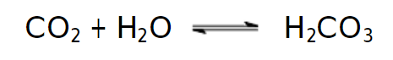
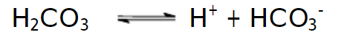
When Carbon Dioxide is added to water, it reacts and produces Carbonic Acid. This acid causes a further reaction and produces a bicarbonate ion along with a hydrogen ion. This will then proceed to lower the pH in the surrounding water as there is now an excess of hydrogen ions in the solution, making it more acidic. The bicarbonate ions will also act as a buffer by slowing the process so that it is easier to halt when the pH reaches the desired value. [5]
The benefits of using Carbon Dioxide to control the pH in water are that it acts as a self-buffering solution which will slow the process as the pH approaches neutral values. By halting the process during this time, the pH can be stabilised at an acceptable value. Carbon Dioxide is also easier to store in large volumes and is much safer to handle than other alternatives such as Sulfuric acid as it can cause severe burns.
4. Materials & Methods

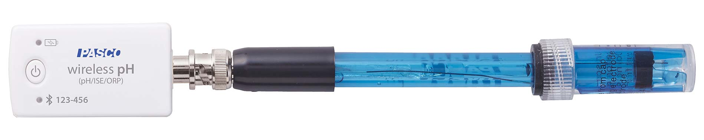
4.1.1 pH Sensor
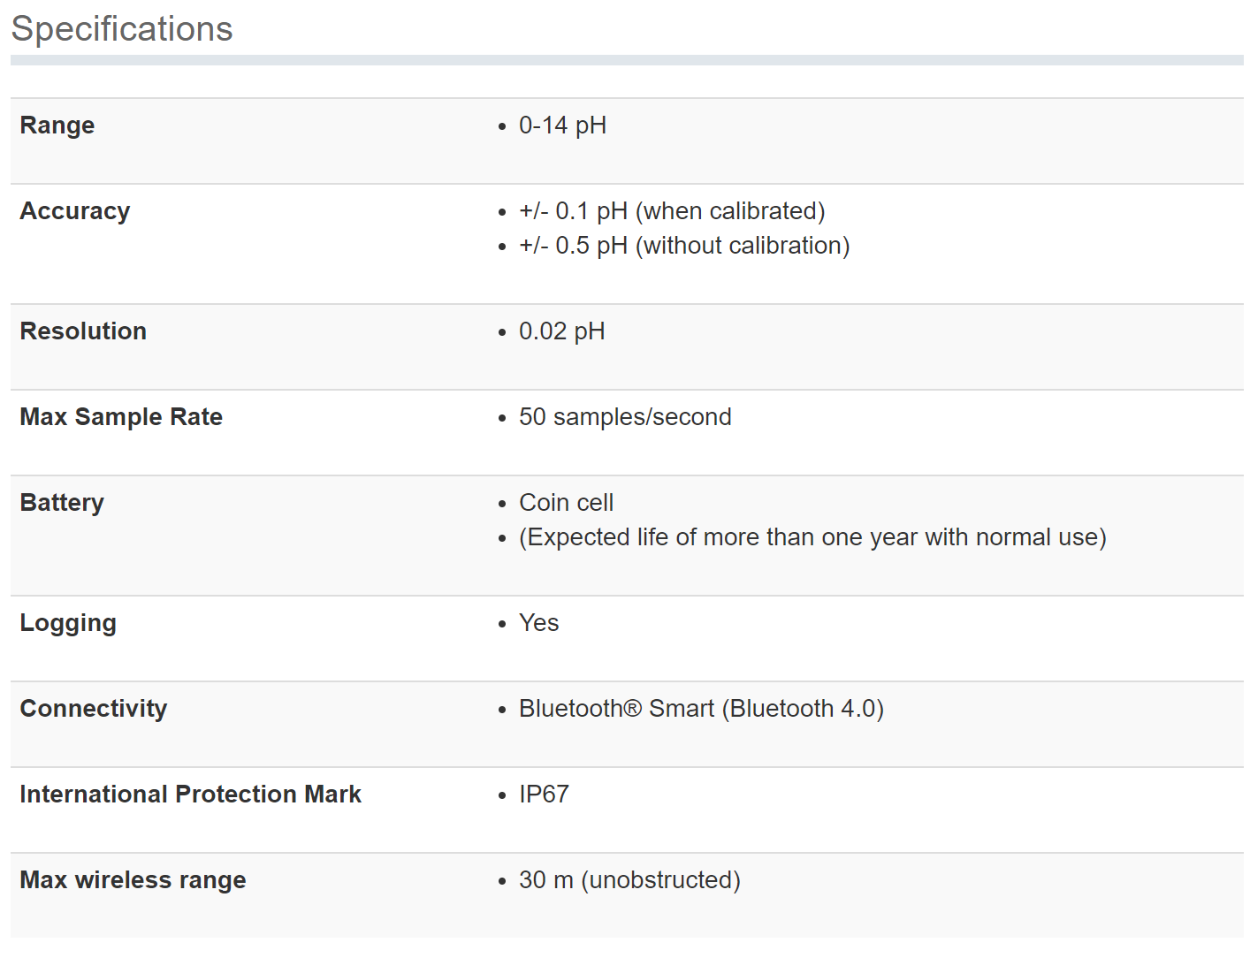
The pH sensor “PS-3204 Wireless pH Sensor”[6] has been selected to measure the pH content of the treated water as it satisfies the requirements. This sensor can measure waters high in alkaline content up to pH 14 and is able to detect changes of up to 0.02pH. The sensor is also suitable for the environment as the probe can be submerged in water and the connection is protected with a rating of 7, allowing for submersion. The sensor is also able to handle the temperature and max pressure of the treated water which will be around room temperature and at approximately 6 BAR. The response time of the sensor is suitable as the rate at which the pH will decrease is relatively slow since carbon dioxide is being used. The sensor will store all data and will be read via Bluetooth.

4.1.2 Gas Valve
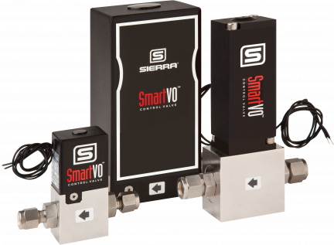
The Gas Valve “VO-100H”[7] has been selected to control the flow of Carbon Dioxide as it satisfies the requirements. This Gas Valve can be controlled digitally and will be compatible with the control system constructed.
The gas valve can also be proportionally controlled to be partially open at different values to precisely control the flow of carbon dioxide. The flow can be made more linear by using an additional controller circuit to maintain the expected 500slpm flow output.
The valve can handle the expected temperature and pressure of the liquified carbon dioxide, which is expected to be -20°C at a pressure of 20 BAR, before it mixes with the treated water. The valve can be controlled using a voltage output or a current output, making the component very compatible and allowing for flexibility during development. While the component is expensive at a cost of £437, with the proper care it can be maintained for several years with little to no maintenance.
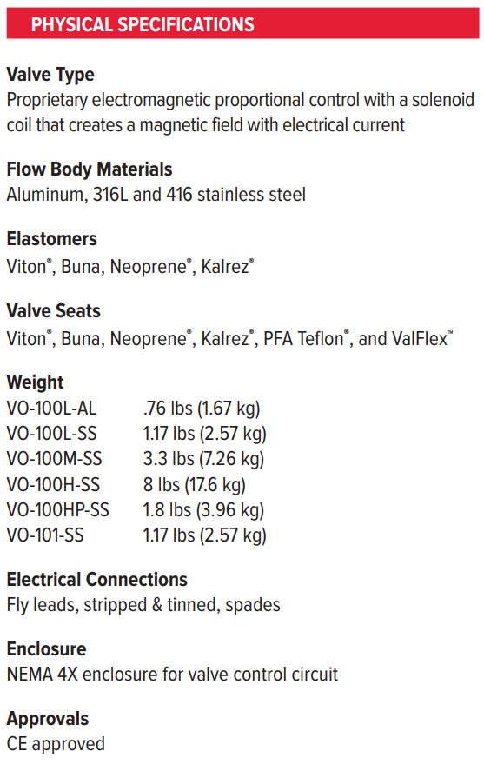
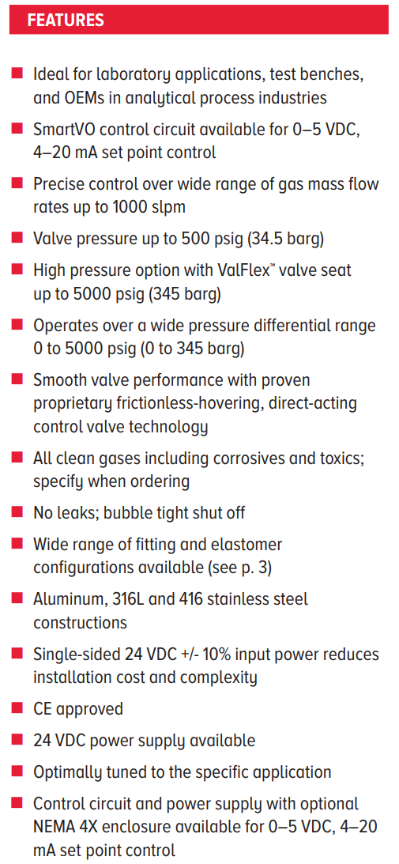
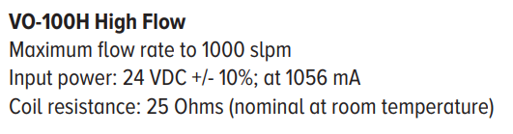
4.2 Discussion of Possible Disturbances
There are several elements of influence that could affect the system which cannot be controlled. These outside elements such as the pH & Temperature of the water being treated as well as the plant flow output are determined by previous processes and control systems already in place. Another outside element that cannot be controlled is the temperature & pressure of the incoming CO2 gas as that is determined by another party which will be using the control system.
Because of these factors, the control system can only be used if the environment is suitable.
The pH and temperature of the water will need to be suitable so that the control system is used effectively. If the pH of the water is already satisfactory, then the system will be inactive. If the flow output of water, the temperature of the water is higher or lower than expected, then the reaction between the CO2 diffused into the water may not obtain the desired pH level. Finally, if the temperature & pressure of the CO2 gas is too high or low, then it may affect the reaction as well as the gas flow valve used as it is rated to handle a specific maximum pressure of gas.

4.3 System Block Diagram
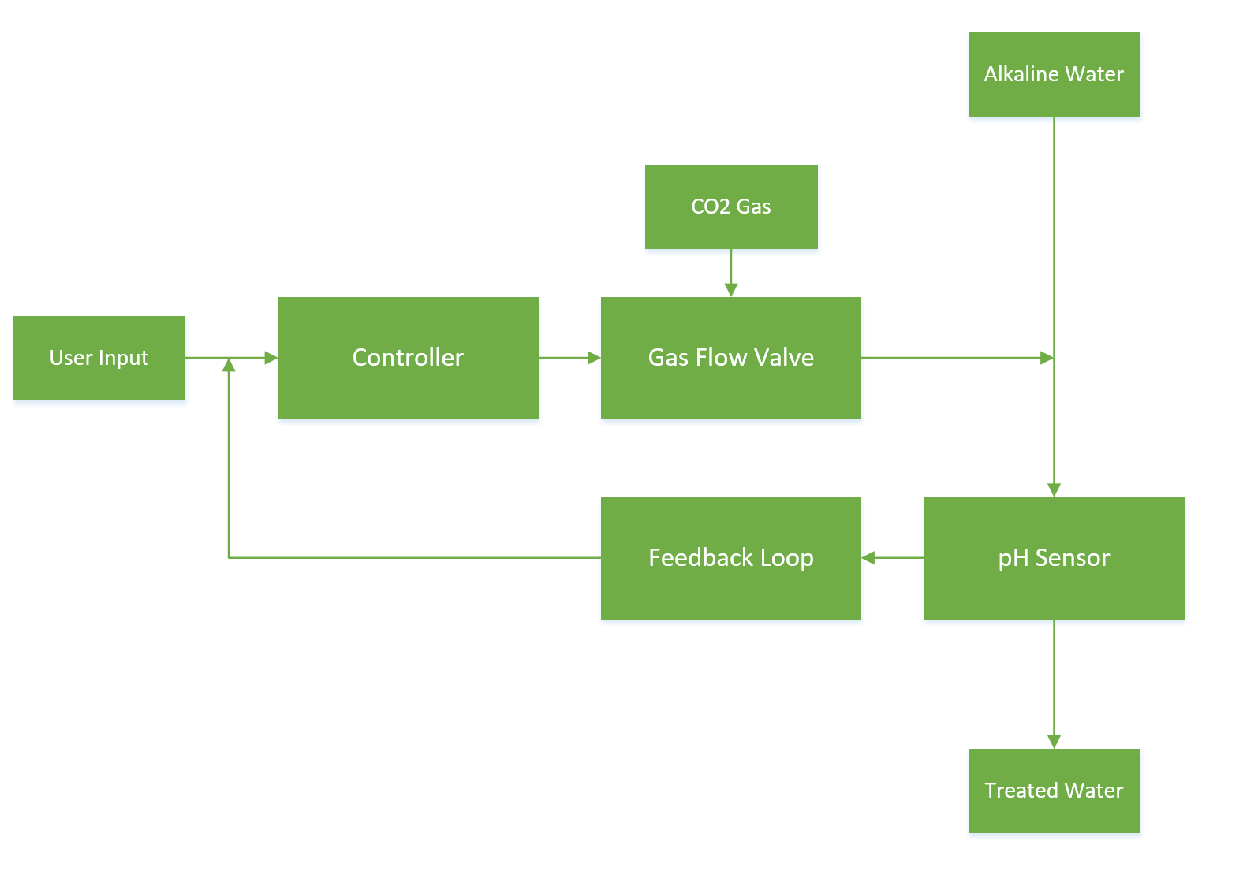

Above is a Block Diagram showing the layout of the control system. Each component chosen such as the pH sensor and the Gas Valve as well as lesser components are clearly represented. Finally, the flow of data through the system is shown from the user input to the pH sensor and back to the controller through the feedback loop.

4.4 Development of Transfer Functions
The transfer function needed to control the amount of CO2 administered will be developed in Simulink by creating a plant that aims to maintain an output of 7pH. This is done because developing the transfer function through other means is difficult due to the logarithmic relationship between pH and CO2.
Below is a screenshot showing the Plant in Simulink which includes transfer functions that control the flowrate of incoming water & injected CO2 as well as the response time & sensitivity of the pH probe used. Other elements such as an Error detector, PID controller, outside disturbance, & signal conditioning are included using the appropriate components.
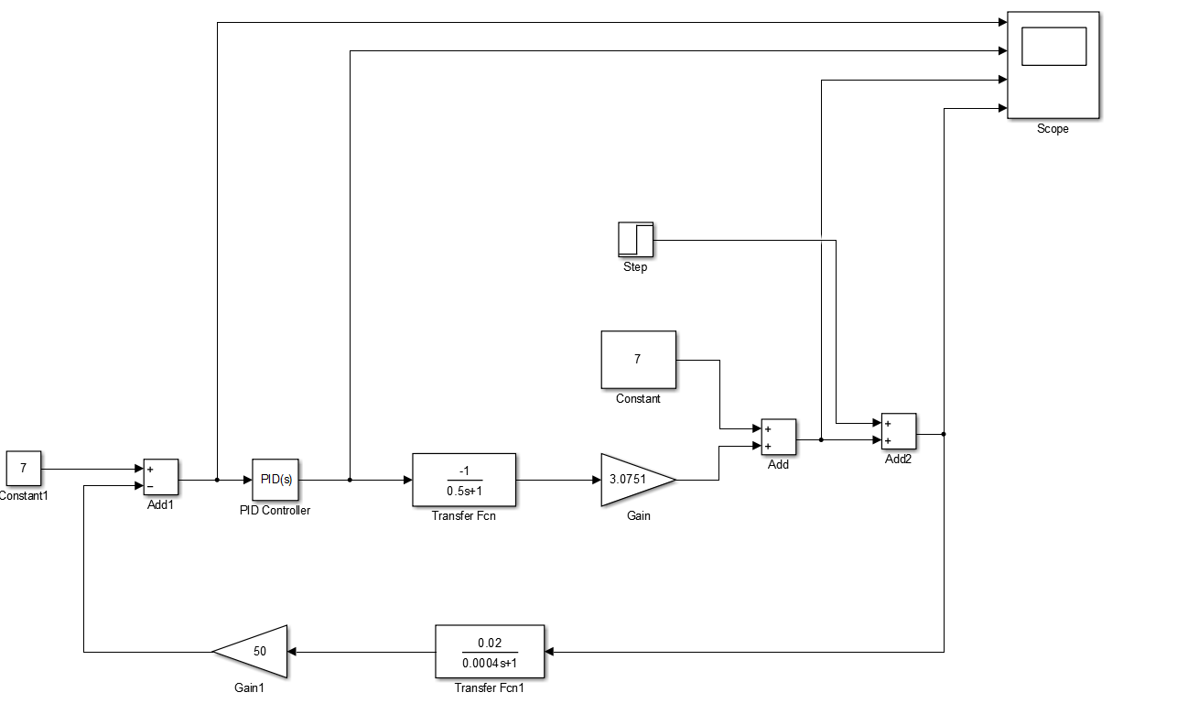
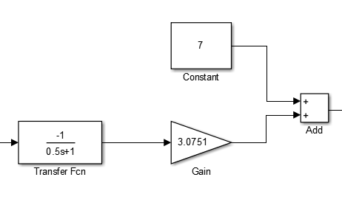
To the right is the transfer function responsible for controlling the Flow Rate & rate of CO2 injected.
A flow rate of 0.5 is used as given in the brief.
-1 is used to determine the direction of output.
The gain of 3.0751 is used as it is the difference between the target of 7pH and the lowest pH that can be obtained. The constant of 7 is used as a set point for the system.
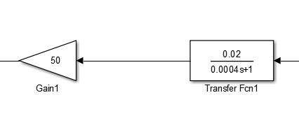
To the left is the transfer function responsible for controlling the response time & sensitivity of the pH probe used as well as the signal conditioning. A gain of 50 is used to increase the output to 7 volts. This is so that the controller is given the correct data.

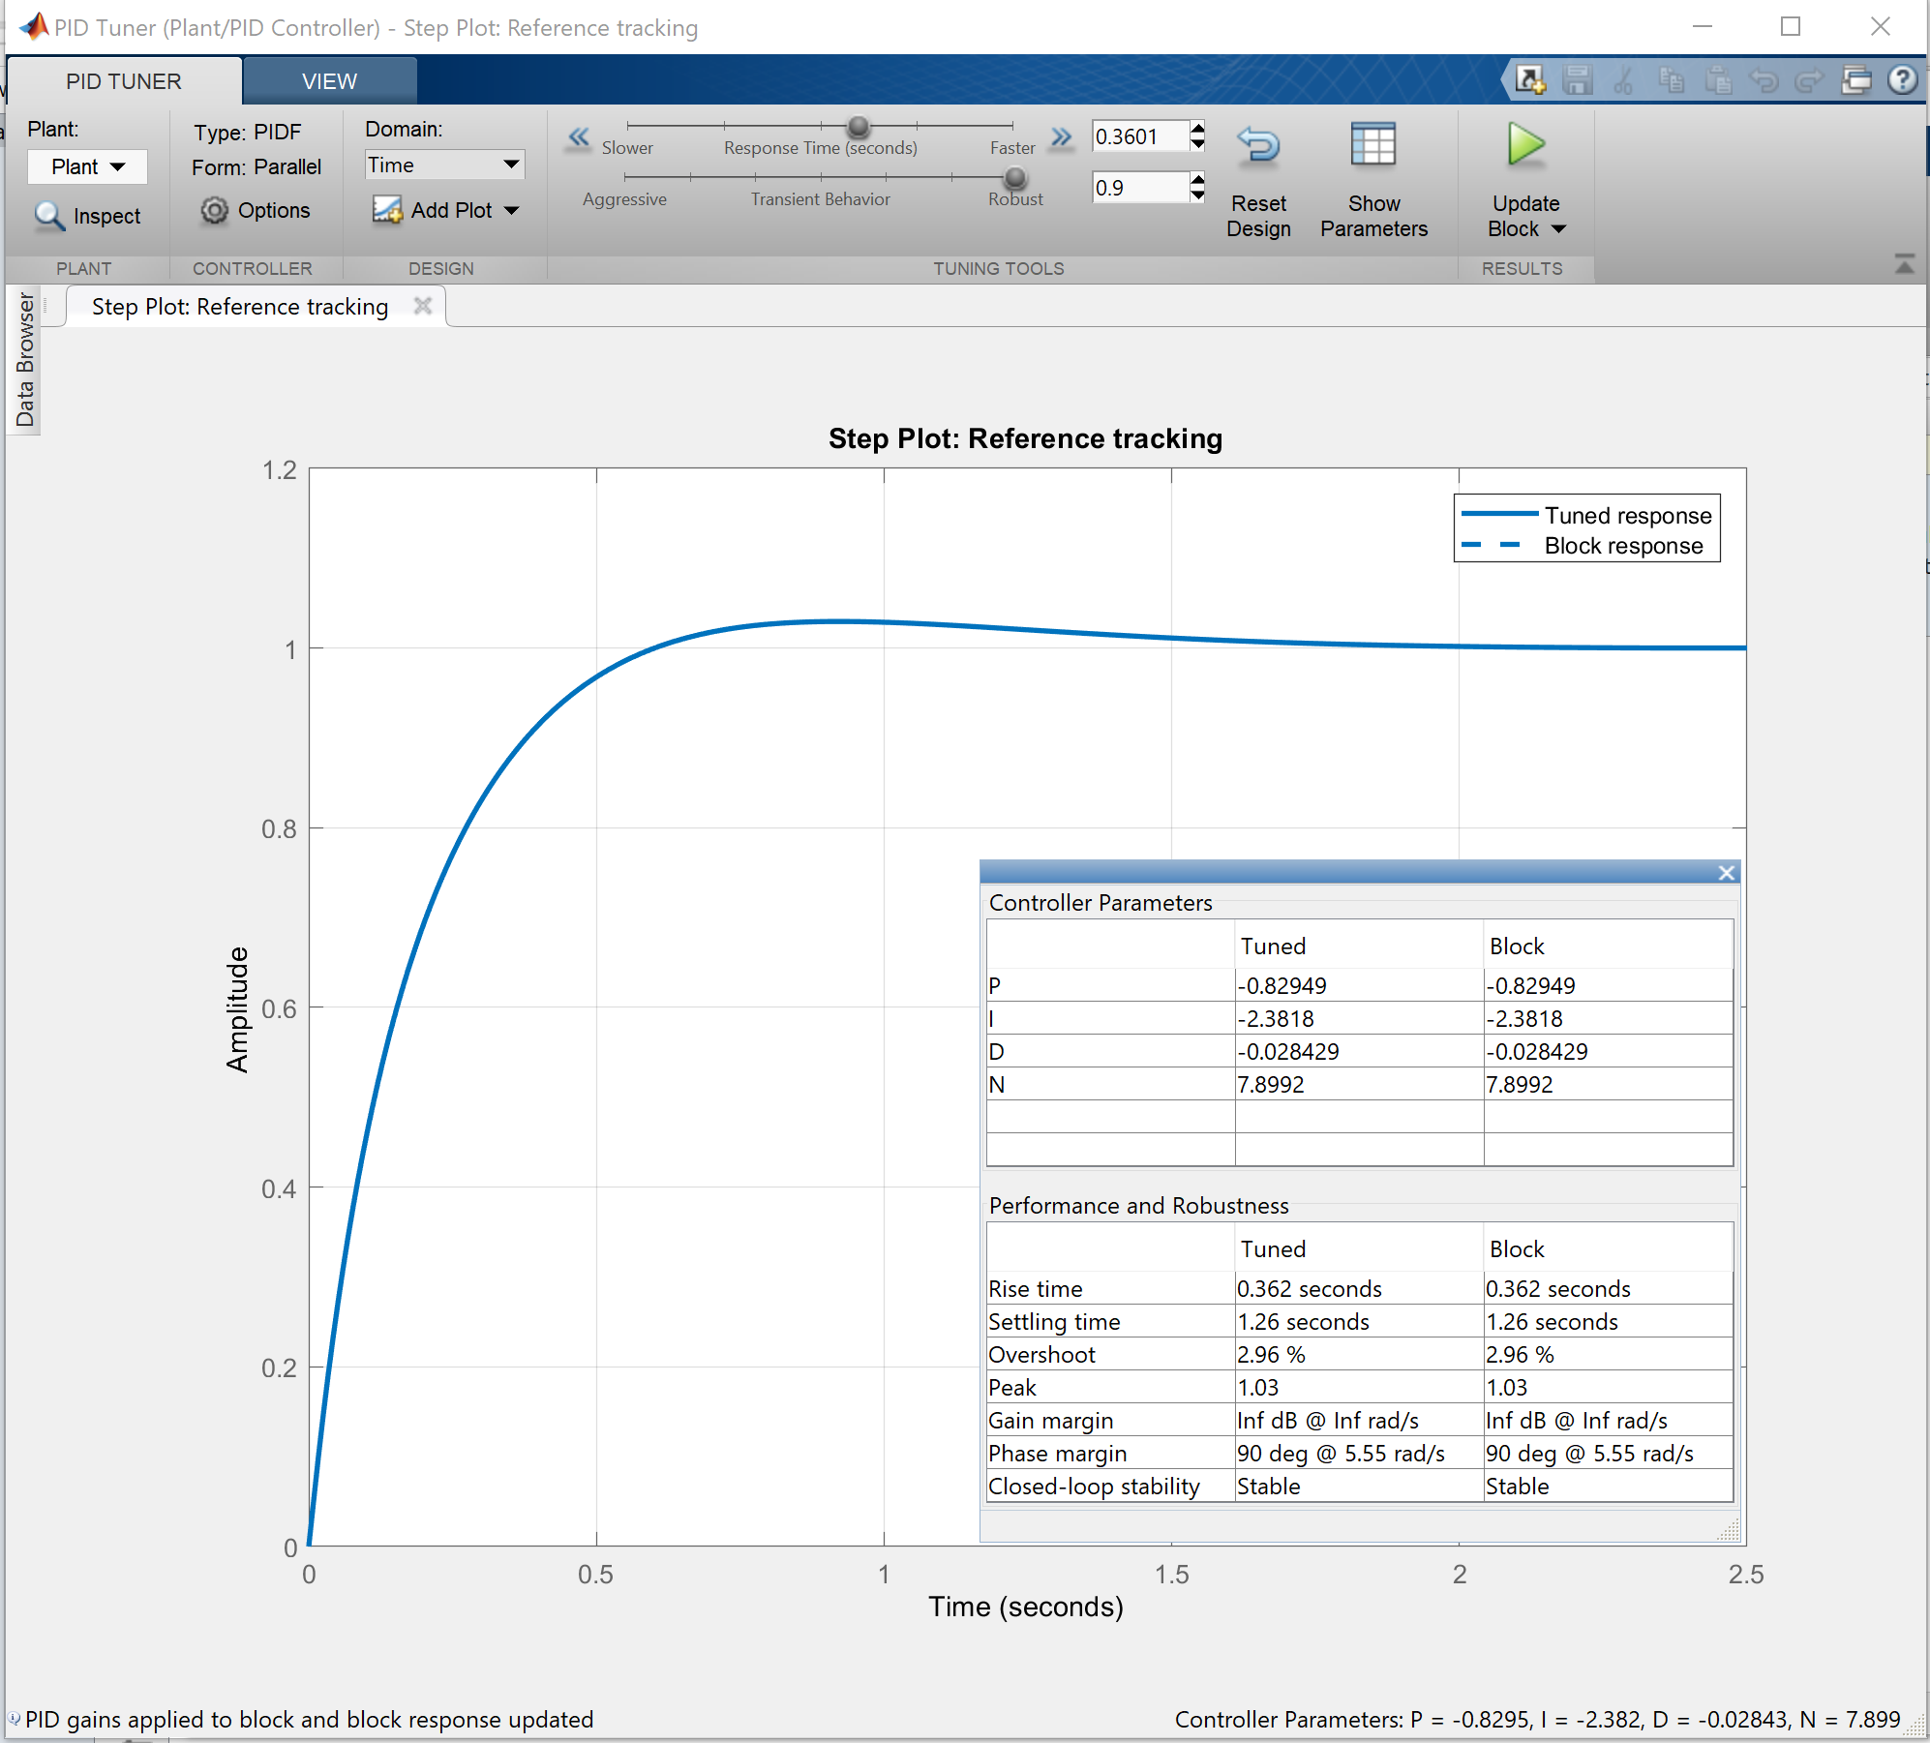
Above is the response curve for the PID controller used as well as the values for Kp, Ki, & Kd.
The parameters such as Overshoot, Rise & Settling time are also shown.
The controller was tuned to obtain an overshoot of less than 5% while also offering a swift rise time of less than a second. The settling time of 1.3 seconds is acceptable along with the overshoot & rise time as it meets expectations for the task being controlled. This is because changing pH by injecting CO2 is a gradual process but also requires that the system can quickly lower the amount of CO2 injected once the target is reached to lower the overshoot in pH levels.

This screenshot below shows the transfer function for the PID Controller. This was obtained by exporting the data to MATLAB and reading the variable created.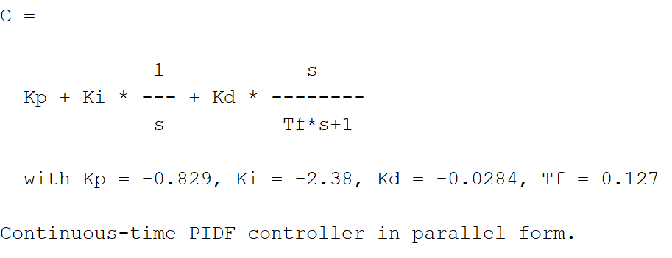
This screenshot below shows the state-space model for the plant excluding the controller. This was obtained by exporting the data to MATLAB and reading the variable created.
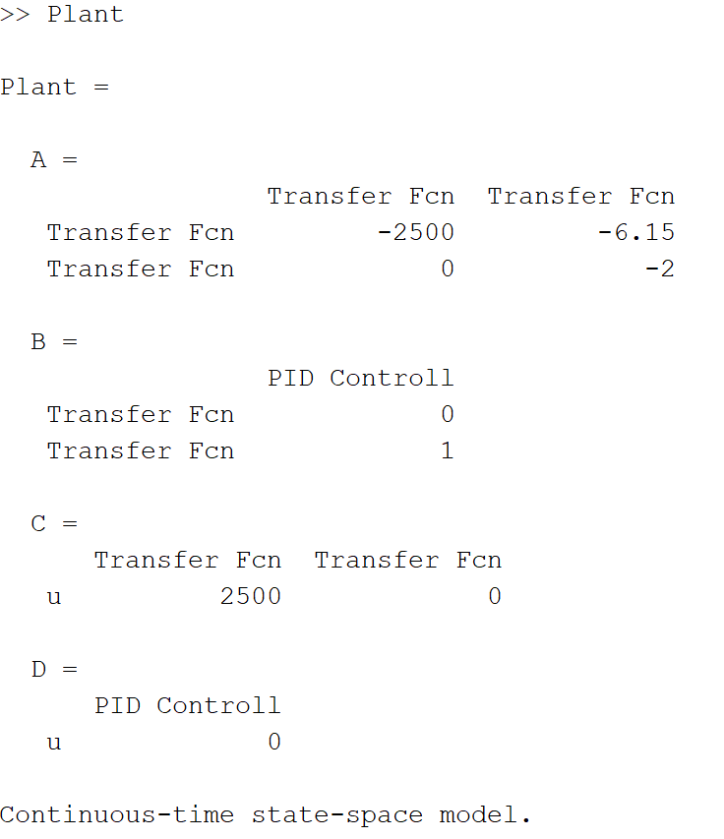

This screenshot below shows the transfer function for the complete plant. This was obtained by using the command “tf(Plant)”.
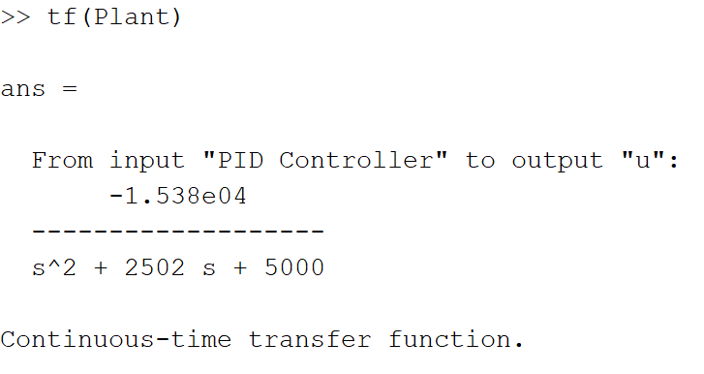
This screenshot below shows the state-space model for the complete plant. This was obtained by using the command “system = C*Plant” and reading the variable “system”.
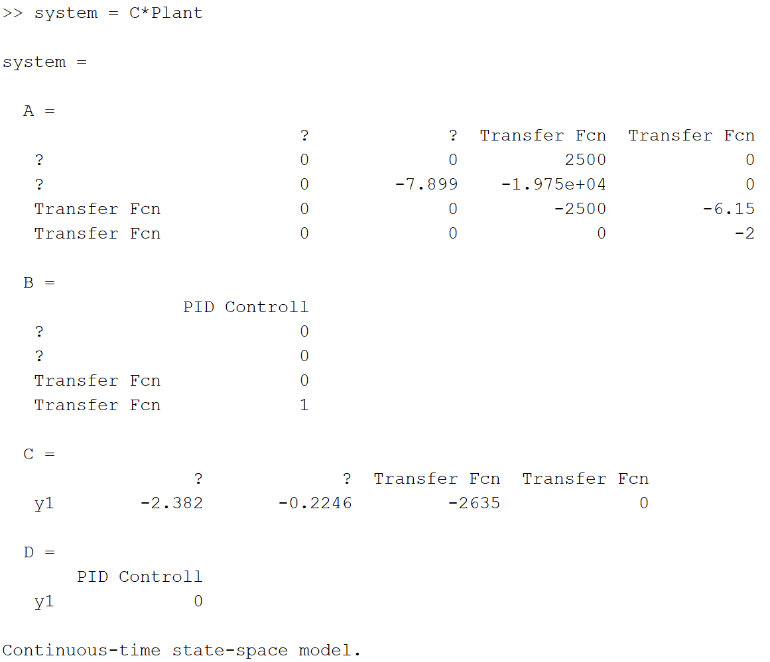
5. Testing & Results
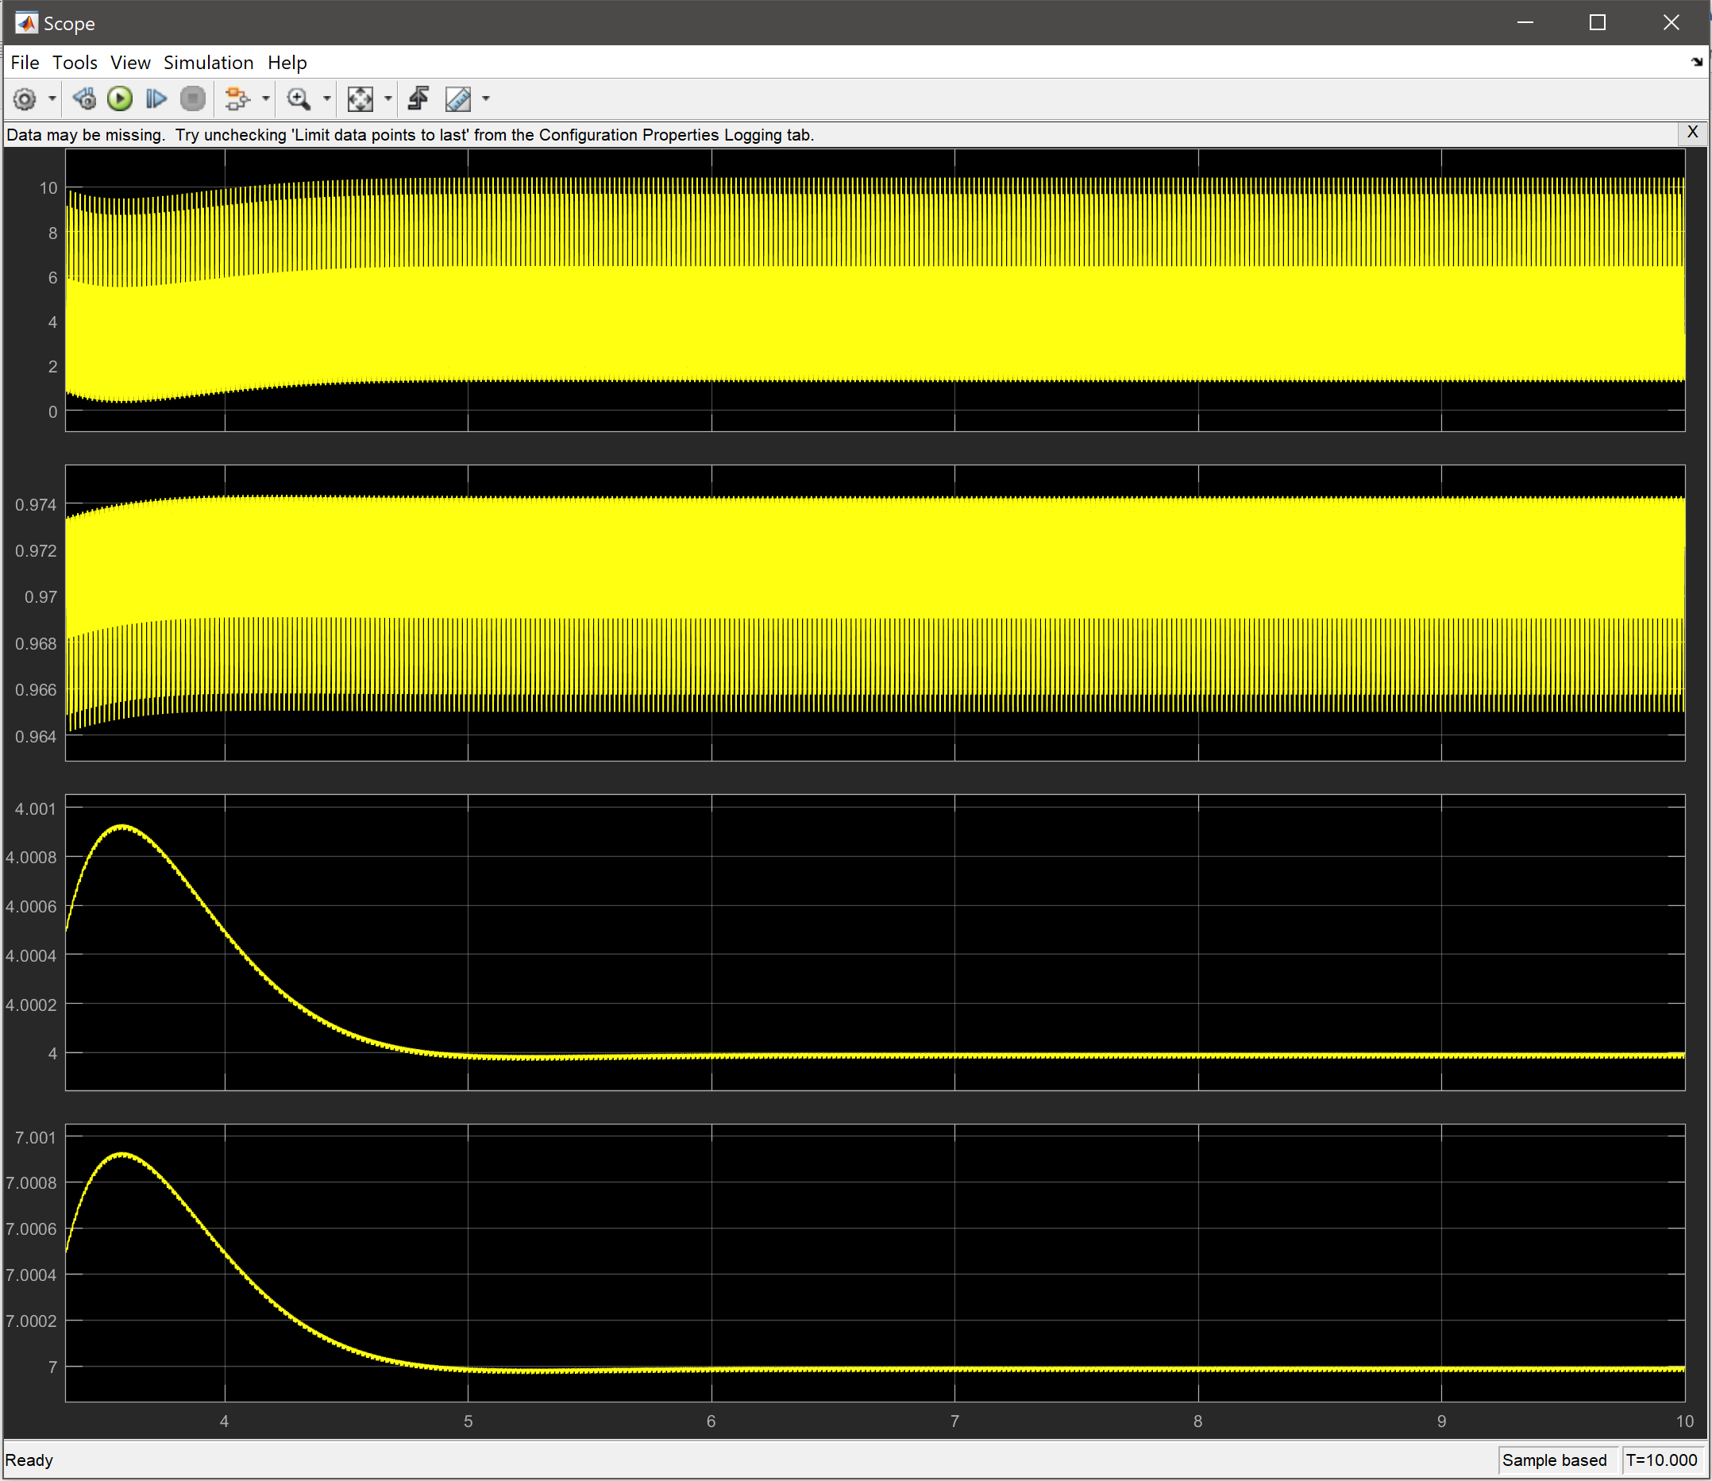
Above is the graph showing the final output as well as intermediate points in the plant.
As shown, the final value of 7pH is obtained after approximately 4.5 seconds using the plant discussed & controller configuration. There are no values to show until approximately 3 seconds as they are filtered out by the filter coefficient used in the controller. This is used to prevent large spikes at the input but as a result, some samples are not used.

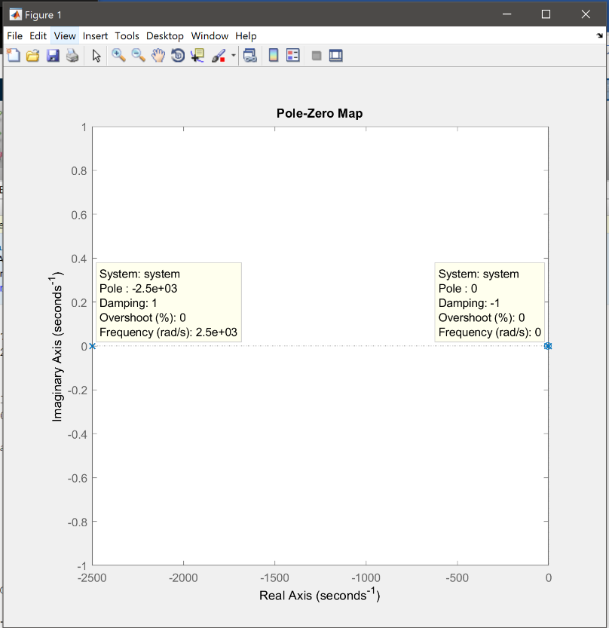
To the left is a Pole-Zero plot of the plant created. The diagram shows that there is a Zero located at the centre of the Real (X) and Imaginary (Y) axis while there is a Pole located at the far negative end of the Real axis and at the centre of the Imaginary axis.
This shows that the system is stable as there is a gradual dampening effect on the oscillation as well as an exponential decay shown by the pole.
Zeros do not affect the stability of the system and as such are negligible.

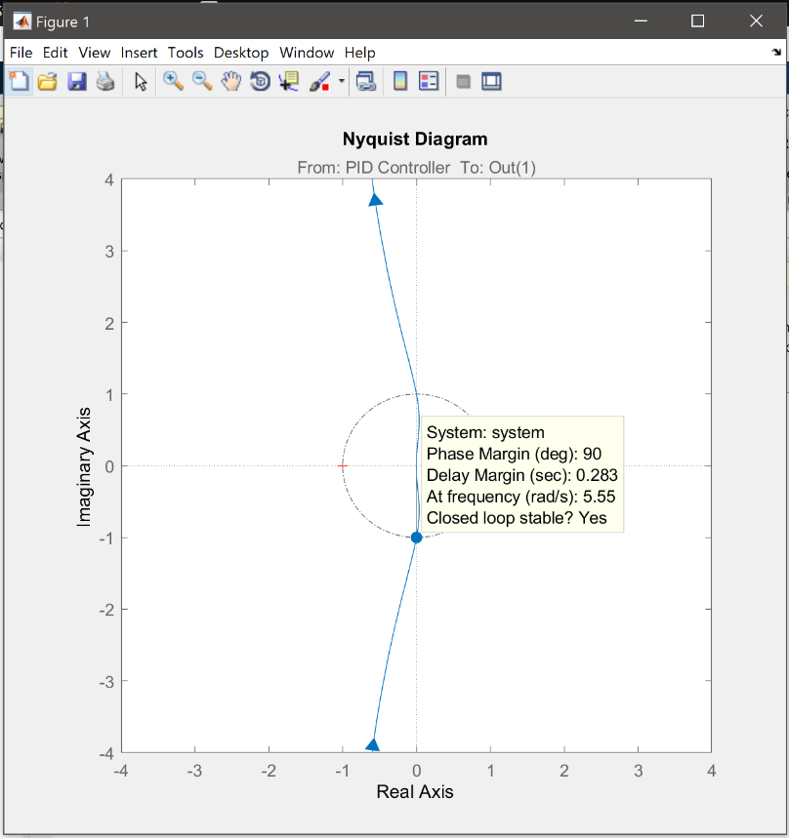
To the right is a Nyquist plot of the plant created. The Phase margin is shown by the angle from the centre of both axis and the point at which the curve intersects the circle. In this case, the system has a phase margin of 90 degrees.
This shows that the system is stable the pole plotted previously are not encircled by the line plotted on the Nyquist plot as it is on the left plane.

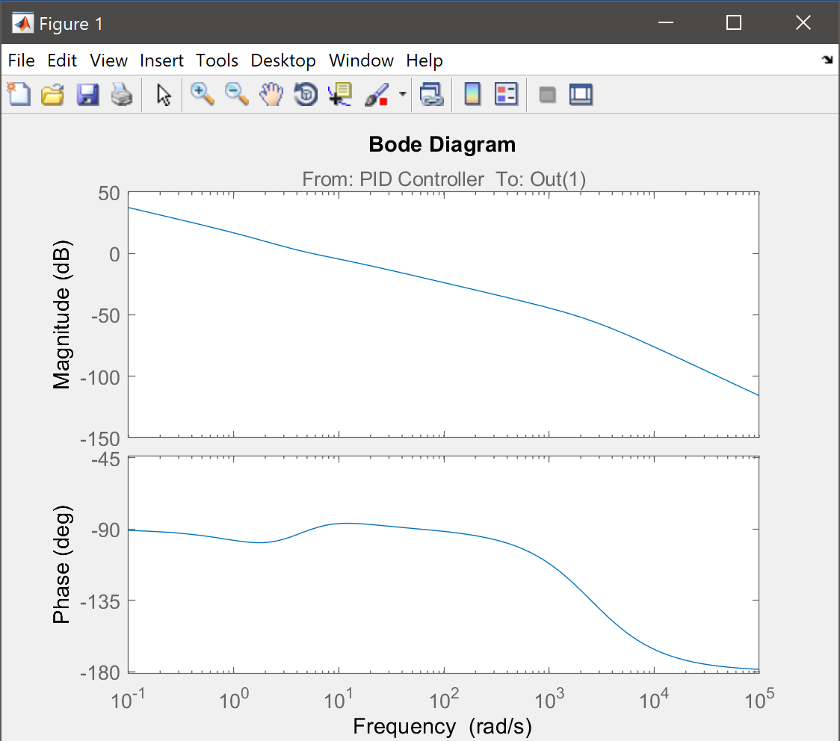
To the right is a complete view of the Bode plot created. Using this bode plot, it is possible to calculate both the phase and gain margins of the system.
The Gain margin is calculated by finding the point at which the phase is -180 degrees on the lower graph and projecting that point onto the upper graph.
The Phase Margin is calculated by finding the point at which the gain is 0 on the above graph and projecting that point onto the lower graph.
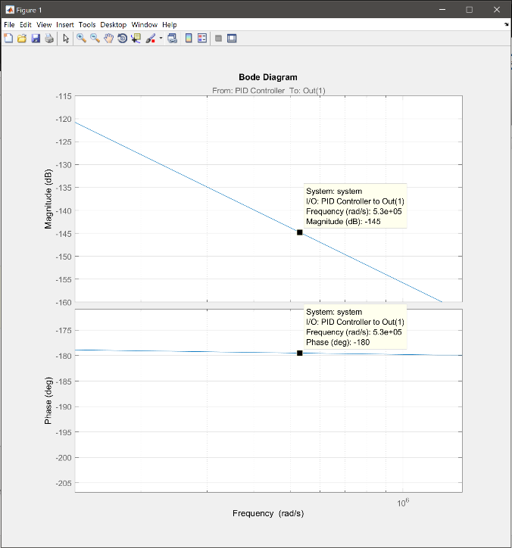
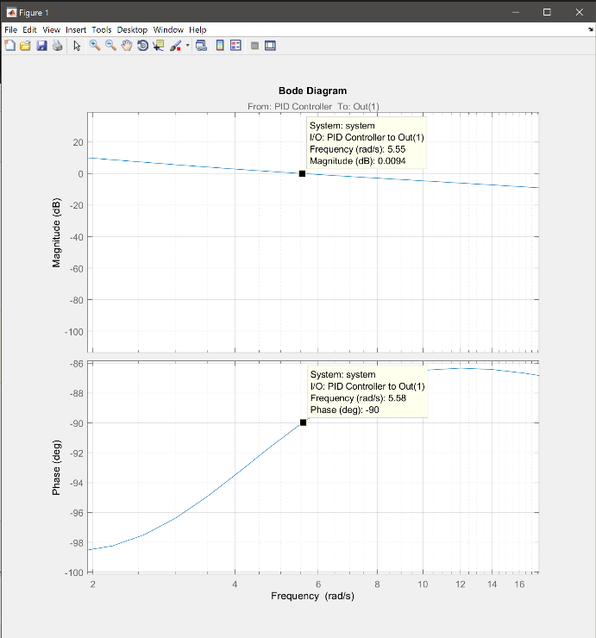
Below are two screenshots of the bode plot zoomed in to show a Gain margin of -145dB and a Phase Margin of -90°. This means that the system can accept an addition gain of 145dB before the limit of stability is reached and an additional phase shift of 90° before the limit of stability is reached.
Both of these points prove that the system created is stable and can handle potential interference.

6. Further Improvements
All the previous graphs and plots show that the system developed is stable and fulfils the purpose of maintaining an acceptable level of pH. However, there are improvements that could be made to produce a more efficient solution such as improving the response time of the system so that samples are not ignored upon start-up. This problem could be solved by either selecting a different pH probe or by adjusting the plant developed so that a suitable controller with the right configuration is used.
There are also several quality-of-life improvements that could be made to the system such as making it account for a range of temperatures and pressures of water as well as varied flow rates. This could be done by selecting the appropriate components in Simulink and building the system so that it changes the necessary values according to the environment it is being used in.

7. Conclusion
In the end, the solution developed meets the expectations set in the given brief as well as the
pre-assumed values used to construct the plant. The components selected perform as intended and the results produced are as expected from the research conducted. The plant constructed is an accurate representation of the environment which the solution would be placed in and clearly demonstrates that it can perform the necessary tasks. Further improvements can be made to the overall system for better performance or usability, showing that it has a potentially long life cycle.

8. References
[1] National Instruments. “PID Theory Explained”. 29th March 2011, [Online].
Available: http://www.ni.com/white-paper/3782/en/. [Accessed 26th November 2017].
[2] G. Jones. “Modes of Control”. University of Wales Trinity Saint David, 2017. [Online]. Available: http://moodle.swanseamet.uwtsd.ac.uk/mod/folder/view.php?id=69326 [Accessed 26th November 2017].
[3] electrical4u. “Types of Controllers | Proportional Integral and Derivative Controllers”. 2017. [Online]. Available: https://www.electrical4u.com/types-of-controllers-proportional-integral-derivative-controllers/ [Accessed 26th November 2017].
[4] eXtension. “Drinking Water Treatment – Adjusting pH”. 3rd January 2011. [Online]. Available: http://articles.extension.org/pages/32302/drinking-water-treatment-ph-adjustment. [Accessed 26th November 2017].
[5] Ibrahim S. Al-Mutaz , Mohammad A. Al-Ghunaimi. “pH Control in Water Treatment Plant by the Addition of Carbon Dioxide”. Riyadh : King Saud University, 2001. [Online]. Available: https://www.researchgate.net/publication/238615738_pH_Control_in_Water_Treatment_Plant_by_the_Addition_of_Carbon_Dioxide. [Accessed 26th November 2017].
[6] PASCO scientific. “Wireless pH Sensor”. 2017. [Online]. Available: https://www.pasco.com/prodCatalog/PS/PS-3204_wireless-ph-sensor/index.cfm. [Accessed 26th November 2017].
[7] Sierra Instruments, Inc. “Precision Gas Flow Control Valves”. 2017. [Online].
Available: http://www.sierrainstruments.com/products/smart-control-valves.html.
[Accessed 26th November 2017].

