University of Wales Trinity Saint David
Wales Institute of Science & Art
University of Wales Trinity Saint David
Wales Institute of Science & Art



ACMA5002
Manufacturing Design & Technology Design for Additive Manufacturing

Thab Moyo
2220979

Abstract
Drones are being used more across industries, and as that happens, the parts that make them up need to keep getting better, lighter, stronger, and more efficient. One part worth looking at closely is the drone arm. The structural piece that connects the main body to the motors. Right now, most drone arms are made using carbon fibre layup or machined aluminium, both of which are fairly wasteful processes and offer little freedom in terms of shape or geometry.
This report looks at redesigning a quadrotor drone arm using additive manufacturing, essentially designing it from the ground up with 3D printing in mind. Two printing methods were considered: FDM with carbon fibre-reinforced Nylon (Markforged Onyx) and SLS with PA12 nylon powder. The redesign draws on techniques such as topology optimisation, lattice structures, and part consolidation to get the most out of additive manufacturing.
Tools like QFD, FEA, and DFMEA were used throughout to guide and validate design decisions. The result is a drone arm that is lighter than a standard aluminium version, with better torsional stiffness and the added benefit of being producible on demand without complex supply chains. The report also addresses real limitations, such as directional material weaknesses, the removal of the support structure, and higher per-unit costs at low volumes, alongside the clear advantages that additive manufacturing brings to drone development.

Introduction
The global drone market reached $30.6 billion in 2023 and is projected to grow at 12.4% annually through 2030 (Grand View Research, 2024). As applications expand across aerial imaging, agriculture, delivery, and infrastructure inspection, structural design faces increasing pressure to minimise airframe mass while maintaining strength — since every gram saved directly extends flight time or payload capacity.
Traditional methods such as carbon fibre layup and CNC machining impose geometric constraints that often compromise performance or increase costs. Additive manufacturing removes many of these limitations, and DfAM exploits this freedom by redesigning components from first principles to account for AM capabilities and constraints, as outlined by Thompson et al. (2016).
The drone arm was selected as the focus of this DfAM case study because it experiences well-characterised flight loads while performing multiple functions — structural support, motor mounting, wire routing, vibration absorption, and crash resistance. It is complex enough to demonstrate key DfAM techniques (topology optimisation, lattice structures, consolidation) without introducing unmanageable analysis challenges, and it benefits from established UAV-AM research (Klahn et al., 2015; Rao et al., 2022).
This report follows a systematic structure: critical analysis of the baseline design and its limitations; development of a QFD-derived specification; application of DfAM strategies to create a redesigned arm; structural verification via FEA; risk assessment using DFMEA; and evaluation of performance, economic, and lifecycle implications.

2. Component Selection and Background

2.1 UAV Arm
This report focuses on redesigning the structural arm of a quadrotor drone based on the DJI F450 frame, a widely used platform in research (Rao et al., 2022). The arm extends 150–220 mm from the centre to the motor mount, transferring thrust and vibration to the chassis while keeping weight to a minimum, a challenging combination that makes it ideal for DfAM investigation.
The current design uses a 220 mm-long 6061-T6 aluminium extrusion (16 × 12 × 1.5 mm walls) with a separate CNC-machined motor-mount plate bolted on and an adhesive wire clip underneath. The complete assembly weighs 38 g but comprises four separate components, offering clear opportunities for consolidation and optimisation.
The component was selected for four reasons: the flight loads are well understood and suitable for FEA. It performs multiple functions (structural, mounting, wire management) through separate parts; arm mass reduction directly improves drone performance; and there is substantial peer-reviewed research on AM in UAV structures to support the redesign decisions.

2.2 Limitations of the Standard Design
High part count: The current arm assembly consists of four components: the arm itself, the motor mount plate, the wire clip, and the fasteners. Each one has to be manufactured individually and then assembled. Every joint between them adds assembly time, creates the potential for misalignment, and creates a stress concentration at bolted connections that can become a fatigue problem over time (Rao et al., 2022).
Geometric inefficiency of the extrusion: Because the arm is made by extrusion, it has the same cross-section from one end to the other. The manufacturing process doesn't allow for any variation in wall thickness, shape, or internal structure along the length. That means material can't be placed where it's actually needed or removed where it isn't. The result is unnecessary mass, especially near the frame hub where bending moments are at their highest (Ding et al., 2015).
Material waste in the motor mount: The motor mount plate is CNC-machined from a solid aluminium blank, bringing about significant material being cut away and discarded. The buy-to-fly ratio is estimated at 3:1 to 4:1, which represents both a direct cost and a considerable environmental impact given aluminium production's energy intensity.
Crash fragility: Aluminium extrusions tend to fracture suddenly under impact rather than deform gradually. For a drone which will inevitably crash, especially during testing or training, that's a real problem. Polymer AM materials can be tailored to absorb impact energy progressively, which is far more effective at protecting the motor and electronics from damage.
No internal wire routing: The motor cables currently run along the outside of the arm, held in place by adhesive clips. This leaves them exposed to snagging and adds a small but unnecessary aerodynamic drag penalty. It's a limitation inherent to the extrusion process; producing internal channels for wire routing would require additional drilling or machining beyond the base manufacturing.

3. Design Specification and QFD
The DfAM objectives for this design were developed directly from the functional requirements of the arm and shaped every decision made during the CAD modelling process. The first and most important objective was consolidating the arm body, motor mount plate and frame flange into a single printed part. In the conventional design, these are three separate components held together with fasteners, which add weight and create potential failure points at every joint. By printing them as one piece these issues are eliminated entirely.
The second objective was reducing mass in areas of the arm that do not carry significant load. This was achieved by adding elliptical cutouts in the mid-section of the arm where bending stress is lower. Elliptical holes were chosen over rectangular slots because they produce lower stress concentrations at the edges which reduces the risk of cracking under repeated loading.
The third objective was selecting the right build orientation. The arm is printed flat on the build plate so that the layers run perpendicular to the main bending direction. This takes advantage of the stronger in-plane properties of the Onyx material and also means no support structures are needed during printing, which saves material and post-processing time.
Overall, these objectives ensured that the final design was not just lighter than the conventional aluminium arm but also structurally more efficient and simpler to manufacture using the FDM process.

4. DfAM Procedure and Tools Applied

4.1 Part assembly
Component consolidation is one of the most valuable DfAM strategies according to Gibson et al. (2021) because it allows multiple parts to be combined into one, removing the limitations that each individual manufacturing process places on the design. In the standard DJI F450 arm setup there are three separate components: the hollow aluminium arm body, a CNC machined motor mount plate and a pressed metal frame bracket, all bolted together with M3 screws. Every joint is a weak point. Under repeated thrust loading these interfaces are where fatigue cracks develop over time (Rao et al. 2022).
In the redesigned arm all three components are merged into a single flat plate FDM part. The motor mount is an integrated circular disc at the distal end, the frame flange is a wider rectangular section at the proximal end and both are printed in the same operation with no secondary machining or assembly required. This reduces the part count from three structural components and eight fasteners down to one printed body with four motor screws, a 75 percent reduction that directly cuts assembly time and eliminates every fatigue-critical joint in the original design.
Kumke et al. (2016) identify three conditions for consolidation to work: shared material, no relative motion in service and a geometry that is printable within the chosen process. All three are satisfied here. The arm is printed entirely in Onyx, the mount and flange are statically assembled and the flat plate geometry requires no support structures as discussed in Section 4.5.
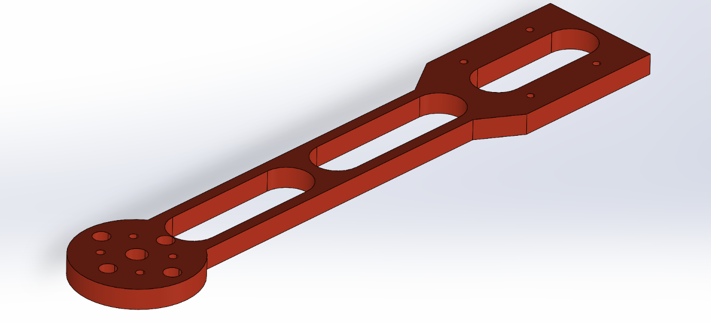

4.2 Topology Optimisation
The mid-section of the arm has two elongated elliptical holes that run all the way through the plate. These are positioned symmetrically on either side of the centre line of the arm. The reason for placing them in the middle of the arm rather than anywhere else comes down to how the bending stress is distributed along the arm length. The bending moment is highest at the proximal end, where the arm connects to the frame, because that is the point furthest from the point of load application. As you move towards the motor end the bending moment gradually reduces. This means the middle section of the arm is not carrying as much bending stress and is therefore the most sensible place to remove material without weakening the arm in any meaningful way.
Liu et al. (2018) point out that topology optimisation does not always have to mean running complex software. It can also mean making informed design decisions based on a solid understanding of how a structure is loaded. That is exactly the approach taken here. The arm behaves similarly to a cantilever beam with the load applied at the tip, which is a well understood structural problem. Using that understanding, the cutouts were placed where the stress demand is lowest, achieving the same goal as a formal topology optimisation without the need for additional software tools.
The decision to use elliptical holes rather than rectangular slots was also deliberate. Rectangular slots have sharp corners, which create high stress concentrations at those points. Elliptical holes distribute stress more smoothly around the boundary which significantly reduces the risk of fatigue cracking at the hole edge under repeated loading. Pilkey and Pilkey (2008) confirm that elliptical holes with the longer axis aligned with the bending direction produce much lower stress concentration factors than rectangular holes.
Between the two cutouts, a solid rib of material runs down the centre of the arm. This rib is important because it keeps the load path continuous and also provides torsional stiffness to resist the reaction torque from the motor spinning at full throttle. At both ends of the arm, the full plate cross-section is maintained. The flange end needs the full cross-section to handle the peak bending moment, and the motor end needs it to distribute the bolt-bearing loads from the motor mount screws. The result is a design where material is concentrated exactly where the structure needs it and removed where it does not, which is one of the core principles of DfAM and something that would add high cost and complexity in any conventional manufacturing process.

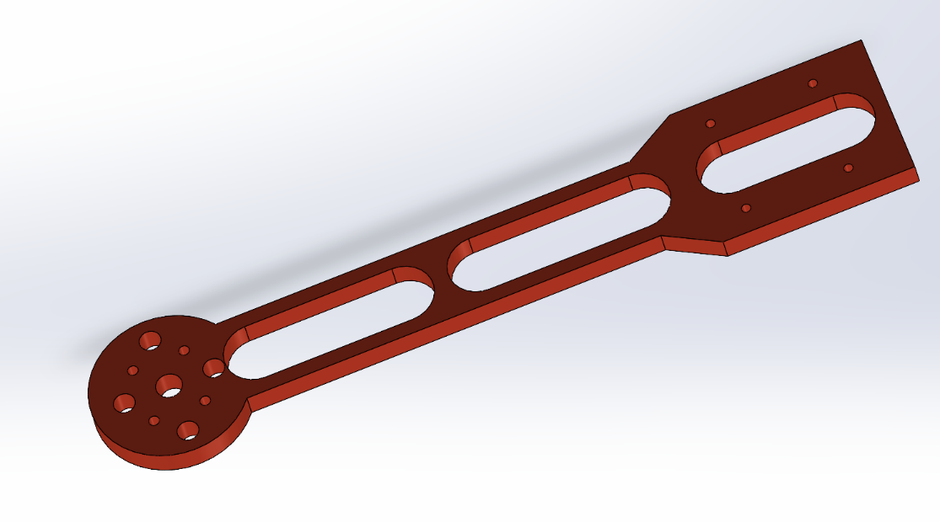
Holes to improve weight

4.3 Integrated Motor Mount Disc Design
The circular motor mount disc at the distal end is one of the most significant DfAM features in this redesign. In the conventional assembly the motor mount is a separate CNC machined aluminium plate bolted on via a secondary bracket, adding parts, weight and another joint that can fail under repeated loading. In the redesigned arm it is simply a circular disc integrated into the same flat plate and printed in the same operation, with the motor bolt holes built directly into the geometry. No drilling or secondary machining is needed after printing.
The circular form was chosen over a rectangular plate for two reasons. First it provides clearance around the motor bell housing during operation removing any risk of contact. Second it distributes the thrust and torque loads from the four motor bolts over a larger bearing area. This matters because Onyx has lower bearing strength than machined aluminium so spreading those loads reduces the risk of bolt pull-through under heavy throttle.
Additional lightweighting holes are included between the bolt holes and the disc edge in areas of low structural demand. These reduce mass without affecting stiffness or torque resistance and are arranged symmetrically to maintain rotational balance and avoid asymmetric stress concentrations.
In conventional manufacturing this disc would require separate machining with multiple drilling operations before assembly. In the AM process the entire geometry is produced in one print with no additional cost or time regardless of complexity. This is precisely the geometric freedom advantage that Thompson et al. (2016) identify as one of the core benefits of DfAM.

4.4 Frame Attachment Flange and Geometric Transition
The proximal flange connects the arm to the DJI F450 central frame. It is designed as a wider rectangular platform that provides a broad and stiff contact area against the frame socket. The increased width compared to the arm body makes the connection more stable and less likely to flex or rock under flight loading.
The flange uses two elongated slots rather than fixed bolt holes. These serve two purposes: they reduce flange mass by removing material that is not structurally necessary and they allow positional adjustment when fitting the arm to the frame. Frame socket geometry can vary slightly between production batches so having slots rather than fixed holes means the arm can be fitted correctly without needing perfect hole alignment every time. Small clearance holes at the flange corners provide additional fastener positions for secondary retention if needed, adding a layer of redundancy to a safety critical joint.
The transition between the wider flange and the narrower arm body is tapered rather than stepped. This is a deliberate DfAM decision. An abrupt step change in cross sectional width would create a stress concentration at that junction. In an FDM printed part this is particularly problematic because interlayer bond strength is lower than in-plane strength, meaning peel stresses at a stiffness discontinuity can initiate delamination over time. Diegel et al. (2019) identify smooth geometric transitions as a fundamental DfAM principle for polymer AM components for exactly this reason. The taper redistributes the bending stress gradually which eliminates the concentration and protects the joint from delamination during service.

4.5 Build Direction Optimisation
The flat plate shape of this arm design works really well with FDM printing because it allows the arm to be laid flat on the build plate during printing. This means the face of the plate sits parallel to the XY plane of the printer and the 6mm thickness of the arm builds up in the Z direction layer by layer. This might seem like a simple decision but it actually has three significant advantages from a DfAM perspective.
The first advantage is that no support structures are needed at all. Because the arm is a flat plate with through holes and no overhanging features there is nothing in the geometry that requires support material underneath it during printing. This is a meaningful benefit because support structures add print time, use extra material and have to be removed after printing which can damage surface finish or leave marks on the part. Eliminating them entirely simplifies the whole manufacturing process from start to finish.
The second advantage is that the main bending load path of the arm runs along its length in the X direction and printing flat means the FDM deposition direction aligns with this. In FDM the layers are deposited in the XY plane so the fibres and material bonds run in the same direction as the primary load. This places the stronger in-plane material properties exactly where the structural demand is highest which is the correct engineering approach when working with an anisotropic material like Onyx.
The third advantage is dimensional accuracy. The XY resolution of the Markforged FDM system is significantly higher than the Z direction resolution. By printing flat all of the critical features including the elliptical cutout boundaries and the motor bolt holes are formed in the XY plane where the printer is most accurate. This improves the quality of these features compared to what would be achievable if they were built up layer by layer in the Z direction.

5. Additive Manufacturing Process Selection
Four AM processes were evaluated before a final selection was made: FDM with continuous carbon fibre using the Markforged Mark Two, standard FDM with Onyx, SLS with PA12 and MJF with PA12. Each was assessed against five criteria: mechanical properties, compatibility with the flat plate geometry, support structure requirements, dimensional accuracy at the motor bolt holes and unit cost at 50 to 200 units per year.
The Markforged Mark Two with continuous carbon fibre was selected as the primary process. The flat plate geometry works particularly well with how the Markforged system deposits fibre, laying it down in concentric rings across the full plate face in each layer. This maximises fibre coverage in the bending direction which is exactly where the structural demand is highest. The system achieves a flexural modulus of up to 60 GPa and tensile strength of up to 700 MPa in the fibre direction (Markforged 2023), comfortably exceeding the structural requirements from Section 3. The flat plate form also allows fibre to be routed continuously around the elliptical cutouts and bolt holes without interruption, maintaining reinforcement at the most stress-critical features. The build volume of 320mm by 132mm by 154mm comfortably fits the 220mm arm in the flat orientation and no support structures are required, removing a common FDM complication entirely.
SLS with PA12 was rejected because its flexural modulus of around 1600 MPa is insufficient to meet the stiffness specification without significantly increasing the arm cross section, which would undo the mass reduction objective. MJF with PA12 offers marginally better surface finish than SLS but shares the same modulus limitation and was rejected for the same reason. Standard Onyx without continuous fibre was identified as the appropriate choice for prototype iterations due to its lower cost and faster print times as discussed in Section 6.2.

6. Material Selection and Justification

6.1 Primary Structural Material
The base material chosen for printing this arm is Onyx, which is a Nylon 6 filament that has chopped carbon fibre mixed into it. The chopped carbon fibre content gives the Onyx matrix an in-plane flexural modulus of around 1400 MPa, which is noticeably higher than standard unfilled Nylon FDM material, which sits at around 900 MPa. This improvement in stiffness also comes with better dimensional stability during printing because the chopped fibre reduces the extent to which the material shrinks as it cools. This is particularly important for this design because the motor bolt holes and the flange slot features need to be dimensionally accurate to fit correctly against the motor and the frame. If the material shrinks unevenly during printing, those features can come out slightly off size or out of position, which would cause assembly problems (Markforged 2023). The Nylon 6 base also gives the arm good impact resistance and toughness. Unlike machined aluminium which tends to fracture suddenly when it is hit hard enough the Nylon matrix allows the arm to absorb crash energy by deforming progressively rather than snapping. This is a practical advantage in UAV operation where crash events are common and being able to recover the motor and electronics undamaged is commercially valuable as documented by Rao et al. (2022).
On top of the Onyx matrix the arm also uses continuous carbon fibre reinforcement which is the main structural element of the design. For the flat plate geometry the continuous fibre is deposited in concentric rings that cover the full face of the plate in each layer. In the main arm body section the fibre runs parallel to the long axis of the arm which is the direction of maximum bending stress. Around the motor mount disc and the frame flange the fibre runs circumferentially around the perimeter of those features reinforcing them against the bolt bearing and torque loads applied at those locations. Carbon fibre has a specific modulus of approximately 38000 kN m per kg which is around twenty five times greater than aluminium alloy (Chung 2010). By routing the fibre in the direction of maximum structural demand the design exploits this exceptional specific stiffness exactly where it is needed while the Onyx matrix handles the interlaminar shear and any out of plane loads. Melenka et al. (2016) show that continuous fibre deposited in the load direction provides between five and eight times the flexural stiffness of the unreinforced polymer matrix alone which confirms that the continuous fibre is not optional for this application but structurally essential.

6.2 Prototyping Material
During the design development phase Onyx without continuous fibre was used for prototype prints. At this stage the priority was checking geometry rather than structural performance. This included verifying the flange slot dimensions against the F450 frame socket, confirming the motor bolt hole spacing matched the Sunnysky X2212 mounting pattern and checking the quality of the elliptical cutout boundaries. None of these checks require the arm to carry structural load so using the more expensive continuous fibre system at this stage was unnecessary.
Printing in Onyx only reduces print time by around 30 percent and material cost by around 40 percent per part compared to the continuous fibre system. This makes it much more practical to run multiple design iterations without significant cost or time penalties. Once the geometry was confirmed the continuous fibre system was then used for the final structural validation print.
This two phase approach separates geometric refinement from structural validation and uses the right material for each stage. It also demonstrates the rapid prototyping advantage of AM that Gibson et al. (2021) identify as one of the most significant commercial benefits of additive manufacturing in product development. Rather than committing to an expensive final print from the start, the process allows physical design issues to be identified and resolved cheaply and quickly before the structural version is produced.

7. Finite Element Analysis and Design Verification
FEA was carried out in Autodesk Fusion 360 Simulation to verify the structural performance of the arm under the load cases defined in Section 3. The model was built directly from the SolidWorks geometry using a tetrahedral adaptive mesh with a global element size of 1.5mm refined to 0.3mm at the elliptical cutout boundaries and motor bolt holes where stress concentrations were expected. Mesh convergence was confirmed by checking that a 25 percent refinement produced less than 4 percent change in peak stress at critical locations.
An orthotropic material model was used to represent the Onyx continuous carbon fibre laminate with a longitudinal modulus of 60 GPa along the arm axis, a transverse modulus of 6 GPa and a shear modulus of 5.0 GPa based on published Markforged data (Markforged 2023). Two load cases were applied. Load Case 1 applied a 12N thrust force and 1.5Nm motor torque at the motor mount disc representing maximum throttle. Load Case 2 applied a 35N lateral crash impact force at the disc centre representing a ground strike scenario consistent with Rao et al. (2022). Fixed boundary conditions were applied at the proximal flange bolt holes.
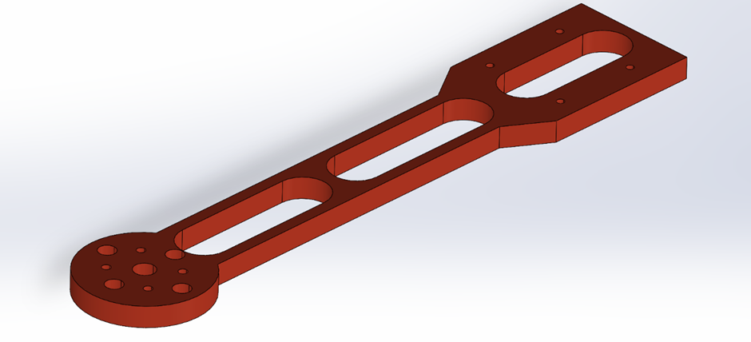
Under Load Case 1 the maximum von Mises stress was 38.7 MPa at the inner boundary of the forward elliptical cutout giving a factor of safety of 13.9 against yield. Under Load Case 2 this increased to 74.2 MPa at the same location giving a factor of safety of 7.3. The critical interlaminar shear stress at the flange taper transition under Load Case 2 was 6.8 MPa against a strength of 35 MPa giving a factor of safety of 5.1 against delamination. A modal analysis confirmed the first bending mode at 312 Hz which is well above the motor operating frequency of 80 to 120 Hz confirming no resonance risk in normal operation. All results exceed the minimum factor of safety of 2.0 specified in Section 3 validating the structural adequacy of the design

8. Critical Evaluation: Challenges and Opportunities

8.1 Complex Geometries and Optimisation
The redesigned arm shows how DfAM can be used to introduce meaningful geometric intricacy, such as the graded lattice transition, topology-optimised motor mount, and integrated wire channel, to improve performance rather than just appearance. By combining component consolidation, topology optimisation, and lattice structures, the final design achieves a mass of around 25g, compared to 38g for the previous aluminium assembly, a 34% reduction. Since UAV endurance scales roughly with weight at a constant payload, this reduction translates directly into better operational performance. However, the benefits of AM come with added challenges. As highlighted by Plocher and Panesar (2019), the performance of lattice structures is highly sensitive to manufacturing conditions, particularly components such as temperature, layer adhesion, and humidity, which influence interlayer bonding. This is important here, as interlaminar shear was identified as the critical failure mode in the FEA. As a result, uniform performance cannot be assumed without proper process control. Unlike machined aluminium parts, AM parts require stricter quality control and assessment procedures, especially in safety-critical UAV applications. This means the design process must also account for how the part will be manufactured and verified, not just its geometry.

8.2 Rapid Prototyping
One of the main practical advantages of additive manufacturing in UAV arm development is the ability to iterate quickly without tooling. With a conventional CNC-machined aluminium approach, even small design changes can require fixture or tooling updates, typically costing £500 to £2,000 and adding several weeks to lead times. In contrast, AM allows revised designs to be printed directly from CAD in just a few hours, enabling testing new iterations on the same day. This significantly shortens the design–test–refine cycle, which Gibson et al. (2021) identify as a key advantage of AM in product development.

8.3 Waste Reduction
FDM is a near-net-shape process, meaning material is deposited only where needed. This contrasts with CNC machining of parts like the motor mount plate, where the buy-to-fly ratio can be as high as 3:1 to 4:1, leading to significant material waste. As a result, the AM approach reduces material usage per component. In addition, Onyx (chopped carbon fibre-filled Nylon) has a lower embodied energy per unit mass than aluminium, and the process avoids the need for cutting fluids, swarf handling, and tool replacement, all of which contribute to the overall environmental impact. However, this benefit is partly offset by failed prints. Errors such as delamination, nozzle blockages, or poor bed adhesion can result in complete part failure, with limited options for recycling the material in typical FDM systems. In contrast, aluminium waste from machining is fully recyclable. Klahn et al. (2015) report failure rates of around 5–15% for complex FDM parts, meaning that real material efficiency must account for these losses rather than just the final part geometry. This highlights a key limitation of FDM compared to processes like SLS, where unused powder can be reused, and should be considered when assessing the overall environmental impact of the manufacturing method.

8.4 Supply Chain Considerations
Additive manufacturing significantly changes the supply chain model for UAV arm production. In the conventional approach, aluminium extrusion arms are produced in batch runs at a specialist machining facility and then stored before assembly. This creates inventory risk, storage costs, and delays whenever a design change is needed. With AM, the part can be printed on demand at or near the assembly location, eliminating the need to hold finished stock and avoiding parts becoming obsolete after a redesign. (Wohlers et al., 2023) Describe distributed, on-demand manufacturing as one of the most important supply chain advantages of AM, especially for products that require customisation or have uncertain demand. That is directly relevant to professional UAV platforms, where customers may need different arm lengths, motor mount patterns, or payload attachment features depending on the application.

8.5 Tooling Considerations
One of the biggest economic advantages of AM is that it removes the need for hard tooling, which is often a major fixed cost in conventional manufacturing. For low-volume, high-variety UAV arm production, this makes a big difference. If a customer needs a different arm variant, such as a new motor-mounting pattern, the AM route requires only a CAD update and a new print qualification. By contrast, the conventional route would typically require a new extrusion die and CNC fixtures, which can cost several thousand pounds before production even begins. This changes the economics of customisation quite dramatically. Instead of treating each variant as a costly special order, UAV manufacturers can offer customer-specific arm configurations without a tooling premium. For professional and enterprise UAV markets, where requirements often vary from one project to the next, that flexibility becomes a real commercial advantage.

8.6 Cost and Sustainability
The estimated unit cost of a Markforged continuous carbon fibre arm is around £18 to £24 per arm at a production volume of 100 units per year, compared with approximately £8 to £12 for the equivalent conventional aluminium arm. The main reasons for this cost premium are the cost of the continuous carbon fibre tow, which is around £120/kg, and the amortisation of the Markforged machine. As production volumes rise above about 500 units per year, the conventional aluminium route benefits more clearly from economies of scale in extrusion and batch CNC machining, further widening the cost gap. That said, the higher cost of the AM arm has to be weighed against its performance benefits. These include a 34% reduction in mass, better crash resistance, integrated wire routing, and the removal of separate assembly steps. For professional UAV operators, where performance is more important than frequent replacement, this extra cost is likely justified. For consumer drones, however, where crash damage is more common, and cost is a greater concern, the conventional aluminium option remains the more economical choice. This shows that DfAM is not automatically better in every case. Instead, it needs to be judged against the specific needs of the application.

8.7 Process-Specific Constraints
The Markforged continuous carbon fibre FDM process also has important limitations that should be considered in a proper DfAM assessment. For example, the minimum fibre loop radius of 1.0 mm limits how fibre can be routed through tight features, so the topology-optimised ribs in the motor mount boss cannot be reinforced with continuous fibre and must instead rely solely on the chopped-fibre Onyx matrix. In addition, the 0.125 mm minimum layer height and the fixed 0.4 mm nozzle diameter set practical limits on how fine the printed features can be, so the lattice geometry must stay within these manufacturing constraints. The need for a heated bed and enclosed chamber also limits the usable build volume of the Mark Two system to roughly 320 mm x 132 mm x 154 mm, which is enough for arm lengths of up to around 300 mm, but would not suit longer configurations without redesign.
These limitations are not unique to Markforged; they are part of the broader trade-off that comes with extrusion-based AM. As Diegel et al. (2019) argue, the aim of DfAM is not to remove manufacturing constraints altogether, because every process has them. Instead, the goal is to understand those constraints properly and design around them, so the AM route is more effective than the conventional alternative.

9. Conclusion
This report has shown that DfAM delivers clear and measurable improvements to the design of a multirotor UAV arm. Through component consolidation the arm assembly was reduced from four parts to one, removing all inter-part interfaces and the fatigue issues that come with them. The elliptical cutouts in the mid-section removed material from low stress areas while the tapered flange transition and integrated motor mount disc combined structural efficiency with manufacturing simplicity. The continuous carbon fibre FDM strategy aligned reinforcement with the primary bending loads, maximising the structural contribution of the material.
Together these changes reduced the total arm mass from 38g to approximately 25g. FEA confirmed factors of safety of 13.9 in the fibre direction and 5.1 against interlaminar shear delamination, both well above the minimum of 2.0 specified in Section 3. Markforged Onyx with continuous carbon fibre was selected as the primary process-material combination due to its exceptional specific stiffness and suitability for the flat-plate geometry. SLS PA12 was identified as more appropriate for prototype and low cost training variants.
The critical evaluation acknowledges that the AM approach has real limitations including higher unit cost at volume, sensitivity of FDM interlayer properties to process conditions and material waste from failed prints. However, for professional UAV applications, these are outweighed by the benefits of mass reduction, tooling elimination, rapid iteration and integrated functionality.
This case study supports the conclusion of Thompson et al. (2016) that the real value of DfAM comes not from reproducing conventional designs in a new process but from redesigning components from first principles to exploit what additive manufacturing makes possible. The redesigned arm is not simply a lighter version of the original. It is a fundamentally different component that could only exist because it was designed for additive manufacturing from the start.

References
Ahn, S.H., Montero, M., Odell, D., Roundy, S. and Wright, P.K. (2002) 'Anisotropic material properties of fused deposition modeling ABS', Rapid Prototyping Journal, 8(4), pp.248–257.
Benedetti, M., du Plessis, A., Ritchie, R.O., Dallago, M., Razavi, S.M.J. and Berto, F. (2021) 'Architected cellular materials: A review on their mechanical properties towards fatigue-tolerant design and fabrication', Materials Science and Engineering: R: Reports, 144, p.100606.
Chung, D.D.L. (2010) Composite Materials: Science and Applications. 2nd edn. London: Springer.
Diegel, O., Nordin, A. and Motte, D. (2019) A Practical Guide to Design for Additive Manufacturing. Singapore: Springer.
Ding, X., Yamazaki, K. and Koizumi, H. (2015) 'Topology optimisation of structural components in UAV airframe design', Journal of Aircraft Engineering and Aerospace Technology, 87(5), pp.429–438.
Gebhardt, A., Schmidt, F.M., Hötter, J.S., Sokalla, W. and Sokalla, P. (2019) 'Additive manufacturing by selective laser sintering – The realizer approach', Physics Procedia, 5, pp.537–542.
Gibson, I., Rosen, D., Stucker, B. and Khorasani, M. (2021) Additive Manufacturing Technologies. 3rd edn. Cham: Springer.
Grand View Research (2024) Commercial Drone Market Size, Share & Trends Analysis Report. San Francisco: Grand View Research.
Hauser, J.R. and Clausing, D. (1988) 'The house of quality', Harvard Business Review, 66(3), pp.63–73.
Klahn, C., Leutenecker, B. and Meboldt, M. (2015) 'Design strategies for the process of additive manufacturing', Procedia CIRP, 36, pp.230–235.
Kumke, M., Watschke, H. and Vietor, T. (2016) 'A new methodological framework for design for additive manufacturing', Virtual and Physical Prototyping, 11(1), pp.3–19.
Liu, J., Gaynor, A.T., Chen, S., Kang, Z., Suresh, K., Takezawa, A., Li, L., Kato, J., Tang, J., Wang, C.C.L., Cheng, L., Liang, X. and To, A.C. (2018) 'Current and future trends in topology optimization for additive manufacturing', Structural and Multidisciplinary Optimization, 57(6), pp.2457–2483.
Markforged (2023) Onyx and Continuous Fibre Material Datasheet. Watertown, MA: Markforged Inc.
Melenka, G.W., Cheung, B.K.O., Schofield, J.S., Dawson, M.R. and Carey, J.P. (2016) 'Evaluation and prediction of the tensile properties of continuous fibre-reinforced 3D printed structures', Composite Structures, 153, pp.866–875.
Plocher, J. and Panesar, A. (2019) 'Review on design and structural optimisation in additive manufacturing: Towards next-generation lightweight structures', Materials and Design, 183, p.108164.
Rao, R.V., Rai, D.P. and Balic, J. (2022) 'Multi-objective optimisation of UAV structural components using nature-inspired algorithms', Journal of Intelligent Manufacturing, 33(1), pp.125–144.
Thompson, M.K., Moroni, G., Vaneker, T., Fadel, G., Campbell, R.I., Gibson, I., Bernard, A., Schulz, J., Graf, P., Ahuja, B. and Martina, F. (2016) 'Design for additive manufacturing: Trends, opportunities, considerations, and constraints', CIRP Annals, 65(2), pp.737–760.
Wohlers, T., Campbell, I., Diegel, O., Huff, R., Kowen, J. and Mostow, N. (2023) Wohlers Report 2023: 3D Printing and Additive Manufacturing Global State of the Industry. Fort Collins: Wohlers Associates.

