December 15, 2022
Mehul Katheria

Coexistent Perspective Essay
Topic- Materiality and Consequences

Explore the idea of Responsible Innovation and how it could improve the transportation industry, analyse innovations in the transportation industry along with how they impacted us, and discuss how Responsible Innovation could have avoided their negative consequences.

Introduction
What are the consequences of our actions? Even though we cannot predict every consequence of our action it is still important to understand what they are and how the impact our surroundings. This is especially important for researchers, engineers, and designers whose actions and innovations have the potential to have a larger impact on the world.
Consequences can be classified as intended and unintended, anticipated and unanticipated. The concept of unanticipated consequence was first established by Robert K. Merton, he defined it as outcomes that are not foreseen and intended from purposive actions. Although the term unanticipated consequence is self-explanatory, to understand it we must differentiate unintended from the intended and understand that undesired effects may not always be undesirable (Merton, 1936, p.1). However, unanticipated consequences should not be conflated with unintended consequences as “consequences that while unintended are not unanticipated” (de Zwart, 2015, p. 2). While Intended consequence are always anticipated, unintended consequences can either be unanticipated or anticipated. Unintended but anticipated consequences can also be either managed or ignored by the actors involved. According to Merton unintended consequences can be perceived as either positive or negative depending on their impact (Merton, 1936).

Responsible Innovation
An effective tool against negative unintended consequences would be ‘Responsible Innovation’ or RI. A working definition for RI was proposed by von Schomberg (2011, p.9) as:
“A transparent, interactive process by which societal actors and innovators become mutually
responsive to each other with a view on the (ethical) acceptability, sustainability and societal desirability of the innovation process and its marketable products (in order to allow a proper embedding of scientific and technological advances in our society)”.
RI aims to reduce negative consequences and bring positive impact on society and the environment. It looks at the key actors in the development & decision making process, asks them to understand their role and responsibilities on a wider stage and look at their effects on society and the environment. Implementing RI into businesses, communities and the society would greatly help in reducing the risk of harmful and unintended consequences.
For businesses their primary responsibility has always been towards their shareholders and earning profit. In this pursuit many times businesses have ignored their social responsibility and ethical obligation if it allowed them to earn more. This practice has led to some irresponsible innovations being made due to reasons such as: rushed development, excessive tunnel vision, bad judgement, greed, wilful ignorance and overlooking collateral damage.
“Irresponsible innovation is reflected in practices where stakeholders were unaware of the importance of the innovation’s societal context, or where stakeholder’s interactions were unproductive in the resolutions of conflicts” (Gwarda- Gruszczyńska, 2016, p.5).
As an example, we can look at Coca Cola, they have been the world’s worst plastic polluter for the fourth consecutive year in 2021 and have known the ill effects of single use plastic bottles and yet for years have ignored this problem (Russ, 2022). Businesses have constantly overlooked moral and ethical obligations in favour of profit. However, not all businesses function this way, some do understand their social responsibility towards society and the environment. To better understand these two sides, I will present two examples, one where social responsibility presided over profit and the other where moral and ethical obligations were overlooked in favour of profit. By highlighting the positive and negative consequences we can better understand the role responsible innovation can play in bringing positive changes to the world.

Nils Bohlin and the Seat Belt
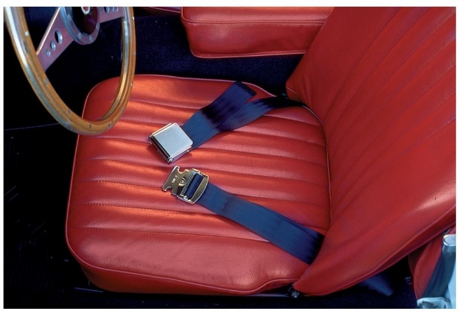
It is very difficult to imagine buying a car today without a seat belt. This safety innovation has proven to be simple yet extremely effective at preventing serious injuries during accidents. Before the modern version of seat belts, cars only came with a two-point seat belt design (Fig. 1), which crosses the lap and only braces the lower body, the upper body was free to move and in the event of an accident would slam into the interior causing serious injuries, the belt could also crush internal organs on impact if positioned badly. They were also clumsy and uncomfortable dissuading people from wearing them.
Figure 1 Two-point seat belt
In 1958 the CEO of Volvo Car Corporation Gunnar Engelau hired a Swedish engineer by the name of Nils Bohlin. Engelau had unfortunately lost a relative in a car accident, partly due to the two-point seat belt. This personal tragedy made him re-evaluate the importance of safety in a vehicle, back then safety was not a priority for car manufacturers, Engelau wanted that to change and so he poached Bohlin from rival company Saab to be their first chief safety engineer. Bohlin had experience working on airplane harnesses and other safety equipment for pilots and he quickly set out to design a harness for cars that was simple, effective and could be put on conveniently with one hand by passengers (History.com, 2010). Within a year he developed the three-point seat belt design (Fig. 2). It was designed to go over the chest and waist bracing the entire body of the passenger. It was also much easier to use and not as uncomfortable as the two-point design. Volvo went to great lengths throughout the 1960s testing the new design to ensure its efficacy in a crash, running experiments and researching thousands of accidents to verify it.
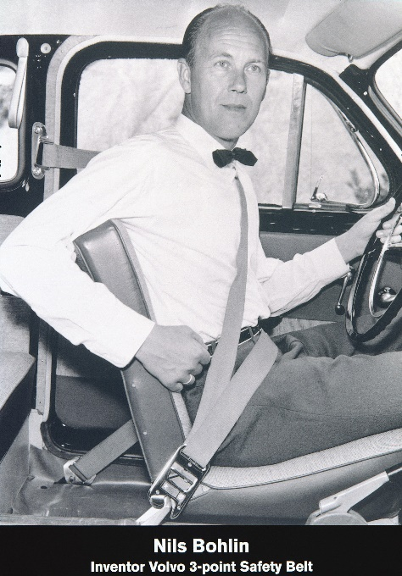
However, like with every innovation this too faced resistance and scepticism from people, but with time, advocation and scientific data, the usage of seat belts grew, from only 25% users in 1965 to over 90% by 1975 in Sweden. “This reminds us that invention and innovation are not the same thing; the latter requires adoption to qualify, making innovation invariably risky” (Bell, 2019).
Interestingly Volvo understood the importance of this innovation and the role it could play in saving lives. Just like every other company they patented the design, but unlike other companies they chose to make the patent available to everyone including their competitors. They could have made this innovation exclusive in order to boost their sales, instead they understood their responsibility towards society and knew that only saving the lives of their customers would not benefit the world. So, they chose to forgo the potential to perhaps earn millions in profits and instead chose to save millions of lives.
Figure 2 Nils Bohlin with his innovation
However, worldwide adoption was still an uphill battle. Europe and Australia were amongst the early adopters to make seat belts mandatory by legislation in 1960s and 1970s with the United States following in the late 1980s. Even though seat belt usage was mandatory they were still not being worn by everyone, according to a paper published in 2001 on ‘The effects of mandatory seat belt laws on driving behaviour and traffic fatalities’ by 1996 only 68% of people in the U.S. were using seat belts (Cohen and Einav, 2001, p.3). Famously, Princess Diana of Wales was not wearing a seat belt during her fatal car crash in Paris in 1997, which investigators and experts believe would have saved her life (Bell, 2019; Swaine, 2008).
During his time at Volvo Bohlin pushed forward the boundaries of passenger safety and protection. In 1970 he realised the need for passengers to be protected from side impacts and created Volvo’s patented SIPS – Side Impact Protection System, it consisted of a strong reinforced body structure and some features that allowed the force from the crash to be distributed across the body of the car and away from the passengers. His continuous efforts to improve passenger safety earned him global recognition and several awards, most notably he was inducted into the International Health and safety Hall of Fame, USA in 1989, inducted into the Automotive Hall of Fame in 1999 and the National Inventors Hall of Fame in 2002 (Volvo cars global newsroom, 2009).
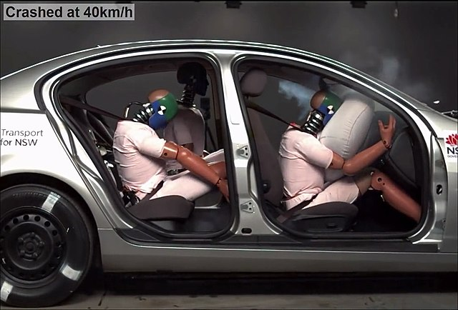
Figure 3 Crash test with seat belt
Thomas Midgley Jr.
The legacy of leaded fuel
In the late 19th and early 20th century horse drawn carriages, trains and ships were the most popular mode of transportation, automobile ownership was on the rise but still relatively low and restricted to the wealthy. The automobiles available back then were also difficult to use and very unreliable. To start them we had to use a hand crank that had to be connected to the engine and spun, however this was extremely dangerous as the engine would often kick back and injure the operator.
In 1911 an engineer named Charles Kettering came up with the prototype of a self-starting car, he was hired by the owner of Cadillac, Henry Leland who had unfortunately lost a friend to an incident involving the hand crank. He was extremely troubled by this and sought to eliminate hand cranks from his vehicles (Veritasium, 2022). In 1912 Cadillac released the Model 30 with the self-starting system developed by Kettering a year ago, however this car’s engine was extremely loud due to ‘engine knocking’.
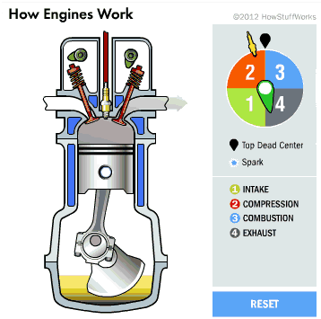
Engine knocking is a phenomenon that was very common back then, typically the engine sucks in the air and fuel mixture, the mixture is then compressed by the pistons to create pressure and then ignited by a spark plug pushing the piston down (Fig. 3). The piston is connected by a rod to the crankshaft that converts this vertical movement into horizontal which goes onto move the vehicle. Engine Knocking is the result when the air and fuel mixture prematurely detonates due to the compression before being ignited by the spark plug. These two different explosions collide with each other sending shockwaves across the engine resulting in a knocking sound. Engine knocking not only damages the engine but also reduces its power, fuel efficiency and lifespan. The solution to this is to use a fuel that has a higher octane level. Octane is a way to measure how much a fuel can be compressed without it detonating and Kettering wanted to solve the engine knocking issue by finding a way to increase a fuel’s octane level.
Figure 4 Engine (Brain and Hall-Geisler, 2000)
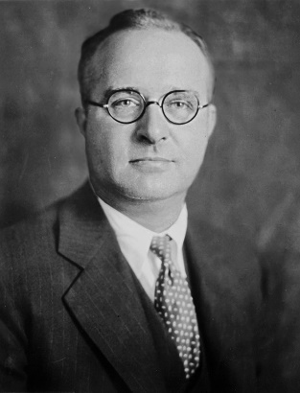
To do this he hired an American chemist and engineer by the name of Thomas Midgley Junior. Midgley began experimenting with additives that would improve a fuels octane level and experimented with everything he could find. He found that adding ethanol did the job, however large amounts of ethanol were needed which would make this option expensive and neither could this be patented. Midgley later found a solution called Tetraethyl Lead, he found that adding a little bit of this to the fuel was extremely effective and approached Kettering with his discovery. Not only was it cost effective but could also be patented allowing them to have a monopoly on its production.
Figure 5 Thomas Midgley Jr.
Soon after the discovery was made public, Midgley and Kettering teamed up with General Motors, Du Pont and Standard Oil Company to form the Ethyl Corporation and Midgley became its vice president (Veritasium, 2022; A. Williams, 2019). They called their new additive Ethyl and did not mention the word lead anywhere in their marketing. Lead is a very well-known and awfully toxic chemical, its dangers have been acknowledged since the roman empire, in 1922 the League of Nations banned the use of leaded paint inside houses because of its toxicity. Midgley, Kettering and the other executives knew that it was poisonous but blinded by greed they dismissed its dangers stating that a small amount of lead is not harmful.
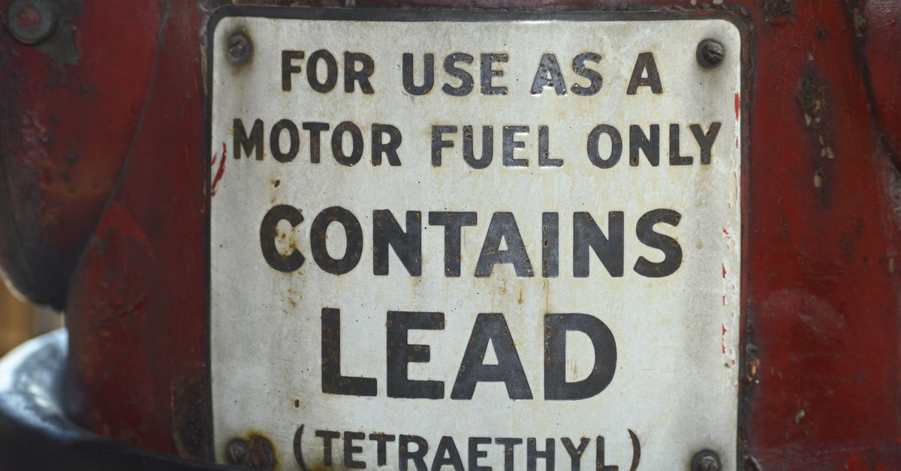
Figure 6 Fuel pump selling Tetraethyl Lead
So, in February 1923, filling stations started selling leaded fuel to the public, Midgley wasn’t there as he was recovering from lead poisoning (Eschner, 2016; A. Williams, 2019). Soon after its production, in 1924 a few workers at a plant in New Jersey died and several others showed severe symptoms of lead poisoning, but the company refused to accept responsibility and blamed the workers. Midgley having suffered from lead poisoning after inhaling fumes of lead did not stop advocating for ethyl and claimed that it was safe, he famously washed his hands with tetraethyl lead in a press conference to show its safety. After this scandal erupted, several states were asked to ban leaded fuel but with corporate pressure and biased studies funded by the lead industry assuring its safety, the sales continued. Using many biased studies and an aggressive marketing campaigns leaded fuel ensured that it was the fuel of choice (A. Williams, 2019; Harford, 2017). Leaded Fuel was sold for more than six decades before its ill effects on health and safety pressured governments into banning it. Japan was the first country to do so in 1986 but it took another three and half decades to completely phase out leaded fuel, in 2021 Algeria became the last country to ban leaded fuel almost a century since it was first sold (Ritchie, 2022).
Lead poisoning can produce symptoms like nausea, diarrhoea, memory loss and kidney failure. However, the symptoms in children are much more severe as they are more susceptible to the effects of it. The effects of such an irresponsible innovation and the refusal of the lead industry to accept its responsibility were immense. A study in 1965 found that in U.S. the levels of airborne lead had increased 1000-fold since 1923. It ended up causing about 1.2 million premature deaths a year, lowered the IQ of countless children and drove many to violence (Kuper, 2022).
Clair Cameron Patterson, an American scientist came across lead pollution when he was trying to calculate the age of the earth. He was trying to date the age of minerals with uranium and lead, since the former decays to produce the latter. But while conducting this experiment he found that some rocks and minerals had more lead than it was supposed to. He started to investigate where this extra lead came from. He began by measuring lead in the oceans at different depths and found that lead concentration was nearly 10 times higher than the concentration at the depth of 4 kms, stating that the pollution was much more recent. Through his experiments he showed that the concentration of lead in the atmosphere and in humans was a thousand times higher than what it used to be, undeniably proving the existence of lead pollution (Veritasium, 2022; Yanes, 2021).
Dr. Herbert Needleman an American psychiatrist studied the wider effects of lead on children. In 1979 he published a paper in the New England Journal of Medicine which looked at 2,000 children, he used children’s fallen teeth to measure the level of lead concentration in their bones. He found that children with higher lead levels had lower IQ points and other behavioural problems. His findings shook the world, the lead industry tried their best to oppose his findings but failed, and now any level of lead in children is considered unsafe (Carey, 2017). Further studies also concluded that children with higher lead levels grew up to commit more crimes and that there was a slow decline in crime rate, which co-related to the ban of leaded fuel and fewer children being exposed to lead pollution (Veritasium, 2022). Studies like these helped expose the lead industry and prompted legislative action against the sale of leaded fuel.

CFC Gas and the ozone disaster
Thomas Midgley Jr. did not stop with tetraethyl lead. He can be credited with not just one but two environmental disasters, the historian J.R. McNeil wrote that Midgley “had more impact on the atmosphere than any other single organism in the Earth’s history” (Kuper, 2022). After creating leaded fuel, General Motors who also manufactured refrigerators asked Midgley to create a safer non-toxic and non-flammable gas that can be used for them. Coolants and gasses like ether, ammonia and sulphur di-oxide used in refrigerators at that time were either flammable or toxic, and their leakage could lead to devastating consequences. Midgley quickly got to work and in 1928 and created chlorofluorocarbon or CFC gas and named it Freon. To demonstrate its safety Midgley famously inhaled this gas, held his breath and then blew out a candle. In the following years CFC was being used in refrigerators, air conditioners and aerosol cans everywhere.
Unfortunately for us, it turns out that CFC gas had a major unintended consequence. In 1974, chemists Maria Molina and Frank Sherwood Rowland published an article that highlighted the effects CFC gas had on the ozone layer and in 1985 their work was validated when scientists found a hole in the ozone layer (Fig. 4) above Antarctica (Nunez, 2019).

Figure 7 Ozone Hole (NASA, 1985)
The ozone layer exists in the stratosphere and blocks harmful ultra-violet rays from the sun, it is vital to our survival on earth, if harmful UV rays from the sun are allowed to reach the surface it would damage plants and marine ecosystems. Studies suggest that human exposure to the harmful UV rays can cause skin cancer and develop cataracts in our eyes (United States Environmental Protection Agency, 2022).
The world recognized the harmful effects of CFC and other ozone depleting substances, repairing and stopping further damage was of utmost importance. Subsequently in 1987 the Montreal Protocol was signed, this landmark agreement intended to phase out any substances that harm the ozone layer and was ratified by all the members of the United Nations (Nunez, 2019). The Montreal Protocol is the most successful multilateral environmental agreement that had universal approval. The ozone layer today is expected to heal by the year 2050, without this agreement the ozone depletion would have continued to deteriorate causing extensive damage. The Montreal Protocol is saving an estimated 2 million people each year by 2030 from skin cancer. Since most of the gasses were greenhouse gasses, phasing them out has also helped with global warming and avoided a 0.5 degree Celsius of global temperature rise by 2100 (UN environment programme).

Conclusion
Both case studies above show that companies willing to impact change on society can do so, it can be positive or negative, the willingness of these actors to favour one over the other plays a crucial role in how our futures can be shaped. Although it is not possible for every company to give out their innovations like Volvo, it is still necessary to understand what led to that decision and it all narrows down to people in charge. Gunnar Engelau had to face a tragic loss to understand the importance of passenger safety, his influence in the company allowed others to understand it and led the company in a direction that affected positive changes, hiring Bohlin and tasking him to design and engineer innovations for passenger safety being one of them. This in turn helped Volvo earn global recognition and increase the sale of their cars. Companies should learn from their example and understand that developing products and innovations that have positive impacts are more beneficial for them in the long run.
In the case of leaded fuel, it is an example of absolute negligence by the key actors involved. During development Midgley could have considered other alternatives that were not toxic, instead he was blinded by the money he would earn. However, we cannot blame Midgley entirely as there were several other people who facilitated the rise of leaded fuel. Together they downplayed its effects, knowing that it was harmful. They funded false studies and tried to silence anyone who spoke against them, this allowed the situation to get worse and the damage more severe. This damage, caused by leaded fuel and CFC could have been prevented if the key actors had not rushed development, looked at the wider consequences of these products and stopped when they realised the harm. The damage could also have been limited if regulations had not been delayed.
To paraphrase the philosopher George Santayana, those who forget their history are condemned to repeat it. The loss of life and damage to the environment cannot be undone, which is why we must learn from the mistakes and ensure that they are not repeated.

How can Responsible Innovation help?
In today’s world responsible innovation is extremely important, our environment is being harmed by existing practices and in order to prevent any more damage we need to design new sustainable alternatives to these current solutions. R. Owen, J. Bessant and M. Heintz suggest that to innovate responsibly entails a collective and continuous commitment to be (Owen, Bessant, Heintz 2013, pp. 38–39):
- Anticipatory with our approach using methods such as foresight, technology assessment and scenario development to discover any potential unintended impacts. We also need to prompt ourselves to ask questions like “what if?” or “what else can I do?”.
- Reflective of our purposes, motivations, intensions, impacts, risks, assumptions, what we know and don’t know, reservations, questions and dilemmas.
- Inclusive/deliberative in the process through dialogue, engagement, debate along with inviting and listening to opinions and perspectives from public and diverse stakeholders.
- Responsive and reflexive to the direction, trajectory and pace of the innovation through participatory and anticipatory governance. (Gwarda-Gruszczyńska, 2016, p. 6)
Innovation relies on creating change through radical and new ideas, and with the help responsible innovation businesses and individuals can find ways to positively impact their own companies, customers, investors, the wider society and the environment. “RI by definition is a normative, values- and purpose-driven concept, which requires the alignment of economic, societal and environmental business goals” (Jarmai, 2020). By doing thorough research of existing products, markets and other factors we can understand problems, produce knowledge and value, that can allow better decision making while dealing with unintended consequences, questions and ethical dilemmas.

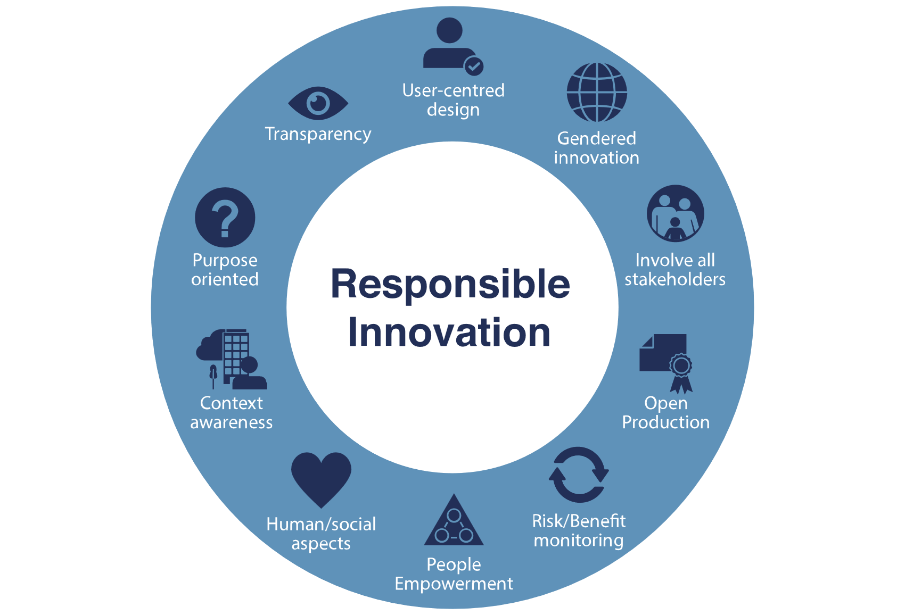
Figure 8 What is responsible innovation

Even though RI did not exist at the time of our case studies, we can still look at their impacts and see how RI could’ve helped in those instances. The invention of the three-point seat belt was revolutionary and Volvo’s gesture was exemplary. But if we look closely then we can see that adoption and acceptance of this innovation took a very long time and RI could have helped with that. By involving the end-user into the development process and collecting their opinions could have eased any worries and helped raise awareness about them. In the case of leaded fuel and CFC, well these disasters could have been completely avoided. By using RI, they could have researched and tested the wider effects of their products, the negative impacts on the health and environment could have been predicted much earlier in the development process. Additionally, after realising the negative impacts, they could have looked at other alternatives, by applying the same process of research, testing and verification, an alternative that was less harmful but still cost effective for the company could have been chosen.
The transportation industry is one of the top polluters on our planet, most vehicles use internal combustion engines that release greenhouse gasses as a by-product which contributes to global warming. Vehicles are also difficult to recycle as they use a mixture of different materials. Implementing RI into the transportation industry could change how we develop our products and find innovative solutions to issues caused by the industry.
“Innovative companies have real power over the development of countries and regions, which clearly raises the question of their social responsibilities” (Gwarda-Gruszczyńska, 2016, p. 2)
Companies must understand their role and responsibility on a wider stage and find innovative ways to solve real world issues while still earning profits from them. RI can also help with employee satisfaction and retention, people today are more conscious of their time and actions and would be more inclined to work at a company that has positive impacts on the world. RI is still emerging as a new field which is why its success cannot be guaranteed, but if companies are willing to then they can innovate in areas that bring positive impact while earning profit, additionally they can also gain benefits such as higher employee satisfaction, retention of skilled employees and gain reputation. We live in a world where innovation and development are constant, there is a visibly important need for responsible innovation to ensure that we do not risk ours and the environments health and safety.

Word Count: 4056

Bibliography

A. Williams, J. (2019) ‘This 1920s Inventor Sped Up Climate Change With His Chemical Creations’, History.com, 23rd August. Available at: https://www.history.com/news/cfcs-leaded-gasoline-inventions-thomas-midgley (Accessed: 13th December 2022)
Bell, D. (2019), ‘Volvo’s Gift To The World, Modern Seat Belts Have Saved Millions Of Lives’. Available at: https://www.forbes.com/sites/douglasbell/2019/08/13/60-years-of-seatbelts-volvos-great-gift-to-the-world/ (Accessed: 25th November 2022)
Cohen, A. and Einav, L. (2001) The Effects of Mandatory Seat Belt Laws on Driving Behavior and Traffic Fatalities, http://www.law.harvard.edu/programs/olin_center/papers/pdf/341.pdf
Carey, B. (2017) ‘Dr. Herbert Needleman, Who Saw Lead’s Wider Harm to Children, Dies at 89’, The New York Times, 27th July. Available at: https://www.nytimes.com/2017/07/27/science/herbert-needleman-dead-lead-poisoning-in-children.html (Accessed: 13th December 2022)
de Zwart, F. ‘Unintended but not unanticipated consequences’. Theor Soc 44, 283–297 (2015). https://doi.org/10.1007/s11186-015-9247-6
Eschner, K. (2016) ‘Leaded Gas Was a Known Poison the Day It Was Invented’, Smithsonian magazine, 9th December. Available at: https://www.smithsonianmag.com/smart-news/leaded-gas-poison-invented-180961368/ (Accessed: 1st December 2022)
Gwarda-Gruszczyńska, E. (2016) Responsible Innovation, 123. https://doi.org/10.18276/epu.2016.123-20 (Accessed: 1st December 2022)
History.com (2010), ‘Three-point seatbelt inventor Nils Bohlin born’. Available at: https://www.history.com/this-day-in-history/three-point-seatbelt-inventor-nils-bohlin-born (Accessed: 12th December 2022)
Harford, T. (2017) ‘Why did we use leaded petrol for so long?’, BBC News, 28th August. Available at: https://www.bbc.co.uk/news/business-40593353 (Accessed: 13th December 2022)
Jarmai, K. (2020). Responsible Innovation Business Opportunities and Strategies for Implementation (Jarmai, Ed.; 1st ed. 2020.). Springer Netherlands. https://doi.org/10.1007/978-94-024-1720-3
Kuper, S. (2022) ‘Thomas Midgley, and the case against progress’, Financial Review, 5th January. Available at: https://www.afr.com/work-and-careers/leaders/thomas-midgley-and-the-case-against-progress-20211213-p59h5u (Accessed: 11th December 2022)
Merton, R. (1936), ‘The Unanticipated Consequences of Purposive Social Action’, American Sociological Review, Vol. 1 No. 6, pp.894–904. https://kamprint.com/essay/merton.html, http://dx.doi.org/10.2307/2084615
Nunez, C. (2019) ‘Ozone depletion, explained’, National Geographic, 18th April. Available at: https://www.nationalgeographic.com/environment/article/ozone-depletion (Accessed: 13th December 2022)
Owen R., Bessant J., Heintz M. (2013), Responsible innovation. Managing the Responsible Emergence of Science and Innovation in Society, Chichester: John Wiley & Sons.
Reyes, J. W. (2007) Environmental Policy as Social Policy? The Impact of Childhood Lead Exposure on Crime, National Bureau of Economic Research. Available at: https://www.nber.org/papers/w13097
von Schomberg, R. (2011). ‘Towards responsible research and innovation in the information and communication technologies and security technologies fields’. Directorate general for research and innovation. https://doi.org/10.2139/ssrn.2436399.
Russ, H. (2022), ‘Coca-Cola, criticized for plastic pollution, pledges 25% reusable packaging’, Reuters, 15th February. Available at: https://www.reuters.com/business/sustainable-business/coca-cola-criticized-plastic-pollution-pledges-25-reusable-packaging-2022-02-10/ (Accessed: 12th December 2022).
Ritchie, H. (2022) ‘How the world eliminated lead from gasoline’. Available at: https://ourworldindata.org/leaded-gasoline-phase-out (Accessed: 13th December 2022)
Swaine, J. (2008) ‘Diana death shows danger of not wearing seatbelt, says minister’, The Telegraph, 2nd November. Available at: https://www.telegraph.co.uk/motoring/3366772/Diana-death-shows-danger-of-not-wearing-seatbelt-says-minister.html (Accessed: 13th December 2022).
UKRI (2022) Responsible Innovation. Available at : https://www.ukri.org/about-us/policies-standards-and-data/good-research-resource-hub/responsible-innovation/#:~:text=For%20researchers%2C%20responsible%20innovation%20is,consequences (Accessed: 13th December 2022)
United States Environmental Protection Agency (2022) Health and Environmental Effects of Ozone Layer Depletion. Available at: https://www.epa.gov/ozone-layer-protection/health-and-environmental-effects-ozone-layer-depletion#:~:text=Ozone%20layer%20depletion%20increases%20the,role%20in%20malignant%20melanoma%20development. (Accessed: 13th December 2022)
UN environment programme, About the Montreal Protocol. Available at: https://www.unep.org/ozonaction/who-we-are/about-montreal-protocol (Accessed: 13th December 2022)
Volvo cars global newsroom (2009) 3-point safety belt from Volvo - the most effective lifesaver in traffic for fifty years. Available at: https://www.media.volvocars.com/global/en-gb/media/pressreleases/18405 (Accessed: 12th December 2022).
Veritasium (2022) The Man Who Accidentally Killed The Most People In History [video]. Available at: https://www.youtube.com/watch?v=IV3dnLzthDA (Accessed: 30th November 2022).
Yanes, J. (2021) ‘Clair Patterson, the Hero Who Got the Lead Out of Gasoline’. Available at: https://www.bbvaopenmind.com/en/science/environment/clair-patterson-got-lead-out-of-gasoline/ (Accessed: 13th December 2022)
Images
Figure 1: Unknown. Available at: https://mossmotors.com/vintage-bolt-in-2-point-seatbelt-flat-mount (Accessed: 12th December 2022)
Figure 2: Volvo trucks (2019) ‘Celebrating 60 years of saving lives with seat belts but more can be done’. Available at: https://www.volvotrucks.com/en-en/news-stories/press-releases/2019/jun/pressrelease-190627.html (Accessed: 6th December 2022)
Figure 3: Transport for NSW (2019), ‘Crash Test - Belted vs Unbelted Passengers’. Available at: https://commons.wikimedia.org/wiki/File:Crash-test-with-airbag-and-safty-belt.jpg (Accessed: 14th December 2022)
Figure 4: Brain, M. and Hall-Geisler, K. (2000) ‘How Car Engines Work’, Howstuffworks. Available at: https://auto.howstuffworks.com/5-ways-modern-car-engines-differ-from-older-car-engines.htm (Accessed: 13th December 2022).
Figure 5: Flavell-While (2010) ‘Thomas Midgley – A troubled legacy’. Available at: https://www.thechemicalengineer.com/features/cewctw-thomas-midgley-a-troubled-legacy/ (Accessed: 6th December 2022)
Figure 6: Piper, K. (2021) ‘One of the worst public health dangers of the past century has finally been eradicated’. Available at: https://www.vox.com/future-perfect/22650920/leaded-gasoline-eradicated-public-health (Accessed: 14th December 2022)
Figure 7: NASA, (1985) Ozone hole watch. Available at: https://ozonewatch.gsfc.nasa.gov/Scripts/big_image.php?date=1985-09-12&hem=S (Accessed: 13th December 2022)
Figure 8: Winter School, ‘What is Responsible Innovation’. Available at: https://adu.unibo.it/winterschool/cose-la-responsible-innovation/ (Accessed: 14th December 2022)

