ACE PRACTICAL PORTFOLIO

Slide 1

Slide 2
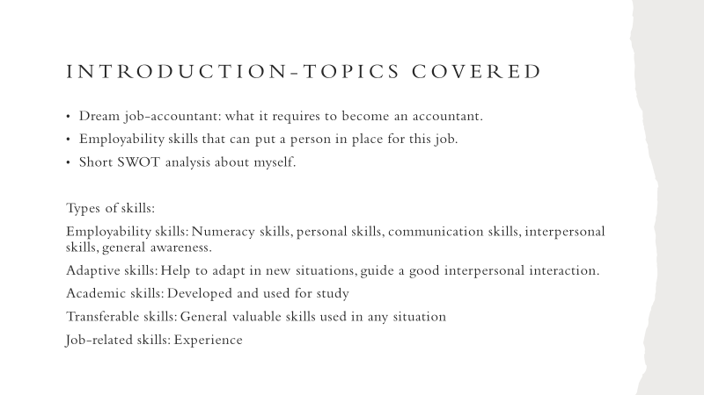

Slide 3

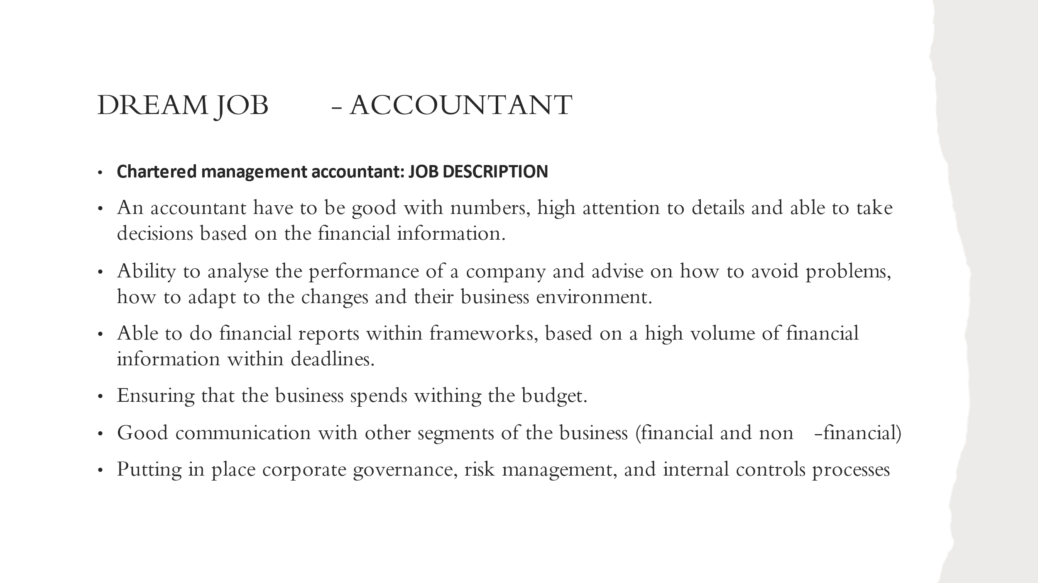
My dream job is to become an accountant and here are some of the characteristic that an accountant must have.
Point 3-Business environment: Maybe they will be affected by covid, Brexit, different political decision or climate change related decisions.
Slide 4
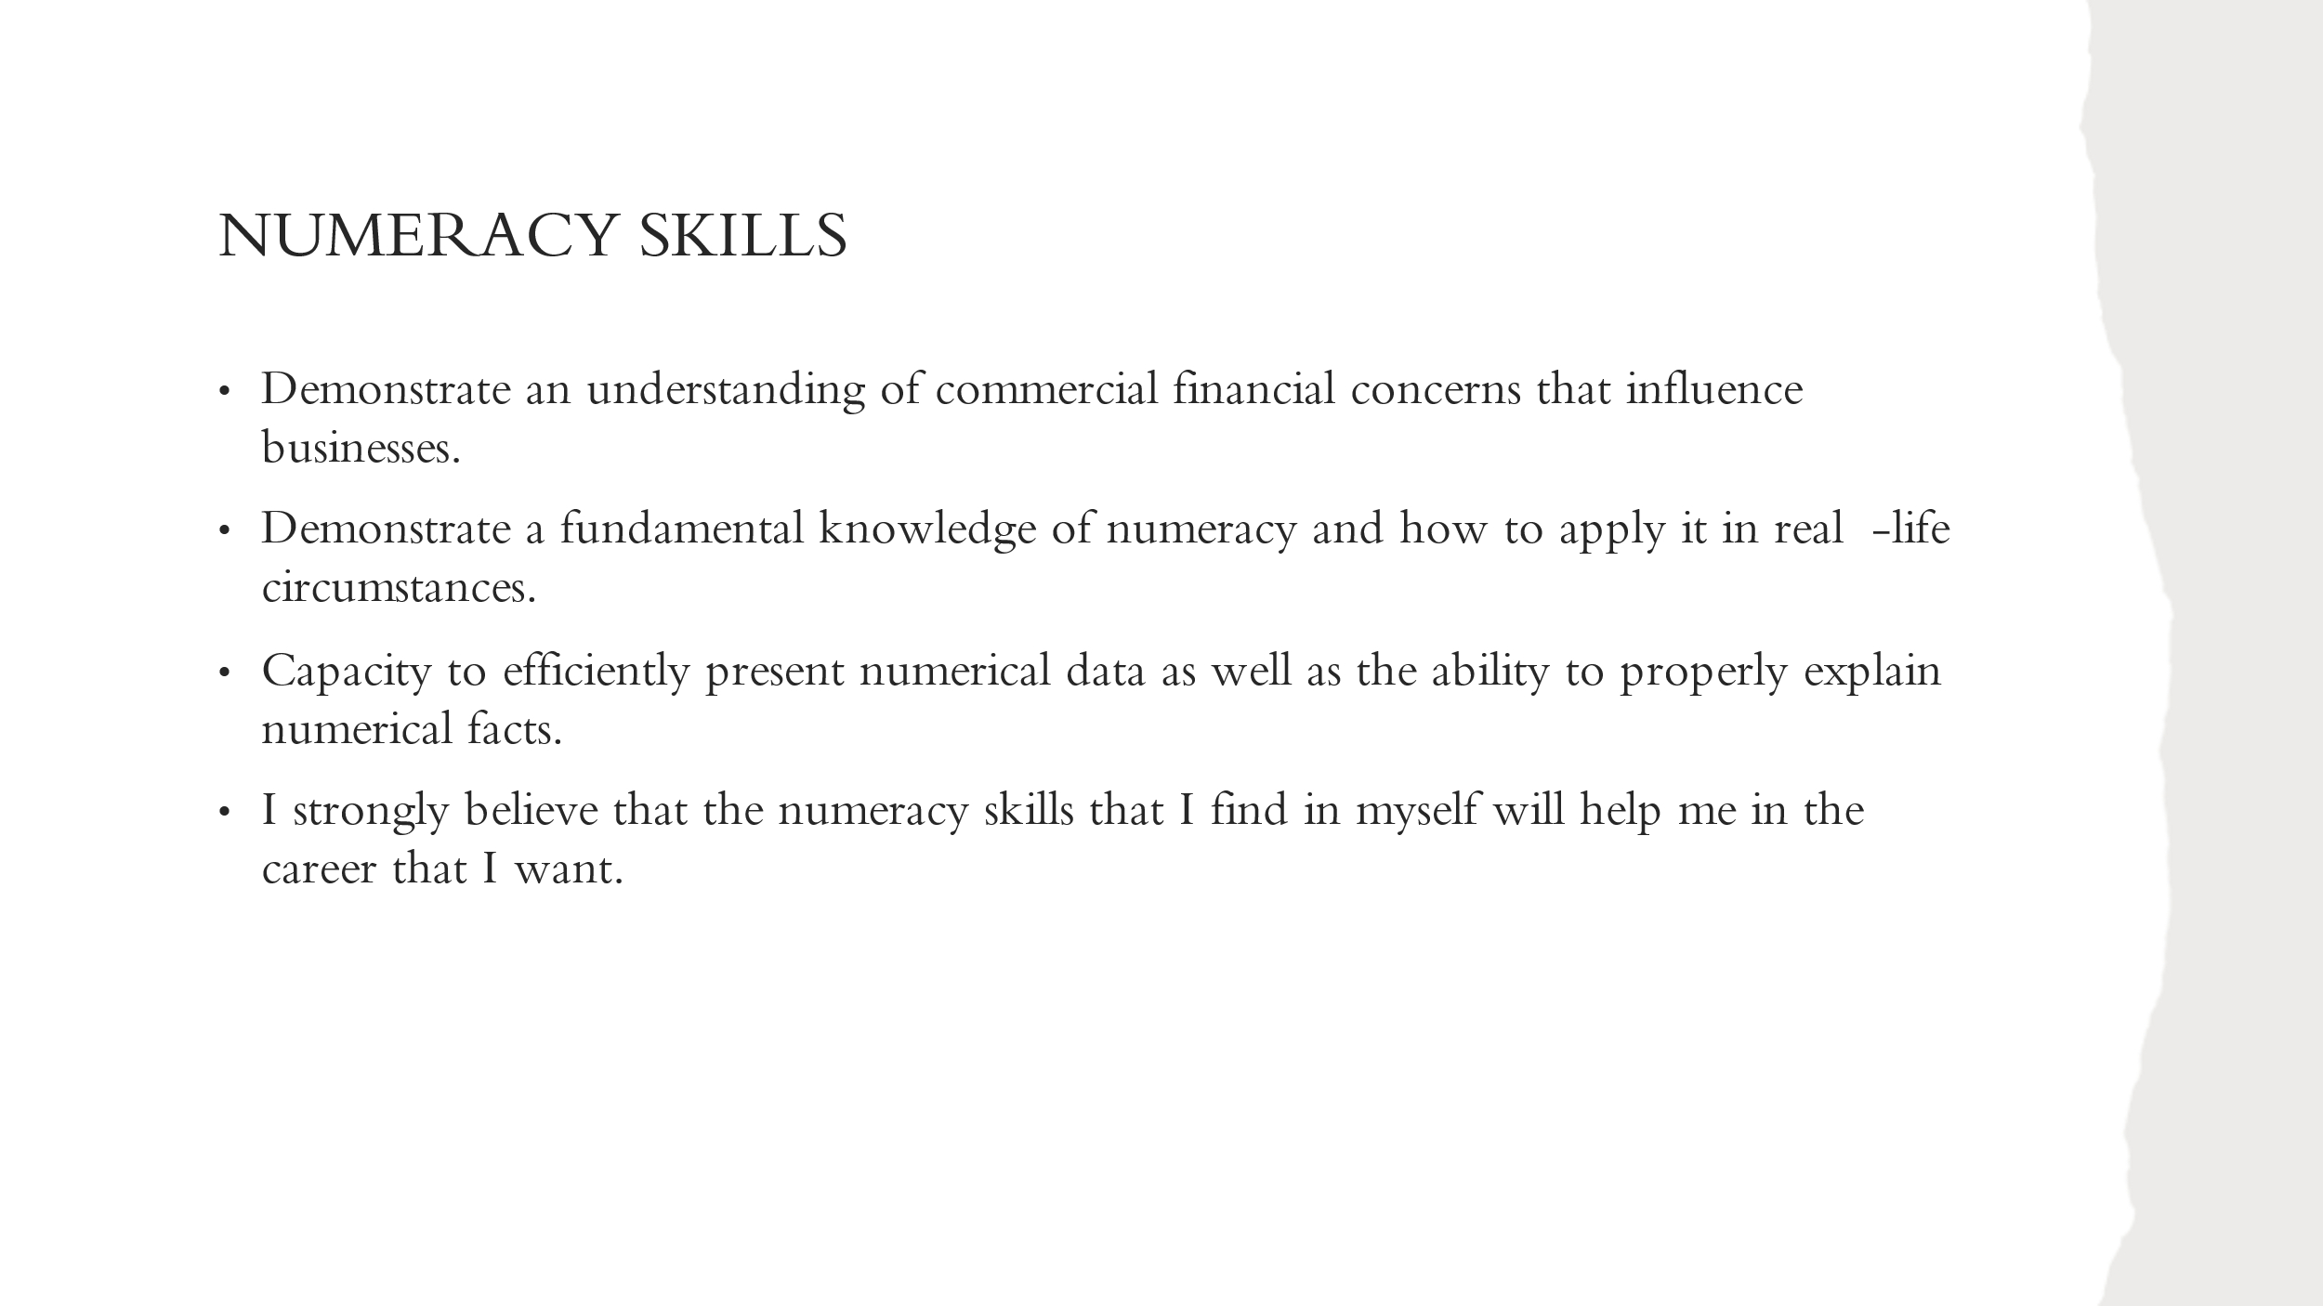

Slide 5
I consider that I have all of these soft skills.

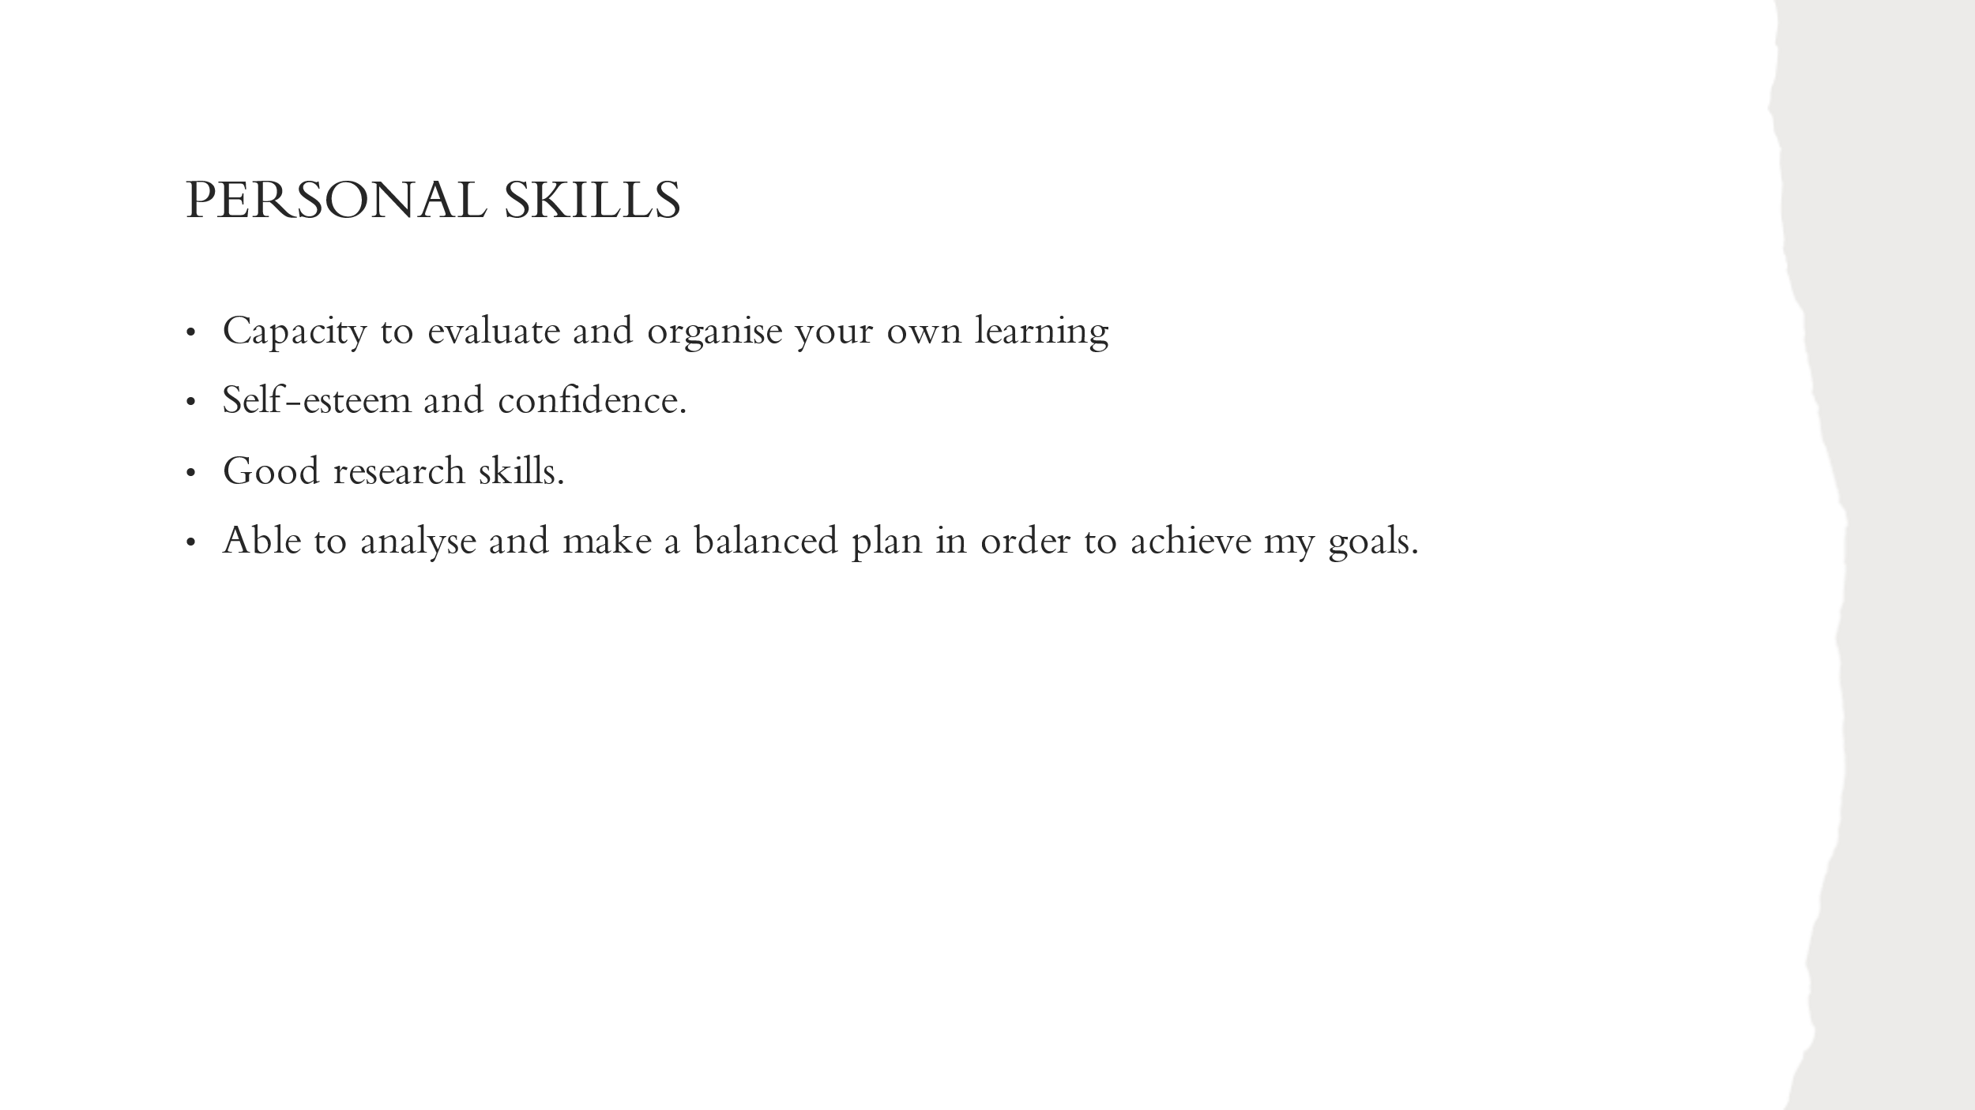
Slide 6
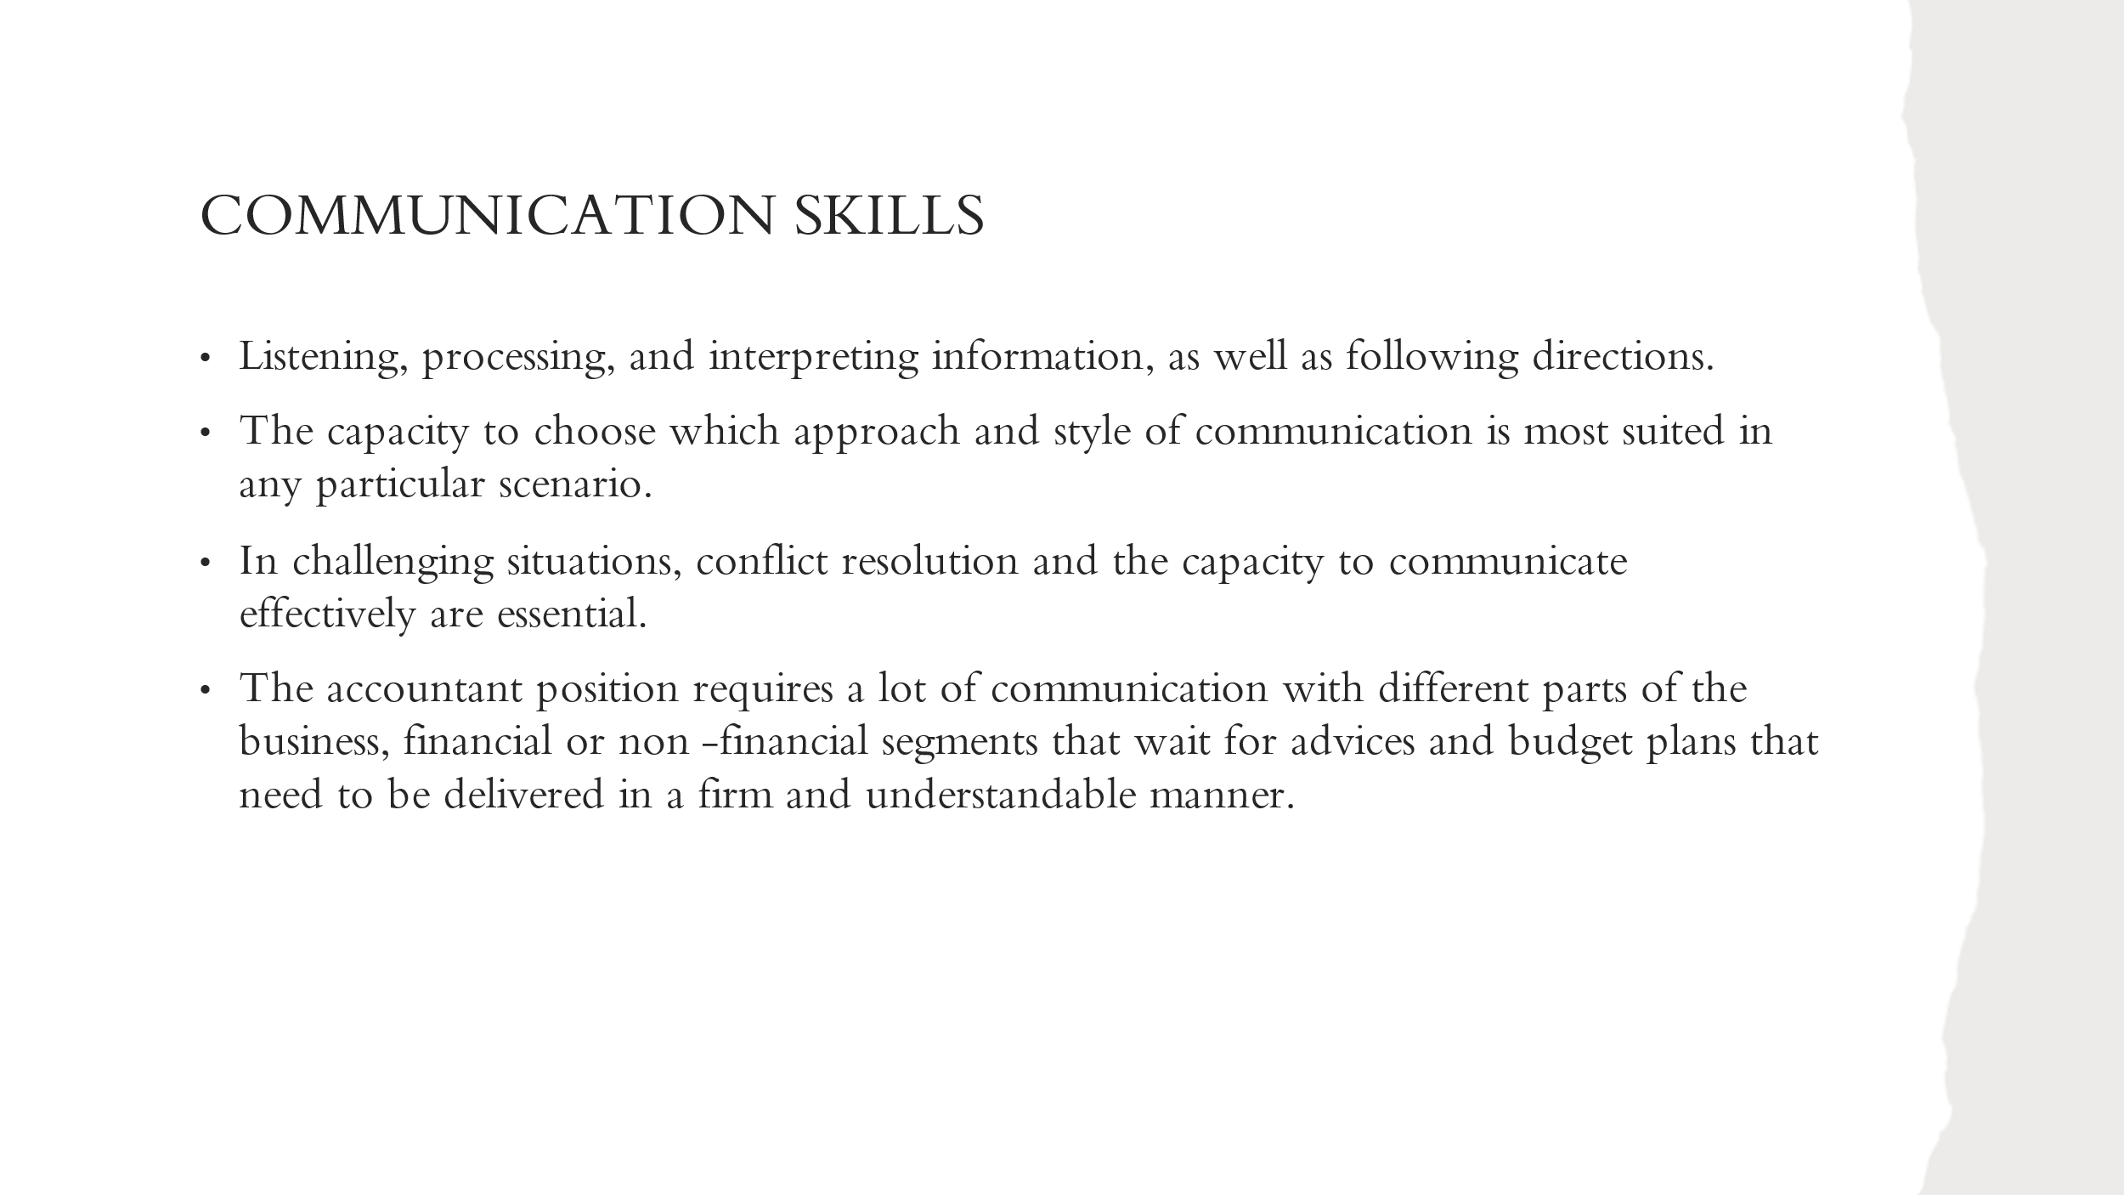

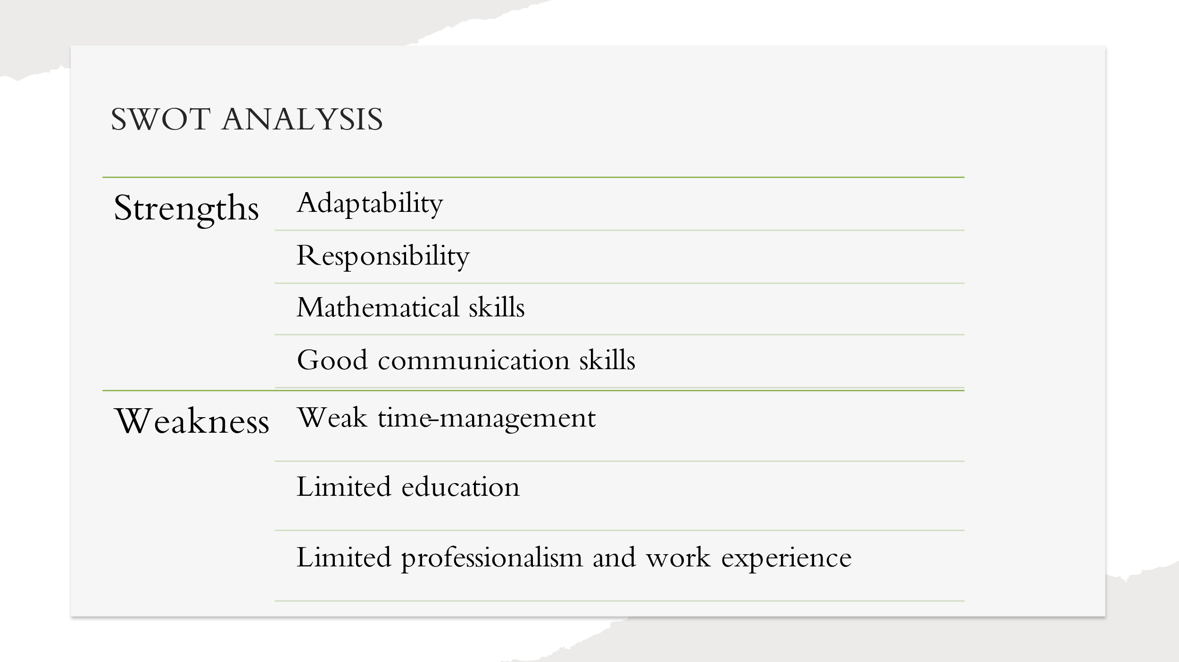
Slide 7

My strengths are that I have adaptive and transferable skills. I am a very responsible person. I always treat my work in a serious manner. I can adapt easily to any situation, any job or team that I have the opportunity to be in. I can communicate well, and I will be able to communicate the decisions to non-financial managers also.
Also, my mathematical skills are well fixed. I always loved math and I like exact things. This will allow me to take good financial decisions, based on the volume of data that will be provided with.
Weakness: However, my time-management is not great and sometimes I struggle to work within strict deadlines. I always finish my work in time, but I leave everything for the last minute and I do everything in one night. At least I am responsible, and I do it. As this presentation. Another Weakness is that I am not educated towards this career. I do not have any course that can put me in an accountant position. I have to start as an assistant, to do some courses, the ACCA qualification and after I will have the ACADEMIC skills that I need. Also, I may not have the professionalism that this field may ask for when dealing with business partners or the shareholders.

Slide 8
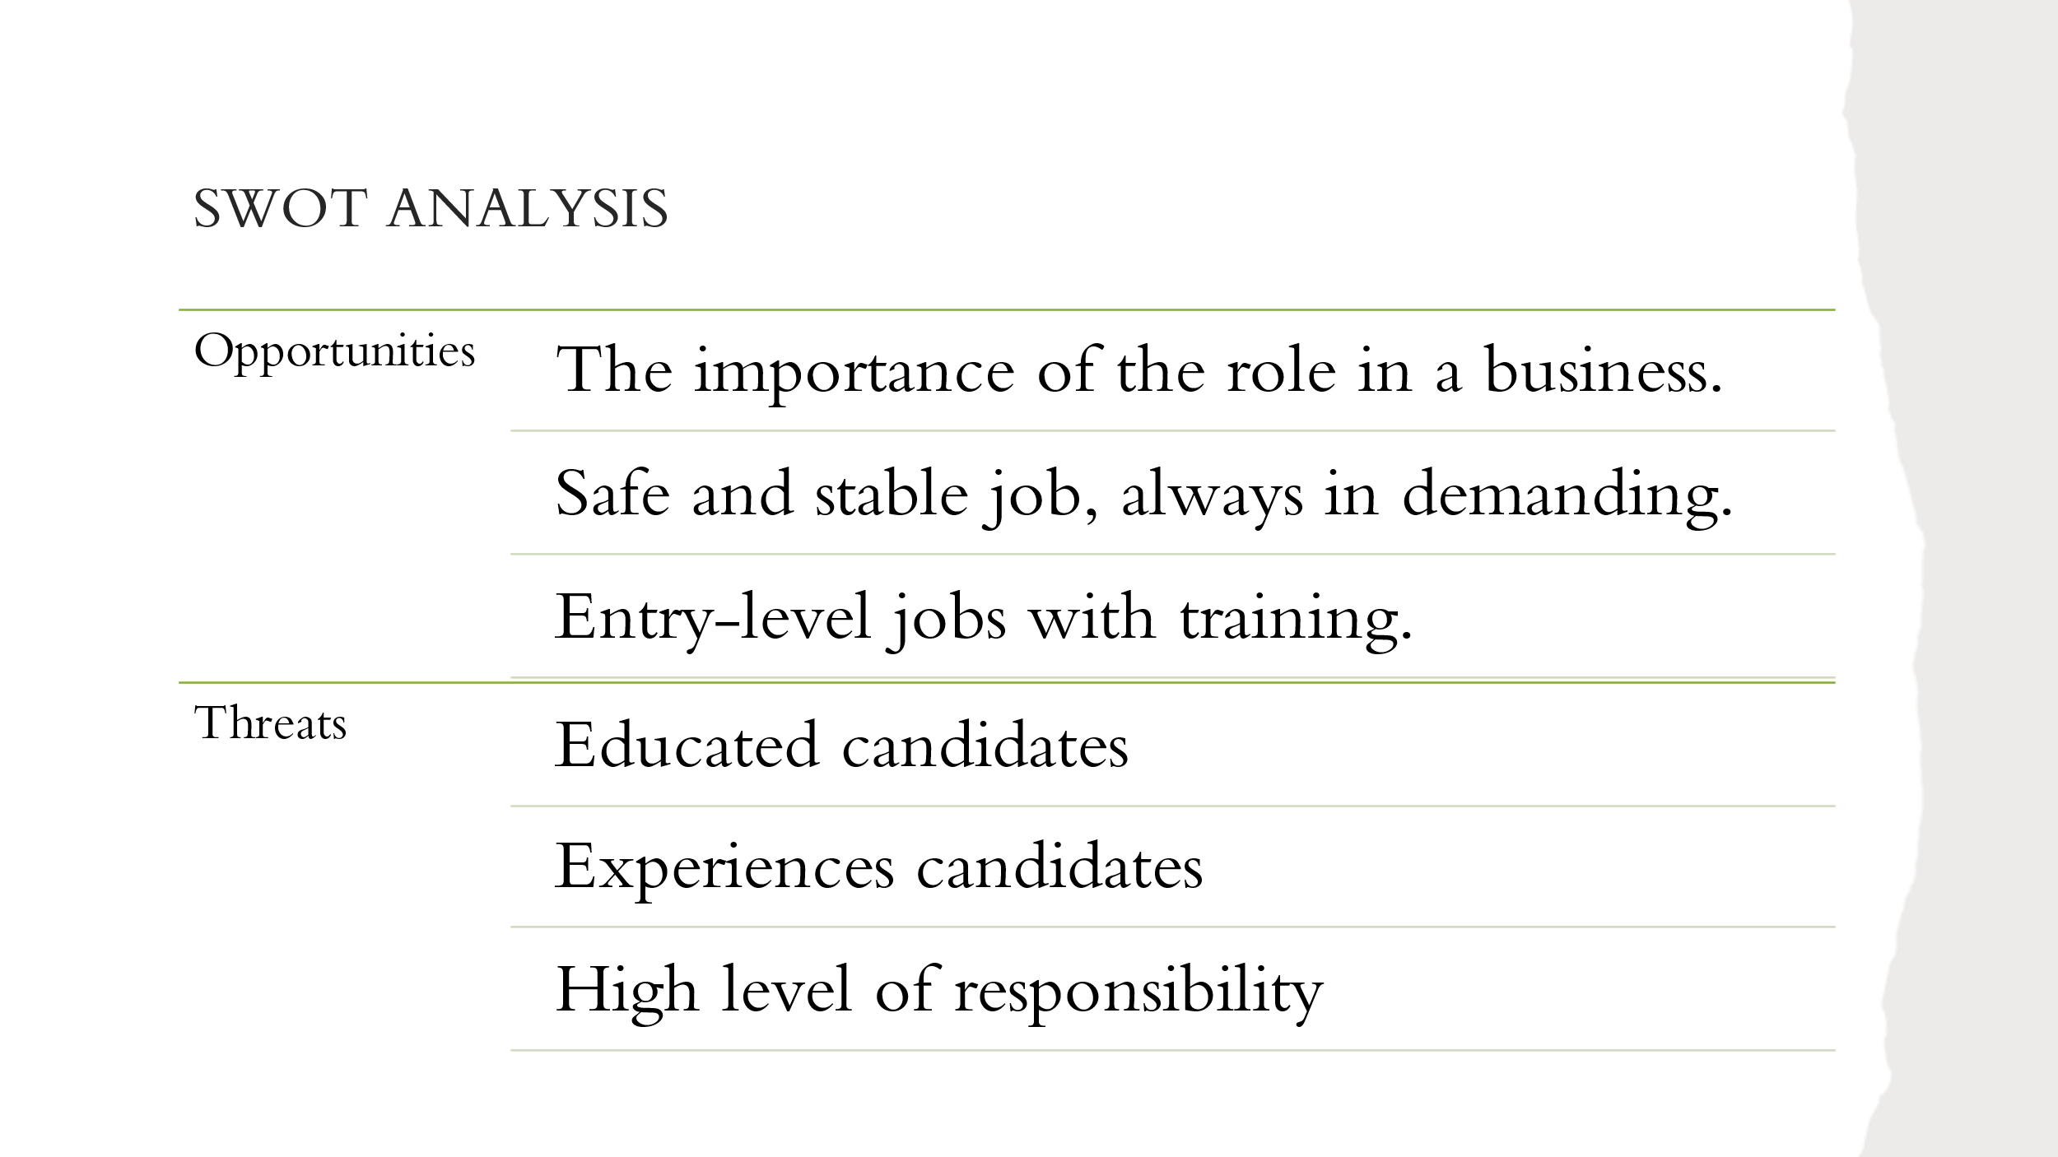
Opportunities: Accountants are always in demand for every business. Accountancy is a service that all of them need, very often . Is a stable job, like a rock. If everything crushes with or without Brexit, Covid or anything, there will always be a demand for accountants. I have read on LinkedIn that are many entry-level jobs that offer training or support to study in the field.
Threats: In my case, the threats may be other candidates with high level of education in the field, maybe some experience, background from family businesses. Maybe if they started to work toward this career earlier in their life, they had a start and some steps in front of me. Also, even if I like to be responsible, the volume of responsibility that working with numbers and budget brings is a bit scary for me. It may be a little bit scary the thought that every mistake can cause a bad financial decision or a wrong financial document.

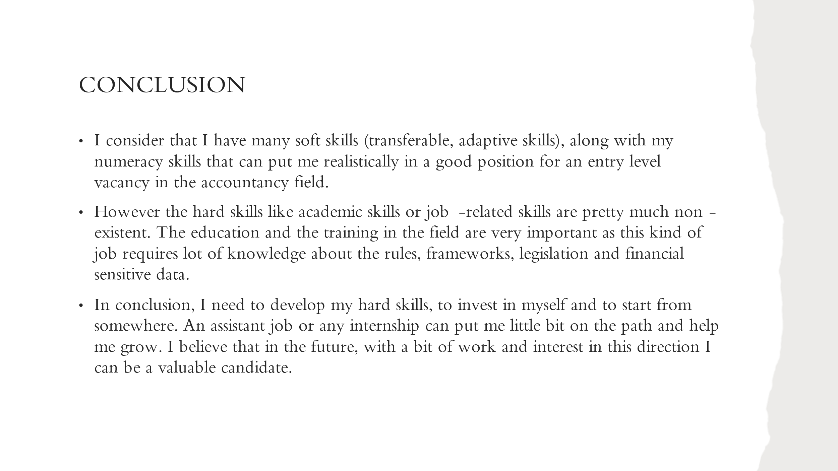
Slide 9

Slide 10


