

Student name: | Johayer Anjum Tahmeed | Student ID number: | 2414378
Programme: | BEng Engineering Programmes
Module: | Mechanics and Dynamics
Module code: | ACHA4026
Lecturer: | Abi Penny
Assignment Title: | Torsion of Shafts
Word Count | 1580
Submission Date: | May 29, 2026

Table of Contents
1.0 Introduction 3
2.0 Experimental Procedure 3
3.0 Results 8
4.0 Analysis 9
5.0 Conclusion 11
6.0 Evaluation 12
7.0 Further Work 13
References 14

1.0 Introduction
This experiment was set up to find the shear modulus (G) of the materials of three circular shafts (brass, aluminium and steel) using the TecQuipment ES5 Torsion of Circular Sections Kit. The aim of the experiment was also to verify the linear relation between torque applied and angle of twist in the elastic region.
Torsion is the action of structural member when it is subjected to a twisting moment, which results in shear stresses building across its cross-section (Hibbeler, 2022). In engineering practice, the torsional load is encountered in components like drive shafts, motor axles, power transmission systems and in drilling equipment. Knowing how a material will respond to torsion is then important for a safe and efficient mechanical design (McClements, 2025).
The torsion equation for a circular shaft within the elastic limit is:
$$\frac{T}{J}=\frac{Gθ}{L} ⇒ TL=GJ$$
T is the torque applied (Nm), L the length of the shaft (m), G the shear modulus (Pa), J the polar second moment of area (m⁴) and θ the angle of twist (radians). The graphs of TL vs. Jθ yield a straight line with a slope of G (Hibbeler, 2022).

2.0 Experimental Procedure
The experiment was carried out with the TecQuipment ES5 Torsion of Circular Sections Kit (TecQuipment 2024). The apparatus is made from a panel that is fixed to a stable base, and has two freely moving chucks attached, one fixed and one free, holding the test rod horizontally. A hanging hook applies incremental loads and is connected to a torque arm which has an angular scale disc attached to the free chuck (TecQuipment, 2024).

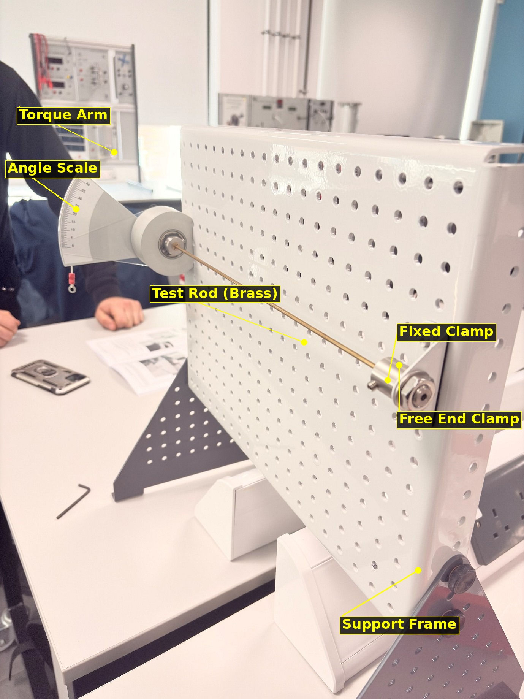
Fig. 1 - Full apparatus setup showing the ES5 torsion kit (TecQuipment, 2024)
The three rods are made of brass, aluminium and steel and were tested one after the other. The gauge length (L) of each rod was 0.34 m and the nominal diameter (D) of the rods was approximately 3.1 mm for brass and aluminium and 3.13 mm for steel. To prevent loading slip on the rod, it was fixed securely in both the chucks. Prior to placing a load on the scale, the angular scale pointer was set to zero as demonstrated in the figures 2 and 3.

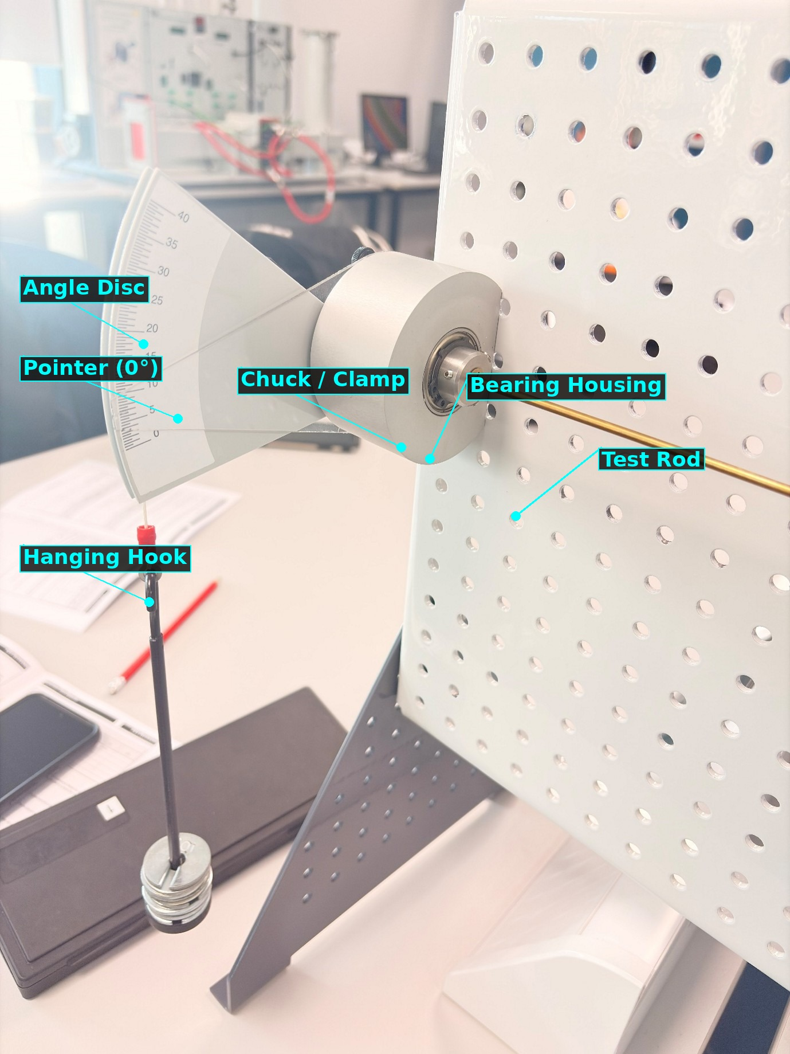
Fig. 2 - Close-up of rod, chuck and bearing housing
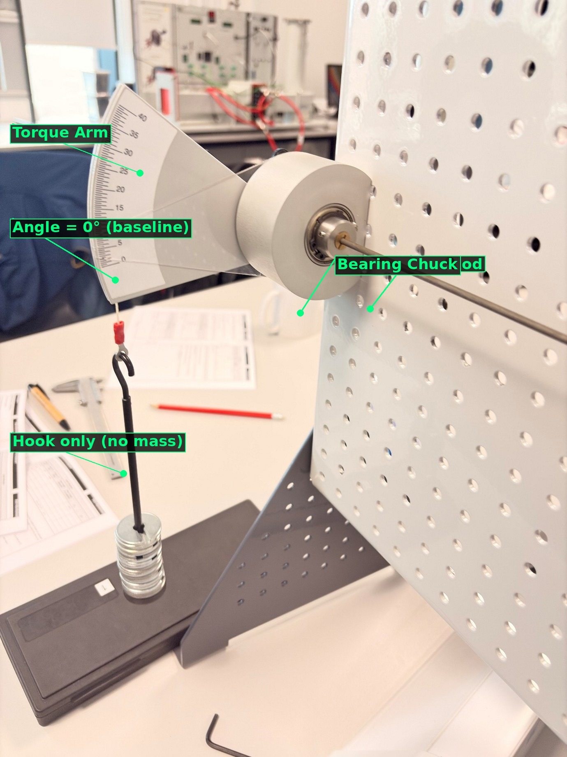
Fig. 3 - Apparatus at zero load (baseline position)
100 g masses were added to the hanging hook, creating the force acting on the torque arm as a result of this downward weight (W = mg), and the torque arm was attached at a chosen radius (r = 0.1 m) from the centre of the shaft. This generated a torque T = F × r at the end of the rod that was free. The angle of twist (θ) was measured at each increment and noted down in degrees on the angular scale disc. The weights were carefully added on so that the material never exceeded its elastic limit, especially for the more malleable aluminium rod. The apparatus loaded is shown in figure 4.
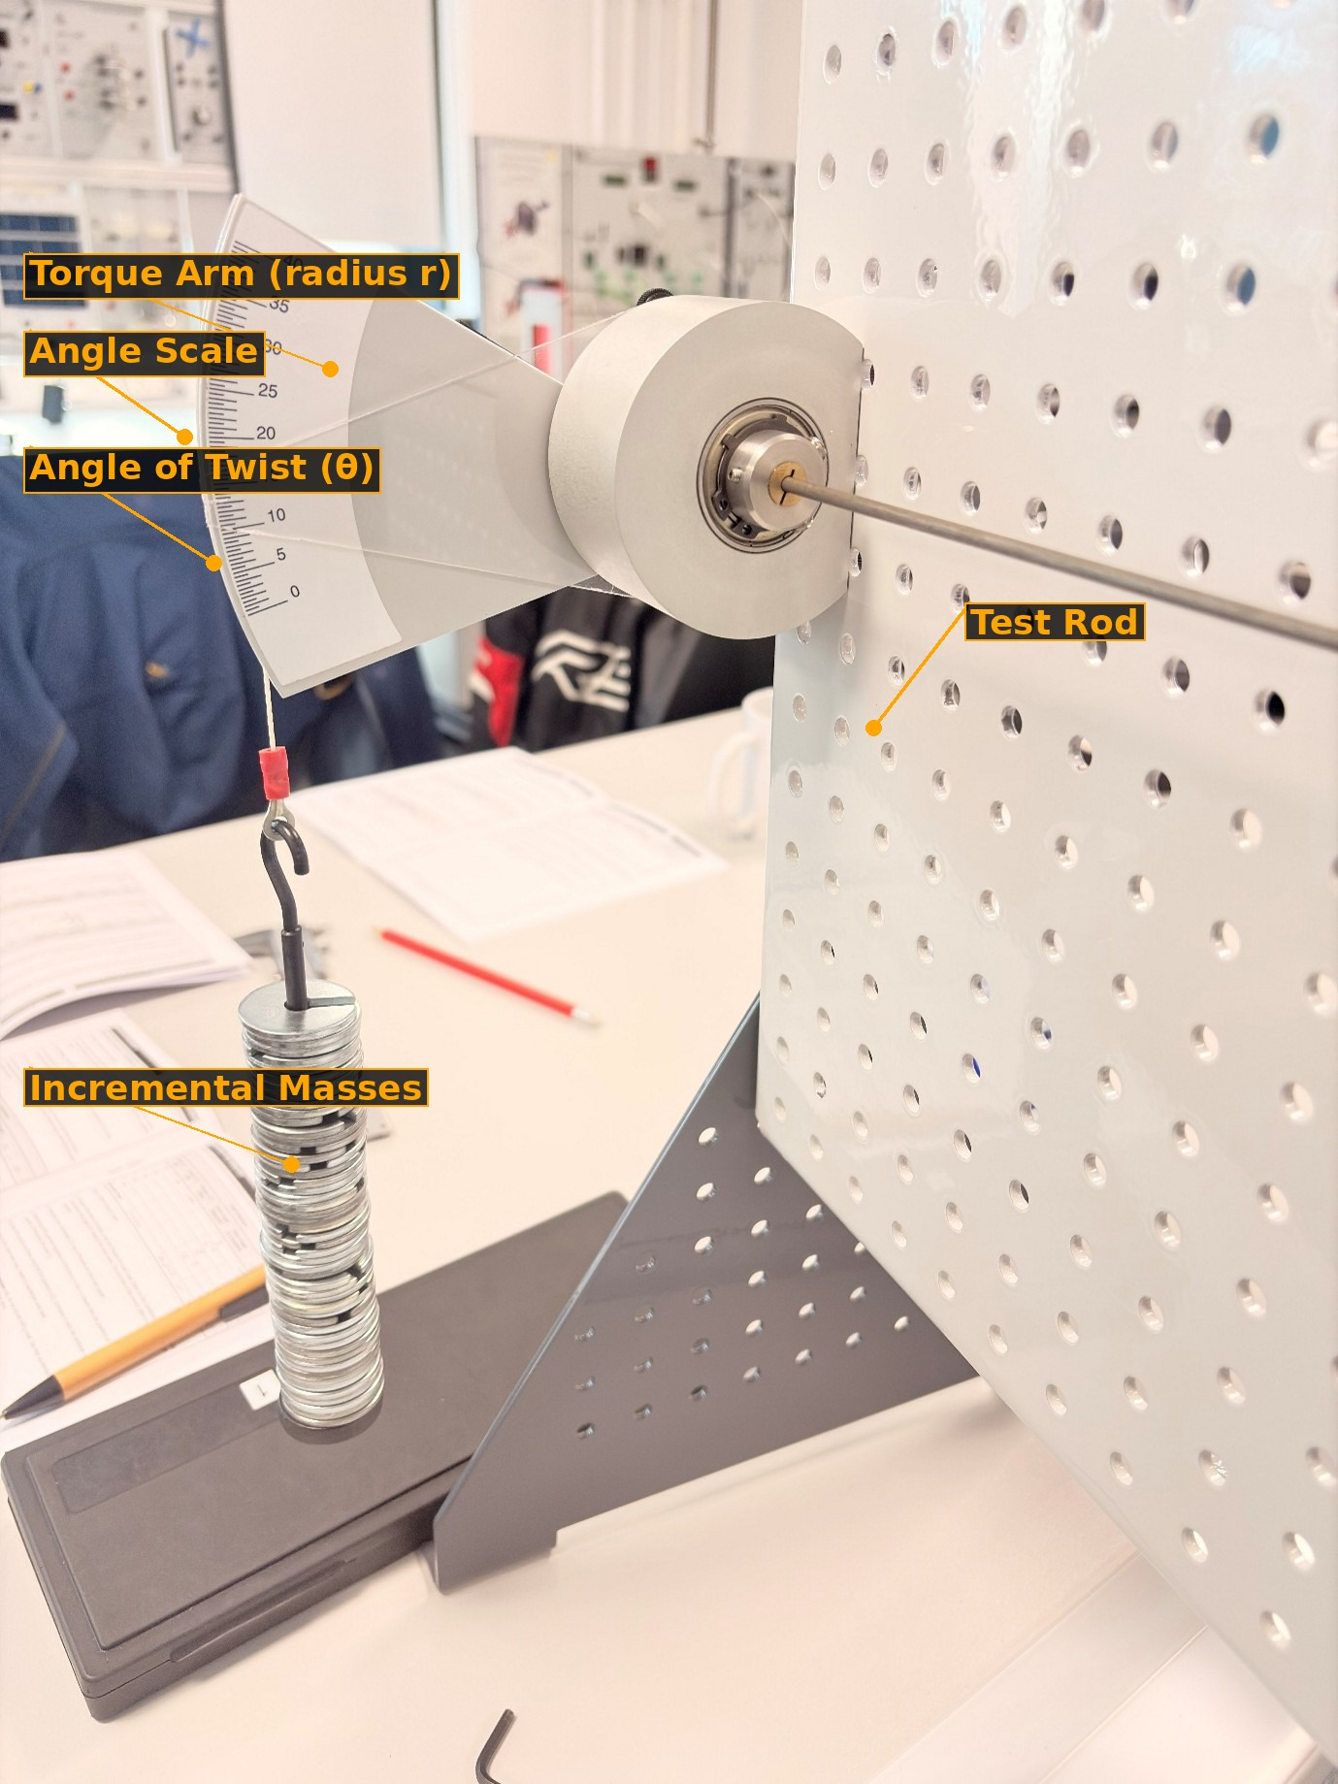
Fig. 4 - Masses applied to torque arm; angle of twist being measured
Angles measured were converted to radians for analysis. The values of torque, T, TL, J, and Jθ were calculated in MS Excel for each data point. For each material, a graph of TL vs Jθ was drawn and trendlines were fitted to the data to obtain the value of G from the gradient (TecQuement, 2024).

3.0 Results
The raw experimental data obtained on each material is displayed below. The second moment of the area of the pole, J, was found using:
$$J=\frac{πD^{4}}{32}$$
This gives J = 9.07 × 10⁻¹² m⁴ for brass and aluminium (D = 3.1 mm), and J = 9.37 × 10⁻¹² m⁴ for steel (D = 3.13 mm).
Table 1: Raw experimental data - Brass rod (TecQuipment, 2024)
Mass (g) | Load W (N) | Torque T (Nm) | Angle θ (°) | Angle θ (rad) | TL (N·m²) | Jθ (m⁴·rad)
100 | 0.98 | 0.098 | 6.5 | 0.113 | 0.033 | 1.03E-12
200 | 1.96 | 0.196 | 12.5 | 0.218 | 0.067 | 1.98E-12
300 | 2.94 | 0.294 | 18 | 0.314 | 0.100 | 2.85E-12
400 | 3.92 | 0.392 | 24 | 0.419 | 0.133 | 3.80E-12
500 | 4.90 | 0.490 | 30 | 0.524 | 0.167 | 4.76E-12
Material: Brass L = 0.34 m D = 3.1 mm J = 9.07 × 10⁻¹² m⁴

Table 2: Raw experimental data - Aluminium rod (TecQuipment, 2024)
Mass (g) | Load W (N) | Torque T (Nm) | Angle θ (°) | Angle θ (rad) | TL (N·m²) | Jθ (m⁴·rad)
100 | 0.98 | 0.098 | 8.5 | 0.148 | 0.033 | 1.35E-12
200 | 1.96 | 0.196 | 17 | 0.297 | 0.067 | 2.70E-12
300 | 2.94 | 0.294 | 25 | 0.436 | 0.100 | 3.96E-12
400 | 3.92 | 0.392 | 32 | 0.559 | 0.133 | 5.08E-12
Material: Aluminium L = 0.34 m D = 3.1 mm J = 9.07 × 10⁻¹² m⁴

Table 3: Raw experimental data - Steel rod (TecQuipment, 2024)
Mass (g) | Load W (N) | Torque T (Nm) | Angle θ (°) | Angle θ (rad) | TL (N·m²) | Jθ (m⁴·rad)
100 | 0.98 | 0.098 | 3.0 | 0.052 | 0.033 | 4.87E-13
200 | 1.96 | 0.196 | 5.5 | 0.096 | 0.067 | 8.94E-13
300 | 2.94 | 0.294 | 8.0 | 0.140 | 0.100 | 1.31E-12
400 | 3.92 | 0.392 | 10.5 | 0.183 | 0.133 | 1.71E-12
500 | 4.90 | 0.490 | 13.0 | 0.227 | 0.167 | 2.12E-12
Material: Steel L = 0.34 m D = 3.13 mm J = 9.37 × 10⁻¹² m⁴

4.0 Analysis
The applied mass m (in kg) was multiplied by the torque arm radius r (m) and g=9.81 (m/s²), to obtain the torque applied at each load increment, T = F × r = m × g × r. A product TL and term Jθ were then calculated for each reading. If we plot the value of TL against Jθ, we will obtain a linear graph, and the gradient of the graph will be equal to the shear modulus G of the material (Hibbeler, 2022):
$$G=\frac{TL}{Jθ}=\text{gradient of }TL\text{ vs }Jθ\text{ graph}$$
Microsoft Excel was used to create a graph for each material for the plot of TL versus Jθ. High R-values (R²) for the three materials also show that deformation is directly proportional to the torque applied for all three materials, indicating that all three materials are elastic throughout the test (Kumar and Shinde, 2020).
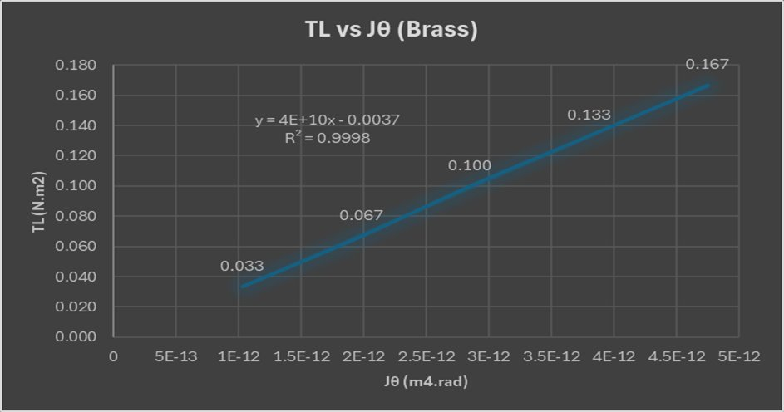
Fig. 5 - TL vs Jθ graph for Brass (G = 4 × 10¹⁰ Pa, R² = 0.9998)

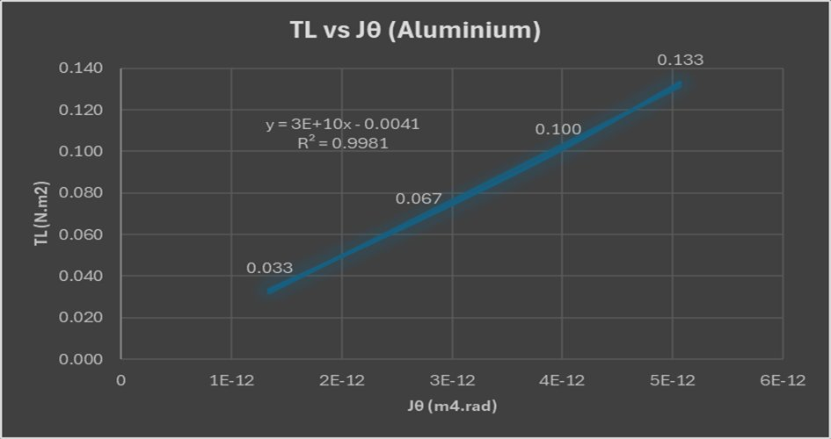
Fig. 6 - TL vs Jθ graph for Aluminium (G = 3 × 10¹⁰ Pa, R² = 0.9981)

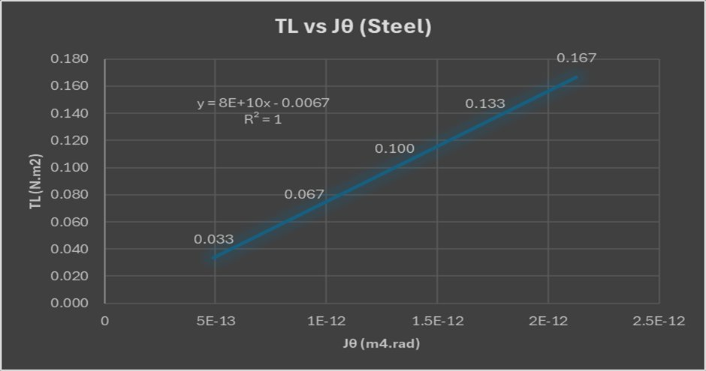
Fig. 7 - TL vs Jθ graph for Steel (G = 8 × 10¹⁰ Pa, R² = 1.00)

5.0 Conclusion
The experimental gradient values of each TL versus Jθ graph calculated using the experimental data are compared with the published literature values as shown in Table 4 (Kumar and Shinde, 2020; IUPAC, 2025).
Table 4: Comparison of experimental and literature shear modulus values
Material | Exp. G (GPa) | Literature G (GPa) | % Difference | Identification
Brass | 40 | 37-42 | ~5% | Confirmed Brass
Aluminium | 30 | 25-26 | ~15% | Confirmed Aluminium
Steel | 80 | 79-80 | ~1% | Confirmed Steel

The percentage difference was worked out from:
$$\%\text{ difference}=\frac{\left|G_{\text{exp}}-G_{\text{lit}}\right|}{G_{\text{lit}}}×100$$
Almost perfect linearity was confirmed by the R² value and the closest agreement was found for steel, with an error of ~1% from the accepted value of 79-80 GPa (IUPAC, 2025). The value of Brass was also in good agreement at ~ 5% with published value of 37-42 Gpa (Kumar and Shinde, 2020). A greater difference was observed in the case of aluminium where the discrepancy is of ~15% from the published value of 25-26 GPa (Kumar and Shinde, 2020). It is attributed to the fact that it has a higher angular deformation which affects the calculated value of G directly, thus all three materials were successfully identified from the G values obtained, and the results are valid in the elastic regime (Hibbeler, 2022).

6.0 Evaluation
To reduce errors and increase the reliability of the results, a number of precautions were taken during the experiment:
- The mass was increase incrementally to prevent the material from being permanently deformed and to keep it within the elastic range of its materials.
- Angular scale was read at eye level for each measurement to prevent parallax error. The pointer was checked to ensure that it returns to zero on rod change.
- The rod was tightly clamped in both chucks prior to loading and the clamp screw was fully tightened to ensure that there was no slippage at the clamp points thereby reducing the effective gauge length.
- The diameter of the rod was checked with vernier calliper before conducting each test. Correct measurement of D is essential because the magnitude of J is proportional to D⁴ and the error in D can lead to large error in G.
- The angle reading was taken after weights were allowed to come to rest, thus eliminating dynamic oscillation effects on the angle reading.

7.0 Further Work
If time and resources were unlimited, the following changes would be made to increase the accuracy and the scope of this experiment:
- Use a digital angle encoder or optical rotary sensor instead of the manual angular scale. This would remove the uncertainty due to human reading error, which was found to be the main source of uncertainty, especially for aluminium.
- Take longer test rods, L = 0.5 - 1.0 m, to obtain larger angles of twist for the same applied torque. The larger the angle the easier it is to read it correctly and the more accurate θ measurements.
- Run the experiment with additional engineering materials (copper, titanium etc.) to create a wider engineering materials comparison database.
- Run the experiment at controlled higher temperatures to study the relationship of the change in G with the change in temperature of each material, applicable in actual situations as engine drive shafts.

References
Hibbeler, R.C. (2022) Mechanics of Materials. 11th edn. Hoboken: Pearson. Available at: https://www.pearson.com/en-us/subject-catalog/p/mechanics-of-materials/P200000003409 (Accessed: 20 May 2026).
IUPAC (2025) Shear modulus. Available at: https://goldbook.iupac.org/terms/view/S05635 (Accessed: 20 May 2026).
Kumar, J. and Shinde, N.S. (2020) ‘Shear moduli of metal specimens using resonant column tests’, Journal of Testing and Evaluation, 48(6), pp. 4846-4856. doi: 10.1520/JTE20180125.
McClements, D. (2025) What is shear modulus? Xometry. Available at: https://www.xometry.com/resources/3d-printing/what-is-shear-modulus/ (Accessed: 20 May 2026).
TecQuipment (2024) Torsion of circular sections kit ES5. Available at: https://www.tecquipment.com/torsion-of-circular-sections-kit (Accessed: 20 May 2026).

