

Student name: Michaela Demeterova
Student ID: 2312297

Module name: Psychopathological Classifications and Provisions
Module code: (BMHP6029_LON)

HEADING
Author name: Michaela Demeterova
Introduction:  Catatonia is a neuropsychiatric syndrome affecting movement, speech, and behaviour. It occurs across psychiatric and medical conditions, including mood disorders, schizophrenia, and neurological illness. Though historically misclassified as schizophrenia, it is now recognised as a distinct, treatable syndrome. Catatonia is not a standalone diagnosis, but a specifier in both DSM-5 and ICD-11 frameworks (Wilson et al., 2025).  - Mood disorders (bipolar and depression) (Wilson et al., 2025)  - Schizophrenia spectrum disorders (Wilson et al., 2025)  - Medical conditions such as epilepsy and autoimmune illness (Wilson et al., 2025)  How common is the disorder? How many people are diagnosed with this disorder?  A large dataset from South London and Maudsley NHS Trust found catatonia in 7–10% of psychiatric inpatients, especially those with mood disorders or psychosis (Rogers et al., 2019). Despite this, it remains under recognised, partly due to diagnostic complexity and stigma (Rogers et al., 2023).  Historical perspectives and treatments:  Historical Perspectives  - Kahlbaum (1874): Defined catatonia as a psychomotor disorder linked to mood and behaviour.  - Hecker (1877): Expanded symptoms (mutism, refusal of food, stereotypy, negativism).  - Kraepelin & Bleuler: Misclassified catatonia as a subtype of schizophrenia.  - Impact: Led to stigma, neglect, and institutionalisation.  - Modern view: Restored as a cross-diagnostic, treatable syndrome (Hirjak et al., 2022).  Historical Treatments  - Early 20th century: Treated as schizophrenia, few effective options (Fink & Taylor, 2003).  - 1950s: Antipsychotics blurred recognition, symptoms mistaken for side effects (Hirjak et al., 2022).  - Late 20th century: Renewed focus on catatonia as distinct and treatable (Rogers et al., 2023).  - Modern care: Benzodiazepines and ECT recognised as effective, often lifesaving (Rogers et al., 2023; Edinoff et al., 2023).  Symptoms:  A person with catatonia may experience stupor, mutism, posturing, negativism, echolalia, echopraxia, agitation, rigidity, staring, or reduced consciousness (Rajagopal, 2018; Royal College of Psychiatrists, 2025)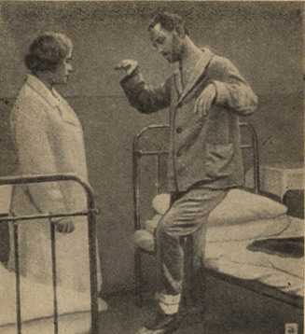  This Photo by Unknown Author is licensed under CC BY-SA |  | Catatonia Across Time: Historical Misconceptions and Contemporary Care Exploring the Social Dimensions of Diagnosis, Treatment, and Provision.    This Photo by Unknown Author is licensed under CC BY-SA  Definition of Catatonia:  Catatonia is a neuropsychiatric syndrome characterised by significant disturbances in movement, speech, and behaviour. A person with catatonia may appear unresponsive, immobile, or display unusual postures, repetitive movements, or echoing of speech or actions. It is not a standalone disorder, but a specifier that can occur in the context of mood disorders, schizophrenia, or medical conditions such as epilepsy or autoimmune illness.  Causes of Catatonia:  Psychiatric Disorders:  - Mood disorders and schizophrenia (APA, 2013; Rogers et al., 2023)  - PTSD (Rajagopal, 2018)  - Epilepsy, Parkinson’s disease, encephalitis (Hirjak et al., 2022; Zingela et al., 2022)  - Autoimmune disorders (Rogers et al., 2019)  - Metabolic imbalances (Sundararajan, 2018)  - Brain injury or stroke (Fink & Taylor, 2003)  Medication and Substance-Related Triggers:  - Antipsychotics, especially in high doses or rapid changes (Sundararajan, 2018; Fink & Taylor, 2003).  - Steroids, benzodiazepine withdrawal, or illicit substances (Edinoff et al., 2023; Rogers et al., 2023).  - Malignant catatonia, a rare life-threatening form requiring urgent treatment (Rogers et al., 2023; Wilson et al., 2025).    This Photo by Unknown Author is licensed under CC BY-NC-ND  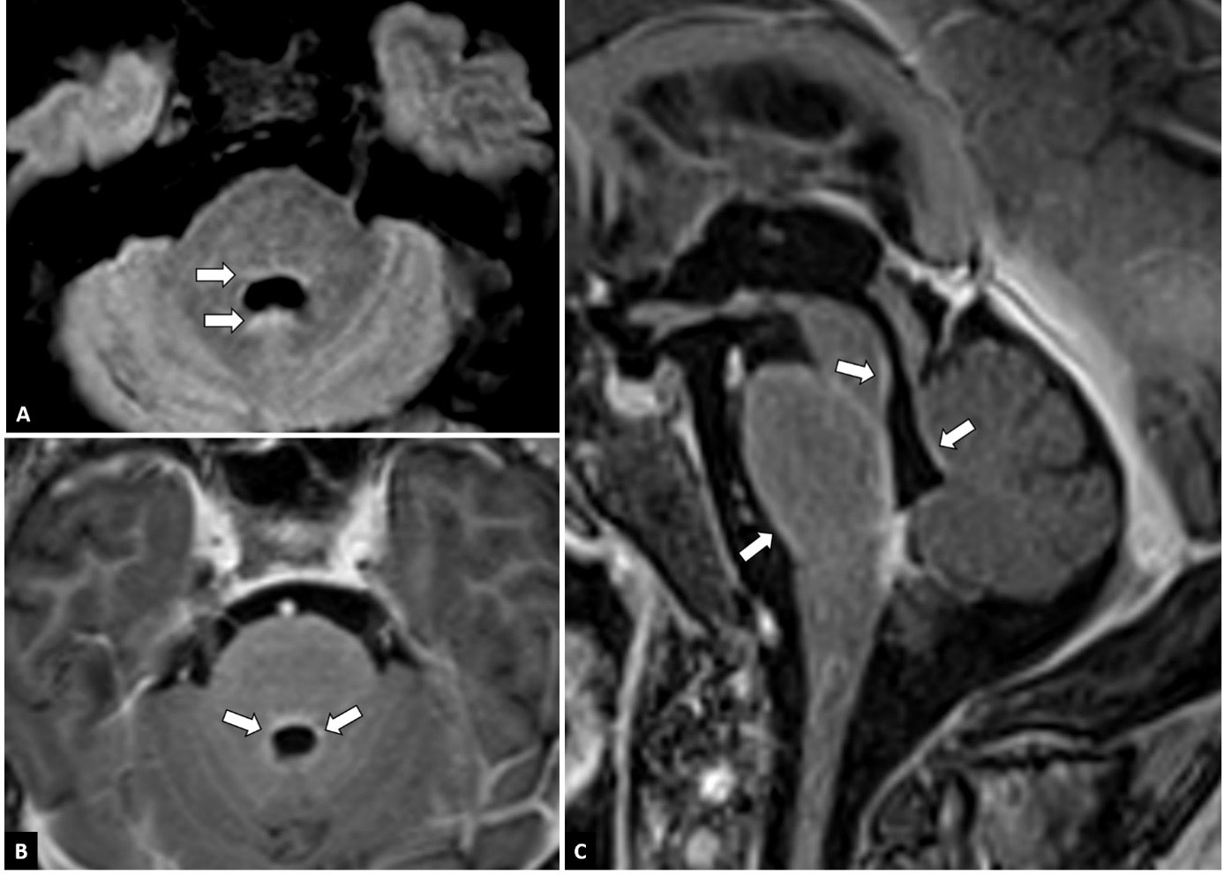  This Photo by Unknown Author is licensed under CC BY  Diagnosis involves:  - Clinical observation: At least three of the core symptoms must be present, as per DSM-5 criteria.  - Lorazepam challenge test: A small dose of lorazepam is given; if symptoms improve within minutes, it supports the diagnosis.  - Exclusion of other conditions: Blood tests, brain scans, and psychiatric evaluation help rule out other causes. |  | Current services and treatments:  Medical Treatments:  - Benzodiazepines (e.g. lorazepam)  - Electroconvulsive Therapy (ECT)  - Treatment of underlying condition (Edinoff et al., 2021)  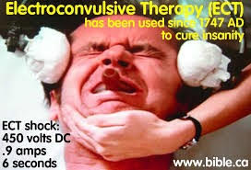  This Photo by Unknown Author is licensed under CC BY-NC  Mental Health Services:  - Psychiatric assessment and inpatient care.  - Multidisciplinary care teams.  - Community mental health services .  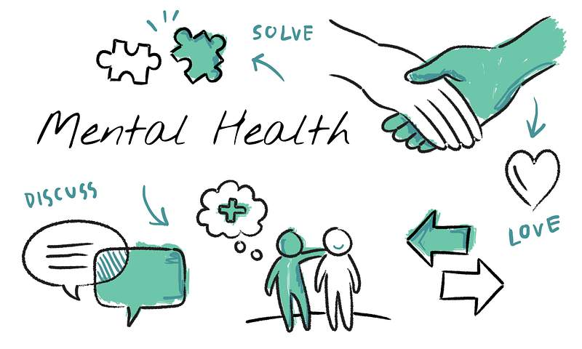  Legal and Safeguarding Support:  - Mental Health Act 1983  - Mental Capacity Act 2005  - Care Act 2014  (Care Learning, 2025).  Supportive Services:  - Crisis intervention teams (Royal College of Psychiatrists, 2025; Rogers et al., 2023).  - Safeguarding and advocacy (CareLearning, 2025; CQC, 2025; GOV.UK, 2024).  - Carer support and education (UCL Faculty of Brain Sciences, 2023; Zingela et al., 2022).  Recommendations:  - Increase awareness and training (Rogers et al., 2023).  - Ensure timely access to benzodiazepines and ECT (BAP, 2023).  - Strengthen integration between mental health, medical, and social care teams (Wilson et al., 2025).  - Apply the Mental Capacity Act 2005 consistently (CareLearning, 2025).  - Promote Independent Mental Health Advocates (IMHAs) (CQC, 2025).  - Enhance post-discharge support (Royal College of Psychiatrists, 2025).  - Embed trauma-informed and dignity-centred approaches (Zingela et al., 2022).  Conclusions:  Catatonia challenges us to listen beyond silence. From historical neglect to modern recognition, progress has been made but gaps remain in diagnosis, access, and trauma informed care. With continued training, legal literacy, and compassionate practice, we can ensure that individuals with catatonia receive timely, dignified, and effective support. Ultimately, this is not just about treatment, it’s about restoring voice, movement, and meaning to those frozen by fear or illness.    This Photo by Unknown Author is licensed under CC BY

Reference List:

- Care Learning (2025). 4.1 Identify relevant legislation in relation to mental illness – Care Learning. Care Learning. Available at: https://carelearning.org.uk/qualifications/level-2-mental-health/unit-01-understanding/4-1-identify-relevant-legislation-in-relation-to-mental-illness/ (Accessed 27 Oct. 2025).
- CQC (2025) Deprivation of Liberty Safeguards under the Mental Capacity Act. Available at: https://www.cqc.org.uk/publications/major-report/state-care/2024-2025/focus/dols (Accessed 27 Oct. 2025).
- DSM-5 (2013) Diagnostic and Statistical Manual of Mental Disorders. 5th ed. Washington, DC: American Psychiatric Association (Accessed 27 Oct. 2025).
- Edinoff, A.N., Kaufman, S.E., Hollier, J.W., Virgen, C.G., Karam, C.A., Malone, G.W., Cornett, E.M., Kaye, A.M. and Kaye, A.D. (2021). Catatonia: Clinical Overview of the Diagnosis, Treatment, and Clinical Challenges. Neurology International, [online] 13(4), pp.570–586. doi:https://doi.org/10.3390/neurolint13040057. (Accessed 29 Oct. 2025).
- Fink, M. and Taylor, M.A. (2003) Catatonia: A Clinician’s Guide to Diagnosis and Treatment. Cambridge: Cambridge University Press. (Accessed 27 Oct. 2025).
- GOV.UK (2024) Better care for mental health patients under major reforms. Available at: https://www.gov.uk/government/news/better-care-for-mental-health-patients-under-major-reforms (Accessed 27 Oct. 2025).
- Hirjak, D., Wolf, R.C., Landwehrmeyer, G.B. and Northoff, G. (2022). Catatonia: looking back and moving forward. Brain. doi:https://doi.org/10.1093/brain/awac196. . (Accessed 29 Oct. 2025).
- Rajagopal, S. (2018) ‘Catatonia’, Advances in Psychiatric Treatment, 14(1), pp.33–40. doi:10.1192/apt.bp.107.004051. (Accessed 27 Oct. 2025).
- Rogers, J., Oldham, M., Fricchione, G., Northoff, G., Wilson, J., Mann, S., Francis, A., Wieck, A., Lee, E., Wachtel, Lewis, G., Grover, S., Hirjak, D., Ahuja, N., Zandi, M., Young, A., Fone, K., Andrews, S., Kessler, D. and Saifee, T. (2023). Evidence-based consensus guidelines for the management of catatonia: Recommendations from the British Association for Psychopharmacology. Journal of Psychopharmacology, 37(4), pp.327–369. Available at: https://www.bap.org.uk/pdfs/BAP_Guidelines-Catatonia.pdf (Accessed 29 Oct. 2025)

- Rogers, J.P., et al. (2023) ‘The diagnosis and treatment of catatonia’, Clinical Medicine, 23(1), pp.45–50. Available at: https://discovery.ucl.ac.uk/id/eprint/10170918/ (Accessed 27 Oct. 2025).
- Rogers, J.P., Pollak, T.A., Begum, N., Griffin, A., Patel, R., Pritchard, M., Broadbent, M., Blackman, G., Kolliakou, A., Stewart, R., Timothy and David, A.S. (2019). 23 Epidemiology of catatonia in a large dataset. doi:https://doi.org/10.1136/jnnp-2019-bnpa.23 [Accessed 27 Oct. 2025].
- Royal College of Psychiatrists (2025) Catatonia: Symptoms, causes, and treatment. [online] Available at: https://www.rcpsych.ac.uk/mental-health/mental-illnesses-and-mental-health-problems/catatonia (Accessed 27 Oct. 2025).
- Sundararajan, R. (2018) ‘Catatonia and neuroleptic malignant syndrome’, Advances in Psychiatric Treatment, 14(1), pp.41–49. doi:10.1192/apt.bp.107.004052. (Accessed 27 Oct. 2025).
- UCL Faculty of Brain Sciences (2023) National guidelines for catatonia developed by UCL academics. Available at: https://www.ucl.ac.uk/brain-sciences/news/2023/apr/much-needed-national-guidelines-catatonia-developed-ucl-academics (Accessed 27 Oct. 2025).
- Wilson, J.E., Oldham, M.A., Francis, A., Perkey, D., Kramer, E., Jiang, S., Yoon, J., Beach, S., Fricchione, G., Gunther, M., Ha, J., Luccarelli, J., Rosen, J., Hamlin, D., Dragonetti, J.D., Gerstenblith, A., Stewart, A.L., Sole, J. and Bourgeois, J.A. (2025). Catatonia: American Psychiatric Association Resource Document. Journal of the Academy of Consultation-Liaison Psychiatry. [online] doi:https://doi.org/10.1016/j.jaclp.2025.05.001. (Accessed 29 Oct. 2025)
- Zingela, Z., et al. (2022) ‘The psychological and subjective experience of catatonia: A qualitative study’, BMC Psychology, 10(1), p.85. doi:10.1186/s40359-022-00885-7 [Accessed 27 Oct. 2025].

‌

