Project Management and Research Methods

Project Proposal
Name: Sai Harsha Jangili
Student Id: 1908692
Subject Tutor: Sue Maw
Project Name: Webicom

Table of Contents
Abstract: 3
Keywords: 3
Introduction: - 3
Working title: 4
Objectives: 4
Background area of study: 8
Need of a web application: 8
Accessibility advantages: 9
Literature review: 9
Research and Methodology: 10
Research Philosophy and Justification: 10
Research Approach and justification: 11
Research Strategies and justification: 11
Methodology: 11
Ethical and legal considerations: 12
References 13

Abstract:
With the advancement in internet technology and an increase in internet users throughout the past couple of years, websites became a primary way to advertise for many businesses, educational institutions and many other companies [1]. For an educational institution, one of the fundamental requirements would be communication with staff and students. For interface, one of the foremost easy ways to keep in touch with the students, faculty and parents is to have a good website. A website can accomplish so for an institution.
This project's primary goal is to create a website, an educational institution in India. This project will be helpful to ensure that all the students and staff who belong to the institution are being updated about the institution. The website will also help other people who are willing to join the institution to get the required information about the institution. This document will give a detailed explanation of why websites are useful to run an institution in India [2] [3].

Keywords:
Website for Institutions, uses of having a website, accessibility advantages, easy to access.

Introduction: -
This project ‘Webicom’ is about creating an official website for an educational institution. In fact, from past few years there are many companies which failed in bringing their business into top position most of those companies failed because they disregarded to have a website to promote their business [1].
Nowadays, an educational institution needs to have a website to make the operations of running the institution a bit easier. The institution's webpage increases the overall image and reputation of the institution which can lead to increased admissions. There are many institutions in India which don't have an official website. One of such institutions has been chosen and a website will be created for that institution.
The site will include information about the educational institution, such as staff information, contact information, booking appointments, tuition fee details, admission details, customer review section and all other significant information on the website. The website will help to communicate with the management of the institution. People can provide feedback about the institution, which will help others choose whether to join the institution or not.
This document will explain how the website will be built for the institution, the working title for the project, background area study, research development methods, a Gantt chart is included for the major deadlines for the project [2] [3].

Working title:
The working title for this project is ‘Webicom’ which means Web Communication is aimed at designing and developing a web application for the reflection of real-world scenarios of an education institution.

Objectives:
This project is mainly about creating a website for an institution which will help the students, staff and other viewers easy to know about what’s happening within the institution.
SMART Analysis:
S: Specific
M: Measurable
A: Achievable
R: Realistic
T: Time bound

The primary objectives of this project are:
- To research what are the main components that should be included in the institution’s website.
Specific: First objective will be to note down the main components that are required for the institution like fee, module information, staff information and other main components.
Measurable: While researching about the website and looking at the institution’s requirements and other website the important components like review section, staff info section and other necessities which should be included in the website will be noted and make sure they will be implemented in the website.
Achievable: There are many articles and journals related to creating a website so, referring those articles, other online notes and by referring the present websites this objective can be achieved.
Realistic: As there are many websites and articles available related to creating a website so, this objective is realistic.
Time bound: This objective will take 3 to 4 weeks to attain and it can be achieved on time because referring to the articles will give a clarity on what need to be implemented in the website with no complications so, this can be achieved within in the time with no delays.
- To learn how to implement the requirements in the website.
Specific: The second objective for this project will be to learn how to implement the components in the website.
Measurable: After researching on the required components to the website the complex components like creating the review section in the website and other complex stuff will be learnt before implementing them in the website. It can be determined by practicing it with the examples online.
Achievable: There are many videos that can be found online related to this topic. So, referring to those videos and other important notes will be helpful in achieving this objective.
Realistic: As there are many videos available on YouTube regarding creating this website this objective is realistic in achieving on time.
Time bound: This objective will take 4 to 5 weeks to complete so, this can be achieved during the study period.

- To implement the requirements in the website.
Specific: The third objective is to implements all the required major components with the suitable web elements like search box, text field, checkbox and other suitable compounds.
Measurable: After learning and practicing how to implement the complex components in the website, they will be executed in the final website and parallelly the other stuff which is not complex will also be implemented in the website. Few measures like going through the notes thoroughly and checking it with the requirements will be done to determine if the objective is achieved.
Achievable: Once going through all the videos and notes online it will get a bit easier to apply them in the website. So, this objective is achievable in time.
Realistic: After getting the required notes and referring to the similar videos online it will be realistic in achieving this objective.
Time bound: This objective will take 7 to 8 weeks to achieve so this can be attainable during the time of study.

- Test the website and check if everything in the website is working fine or no.
Specific: The fourth objective is to test the website created and check if there are any issues found in the website.
Measurable: It can be determined that this objective is achieved by testing the website manually and check of all the sections are working properly.
Achievable: It can be achieved easily because it is only testing the website if every component is working fine or not.
Realistic: Testing the website created is realistic and can be achieved easily on time.
Time bound: This objective takes approximately 2 weeks achieve and it can be easily achieved during the period of study.

- Fix the issues found during testing the website.
Specific: After fixing the issues found during testing and if everything is fine with no issues the website will be published online by purchasing a domain for the website.
Measurable: It can be determined that this objective is achieved by testing the websites again after fixing the issues and if there are no issue found that indicated that the objective is achieved.
Achievable: It can be achieved by going thorough the errors in the code and trying to fix them if there are any difficulties in fixing the errors then online notes or videos or can be referred to fix the bugs.
Realistic: This objective is realistic in achieving because once the testing is done and the website is ready then a domain can be purchased online in the websites like GoDaddy and any other sources.
Time bound: This objective will take 3 to 4 weeks to achieve and this can be achieved during the study period
These are the main objectives that will be achieved in this project.

Background area of study:
Websites play a vital role nowadays in promoting a business - like supermarket, IT companies or any other companies, institutions and many more. Webpage will mainly be helpful in expressing the business, having a good quality website will easily develop the business. Most of the companies which didn’t prefer having a website didn’t bring their business as expected.
A research has shown that educational institutions which maintain good interaction and communication with parents and children has always been in the top position and the common source of interaction for most of the institutions is through a website [4]. So, in this project a website for an institution will be created to make the interaction easy for the respective institution.
This project is worth doing because going through the researches which were taken from last few years show that a website is used to improve the effect of the given advertisement, it will be very accessible to the new people who don’t know about the institution, everyone can be updated easily about the news, improvement can be seen in the productivity, market expansion, information can be easily reached by the people in local and far away from the institution, helpful in building the institution’s reputation and it will also save time and money [5].

Need of a web application:
Nowadays web application is essential to maintain a business and run it successfully. Before a parent and/or a student visit the institution there is an opportunity for them to visit the school virtually using the institution’s website, looking into that website and going through the reviews they can decide if the institution suits for their education. The site gives a first good impression for a student or a parent. In the same way, it is easy for those who are willing to work in the institution they can visit the website and search if there are any recruitments taking place in the institution. It will be accessible for the students who are already studying in the institution to know the term schedule, start date and end date etc. Also they can get staff contact details and other essential information published on the website [6] [7].

Accessibility advantages:
This project mainly focuses on developing the web application and make it accessible for everyone who belong to the institution like students, staff and other people who are looking to join in the institution so, that they can get all the information through the website and without need of walking into the institution all the way. The research will be done regarding the advantages of having a website for the institutions and the important components that are related to the institution will be included in the web application.

Literature review:
Website is a very important thing an educational institution should have in the contemporary world to develop their institution, it will definitely impact people’s first impression on the institution [8]. A website for an institution is useful to attract new people and make them join the institution and as well serve the current student needs [8]. The creation of websites needs much attention while developing.
In a survey which was conducted based on student active hours in the school’s website. In the survey the student’s activity will be assessed via entry and exit, students were observed for a month and the statistics say that 80% of students accessed the website once or twice a day and 90% of students stated that the websit1e was well organized and convenient to use [9]. Since July 2013, there have been an aggregate of 9740 online visits with 4113 remarkable visits to the site (a regular of 17 visits for every day and out of them 6 new logins every day) [9].
Having a website for a school will also help parents to access it to know the information of their child daily activities and also to know about the how the education is taking place in the school, there was a research taken in which 100 Irish schools were observed for few days and it shows that having a website for school will also help parents to know about their child’s education [10].
Based on a study taken in Singapore which had the involvement of 176 primary school websites in the study. The study is about how the primary schools in Singapore use their school websites and what kind of information is stored and how it is being presented in their website. The study indicates that the most of the school’s websites contain the basic information about the school and use the images, graphics to make the website look good and attractive with the interface design. Most of the schools made sure that their website is up to date with all the important information stored in the website [11].
As of 2014 review 87% of American adults who are aged 18 and elder are using internet, so having a website for a school or an institution will also help them spend some time on the website to keep themselves updated [12].
The website that is well designed and with excellent usability service has been recognized to be influencing visitor’s retention towards it and increase in the number of visits to has been observed [13]. Website is important not only for institutions but also for organizations because using a website is the fastest way to get accessed to millions of customers [14].
An institution that regularly keeps their websites updated give assurance to their students and other customers and stimuluses them to keep visiting the website repeatedly and institution should also make sure that their link is available and working properly, visitors to the website can be attracted by using professional appearance like good texts, proper fonts, suitable font size, good grammar, good quality pictures and resolution are the main things which make the website look good and professional [15].

Research and Methodology:
This section will explain the selection and justifying the selection of the most relevant research philosophy and with the linked relevant research approach, the method used to for developing the website.

Research Philosophy and Justification:
The research philosophy selected for this project will be positivism throughout this project for the software development. Positivism will be suitable for web developing because it is related to development part. In positivism the role of a developer is limited to data collection and interpretation, it mainly depends on quantifiable development that is related to this project web development [16].

Research Approach and justification:
The research approach selected for this project will be deductive approach in link with positivism philosophy. Deductive approach normally begins with a hypothesis, find the data and test its implications with the data collected. In the deductive method the researcher moves from more general level and further gets into more detail and specific in the topic.
Deductive approach is mainly about scientific research which means the researcher first researches the articles and journal that are already done and then analyzes them with their work [17]. The research will first start about what are the main components that need to be included in the website by referring to online articles and the other institution’s websites and based on the deductive research approach the main components will be analyzed and will be tried to implement in the website.

Research Strategies and justification:
The research strategy that will be undertaken in this project will be software development and document reviewing. To gather the information required for the creation of a website the document reviewing is important so that the important information can be noted and for creating a website the development of the code will be done.

Methodology:
The software development methodology that will be used for this project is Lean Development methodology. This methodology is mainly ideal for solo developers and in this methodology the elimination process will help in speeding up the project and completes the tasks on time. The aim of this methodology is to develop the software rapidly with very minimal budget and with limited workflow.
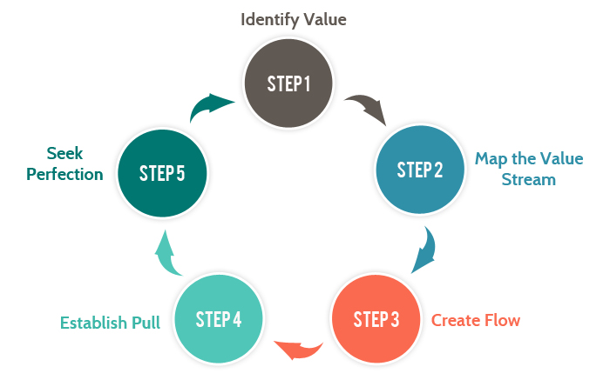 [18].
Using this methodology for this project will help the developer to deliver the project on time and will help in reducing the budget of the project.

Resources:
The resources that will be required for this project are:
- Computer/Laptop
- Visual Studio Software
- Notepad ++
- Bootstrap
- Microsoft Office

Gantt Chart:
The project is properly planned, scheduled and is aimed to successfully finish it by the April 2021. The Gantt chart is attached to this document to show the major deadline of this project and the project will be planned and processed to the Gantt chart.
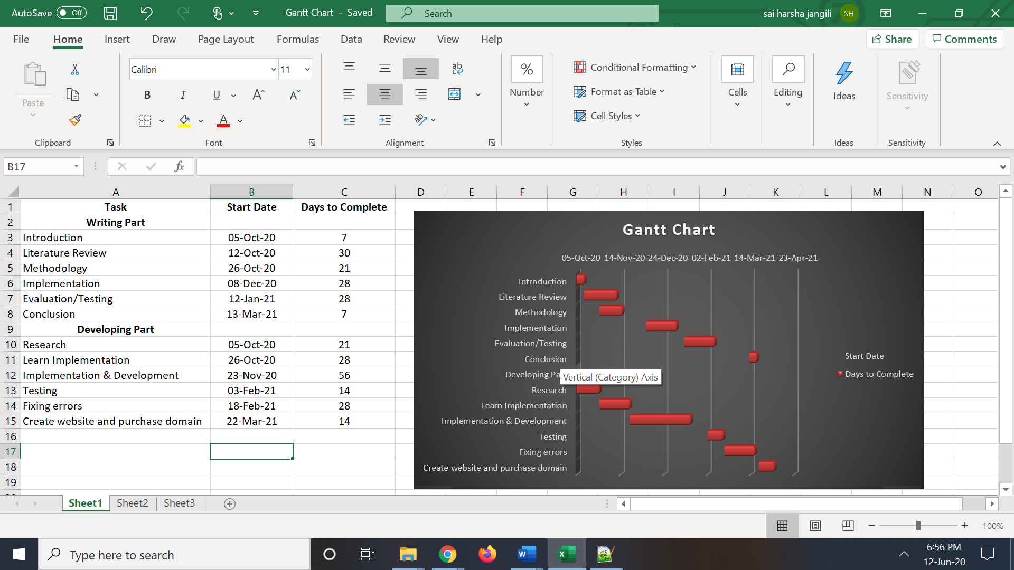

References

[1] |  | A. Dingli, "An Intelligent Framework for Website Usability," Advances in Human-Computer Interaction, vol. 2014, p. 13, 2014.
[2] |  | T. Frick, "Building a Large, Successful Website Efficiently through Inquiry-Based Design and Content Management Tools," vol. 49, p. 31, 1994.
[3] |  | W. H. A. A. M. J. I. Mirfa Manzoor, "The importance of Higher Education Website and its Usability," Internation Journal of Basic and Applied Sciences, vol. 1, pp. 150-163, 2012.
[4] |  | L. Gu, "Using school websites for home–school communication and parental involvement?," Full Terms & Conditions of access and use can be found at , vol. 3, no. 2, pp. 133-143, 2017.
[5] |  | Various, "Ecotone," 22 Apr 2020. [Online]. Available: https://www.ecotonedigital.com/content-marketing/18-benefits-of-a-website-for-small-businesses/. [Accessed 30 May 2020].
[6] |  | C. Bennett, "Thoughtco.," 30 Jan 2019. [Online]. Available: https://www.thoughtco.com/schools-website-first-impression-7655. [Accessed 12 May 2020].
[7] |  | Sherman, "Lyfemarketing," 4 Oct 2019. [Online]. Available: https://www.lyfemarketing.com/blog/importance-of-a-website/. [Accessed 20 May 2020].
[8] |  | Manzoor, The Importance of a higher education website and its usability, vol. 1, no. 2, p. 14, 2012.
[9] |  | P. M. B. D. N. D. R. O. K. P. A. T. S. B. S. M. D. Naman S. Desai, Current Problems in Diagnostic Radiology, vol. 45, no. 1, pp. 17-22, The Use of an Integrated Website to Enhance the Educational Experience in a Medical School Radiology Clerkship Course.
[10] |  | L. G. a. E. Eivers, "Primary school websites in Ireland: how are they used to inform and involve parents?," Irish Educational Studies, vol. 37, no. 4, pp. 411-430, 2018.
[11] |  | C. H. a. A. K. F. Soong, "Beyond Electronic Brochures: An analysis of Singapore primary school web sites," Educational Media International, vol. 44, no. 1, pp. 33-42, 2007.
[12] |  | "Internet User Demographics," Pew Research Center, 14 Nov 2013. [Online]. Available: http://www.pewinternet.org/data-trend/internet-use/latest-stats/. [Accessed 28 May 2020].
[13] |  | T. N. F. C. P. E. Avouris Nikolaos, " Advances in Informatics," Website evaluation: A usability-based perspective, pp. 217-231, 2003.
[14] |  | G. a. B. Belch, "Advertising and promotion," An integrated marketing communications perspective, 2007.
[15] |  | H. W. L. H. S. A. Teik Chooi Ooi, "Education websites and their benefits to potential international students: a case studyof higher education service providers in Malaysia.," Current Issues in Education, vol. 13, no. 1, pp. 1-37, 2010.
[16] |  | H. Feigl, "Positivism," Philosophy, 2019.
[17] |  | D. Gabriel, "Inductive and deductive approaches to researches," Dr.Deborah Gabriel, 17 March 2013. [Online]. Available: https://deborahgabriel.com/2013/03/17/inductive-and-deductive-approaches-to-research/#:~:text=A%20deductive%20approach%20usually%20begins,the%20scope%20of%20the%20study.&text=Inductive%20approaches%20are%20generally%20associated,commonly%20associated%20wi. [Accessed 28 May 2020].
[18] |  | "Top 12 Software Development Methodologies & its Advantages / Disadvantages," TatvaSoft, [Online]. Available: https://www.tatvasoft.com/blog/top-12-software-development-methodologies-and-its-advantages-disadvantages/#anchor10. [Accessed 30 May 2020].

