2018


Change management process; a case study for Marriott International hotel (Brand Expansion from Organic Growth to Merger and Acquisition).

School of Tourism and Hospitality
Mtour Tourism and Events Management (547T) level 7
Student number: p150709
Module tutor: Mike Davies
Title of Module: managing change within Tourism and Events Organisations
Title of the Assignment: “Change is inventible and tourism organisations must be adaptable to changing environments if they wish to survive and thrive. The advert of the sharing economy and so- called “crowd capitalism” represents new challenges to the status quo and established sector operating models. Acting as a nominated change agent, advise a tourism/events related organisation of your choice undergoing a large or incremental change owing to the impact of the sharing economy using a suitable change management framework.”

Submission date: 8th of January, 2018

Student number: p150709

Change management process; a case study of Marriott international hotel inc (Brand Expansion from organic growth to merger and acquisition).

Executive summary

In modern society change has become important aspect to human and organisation’s life, both individual and organisation need to constantly undertake change to survive in constantly changing environment.
Nowadays most organisations are working in dynamic business environment that require them to undertake different change initiatives projects to proactive respond to both internal and external challenges(O’Toole, 1995) Whatever the size of the change initiative involved, the organisation has to effectively design and adopt strategy that will lead them to archive the desirable outcome(Wille and Hodgson, 1991). In other word the organisation need to effectively apply change management process that will reduce risks and produce expected results.

This report aiming to advise Marriott international hotel in relation to its recent global expansion growth strategy, when the organisation decides to expand its brand portfolio from organic grow approach to merger and acquisition approach.

Methodology

This report is written as part of coursework, all the information in this report drawn from various sources, such as text books, website, classroom notes, electronic databases, government official sites, journals and many other relevant sources. Data were collected from both primary and secondary research.

Conclusion

Despite of the fact that, change has becomes an integral of organisation’s life, and many theories and approaches are developed to guide academics and practitioners, to many organisations, change has become a painful process, around 70 per cent of all change programme initiated around the world failed to achieve the desirable outcome (Balogun and Hope, 2004).

It may be suggested that this low success rate indicates a fundamental lack of a valid framework of how to implement and manage organisational change (Todnem, 2005), because what is current available to academics and practitioners is a wide range of contradictory and confusing theories and approaches (Burnes, 2009). However, if the managements have to critical asses how the organisation works and functions will help them allocate relevant approaches that can help produce better outcome.

Therefore, this case study examine the change occurred in Marriott international hotel, when the company decided to expand its brand portfolio from organic growth approach to merger and acquisition approach.

Introduction

Organisational change is unavoidable element to most organisations if they need to survive in current dynamic market environment. Organisational change is one of the important aspects to be considered throughout organisation’s life circle, because when it happens it effects the entire organisation rather than part of it. Nowadays most organisations operates under constantly changing environment, factor such as globalization led by rapidly advanced technology, cultural diversity, change in global economy, environmental impact, change in government policies, change in consumer behaviour and many other factors have continues to challenge many organisations(Mest, March 21.2017)
Therefore organisation’s ability to recognise the need for change and implementation of change in effective manner, in a proactive to respond to both internal and external pressure is critical essential for the performance of organisation.

Marriott international is the world leading Hotel Company that manages and franchises portfolio hotels and lodging facilities. More than 95% of operating profit is generated from asset-light franchise and management contracts. The company is based in Bethesda, Maryland, USA; it’s one of the largest hotel brands across the world with more than 6,000 properties in 122 countries and territories. Marriott offers broad options to its customers, from luxurious resorts to urban retreats and bold boutiques. Since recession the company has continued to flourish and dominate the world hospitality market, until the end of 2016, the company had 569 properties in Asia Pacific, over 200 hotels in Africa, followed by 512 properties in Continental Europe. The company’s success was achieved through its business operational model that allowed the business to grow and ..

https://www.statista.com/statistics/247304/number-of-marriott-international-hotel-rooms-worldwide/ (Accessed/01/12/2017).

Background information

Marriott international hotel is one of the largest traditional accommodation providers around the world. Like many other organisations, Marriott international was among of the companies that were affected by global economic slump in 2008; however, after recession the number of Marriott International hotel rooms as well as the number of hotels has seen a year on year growth. For many years Marriott international adopted the franchise approach model to its business growth strategy, this model benefits the Marriott through franchise fees, about 9-12 per cent of total sale generated from franchised property goes to Marriott. Unfortunately, like many other organisations wanting to expand their business to respond to changing business environment, Marriott international hotels adopted new growth model that helped the organisation to increase its size. From 2014-2016 the company transformed its global growth strategy from organic growth approach (franchise approach) to merger and acquisition approach.

Table 1: Number of Marriott International Hotel Rooms worldwide from 2009-2016
Year | Number of room
2009 | 595461
2010 | 618104
2011 | 643196
2012 | 660394
2013 | 675623
2014 | 714765
2015 | 759330
2016 | 1190604

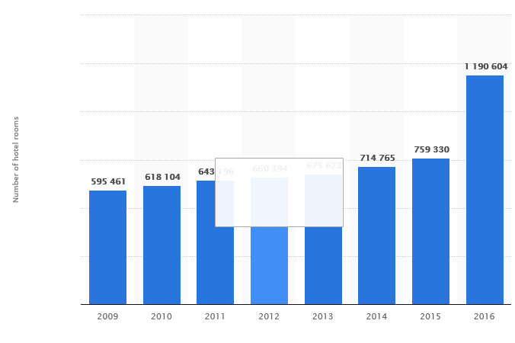
Source: https://www.statista.com/statistics/247304/number-of-marriott-international-hotel-rooms-worldwide/(Accessed/01/12/2017)

Marriott’s exiting growth approach (franchise)
It can be agree that, hotels are capital intense business that consumes lots of time and resources to open each new property. To avoid associated risks, Marriott international decided to grow its brand portfolio through licensed out its brand name to an existing hotel business owners; in turn these organisations pays Marriott certain percentage for using its brand name. There are many benefits associated to this approach, through franchise approach Marriott can now offer wide options to its customers, from luxurious resorts to urban retreats and bold boutiques. From financial point of view, this approach helps Marriott international to spend less or no cost at all when adding new property. Moreover, the franchise model help Marriott international and franchisee to focus on their digital strategy and consumer loyalty program, giving the hotel owner access to those systems and rewards, while also getting more members to join the programs and keep tighter control over the customers’ experience and data. However, this approach comes with its own risks too, Marriott can lose it’s brand reputation if the franchise opt not follow brand guideline, also financial risks due to slow down or bankrupt to some franchisees’ business. Despite of the risks involved, Marriott continued to apply the franchise approach to its growth strategy, however, due to challenges facing hospitality industry, mostly the rise of Airbnb and its operational model has largely forced Marriott international to increase its brand portfolio, and this time around Marriott decided to acquire well established business rather than giving out its brand name or build from scratch.

What has changed ?

Marriott is one of the organisations that embrace change constantly; however, this time around the company has excessively increased the number of hotels as well as number of rooms within shot period of time. Its Marriott’s habit to expand its brand name globally; however what seems to have changed was company’s decision of becoming the primary owner of Pretoria and Starwood hotels, rather than lending its brand name out as usual. The acquisition of the two well established hotels have helped Marriott to expand its brand portfolio and focus on customer experience. With Pretoria buy, has positioned Marriott as the largest hotel company in Africa, and the Acquisitions of Starwood hotels, has strengthened Marriott brand portfolio from 87 countries and territories during 2015 to 122 by the end of 2016. Furthermore,

A need of change- growth strategy
“since the need for change often is unpredictable, it tend to be reactive, discontinuous ag hoc and often triggered by situation of crisis”(Todnem, 2005:02).
If we take a close look on what is happening in today’s world, it can be agreed that to some extent, not to mention about organisations has to constantly change, but even individual has to embrace change to cope with pressure of the modern society.
Marriot hotel is a type of organisation that has to make change regularly in its products and business strategy so as it can meet consumer demands and expectation as well as to overcome both external and internal challenges. A need for change in Marriott hotel can be assessed through utilising SWOT and PESTEL analysis.
From SWOT analysis perspectives three elements of this model has contributed to Marriot to detect a need for change in its growth strategy.
Weakness:
- Decline in room occupancy rate, as its shown in appendix 1
- Fail to meet the need and expectoration customers (generation Y who value experience and need to live like local)

Opportunities:
- company need to expand in order to gain market share due to growing number of travellers around the world as it was predicted by UNWTO ( see appendix 2)
- To attract new markets: growth in middle class in China, India and South America
Threats
- Change in consumer behaviour: the preference of Millennials
- Competitors ( the rise of peer to peer accommodation, Airbnb)

From PESTEL analysis, the economic, technology and social aspect of this model has also played massive role in shaping Marriott international to align its growth strategy

Economic
To increase revenue potential: from business point of view, the purpose of any business is to make profit, if the company failed to generate profit, it is critical essential for organisation to review its business strategy and make necessary amendment if need to. Using BCG’s the Growth-Share Matrix analogy, Marriott international product portfolio can be classified as a “Star business”, with high growth and high market share for many years, however because of current strive competition from so called peer to peer networked accommodation platforms which has overpowered the traditional accommodation markets; Marriott product portfolio began to shift to another element of this model. Through peer to peer networked business models, Airbnb as an example, the company’s business model, that generates profit through acting as Commutation Bridge between customers and hosts, has challenged and positioned Marriott business portfolio to Cash-cows product. By definition, Cash-cows are classified as a former Star whose rate of market growth is in decline (Burnes, 2009). To maintain and improve its former competitive position, Marriott decided to make necessary investments on its product and service, by adding more hotels and rooms worldwide through acquisition approach that help company to attract new market niche and maintain profit margin.

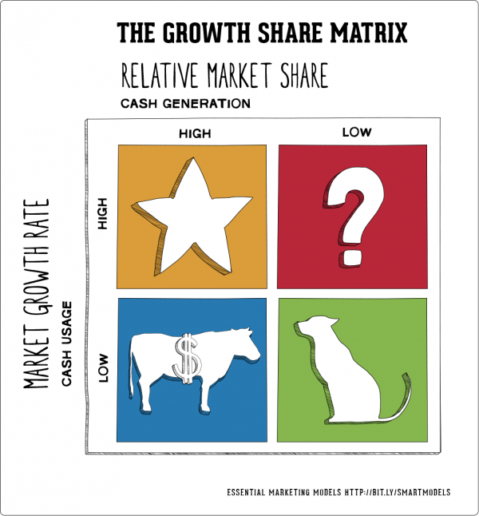
https://www.smartinsights.com/marketing-planning/marketing-models/use-bcg-matrix/

Technology

The process of digitalisation is disrupting old business models harder then we realise, the traditional market for tourism accommodation involves tourists renting rooms from formal business, such as hotel, however the new communicative technologies that enabled total connectivity and peer to peer networks has shaken up this model. Through new communication technologies and the internet everybody communicate with everything, this technology innovation has successful allowed individuals to become entrepreneurs who challenges traditional suppliers such as Marriott, their business approach force traditional suppliers to actively seek alternative methods to compete with them. Because of this Marriott is one of the organisation that is current underwent massive expansion project of its brand so as it can compete with airbnb that has proven to be a large competitor in hospitality industry through its business model

How Airbnb became competitive

Airbnb is online market place that permits the large-scale rental of spaces from one ordinary person to another. Its business model is part of a large rise in the “sharing economy” which characterised with the concept of individuals renting access to their unused assets, ranging from living spaces to cars to power tool (Guttentag, 2013).
The root for tremendous transformation within tourism accommodation industry can be traced back in 2007 in San Francisco apartment, whereby no one could imagine that three common air mattresses on floor would one day make become a competitive business model that big companies such as Marriott have to invest their time and resources to intensively compete with it. It was all started when a major conference was held in San Francisco, and two recent university graduates decided to create a simple website and successfully advertised their apartment as an AirBed & Breakfast for conference delegates looking for low cost accommodation. After to successful host the conference delegates, the roommates recruited another friend and turned the website into a service for other people to advertise their spaces as shared accommodation for tourist. In 2009 the website was re-launched as Airbnb.com, and the business idea expand beyond shared accommodations to rental full residences(Tully, June 2017
Since then Airbnb has rapidly grown with more than two millions listings worldwide, and over 50 million guests that used the service by 2017. The company drives revenue from guest and host, airbnb charge guest 12 percent and hosts 3 percent through each transaction from booking made via Airbnb website. The rise of airbnb has become good news for tourists who seek for cheap accommodation, and hosts who wanting to earn extra income, but it bad news for hospitality industries. Airbnb position itself as a cheap option, offer unique expertise, hosts are part of community this meant that have experience and wide knowledge about the area. It cost zero for airbnb to add lings to the website. However, it is different story for hotel industry, hotels works under strictly regulations, recruit staff to provide service, have to pay the cost of running the property, and so on. Hospitality industry describes airbnb business model as disruptive innovation, however from business point of view, this type of business can be described as entrepreneurship process.

Change management process: Marriott international Hotel

Management change process
Change management has been a controversial topic that is being studied and discussed by the philosophers, business expertise and researchers for so many years. As a result, a number of change management theories, approaches and philosophies are being developed to help management professionals to implement successful changes in the organisation (Burnes, 2009)
According to Moran and Brightman,(2001:111) defined change management as “the process of continually reviewing an organisation’s direction, structure and capabilities to serve the ever changing needs of external and internal customers”(Todnem, 2005).
According to Burnes (2004) change is an ever-present feature of organisational life, both at an operational and strategic level. Therefore, there should no question regarding the importance to any organisations, of its ability to identify where it needs to be in the future, and how to manage the changes required getting there(Carnall, 2003)

Although there is not one widely accepted, clear and practical approach to organisational change management that explains what changes organisation need to make and how to implement them, however to some extent the planned approach to organisational change management attempts to explain the process that bring about change(Todnem,2005; Burnes, 2004). Moreover, the planned approach emphasises the importance of different states which an organisation will have to go through in order move from its current unsatisfactory state to an identified desired state (Todmen, 2005; Eldrod II and Tippett, 2002).
The concept of planned approach change was initiated in 1946 by Lewin, who was a theorist, researcher and practitioner in interpersonal, group, intergroup, and community (Eldrod II and Tippett, 2002; Todnem, 2005). He believed that, before change and new behaviour can be adopted successfully, the previous behaviour has to be discarded (Burnes, 2004). According to Lewin (1952 in Cameron and Green, 2009; Todnem, 2005, Eldrod II and Tippett, 2002) for change to be successful archived, the organisation must therefore follow three steps. The first step involves unfreezing the current state of affairs, and then moving to new level and final step is refreezing the new state.
Even though this model was adopted as a general framework for understanding the process of organisation change, it rather broad and does not seem to fit in the modern changing environment (Todnem, 2005). Therefore several authors have later developed Lewin’s works in an attempt to make it more practical (Todnem, 2005). For instance Bullock and Batten developed a four phase model of planned change, that sprits the process in to exploration, planning, action and integration (Burnes, 2004). Some scholars agreed that, Bullock and Batten’s planned change approach is a highly applicable model for most change situation (Todnem, 2005; Burnes, 2004, Hodgson and Wille, 1991).
Despite the fact that the planned approach to change is long established and seem to be highly effective, however this approach focus more in how to deal with small-scale and incremental change, therefore , the approach is not applicable to situations that require rapid and transformational change( Todnem, 2005)

Because of this the emergent approach has gained ground, this approach to change provide general knowledge on the basis that, change should not be perceived as a series of linear events within a given period of time, it rather be considered as a continuous, open ended process of adapting to changing circumstance and conditions (Todnem, 2005; Burnes, 1996, 2004). Despite the fact that , there is no universal rules when it comes to leading and managing change, but advocated to this model have suggested sequences of actions that organisations should follow when planning change initiatives(Burnes, 2009). Kotter’s (1996) Eight-stage Process and Luecke’s Seven Steps (2003) (Todnem, 2005), are best suited advocated for emergent to change approach. See the table below for further explanations about Kotter’s and Luecke’s change management models.

Kotter’s Eight-Stage Process | Luecke’s Seven Steps
Establishing a sense of urgency | Mobilise energy and commitment through joint identification of business problems and their solutions
Creating a guiding coalition | Develop a shared vision of how to organise and manage for competitiveness
Developing a vision strategy | Identify the leadership
Communicating the change vision | Focus on results not on activities
Empowering broad-based action | Start changes at the periphery, then let it spread to other units without pushing it from the top
Generating short-term wins | Institutionalise success through formal policies systems, and structure
Consolidating gains and producing more change | Monitor and adjust strategies in response to problems in the change process.
Anchoring new approaches in culture
Source: (Todnem, 2005).

How the model can be utilized in small scale and large scale program
Organizational change occurs when a company makes a transition from its current state to some desired future state. Such a transition may be relatively minor, for instance of installing a new software programme or quite major that may transform the entire organisation (Bamford, and Forrester, 2003).

There are different change management models to help and guide academics and practitioners’ in how changes should be planed, managed and implemented
whether is large or small scale change, organisations’ ability to respond to change varies from one organisation to another, and they all respond in different way, however some scholars suggested that, one way of understanding how organisation may react to change is though how the organisation work. People have different assumptions and view point about how the organisation works. The use of metaphors has become important way of expressing these assumptions. Some people describe organisation as a political system where coalition are formed and power rules the supreme (Carnall, 2003), and others believe organisation work as a machines, organisms as well as flux and transformation.
As an a change agent, it its critical essential to understand the way the organisation in question work and function, through its organisation metaphor will help understand how the proposed change should be approached, and allocate the best suited change management model that fit the purpose.

For stance, when dealing with change that related to strategic growth, managers and leaders should understand and consider the importance of organisational factors in translating a growth strategy into reality; because this can actual dampen a company’s growth plans (Dewhurst et al, 2011). Therefore when a need of change required, it is worthwhile for leaders and managers to invest their time to assess if the existing structure are flexible enough to support the new initiatives, as well as to examine if key employees have adequate knowledge and skills needed to cope with additional complexity that growth brings.
Marriott for example, wanted to expand its brand portfolio that will appeal to different market segments, especially the millennials (who are tech-savvy and value experience “live like local”) as well as to compete with Airbnb. To retain its existing market and attract new market niche, Marriott bought Pretoria hotel and Starwood hotel. The common idea was to create new hotel platform that will provide services that fits individual needs such as high end market. The acquisition has successful increased Marriott image and popularity; however, Marriott invested massive time and money to purchase the two hotels, this means that, it will take time for Marriott to return the money invested, and time invested can’t be replaced. It will cost Marriott money to train managers and employees to adopt new system.

This show Lewin’s force field analysis would have worked for Marriott change project

Drives for change | Change needed | Resistance for force
The competitors business growth models overlaps our existing growth strategy(Airbnb) | We need grow our brand portfolio to remain competitive. | Hotel operates under restricted regulations, while Airbnb business operated under minimal regulation
Change in consumer behaviour  Need of feel like local and |  | Its costly if the company decide to open new hotel  Have to employ managers to run the business  Cost of long after the building  Wages  While it cost nothing for airbnb to add another property  Hosts are responsible for up keeping of the property (airbnb)  Managers and employee fear for uncertainty

Looking at the drives forces from the above table , it make sense for Marriott international hotel to adopt new growth strategy, for instance, in order for Marriott to provide the need of the customer, the company needs hotels that will be designed to meet the need millennials while old hotels continues to cater for other market niche.

Stakeholders involved an their importance

How to identify and deal with resistance factors for change
Organisation’s ability to accept, address and share the need for change right at the beginning is among of the methods that will help the organisation to understand the supporters and non supporter to the proposed change initiatives. From human behaviour perspective, resistance to change is the normal reaction from people who have become accustomed to a certain way of doing things, however, people do not resist change, but they tend to resist the aspect of change that is more likely to affect them. If the change is not well communicated and explained to those involves, it can create fears, conflict among individuals and reduces people’s morale. Therefore, change management approaches should not be classified and used as just a tool that guide and lead mangers how to deal with resistance when occurs, it rather be considered as an effective equipment for activating and engaging employees. As an example, system thinking approach will be best way of engaging the employees this model sees communication as an integrated process that facilitates change within the organisation. Organisation can communicate change through training, surveys, reward system, team building workshops, and seminars.

Once the change has implemented, the organisation need to refreeze by developing new ways that of working through the adoption of new norms, policies and procedures that will allow the business to operate in effective ways. Management can easily understand if the desirable outcome was achieved through the way people cope with new ways of doing thing. If the tension is higher the comfort, this means that the management deed to review the strategy gain and highlight any issue that cause discomfort. This bring us back to the approach that described change is a continuous process.

Conclusion

Every organisations has its unique reasons for undertaking different change initiatives, for instance, some organisation needs to change so as they can respond to rapidly changing environment, to improve the overall performance of the company, to improve the effectiveness and efficiency, to comply with new regulations, to increase employees performance, to improve profitability and return on overall investment, and so forth

After to critically assess change management theories and approaches, and compare to Marriott’s change management approach, I came to realise that, it was best option for Marriott to adopt new strategy, because its expansion programme has developed new hostel styles such home style hotels that provide customer access to communal area. Marriott now focus more in customer experience, trying to win the millennials generation, Marriott has created feel like local atmosphere, where by guest gets change to try local food and beverages, as well to watch live band within hotel premises.

However, the rapidly growth approach Marriott continues to embrace, may negatively affect organisational performance in years to come. Despite with the outstanding growth potential, factors such as political unrest in Middle East, post- Brexit in Europe, economic issues in Brazil, oversupply hotels in America, fluctuation in exchange rates are challenges the growth of tourism industry, “Marriott Rides on Expansion, 2010”

Recommendations

From change management perspectives, it is time for Marriott to re-assess its growth strategy and freeze the change that are already happen, sometimes is better for company to value quality that quantity. This means that having many hotels inline does not necessary add value, it rather increase the cost of operational and management.

Appendix

Table 1: Number of Marriott International Hotels worldwide from 2009 to 2016
Year | Number of hotel
2009 | 3420
2010 | 3545
2011 | 3718
2012 | 3801
2013 | 3901
2014 | 4175
2015 | 4424
2016 | 6080
Source: https://www.statista.com/statistics/247304/number-of-marriott-international-hotel-rooms-worldwide/(Accessed/01/12/2017)

Table2: Occupancy rate of Marriot International Hotels worldwide from 2010 to 2016 by region.
 | North America | Caribbean & Latin America | Continental Europe | United Kingdom | Middle East & Africa | Asia Pacific | Overall worldwide
2010 | 68.1% | 70.7% | 71.1% | 76.4% | 70.5% | 66.7% | 68.7%
2011 | 70.2% | 72.6% | 73.2 | - | 58.8% | 73.1 | 70.3
2012 | 71.6% | 72.5% | 72.7 | - | 61.8 | 73 | 71.4
2013 | 72.3% | 73.6% | 73.5 | - | 55.7 | 73 | 70.7
2014 | 74.2% | 73.6% | 74.9 | - | 60 | 73.7 | 73.1
2015 | 74.7% | 72.4% | 75.9 | - | 61.2 | 74 | 74.1
2016 | 75.8% | 65.3% | 71.8 | - | 64.6 | 75 | 72.5
Source:http://www.macrotrends.net/stocks/charts/MAR/balance-sheet/marriott-intl-a-assets-liabilities-equity-history( Accessed: 01/12/2017)

Income of Marriott International Worldwide from 2007 to 2016(in million US dollar)
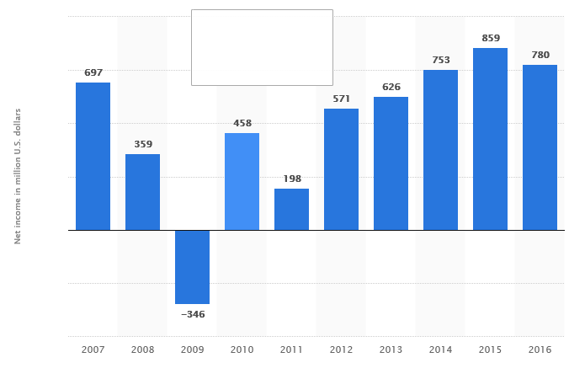
Source: https://www.statista.com/statistics/256252/net-income-of-marriott-international/

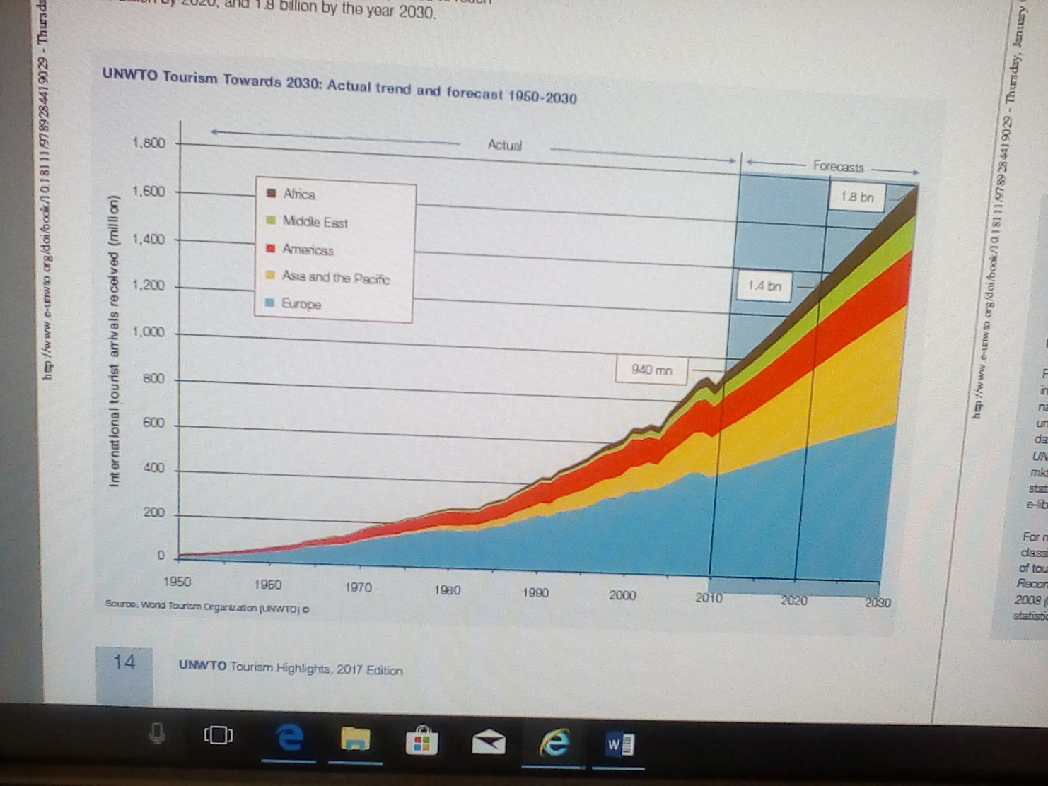

Number of international tourist arrivals worldwide from 2005 to 2016, by region(in millions)
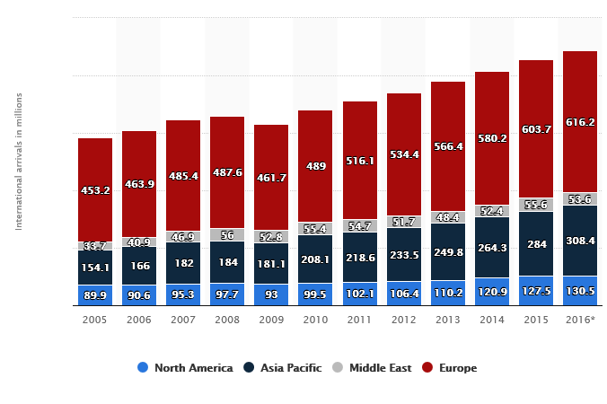
https://www.e-unwto.org/doi/pdf/10.18111/9789284419029 (Accessed: 30/12/2017)

The table bellow present the most common organisation metaphor which includes key belief, assumption about organisation change, limitations and best suited change management model

Metaphor | Key belief | Assumption about organisation change | Limitations | Change management model
Organisation as machine | Each employee should have only one line manager  Labour should be divided into specific roles  Each individual should be managed in by objectives  Teams represent no more than summation of individual efforts  Management should control and there should be employee discipline | The organisation can be changed to an agreed end state by those in position of authority  There will be resistance and this need to be managed  Change can be executed well if it is well planed and well controlled. | This approach works in stable situation, when change needed, this will be seen and experienced by employees as disruptive model, hence encourage resistance.  If change approached with this approach, it require strong management action, inspirational vision and control from top down | Lewin, three-step model  Bullock and Batten, planned change  Kotter, eight steps  William Bridges, managing the transition
Organisation as Political system | You can’t stay out of organisation politics: you’re already in it  Building support for your approach is essential if you want to make anything happen  Coalitions between individuals are more important than work teams  You need to know who is powerful, and who they are close to  There is an important political map that which overrides the published organisation structure  The most important decision in an organisation concern the allocation of scarce resources, that is, who gets what, and these are reached through bargaining, negotiation and vying for position | The change will not work unless its supported by a powerful person  The wider support for this change the better  Its important to understand the political map, and to understand who will be inners and looser as a result of this change  Positive strategies include creating new coalitions and renegotiation issues. | Its assumption shows that, in an organisational endeavour , there are always winners and losers  Can turn organisational life into political zone war | Kotter, eight steps  Nadler and Tushman, congruence model  Carnall, change management model  Senge, systemic model  Stacey and Shaw, complex responsive process.
Organisation as organism | There is no one best way design or manage an organisation  The flow of information between different parts of the systems and its environment is key to the organisation’s success  It is important to maximize the fit between individual, team and organisational need. | Change are made only in respond to changes in the external environment (rather than using an internal focus)  Individuals and groups need to be psychologically aware of the need for change in order to adopt.  The respond to change in the environment can be designed and worked towards  Participation and psychological support are necessary strategies for success. | The idea of organisation as adaptive is flawed; the organisation is not real an adaptive unit, at the mercy of its environment. In reality it can shape the environment by collaborating with communities or with other organisation or by initiating a new product or service that may change the environment in a significant way. | Lewin, three-step model  Kotter, eight steps  Beckhard and Harris, change formula  Nadler and Tushman, congruence model  William Bridges, managing the transition  Carnall, change management model  Senge, systemic model
Organisation as flux and transformation | Organisation naturally emerges out of chaos  Organisation have natural a capacity to self –renew  Organisation life is not governed by the rules of cause and effect  Key tension are important in the emergence of new ways of doing things  The formal organisational structure (teams, hierarchies) only represents one of many dimensions of organisational life. | Change cannot be managed. It emerges  Managers are not outside of system they manage. They are part of the whole environment  Tension and conflict are important feature of emerging change  Manager act as enablers. They enable people to exchange views and focus on significant differences. | It disturb both manager and consultants  It does not lead to action plan | William Bridges, managing the transition  Senge, systemic model  Stacey and Shaw, complex responsive process.

References
Burnes, B (2009). Managing Change. 5th ed. England : Pearson Education Limited. p 109-117.
Carnall, C (2007). Managing Changes in Organisation. England : Pearson Education Limited. P95-108.
Cameron, E and Green, M (2004,2009). Making Sense of Change Managemnt. 2nd ed. London : Kogan Page Limited. P34-85.
Ottaway, R (1779). Change Agents at work. London : Association Business Press. 52-74.

Mest, Elliot (2017, March 21) “5 growth opportunities for Marriott. Hotel Management retrieved https://www.hotelmanagement.net/development/marriott-s-3-year-plan-includes-300-000-new-rooms

Tully, S (June, 2017)”why Hotel Giant Marriott is on an Expansion Binge, as it Fends off Airbnb. Fortune newspaper. Retrieved http://fortune.com/2017/06/14/marriott-arne-sorenson-starwood-acquisition-airbnb/

Wille, E and Hodgson, P (1991). Making Change Work. London : Mercury Books. p 12-25.

http://fortune.com/2017/06/14/marriott-arne-sorenson-starwood-acquisition-airbnb /(Accessed: 27/12/2017)

http://news.marriott.com/2017/03/marriott-international-announces-2020-growth-vision-europe-post-starwood-acquisition/ ( Accessed: 27/12/2017)

http://www.nasdaq.com/article/marriott-rides-on-expansion-initiatives-revenue-woes-stay-cm843233 ( Accessed: 30/12/2017)

https://www.prnewswire.com/news-releases/marriott-international-embarks-on-global-independent -( Accessed:30/12/2017 )hotel-expansion-as-more-consumers-and-owners-seek-unique-experiences-powered-by-marriott-300468223.html

https://www.hotelmanagement.net/development/5-ways-marriott-planning-for-development-domination ( Accessed: 05/01/2018)

http://www.travelweekly.com/Travel-News/Hotel-News/Marriott-plans-massive-expansion-of-select-service-brands ( Accessed: 05/01/2018)

https://www.hospitalitynet.org/news/4081596.html

